My 3D Scene

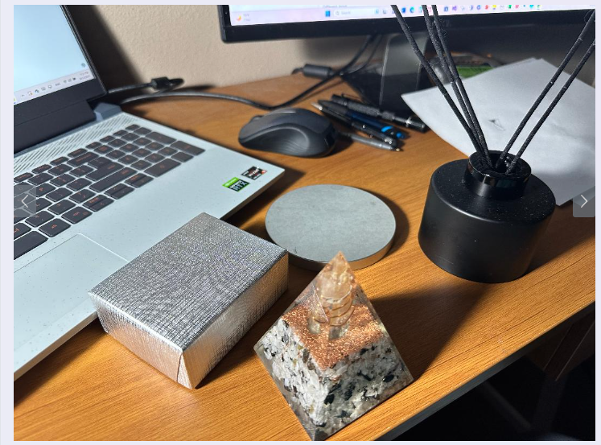

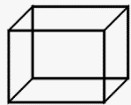

The four shapes that I chose, are a cube, cylinder, pyramid, and plane. Let’s start with the cube.

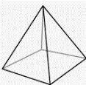The grey jewelry box emulates this shape. This shape consists of eight sides total that will have to be constructed in openGL. I chose the cylinder as well. The black incent holder is cylindrical. It consists of an extension on it’s top, that is used to hold the incent sticks in place. The pyramid is similar to the paper weight pyramid shown above. It consists of three sides, and a base. For the pyramid, all three sides will come to one single coordinate point in OpenGL. The plane is similar to the round top, shown in the picture above. It is flat for the most part, but round. This type of plane is not normal, but I think it’s cool.

I will try to replicate the pyramid in an 3D shape. For me, it is the easiest rout to go. The round object in my scene, can be either a plane, or extruded, to kind of semi-cylinder like. My desktop will be the plane, since I have all of these shapes pilled onto it. Once I start can visualize where my coordinates are, It should not be to big of a deal to create the shapes.