**Construction Supplier**

SE 305 – Software Specification and Design

Term Project Design Document

Ege DELİGURU

Onat ÇİPLİ

December 22, 2017

1. Introduction

In our project as a team we try to design a program for one construction supplier company in Urla in İzmir.That company is creating link between the customer and the factory.Currently, our client doing some of the basic operation via phone call like asking for stock etc...Therefore, our client want us to design a program to get rid of from that conflict and organize the records of customer more efficiently in the computer rather than papers in dossiers.

2. Problem Definition

So we started from understanding the system,which is system requirments analysis. What ı mean how the system is working and what are the things which we need to be carefull. Thats why we did interview with our customer and ask him to close-end and open-end question to have a better understanding about the system.

After we collect the informations about the system and how it works.As a team we try create functional and non-functional requirements and try to create diagrams and documentation with considering our functional requirements and our knowledge.

3. Proposed System Design

3.1. Requirements

**Functional Requirements:**

1. **Create Customer Record**
2. **Access Customer Record**
3. **List Contruction Stock**
4. **Purchase**
5. **Invoice**

**Non-Functional Requirements:**

1. **The system should run in less 1 minute**
2. **The system should have at least 512 MB of memory**
3. **The system should be win 7 or better operating system**
4. **The system should have internet connection**

3.2. Context Model

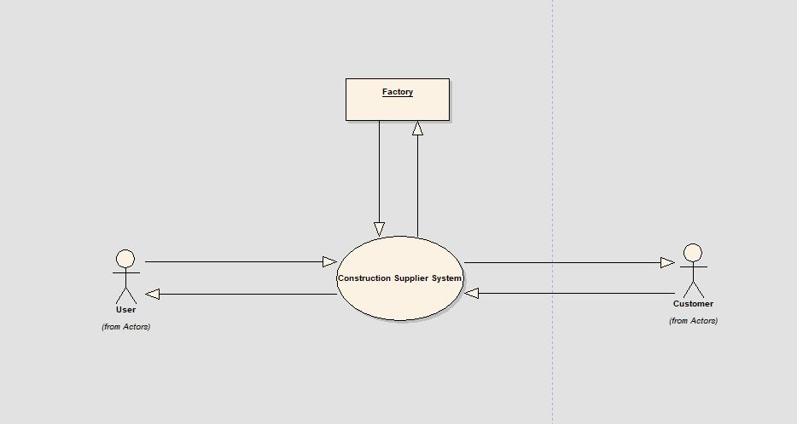

3.3. Data Flow Diagram

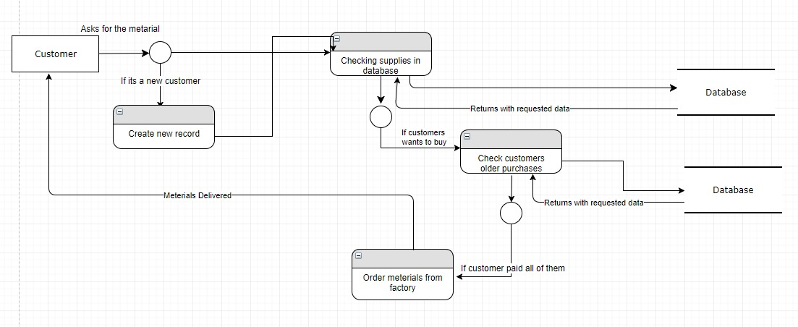

3.4. Activity Diagrams

Diagram 1: Access Customer Record

C:\Documents and Settings\Administrator\Desktop\Image2.EMF

Diagram 2: Create Customer Record

C:\Documents and Settings\Administrator\Desktop\Image2.EMF

Diagram 3: Invoice

C:\Documents and Settings\Administrator\Desktop\Image2.EMF

Diagram 4: List Construction Stock

C:\Documents and Settings\Administrator\Desktop\Image2.EMF

Diagram 5: Purchase

C:\Documents and Settings\Administrator\Desktop\Image2.EMF

3.5. Use Cases

3.5.1. Actors

C:\Documents and Settings\Administrator\Desktop\Image2.EMF

3.5.2. Use Case Diagrams

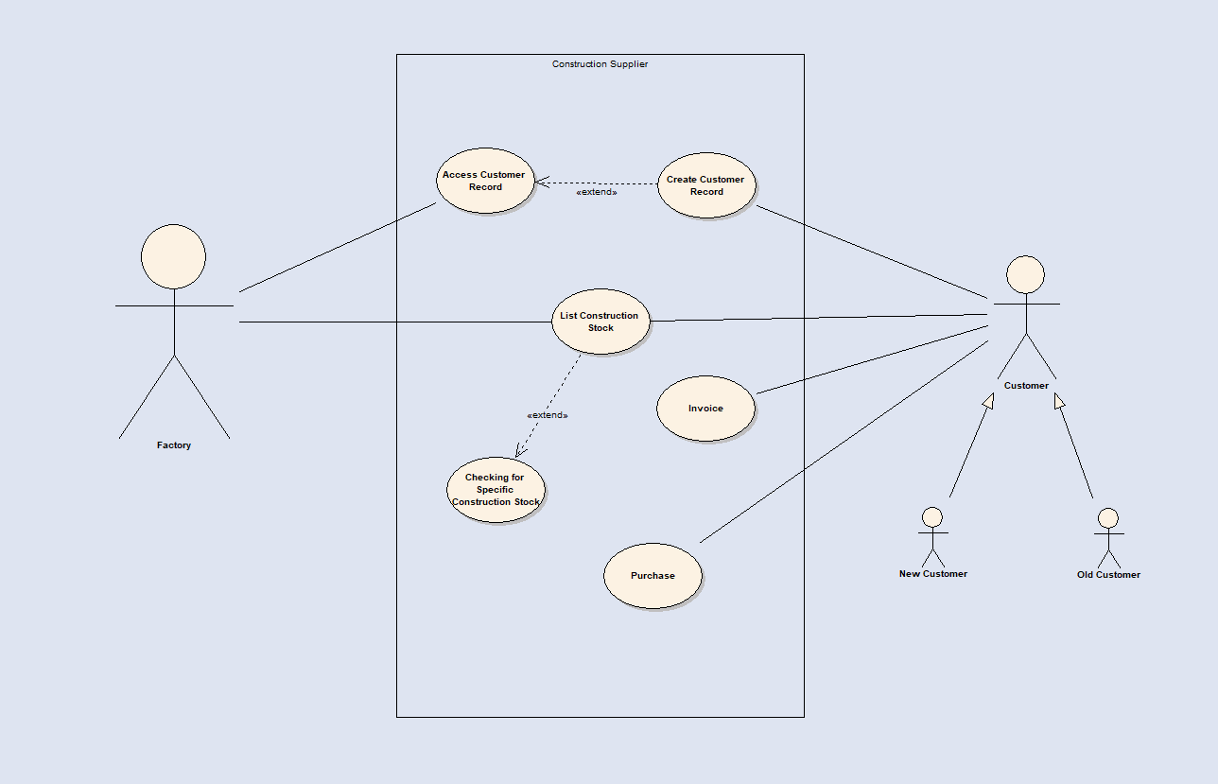

3.6. Use Case Text

Purchasing Construction Materials From Supplier

Primary Actors:Customer(new and old customer),Factory

Precotions:Network connection is active and Factory has available materials

**Basic Flow of Events:**

1. Customer comes to company and say he/she want to buy construction material or materials.

2.Before start informing the customer company will create that customers’ record for security issues.

3.Customer will tell what him/her need as a construction materials like cement, metal, brick.

4.Company show what kind of material they have for example c20,c30 which are kinds of cement.

5.Customer tell what kind of material or brand they want.

6.Company ask stock detail from factory for the need of customer.

7.Company tell the price with adding adding V.A.T to the customer

8.Customer accept the price and pay the price of materials.

9.Company ask for date and time to deliver the materials.

10.Customer tell the available time for itself.

11.Company start the purchasing and took the money.

12.Company prints the invoice and give it to the customer.

13.Customer leaves.

**Alternative Flow of Events:**

2a. Customer is already exist in the sytem so if it is company need to access the customer record and should validate.

2a1. If this is not belong the customer company should create new customer record.

5a.Company may not have the brand which customer desire so company can show alternative option with the same features and qualities.

5a1. Customer is not accept the alternative suggestion of company and leave the company.

8a. Customer may not accept the price of materials and can want a discount.

8a1.Company can think discount option if the customer wants to buy a lot of materials.

8a2.Company may refuse to changing the price of material so customer leaves.

10a. The delivery time given by company may not be available for the customer so that company need to find another available time for the customer.

3.7. Class Diagrams

3.7.1. Class Diagram 1: Class Model

C:\Documents and Settings\Administrator\Desktop\Image2.EMF

3.8. Communication Diagrams

3.8.1. Communication Diagram 1: Payment

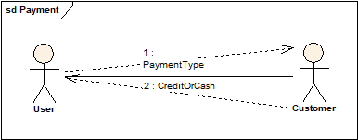

Communication Diagram 2 : Account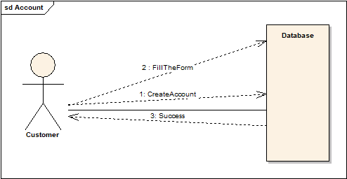

Communication Diagram 3 : Invoice

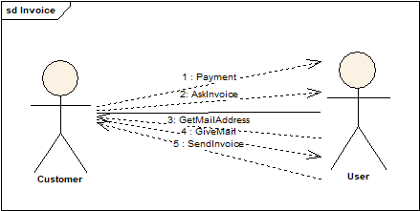

Communication Diagram 4 : AskMaterial

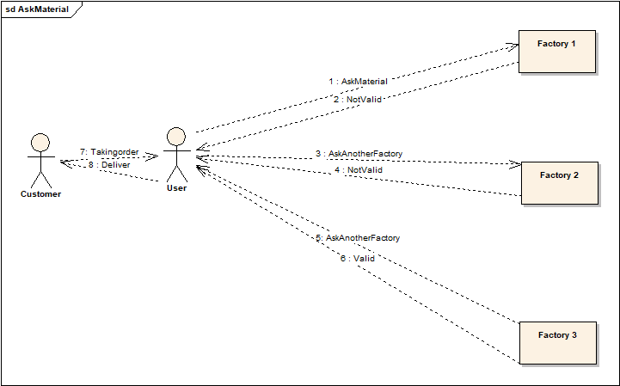

Communication Diagram 5 : Request

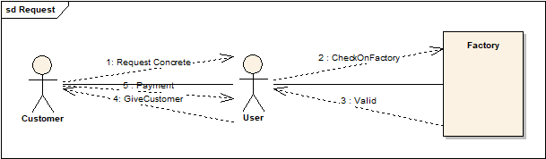

3.9. Sequence Diagrams

3.9.1. Sequence Diagram 1:

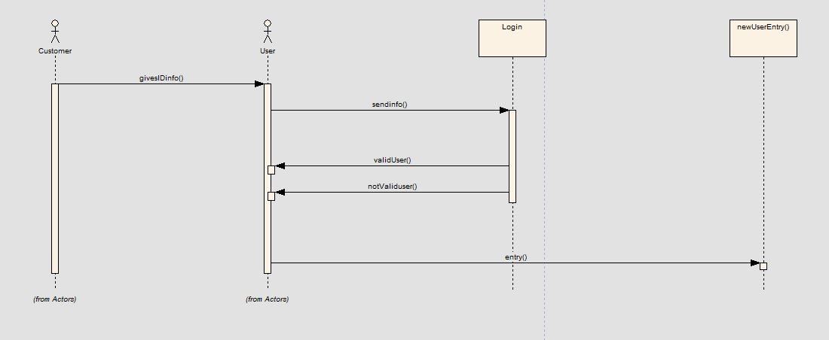

Sequence Diagram 2:

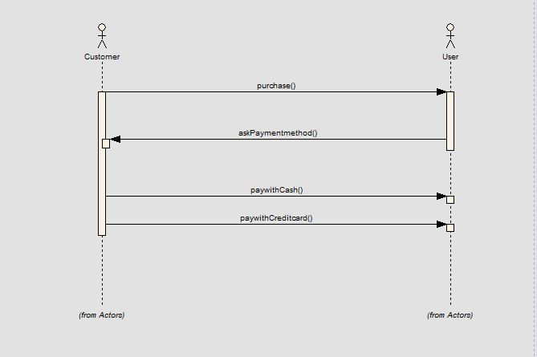

Sequence Diagram 3:

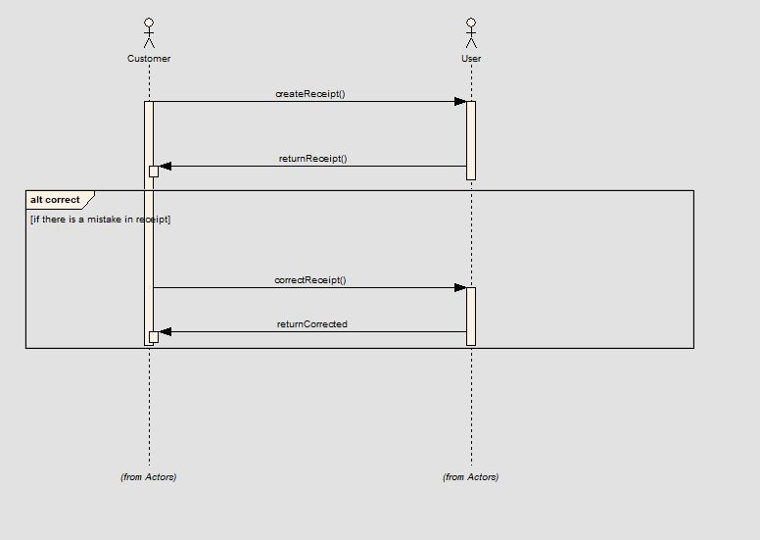

Sequence Diagram 4:

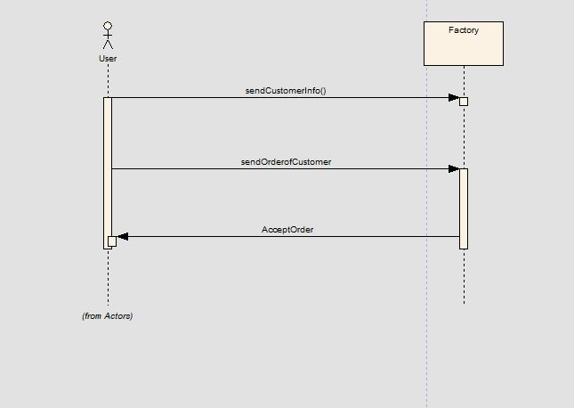

Sequence Diagram 5:

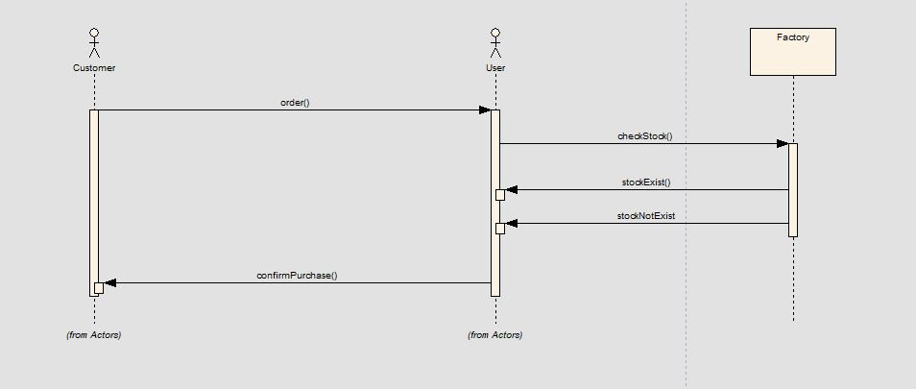

3.10. User Interfaces

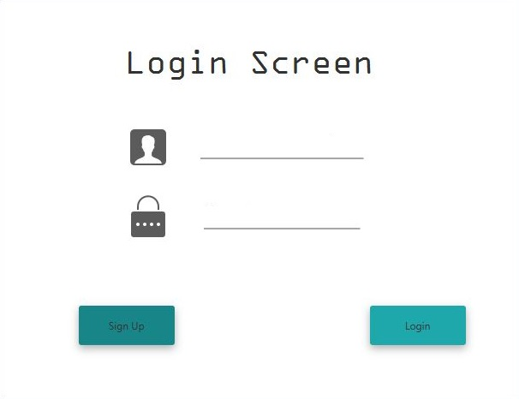

Interface 2 :

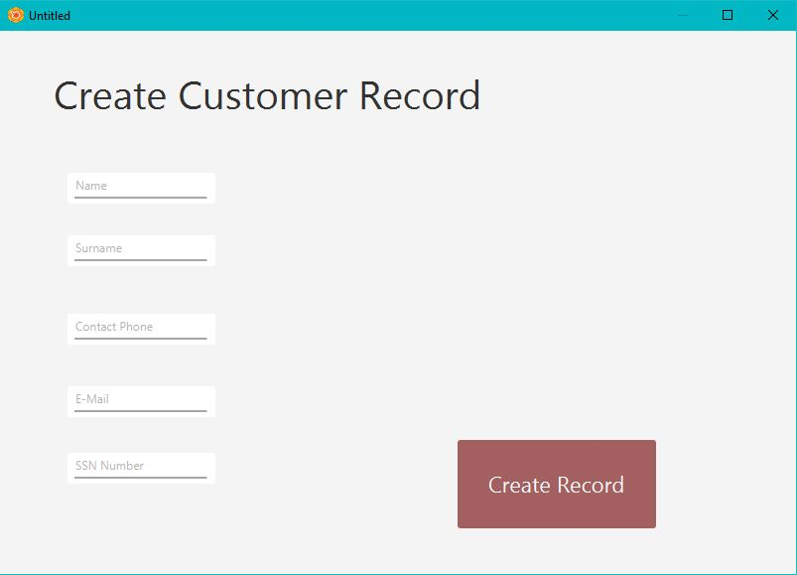

Interface 3 :

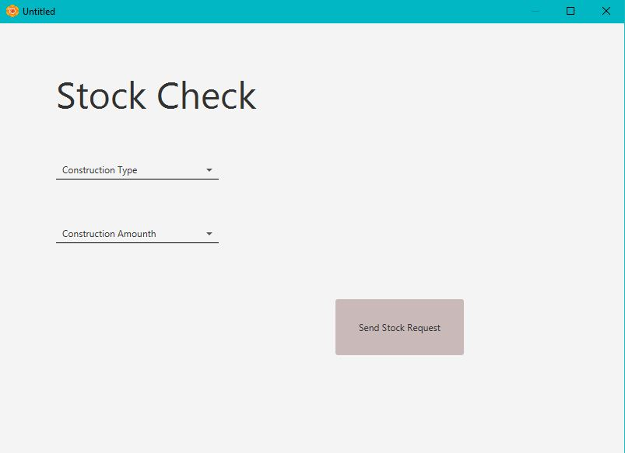

4. Architectural Pattern

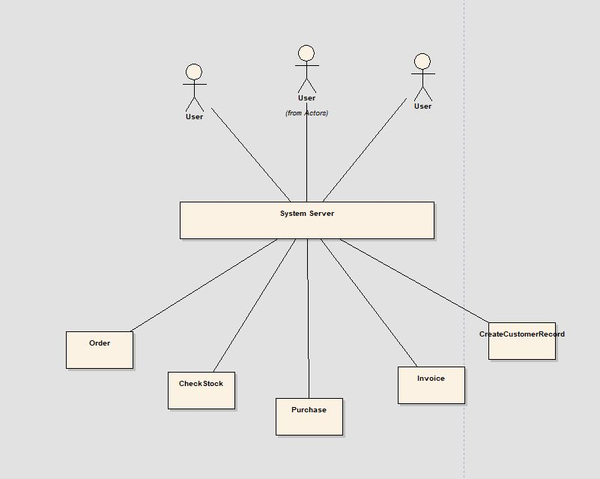

We choose server client patter because in our project there can be many user who try to access the system at the same time to do different request.

5. Conclusion

As we mention in the problem definition as team we are trying to design a program for the construction supplier company.Our is aim is to create better and fast linking between the company and the suppliers factories.

After interview with the stakeholder of our company we started to analyzed the system and with the information we gathered we try to impelemnt some diagrams like use case diagram,action diagram,sequence diagram,class diagram and etc.. to understand the general view of the system and how it is working.

After these steps we again meet with our customer to tell him what are the things which are slow down the process of the job and we showed him our advice to fix these slowness with the help of our diagram.

After that step customer accept our solution and we implement all the document which is at this document.As a last phase of our diagrams and with the help of our program our customer can achieve customer needs better and faster.