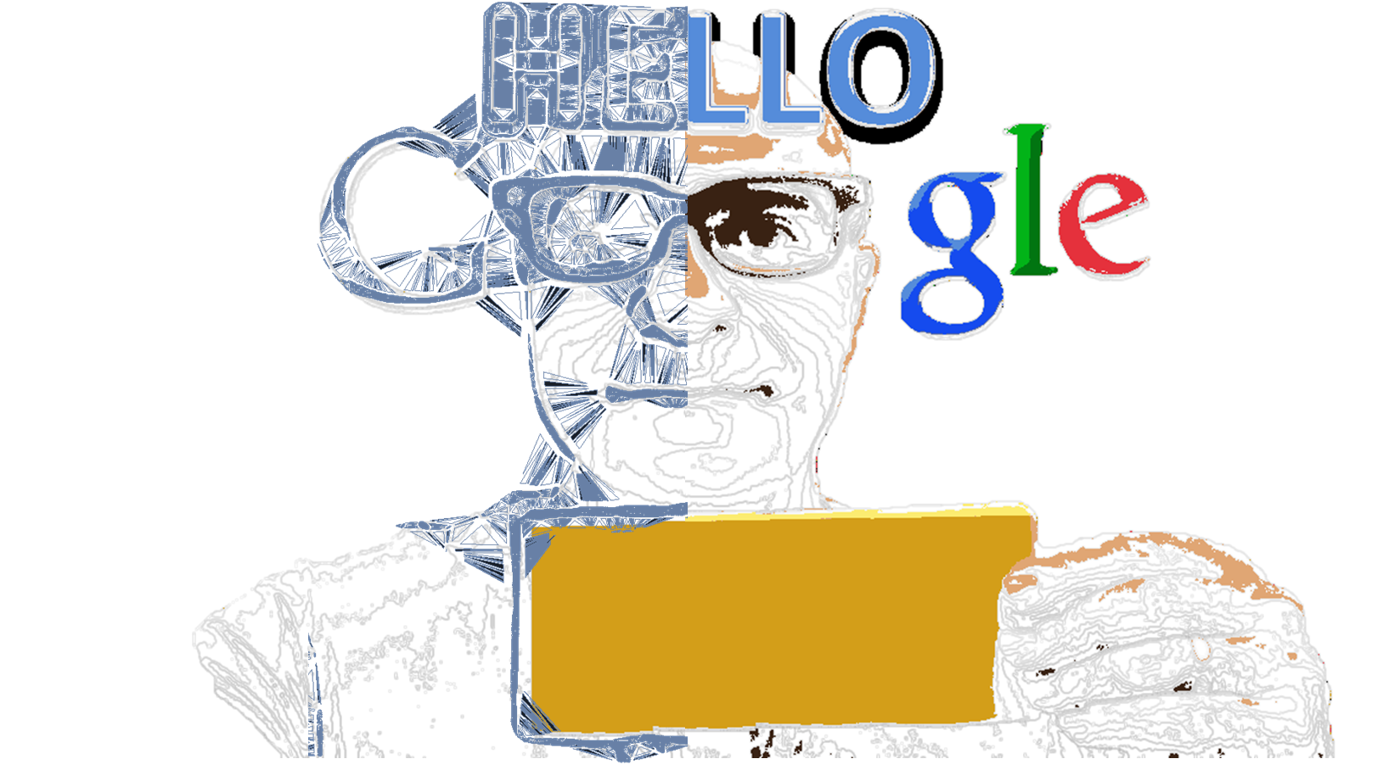

**I consider myself as a hardworking, educated, energetic and passionate person. I value creativity more than intelligence, recognize generally accepted ethical codes, I respect people of any color, ethnical background and sexual orientation, do not believe in races, do not believe in anything in general, instead I try to learn and understand. I fell happy and satisfied, if I can make people around me happy and safe. I am convinced that a Company like Google Inc. will be able to shape, change and finally safe the world and the tiny life on it through innovation and technology. From my point of view, my willingness of to be a part of it is cristal clear. If you share the same opinion with me, please give a look to my documents.**