CCDA Extended Validation Design

# Introduction

The SITE application performs CCDA validation based on both syntax and semantics of the XML document as well as MU2 validation. The current validator does not validate against the actual vocabulary values.

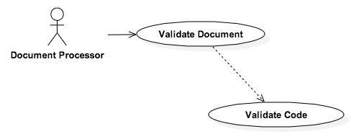

The primary use case of this system is to validate a CCDA Document. The validation engine will include a robust configuration to individually evaulate values of XPath expressions. The initial validation will include validating entered codes against the vocabulary validation engine.

# Software Component Views

At a high-level, a Validation Engine will be created to perform the necessary validation logic. This validation logic will be created in a modular fashion to allow consumption of this engine in two manners. The Validation Engine can be consumed in two separate manners: an exposed web service and an API that can be directly integrated into a consuming application.

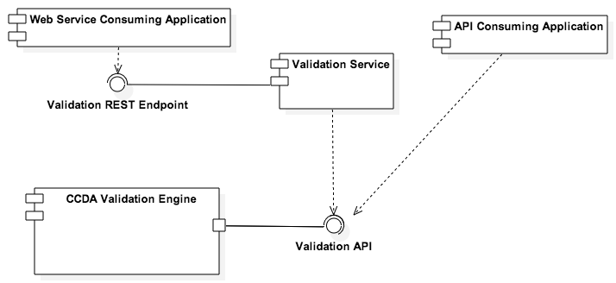

## Logical Component View

The Validation Engine will include business logic appropriate to perform the configured validations. The configuration will be loaded at initialization. A configuration interface will be available to add in future validations extensions.

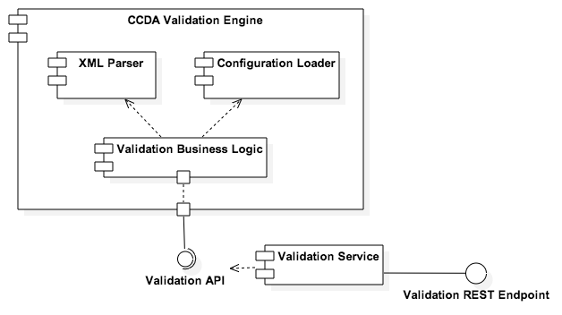

## Collaboration View

The primary function of the CCDA Extended validation service is to validate the CCDA file.

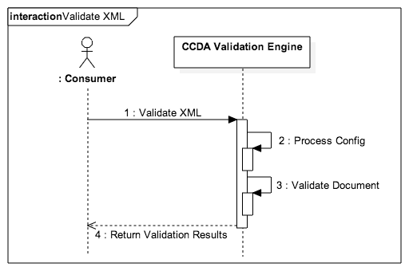

### Validate CCDA File

The Validate CCDA File functionality will utilize the initialized configuration files.

## Technology View

The Vocabulary Value Set Validator will be deployed as a RESTful web service on an Apache Tomcat 7.0 application server. The web service will use the following libraries:

* Spring MVC Restful Services
* Hibernate as a JPA Persistence Provider
* Spring Framework (for IoC and AoP)

## Data View

Not Applicable

## Package View

TBD

## Configuration Details

Configuration information will be located in the environment.properties file associated with the project. Additional configuration items will be determined at implementation.