Vocabulary Value Set Validation Design

# Introduction

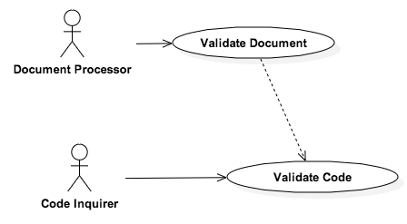One of the major issues in clinical document validation is the lack of validation of vocabulary value set validations. In healthcare, there are multiple standard vocabulary value sets, such as SNOMED CT, RxNorm, LOINC, and ICD-10-CM, which are used to define clinical concepts used in clinical quality measures. To solve this issue, an extensible system will be developed to support validation against common vocabulary value sets.

The primary use case of this system is to validate a code.

# Software Component Views

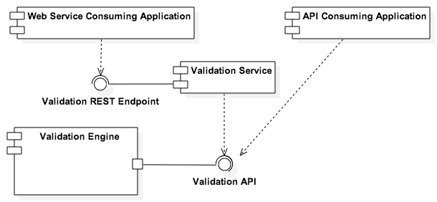At a high-level, a Validation Engine will be created to perform the necessary validation logic. This validation logic will be created in a modular fashion to allow consumption of this engine in two manners. The Validation Engine can be consumed in two separate manners: an exposed web service and an API that can be directly integrated into a consuming application.

## Logical Component View

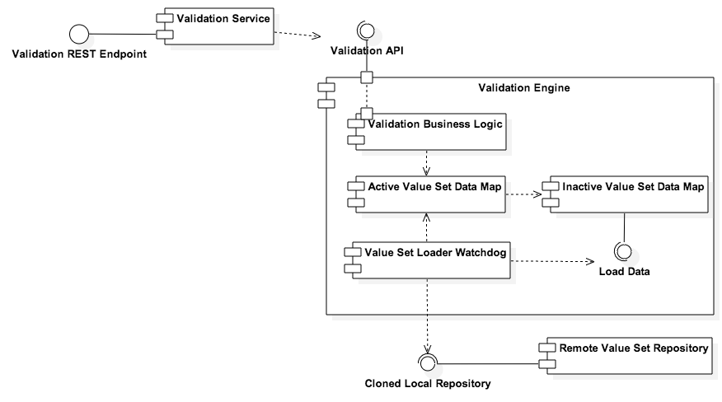The Validation Engine will include business logic appropriate to perform the necessary value set code lookups. The business logic will interact with an active value set data map, which will store the currently evaluated version of the value set.

The authoritative list of value set codes will reside in a GitHub repository. The Validation Engine will include a watchdog task that will periodically scan the repository for changes. If changes to the repository are detected, they will be loaded into an inactive value set data map. Once loaded and verified, the new map will be activated and the old value set data map will be deactivated.

## Collaboration View

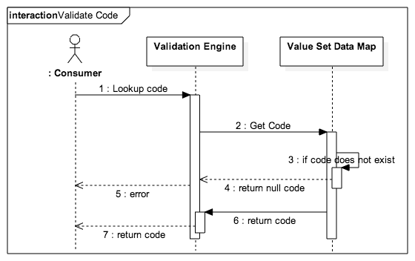There are two primary functions for the system. The first function is provided to satisfy the primary use case of validating a code against a vocabulary value set. The second function performs the update of a value set map whenever the repository is updated.

### Validate Code

The Validate Code functionality will look up a code for a specific vocabulary in the currently active value set data match. If the code does not exist, an error will be returned. If a code exists, the information pertaining to the code will be returned.

### Update Value Set Map

When a contributor updated the repository, the update will be detected by the next iteration of the Validation Engine Watchdog task. The watchdog task will asynchronously poll the repository location at a configurable interval. When the watchdog task discovers a change to the repository, it will load the new value sets into an inactive value set map. Once the value sets have been loaded and verified, the inactive value set will become active and the active value set will be deactivated and released.

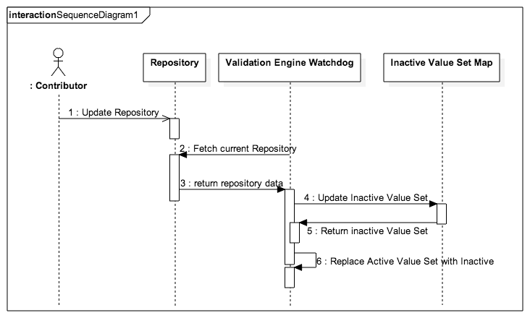

## Technology View

The Vocabulary Value Set Validator will be deployed as a RESTful web service on a Apache Tomcat 7.0 application server. The web service will use the following libraries:

* Apache CXF
* Hibernate as a JPA Persistence Provider
* Spring Framework (for IoC and AoP)

## Data View

Value set data will be managed in the following GitHub Repository: TBD

## Package View

TBD

## Configuration Details

Configuration information will be located in the environment.properties file associated with the project. Additional configuration items will be determined at implementation.