Lagrange – A Space Elevator Game

* How to gamify?
  + Funding?
    - Initial investment + performance
    - Bill Gates, etc rich list <https://en.wikipedia.org/wiki/The_World%27s_Billionaires>
    - Country <https://en.wikipedia.org/wiki/List_of_countries_by_GDP_(nominal)>
  + Payload vs target
  + Consumption (death/shutdown)
  + Declining performance vs maintenance
  + Automate later (robots unlocked) to avoid micromanagement

<https://en.wikipedia.org/wiki/Space_elevator>

1. Download SourceTree

Pringle: 2. Clone your repo from github to whatever folder you want to work from on your local machine.

Pringle: 3. Copy your gamemaker work into that same folder

Pringle: 4. Make a .gitignore file with your build directories in it.

Pringle: 5. Commit everything that's left.

Pringle: 6. Push!

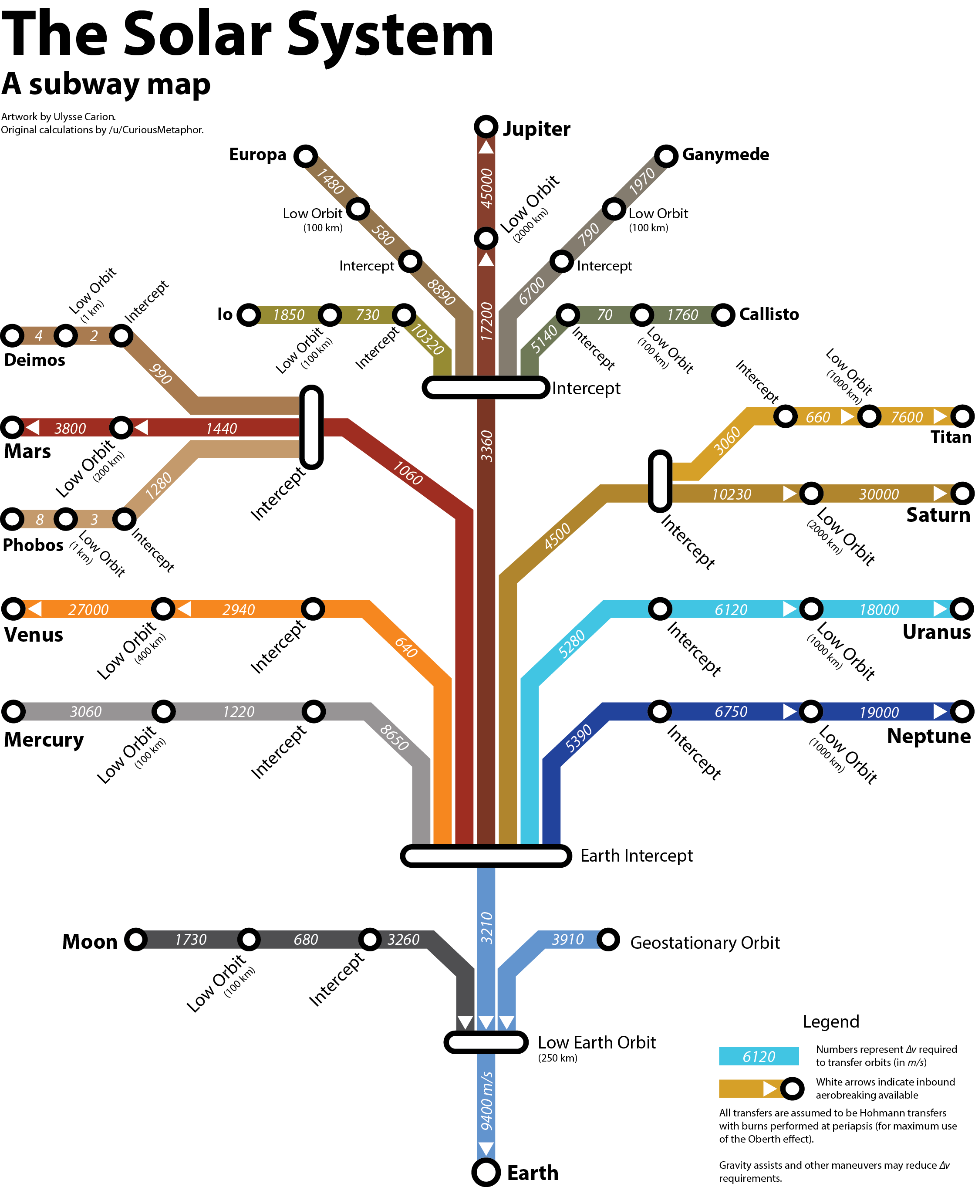

* Launch Systems <https://en.wikipedia.org/wiki/Launch_service_provider>
  + NASA SLS
  + Blue Origin
  + SpaceX
    - <https://en.wikipedia.org/wiki/SpaceX>
    - <https://en.wikipedia.org/wiki/Interplanetary_Transport_System>
  + Virgin
  + Arianespace
    - <https://en.wikipedia.org/wiki/Arianespace>
* <https://en.wikipedia.org/wiki/Comparison_of_orbital_launch_systems>
  + 20 ton +
  + Start date for campaign vs available platforms?
* Discover
* The Moon's orbit is around 9 times larger (in radius and length) than geostationary orbit.
* 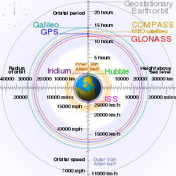
  + LEO – Low Earth Orbit
  + LTO – Lunar Transfer Orbit
  + GTO Geosync Transfer Orbit
  + GEO – Geostationary Orbit
  + Etc
  + Subway to include travel times (and travel windows ex-Earth/Lunar)
* Spheres of influence

|  |  |  |  |  |
| --- | --- | --- | --- | --- |
| **Body** | **SOI radius (10^6 km)** | **SOI radius (body radii)** | **Surface Gravity (m/s^2)** | **Radius** |
| Mercury | 0.112 | 46 |  |  |
| Venus | 0.616 | 102 |  |  |
| Earth | 0.924 | 145 | 9.807 | 6371 |
| Moon | 0.0661 | 38 | 1.62 | 1738 |
| Mars | 0.576 | 170 |  |  |
| Jupiter | 48.2 | 687 |  |  |
| Saturn | 54.6 | 1025 |  |  |
| Uranus | 51.8 | 2040 |  |  |
| Neptune | 86.8 | 3525 |  |  |

* Asteroid Capture
  + Carbonaceous
    - Solar panels
    - Volatiles (i.e. Water!)
  + Rocky
    - Generic
    - Mass
  + Metallic
    - Valuable
    - Advanced
* Construct
  + Power generation
    - Solar
    - Fission
    - Fusion (unlock)
  + Production facilities
    - Solar panels
    - Cable
    - Generators
    - Bio-production
    - Advanced (unlock)
    - Spaceship
  + Launch facilities
    - Launchpad
    - Railgun for no-atmosphere (unlock)
    - Locations
      * Earth 96px = 140km per px
      * Lunar 24 px at 2800px
      * Satellite (Lagrange, Phobos, Ceres, Eros)
      * Mars
      * Geo-sync
  + Supply runs
  + Space Elevator locations
    - The Moon <https://en.wikipedia.org/wiki/Moon>
      * <https://en.wikipedia.org/wiki/Lunar_space_elevator>
      * Or not:
        + <https://astronomy.stackexchange.com/questions/20499/is-it-possible-to-achieve-a-stable-lunarstationary-orbit-around-the-moon>
    - Mars: <https://en.wikipedia.org/wiki/Mars>
      * <http://www.nss.org/settlement/mars/2003-SpaceColonizationUsingSpaceElevatorsFromPhobos.pdf>
      * <https://forum.nasaspaceflight.com/index.php?topic=37667.0>
    - Macapa, Brasil
      * Amazon port
      * East Coast Americas
      * @0.101772,-51.2369474
    - Chamanga, Ecuador
      * Port
      * West Coast Americas
      * @0.2693571,-79.9589468
    - Kenya
    - Isla Isabella
      * Off West Coast Americas
      * Private development
      * @-0.794891,-91.0665257
    - Aranuka Island, Kiribati
      * Central Pacific
      * Private Development
      * @0.1745024,173.5924631
    - Porto Allegre, Sao Tome & Principe
      * Private Development
      * West Coast Africas
      * @-0.0029956,6.4826291
    - Pontianak, Indonesia
      * Riverine Port
      * Borneo
      * @-0.0786271,109.3862272
    - Kampala, Uganda
      * Capital
      * Central Africa
      * @0.3130291,32.5290849