Questions and Exercises to work out and turn in:

Grading Guidelines:

* A right answer will get full credit when:

1. It is right (worth 25%)
2. It is right **AND** neatly presented making it easy and pleasant to read. (worth an **extra** 15%)
3. There is an **obvious and clear link** between 1) the information provided in the exercise and in class and 2) the final answer. A clear link is built by properly writing, justifying, and documenting an answer (worth an **extra** 60%).
4. Calculation mistakes will be minimally penalized (2 to 5% of full credit) while errors on units will be more heavily penalized.

You are welcome/encouraged to discuss exercises with other students or the instructor. But, ultimately, **personal** writing is expected.

* USE THIS FILE AS THE STARTING DOCUMENT YOU WILL TURN IN. **DO NOT DELETE ANYTHING FROM THIS FILE:** JUST **INSERT** YOUR ANSWERS.
* IF USING HAND WRITING (STRONGLY DISCOURAGED), **USE THIS FILE** BY CREATING SUFFICIENT SPACE AND WRITE IN YOUR ANSWERS.
* FAILING TO FOLLOW TURN IN DIRECTIONS /GUIDELINES WILL COST **A 30% PENALTY.**

**Objectives of this assignment**:

* to use and manipulate the concepts presented in this module
* to propose and write algorithms in pseudocode
* to analyze the time complexity of algorithms
* to analyze the space complexity of algorithms
* to learn autonomously new concepts

What you need to do:

Answer the questions and/or solve the exercises described below.

Exercise 1 (15 points)

Write pseudocode for MAKE-SET, FIND-SET, and UNION using the linked-list

representation and the weighted-union heuristic. Make sure to specify the attributes

that you assume for set objects and list objects.

Set objects have a head attribute that points to the first object in the list, which is also the representative, a tail attribute that points to the last object in the list, and a length attribute that holds the number of items in the list. List objects each have a member attribute, which is the data it is holding, a next attribute which points to the next object in the list, and a set object attribute which points back to the set object.

MAKE-SET(x)

1. set = new SetObject()
2. list = new LinkedList<ListObject>()
3. list.add(x)
4. setObject.head = x
5. setObject.tail = x
6. x.next = null
7. x.setObject = set

FIND-SET(x)

1. return x.setObject.head

UNION(x, y)

1. if x.setObject.length > y.setObject.length
2. x.setObject.tail.next = y.setObject.head
3. x.setObject.tail = y.setObject.tail
4. for each ListObject listObject in y.setObject
5. listObject.setObject = x.setObject
6. y.setObject.head = null
7. y.setObject.tail = null
8. else
9. y.setObject.tail.next = x.setObject.head
10. y.setObject.tail = x.setObject.tail
11. for each ListObject listObject in x.setObject
12. listObject.setObject = y.setObject
13. x.setObject.head = null
14. x.setObject.tail = null

Exercise 2 (15 points)

Show the data structure that results and the answers returned by the FIND-SET

operations in the following program. Use the linked-list representation with the

weighted-union heuristic.

1 for i = 1 to 16

2 MAKE-SET(xi)

3 for i = 1 to 15 by 2

4 UNION(xi, xi+1)

5 for i = 1 to 13 by 4

6 UNION(xi, xi+2)

7 UNION(x1,x5)

8 UNION(x11, x13)

9 UNION(x1; x10)

10 FIND-SET(x2)

11 FIND-SET(x9)

The data structure that results from running this algorithm results in a single set that contains x1 through x16. Thus, both FIND-SET operations will result in the answer being x1.

Lines 1-2 create sets S1 = {x1}, S2 = {x2} … S16 = {x16}. Lines 3-4 union some of those sets so that they become S1 = {x1, x2}, S3 = {x3, x4} … S15 = {x15, x16}. Lines 5-6 union them further so that they become S1 = {x1, x2, x3, x4}, S5 = {x5, x6, x7, x8}, S9 = {x9, x10, x11, x12}, S13 = {x13, x14, x15, x16}. Line 7 combines S1 and S2, creating S1 = {x1, x2, x3, x4, x5, x6, x7, x8}, S9 = {x9, x10, x11, x12}, S13 = {x13, x14, x15, x16}. Line 8 unions S9 and S13, creating S1 = {x1, x2, x3, x4, x5, x6, x7, x8}, S9 = {x9, x10, x11, x12, x13, x14, x15, x16}. Finally, line 9 combines S1 and S9, creating S1 = {x1, x2, x3, x4, x5, x6, x7, x8, x9, x10, x11, x12, x13, x14, x15, x16}

Exercise 3 (20 points) non recursive version of FIND-SET

Write a non recursive version of FIND-SET with path compression.

FIND-SET(x)

1. y = x
2. w = x
3. While y ≠ y.p
4. y = y.p
5. While x ≠ x.p
6. x = x.p
7. w.p = y
8. w = x
9. return y

Exercise 4 (20 points)

Let an edge (p,q) that has the smallest (minimum) weight in a connected graph G=(V,E,w) where w is the weight function. Show (Prove)that the edge (p,q) belongs to some minimum spanning tree of G. (Hint: inspire yourself from the proof of Theorem 23.1. See Figure 23.3)

Let $G=(V, E)$ be a connected graph with a real-valued weight function $w$ defined on $E$. Let $A$ be a subset of $E$ that is included in some minimum spanning tree for $G.$ Let $(S, V-S)$ be any cut of $G$ that respects $A,$ and let $\left(p, q\right)$ be an edge crossing the cut $(S, V-S)$. Since $(p, q)$ has the smallest weight in $G,$ this would implicitly make edge $(p, q)$ a light edge. According to the proof for theorem 23.1 in the textbook, edge $\left(p, q\right)$ is a safe edge for $A$.

The loop invariant for the *Generic-MST(G, w)* algorithm states that “prior to each iteration, $A$ is a subset of some minimum spanning tree.” Consider a spanning tree $T$ that contains the edge $\left(p, q\right).$ Let $T_{p}$ be the spanning tree on one side of the cut containing the vertex $p,$ and let $T_{q}$ be the spanning tree on the other side of the cut that contains vertex $q.$ If we determine that there is a crossing edge $\left(x, y\right)$ that adheres to this loop invariant, and the edge has a weight $w\left(x, y\right)<w\left(p, q\right),$ then the new spanning tree new can be defined as new = p q­ which would have the weight new ) = p q­ ) . Since $T=T_{p}∪T_{q}∪\left(p, q\right),$ this can also be written as ${w(T}_{new})= w\left(T_{p}∪ T_{q}\right)+w\left(p, q\right)+[w\left(x, y\right)-w\left(p, q\right)]$ or $w\left(T_{new}\right)= w\left(T\right)+w\left(x, y\right)=w(p, q)$. This would indicate that $w\left(T_{new}\right)<w(T)$ which is a contradiction to the statement that $w\left(p, q\right)<w(x, y)$ for all $\left(x, y\right)$ that cross the cut $\left(S, V-S\right).$

$∴$ Therefore, ($p, q)$ is the light edge and is contained in a minimum spanning tree of $G$.

Exercise 4 (15 points) Kruskal’s Algorithm

Consider this graph G=(V, E, w) provided as an adjacency-matrix. V=(H, G, F, E, D, C, B, A)

|  |  |  |  |  |  |  |  |  |
| --- | --- | --- | --- | --- | --- | --- | --- | --- |
|  | H | G | F | E | D | C | B | A |
| H |  |  |  |  |  |  |  | 4 |
| G |  |  | 8 |  |  | 5 |  |  |
| F |  | 8 |  | 6 |  | 1 |  |  |
| E |  |  | 6 |  | 3 |  |  |  |
| D |  |  |  | 3 |  | 9 |  |  |
| C |  | 5 | 1 |  | 9 |  | 7 |  |
| B |  |  |  |  |  | 7 |  | 2 |
| A | 4 |  |  |  |  |  | 2 |  |

1. Draw this graph
2. Trace Kruskal’s algorithm and show step by the step the construction of the minimum spanning tree.
   1. See next page…

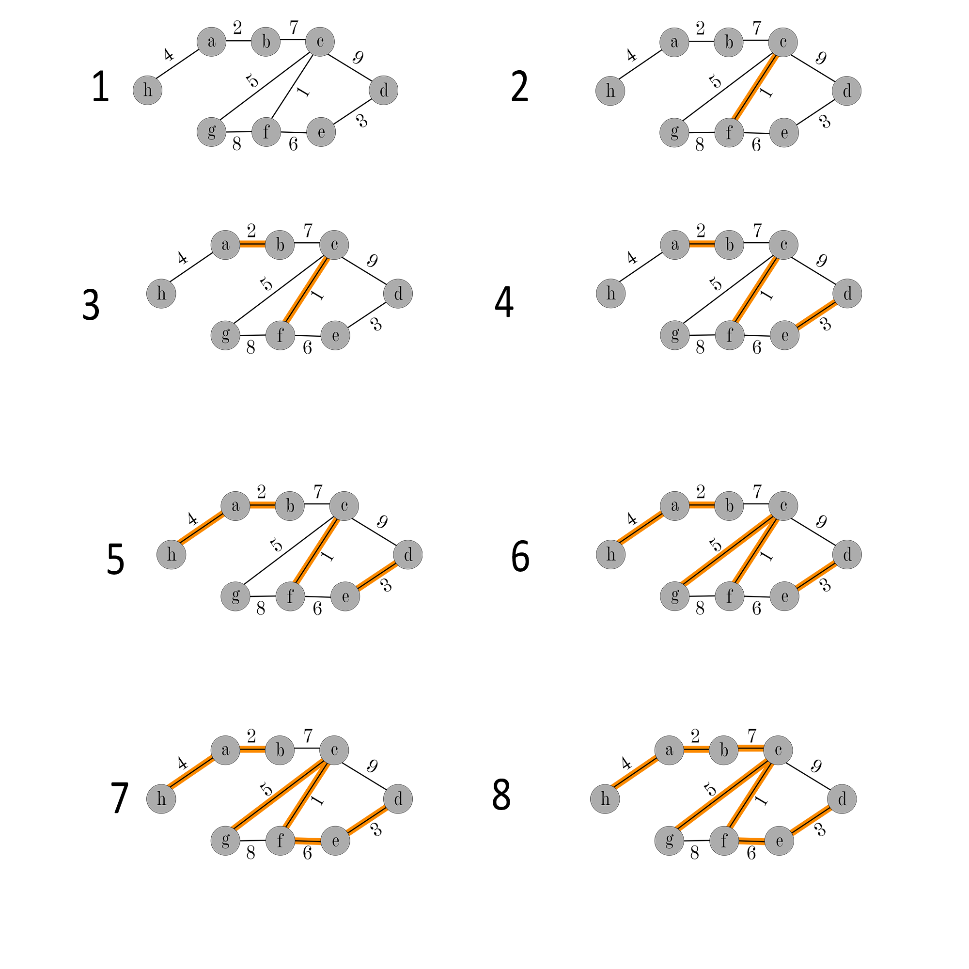

Exercise 5 (15 points) Prim’s Algorithm

Consider this graph G=(V, E, w) provided as an adjacency-matrix. V=(H, G, F, E, D, C, B, A)

|  |  |  |  |  |  |  |  |  |
| --- | --- | --- | --- | --- | --- | --- | --- | --- |
|  | H | G | F | E | D | C | B | A |
| H |  |  |  |  |  |  |  | 4 |
| G |  |  | 8 |  |  | 5 |  |  |
| F |  | 8 |  | 6 |  | 1 |  |  |
| E |  |  | 6 |  | 3 |  |  |  |
| D |  |  |  | 3 |  | 9 |  |  |
| C |  | 5 | 1 |  | 9 |  | 7 |  |
| B |  |  |  |  |  | 7 |  | 2 |
| A | 4 |  |  |  |  |  | 2 |  |

1. Draw this graph (It is the same as the previous question. Copy/Paste would be just fine).
2. Trace Prim’s algorithm starting from Vertex F and show step by the step the construction of the minimum spanning tree.
   1. See next page…

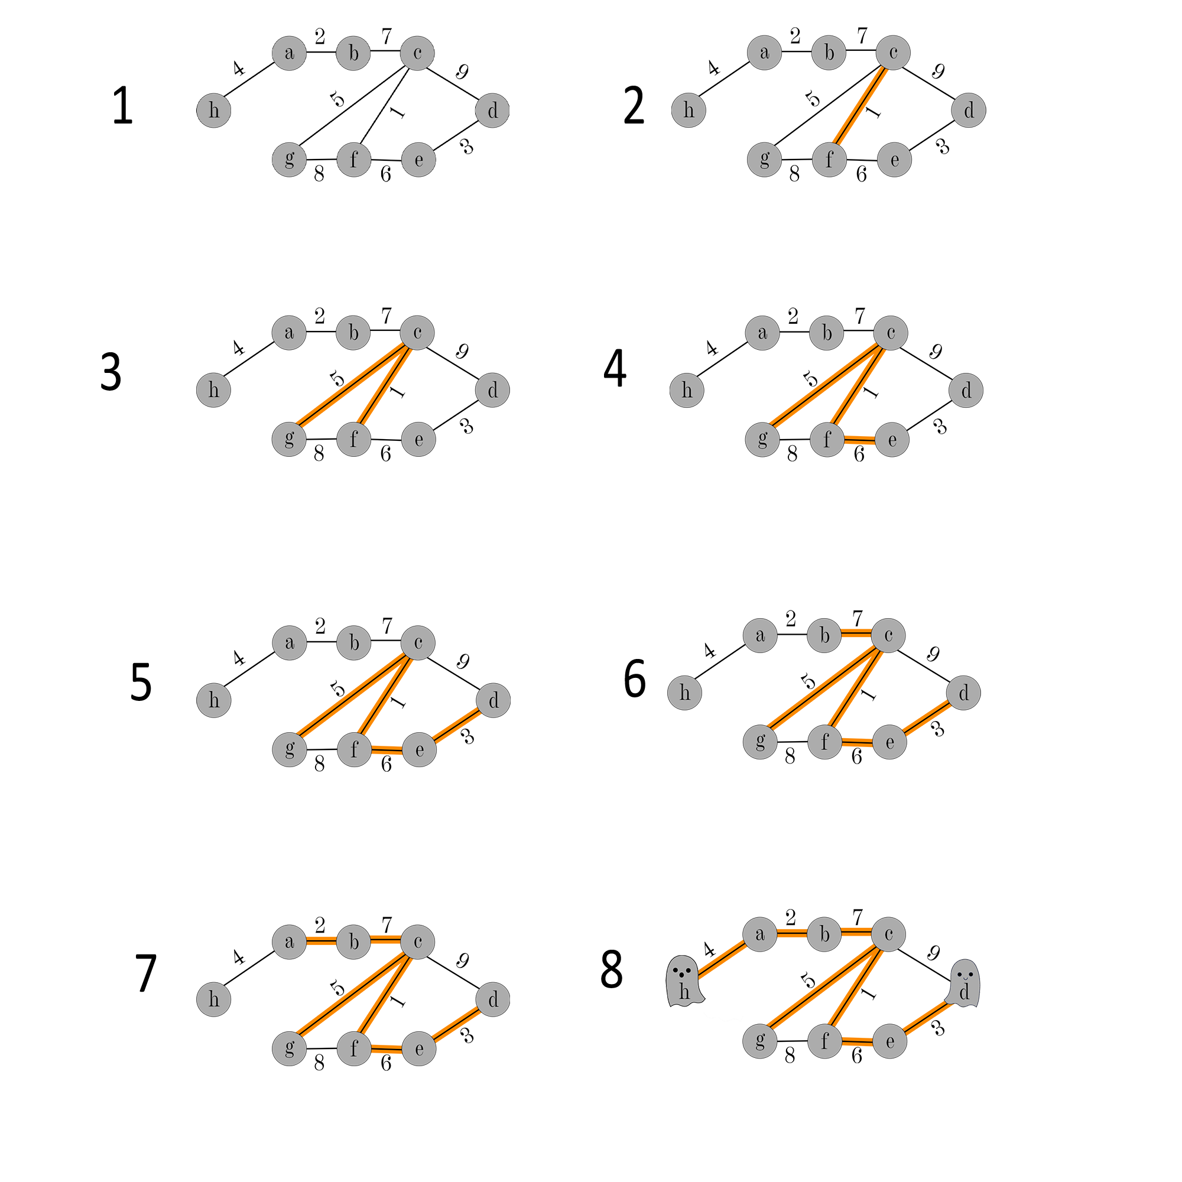

1. Compare the minimum spanning trees obtained by Kruskal’s and Prim’s algorithms, respectively.
   1. In this case, the two MST obtained by Kruskal’s and Prim’s algorithms, were the same. With Kruskal’s, the edges are sorted by weight and are added systematically from lowest weight to highest, if the edge does not create a cycle. This guarantees that only the lowest weighted edges are included in the final MST.

In Prim’s algorithm, there is a specified starting vertex (in this case $f$), and edges are implicitly added that are attached to previously explored vertices. On a graph with duplicate edge weights (ie multiple edges with the same weight), then the final graph would depend on the starting point, and would potentially turn out differently given a different starting vertex. Since the graph above has only unique edge weights, the final MST (under Prim’s algorithm) will always turn out the same, regardless of starting vertex.

**What you need to turn in:**

* Electronic copy of this file (including your answers) (standalone). Submit the file as a Microsoft Word or PDF file.
* Recall that answers must be well written, documented, justified, and presented to get full credit.
* How this assignment will be graded:
* A right answer will get full credit when:
* It is right (worth 25%)
* It is right AND neatly presented making it easy and pleasant to read. (worth 15%)
* There is an obvious and clear link between 1) the information provided in the exercise and in class and 2) the final answer. A clear link is built by properly writing, justifying, and documenting an answer (worth 60%).
* Calculation mistakes will be minimally penalized (2 to 5% of full credit) while errors on units will be more heavily penalized.
* You are welcome/encouraged to discuss exercises with other students or the instructor. But, ultimately, personal writing is expected.