-- 创建数据库（如果不存在）

CREATE DATABASE IF NOT EXISTS your_database;

-- 切换到创建的数据库

USE your_database;

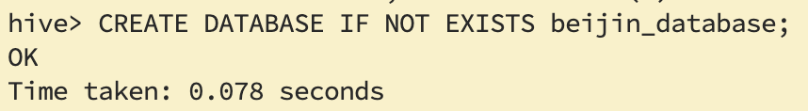

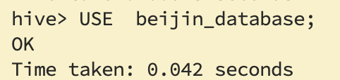



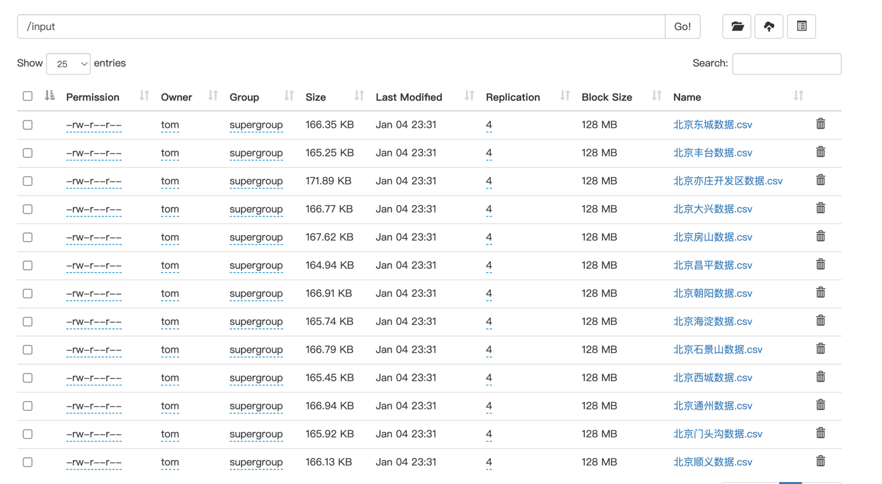

CREATE TABLE IF NOT EXISTS beijin (

Layout STRING,

`Floor` STRING,

Area DOUBLE,

Decoration STRING,

Price INT,

Community STRING,

Region STRING,

Elevator STRING,

ListedTime STRING,

Purpose STRING,

UnitPrice INT

) ROW FORMAT DELIMITED

FIELDS TERMINATED BY ','

STORED AS TEXTFILE;

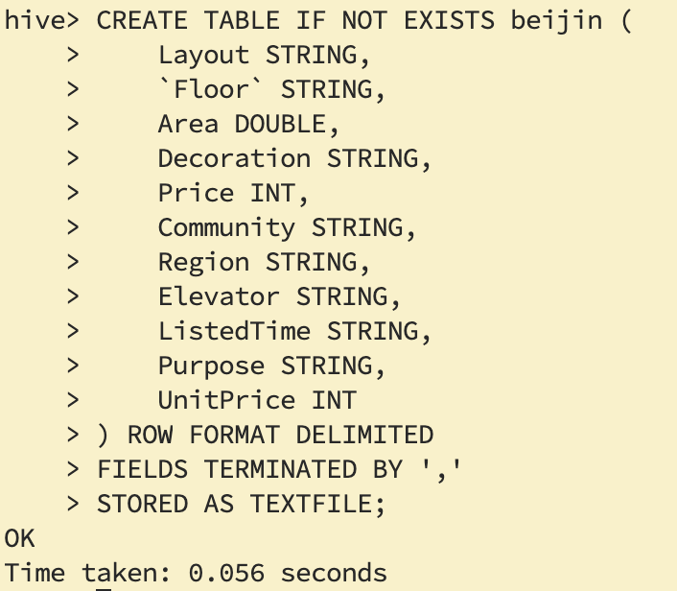

LOAD DATA LOCAL INPATH /opt/beijing/data.csv' INTO TABLE beijin;

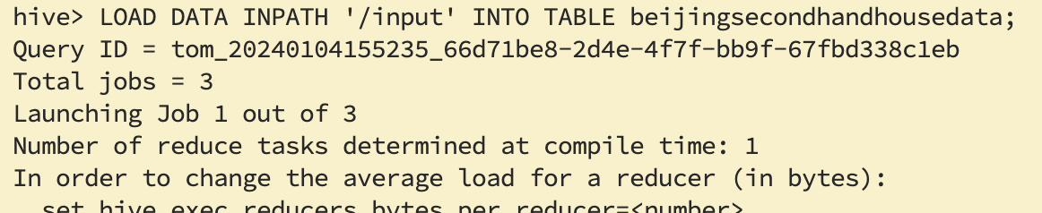

SELECT * FROM beijingsecondhandhousedata LIMIT 10;

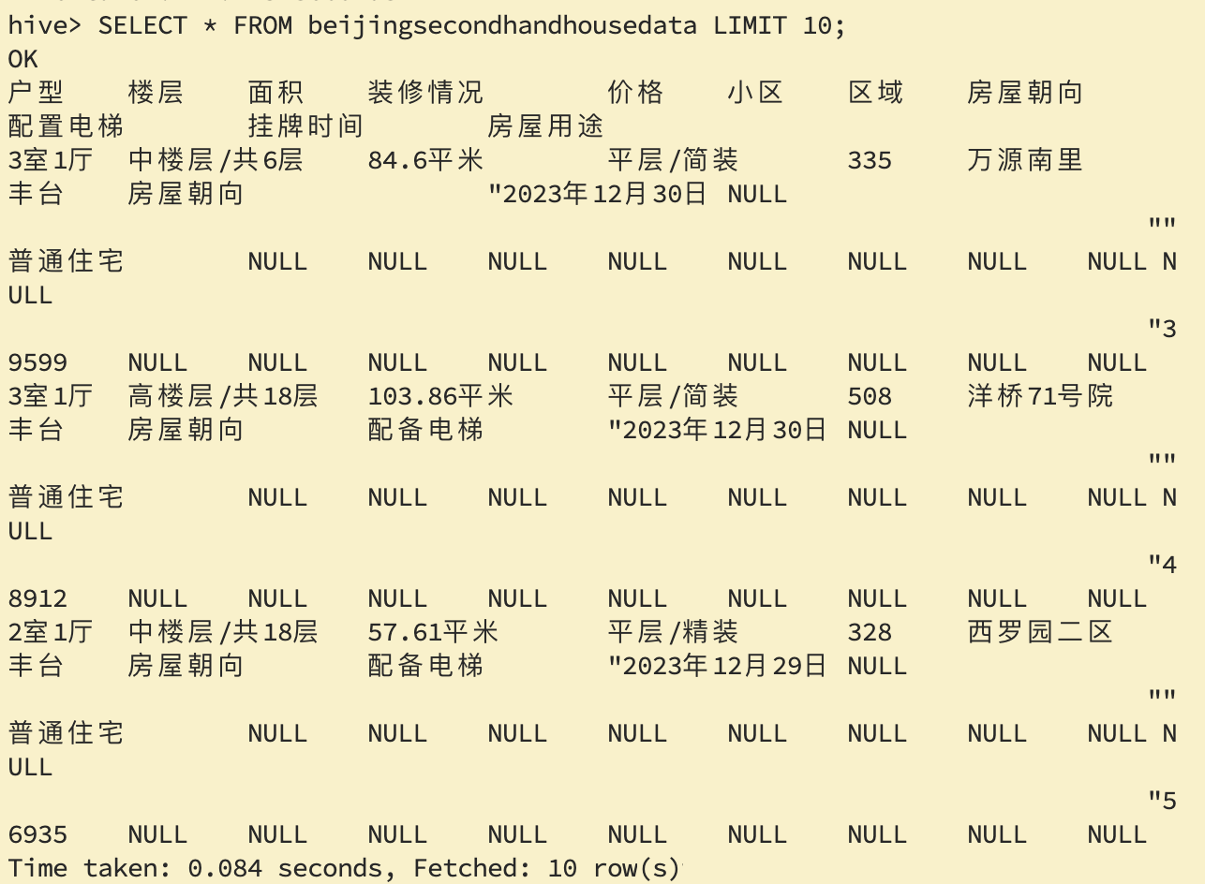

1.统计不同Layout 数量，并按大到小排序

SELECT Layout, COUNT(*) AS LayoutCount

FROM BeijingSecondhandHouseData

GROUP BY Layout

ORDER BY LayoutCount DESC;

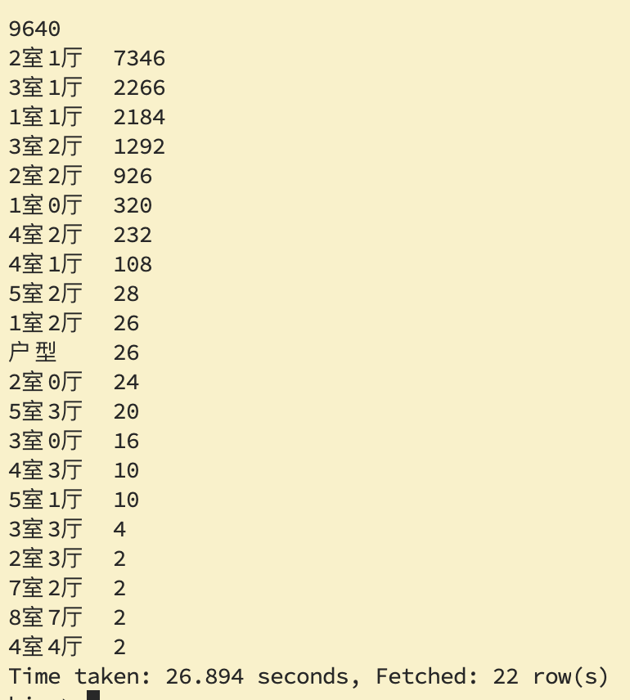

2.统计各区域的每平方米价格平均值

SELECT

Region,

AVG(UnitPrice)

FROM

beijin

GROUP BY

Region;

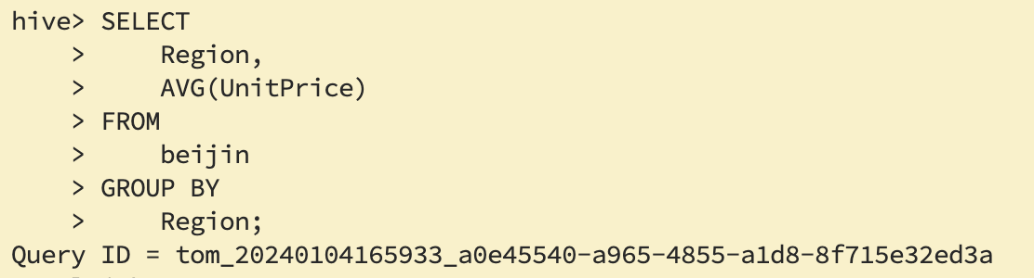

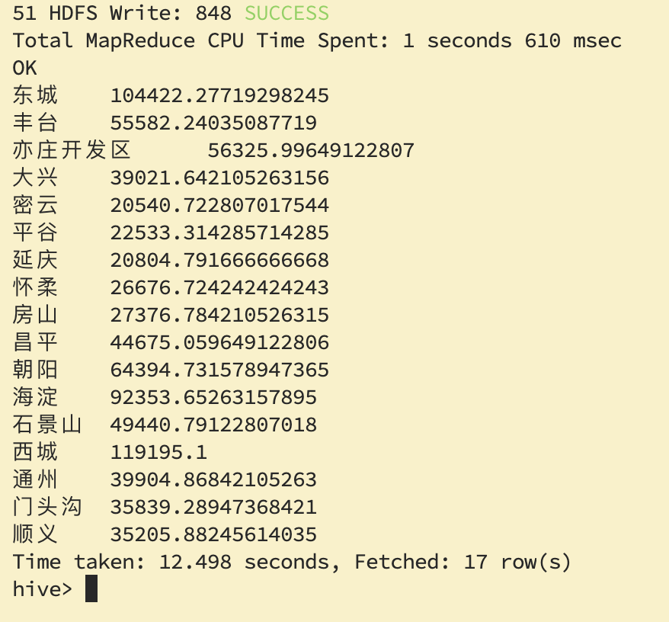

3.查询各区域电梯比例

-- 创建临时表 RegionElevatorCountTemp

CREATE TABLE IF NOT EXISTS RegionElevatorCountTemp AS

SELECT

Region,

COUNT(*) AS TotalCount,

SUM(CASE WHEN Elevator = '配备电梯' THEN 1 ELSE 0 END) AS ElevatorCount

FROM

beijin

GROUP BY

Region;

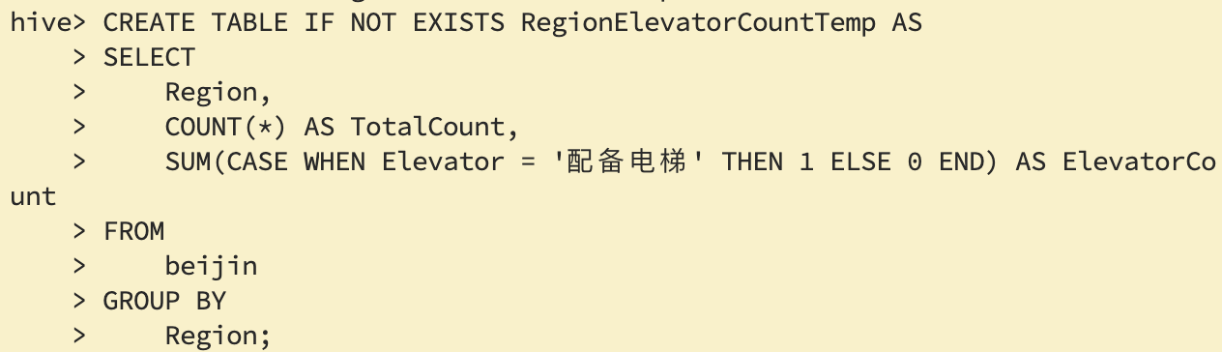

-- 创建表 RegionElevatorCount

CREATE TABLE IF NOT EXISTS RegionElevatorCount AS

SELECT

Region,

CAST(ElevatorCount AS DOUBLE) / CAST(TotalCount AS DOUBLE) AS ElevatorProbability

FROM

RegionElevatorCountTemp;

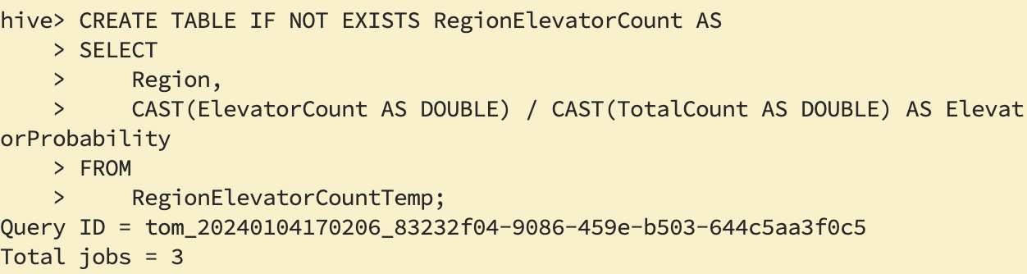

-- 查询结果

SELECT * FROM RegionElevatorCount;

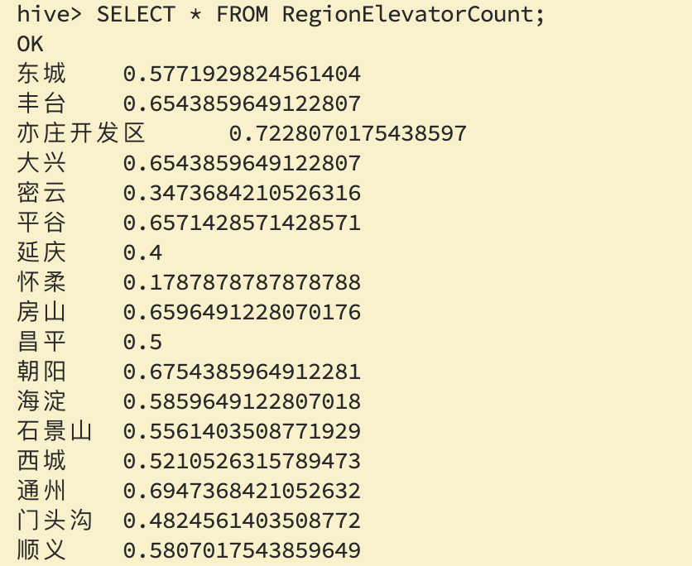

4.北京二手房价区间

SELECT

PriceRange,

COUNT(*) AS PriceCount

FROM (

SELECT

CASE

WHEN Price BETWEEN 0 AND 200 THEN '0-200'

WHEN Price BETWEEN 201 AND 400 THEN '200-400'

WHEN Price BETWEEN 401 AND 600 THEN '400-600'

WHEN Price BETWEEN 601 AND 800 THEN '600-800'

ELSE '800以上'

END AS PriceRange

FROM

beijin

) AS subquery

GROUP BY

PriceRange;

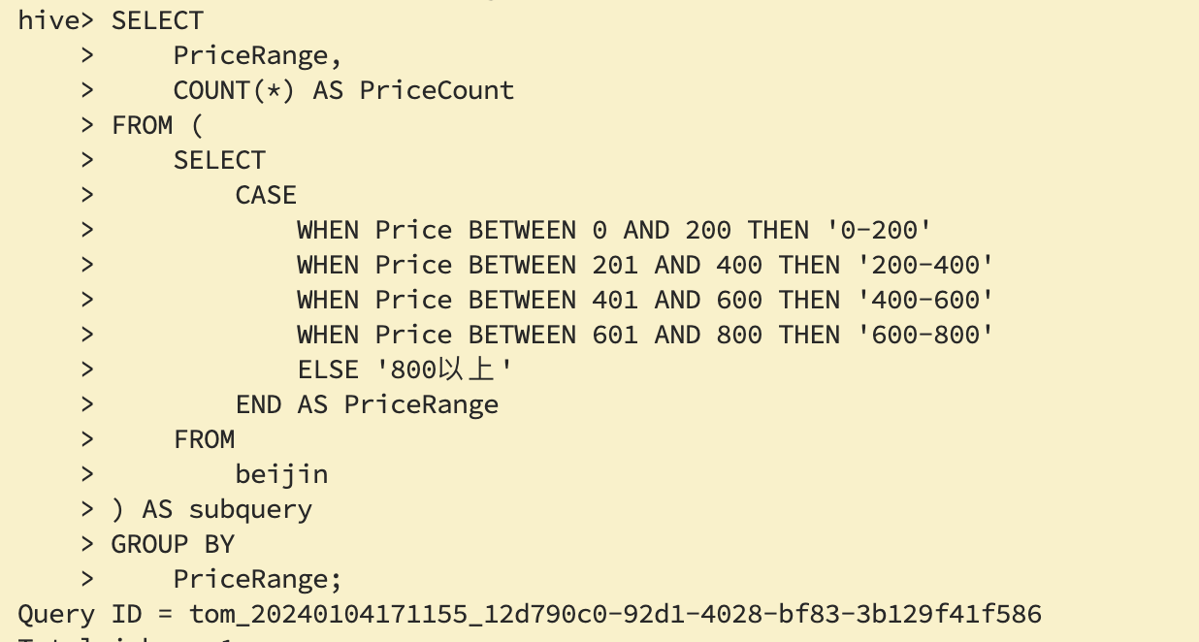

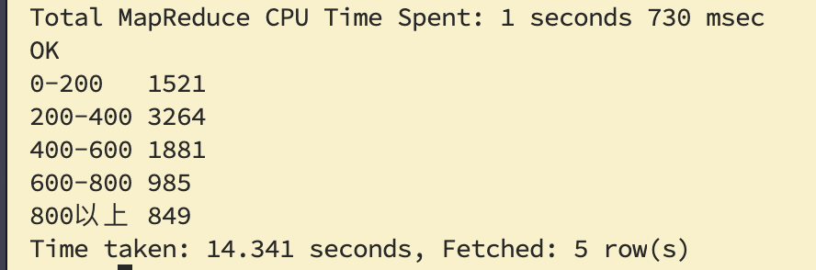

5.统计 Decoration 列的各比例

SELECT Decoration, COUNT(1) AS Count, ROUND(COUNT(1) * 100.0 / (SELECT COUNT(1) FROM beijin), 2) AS Percentage

FROM beijin

GROUP BY Decoration;

