Von Neumann Stability Analysis of various discretisations of the diffusion equation

Author: Tan Beng Hau, Cavitation Lab

Date Accessed: 13 Jan 2019

Objective: Compare the stability of the explicit and implicit solution schemes of the diffusion equation

$$\frac{∂u}{∂t}=D\frac{∂^{2}u}{∂x^{2}}$$

The explicit scheme

In the explicit scheme, the time is discretised forward in time and the space $x$ coordinate is discretised using centred differences

$$\frac{u_{i}^{n+1}-u_{i}^{n}}{Δt}=D\frac{u_{i-1}^{n}-u_{i}^{n}+u_{i+1}^{n}}{{\left(Δx\right)}^{2}}$$

Which $i$ refers to the space grid and $n$ the time grid. Re-arranging gives:

$$u_{i}^{n+1}=u_{i}^{n}+\frac{DΔt}{{\left(Δx\right)}^{2}}\left(u_{i-1}^{n}-u_{i}^{n}+u_{i+1}^{n}\right)$$

This form of discretisation shows that we can solve all the solution points at a future $t=n+1$ using only the points that we have at the present time $t_{n}=n$. In this module, the calculations at all time steps are stored in a 2-dimensional array. For numerical solution in this notebook, starting with the boundary conditions:

$$u\left(x=0,t\right)=0$$

$$u\left(x=L,t\right)=0$$

The initial condition:

$$u\left(x,t=0\right)=\sin\left(πx\right)$$

In the calculations, the Courant-Friedrichs-Lewy or CFL number:

$$α≡\frac{DΔt}{{\left(Δx\right)}^{2}}$$

Stability of the explicit scheme

Any single-valued and continuous function $f(x)$ can be expressed as a Fourier series. Single-valued means that for every $x$ input into a function $f\left(x\right)$ there is only one possible value.

$$u\left(t_{n}, x_{j}\right)=\sum_{j}{\hat{u}\left(t\right)\exp\left(ikx\right)}$$

Where $k$ is the wavenumber in Fourier space. Change the space variable to $j$ to accommodate the complex number variable $i$ and also use the discrete form of the space variable $x_{j}=jΔx$. This gives

$$u_{j}^{n}={\hat{u}}^{n}e^{ikjΔx}$$

The explicit form of the discretised diffusion equation is

$${\hat{u}}^{n+1}e^{ikjΔx}={\hat{u}}^{n}e^{ikjΔx}+α\left[{\hat{u}}^{n}e^{ik(j-1)Δx}-2{\hat{u}}^{n}e^{ikjΔx}+{\hat{u}}^{n}e^{ik(j+1)Δx}\right]$$

For $j=0,1,…, N_{j}$. The exponential terms $e^{ikjΔx}$ cancel out, giving:

$${\hat{u}}^{n+1}={\hat{u}}^{n}\left[1+α\left(e^{-ikΔx}-2+e^{ikΔx}\right)\right]$$

This cancellation tells us that we do not have to worry about which $j$ we are analysing in the Fourier expansion, it applies equally to all the terms in the expansion. To quantify how the remaining exponential terms behave from timestep $n$ to $n+1$, the **growth factor** is defined:

$$G\left(k\right)=\frac{{\hat{u}}^{n+1}}{{\hat{u}}^{n}}= α\left(e^{-ikΔx}-2+e^{ikΔx}\right)$$

Substituting Euler equation $e^{ix}=\cos\left(x\right)+i\sin\left(x\right)$ into the above equation:

$$G\left(k\right)=1+α\left[2\cos\left(kΔx\right)-2\right]$$

For the growth of the Fourier mode to be stable, $\left|G\left(k\right)\right|≤1$. Use the identity $\cos\left(x\right)=1-2\sin^{2}\left(\frac{x}{2}\right)$

$$G\left(k\right)=1+α\left[2-4\sin^{2}\left(\frac{kΔx}{2}\right)-2\right]$$

Rearranging the inequality gives:

$$0<4α\sin^{2}\left(\frac{kΔx}{2}\right)<2$$

The maximum value of sine function is 1, which leaves use with the condition for stability of the explicit scheme:

$$α<\frac{1}{2}$$

The disadvantages of the explicit scheme are listed below:

* The condition for stability can be very severe and will require very small time steps $Δt$ in general
* Because of the above, the explicit scheme can be computationally intensive
* The scheme is only accurate to first order due to the time intensive

The Implicit scheme

When solving the 1-dimension diffusion equation, the implicit scheme is an improvement on the explicit scheme in that it is more stable. In the implicit scheme, the time coordinate is discretised by backward differences

$$\frac{u_{i}^{n}-u_{i}^{n+1}}{Δt}=D\frac{u_{i-1}^{n+1}-2u_{i}^{n+1}+u_{i+1}^{n+1}}{{\left(Δx\right)}^{2}}$$

Rearranging gives the update equation:

$$u_{i}^{n}=-αu_{i-1}^{n+1}+\left(1+2α\right)u_{i}^{n+1}-αu_{i+1}^{n+1}$$

Writing out a few of the equations gives:

$$u_{1}^{n}=-αu_{0}^{n+1}+\left(1+2α\right)u_{1}^{n+1}-αu_{2}^{n+1}$$

$$u_{2}^{n}=-αu_{1}^{n+1}+\left(1+2α\right)u_{2}^{n+1}-αu_{3}^{n+1}$$

$$…$$

$$u_{N_{x}-2}^{n}=-αu_{N_{x}-3}^{n+1}+\left(1+2α\right)u_{N_{x}-2}^{n+1}-αu_{N_{x}-1}^{n+1}$$

At time $n$, $u_{i}^{n}$ is known but $u_{i}^{n+1}$ is not since we are trying to predict what the diffusion does in the future

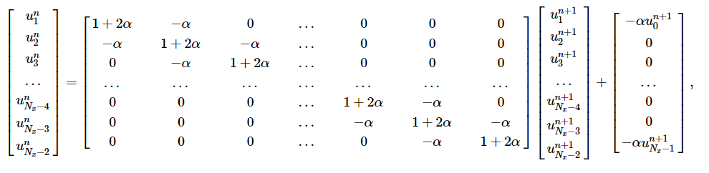

Or in short

$$u^{n}=Mu^{n+1}+b$$

where **M** is the tridiagonal matrix. Note that we have to supply an additional vector **b** for the $u_{0}$ and $u_{N_{x}-1}$ terms which do not go into the solution matrix – these values are supplied from the boundary conditions. We then can be for the future terms:

$$u^{n+1}=M^{-1}\left(u^{n}-b\right)$$

Stability analysis of the implicit scheme

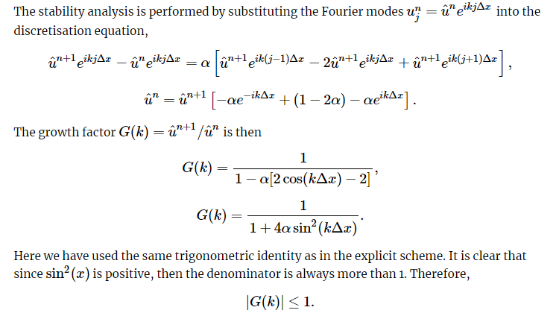

In other words, the **implicit scheme is unconditionally stable** – It is stable for any choice of the grid spacings $Δx$ and $Δt$. There are a few downsides of the implicit scheme

It is slow since the matrix has to be inverted at each time step. This usually means Gaussian Elimination and back-substitution. However, there are algorithms that speed up the solution of the coefficient matrix M i.e. L-U decomposition

It used more code, especially if you want to implement your own equation solver during the inversion step

It is accurate to only first order in $x$