The red angles are right turns at 135 degrees.

The blue angles are left turns at 135 degrees.

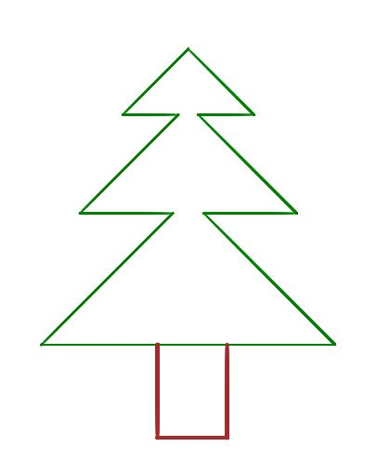

200

150

60

100

100

200

Turtle will start where arrow is.

Right

135

135

135

Right

135

Left

Left

135

The purple angle is 90 degrees to the left.

135

Left

1355