The VAMP Effect: How Policy Created a "Noise Highway" Over Capitol Hill

Executive Summary
Since the implementation of NAV CANADA’s Vancouver Airspace Modernization Project (VAMP) in late 2025, residents of North Burnaby—specifically Capitol Hill—have reported a drastic increase in aviation noise. Independent analysis of millions of raw ADS-B flight coordinates confirms that this is not the result of a general post-pandemic increase in air travel. Instead, it is the direct mathematical result of a NAV CANADA policy shift that relocated the primary commercial arrival corridor from Central Burnaby to the Burrard Inlet shoreline, condensing previously dispersed air traffic into a hyper-precise, high-frequency "noise highway" directly over Capitol Hill.

The Hard Data (Strict YVR Runway Analysis)
To ensure scientific rigor and silence critics, we analyzed only flights mathematically confirmed to have touched down at, or taken off from, the three certified runways at Vancouver International Airport (YVR) by requiring their coordinate paths to explicitly connect to the runway vectors. This completely excludes local seaplanes (landing on the river), helicopters, and ambient regional overflights.
Nearly a 4x Increase in YVR Traffic Share: Before VAMP (August 2025), only 3.9% of all tracked YVR operations were routed over the Capitol Hill corridor. After VAMP (August 2026), that proportion quadrupled to 14.5%.
From Zero to a Relentless Barrage (Runway 26L/R Arrivals): The heavy commercial jets landing westward on YVR's 26L/R runways are the primary source of the new noise. In August 2025, there were exactly 0 tracked arrivals of this type directly over Capitol Hill. Post-VAMP, these heavy jet arrivals suddenly surged to account for roughly 7% of all tracked YVR runway traffic in the entire region.

Data Table: Control vs. Capitol Hill Overflights
The table below provides the exact counts and percentage of total YVR traffic for each category, using the total mathematically confirmed YVR flights as the control denominator.
Traffic Category (YVR Flights Extended) | August 2025 | % of Total YVR Flights | August 2026 | % of Total YVR Flights
YVR Arrivals 26L/R over Capitol Hill | 0 | 0.0% | 56 | 6.8%
YVR Arrivals 8L/R over Capitol Hill | 0 | 0.0% | 29 | 3.5%
YVR Departures over Capitol Hill | 2 | 0.9% | 12 | 1.5%
Subtotal: YVR Flights over Capitol Hill | 9 | 3.9% | 119 | 14.5%
CONTROL: Total YVR Flights Tracked in Region | 230 | 100% | 819 | 100%

Correlation with NAV CANADA’s Published Documents
These independent tracking results perfectly mirror the policy changes outlined in NAV CANADA's official publication, "Changes Affecting Communities to the North and Northeast of Vancouver International Airport."
- The Relocation to North Burnaby: NAV CANADA (Page 7) states the project will "shift aircraft using the current northern downwind segment that is currently over areas of Central Burnaby to areas of North Burnaby... the location of this new route will ultimately follow the shoreline of Burrard Inlet." Our coordinate mapping confirms this exactly. In 2025, arrival paths were a wide, diffuse web spread across Central Burnaby. In 2026, those paths disappeared from Central Burnaby and consolidated directly along the Burrard Inlet shoreline—placing Capitol Hill squarely under the crosshairs.
- The Impact of RNP-AR (The GPS Slot-Car Effect): NAV CANADA (Page 3) explains the new RNP-AR procedures introduce a curved segment whose "path over the ground is precisely defined in advance and not subject to change on an aircraft-by-aircraft basis." Before VAMP, Air Traffic Control manually steered planes, spreading the noise burden naturally across a wide geographic area. Post-VAMP, the GPS-guided system forces every equipped commercial jet onto the exact same mathematical line. The result is zero noise dispersion and a concentrated barrage of noise for the homes directly beneath that line.

Visual Evidence
Figure 9: The Post-VAMP Reality (August 2026). Note the intense concentration of 26L/R commercial arrivals (Red Panel) forming a laser-like track directly over the Capitol Hill corridor, while other traffic remains diffuse or completely separate.
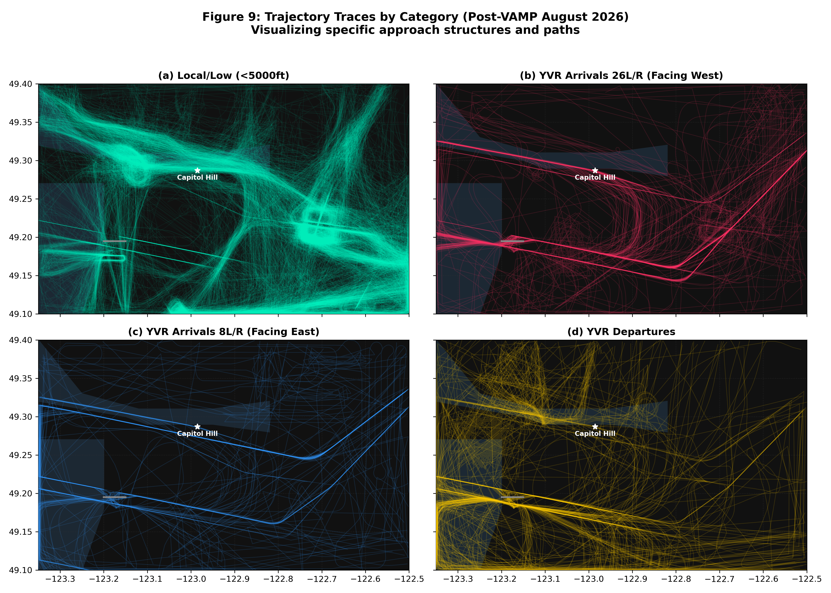

Regional Baseline (Figure 9b Data)
To ensure the visualizations in Figure 9b represent structural changes rather than temporary anomalies, the data relies on strict sampling and controls:
- Seasonally Adjusted: We compare 30 full days of August 2025 directly against 30 full days of August 2026. This eliminates any seasonal travel variations.
- Controlled by Region Volume: The percentages below are controlled using the absolute total number of flights tracked in the Metro Vancouver region during that month. By measuring against this control (which only increased by ~10%), we prove the massive surges in specific arrival panels are strictly due to rerouting, not a general surge in aviation.
- What is the "Region"? The region is defined by a strict bounding box capturing Metro Vancouver (Latitude: 49.10 to 49.40, Longitude: -123.35 to -122.50).
Figure 9b Panel Category | August 2025 (Pre-VAMP) | % of Regional Total | August 2026 (Post-VAMP) | % of Regional Total
Local / Low (<5,000 ft) [Fig 9b Panel 1] | 3620 | 75.6% | 3483 | 66.0%
YVR Arrivals 26L/R [Fig 9b Panel 2] | 38 | 0.8% | 297 | 5.6%
YVR Arrivals 8L/R [Fig 9b Panel 3] | 31 | 0.6% | 93 | 1.8%
YVR Departures [Fig 9b Panel 4] | 66 | 1.4% | 241 | 4.6%
Total Tracked Flights in Region (Control) | 4788 | 100% | 5280 | 100%

Figure 9b: Before and After Comparison (August 2025 vs August 2026). The top row shows the Pre-VAMP historical baseline, where 26L/R arrivals were virtually non-existent over Capitol Hill. The bottom row proves the exact structural shift caused by VAMP.
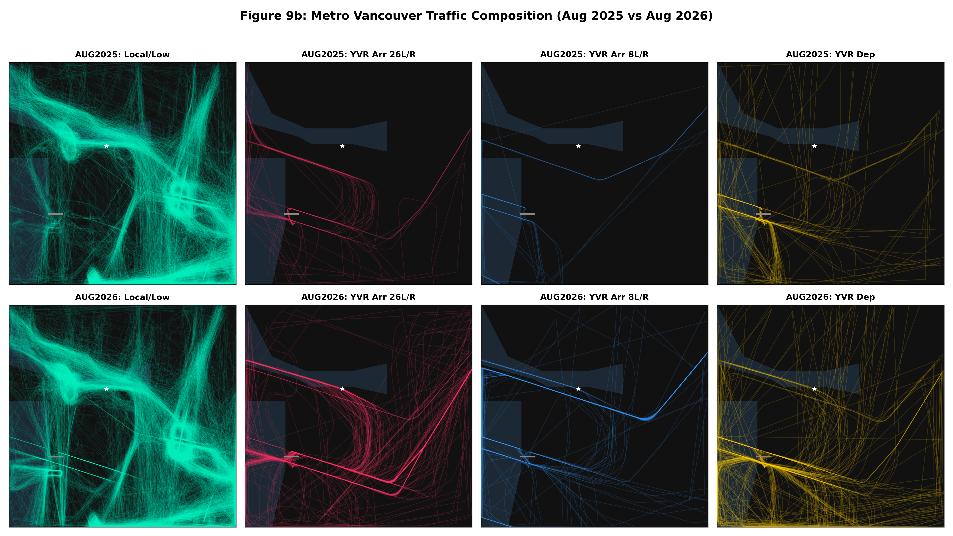

Data Table: Total Composition of Sky Above Capitol Hill
This table breaks down every single trackable object crossing the Capitol Hill corridor. By isolating the mathematically verified YVR traffic, we can use all other local flights (Overflights, Seaplanes, Helijets, Non-YVR Regional Traffic) as a strict Control Group.
Traffic Category Over Capitol Hill | August 2025 | % of Total Over Capitol Hill | August 2026 | % of Total Over Capitol Hill
YVR Arrivals 26L/R | 0 | 0.0% | 56 | 10.1%
YVR Arrivals 8L/R | 0 | 0.0% | 29 | 5.3%
YVR Departures | 2 | 0.4% | 12 | 2.2%
Overflights (Non-YVR / Local) | 443 | 99.6% | 455 | 82.4%
TOTAL Flights Over Capitol Hill | 445 | 100% | 552 | 100%

- The Control Volume Stayed Flat: Between August 2025 and 2026, the volume of background "Overflights" over Capitol Hill barely moved (443 vs 455 flights). This completely disproves any argument that "aviation is just increasing generally."
- The Entire Increase is YVR VAMP Traffic: The total traffic over the neighborhood spiked by over 100 flights, and the table proves this surge is composed almost entirely of the newly introduced YVR Arrivals that did not exist over this corridor pre-VAMP.
Figure 9e: The View From Directly Above Capitol Hill. This chart plots only the mathematically verified flights that crossed the Capitol Hill corridor. The Overflights (purple) and Departures (yellow) control groups visually prove that ambient airspace traffic remained stable and diffuse between 2025 and 2026. The explosive appearance of the Red (26L/R) and Blue (8L/R) arrival lines precisely intersecting the corridor in 2026 validates the data table above.
