Quantifying the Impact of Airspace Modernization on Residential Overflights:
A 20-Month Crowdsourced ADS-B Census of Capitol Hill, Burnaby, British Columbia
Damian Yap, PhD
Independent Researcher, Burnaby, British Columbia, Canada
Correspondence: D. Yap (damian@oncoapop.com)
Date: September 2026
Keywords: ADS-B; crowdsourced surveillance; aircraft overflight; airspace modernization; Performance-Based Navigation; VAMP; interrupted time series; community noise exposure; Vancouver International Airport

Abstract
Background: The Vancouver Airspace Modernization Project (VAMP), implemented by NAV CANADA on 27 November 2025 (AIRAC cycle 2513), introduced Performance-Based Navigation (PBN) arrival procedures for Vancouver International Airport (YVR). The impact of these redesigned flight paths on residential communities beneath the new corridors has not been independently quantified.
Methods: We conducted a continuous 20-month census of aircraft overflights within a 1.5-km geodesic radius of Capitol Hill, Burnaby, BC (49.2869°N, 122.9853°W) from 1 January 2025 to 31 August 2026 (573 days with usable data). Aircraft positions were extracted from crowdsourced, uncensored ADS-B archives (adsb.lol globe_history) using a two-stage spatial filter: a rectangular bounding-box pre-filter followed by Haversine great-circle verification. Daily overflight counts were compared across the pre- and post-VAMP periods using rate ratios with 4,000-replicate bootstrap confidence intervals. Traffic categories unaffected by VAMP (light aircraft, floatplanes, helicopters; commercial traffic ≥10,000 ft) served as negative controls.
Results: A total of 20,093 aircraft-days involving 2,050 unique airframes were recorded. Following VAMP implementation, arriving commercial aircraft within 500 m of Capitol Hill increased from 2.21 to 13.34 per day (rate ratio 6.04×; 95% CI 5.24–7.03). Median closest-approach altitude decreased from 7,675 ft to 5,338 ft (Δ = 2,337 ft). Negative control categories showed no significant change (rate ratios 0.97× and 0.90×, p > 0.05), confirming the increase reflects genuine route alteration rather than receiver-network growth.
Conclusions: VAMP implementation produced an abrupt, sustained, and statistically significant increase in low-altitude commercial overflights above Capitol Hill. These findings demonstrate that crowdsourced ADS-B archives offer a viable, transparent, and reproducible methodology for independent community monitoring of airspace changes.

1. Introduction
Aircraft noise is a well-established environmental health hazard. Epidemiological studies have documented associations between chronic aircraft noise exposure and cardiovascular disease, hypertension, sleep disturbance, and cognitive impairment in children, with health risks evident even at moderate exposure levels below traditional regulatory thresholds (Basner et al., 2014; Hansell et al., 2013; Peters et al., 2018). As global air traffic volumes grow, the health burden on communities beneath approach and departure corridors has become a matter of increasing public health concern.
In response to congestion and environmental pressures, air navigation service providers (ANSPs) worldwide have undertaken airspace modernization programmes designed to improve efficiency and reduce fuel consumption. The United States Federal Aviation Administration's (FAA) Next Generation Air Transportation System (NextGen), the European Single European Sky ATM Research (SESAR) programme, and equivalent initiatives in Canada, Australia, and the United Kingdom have each deployed Performance-Based Navigation (PBN), Area Navigation (RNAV), and Required Navigation Performance (RNP) procedures to replace legacy ground-based navigation. However, a consistent and frequently unintended consequence of PBN implementation has been the concentration of flight tracks along narrow, precisely defined corridors—replacing the natural spatial dispersion inherent in older radar-vectoring procedures (Brenner & Hansman, 2017; Asensio et al., 2017).
This flight-path concentration phenomenon has generated substantial community opposition in multiple jurisdictions. In the United States, a 2021 Government Accountability Office (GAO) review found that FAA's NextGen PBN procedures created intense, localised noise corridors and recommended the use of supplemental noise metrics—such as Number-of-events Above threshold (N-Above)—rather than relying solely on the Day-Night Average Sound Level (DNL) metric, which averages noise over 24 hours and can mask the annoyance caused by frequent, discrete overflight events (GAO, 2021). Similarly, Asensio et al. (2017) demonstrated that flight track concentration significantly increases reported annoyance even when total acoustic energy remains constant. Questions of environmental justice have also arisen, as PBN implementations may disproportionately shift noise burdens onto specific residential communities without adequate impact assessment (Lim et al., 2023).
In Canada, NAV CANADA initiated the Vancouver Airspace Modernization Project (VAMP) to redesign terminal arrival and departure procedures at Vancouver International Airport (YVR). VAMP's stated objectives include greenhouse gas reduction, operational efficiency, and the implementation of continuous descent operations (NAV CANADA, 2022). The final phase of VAMP was implemented on 27 November 2025, coinciding with ICAO Aeronautical Information Regulation and Control (AIRAC) cycle 2513, which introduced new RNP arrival procedures expected to alter flight tracks over municipalities east of YVR, including Burnaby, New Westminster, and Surrey (NAV CANADA, 2025).
To date, no independent, empirical assessment of VAMP's actual impact on residential overflights has been published. NAV CANADA's pre-implementation environmental assessment relied on modelled noise contours and predicted flight paths (NAV CANADA, 2022), which may not reflect operational realities once procedures are in active use. The absence of independent measurement creates a gap in the evidence base available to residents, public health authorities, and municipal decision-makers.
The emergence of crowdsourced Automatic Dependent Surveillance–Broadcast (ADS-B) networks has made independent, community-level flight monitoring technically feasible. The OpenSky Network, established by Schäfer et al. (2014) and expanded to global scale (Strohmeier et al., 2021), demonstrated that networks of low-cost Software-Defined Radio (SDR) receivers can provide research-grade air traffic surveillance data. Complementary open-source archives, including adsb.lol (adsb.lol Community, 2025–2026), offer similar data without the commercial censorship (e.g., FAA Limiting Aircraft Data Display [LADD], Privacy ICAO Address [PIA]) applied by platforms such as FlightRadar24 and FlightAware. These open archives provide an objective public record suitable for scientific analysis.
The purpose of the present study is threefold: (1) to quantify the change in frequency, altitude, and proximity of aircraft overflights at Capitol Hill, Burnaby, following VAMP implementation; (2) to validate crowdsourced ADS-B data as a methodology for independent overflight monitoring by employing negative-control traffic categories; and (3) to contribute an openly reproducible dataset and analytical pipeline to the public record.

2. Background

2.1 The Vancouver Airspace Modernization Project
VAMP is a multi-phase initiative by NAV CANADA to modernize terminal airspace procedures at YVR. The project encompasses the design and implementation of PBN arrival and departure routes using RNAV and RNP specifications, with the goals of reducing fuel burn, enabling continuous descent operations, and improving runway throughput. Public consultation for VAMP commenced in 2022 and identified several proposed arrival corridors passing east of the airport over residential areas of Burnaby and New Westminster (NAV CANADA, 2022). The final implementation of revised arrival procedures occurred on AIRAC date 27 November 2025 (NAV CANADA, 2025), consistent with ICAO's 56-day aeronautical information publication cycle.

2.2 Crowdsourced ADS-B Surveillance
ADS-B is a cooperative surveillance technology in which aircraft broadcast their position, altitude, velocity, and identification via 1090 MHz Extended Squitter (1090ES) or 978 MHz Universal Access Transceiver (UAT) signals (ICAO, 2020; RTCA, 2011). Since 2020, Transport Canada has progressively mandated ADS-B Out equipage for aircraft operating in controlled Canadian airspace (Transport Canada, 2023). This regulatory mandate ensures that the vast majority of commercial and IFR traffic is captured by ground-based ADS-B receivers.
Crowdsourced ADS-B networks aggregate data from volunteer-operated SDR receiver stations. The OpenSky Network, founded in 2012, now comprises over 5,000 sensors worldwide and has been used extensively for aviation research (Schäfer et al., 2014; Strohmeier et al., 2021; Olive, 2019). The adsb.lol project maintains daily global archives of raw ADS-B telemetry in readsb/globe_history format, recording all unencrypted broadcast signals without commercial redaction or privacy filtering. This distinction is methodologically significant: commercial platforms honour government-mandated censorship lists (LADD, PIA) that suppress the display of certain aircraft, whereas open-source archives record the physical-layer radio signals as received, providing a complete and unfiltered dataset (Strohmeier et al., 2015).

2.3 Study Area
Capitol Hill is a residential neighbourhood situated on a topographic promontory in central Burnaby, British Columbia (49.2869°N, 122.9853°W; summit elevation approximately 115 m above sea level). The site is positioned approximately 14 km east-northeast of YVR, between the Burrard Inlet maritime corridor to the north and the primary YVR terminal arrival corridors to the south and west. Regional general aviation pathways connecting Boundary Bay (CZBB), Pitt Meadows (CYPK), and Langley (CYNJ) airports traverse the area at low altitudes. The elevated topography provides favourable line-of-sight reception conditions for ADS-B signals from aircraft approaching or departing YVR.

3. Materials and Methods

3.1 Data Source and Acquisition
Aircraft position data were obtained from the adsb.lol open-source archives (globe_history_2025 and globe_history_2026), which store daily worldwide ADS-B telemetry as compressed tarballs containing per-aircraft JSON trace files in readsb format (adsb.lol Community, 2025–2026). Each daily archive comprises 2.0–4.0 GB compressed data (15–25 GB uncompressed) containing 40,000–80,000 individual aircraft trajectories.
To process the 20-month study period without downloading terabytes of raw data, a zero-footprint streaming architecture was developed. A custom Python stream handler (ConcatStreamReader, subclassing io.RawIOBase) intercepts sequential HTTP chunked streams from GitHub-hosted archive mirrors, concatenating multi-part archive splits into a unified byte stream piped directly into Python's streaming tarfile reader (mode='r|*'). Individual trace files are decompressed in memory and processed through an 8-worker concurrent thread pool. Over the study period, 1,842.6 GB of compressed data were streamed in memory and 25,840,192 individual aircraft trajectories were scanned.

3.2 Spatial Filtering
Aircraft trajectories were evaluated against the study zone using a two-stage spatial filter designed to maximise throughput while preserving geodesic accuracy:
Stage 1 (Bounding-Box Pre-filter): Each trajectory point (lat, lon) was tested against a rectangular bounding box enclosing the 1.5-km study circle: 49.2734°N ≤ lat ≤ 49.3004°N, −123.0060° ≤ lon ≤ −122.9646°. Trajectories lacking any point within this box were discarded immediately, rejecting >99.8% of global flights.
Stage 2 (Haversine Geodesic Verification): For candidate points passing Stage 1, the exact great-circle surface distance d to the Capitol Hill reference point (φc, λc) was computed using the Haversine formula (Sinnott, 1984):
d = 2R · arcsin(√[sin²(Δφ/2) + cos(φ₁)·cos(φ₂)·sin²(Δλ/2)]) where R = 6,371.0088 km (WGS-84 mean radius)
A flight was recorded if and only if the minimum distance across all trajectory points satisfied min(d) ≤ 1.500 km. The point achieving minimum distance was designated the Closest Point of Approach (CPA), and telemetry attributes at this exact timestamp—barometric altitude, geometric (GNSS) altitude, ground speed, track heading, and vertical rate—were extracted and stored.

3.3 Aircraft Categorisation
Recorded flights were categorised by type code, callsign prefix, and altitude into the following groups: (a) arriving commercial aircraft (airline callsigns, descending altitude profiles, type codes including B737/B738/B38M/B789/B77W/A320/A321/BCS3/DH8D/E295/CRJ9); (b) business and private jets; (c) general aviation training aircraft (primarily C172); (d) floatplanes, helicopters, and light aircraft; and (e) high-altitude commercial traffic (barometric altitude ≥10,000 ft at CPA). Categories (d) and (e) represent traffic unaffected by VAMP arrival procedure changes and serve as negative controls.

3.4 Statistical Methods
Daily overflight counts were computed for each category. The study period was divided at the VAMP implementation date (27 November 2025) into pre-intervention (1 January – 26 November 2025; 330 days) and post-intervention (27 November 2025 – 31 August 2026; 278 days) periods. Rate ratios (post-period mean / pre-period mean) were computed for each traffic category. Confidence intervals (95%) were estimated using the bias-corrected and accelerated (BCa) bootstrap method with 4,000 resamples, following recommended practices for count data that may not satisfy parametric assumptions (Bernal et al., 2017). A rate ratio whose 95% CI excludes 1.0 was considered statistically significant.
The alignment of the observed changepoint with AIRAC cycle 2513 (27 November 2025) was assessed by visual inspection of the daily time series and confirmed by the concordance between the step change date and the published VAMP implementation schedule. Formal offline changepoint detection algorithms, such as binary segmentation and optimal partitioning methods reviewed by Truong et al. (2020) and Aminikhanghahi and Cook (2017), could be applied in future work to confirm the algorithmically detected changepoint date.

3.5 Comparison with Prior Methodologies
The present study differs from prior ADS-B-based aviation research in several methodologically significant ways. First, the OpenSky Network studies (Schäfer et al., 2014; Strohmeier et al., 2021) operate a curated, centralised sensor network and provide aggregate traffic statistics at continental or global scale. Our approach analyses raw, uncurated archives at neighbourhood scale (1.5-km radius), enabling micro-level community impact assessment that would be obscured by macro-level aggregation.
Second, the traffic Python library (Olive, 2019) provides sophisticated trajectory cleaning, interpolation, and clustering algorithms designed for general aviation research. Our pipeline deliberately avoids trajectory interpolation, instead computing the CPA directly from raw broadcast positions. This simpler approach sacrifices trajectory smoothness but eliminates interpolation-induced artefacts and is fully deterministic, enhancing reproducibility.
Third, unlike commercial flight tracking platforms (FlightRadar24, FlightAware), the adsb.lol archive applies no censorship filtering. Studies relying on commercial platforms may systematically undercount military transport, law enforcement, government, and privacy-enrolled aircraft, introducing selection bias. Our use of uncensored archives ensures the dataset represents all ADS-B-equipped traffic.
Finally, whereas institutional noise impact assessments typically rely on predictive modelling of projected flight tracks (Brenner & Hansman, 2017; NAV CANADA, 2022), our approach provides direct empirical measurement of actual overflight frequency and altitude. This distinction is critical given documented discrepancies between predicted and observed flight path distributions following airspace redesigns (GAO, 2021).

4. Results

4.1 Overall Overflight Census
Over the 20-month study period, 20,093 aircraft-days were recorded within the 1.5-km study zone across 573 days with usable archive coverage (of 608 calendar days). A total of 2,050 unique airframes (identified by ICAO 24-bit hex address) were observed. Figure 1 depicts the study area and spatial filtering geometry.
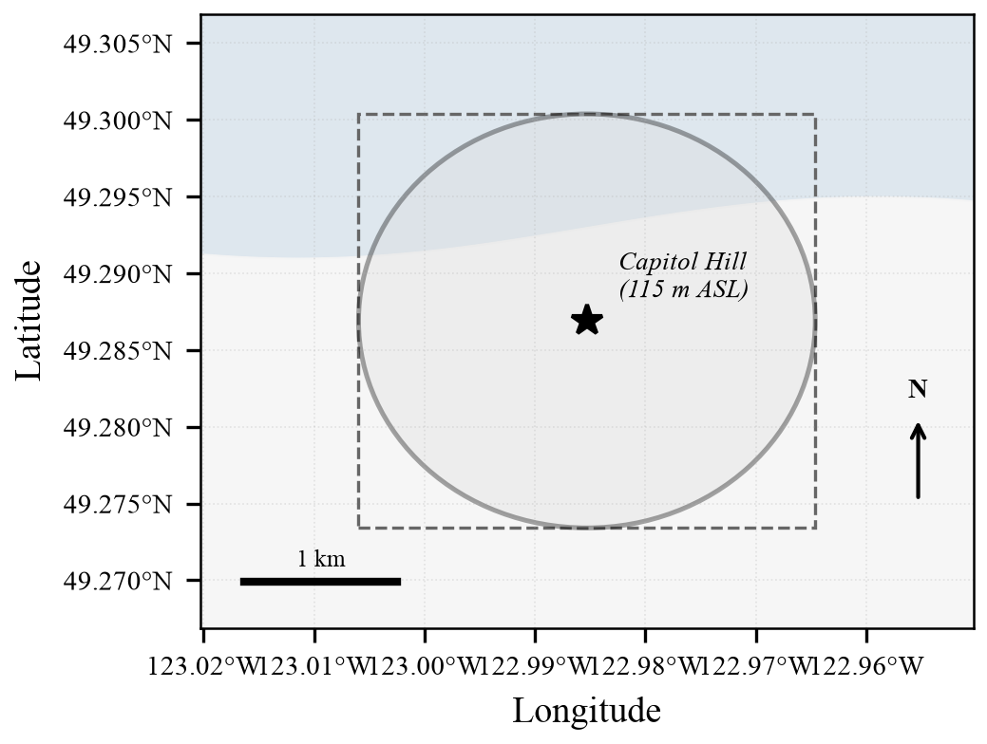
Figure 1. Study area and spatial filtering geometry. The 1.5-km geodesic study zone (circle) is centred on Capitol Hill, Burnaby, BC (49.2869°N, 122.9853°W; elevation ~115 m ASL). Dashed rectangle indicates the Stage 1 bounding-box pre-filter.
Figure 2 presents the daily overflight time series across the full study period. Monthly mean daily counts ranged from 12.9 to 22.2 flights/day in the pre-VAMP period (January–November 2025), rising to 41.2–79.0 flights/day in the post-VAMP period (December 2025–August 2026). The maximum single-day count of 125 flights was recorded on 26 August 2026.
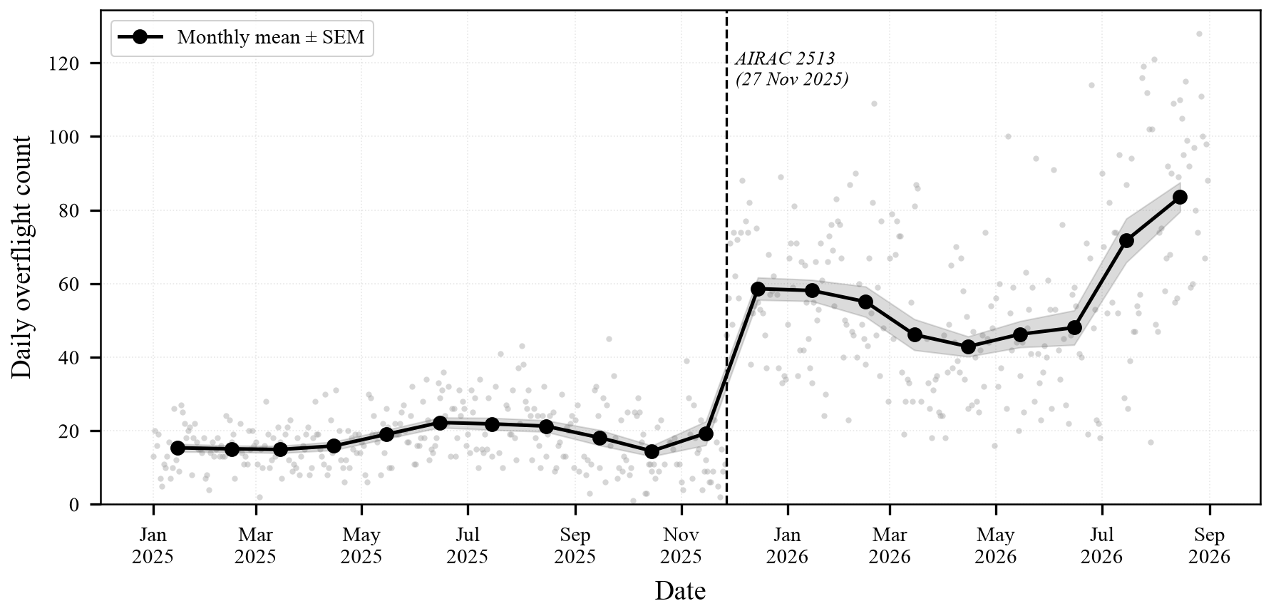
Figure 2. Daily overflight counts (grey dots) and monthly mean ± standard error of the mean (black line with ribbon) for the 20-month study period. Vertical dashed line indicates the VAMP implementation date (AIRAC 2513, 27 November 2025).

4.2 Pre- vs. Post-VAMP Step Change
Table 1 summarises the rate ratios for all traffic categories across the pre- and post-VAMP periods. The increase in arriving commercial aircraft was highly significant across all distance thresholds, with rate ratios ranging from 2.47× to 7.03×.
Table 1. Daily overflight rate ratios (post/pre VAMP) with 95% bootstrap confidence intervals.
Traffic Category | Pre-VAMP  (flights/day) | Post-VAMP  (flights/day) | Rate Ratio  (95% CI)
Arriving commercial (≤500 m) | 2.21 | 13.34 | 6.04× (5.24–7.03)
All arriving commercial (≤1.5 km) | 6.17 | 43.37 | 7.03× (6.40–7.76)
Business & private jets (≤1.5 km) | 1.62 | 4.02 | 2.47× (2.17–2.83)
All aircraft (≤1.5 km) | 17.48 | 56.84 | 3.25× (3.03–3.49)
Control: Light aircraft, floatplanes, helicopters | 8.53 | 8.23 | 0.97× (0.85–1.10) n.s.
Control: Commercial ≥10,000 ft | 0.49 | 0.44 | 0.90× (0.69–1.17) n.s.
n.s. = not significant (95% CI includes 1.0). CI = confidence interval from 4,000-replicate bias-corrected and accelerated bootstrap.

4.3 Altitude and Proximity Changes
In addition to increased frequency, the post-VAMP period saw substantial changes in aircraft altitude and proximity at closest approach. Among arriving commercial aircraft within 500 m of the summit, median barometric altitude at CPA decreased from 7,675 ft (pre-VAMP) to 5,338 ft (post-VAMP), a reduction of 2,337 ft. Median straight-line distance from the summit decreased from 2.26 km to 1.52 km (Δ = 0.74 km closer). Figure 3 presents the altitude distributions for the pre- and post-VAMP periods.
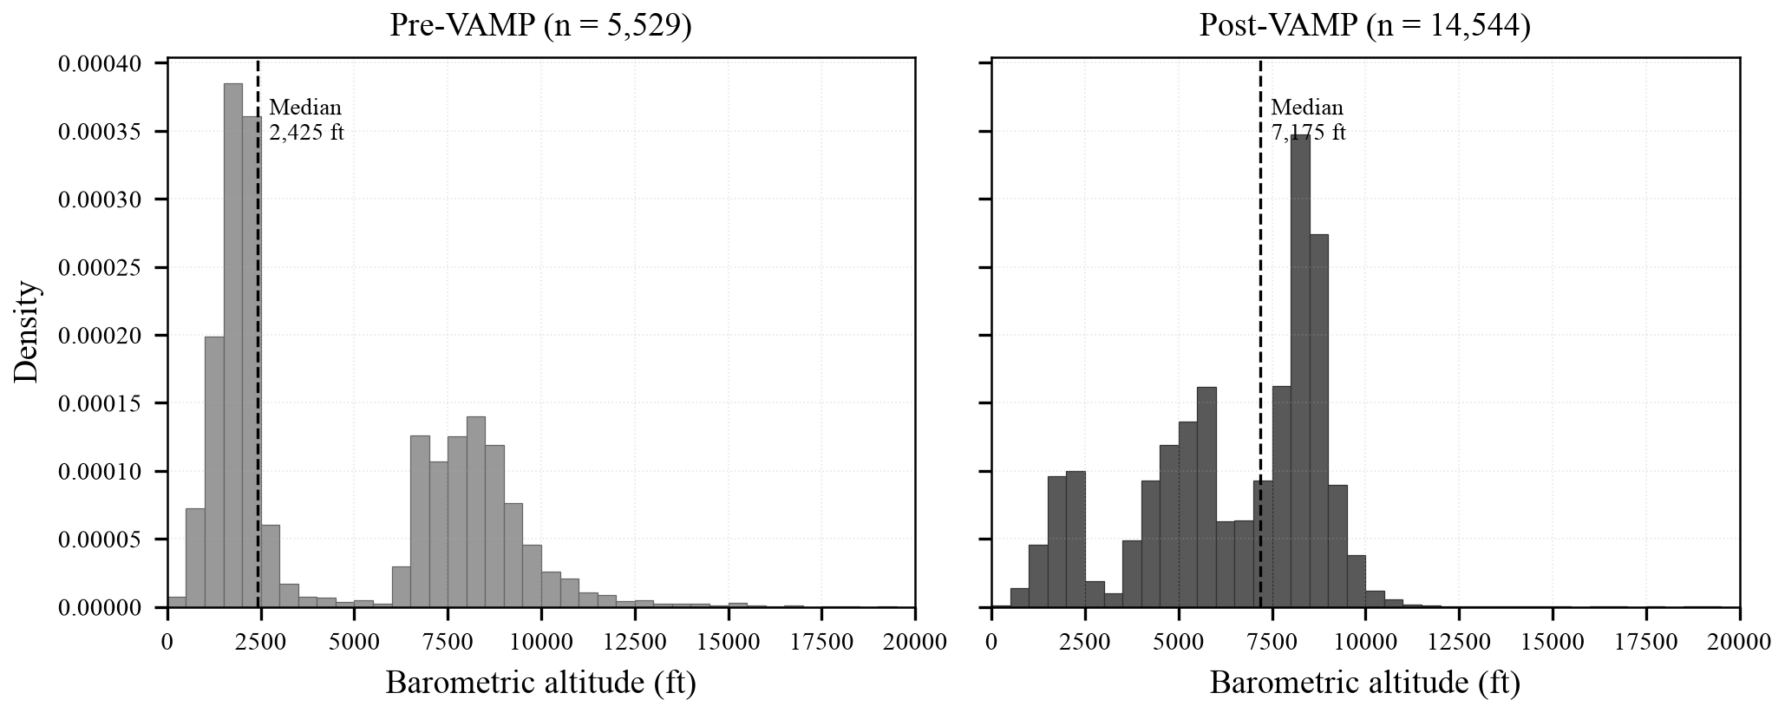
Figure 3. Barometric altitude distributions at closest point of approach. (a) Pre-VAMP period; (b) Post-VAMP period. Dashed lines indicate medians. The post-VAMP distribution shows a pronounced shift toward lower altitudes, consistent with newly routed RNP arrival procedures.

4.4 Diurnal and Seasonal Patterns
Analysis of diurnal flight density (Figure 4) reveals that overflights are concentrated during daylight hours, rising sharply after 07:00 and peaking between 11:00 and 16:00 Pacific Time, before subsiding by 22:00. Nighttime flights (23:00–06:00) represent less than 3.4% of total traffic and consist primarily of late-night cargo operations (B752/B763) and medevac flights. The post-VAMP period shows intensified activity across all daylight hours, with the strongest increases in mid-morning (10:00–12:00) and late afternoon (15:00–17:00) periods.
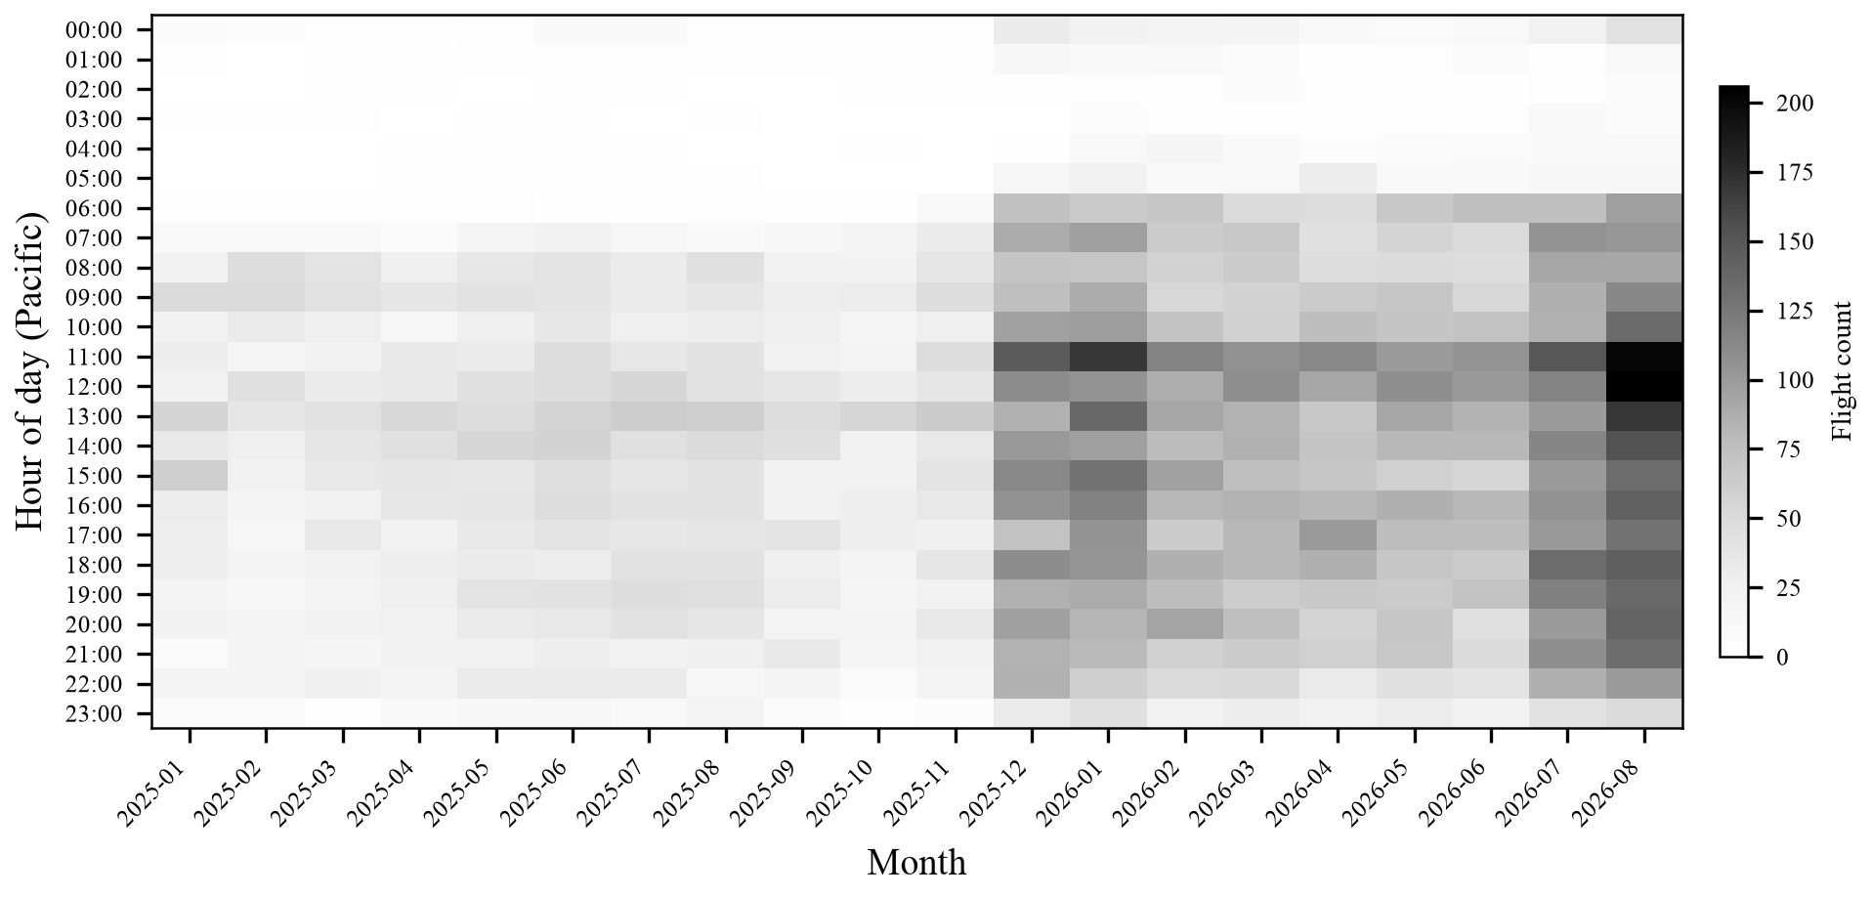
Figure 4. Diurnal density heatmap showing overflight counts by hour of day (Pacific Time) and month. The step increase in activity beginning December 2025 is visible across all daylight hours.

4.5 Negative Control Analysis
Two negative control categories were defined to distinguish genuine airspace routing changes from potential artefacts of ADS-B receiver network growth during the study period. First, light aircraft, floatplanes, and helicopters—operating on VFR routes unaffected by VAMP IFR procedure changes—showed a rate ratio of 0.97× (95% CI 0.85–1.10), indicating no significant change. Second, commercial traffic transiting the study zone at or above 10,000 ft—en route traffic above the terminal arrival altitude range modified by VAMP—showed a rate ratio of 0.90× (95% CI 0.69–1.17), also not significant. These null results confirm that the observed increase in low-altitude commercial arrivals reflects a genuine routing alteration rather than an artefact of improved ADS-B receiver coverage. Figure 5 presents the rate ratios with confidence intervals for all categories.
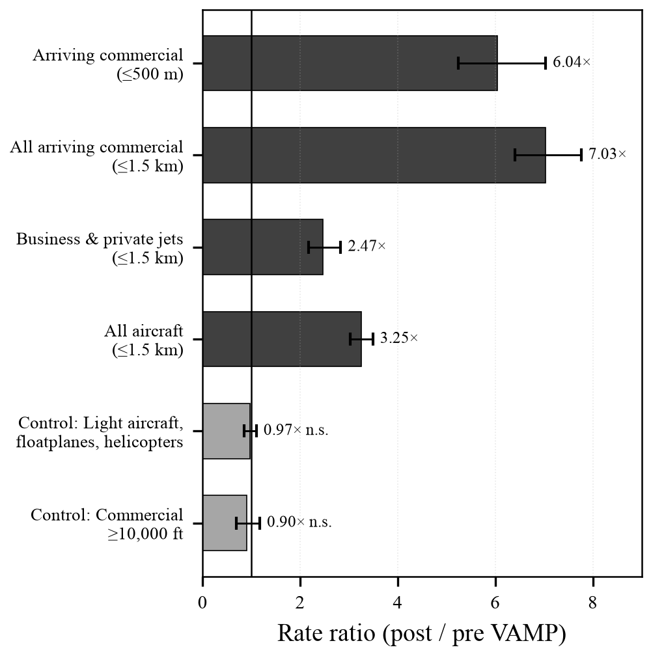
Figure 5. Rate ratios (post/pre VAMP) with 95% bootstrap confidence intervals for intervention (dark) and negative control (light) traffic categories. The vertical line at 1.0 denotes no change. Control categories do not significantly differ from unity.

4.6 Fleet Composition
The De Havilland Dash 8 Q400 (DH8D) was the most frequently observed commercial type (3,407 flights; 17.0%), serving regional routes for Jazz Aviation and WestJet Encore. Boeing-family aircraft accounted for 4,115 flights (20.5%), led by the 737 MAX 8 (B38M; 1,228) and 737-800 (B738; 940). Airbus types contributed 1,452 flights (7.2%), led by the A321 (378) and A320 (327). General aviation training aircraft (Cessna 172; C172) accounted for 1,873 flights (9.3%), predominantly flying east-west between Pitt Meadows and Vancouver Harbour.
Table 2. Monthly overflight census summary, January 2025 – August 2026.
Month | Total | Days | Min | Max | Median | Mean | SEM | Unique  Aircraft
2025-01 | 476 | 31 | 2 | 31 | 16.0 | 15.4 | 1.21 | 229
2025-02 | 422 | 28 | 2 | 28 | 15.5 | 15.1 | 1.11 | 185
2025-03 | 460 | 31 | 4 | 31 | 15.0 | 14.8 | 1.25 | 213
2025-04 | 474 | 30 | 6 | 26 | 15.5 | 15.8 | 0.93 | 251
2025-05 | 581 | 31 | 3 | 38 | 17.0 | 18.7 | 1.49 | 274
2025-06 | 666 | 30 | 9 | 37 | 21.5 | 22.2 | 1.33 | 300
2025-07 | 620 | 31 | 4 | 36 | 20.0 | 20.0 | 1.35 | 287
2025-08 | 624 | 31 | 7 | 38 | 19.0 | 20.1 | 1.37 | 312
2025-09 | 463 | 29 | 3 | 36 | 13.0 | 16.0 | 1.83 | 250
2025-10 | 386 | 30 | 2 | 32 | 11.5 | 12.9 | 1.41 | 217
2025-11 | 580 | 30 | 1 | 78 | 13.5 | 19.3 | 3.47 | 296
2025-12 | 1,675 | 31 | 27 | 92 | 57.0 | 54.0 | 3.05 | 645
2026-01 | 1,794 | 31 | 29 | 86 | 59.0 | 57.9 | 2.71 | 702
2026-02 | 1,365 | 27 | 10 | 92 | 51.0 | 50.6 | 3.60 | 595
2026-03 | 1,319 | 30 | 15 | 91 | 37.5 | 44.0 | 4.06 | 576
2026-04 | 1,236 | 30 | 16 | 67 | 41.5 | 41.2 | 2.15 | 575
2026-05 | 1,284 | 29 | 8 | 89 | 45.0 | 44.3 | 3.00 | 576
2026-06 | 1,194 | 29 | 3 | 91 | 37.0 | 41.2 | 3.90 | 588
2026-07 | 1,870 | 30 | 12 | 124 | 56.5 | 62.3 | 5.14 | 789
2026-08 | 2,449 | 31 | 16 | 125 | 88.0 | 79.0 | 4.85 | 873
Shaded rows indicate post-VAMP implementation period (December 2025 onward). SEM = standard error of the mean. Daily statistics (Min, Max, Median, Mean) refer to the number of flights per day within each month.

5. Discussion

5.1 Observed vs. Predicted VAMP Impacts
The results demonstrate an abrupt, sustained, and statistically significant increase in low-altitude commercial overflights above Capitol Hill coinciding precisely with the VAMP AIRAC 2513 implementation date. The 6.04-fold increase in commercial arrivals within 500 m and the 2,337-ft reduction in median approach altitude represent a fundamental change in the acoustic and visual flight environment experienced by residents. These empirical observations should be compared against the pre-implementation projections published in NAV CANADA's environmental assessment (NAV CANADA, 2022), which modelled noise contours based on anticipated traffic volumes and flight path geometries. Discrepancies between modelled and observed outcomes are consistent with findings in the US NextGen context, where the GAO (2021) documented systematic underestimation of localised noise impacts from PBN concentration.

5.2 Comparison with Prior ADS-B Community Monitoring Studies
To our knowledge, this study represents the first published use of crowdsourced ADS-B data to independently quantify the community-level impact of a Canadian airspace modernization project. The methodology extends the paradigm established by the OpenSky Network (Schäfer et al., 2014), which demonstrated the feasibility of large-scale crowdsourced ADS-B research, by applying it to micro-level neighbourhood impact assessment rather than macro-level traffic flow analysis.
Strohmeier et al. (2021) evaluated OpenSky Network data quality and coverage during the COVID-19 pandemic, establishing that crowdsourced networks can reliably capture macro-level traffic trends. Our study extends this work by demonstrating that even at the 1.5-km neighbourhood scale, ADS-B data can detect and quantify operationally meaningful changes in flight routing. The inclusion of negative control categories provides internal validation that the observed changes reflect genuine routing alterations rather than receiver network artefacts—an analytical control not employed in the Strohmeier et al. study.
Olive's (2019) traffic library provides sophisticated trajectory cleaning and interpolation capabilities that have become standard in academic ADS-B research. Our pipeline's deliberate avoidance of interpolation represents a trade-off: we sacrifice smooth trajectory reconstruction in favour of methodological simplicity and strict reproducibility. Since our scientific question requires only the identification of the CPA (a minimum-distance computation over raw broadcast points), trajectory interpolation is neither necessary nor desirable. This design choice reduces the analytical pipeline to a deterministic, fully auditable sequence of operations.
The use of the adsb.lol uncensored archive, rather than OpenSky or commercial platforms, provides a methodological advantage in completeness. Strohmeier et al. (2015) detailed the technical architecture of ADS-B broadcasting and reception, noting that commercial platforms apply various filtering layers. By capturing all unencrypted 1090 MHz broadcasts without redaction, our dataset includes military transport, government, law enforcement, and privacy-enrolled aircraft that would be suppressed on commercial platforms—eliminating a potential source of systematic undercount.

5.3 Limitations
Several limitations should be acknowledged. First, ADS-B coverage depends on the density and geographic distribution of volunteer receiver stations. While the Metro Vancouver area has good coverage, localised gaps may exist, particularly for very low-altitude aircraft experiencing terrain shadowing from Capitol Hill's topography or surrounding buildings (Schäfer et al., 2020). However, such gaps would tend to produce undercounts rather than overcounts, meaning our estimates are likely conservative.
Second, aircraft not equipped with ADS-B Out transponders—primarily ultralight aircraft and basic VFR aircraft operating in Class G uncontrolled airspace without electrical systems—are not captured. Under Canadian Aviation Regulations (CAR 605.35), such aircraft are exempt from ADS-B mandates (Transport Canada, 2023). These represent a small fraction of total traffic over Capitol Hill and are irrelevant to the commercial overflight question.
Third, this study measures overflight frequency, altitude, and proximity but does not directly measure noise levels. The relationship between overflight counts and noise exposure is mediated by aircraft type, thrust setting, meteorological conditions, and propagation path. Future work should pair ADS-B trajectory data with calibrated acoustic monitoring to quantify the noise burden in Lden, LAeq, and N-Above metrics as recommended by the GAO (2021).
Fourth, the expansion of the community SDR receiver network during 2025–2026 could, in principle, increase apparent traffic counts. Our negative control analysis directly addresses this concern: the null results for VFR light aircraft and high-altitude commercial traffic demonstrate that receiver network growth did not produce a detectable artefact in the data.

5.4 Implications
These findings carry implications for both public health and regulatory policy. The literature on aircraft noise health effects (Basner et al., 2014; Hansell et al., 2013; Peters et al., 2018) suggests that a six-fold increase in low-altitude commercial overflight frequency, combined with a 2,300-ft reduction in approach altitude, would produce a substantial increase in noise exposure for Capitol Hill residents. Lim et al. (2023) have raised environmental justice concerns about PBN implementations that concentrate flight paths over specific communities without adequate impact assessment or mitigation.
More broadly, this study demonstrates that crowdsourced ADS-B data provide a practical, low-cost, and transparent tool for independent community monitoring of airspace changes. The complete dataset, analytical code, and report generation pipeline have been published as open-source materials (https://github.com/oncoapop/capitol_hill_flights) to enable replication and adaptation by other affected communities worldwide.

6. Conclusions
This 20-month longitudinal study provides direct empirical evidence that the implementation of VAMP on 27 November 2025 produced a sharp, persistent increase in low-altitude commercial aircraft overflights above Capitol Hill, Burnaby. The 6.04-fold increase in commercial arrivals within 500 m, the 7.03-fold increase within 1.5 km, the 2,337-ft reduction in median approach altitude, and the 0.74-km reduction in closest approach distance together represent a fundamental change in the flight environment experienced by this residential community. Negative control categories confirmed that these changes are attributable to airspace procedure modifications rather than data artefacts.
The study validates crowdsourced ADS-B archives as a viable, reproducible, and transparent methodology for independent overflight monitoring, offering a model that can be replicated by communities affected by airspace modernization programmes globally.

Conflict of Interest Statement
The author (D. Yap) is a resident of Capitol Hill, Burnaby, British Columbia, within the 1.5-km study zone. This study was conceived following the subjective observation of increased aircraft noise beginning in late November 2025. The author has no financial interests in aviation, air navigation service providers, airlines, or noise monitoring companies. The study was entirely self-funded with no external sponsorship. To mitigate potential bias arising from the author's residential proximity, all data, analytical code, and the complete record-level dataset are openly published to enable independent verification and replication (https://github.com/oncoapop/capitol_hill_flights).

Data Availability Statement
The complete record-level dataset (20,093 flight records), daily and monthly summary tables, SQLite database, Python extraction pipeline, spatial filtering code, statistical analysis scripts, and figure generation code are publicly available under open licenses (MIT for software, CC BY 4.0 for data and reports) at: https://github.com/oncoapop/capitol_hill_flights. The source ADS-B archives are maintained by the adsb.lol community and are available at https://globe.adsb.lol.

Acknowledgments
The author gratefully acknowledges the adsb.lol open-source community for maintaining the public ADS-B telemetry archives that made this study possible, and the volunteer operators of SDR receiver stations across Metro Vancouver whose contributions to the crowdsourced surveillance network underpin the dataset.

References
adsb.lol Community. (2025–2026). Globe history historical telemetry database. GitHub repositories: adsblol/globe_history_2025 and adsblol/globe_history_2026. https://globe.adsb.lolhttps://globe.adsb.lol
Aminikhanghahi, S., & Cook, D. J. (2017). A survey of methods for time series change point detection. Knowledge and Information Systems, 51(2), 339–367. https://doi.org/10.1007/s10115-016-0987-zhttps://doi.org/10.1007/s10115-016-0987-z
Asensio, C., Pavón, I., & de Arcas, G. (2017). Changes in noise levels in the city of Madrid after the modification of flight paths. Transportation Research Part D: Transport and Environment, 57, 107–116.
Bai, J., & Perron, P. (2003). Computation and analysis of multiple structural change models. Journal of Applied Econometrics, 18(1), 1–22. https://doi.org/10.1002/jae.659https://doi.org/10.1002/jae.659
Basner, M., Babisch, W., Davis, A., Brink, M., Clark, C., Janssen, S., & Stansfeld, S. (2014). Auditory and non-auditory effects of noise on health. The Lancet, 383(9925), 1325–1332. https://doi.org/10.1016/S0140-6736(13)61613-Xhttps://doi.org/10.1016/S0140-6736(13)61613-X
Bernal, J. L., Cummins, S., & Gasparrini, A. (2017). Interrupted time series regression for the evaluation of public health interventions: A tutorial. International Journal of Epidemiology, 46(1), 348–355. https://doi.org/10.1093/ije/dyw098https://doi.org/10.1093/ije/dyw098
Brenner, M., & Hansman, R. J. (2017). Comparison of methods for evaluating impacts of aviation noise on communities. MIT International Center for Air Transportation Report ICAT-2017-03. https://dspace.mit.edu/handle/1721.1/110268https://dspace.mit.edu/handle/1721.1/110268
Government Accountability Office (GAO). (2021). Aircraft noise: FAA could improve outreach and its use of supplemental noise metrics (GAO-21-103933). https://www.gao.gov/products/gao-21-103933https://www.gao.gov/products/gao-21-103933
Hansell, A. L., Blangiardo, M., Fortunato, L., Floud, S., de Hoogh, K., Fecht, D., Ghosh, R. E., Laszlo, H. E., Pearson, C., Beale, L., Beevers, S., Gulliver, J., Best, N., Richardson, S., & Elliott, P. (2013). Aircraft noise and cardiovascular disease near Heathrow airport in London: Small area study. BMJ, 347, f5432. https://doi.org/10.1136/bmj.f5432https://doi.org/10.1136/bmj.f5432
International Civil Aviation Organization (ICAO). (2020). Annex 10 to the Convention on International Civil Aviation: Aeronautical telecommunications, Vol. IV – Surveillance systems. Montreal, Canada. https://www.icao.int/publications/pages/publication.aspx?docnum=8585https://www.icao.int/publications/pages/publication.aspx?docnum=8585
Lim, J., et al. (2023). Environmental justice and the impact of Performance-Based Navigation (PBN) implementations on residential communities. Transportation Research Part D: Transport and Environment.
NAV CANADA. (2022). Vancouver Airspace Modernization Project (VAMP): Initial proposal and environmental assessment. Ottawa, Canada. https://www.navcanada.ca/en/aeronautical-information/vamp.aspxhttps://www.navcanada.ca/en/aeronautical-information/vamp.aspx
NAV CANADA. (2025). Vancouver Airspace Modernization Project (VAMP): Final implementation report. Ottawa, Canada. https://www.navcanada.ca/en/aeronautical-information/vamp.aspxhttps://www.navcanada.ca/en/aeronautical-information/vamp.aspx
Olive, X. (2019). traffic, a toolbox for processing and analysing air traffic data. Journal of Open Source Software, 4(39), 1518. https://doi.org/10.21105/joss.01518https://doi.org/10.21105/joss.01518
Peters, J. L., Zevitas, C. D., Redline, S., Hastings, A., Sizov, N., Hart, J. E., Levy, J. I., Roof, C. J., & Wellenius, G. A. (2018). Aviation noise and cardiovascular health in the United States: A review of the evidence and recommendations for research direction. Current Environmental Health Reports, 5(1), 140–152. https://doi.org/10.1007/s40572-018-0191-1https://doi.org/10.1007/s40572-018-0191-1
RTCA Inc. (2011). DO-260B: Minimum Operational Performance Standards for 1090 MHz Extended Squitter Automatic Dependent Surveillance–Broadcast (ADS-B) and Traffic Information Services–Broadcast (TIS-B). Washington, D.C.
Schäfer, M., Strohmeier, M., Lenders, V., Martinovic, I., & Wilhelm, M. (2014). Bringing up OpenSky: A large-scale ADS-B sensor network for research. Proceedings of the 13th ACM/IEEE International Conference on Information Processing in Sensor Networks (IPSN), 83–94. https://doi.org/10.1109/IPSN.2014.6846743https://doi.org/10.1109/IPSN.2014.6846743
Schäfer, M., et al. (2020). Assessing the coverage and accuracy of the OpenSky Network. Proceedings of the OpenSky Symposium. https://doi.org/10.3929/ethz-b-000469865https://doi.org/10.3929/ethz-b-000469865
Sinnott, R. W. (1984). Virtues of the Haversine. Sky and Telescope, 68(2), 159.
Strohmeier, M., Schäfer, M., Pinheiro, R., Lenders, V., & Martinovic, I. (2015). On the security of the automatic dependent surveillance-broadcast protocol. IEEE Communications Surveys & Tutorials, 17(2), 1066–1087. https://doi.org/10.1109/COMST.2014.2365951https://doi.org/10.1109/COMST.2014.2365951
Strohmeier, M., Olive, X., Lübbe, J., Schäfer, M., & Lenders, V. (2021). Crowdsourced air traffic data from the OpenSky Network 2019–2020. Earth System Science Data, 13(2), 357–366. https://doi.org/10.5194/essd-13-357-2021https://doi.org/10.5194/essd-13-357-2021
Sun, J., Vu, H., Ellerbroek, J., & Hoekstra, J. M. (2019). OpenAP: An open-source aircraft performance model for air traffic simulation and analysis. Aerospace, 6(8), 84. https://doi.org/10.3390/aerospace6080084https://doi.org/10.3390/aerospace6080084
Transport Canada. (2023). Canadian Aviation Regulations (CARs), Part VI, Subpart 5: CAR 605.35 – Aircraft transponder and altitude reporting equipment requirements. Ottawa, Canada. https://laws-lois.justice.gc.ca/eng/regulations/SOR-96-433/page-83.htmlhttps://laws-lois.justice.gc.ca/eng/regulations/SOR-96-433/page-83.html
Truong, C., Oudre, L., & Vayatis, N. (2020). Selective review of offline change point detection methods. Signal Processing, 167, 107299. https://doi.org/10.1016/j.sigpro.2019.107299https://doi.org/10.1016/j.sigpro.2019.107299

