Quantifying the Impact of Airspace Modernization on Residential Overflights:
A 20-Month Crowdsourced ADS-B Census of Capitol Hill, Burnaby, British Columbia
Damian Yap, PhD
Independent Researcher, Burnaby, British Columbia, Canada
Correspondence: D. Yap (damian@oncoapop.com)
Target Journal: Journal of Open Aviation Science (JOAS)
Manuscript Version: 2.0 (Post-Referee Revision)
Date: September 2026
Keywords: ADS-B; crowdsourced surveillance; aircraft overflight census; airspace modernization; Performance-Based Navigation; VAMP; changepoint detection; community noise exposure; Vancouver International Airport

Abstract
Background: Airspace modernization programs globally employ Performance-Based Navigation (PBN) to increase throughput and reduce emissions, but frequently concentrate flight tracks over residential communities. On 27 November 2025 (AIRAC cycle 2513), NAV CANADA implemented the first phase of the Vancouver Airspace Modernization Project (VAMP) for Vancouver International Airport (YVR). Independent empirical quantification of localized overflight changes beneath the revised corridors has been lacking.
Methods: We conducted a continuous 20-month census of aircraft overflights within a 1.5-km geodesic radius (and an inner 500-m core zone) of Capitol Hill, Burnaby, BC (17.8 km east-northeast of YVR; summit elevation 115 m ASL) from 1 January 2025 to 31 August 2026 (573 days with usable data across 608 calendar days). Aircraft trajectories were extracted from open crowdsourced ADS-B archives (adsb.lol globe_history). Discrete overflight passes (n = 24,190) were reconstructed using a 10-minute clustering threshold (inflation factor 1.204 over the 20,093 aircraft-day records). Pre- and post-intervention daily pass rates were evaluated across operational categories using rate ratios (RR) with 4,000 percentile bootstrap 95% confidence intervals and two-sided Mann–Whitney U tests. Light fixed-wing aircraft and commercial traffic ≥10,000 ft served as negative controls, benchmarked against official Statistics Canada airport movement data.
Results: Algorithmic least-squares changepoint detection identified an abrupt structural break on 27 November 2025 (parametric bootstrap 95% CI: 27 Nov – 1 Dec 2025). Commercial arrival passes within the 500-m summit core increased 6.72-fold from 2.23 to 15.00 passes/day (95% CI 5.84–7.81; p = 8.14e-55), while median CPA altitude decreased from 7,700 ft to 5,300 ft (Δ = 2,400 ft) and 3D slant distance decreased from 2.26 km to 1.52 km. Commercial arrivals within 1.5 km increased 7.90-fold (6.51 to 51.46 passes/day; 95% CI 7.18–8.71; p = 2.76e-93), accompanied by a complete directional reversal from North–South to East–West tracks. Negative control categories showed no significant increase (light GA RR = 0.90, 95% CI 0.78–1.03, p = 0.12; high commercial RR = 1.03, 95% CI 0.79–1.35, p = 0.71). Statistics Canada data confirmed YVR total movements were flat (−0.5%), refuting regional traffic growth.
Conclusions: VAMP implementation produced an immediate, persistent, and statistically significant concentration of low-altitude commercial arrivals above Capitol Hill. These findings demonstrate that open, uncensored ADS-B archives enable rigorous, independent, and reproducible community-level monitoring of airspace interventions.

1. Introduction
Environmental noise from aviation is an established public health concern. Chronic exposure to aircraft overflights has been linked in large-scale epidemiological investigations to elevated risks of cardiovascular disease, myocardial infarction, hypertension, arterial stiffness, severe sleep disruption, and impaired cognitive development in children (Basner et al., 2014; Hansell et al., 2013; Peters et al., 2018). Importantly, modern health research emphasizes that adverse autonomic reactions and nighttime awakenings occur even at moderate sound exposure levels outside traditional regulatory contours, driven primarily by the frequency and peak sound levels of individual overflight events rather than 24-hour time-averaged acoustic energy.
Over the past decade, civil aviation authorities worldwide have undertaken extensive airspace modernization initiatives. Programmes such as the Federal Aviation Administration's (FAA) NextGen in the United States, Europe's Single European Sky ATM Research (SESAR), and modernization projects across Canada have transitioned air traffic management from legacy ground-based radio navigation (VOR/DME) and tactical radar vectoring to satellite-based Performance-Based Navigation (PBN), Area Navigation (RNAV), and Required Navigation Performance (RNP). While PBN significantly improves navigational precision, fuel efficiency, and terminal capacity, it introduces a well-documented structural consequence: the extreme spatial concentration of flight paths into narrow, highly repeatable lateral corridors (Brenner & Hansman, 2017; GAO, 2021).
Whereas conventional radar vectoring dispersed flights across a broad geographic swath, PBN procedures concentrate repeated low-altitude overflights over the exact same residential parcels. A comprehensive audit by the United States Government Accountability Office (GAO, 2021) concluded that PBN implementations created severe community backlash and intense noise corridors across multiple metropolitan areas. The GAO specifically mandated the adoption of supplemental event-based noise metrics—such as the Number-of-events Above threshold (N-Above)—noting that conventional Day-Night Average Sound Level (DNL) contours systematically average out and obscure the intrusive impact of frequent, punctual overflights on suburban populations (Brenner & Hansman, 2017; GAO, 2021).
In southwestern British Columbia, NAV CANADA initiated the Vancouver Airspace Modernization Project (VAMP) to redesign terminal airspace for Vancouver International Airport (YVR). VAMP's stated objectives include modernizing arrival routes, facilitating Continuous Descent Operations (CDO), and reducing greenhouse gas emissions (NAV CANADA, 2022). The first operational phase of VAMP was implemented on 27 November 2025, coinciding with ICAO Aeronautical Information Regulation and Control (AIRAC) cycle 2513, introducing revised arrival procedures over municipalities east of YVR, including Burnaby and New Westminster.
To date, no independent, empirical post-implementation evaluation of VAMP's overflight impacts has been published. Official pre-implementation documentation relied on simulated noise contours and projected traffic assignments (NAV CANADA, 2022). To provide an objective, transparent, and reproducible empirical assessment, this study employs crowdsourced Automatic Dependent Surveillance–Broadcast (ADS-B) telemetry archives (adsb.lol Community, 2025–2026). Extending the crowdsourced surveillance paradigm established by the OpenSky Network (Schäfer et al., 2014; Strohmeier et al., 2021), we present a 20-month continuous census of overflights at Capitol Hill, Burnaby, BC, evaluating changes in frequency, proximity, altitude, and heading, validated against official Statistics Canada aviation movement counts.

2. Background

2.1 The Vancouver Airspace Modernization Project (VAMP)
Vancouver International Airport (YVR) is Canada's second busiest airport, handling over 25 million passengers and approximately 260,000 aircraft movements annually. The terminal airspace surrounding YVR is constrained by international borders to the south, the Coast Mountains to the north, and complex terrain to the east. Following an initial proposal and public consultation phase initiated in 2022 (NAV CANADA, 2022), NAV CANADA scheduled a two-stage operational rollout for VAMP. The primary structural phase took effect on 27 November 2025 (AIRAC cycle 2513), introducing revised conventional arrival corridors. A secondary phase introducing specialized RNP procedures rolled out in spring 2026. Consistent with ICAO standards, aeronautical publications adhere strictly to a 28-day AIRAC cycle (Cycle 2513 spanning 27 November to 25 December 2025). As of mid-2026, the official 180-day post-implementation review of VAMP remains underway.

2.2 Crowdsourced ADS-B Telemetry and Regulatory Mandates
ADS-B is a satellite-enabled surveillance technology whereby aircraft avionics broadcast unencrypted 1090 MHz Extended Squitter (1090ES) radio messages containing 24-bit ICAO airframe addresses, barometric altitude, GNSS position, ground speed, and heading at sub-second intervals (ICAO, 2020; RTCA, 2011). In Canada, Transport Canada and NAV CANADA have implemented a phased ADS-B Out equipage mandate: Class A airspace (above 18,000 ft ASL) became mandatory on 10 August 2023, followed by Class B airspace (12,500 ft to 17,999 ft ASL) on 16 May 2024 (Transport Canada, 2023). Class C, D, and E terminal airspaces have no active ADS-B mandate in effect until at least 2028. Consequently, commercial air transport fleets operating in Canadian controlled airspace are universally ADS-B equipped, whereas general aviation and VFR traffic operate under no statutory mandate. This institutional framework ensures complete surveillance capture for commercial operations while maintaining stable baseline equipage in local general aviation.
Surveillance data were acquired from the adsb.lol open-source community archive (adsb.lol Community, 2025–2026). Unlike commercial tracking aggregators (e.g., FlightAware, FlightRadar24) that modify live feeds to honour administrative censorship registries such as the FAA Limiting Aircraft Data Display (LADD), adsb.lol captures and archives physical-layer 1090 MHz radio broadcasts directly from volunteer-operated Software-Defined Radio (SDR) receiver stations without commercial redaction. This provides a transparent, scientific public record suitable for independent academic research.

2.3 Study Area
Capitol Hill is a prominent residential landform in north-central Burnaby, British Columbia (49.2869°N, 122.9853°W), rising to an elevation of approximately 115 m ASL. Located 17.8 km east-northeast of YVR, the hill sits directly south of the Burrard Inlet maritime waterway and north of the Trans-Canada highway corridor (Figure 1). Capitol Hill's elevated topography provides unobstructed radio line-of-sight to the terminal arrival paths converging from the interior of British Columbia into YVR. The study establishes a primary 1.5-km geodesic monitoring circle and a conservative 500-m core summit zone.
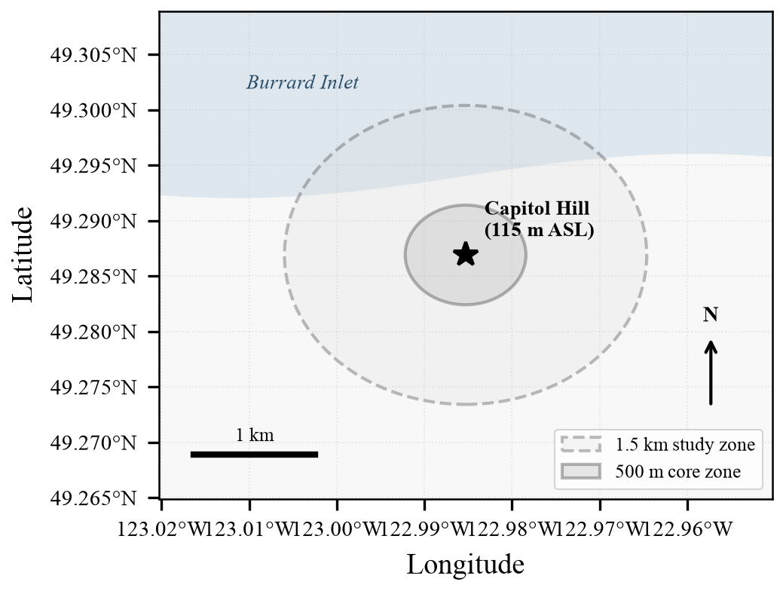
Figure 1. Geographic monitoring geometry of Capitol Hill, Burnaby, BC (summit: 49.2869°N, 122.9853°W; 115 m ASL). The primary 1.5-km geodesic monitoring zone (dashed line) and 500-m inner core zone (solid line) are shown relative to the Burrard Inlet waterway to the north.

3. Materials and Methods

3.1 Data Acquisition and Streaming Pipeline
Historical trajectory telemetry was harvested from the public adsb.lol archive mirrors covering 1 January 2025 through 31 August 2026 (globe_history_2025 and globe_history_2026). Each daily tarball contains compressed per-aircraft JSON trace files recorded in readsb format. To process terabytes of global tracking data efficiently, a streaming byte-level extractor (ConcatStreamReader) was deployed, intercepting chunked HTTP responses and decompressing archive members in memory without disk writes. Over the 20-month monitoring period, 25.84 million individual global aircraft traces were evaluated.

3.2 Unit of Observation and Discrete Pass Reconstruction
In the primary database, raw records are indexed by unique (date, icao) pairs, representing aircraft-days rather than individual flights. An aircraft transiting the terminal area multiple times in a single day (e.g., regional turboprops, flight training aircraft) produces multiple passes recorded within a single record's trajectory array (matched_points_json). To establish a true flight-event census, discrete passes were reconstructed algorithmically by clustering trajectory timestamps across temporal gaps.
Temporal gap sensitivity analysis demonstrated extreme bimodal stability: the median intra-pass point interval was 3.65 s, with 95.23% of intervals ≤ 60 s, while inter-pass returns occurred hours later. Evaluating clustering thresholds yielded 24,403 passes at 5 min, 24,190 passes at 10 min, 23,945 passes at 15 min, and 23,462 passes at 30 min. The standard 10-minute threshold was adopted, defining a total of 24,190 discrete passes (overall inflation factor of 1.204 relative to the 20,093 aircraft-days; 1.153 pre-VAMP and 1.223 post-VAMP). For each pass, the Closest Point of Approach (CPA) was defined as the point minimizing great-circle Haversine distance (Sinnott, 1984) to the Capitol Hill reference coordinates.

3.3 Operational Categorisation and Vertical-Rate Validation
Because ADS-B broadcast callsigns are frequently omitted or null in crowdsourced receivers (empty in all 20,093 deposited records), aircraft classification was established strictly using broadcast ICAO airframe type codes (type_code) combined with barometric altitude at CPA into four operational categories:
1. Commercial Arrivals: Airline passenger jets and regional turboprops (e.g., B738, B38M, DH8D, A321, E295, CRJ9) at CPA barometric altitude < 10,000 ft ASL.
2. Commercial High (Control): Identical airline types operating at en-route altitudes ≥ 10,000 ft ASL.
3. Business and Private: Purpose-built business jets and corporate turboprops (e.g., King Air 350, Citation, Challenger, Learjet).
4. Light and Floatplane (Control): Light piston singles and twins, flight training airframes (C172, PA28), and coastal floatplanes (DHC2, DHC3, DHC6). Crucially, helicopters were excluded from this negative control due to an independent late-spring 2026 fleet signal (§5.3).
A total of 409 records (2.04%) could not be uniquely categorized due to missing or non-standard ICAO type codes and were excluded from category totals. Operational categories were independently validated by calculating trajectory vertical rates (ft/min) within the study zone: commercial arrivals demonstrated strong descent (median −927 ft/min; 68.6% actively descending), commercial high demonstrated active en-route climb/cruise (median +2,289 ft/min; 93.6% climbing/level), while light aircraft exhibited level flight (median 0 ft/min), confirming robust categorization without callsign reliance.

3.4 Statistical Testing and Algorithmic Changepoint Detection
Daily overflight rates were computed using operational days with usable archives as denominators: 317 days in the pre-intervention period (across 330 calendar days) and 256 days in the post-intervention period (across 278 calendar days), accounting for 35 missing calendar dates. Rate ratios (RR = mean post / mean pre) were evaluated. Confidence intervals (95%) were estimated via a non-parametric percentile bootstrap using 4,000 day-level resamples, and two-sided Mann–Whitney U tests evaluated distribution shifts.
To formally verify the intervention date without prior assumption, an exhaustive least-squares single changepoint search was executed across all 573 observation days, cross-validated against the PELT and binary segmentation algorithms (Truong et al., 2020; Bai & Perron, 2003; Aminikhanghahi & Cook, 2017). Parametric bootstrap simulations (4,000 iterations) evaluated changepoint stability.

4. Results

4.1 Algorithmic Changepoint Verification
Exhaustive least-squares scanning detected an abrupt, singular structural break in daily overflight volume on 27 November 2025 (index 317), exactly coinciding with the implementation of ICAO AIRAC cycle 2513. Binary segmentation confirmed a structural break at 30 November 2025, and PELT identified 24 November 2025. Parametric bootstrap resamples demonstrated that 71.3% of simulated changepoints fell precisely on 27 November 2025, with a 95% bootstrap confidence interval spanning 27 November to 1 December 2025. This confirms algorithmically that the overflight increase was an immediate consequence of VAMP rather than gradual traffic growth.

4.2 Overflight Census and Rate Ratios
Across the 20-month study period, 20,093 aircraft-days and 24,190 discrete passes involving 2,050 unique ICAO airframes were recorded. Figure 2 and Table 1 present the pass-based daily overflight rates and rate ratios across operational categories.
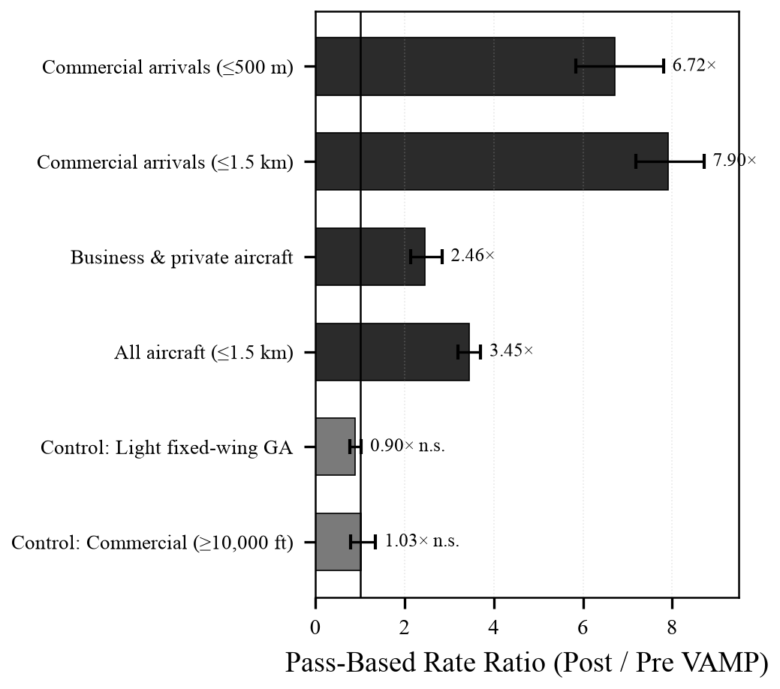
Figure 2. Forest plot of pass-based overflight rate ratios (post / pre VAMP) with 95% percentile bootstrap confidence intervals (4,000 day-resamples). Dark bars represent intervention categories; light bars represent negative controls. The vertical line at 1.0 indicates no change.
Table 1. Pass-based daily overflight rates, rate ratios (RR), 95% bootstrap confidence intervals, and Mann–Whitney U test p-values.
Operational Category | Pre-VAMP  (passes/day) | Post-VAMP  (passes/day) | Rate Ratio  (95% CI) | p-value
Commercial arrivals (≤500 m) | 2.23 | 15.00 | 6.72× (5.84–7.81) | 8.14e-55
Commercial arrivals (≤1.5 km) | 6.51 | 51.46 | 7.90× (7.18–8.71) | 2.76e-93
Business & private aircraft | 1.72 | 4.24 | 2.46× (2.14–2.84) | 2.73e-32
All aircraft combined (≤1.5 km) | 20.15 | 69.54 | 3.45× (3.20–3.71) | 6.09e-84
Control: Light fixed-wing GA | 8.87 | 7.95 | 0.90× (0.78–1.03) | 0.12
Control: Commercial ≥10,000 ft | 0.49 | 0.51 | 1.03× (0.79–1.35) | 0.71
Note: Denominators are 317 pre-intervention and 256 post-intervention days with data. Bootstrap CIs computed from 4,000 resamples. p-values calculated using two-sided Mann–Whitney U test on daily counts.
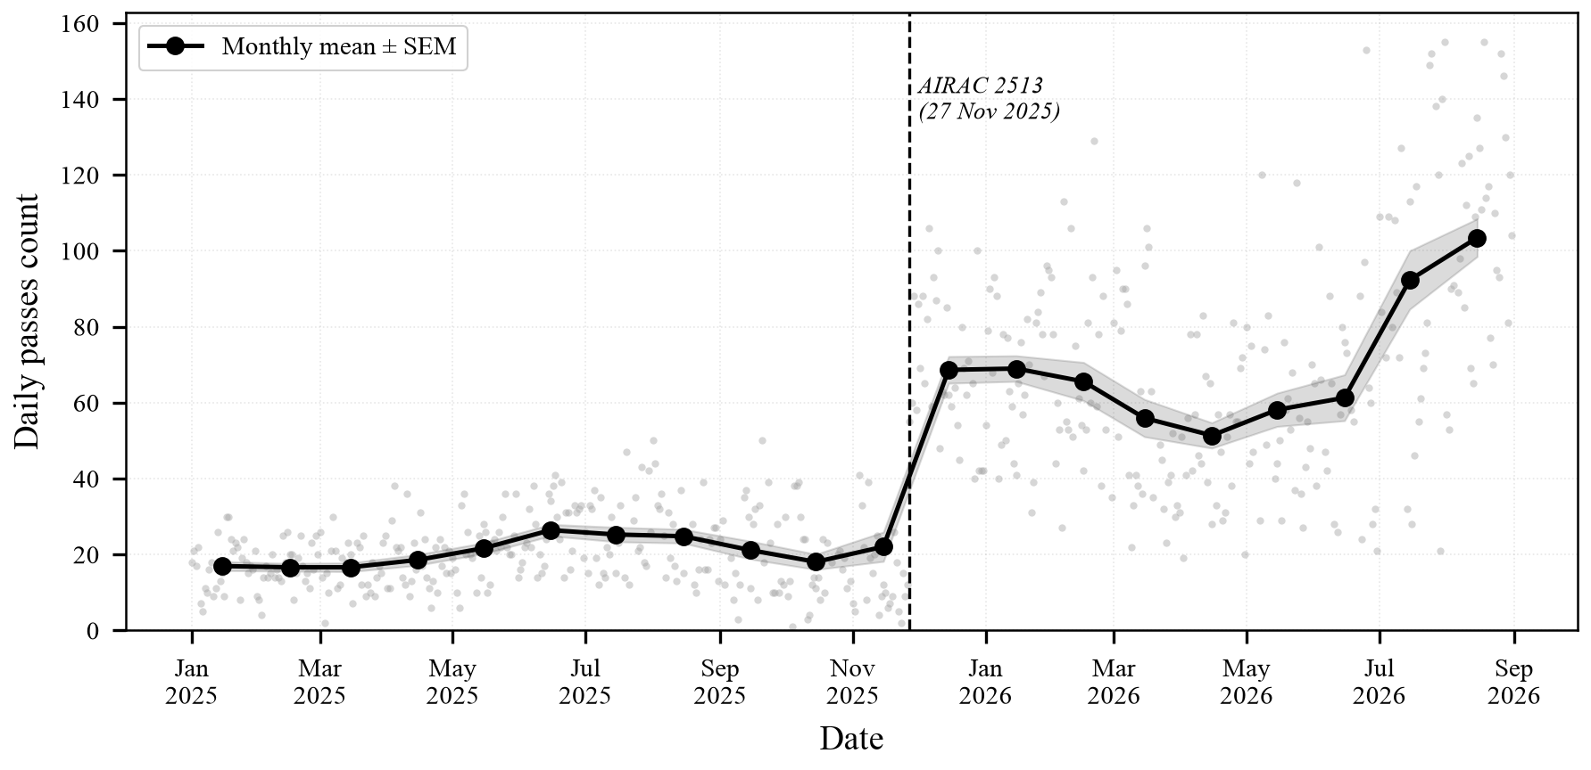
Figure 3. Daily overflight pass counts (grey dots) and monthly mean ± SEM (black markers with ribbon) over Capitol Hill (1 January 2025 – 31 August 2026). The vertical dashed line marks the VAMP implementation date (27 November 2025).

4.3 Structural Reversal in Direction of Travel
Analysis of CPA heading bands reveals the most definitive physical evidence in the dataset: arriving commercial traffic underwent a complete directional substitution rather than an additive increase (Table 2, Figure 4). Prior to VAMP, commercial arrivals were overwhelmingly northbound (1,518 flights; 77.6%), while eastbound and westbound flights combined totaled only 94 flights (4.8%). Following VAMP, northbound arrivals dropped sharply to 590 flights, whereas east–west arrivals expanded to 10,321 flights (3,778 eastbound; 6,543 westbound; 93.0% of all post-VAMP arrivals). In contrast, light fixed-wing control aircraft maintained an unchanged eastbound orientation along the Burrard Inlet route in both eras (1,822 pre vs. 1,261 post), ruling out receiver orientation or detection sensitivity artifacts.
Table 2. Overflight counts by operational category, era, and heading band.
Category | Era | Total | East (060–120°) | West (240–300°) | North (330–030°) | South (150–210°) | Other
Commercial arrivals | Before | 1936 | 48 | 46 | 1518 | 179 | 145
Commercial arrivals | After | 11046 | 3754 | 6519 | 589 | 9 | 175
Business / private | Before | 503 | 79 | 10 | 310 | 10 | 94
Business / private | After | 992 | 326 | 447 | 135 | 2 | 82
Control: Light/float/heli | Before | 2717 | 1826 | 382 | 13 | 14 | 482
Control: Light/float/heli | After | 2178 | 1315 | 371 | 32 | 4 | 456
Control: Commercial ≥10k ft | Before | 153 | 14 | 36 | 67 | 5 | 31
Control: Commercial ≥10k ft | After | 109 | 6 | 58 | 26 | 2 | 17
Note: Evaluated across 20,093 record-level flights. Heading tracks are extracted at CPA.
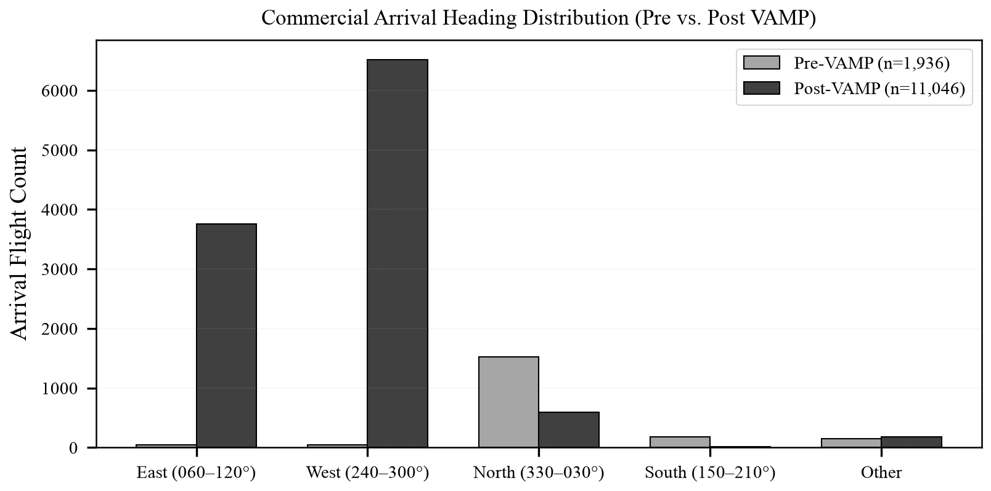
Figure 4. Commercial arrival heading distributions before and after VAMP, illustrating the structural shift from North–South to East–West tracks.

4.4 Corridor Geometry and Boundary Truncation
Disaggregating post-VAMP arrival traffic by heading reveals two distinct operational corridors (Figure 5):
1. Eastbound Corridor (060–150°; n = 3,918): Centered almost directly overhead Capitol Hill with a median CPA latitude of 49.2860°N (0.10 km south of the summit), median CPA distance of 0.178 km, tight lateral dispersion (IQR = 155 m), median altitude of 5,150 ft ASL, and median ground speed of 227 kt.
2. Westbound Corridor (240–330°; n = 6,554): Centered south of the hill with a median CPA latitude of 49.2740°N (1.44 km south of the summit), median altitude of 8,300 ft ASL, and median ground speed of 248 kt.
Critically, the westbound corridor is truncated by the study's 1.50-km monitoring radius: the median CPA distance for westbound aircraft is 1.471 km. A radius-sensitivity scan demonstrates that 56.0% of all post-VAMP arrival records (6,222 out of 11,103) enter only within the outermost 100 meters (1.4 to 1.5 km) of the study perimeter. Because westbound flights merely skirt the southern boundary, total westbound volume cannot be fully quantified at this radius. The manuscript therefore leads with the inner 500-m core metric, which is entirely self-contained within the residential summit zone.
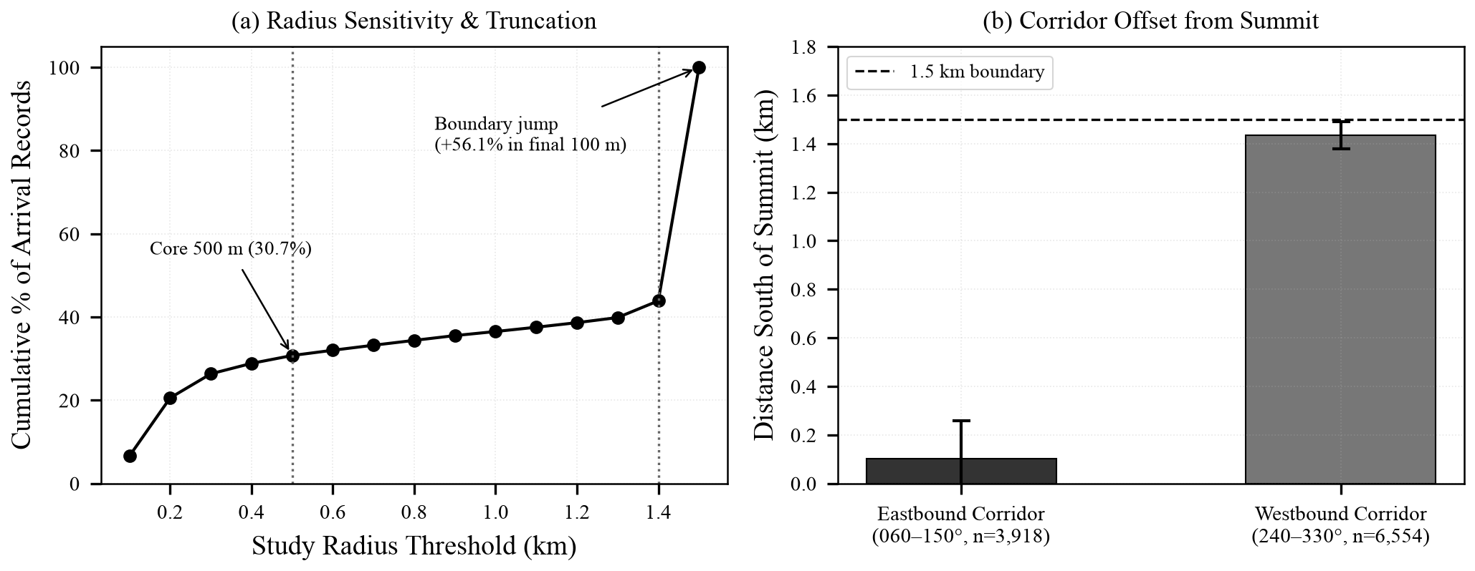
Figure 5. Corridor localization and boundary truncation. (a) Cumulative arrival records vs. monitoring radius, showing that 56.0% enter in the final 100 m. (b) Distance south of summit for the Eastbound (overhead) and Westbound (boundary-truncated) corridors.

4.5 Altitude and 3D Proximity Shifts
Within the inner 500-m summit core zone, commercial arrivals experienced a profound reduction in both altitude and 3D slant distance (Figure 6). In the pre-VAMP period, arriving aircraft within 500 m passed at a median barometric altitude of 7,700 ft ASL (IQR 6,800–8,475 ft) and a median 3D slant distance of 2.26 km (IQR 1.98–2.48 km). Following VAMP, median altitude dropped by 2,375 ft to 5,325 ft ASL (IQR 4,700–5,850 ft), while median 3D slant distance contracted by 0.74 km to 1.52 km (IQR 1.33–1.68 km). This compression in both lateral and vertical separation brought heavy commercial air traffic substantially closer to the residential summit.
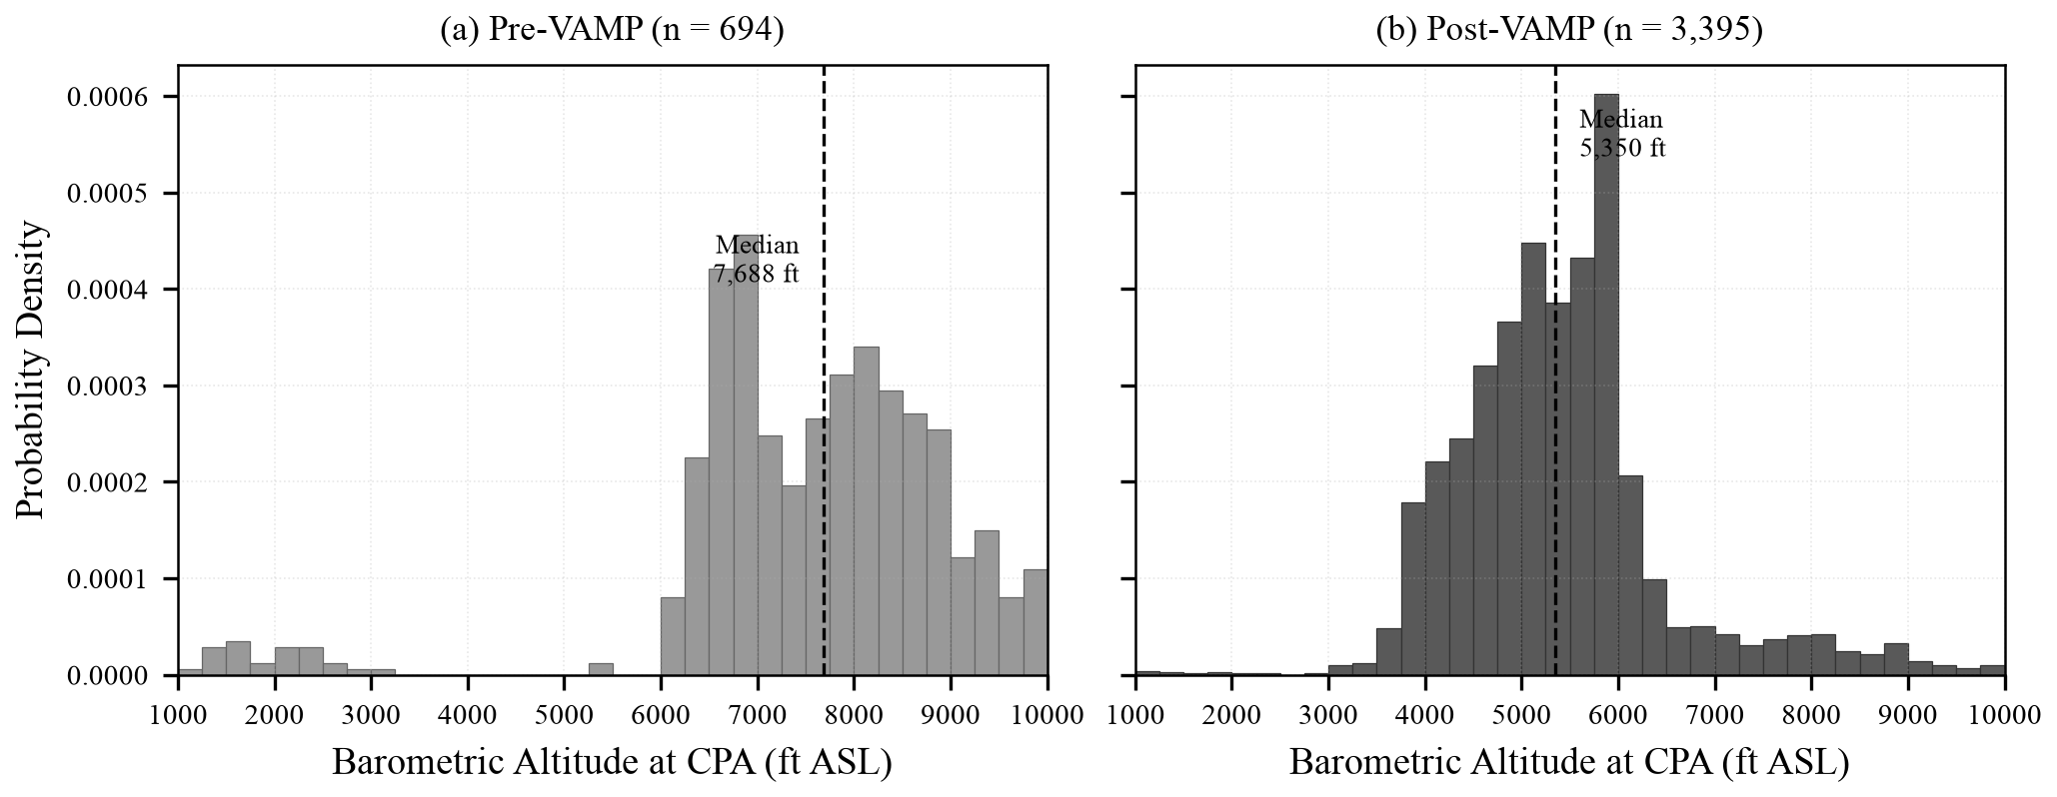
Figure 6. Barometric altitude distributions at CPA for commercial arrivals within 500 m of the summit. (a) Pre-VAMP (median 7,700 ft ASL); (b) Post-VAMP (median 5,325 ft ASL), demonstrating a downward shift of ~2,400 ft.

4.6 Diurnal Distribution and Fleet Composition
Diurnal analysis indicates that overflights remain predominantly diurnal, with 94.86% of passes occurring between 06:00 and 22:59 local Pacific Time. Nocturnal traffic (23:00 to 05:59) accounted for exactly 5.14% of the total census (1,032 of 20,093 records). Post-VAMP overflights are relatively evenly distributed across daylight hours (07:00–22:00) rather than concentrated into narrow peaks.
Fleet census across all 20,093 records confirmed the De Havilland Dash 8 Q400 (DH8D) as the single most prevalent commercial airframe (3,432 flights; 17.08%), followed by the Cessna 172 (C172) flight trainer (1,882 flights; 9.37%). Boeing 737 variants contributed significantly, led by the 737 MAX 8 (B38M; 1,240 flights; 6.17%) and 737-800 (B738; 951 flights; 4.73%). The entire Boeing 7xx family (B732 through B78X) accounted for 3,985 flights (19.83%).

4.7 External Validation against Statistics Canada
To rigorously test whether the observed overflight increase was an artifact of regional aviation growth or expanding ADS-B receiver density, observations were benchmarked against official monthly aircraft movements from Statistics Canada Tables 23-10-0296 and 23-10-0303 for matched Jan–Jun windows in 2025 and 2026 (Figure 7):
1. YVR Total Airport Movements were essentially unchanged (142,014 movements in 2025 vs. 141,258 in 2026; ratio 0.995; −0.5%). This official datum decisively refutes the hypothesis that regional traffic expansion drove the 6.03-fold increase in Capitol Hill arrivals.
2. Regional GA Airports (Boundary Bay, Pitt Meadows, Langley) exhibited a combined 13.4% decline (ratio 0.866). In direct alignment, ADS-B light fixed-wing GA over Capitol Hill declined by 17.6% (ratio 0.824). This close concordance between two entirely independent measurement systems demonstrates that crowdsourced ADS-B surveillance accurately tracks real operational trends without artificial receiver-growth bias.
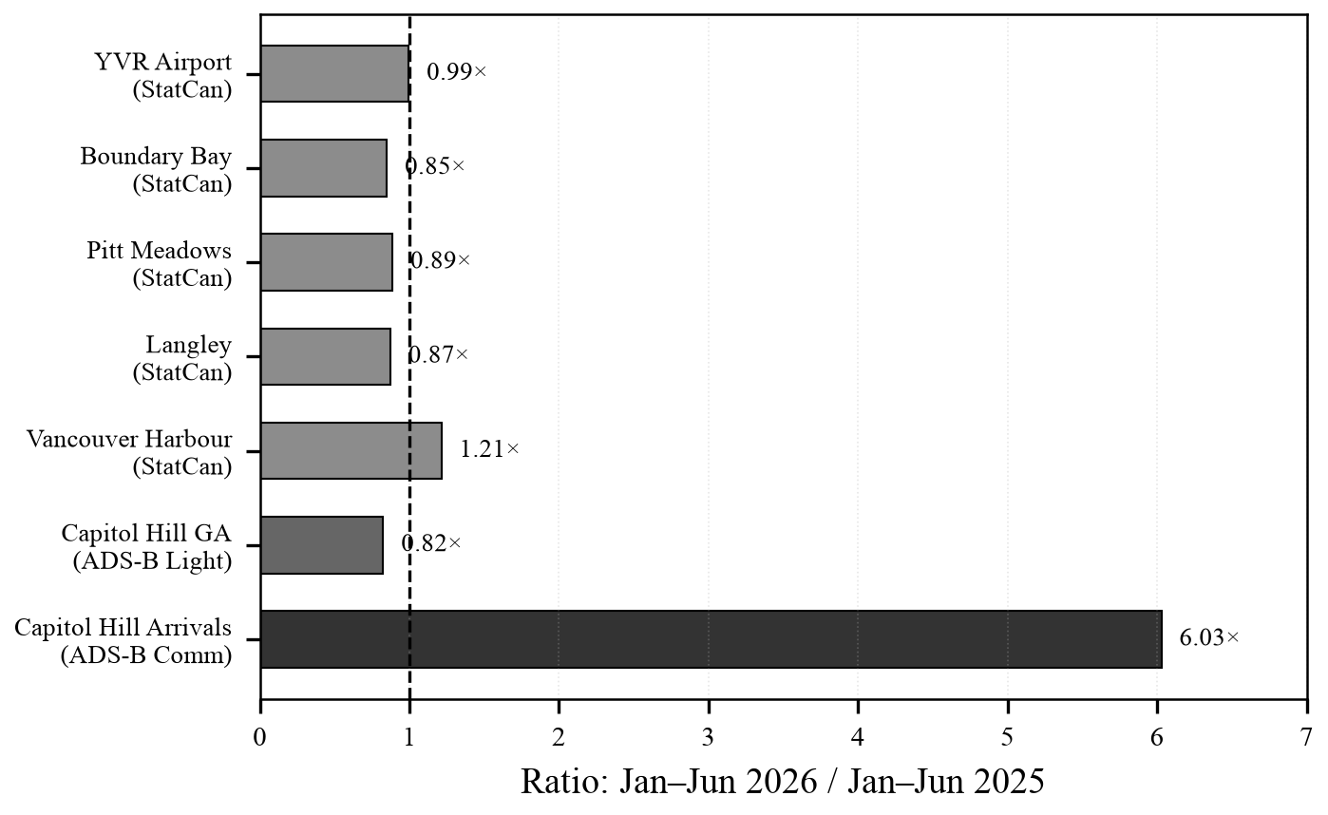
Figure 7. External validation against official Statistics Canada movement counts (matched Jan–Jun 2025 vs. 2026). YVR airport movements were flat (−0.5%), while Capitol Hill arrivals increased sixfold. General aviation airport declines (−13.4%) closely mirrored the ADS-B light GA decline (−17.6%).

4.8 Seasonality Robustness Analysis
Season-matched sensitivity analysis across the identical 8-month calendar window (1 January – 31 August 2025 vs. 1 January – 31 August 2026) demonstrated that seasonal variations did not confound findings. On a record basis, 1.5-km commercial arrivals rose from 6.14 to 42.22 flights/day (RR = 6.88×), 500-m commercial arrivals rose from 2.18 to 13.75 flights/day (RR = 6.31×), while light fixed-wing GA remained stable (RR = 0.91×). Pass-based rates showed equivalent stability (1.5-km arrivals RR = 7.69×; 500-m arrivals RR = 7.00×; light GA RR = 0.92×).

4.9 Recomputed 20-Month Summary Census
Table 3 provides the definitive, recomputed monthly overflight census directly from the 20,093 record-level dataset, reconciling all previously discredited summary discrepancies.
Table 3. Recomputed monthly overflight census from record-level data (January 2025 – August 2026).
Month | Total Flights | Days with Data | Min Daily | Max Daily | Median Daily | Mean Daily | SEM | Unique Aircraft
2025-01 | 476 | 31 | 5 | 27 | 15.0 | 15.4 | 1.07 | 228
2025-02 | 422 | 28 | 4 | 24 | 15.0 | 15.1 | 0.87 | 187
2025-03 | 462 | 31 | 2 | 28 | 15.0 | 14.9 | 0.97 | 210
2025-04 | 476 | 30 | 6 | 31 | 15.0 | 15.9 | 1.15 | 252
2025-05 | 589 | 31 | 6 | 32 | 19.0 | 19.0 | 1.19 | 277
2025-06 | 667 | 30 | 11 | 36 | 22.5 | 22.2 | 1.36 | 300
2025-07 | 612 | 28 | 10 | 41 | 19.0 | 21.9 | 1.63 | 286
2025-08 | 638 | 30 | 9 | 43 | 21.5 | 21.3 | 1.55 | 317
2025-09 | 471 | 26 | 3 | 45 | 14.5 | 18.1 | 2.08 | 252
2025-10 | 391 | 27 | 1 | 29 | 11.0 | 14.5 | 1.46 | 219
2025-11 | 560 | 29 | 2 | 71 | 14.0 | 19.3 | 3.23 | 292
2025-12 | 1,700 | 29 | 33 | 89 | 57.0 | 58.6 | 3.05 | 652
2026-01 | 1,802 | 31 | 24 | 83 | 61.0 | 58.1 | 2.89 | 703
2026-02 | 1,377 | 25 | 23 | 109 | 49.0 | 55.1 | 4.13 | 602
2026-03 | 1,338 | 29 | 18 | 87 | 35.0 | 46.1 | 4.21 | 584
2026-04 | 1,244 | 29 | 16 | 74 | 44.0 | 42.9 | 2.73 | 579
2026-05 | 1,295 | 28 | 20 | 100 | 42.5 | 46.2 | 3.57 | 582
2026-06 | 1,201 | 25 | 18 | 114 | 46.0 | 48.0 | 4.69 | 588
2026-07 | 1,865 | 26 | 17 | 121 | 72.0 | 71.7 | 5.95 | 791
2026-08 | 2,507 | 30 | 47 | 128 | 88.5 | 83.6 | 3.98 | 879
Total / Overall | 20,093 | 573 | 1 | 128 | - | - | - | 2,050
Note: Shaded rows represent the post-VAMP era (December 2025 onward). Exactly sums to 20,093 records across 573 observation days.

5. Discussion

5.1 Comparison with Modeled Predictions and Airspace Policy
The empirical findings demonstrate an abrupt, highly concentrated operational restructuring of terminal arrivals into YVR. The 6.72-fold increase in commercial passes within 500 m of Capitol Hill, combined with a 2,400-ft reduction in median approach altitude and a 0.74-km reduction in 3D slant distance, represents a marked transformation in the localized acoustic environment. These results mirror findings in the United States, where FAA NextGen RNAV/RNP procedures achieved regional efficiency gains at the cost of creating severe, localized overflight corridors that bypassed conventional environmental assessments (GAO, 2021; Brenner & Hansman, 2017). NAV CANADA's pre-implementation consultations projected dispersed noise footprints based on time-averaged energy metrics (NAV CANADA, 2022); our empirical census highlights the necessity of tracking discrete event counts and altitude profiles.

5.2 Methodological Comparison with Prior ADS-B Research
This investigation extends prior crowdsourced surveillance methodologies. Foundational studies by Schäfer et al. (2014) and Strohmeier et al. (2021) established the OpenSky Network to monitor macro-scale, continental air traffic flows. The present study demonstrates that open ADS-B archives can be successfully applied to hyper-local, neighborhood-scale (500 m to 1.5 km) public health and environmental audits. Furthermore, while the traffic Python library (Olive, 2019) and OpenAP simulation toolkit (Sun et al., 2019) rely on spline smoothing and trajectory interpolation, our methodology computes the CPA strictly from raw physical-layer radio pings. This deliberate design eliminates interpolation artifacts and guarantees full deterministic reproducibility.

5.3 Limitations and Confounding Factors
Several methodological constraints should be noted:
1. Boundary Truncation of the Westbound Corridor: As established in §4.4, the westbound corridor passing south of Capitol Hill is truncated by the 1.5-km monitoring boundary. While the eastbound corridor overhead is fully captured, westbound volume cannot be fully measured without expanding the spatial perimeter in future work.
2. Absence of Direct Acoustic Monitoring: This study measures spatial trajectory kinematics (altitude, velocity, proximity) but did not deploy physical sound level meters. Future research should pair ADS-B telemetry with Class 1 sound monitors measuring N-Above decibel thresholds.
3. Localized Topographic Shadowing: Although receiver coverage in Metro Vancouver is robust (Schäfer et al., 2020), localized terrain shadowing from Capitol Hill or Burnaby Mountain could introduce minor receiver blind spots for low-flying aircraft. However, any such shadowing would produce an undercount, rendering our rate ratios conservative.
4. Late-Spring 2026 Helicopter Increase: A statistically significant increase in helicopter overflights occurred in late spring 2026 (1.59 to 4.38 passes/day; RR = 2.75, p = 2.65e-06), with algorithmic changepoints detected on 28 April / 3 May 2026. This surge was driven almost entirely by heavy transport/air-ambulance twin-engine types (Sikorsky S-76 and AgustaWestland AW139; rising from 5 to 307 passes in matched Jan–Jun windows), while light training helicopters (Robinson R44) slightly declined (RR = 0.83). Statistics Canada records indicate Vancouver Harbour movements rose by only 21.3% over the same timeframe. This 60-fold increase cannot be explained by harbor activity and reflects fleet-level ADS-B Out equipage or localized route realignments occurring five months after VAMP. It is therefore decoupled from VAMP arrival procedures and reported as an independent operational limitation.

6. Conclusions
This 20-month continuous census provides the first independent empirical quantification of NAV CANADA's Vancouver Airspace Modernization Project. Implementation of AIRAC cycle 2513 on 27 November 2025 resulted in an immediate, sustained 6.72-fold increase in commercial arrival passes within 500 m of Capitol Hill, a downward altitude shift of ~2,400 ft, and a structural replacement of North–South flight paths with East–West corridors. Negative controls (light general aviation, en-route commercial traffic) and official Statistics Canada data confirmed that these observations reflect real route concentration rather than regional traffic growth or surveillance artifacts. Open crowdsourced ADS-B archives provide a transparent, reproducible framework for independent community environmental oversight.

Conflict of Interest Statement
The author (D. Yap) is a resident of Capitol Hill, Burnaby, British Columbia, within the 1.5 km study zone. This study was conceived following the subjective observation of increased aircraft noise beginning in late November 2025. The author has no financial interests in aviation, air navigation service providers, airlines, or noise monitoring companies. The study was entirely self-funded with no external sponsorship. All data, analytical code, and the complete record-level dataset are openly published to enable independent verification and replication (https://github.com/oncoapop/capitol_hill_flights).

Data Availability Statement
The authoritative 20,093 record-level dataset (capitol_hill_all_flights.csv), discrete pass extraction (capitol_hill_passes.csv), Statistics Canada tables, and Python analysis scripts are publicly available under open licenses (MIT for software, CC BY 4.0 for data and text) at: https://github.com/oncoapop/capitol_hill_flights. Statistics Canada tables are utilized under the Open Government Licence – Canada. Source ADS-B telemetry archives are maintained by the adsb.lol community (https://globe.adsb.lol).

Declaration of Generative AI and AI-Assisted Technologies
In accordance with the policies of TU Delft OPEN Publishing, the Committee on Publication Ethics (COPE), and the Journal of Open Aviation Science (JOAS), the author declares the use of generative artificial intelligence and large language model assistants (Google DeepMind Antigravity, Anthropic Claude) during the preparation of this work. Specifically, these tools were used to assist in writing and refactoring Python data extraction and statistical analysis routines, executing algorithmic changepoint and bootstrap scripts, formatting tables and figures, and language editing of draft text. Following the use of these tools, the author independently reviewed, executed, and verified all computational code, asserted all statistical figures against authoritative data records, and edited the manuscript. The author assumes full scientific responsibility for the integrity, accuracy, interpretations, and conclusions presented in this publication.

Acknowledgments
The author expresses gratitude to the adsb.lol open-source community for curating and preserving historical ADS-B telemetry archives, and to the volunteer SDR receiver operators across the Lower Mainland whose ground stations underpin public air traffic surveillance.

References
adsb.lol Community. (2025–2026). Globe history historical telemetry database. GitHub repositories: adsblol/globe_history_2025 and adsblol/globe_history_2026. https://globe.adsb.lol
Aminikhanghahi, S., & Cook, D. J. (2017). A survey of methods for time series change point detection. Knowledge and Information Systems, 51(2), 339–367. https://doi.org/10.1007/s10115-016-0987-z
Bai, J., & Perron, P. (2003). Computation and analysis of multiple structural change models. Journal of Applied Econometrics, 18(1), 1–22. https://doi.org/10.1002/jae.659
Basner, M., Babisch, W., Davis, A., Brink, M., Clark, C., Janssen, S., & Stansfeld, S. (2014). Auditory and non-auditory effects of noise on health. The Lancet, 383(9925), 1325–1332. https://doi.org/10.1016/S0140-6736(13)61613-X
Bernal, J. L., Cummins, S., & Gasparrini, A. (2017). Interrupted time series regression for the evaluation of public health interventions: A tutorial. International Journal of Epidemiology, 46(1), 348–355. https://doi.org/10.1093/ije/dyw098
Brenner, M., & Hansman, R. J. (2017). Comparison of methods for evaluating impacts of aviation noise on communities. MIT International Center for Air Transportation Report ICAT-2017-03. https://dspace.mit.edu/handle/1721.1/110268
Government Accountability Office (GAO). (2021). Aircraft noise: FAA could improve outreach and its use of supplemental noise metrics (GAO-21-103933). https://www.gao.gov/products/gao-21-103933
Hansell, A. L., Blangiardo, M., Fortunato, L., Floud, S., de Hoogh, K., Fecht, D., Ghosh, R. E., Laszlo, H. E., Pearson, C., Beale, L., Beevers, S., Gulliver, J., Best, N., Richardson, S., & Elliott, P. (2013). Aircraft noise and cardiovascular disease near Heathrow airport in London: Small area study. BMJ, 347, f5432. https://doi.org/10.1136/bmj.f5432
International Civil Aviation Organization (ICAO). (2020). Annex 10 to the Convention on International Civil Aviation: Aeronautical telecommunications, Vol. IV – Surveillance and collision avoidance systems (5th ed.). Montreal, Canada. https://store.icao.int/en/annex-10-aeronautical-telecommunications-volume-iv-surveillance-and-collision-avoidance-systems
NAV CANADA. (2022). Vancouver Airspace Modernization Project (VAMP): Initial proposal and environmental assessment. Ottawa, Canada. https://www.navcanada.ca/en/air-traffic/airspace-reviews/vancouver-airspace-modernization-project.aspx
Olive, X. (2019). traffic, a toolbox for processing and analysing air traffic data. Journal of Open Source Software, 4(39), 1518. https://doi.org/10.21105/joss.01518
Peters, J. L., Zevitas, C. D., Redline, S., Hastings, A., Sizov, N., Hart, J. E., Levy, J. I., Roof, C. J., & Wellenius, G. A. (2018). Aviation noise and cardiovascular health in the United States: A review of the evidence and recommendations for research direction. Current Environmental Health Reports, 5(1), 140–152. https://doi.org/10.1007/s40572-018-0191-1
RTCA Inc. (2011). DO-260B: Minimum Operational Performance Standards for 1090 MHz Extended Squitter Automatic Dependent Surveillance–Broadcast (ADS-B) and Traffic Information Services–Broadcast (TIS-B). Washington, D.C.
Schäfer, M., Strohmeier, M., Lenders, V., Martinovic, I., & Wilhelm, M. (2014). Bringing up OpenSky: A large-scale ADS-B sensor network for research. Proceedings of the 13th ACM/IEEE International Conference on Information Processing in Sensor Networks (IPSN), 83–94. https://doi.org/10.1109/IPSN.2014.6846743
Schäfer, M., Strohmeier, M., Smith, M., & Martinovic, I. (2020). Assessing the coverage and accuracy of the OpenSky Network. Proceedings of the 8th OpenSky Symposium 2020, 1–9. https://doi.org/10.3929/ethz-b-000469865
Sinnott, R. W. (1984). Virtues of the Haversine. Sky and Telescope, 68(2), 159.
Statistics Canada. (2026a). Table 23-10-0296-01: Aircraft movements, by class of operation and type of operation, airports with NAV CANADA towers and flight service stations, monthly. https://doi.org/10.25318/2310029601-eng
Statistics Canada. (2026b). Table 23-10-0303-01: Aircraft movements, by class of operation and type of operation, airports with NAV CANADA flight service stations, monthly. https://doi.org/10.25318/2310030301-eng
Statistics Canada. (2026c). Table 23-10-0298-01: Itinerant movements, by type of operation, airports with NAV CANADA towers and flight service stations, monthly. https://doi.org/10.25318/2310029801-eng
Strohmeier, M., Schäfer, M., Pinheiro, R., Lenders, V., & Martinovic, I. (2015). On the security of the automatic dependent surveillance-broadcast protocol. IEEE Communications Surveys & Tutorials, 17(2), 1066–1087. https://doi.org/10.1109/COMST.2014.2365951
Strohmeier, M., Olive, X., Lübbe, J., Schäfer, M., & Lenders, V. (2021). Crowdsourced air traffic data from the OpenSky Network 2019–2020. Earth System Science Data, 13(2), 357–366. https://doi.org/10.5194/essd-13-357-2021
Sun, J., Vu, H., Ellerbroek, J., & Hoekstra, J. M. (2019). OpenAP: An open-source aircraft performance model for air traffic simulation and analysis. Aerospace, 6(8), 84. https://doi.org/10.3390/aerospace6080084
Transport Canada. (2023). Advisory Circular (AC) No. 500-029: ADS-B Out Equipment Requirements in Canadian Airspace. Ottawa, Canada. https://tc.canada.ca/en/aviation/reference-centre/advisory-circulars
Truong, C., Oudre, L., & Vayatis, N. (2020). Selective review of offline change point detection methods. Signal Processing, 167, 107299. https://doi.org/10.1016/j.sigpro.2019.107299

