OncoReconcile AI

AI-Powered Precision Oncology Data Quality, Semantic Harmonization, Governance, Interoperability & Analytics

DFWIT 2026 AI & Startup Competition — Final Submission
Team Variant Vanguard
Final branch:
https://github.com/oncoreconcile-ai/oncoreconcile-ai/tree/enterprise-patient-journey-demo
Demo video:
https://drive.google.com/file/d/1x1MZUvCIXHdJ_M4LhPHl15NzQOj-0nVI/view
Submission date: July 12, 2026

Executive Summary
OncoReconcile AI is a human-governed AI platform that transforms fragmented oncology terminology into governed, explainable, interoperable, and AI-ready data assets. The platform reconciles inconsistent disease names, gene symbols, and genomic variants through deterministic normalization, evidence-supported reconciliation, confidence scoring, provenance tracking, and human governance workflows.
Rather than replacing expert curators, OncoReconcile AI accelerates oncology data harmonization while preserving transparency, auditability, and human oversight.

The Problem: Fragmented Oncology Data
Precision oncology depends on data from electronic health records, molecular laboratories, research systems, clinical trials, and external partners. The same disease, gene, variant, treatment, or laboratory concept is frequently represented with different names and codes.
A real example: one laboratory reports HER2, another reports HER-2, a third reports ERBB2, and a claims system records V-erb-b2. A researcher trying to identify all ERBB2-altered patients must manually reconcile these representations — every time, for every project.
This fragmentation creates expensive, repetitive work:
Impact | Real-world consequence
Manual curation | Experts spend weeks cleaning and mapping data instead of analyzing it
Fragmented cohorts | Patient populations are split across terminologies, hiding signal
Inconsistent analytics | Biomarker trends, outcome analyses, and AI inputs depend on how terminology was mapped
Interoperability gaps | FHIR, OMOP, and research exports use different coding systems that are not aligned
Safety risk | Forced automatic mappings disguise uncertainty — bad data becomes harder to detect downstream
Trustworthy AI requires trustworthy data. Poorly harmonized data produces unreliable analytics, reduces confidence in AI outputs, and slows precision medicine adoption.
OncoReconcile AI is a governed data-quality layer that converts fragmented oncology data into standardized, explainable, reviewable, and reusable information — before it reaches analytics, AI, or interoperability pipelines.

The Product
Raw oncology data
↓
Semantic normalization
↓
Disease / gene / variant reconciliation
↓
Evidence + confidence scoring
↓
AUTO_RECONCILE | REVIEW_REQUIRED | CANNOT_RECONCILE
↓
Human governance and audit history
↓
Coding-system mapping
↓
FHIR | OMOP | Knowledge Graph
↓
Enterprise analytics and AI-ready datasets
The product combines:
- disease, gene, and variant normalization;
- evidence packages and transparent score breakdowns;
- a governed review queue and adjudication history;
- optional LLM suggestions restricted to review-required cases;
- semantic mappings across oncology coding systems;
- synthetic longitudinal patient journeys;
- enterprise, governance, and executive analytics;
- FHIR R4, OMOP CDM v5.4, and knowledge-graph export prototypes;
- interactive APIs and benchmark evaluation.
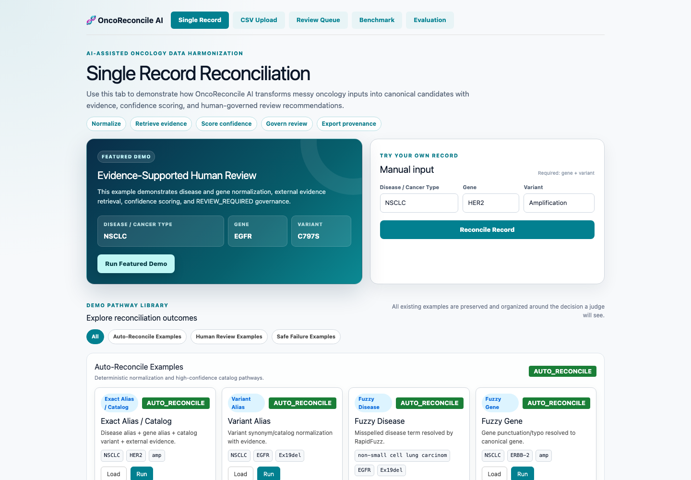
Platform homepage

Working Reconciliation & Evidence
A user submits a disease, gene, and variant record. The platform:
- normalizes the raw text;
- checks governed aliases and catalogs;
- retrieves supporting context and evidence;
- calculates a confidence score;
- assigns a safety-aware status;
- presents evidence, alternatives, notes, and an audit trail;
- exports the governed result through standards-oriented formats.
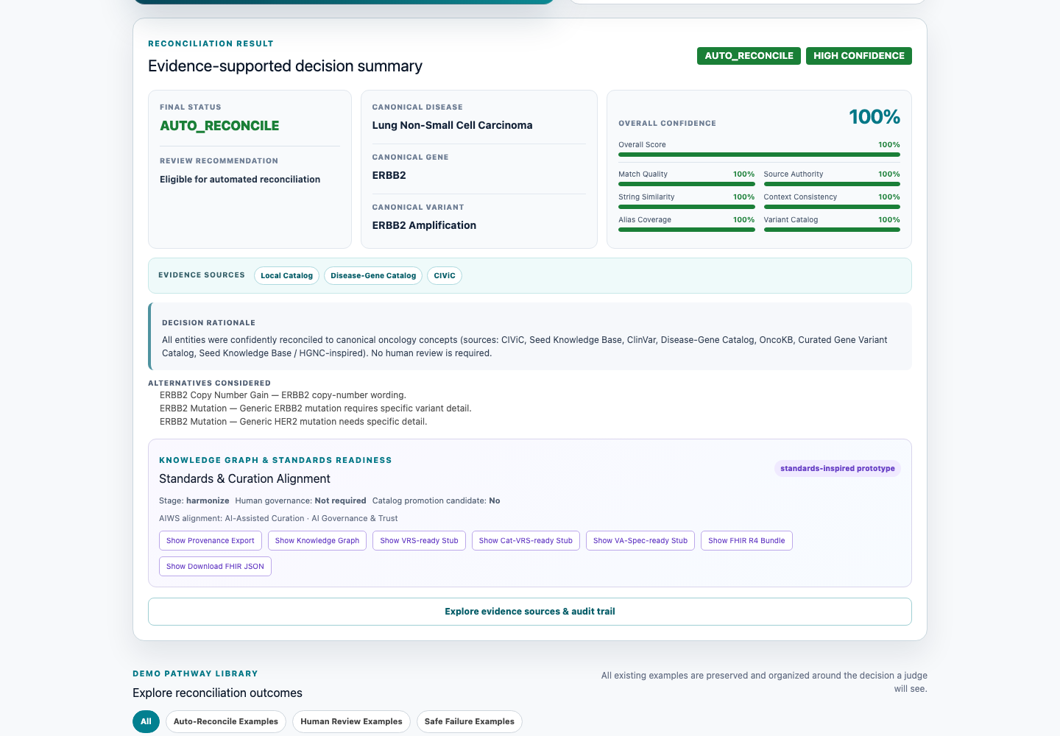
High-confidence reconciliation with evidence

Human-Governed AI
The platform does not force an answer when evidence is incomplete.
Status | Meaning
AUTO_RECONCILE | Evidence supports a high-confidence canonical mapping
REVIEW_REQUIRED | A plausible mapping exists, but a person must decide
CANNOT_RECONCILE | No sufficiently trustworthy mapping is available
Optional LLM assistance is model-agnostic and restricted to review suggestions. It cannot silently promote an uncertain case to automatic acceptance.
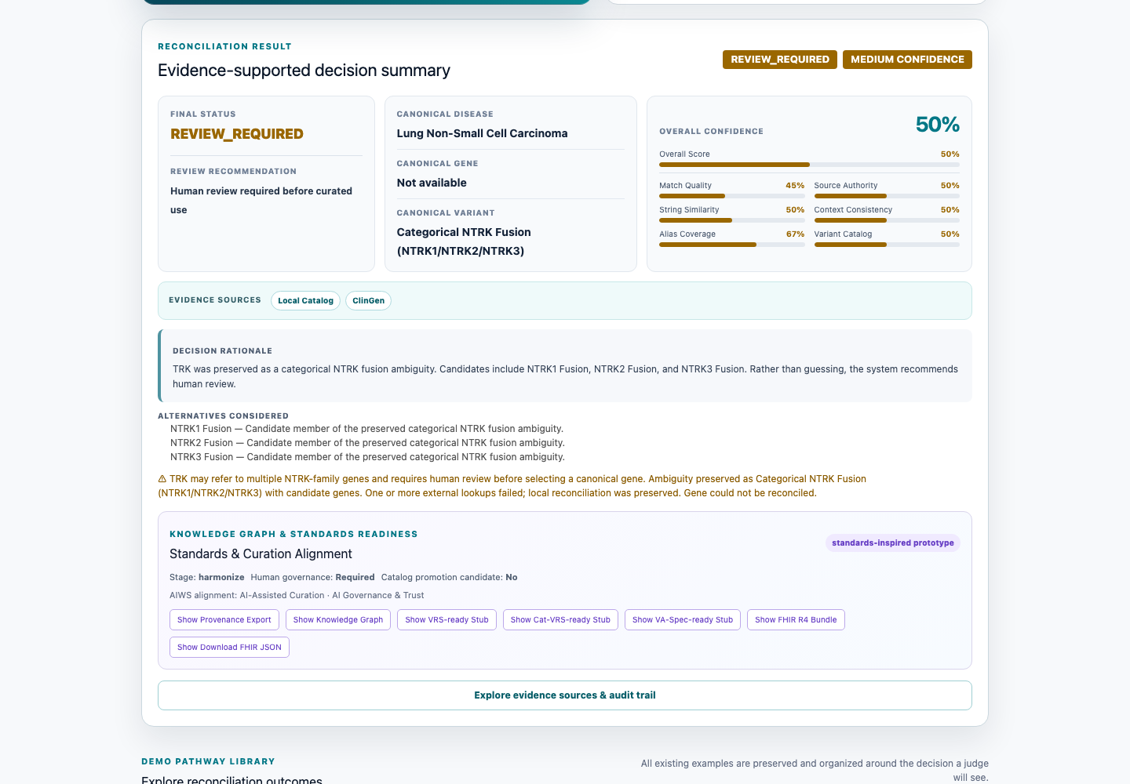
Ambiguous case routed to human review
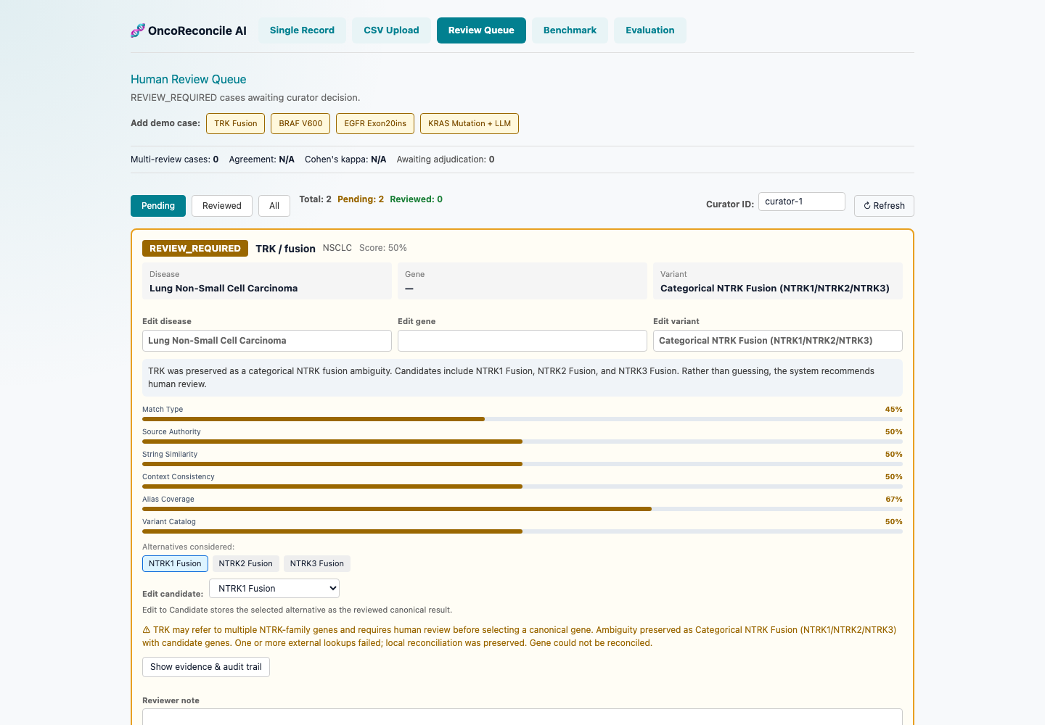
Review queue and curator workflow

Enterprise Patient Journey
The enterprise demonstration expands the reconciliation workflow into longitudinal analytics:
- 18 synthetic oncology patients;
- NSCLC, breast cancer, colorectal cancer, melanoma, and AML;
- diagnosis, histology, stage, biomarkers, genomic alterations, treatment lines, response, progression, trial flags, and governance signals;
- patient, cohort, terminology, quality, governance, and executive views;
- expanded FHIR, OMOP, and knowledge-graph exports.
All patient journey data is synthetic and used only for product demonstration.

Semantic Harmonization
Domain | Demonstrated coding systems
Disease | SNOMED CT, NCIt, OncoTree, ICD-10
Histology | SNOMED CT, NCIt
Gene | HGNC
Drug | RxNorm, ATC
Variant / biomarker | ClinVar, ClinGen-inspired identifiers
Laboratory test | LOINC
Mappings retain source, confidence, and review status. These are prototype mappings, not a complete certified terminology service.

Interoperability
The platform demonstrates:
- FHIR R4 Bundle export: Patient, Condition, Observation, MedicationStatement, and Provenance resources;
- OMOP CDM v5.4-oriented export: condition occurrence, measurement, observation, and drug exposure records;
- knowledge graph export: disease-gene-variant-treatment-evidence relationships;
- API-first integration: FastAPI endpoints and interactive OpenAPI documentation.
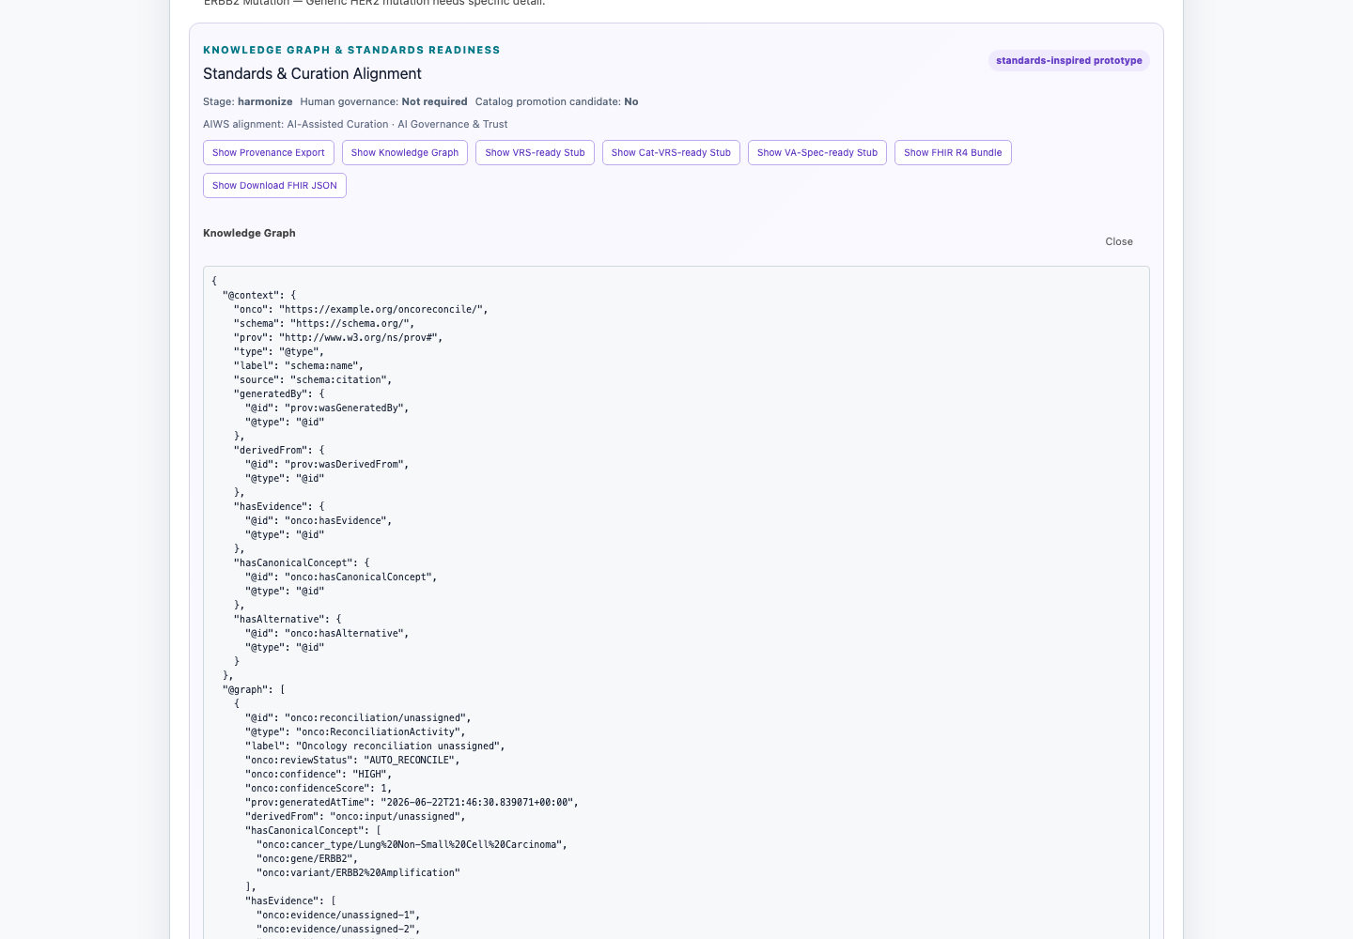
Knowledge graph export
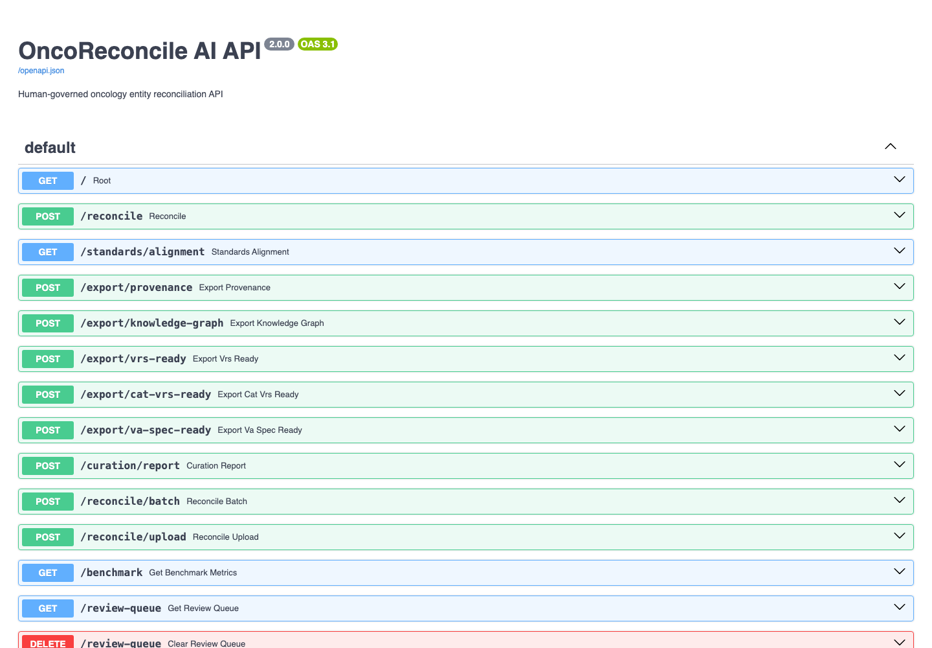
Interactive API documentation

Final Demo Screenshots
The following screenshots demonstrate the complete OncoReconcile AI enterprise platform workflow.

1. Homepage

Homepage showing the Single Record Reconciliation interface, featured demo, and manual input form.

2. Single Record Reconciliation

Evidence-supported reconciliation result showing canonical values, confidence score, evidence sources, and audit trail.

3. Review Required Case

Cat-VRS-style ambiguity (TRK fusion) preserved for accountable human review.

4. Review Queue

Governed review queue with decision controls, alternatives, evidence, and audit history.

5. Evaluation Dashboard

Benchmark validation metrics, accuracy and coverage gauges, failure analysis, and reviewer agreement.

6. Knowledge Graph Export

JSON-LD knowledge graph with disease-gene-variant-treatment-evidence relationships.

7. API Documentation

FastAPI interactive OpenAPI documentation exposing reconciliation, review, analytics, and export endpoints.

8. Enterprise Patient Journey
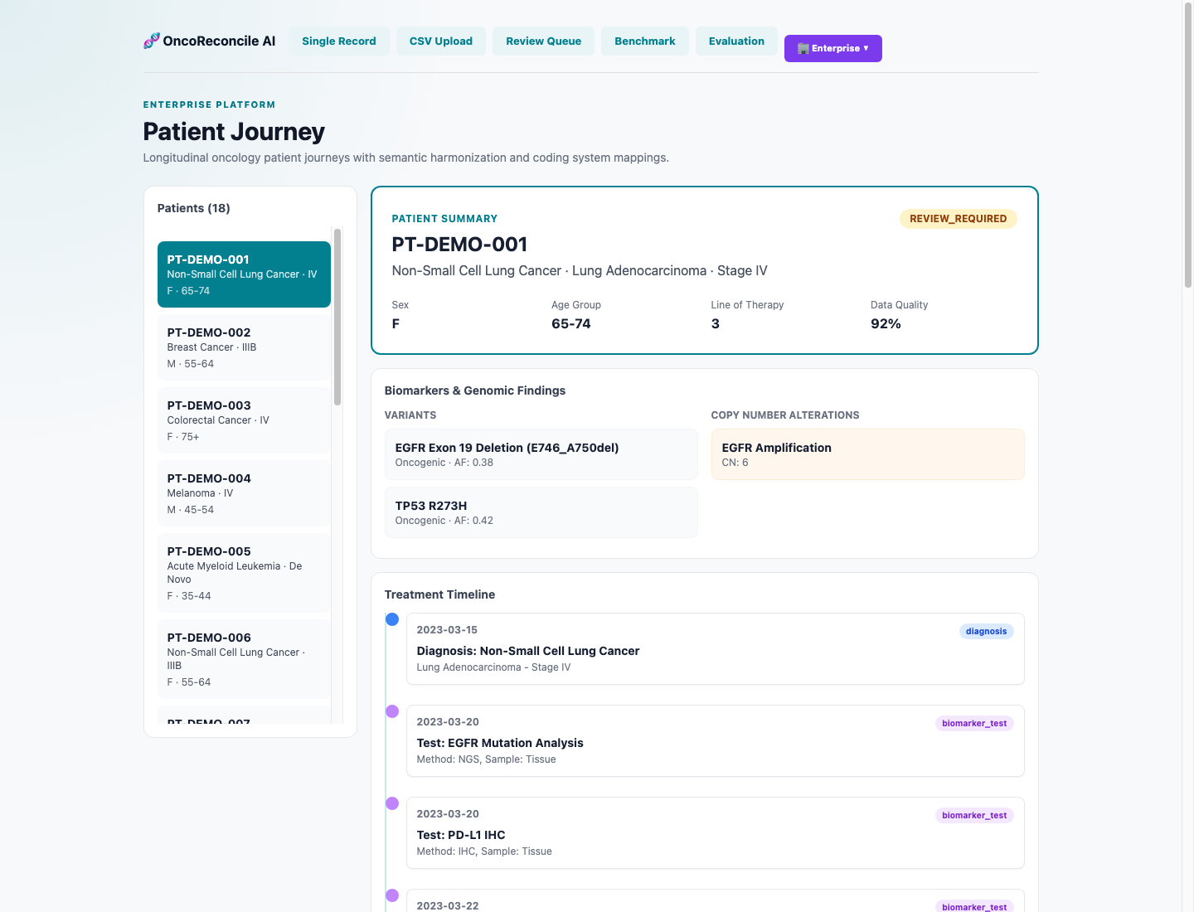 Longitudinal patient journey view showing diagnosis, biomarkers, copy-number alterations, treatment timeline, review status, and quality indicators.

9. Executive Dashboard
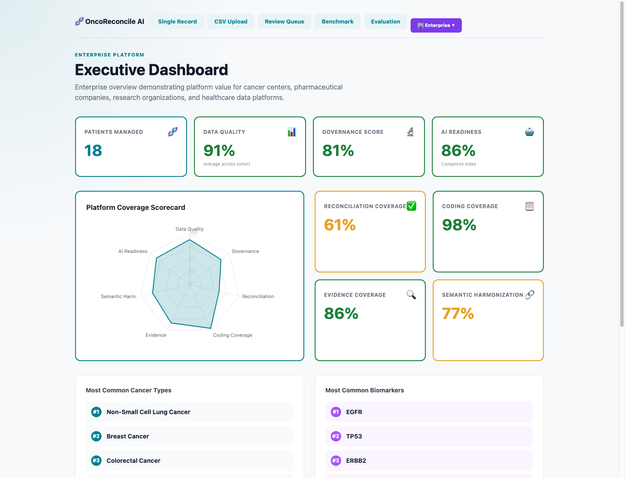 Enterprise dashboard summarizing patients managed, data quality, governance, AI readiness, reconciliation coverage, evidence coverage, and semantic harmonization.

10. Coding System Alignment
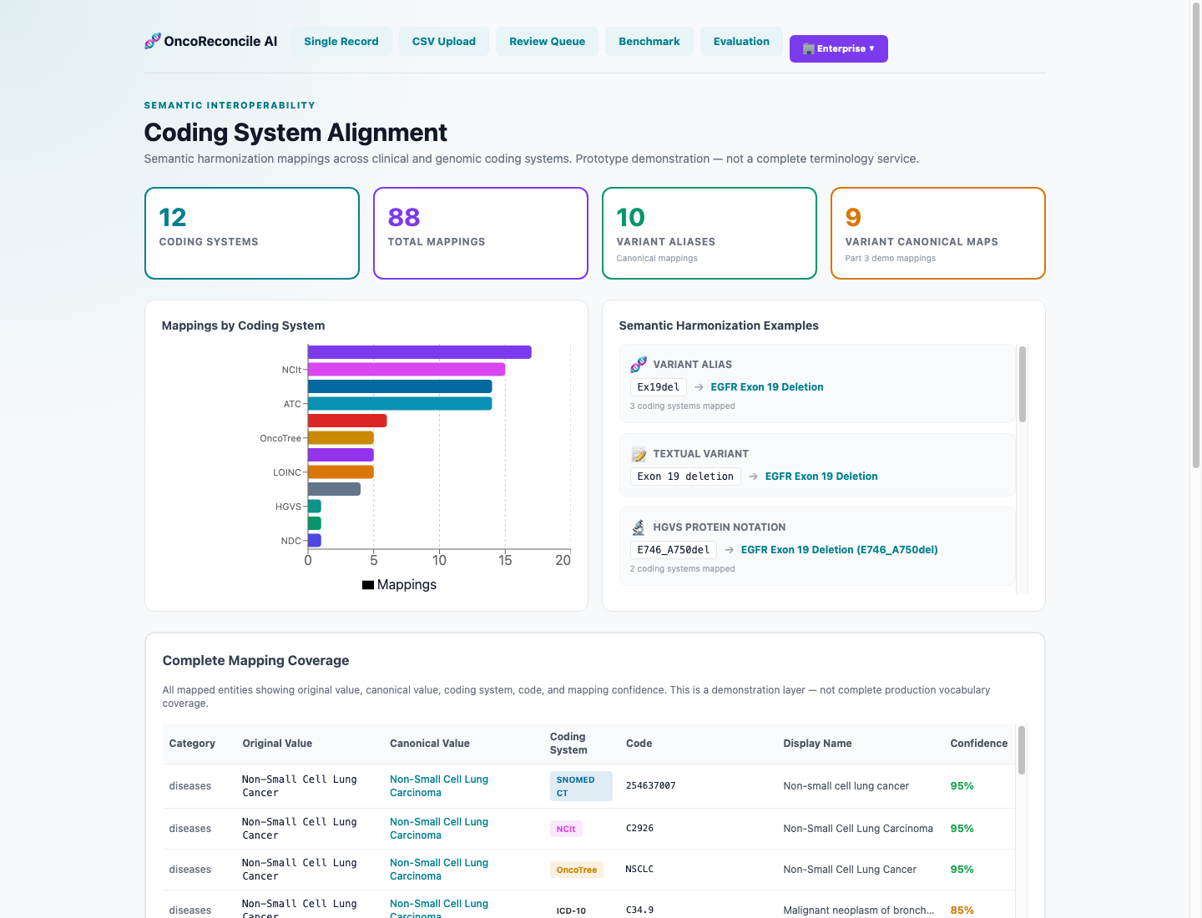 Semantic interoperability dashboard showing coding-system coverage, canonical mappings, terminology examples, and complete mapping coverage.

Evidence Retrieval Architecture
The current prototype adds curated HGVS resolution, structured ClinVar retrieval, CIViC variant-record search, a unified evidence model, and a separately reported evidence-weight calculation.

Architecture
Input (Disease, Gene, Variant)
│
▼
Disease Reconciliation
│
▼
Gene Reconciliation
│
▼
Variant Reconciliation
│
▼
Canonical HGVS Generation [IMPLEMENTED]
├── Protein HGVS (p.Cys797Ser)
├── Coding HGVS (c.2390G>C)
├── Genomic HGVS (chr7:g.55249192G>C)
└── VRS future fields (vrs_id, vrs_ready — design stubs)
│
▼
Evidence Retrieval Layer [IMPLEMENTED]
├── ClinVar (NCBI E-utilities, HGVS-first)
├── CIViC (GraphQL variant search)
├── Local Catalog (curated alias evidence)
└── MyVariant.info (live variant annotation)
│
▼
Unified Evidence Model [IMPLEMENTED]
Deduplication, ranking, source-grouped display
│
▼
Evidence Summary & Weighting [IMPLEMENTED]
ClinVar metadata and source configuration → separate breakdown
│
▼
Existing Confidence Score + Separate Evidence Breakdown

Canonical HGVS
The resolver returns protein, coding, and genomic HGVS fields when present in a curated map of 30 entries across 10 genes. A best-effort pattern fallback handles simple protein substitutions but is not a full HGVS validator. Each result includes vrs_id and vrs_ready fields as GA4GH VRS placeholders.

ClinVar Integration
The evidence_clinvar service queries NCBI ClinVar via E-utilities using HGVS-first strategy with rate-limiting (3 req/s). Retrieves clinical significance, review status, variation ID, accession, and submission count. Confidence is mapped from review status (practice guideline → 0.95, expert panel → 0.90, etc.).

CIViC Integration
The evidence_civic service queries CIViC via GraphQL variant search and returns variant name, CIViC variant ID, and a direct record URL. Evidence statements, levels, therapies, diseases, and citations are not yet retrieved by the active path.

Unified Evidence Model
Evidence sources share a common schema with deduplication and source grouping for frontend display. A capped evidence-weight value and breakdown are returned separately; they do not currently change the core confidence score or reconciliation routing.

New API Endpoints
Endpoint | Description
POST /evidence/federated | Fetch all-source evidence for a gene+variant
POST /hgvs/resolve | Resolve canonical HGVS
POST /evidence/boost | Compute confidence score boost

Future Architecture (Design Only)
Interface stubs exist for: GA4GH VRS (vrs_id, vrs_ready), ClinGen Allele Registry, OncoKB, gnomAD, GA4GH Beacon, GA4GH Phenopackets. No implementation has been started.

Testing
The evidence-upgrade functionality is covered by the backend reconciliation test suite. During final project validation, pytest collected 149 backend tests, of which 146 passed deterministically and 3 live-evidence tests were intentionally skipped when external network services were unavailable. A subsequent local verification on July 12, 2026 produced the same backend result: 146 passed; 3 skipped.
The frontend production build also completed successfully.
The evaluation assets include 191 curated API and regression test cases together with a 500-case expanded benchmark dataset used for engineering evaluation. The latest recorded benchmark results achieved 96.6% gene reconciliation accuracy, 94.6% variant reconciliation accuracy, 89.8% safety-aware status accuracy, and a 0% false auto-accept rate.
The benchmark assets are internal engineering evaluation materials, not clinical validation studies.

Validation
Reviewed on July 12, 2026:
Metric | Result
Backend test suite | 149 tests collected; 146 passed; 3 skipped (live external-evidence tests)
Frontend production build | Passing
Current API & regression benchmark | 191 curated test cases
Expanded engineering benchmark | 500 benchmark cases
Gene reconciliation accuracy | 96.6%
Variant reconciliation accuracy | 94.6%
Safety-aware status accuracy | 89.8%
False auto-accept rate | 0%
Note: The benchmark assets are intended for internal engineering evaluation and software quality assessment. They are not clinical validation studies or measures of clinical performance.
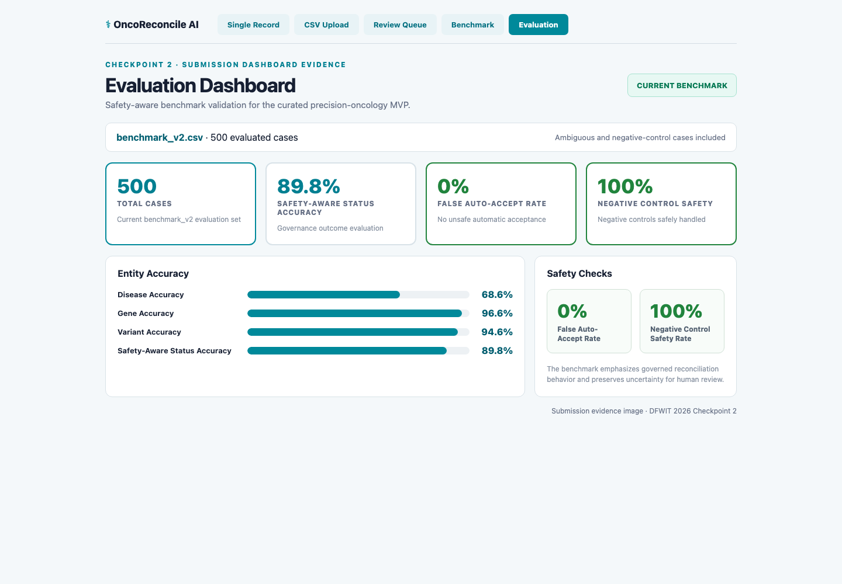
Benchmark and safety evaluation dashboard

Customer Pain Points
Before OncoReconcile AI, each oncology organization independently solves the same terminology fragmentation problem — often multiple times across different projects and teams.
Stage | Current approach | Hidden cost
Data ingestion | Spreadsheets, one-off scripts, manual lookup | Hours per dataset, errors from copy-paste
Terminology mapping | Each analyst rebuilds mappings for each project | Duplicate work, inconsistent results across teams
Ambiguity handling | Guesses or escalates through email | Lost context, no audit trail, delays
Quality validation | Manual spot-checking | Inconsistent coverage, hard to reproduce
Interoperability | Ad hoc FHIR/OMOP field mapping | Fragile, project-specific, hard to maintain
Governance | Email chains, meeting decisions, post-hoc documentation | No traceability, hard to prove compliance
The result: organizations spend expert time on data plumbing instead of science, and every project starts from scratch.

Customer Personas
Customer | Primary Pain | Value OncoReconcile Provides
Cancer Centers | Biomarker data is fragmented across EHR, laboratory, and registry systems, making cohort identification slow and unreliable | Harmonized patient data, governed review workflows, and AI-ready datasets for precision oncology programs
Molecular Diagnostic Laboratories | Variant naming inconsistencies between reporting systems, clinical databases, and research partners increase manual review | Standardized gene/variant representation, automated evidence lookup, and quality dashboards
CROs | Multi-site clinical trial data arrives with different terminology standards, requiring weeks of harmonization before analysis | Cross-site data standardization, governed mappings, and FHIR/OMOP-ready outputs
Pharmaceutical Companies | Real-world evidence and biomarker programs depend on consistent terminology across data partners that may use different coding systems | Cohort analytics, RWE pipelines, clinical trial matching, and reproducible governance
Genomic Knowledgebases | Curating public and internal variant evidence requires reconciling gene and variant names from heterogeneous sources | Normalized inputs, evidence retrieval, governed review, and audit-ready curation
Healthcare AI Platforms | AI model training and evaluation are only as reliable as the underlying terminology mappings | Governed, provenance-tracked data with explicit uncertainty — trustworthy AI starts with trustworthy data

Business Model
Revenue stream | Description | Maturity
Professional Services | Oncology data harmonization, terminology assessment, governance workflow design, FHIR/OMOP implementation support | Immediate — project-based engagements
SaaS — Team | Shared review queues, batch reconciliation, governed catalogs, audit dashboards, quality reporting | Near-term — subscription pricing
SaaS — Enterprise | Multi-user governance, role-based access, persistent storage, enterprise analytics, API access | Medium-term — custom pricing
Enterprise APIs | Reconciliation, evidence, governance, and export APIs for integration into customer platforms | Medium-term — usage-based or contract
Licensing & Deployment | Private-cloud or customer-controlled deployment for regulated environments | Long-term — enterprise agreements

Go-to-Market Strategy
- Validate with services — data-quality assessments and harmonization projects generate revenue while building domain understanding and customer relationships.
- Convert to SaaS — pilot customers transition to team subscriptions as governed workflows demonstrate measurable value.
- Scale through APIs — enterprise customers integrate OncoReconcile capabilities into their own platforms, creating recurring API revenue.

ROI Framework
OncoReconcile AI does not make unsupported numerical claims. Instead, it delivers measurable operational improvements:
Benefit | How it creates value
Reduced manual normalization | Curated alias catalogs and automated reconciliation replace spreadsheet-based lookups
Standardized review workflows | Structured governance replaces email chains and undocumented decisions
Improved traceability | Every mapping has evidence, provenance, and audit history — reproducible and defensible
Governed AI-ready datasets | Data quality is measured and uncertainty is explicit before data reaches analytics or AI
Reusable mappings | Once reconciled, a concept is mapped across all coding systems — not rebuilt for each project
Scalable enterprise curation | Human reviewers focus on ambiguous cases while routine mappings are automated

Competitive Differentiation

How OncoReconcile AI compares
Capability | Manual Curation | Terminology Mapping Tools | Generic LLM Assistants | OncoReconcile AI
Disease normalization | Manual | ✓ | Inconsistent | ✓
Gene normalization | Manual | Partial | Inconsistent | ✓
Variant normalization | Manual | Partial | Inconsistent | ✓
Canonical HGVS | Manual lookup | ✗ | ✗ | ✓ (30 curated entries)
Evidence retrieval | Manual search | ✗ | Hallucination risk | ✓ (guarded MyVariant, ClinVar, CIViC, and experimental ClinGen lookup)
Confidence scoring | Subjective | ✗ | ✗ | ✓ (6-signal numeric score)
Human governance | ✗ | ✗ | ✗ | ✓ (review queue, approve/reject/edit/reopen)
Audit trail | ✗ | ✗ | Unreliable | ✓ (chronological, reviewer-identified)
Review agreement metrics | ✗ | ✗ | ✗ | ✓ (Cohen’s kappa, adjudication)
Knowledge graph | ✗ | ✗ | Unreliable | ✓ (JSON-LD, disease-gene-variant-evidence)
FHIR export | Manual mapping | ✗ | ✗ | ✓ (R4 Bundle prototype)
OMOP export | Manual mapping | ✗ | ✗ | ✓ (CDM v5.4-oriented prototype)
Categorical ambiguity preservation | ✗ | ✗ | ✗ | ✓ (Cat-VRS-inspired)
Negative control safety testing | ✗ | ✗ | ✗ | ✓ (benchmark with 0% false auto-accept)
Enterprise analytics | ✗ | ✗ | ✗ | ✓ (patient journey, executive, governance)
The key difference: OncoReconcile AI combines all of these capabilities in an oncology-specific, governance-first platform. It is not a terminology tool, not a knowledgebase, and not a generic AI — it is a governed data-quality layer for precision oncology.

Why This Combination Matters
- Manual curation is slow, inconsistent, and does not scale.
- Terminology mapping tools resolve codes but do not handle variant normalization, evidence, or governance.
- Generic LLM assistants hallucinate, lack provenance, and cannot be trusted for regulated data.
- OncoReconcile AI provides deterministic reconciliation where possible, evidence-supported review where needed, and human governance everywhere.

Social Impact
Impact | How OncoReconcile AI contributes
Higher-quality oncology data | Standardized terminology reduces errors, fragmentation, and ambiguity in datasets used for research and analytics
Reproducible research | Governed mappings with audit trails mean every data transformation can be traced, validated, and reproduced
Trustworthy AI development | AI models trained on governed, provenance-tracked data with explicit uncertainty markers are safer and more transparent
Reduced repetitive work | Automation of routine normalization frees expert curators to focus on ambiguous cases and higher-value analysis
Human accountability | The governance model ensures human experts remain in the loop for uncertain decisions — AI assists, humans decide
Interoperability for better care | Standardized data across institutions supports larger, more diverse research cohorts and more robust evidence generation
OncoReconcile AI is a data-quality and governance platform. It does not make clinical decisions, provide treatment recommendations, or replace clinical judgment. Its impact is enabling better, more trustworthy data — which is a prerequisite for safer AI and more reliable research in precision oncology.

Team
Variant Vanguard combines healthcare data-engineering insight, software development, product strategy, and a governance-first AI philosophy.
The team’s core insight is simple: oncology organizations do not only need a model that produces an answer. They need a data-quality platform that can explain the answer, preserve uncertainty, route difficult cases to experts, and integrate governed results across the enterprise.

Roadmap
- improve disease normalization and governed catalog coverage;
- validate workflow value with de-identified pilot data;
- add authentication, persistent enterprise storage, and role-based access;
- measure curator time, review agreement, and correction rates;
- expand integration and standards-conformance testing;
- scale into a customer-controlled oncology data-quality platform.

Standards Alignment & Reference Resources
OncoReconcile AI is designed to align with widely adopted healthcare interoperability, precision oncology, and biomedical knowledge standards. These resources inform the platform’s semantic harmonization, governance, interoperability, and future expansion roadmap.

Healthcare Interoperability
- HL7 FHIR (Fast Healthcare Interoperability Resources)
- OMOP Common Data Model (OHDSI)
- SNOMED CT
- LOINC
- RxNorm
- ICD-10-CM

Precision Oncology & Genomics Standards
- HGNC Gene Nomenclature
- ClinVar
- ClinGen Allele Registry
- GA4GH Variant Representation Specification (VRS)
- GA4GH Categorical Variation Representation (Cat-VRS)
- GA4GH Variant Annotation Specification (VA-Spec)
- NCI Thesaurus (NCIt)
- OncoTree

Biomedical Knowledge Sources
- CIViC (Clinical Interpretation of Variants in Cancer)
- MyGene.info
- MyVariant.info
- AACR Project GENIE
- ClinGen
- National Center for Biotechnology Information (NCBI)

Platform Positioning
OncoReconcile AI does not replace these standards or knowledge resources. Instead, the platform provides a governance and semantic harmonization layer that helps organizations transform heterogeneous oncology data into explainable, interoperable, and AI-ready assets.
Current implementation includes selected interoperability and terminology concepts. Additional standards integration remains part of the future product roadmap.

Repository Resources

Primary Repository
https://github.com/oncoreconcile-ai/oncoreconcile-ai

Submission Branch
https://github.com/oncoreconcile-ai/oncoreconcile-ai/tree/enterprise-patient-journey-demo

Key Documentation
- README
- Final Submission
- Architecture
- Architecture Diagrams
- Commercial Strategy
- Roadmap
- Curation Methodology
- Data Curation Pipeline
- Enterprise Patient Journey Demo

Supporting Assets
- Enterprise Analytics Dashboard: executive dashboard demonstrating harmonization KPIs, governance metrics, evidence distribution, and operational analytics.
- Benchmark Evaluation Framework: curated benchmark dataset and validation methodology for evaluating reconciliation accuracy and governance workflows.
- Review Queue Governance Workflow: human review workflow supporting reviewer agreement metrics, Cohen’s Kappa, adjudication, audit trail, and governed curation.
- Knowledge Graph Export Prototype: JSON-LD prototype illustrating canonical disease, gene, variant, evidence, provenance, and relationship modeling.
- Prepared FHIR Demo Export
- Prepared OMOP Demo Export
- Demo Export Documentation

Links
Repository:
https://github.com/oncoreconcile-ai/oncoreconcile-ai/tree/enterprise-patient-journey-demo
Final submission:
https://docs.google.com/document/d/1SbL5lo-suS56S8TtRIwaH1IyHVYw3yaIVhLhYaURaQI/edit?tab=t.0
Architecture:
https://github.com/oncoreconcile-ai/oncoreconcile-ai/blob/enterprise-patient-journey-demo/docs/architecture.md
Enterprise demo documentation:
https://github.com/oncoreconcile-ai/oncoreconcile-ai/blob/enterprise-patient-journey-demo/docs/enterprise_patient_journey_demo.md
Official DFWIT rules:
https://ai.dfwit.org/Rules

Disclaimer
OncoReconcile AI is a prototype biomedical data harmonization, governance, interoperability, and analytics platform. It has not been clinically validated. It is not a medical device, clinical decision support system, diagnostic system, or treatment-recommendation system and does not provide medical advice.
FHIR, OMOP, terminology, and knowledge-graph capabilities are prototypes requiring implementation-specific validation before production use. The enterprise patient journey uses entirely synthetic data; no real patient data is included.

Appendix A – Standards & Reference Resources
OncoReconcile AI is designed to work alongside widely adopted healthcare interoperability, precision oncology, terminology, and biomedical knowledge resources.

Healthcare Interoperability
- HL7 FHIR (Fast Healthcare Interoperability Resources)
- OMOP Common Data Model (OHDSI)
- SNOMED CT
- LOINC
- RxNorm
- ICD-10-CM

Precision Oncology & Genomics Standards
- HGNC Gene Nomenclature
- ClinVar
- ClinGen Allele Registry
- GA4GH Variant Representation Specification (VRS)
- GA4GH Categorical Variation Representation (Cat-VRS)
- GA4GH Variant Annotation Specification (VA-Spec)
- NCI Thesaurus (NCIt)
- OncoTree

Biomedical Knowledge Sources
- CIViC (Clinical Interpretation of Variants in Cancer)
- MyGene.info
- MyVariant.info
- AACR Project GENIE
- ClinGen
- National Center for Biotechnology Information (NCBI)

Enterprise Positioning
OncoReconcile AI does not replace these standards or knowledge resources. It provides the governance, semantic harmonization, evidence, and workflow layer needed to apply them to heterogeneous oncology data and produce explainable, interoperable, and AI-ready assets.
Current implementation demonstrates selected terminology and interoperability concepts. Broader standards integration and conformance testing remain part of the product roadmap.

