OncoReconcile AI

AI-Powered Precision Oncology Data Quality, Governance & Interoperability Platform

DFWIT AI & Startup Competition 2026

Checkpoint 2 Primary Submission
Team: Variant Vanguard
Submission Date: June 27, 2026
Demo Video: https://drive.google.com/file/d/12k0wm4KthaTWYMj6u33mElQiiQ2KhR7p/view

Executive Summary
OncoReconcile AI is an AI-powered biomedical data quality, governance, and interoperability platform designed to improve the consistency, explainability, and AI-readiness of oncology and clinical genomics data.
The platform reconciles heterogeneous disease names, genes, and genomic variants into standardized canonical representations using:
- AI-assisted entity resolution
- Evidence retrieval
- Confidence scoring
- Explainable recommendations
- Human review workflows
- Standards-aligned exports
Rather than forcing uncertain mappings, the system surfaces supporting evidence and routes ambiguous cases through expert review.
The result is trustworthy, explainable, and reusable oncology data suitable for precision medicine, clinical research, healthcare analytics, and future AI applications.

Checkpoint 2 Deliverables
- Human-governed reconciliation engine
- Single-record reconciliation
- Batch reconciliation
- Evidence retrieval
- Review queue and reviewer governance workflow
- 500-case benchmark evaluation
- Evaluation dashboard
- FHIR export prototype
- OMOP export prototype
- Knowledge graph export prototype
- Data collection and curation pipeline
- PDF-ready documentation package
- Screenshots and demo assets

Official Judging Alignment
This Checkpoint 2 submission is organized around the DFWIT judging dimensions:
Judging Dimension | How OncoReconcile AI Addresses It
Innovation, Business Value & Social Impact | Applies AI-assisted reconciliation to precision-oncology data quality, a high-friction healthcare data problem that affects analytics, research, interoperability, and trustworthy AI readiness.
Tech Solution, Quality & User Experience | Provides a working FastAPI + React application with guided single-record demos, CSV batch reconciliation, human review, benchmark dashboards, evidence display, and standards-inspired export prototypes.
Business Development | Positions the product as a biomedical data quality layer for cancer centers, molecular labs, healthcare data platforms, AI teams, and pharma analytics groups, with future services, SaaS, and API paths.
Presentation | Uses a judge-friendly GUI flow: reconcile a record, show evidence and governance, process a CSV batch, review ambiguous cases, and explain benchmark results from the dashboard.

Problem Statement
Precision oncology data is fragmented across multiple sources:
- Electronic Health Records (EHR)
- Molecular Diagnostic Laboratories
- Clinical Trials
- Research Databases
- Real-World Evidence Platforms
- Healthcare Analytics Systems
The same biological concept frequently appears under different names.
Input | Canonical Representation
HER2 | ERBB2
HER1 | EGFR
p53 | TP53
NSCLC | Lung Non-Small Cell Carcinoma
Ex19del | EGFR Exon 19 Deletion
FLT3 ITD | FLT3 Internal Tandem Duplication
These inconsistencies create challenges for:
- Biomarker analytics
- Cohort generation
- Clinical trial matching
- Data integration
- AI model development
- Healthcare interoperability
Organizations often spend substantial effort manually harmonizing data before it becomes useful.

Why This Matters
Healthcare organizations are increasingly adopting AI. However:
Trustworthy AI requires trustworthy data.
Poorly standardized oncology data can lead to:
- Reduced data quality
- Increased manual effort
- Inconsistent analytics
- Lower interoperability
- Reduced confidence in AI systems
OncoReconcile AI focuses on improving data quality before downstream analytics and AI workflows.

Solution Overview
Disease / Gene / Variant Input
|
v
Entity Resolution
|
v
Evidence Retrieval
|
v
Confidence Scoring
|
v
Governance Decision
/ | \
AUTO_RECONCILE REVIEW_REQUIRED CANNOT_RECONCILE
|
v
Human Review
|
v
Curated Output
|
v
FHIR / OMOP / Analytics
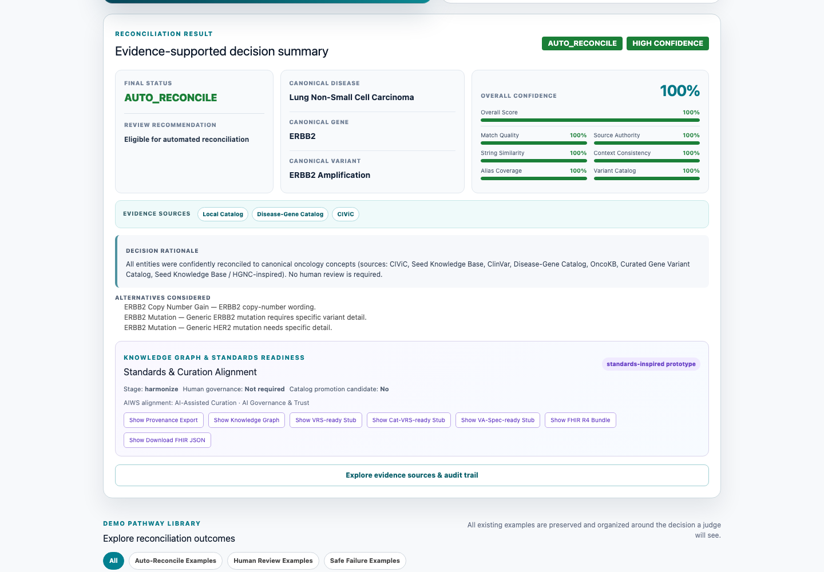
Figure 1. Single Record Reconciliation

Core Platform Capabilities

Reconciliation Engine
- Disease reconciliation
- Gene reconciliation
- Variant reconciliation
- Alias normalization
- Fuzzy matching
- Compound disease-gene-variant reasoning

Evidence Intelligence
- Local oncology catalogs
- MyVariant.info integration
- ClinVar integration
- CIViC integration
- ClinGen reference support

Explainable AI
- Confidence scores
- Audit trails
- Evidence packages
- Alternative candidate suggestions
- Provenance tracking

Human Governance
- Review queue
- Reviewer decisions
- Adjudication workflow
- Review reopening
- Governance metrics

Interoperability
- FHIR export
- OMOP export
- Knowledge graph export
- VRS-inspired structures
- Cat-VRS-inspired structures
- VA-Spec-inspired provenance

Analytics
- Evaluation dashboard
- Benchmark reporting
- Safety reporting
- Review metrics
- Data quality metrics

GUI Demonstration Workflow
The current frontend is organized into five judge-facing tabs:
GUI Tab | What Judges Can See
Single Record | Manual disease/gene/variant input, featured demo case, guided examples, canonical output, confidence score, evidence badges, decision rationale, alternatives, audit trail, and standards/export actions.
CSV Upload | Sample CSV, downloadable demo CSV, upload-and-reconcile workflow, batch status summary, and expandable result cards for each row.
Review Queue | Seeded review examples, pending/reviewed filters, curator ID, evidence/candidate indicators, approve/reject/edit/reopen actions, review history, and adjudication support.
Benchmark | Accuracy, coverage, review rate, total cases, status counts, evidence counts, review-decision counts, and benchmark-source explanation.
Evaluation | Visual KPI cards, status distribution, accuracy/coverage chart, review-rate chart, false auto-accept rate, evidence-source chart, reviewer agreement, review-decision chart, and failure breakdown.
This workflow directly supports the presentation score because the demo can move from a messy oncology input to a governed, explainable, benchmarked output without requiring judges to inspect code.

Technical Architecture
Clinical Data Sources
Genomic Data Sources
Laboratory Data Sources
|
v
Normalization Layer
|
v
Entity Resolution Layer
|
v
Evidence Retrieval
|
v
Confidence Engine
|
v
Governance Engine
|
v
Human Review
|
v
FHIR / OMOP Export
|
v
Analytics & AI Applications
The architecture separates deterministic normalization, evidence discovery, confidence assessment, governance, and export. This separation supports traceability and allows enterprise teams to integrate the platform into existing oncology data pipelines without making automated clinical decisions.

Data Collection & Curation Pipeline
Public Biomedical Sources
↓
Automated Collection Scripts
↓
Candidate Data
↓
Human Review / Curation
↓
Curated Knowledge Catalogs
↓
Benchmark Generation
↓
Reconciliation Engine
↓
Evaluation & Governance
The current governed pipeline includes:
- MyGene.info — gene alias collection and gene-symbol support through download_gene_aliases_from_mygene.py, producing raw_gene_alias_candidates.json and gene_aliases.json.
- CIViC — cancer-variant candidate collection through download_variant_candidates_from_civic_graphql.py, producing civic_variant_candidates.csv.
- Disease aliases — disease_aliases.json, the manually curated MVP disease-normalization knowledge base.
- Disease-gene catalog — disease_gene_catalog.csv, a curated/static source of disease-gene context.
- Gene-variant catalog — built through create_gene_variant_catalog.py, create_expanded_gene_variant_catalog.py, or create_curated_catalog_from_review.py, producing gene_variant_catalog.csv.
- Benchmark generation — generate_benchmark_cases_from_catalogs.py produces benchmark_cases.csv. The newer benchmark_v2.csv is the current benchmark and contains 500 cases.
Data Source | Purpose | Current Status
MyGene.info | Gene aliases | Integrated
CIViC | Variant candidates | Integrated
ClinVar | Evidence support | Integrated
MyVariant.info | Evidence retrieval | Integrated
HGNC | Gene nomenclature support | Curated / integrated
ClinGen Allele Registry | Variant reference support | Integrated
Internal Curated Catalogs | Production mappings | Active
Downloaded candidate data is not blindly promoted into production. Candidate aliases and variants are reviewed before becoming curated catalog entries. Ambiguous terms such as TRK should route to REVIEW_REQUIRED; unknown terms should route to CANNOT_RECONCILE.
The data-source roadmap includes NCIt, OncoTree, COSMIC, OncoKB, SEER, TCGA, AACR GENIE, GA4GH VRS, GA4GH Cat-VRS, GA4GH VA-Spec, FHIR Genomics, and OMOP Oncology. These are future expansion targets, not claims of current clinical validation or complete standards compliance.
This governed data pipeline demonstrates that OncoReconcile AI is building a reusable biomedical knowledge asset and data quality infrastructure, not just a one-off reconciliation demo.

Reviewer Governance Workflow
OncoReconcile AI is designed around three explicit outcomes:
Outcome | Meaning | Next Step
AUTO_RECONCILE | Evidence and confidence support an automatic canonical mapping | Result remains auditable and exportable
REVIEW_REQUIRED | A plausible mapping exists but ambiguity or evidence gaps remain | Route to a human reviewer
CANNOT_RECONCILE | Available evidence does not support a reliable candidate | Preserve uncertainty and request additional information
The governance workflow supports:
- Stable review-queue cases and duplicate prevention
- Reviewer approval, rejection, or canonical-value editing
- Reviewer notes and chronological decision history
- Reopening cases when new evidence becomes available
- Multi-reviewer agreement measurement
- Cohen’s kappa reporting
- Disagreement detection and senior-reviewer adjudication
- Auditable provenance for the final governed result
The governing principle is:
AI assists. Humans decide.
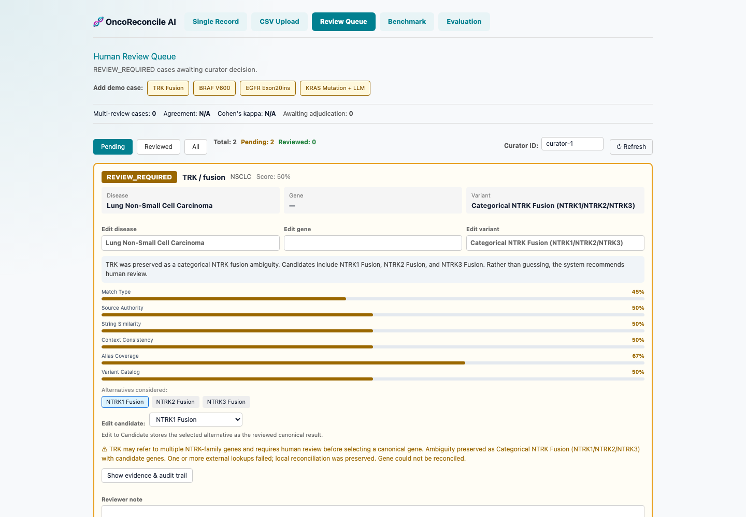
Figure 2. Human Review Queue

Validation & Quality
Current competition submission status:
Metric | Result
Backend Tests | 102 Passed
Benchmark | 500 Cases
Frontend Build | Passing
Evaluation Dashboard | Operational
Review Queue | Operational
Evidence Package | Operational
FHIR Export Prototype | Operational
OMOP Export Prototype | Operational
Knowledge Graph Export Prototype | Operational

Benchmark Evaluation Results
The benchmark framework supports alias normalization testing, ambiguous terminology testing, review-required scenarios, negative-control safety testing, and regression testing.
Evaluation Metric | Result
Disease Accuracy | 68.6%
Gene Accuracy | 96.6%
Variant Accuracy | 94.6%
Safety-Aware Status Accuracy | 89.8%
False Auto-Accept Rate | 0%
Negative Control Safety Rate | 100%
The 500-case benchmark intentionally includes difficult ambiguity scenarios. Disease accuracy remains the clearest improvement opportunity, while the 0% false auto-accept rate demonstrates the value of routing uncertainty into governed review instead of forcing unsafe mappings.
The benchmark intentionally includes ambiguous and negative-control cases to evaluate safety-aware reconciliation behavior, not only exact-match accuracy.

Evaluation Dashboard Evidence
The submission dashboard evidence below summarizes the current benchmark_v2.csv evaluation context and the validated Checkpoint 2 metrics.
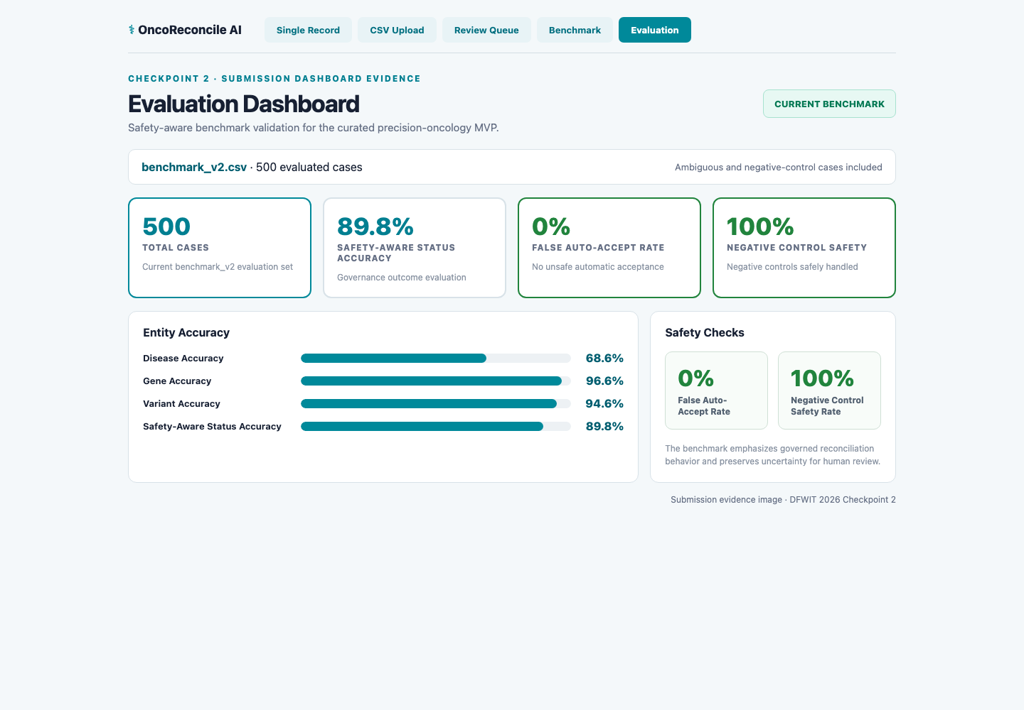
Figure 3. Evaluation Dashboard

FHIR Interoperability
The platform provides an operational FHIR R4 export prototype for downstream healthcare integration.
FHIR output can represent:
- Patient context using a non-identifying placeholder where required
- Oncology disease as a Condition
- Gene and variant findings as Observation resources
- Sequence context as MolecularSequence
- Consolidated output as a DiagnosticReport
- Reconciliation activity and lineage as Provenance
- Confidence and review status through transparent extensions
The export layer preserves source terminology and reconciliation metadata so an enterprise system can trace the standardized result back to the original input. It is intended as an interoperability bridge for genomics pipelines, EHR integration, analytics, and governed data exchange—not as clinical interpretation.

OMOP Interoperability
The platform provides an operational OMOP CDM v5.4-oriented export prototype for research and real-world evidence workflows.
OMOP output maps:
- Disease concepts to condition_occurrence
- Gene findings to measurement
- Variant findings to observation
- Known SNOMED and LOINC source codes to available OMOP standard concept identifiers
- Unresolved concepts to preserved source values for later vocabulary resolution
This structure supports cohort preparation, analytics, and integration with OMOP-based research environments while making vocabulary gaps explicit. A production deployment can connect the exporter to a complete OMOP vocabulary service for broader concept resolution.

Enterprise Platform Vision
OncoReconcile AI is designed to grow from a focused reconciliation application into an enterprise precision-oncology data quality platform.

Enterprise Data Quality Layer
The platform can sit between source systems and downstream applications:
EHR + Laboratory + Registry + Research Data
|
v
OncoReconcile Quality Layer
|
+------------+-------------+
| | |
v v v
FHIR/OMOP Analytics AI Applications
Enterprise capabilities can include:
- Batch and API-based reconciliation
- Organization-specific terminology catalogs
- Role-based reviewer workspaces
- Data-quality and governance dashboards
- Evidence and provenance APIs
- Auditable catalog-promotion workflows
- Multi-tenant or private enterprise deployment
- Integration with clinical, research, and analytics environments

Commercial Paths
Potential future offerings include:

Professional Services
- Oncology data harmonization
- FHIR implementation
- OMOP implementation
- Clinical genomics consulting

SaaS Platform
- Individual subscriptions
- Team subscriptions
- Enterprise deployments

Enterprise APIs
- Reconciliation API
- Evidence API
- Governance API
- FHIR Quality API
- Interoperability API

Patient Journey Analytics Vision
The same normalized disease, gene, variant, evidence, and governance data can support a future longitudinal patient-journey analytics layer.
Diagnosis
|
v
Biomarker Testing
|
v
Treatment
|
v
Response
|
v
Progression
|
v
Next Therapy
Planned patient-journey capabilities include:
- Diagnosis timelines
- Biomarker-testing timelines
- Treatment history
- Disease-progression tracking
- Outcome reporting
- Cohort-level pathway analysis
- Data-completeness and quality monitoring across the journey
This is an enterprise analytics vision, not a claim that the current platform provides treatment recommendations or autonomous clinical decision support.

Innovation

Human-Governed AI
Rather than forcing automatic decisions, uncertain cases are escalated to human reviewers.

Explainable Reconciliation
Every recommendation includes:
- Evidence
- Confidence score
- Audit trail
- Provenance

Governance-First Design
The platform prioritizes transparency, reproducibility, and trust.

Biomedical Specialization
Unlike general-purpose entity-resolution systems, OncoReconcile AI is purpose-built for precision-oncology workflows.

User Experience & Product Quality
The Checkpoint 2 GUI is designed to make the system understandable in a short live demo:
- The Single Record tab includes curated example pathways for AUTO_RECONCILE, REVIEW_REQUIRED, and CANNOT_RECONCILE.
- The result view separates canonical output, confidence, evidence, decision rationale, audit trail, alternatives, and standards/export actions.
- The CSV Upload tab demonstrates a repeatable batch workflow using the same reconciliation engine.
- The Review Queue tab shows how uncertain records become human-governed decisions instead of silent automated guesses.
- The Benchmark and Evaluation tabs make quality, safety, and remaining gaps visible through metrics and charts.

Team Differentiation
Team Variant Vanguard combines experience in precision oncology, clinical genomics, biomedical data engineering, healthcare interoperability, OMOP/FHIR-oriented data modeling, and AI-assisted data quality workflows. This domain background shaped the project’s focus on governed reconciliation, explainability, evidence, and auditability rather than black-box automation.

Expert Feedback & Customer Discovery
Early feedback from precision oncology and standards-oriented discussions highlighted several needs: reducing interpretation bottlenecks, preserving provenance, supporting human review, and aligning reconciliation outputs with emerging interoperability standards. This feedback informed the platform’s emphasis on human governance, evidence packages, benchmark evaluation, and standards-aligned exports.
This feedback is formative and does not represent formal clinical validation.

Target Users
User Type | Example Use Cases
Cancer Centers | Data harmonization
Molecular Laboratories | Variant normalization
Pharmaceutical Companies | Biomarker analytics
Clinical Researchers | Cohort generation
Healthcare AI Teams | AI-ready datasets
Healthcare Data Platforms | Interoperability

Business Opportunity
Precision oncology generates growing volumes of clinical and genomic information, while healthcare organizations face pressure to improve data quality, reduce manual curation, support AI initiatives, and exchange data through standards-based interfaces.
OncoReconcile AI addresses this market as a biomedical data quality layer rather than a standalone terminology lookup tool. Its combination of reconciliation, evidence, governance, interoperability, and benchmark-driven validation creates a path toward enterprise services, SaaS deployment, and API licensing.

Demonstration Assets
The Checkpoint 2 demonstration includes:
- Single Record Reconciliation tab
- CSV Upload tab
- Human Review Queue tab
- Benchmark tab
- Evaluation Dashboard tab
- Evidence package and audit-trail display
- Provenance export
- Knowledge graph export
- FHIR export prototype
- OMOP export prototype
Suggested live demo order:
- Run the featured single-record demo and explain evidence, confidence, and review status.
- Open detailed evidence to show local evidence, live external evidence, safe API error handling, governance evidence, and audit trail.
- Use the standards/export buttons to show provenance, knowledge graph, VRS-ready, Cat-VRS-ready, VA-Spec-ready, and FHIR JSON outputs.
- Upload or use the sample CSV to show repeatable batch reconciliation.
- Seed and review an ambiguous case in the Human Review Queue.
- Close with Benchmark and Evaluation dashboards to show measured quality, safety-aware status accuracy, and false auto-accept rate.

Social Impact
Higher-quality oncology data can support:
- Better clinical research
- Safer healthcare AI
- Improved biomarker analytics
- Faster cohort discovery
- Greater interoperability
The platform promotes trustworthy AI by ensuring uncertain recommendations receive human review.

Long-Term Vision
OncoReconcile AI aims to become the biomedical data quality and interoperability layer for precision oncology.
Future directions include:
- Multi-cancer support
- Enterprise APIs
- Biomedical knowledge graphs
- AI-assisted curation
- Clinical trial harmonization
- Patient journey analytics
- Precision oncology intelligence platforms

Repository & Resources
All links in this PDF-export version are absolute and point to the startup-platform submission branch.
Resource | URL
Repository | https://github.com/oncoreconcile-ai/oncoreconcile-ai/tree/startup-platform
README | https://github.com/oncoreconcile-ai/oncoreconcile-ai/blob/startup-platform/README.md
Primary Submission | https://github.com/oncoreconcile-ai/oncoreconcile-ai/blob/startup-platform/docs/DFWIT_Checkpoint2_Primary_Submission.md
Startup Platform Overview | https://github.com/oncoreconcile-ai/oncoreconcile-ai/blob/startup-platform/docs/startup_platform_overview.md
Architecture | https://github.com/oncoreconcile-ai/oncoreconcile-ai/blob/startup-platform/docs/architecture.md
Architecture Diagrams | https://github.com/oncoreconcile-ai/oncoreconcile-ai/blob/startup-platform/docs/architecture_diagrams.md
Commercial Strategy | https://github.com/oncoreconcile-ai/oncoreconcile-ai/blob/startup-platform/docs/commercial_strategy.md
Roadmap | https://github.com/oncoreconcile-ai/oncoreconcile-ai/blob/startup-platform/docs/roadmap.md
Curation Methodology | https://github.com/oncoreconcile-ai/oncoreconcile-ai/blob/startup-platform/docs/curation_methodology.md
Expert Feedback Summary | https://github.com/oncoreconcile-ai/oncoreconcile-ai/blob/startup-platform/docs/expert_feedback_summary.md

Repository and Branch Information
Organization: oncoreconcile-ai
Repository: oncoreconcile-ai
Submission branch: startup-platform
Branch URL: https://github.com/oncoreconcile-ai/oncoreconcile-ai/tree/startup-platform

Disclaimer
OncoReconcile AI is a biomedical data harmonization and governance platform.
It is not a clinical decision support system and does not provide diagnosis, treatment recommendations, or medical advice.

