Wiring the Raspberry Pi and LEDs

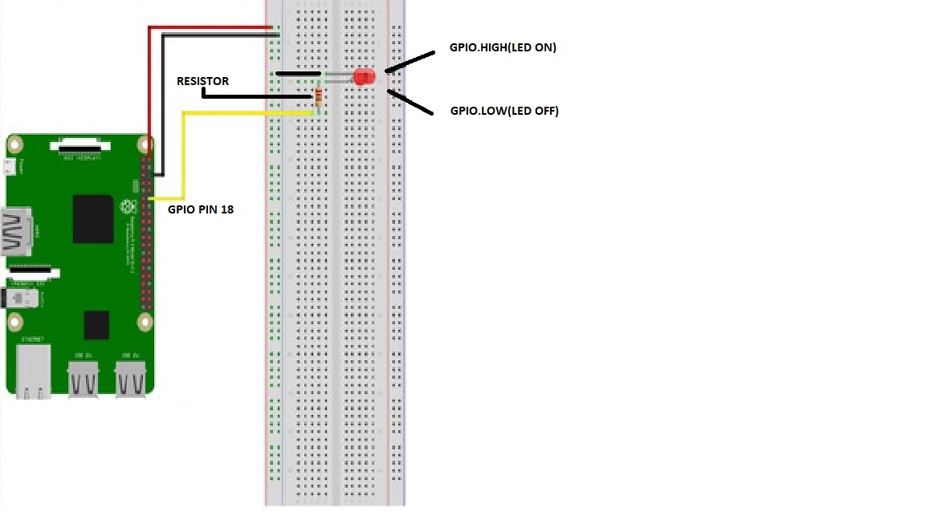  
  
I haven't tried on real HW, so I decided to show the wiring to GPIO pin 18, using a 220ohm resistor, according to the ready-made projects I found.  
When controlling the GPIO, the HIGH mode LED is on and the LOW mode LED is off. I used python language to design the Raspberry Pi GPIO control (RSPi_LED_BLINK.py, RSPi_LED_ON_OFF.py).  
  
Using Virtualbox I installed the official Raspberry Pi OS.  
  
I tried to set up the webserver for the first time, I installed apache into the Raspberry OS(not finished yet). I made only a basic html page (RSPi_LED_page.html) without control options, also first experience.  
  
Translated with www.DeepL.com/Translator (free version)