MPC-MAP Assignment No. 4 - Report

Author: Ondřej Březina

Date: 13.4.2026

Task 1
The pose prediction algorithm was implemented using a probabilistic kinematic model of a differential drive system. Gaussian noise was added to the wheel speeds to accurately reflect the inherent uncertainties and drift of real-world odometry.

Task 2
Simulated distance measurements for each particle were acquired using the ray_cast function. A normal distribution model was applied to evaluate the sensory data and calculate the weight of every particle. Following this evaluation, all weights were normalized.

Task 3
The Low Variance Systematic Resampling algorithm was implemented to select next generation of particles. To mitigate the issue of particle degeneracy and impoverishment, Gaussian noise was applied to the cloned particles. Furthermore, a percentage of completely random particles was injected during this phase to maintain global map coverage and counter robot kidnapping.

Task 4
The robot initially performs rotational movements to gather distinct environmental features and establish a localized position. After this initial period, it begins navigating the map using its estimated pose.

Successful navigation to the goal is dependent on optimal convergence of the particles.
The major challenge encountered during this assignment was calibrating these probabilistic parameters (such as sigma for weights , resample noise, prediction noise and the random particle injection rate) to ensure the system could recover from kidnapped robot scenarios and successfully drive to the end.

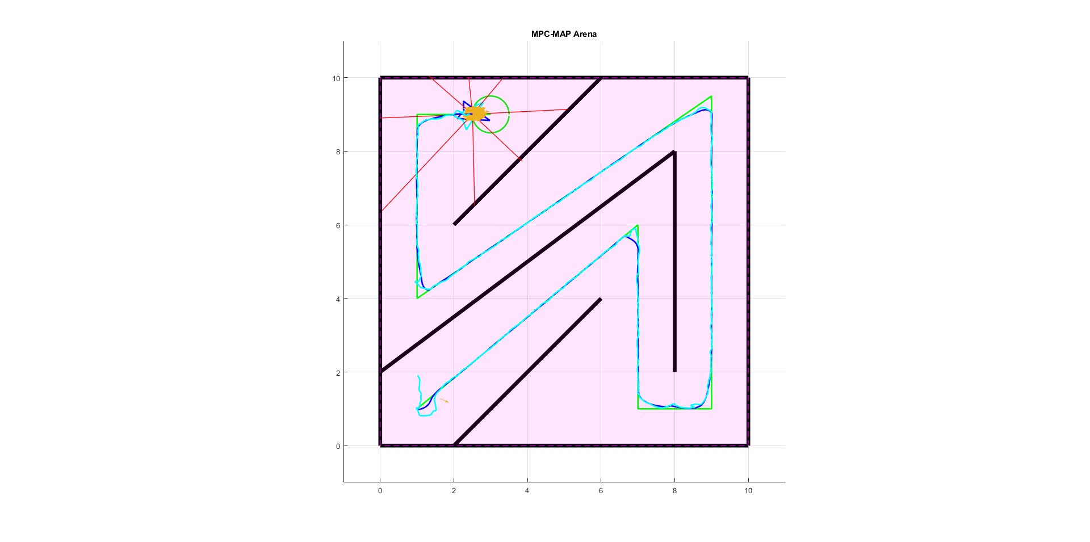
Figure 1 - Succesful run

