MPC-MAP Assignment No. 5 - Report

Author: Ondřej Březina

Date: 20.4.2026

Task 1
An initialization phase was implemented to examine the uncertainty of the GNSS sensor. During this phase, the robot remains stationary while a buffer of GNSS data (approximately 30 samples) is collected to ensure a stable and statistically significant measurement set.
Then the init_kalman_filter function is executed. This procedure calculates the sample mean and the covariance matrix (cov) from the gathered data. The calculated mean serves as the initial state estimate ($\mu$), while the covariance matrix is utilized to construct the measurement noise matrix ($Q$). After the noise matrices are successfully initialized and the starting belief is established, a kf_enabled flag is set to true, allowing the algorithm to proceed to the EKF prediction and correction cycles.

Task 2
In this task, the Extended Kalman Filter (EKF) was implemented for the prediction step, alongside the standard Kalman Filter (KF) for the correction/measurement phase.

Task 3
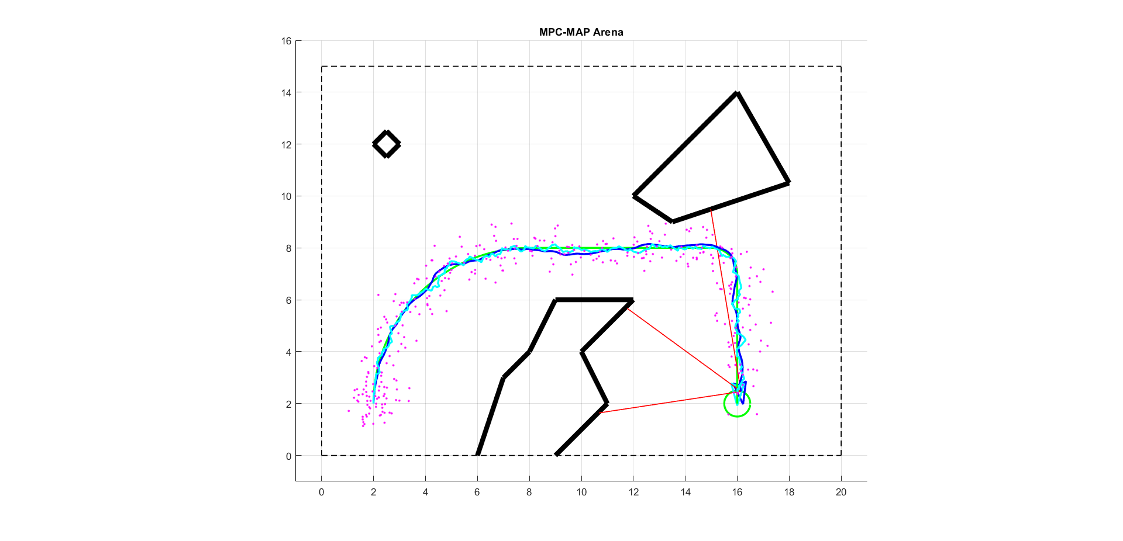
For this task, the initial pose was explicitly set to [2, 2, \pi/2] with a zero covariance matrix, reflecting absolute certainty in the starting position. Throughout the run, the robot relied entirely on the EKF-estimated pose for control and navigation. The measurement noise matrix Q was assembled using the previously calculated GNSS covariance. To achieve optimal tracking performance, the process noise matrix R was tuned. Starting from an initial variance estimate of 0.01, the values were reduced down to 0.001.
Figure 1 - Succesful run with known position

Task 4

For the final deployment, the true initial pose was assumed unknown to the filter (physically set to [4, 2, -pi/4] in the simulation). To determine the initial belief, the procedure from Task 1 was utilized by collecting a static buffer of 50 GNSS samples.
Since GNSS cannot directly measure orientation, the initial heading was assigned a high variance of 2 pi
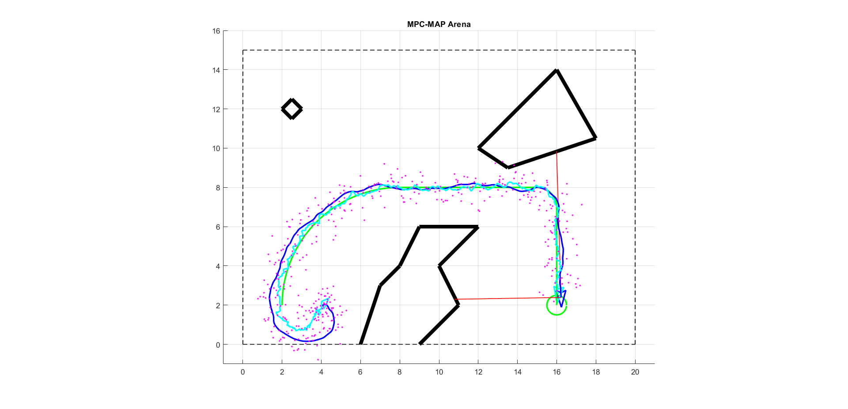
During the run, it was observed that the EKF successfully compensated for the unknown initial heading. As the robot began to move, the prediction and correction cycles allowed the estimated pose to rapidly converge to the true pose values, proving that orientation can be accurately estimated indirectly.
Figure 2 - Succesful run with unknown position

