MPC-MAP Assignment No. 1 - Report

Author: Ondřej Březina

Date: 29.3.2026

Task 2
A custom outdoor map was created to position the static robot so that its 8-channel LiDAR faced obstacles at specific, varying distances (1, 2, 3, 4, 1, 6, 10, and 8). Measurement data was then collected over 500 simulation periods to calculate the standard deviation (std) for both the LiDAR and the GNSS receiver.

- LiDAR: Despite the varying distances to the obstacles, the std values remained consistent across all 8 individual channels.
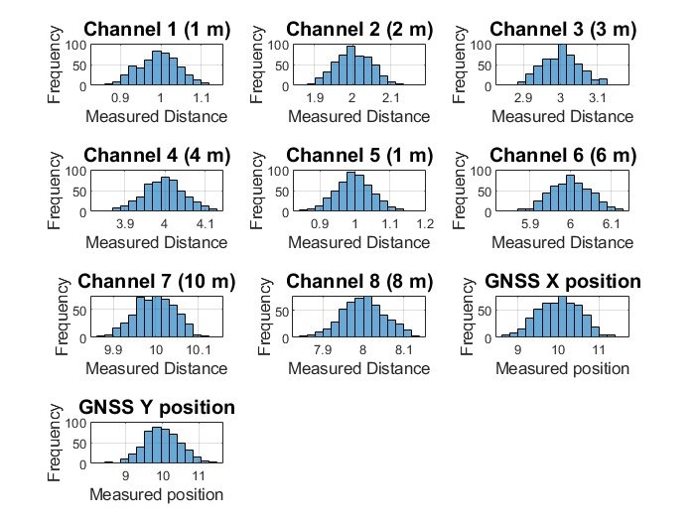
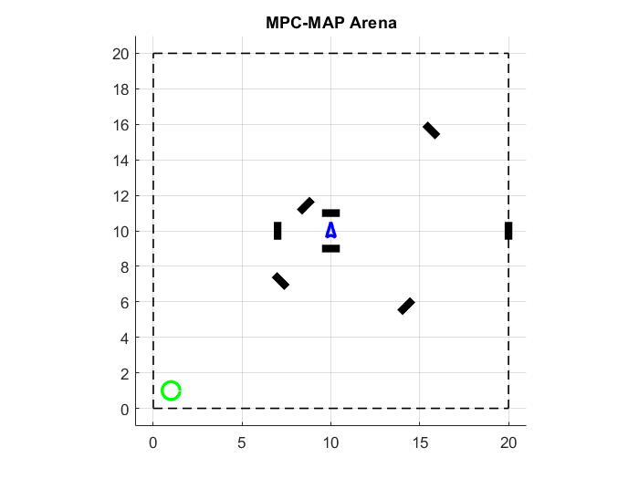
- GNSS: The std values for both the X and Y axes were practically identical.
Figure 1 Task 2 histograms
Figure 2 Custom map for tasks 2-4

Task 3
The resultant matrices were verified to be 8x8 for the LiDAR and 2x2 for the GNSS.
- Diagonal Values: The values on the main diagonals of both matrices perfectly match the squared standard deviations (variance = std^2) calculated in Task 2.
- Off-Diagonal Values: The off-diagonal elements approach zero, indicating that the measurement noise is independent and uncorrelated across individual LiDAR channels and GNSS axes.

Task 4
A custom norm_pdf function was implemented to calculate the probability density function of a normal distribution. Using the standard deviations obtained in Task 2 for the 1st LiDAR channel and the GNSS X-axis, two PDFs were generated with the mean set to zero.
The resulting plot visually compares the noise profiles of both sensors on a single axis.

- The LiDAR PDF exhibits a significantly narrower and taller peak compared to the wider GNSS curve. This clearly illustrates that the LiDAR sensor is more precise and has a lower measurement uncertainty than the GNSS receiver.
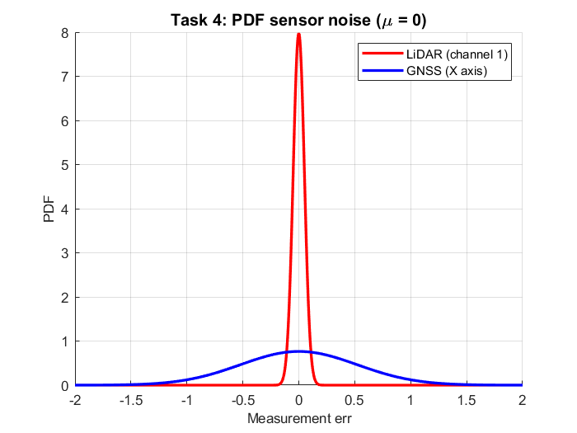
Figure 3 PDF

TASK 5

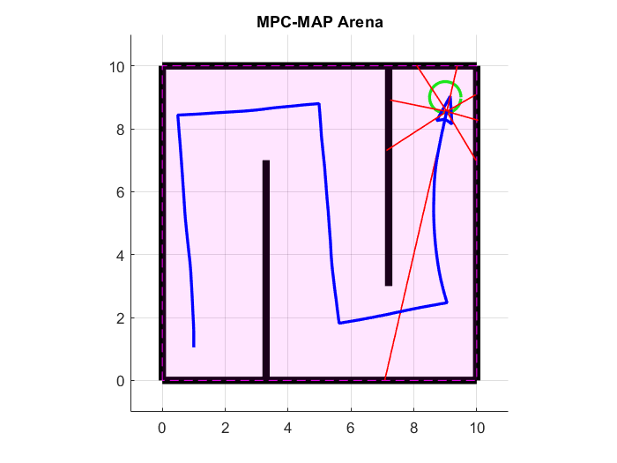
Potential sources of uncertainty in the robot's motion can be caused by odometry drift, wheel slippage, uneven surfaces, and poor wheel speed control (where the wheel does not spin exactly as commanded). Because these mechanical and environmental errors accumulate over time without sensor correction, the actual trajectory will increasingly diverge from the planned path
Figure 4 Successful completion of the indoor 1 map

