MPC-MAP Assignment No. 6 - Report

Author: Ondřej Březina

Date: 27.4.2026

Task 1
The A* algorithm was implemented to find the optimal path from the robot's estimated position to the target goal on a discrete map if path exists.

Diagonal Corner-cutting safety logic was implemented by checking orthogonal adjacent cells, ensuring the robot does not attempt diagonal moves between two intersecting obstacles.

Task 2
To prevent physical collisions, walls were inflated by definable variable using convolution kernel, forcing the A* algorithm to plan paths that maintain a safe geometric distance from the actual walls

Task 3
Iterative smoothing algorithm provided in the lecture was implemented.

A higher value of alpha heavily penalizes deviations from the original path coordinates, ensuring that the smoothed trajectory respects the path.

A higher value of beta acts like a string, rounding off sharp corners and producing a continuous, smooth curve
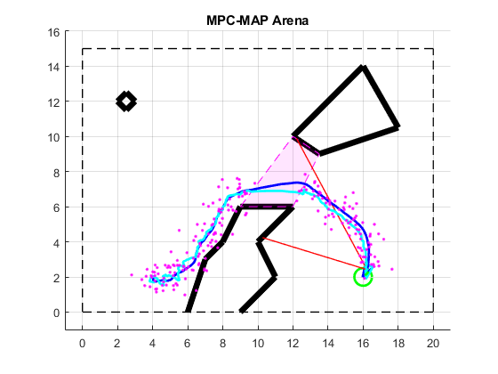
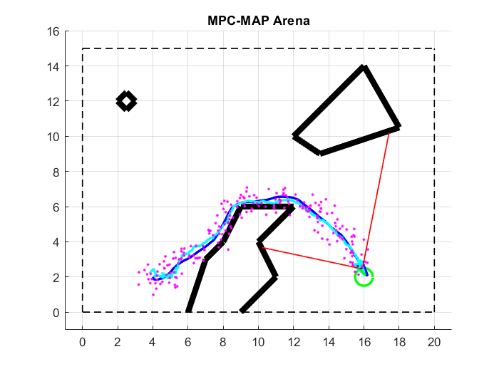
Figure 2 - Succesful run before inflated walls and smoothing algorithm
Figure 2 – Succesful run after inflated walls and smoothing algorithm

