Přidat screenshots z Resource group

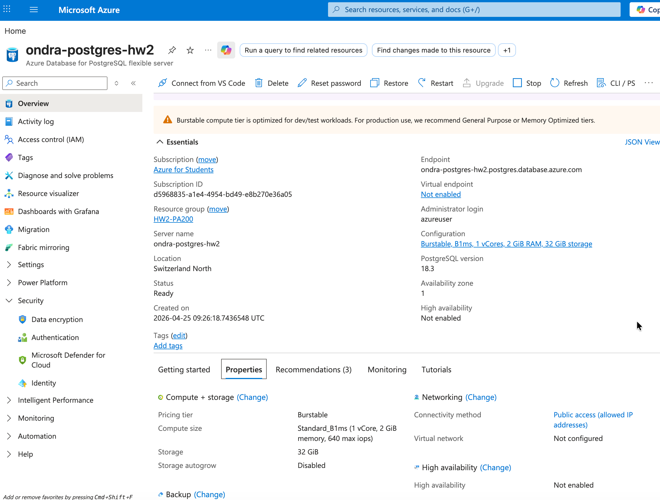
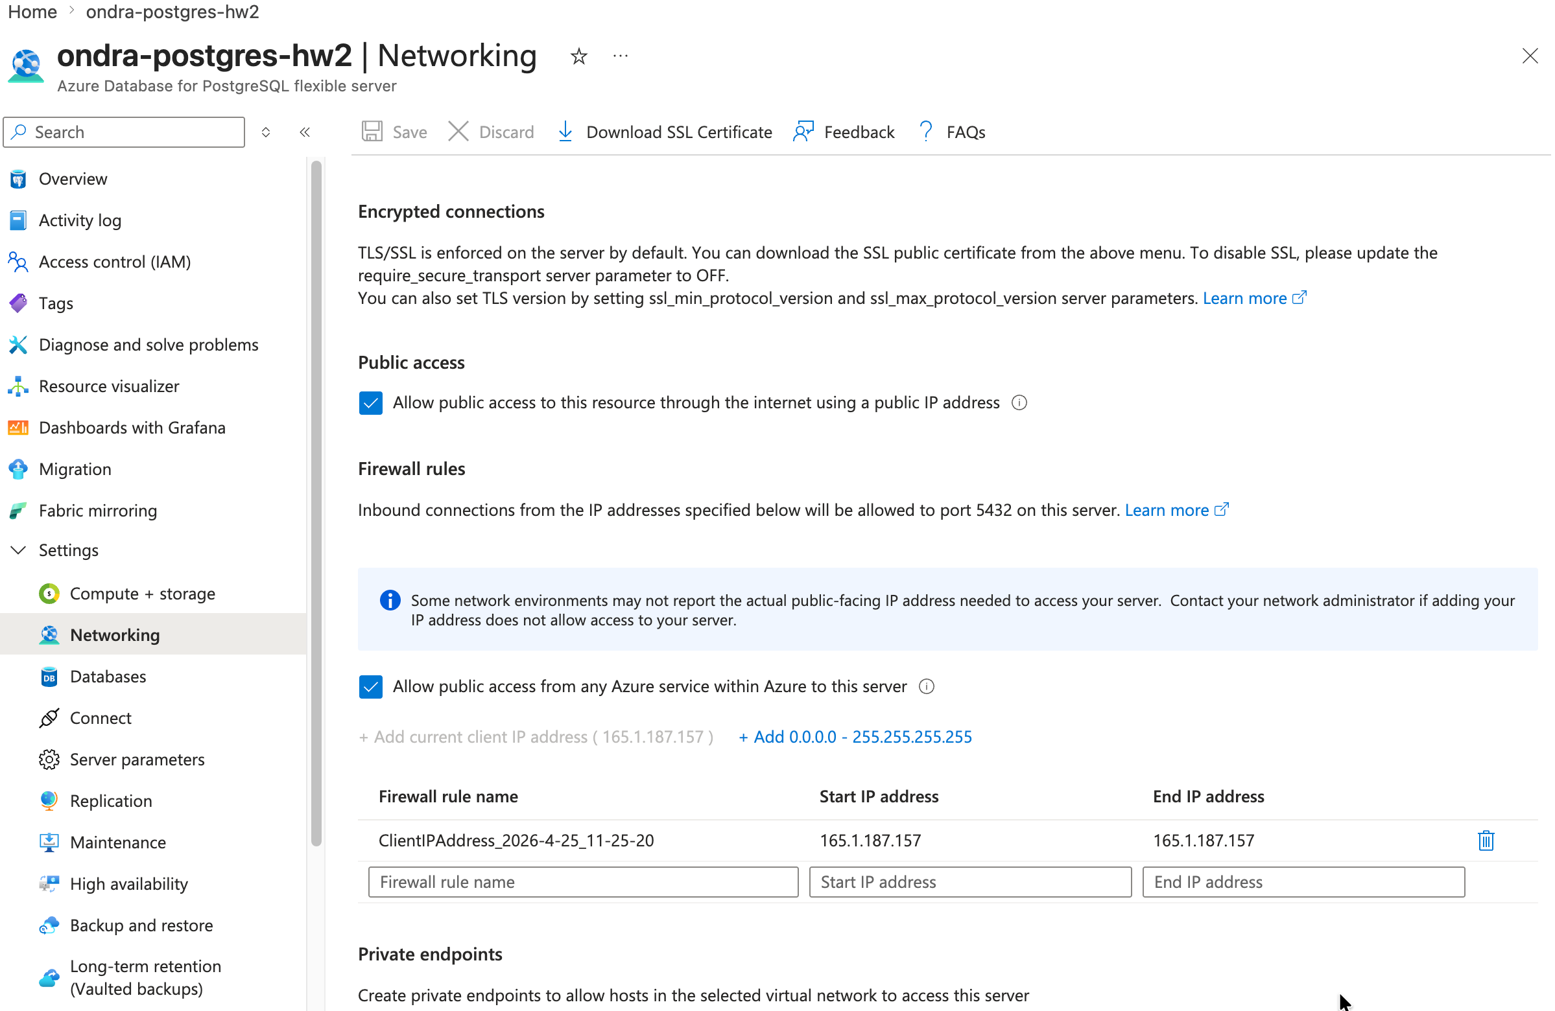
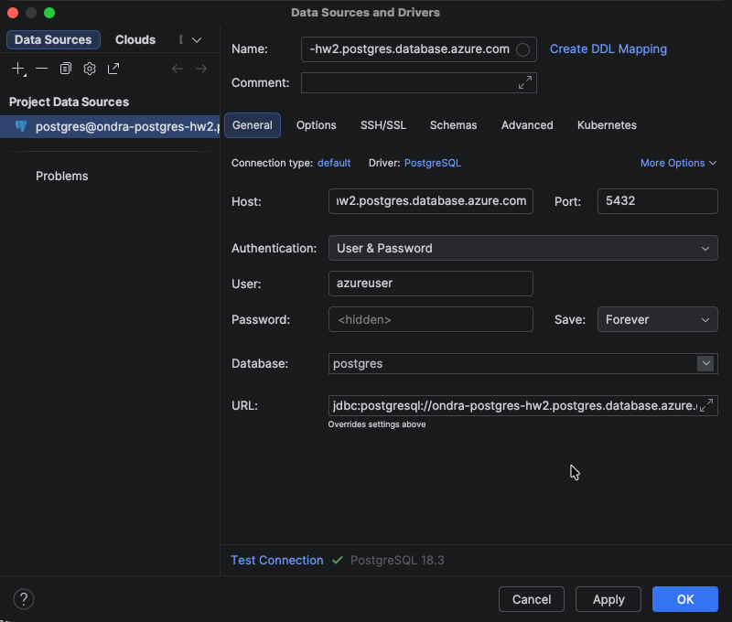

Vytvořil jsem App Service Plan na kterým poběží moje Web App:
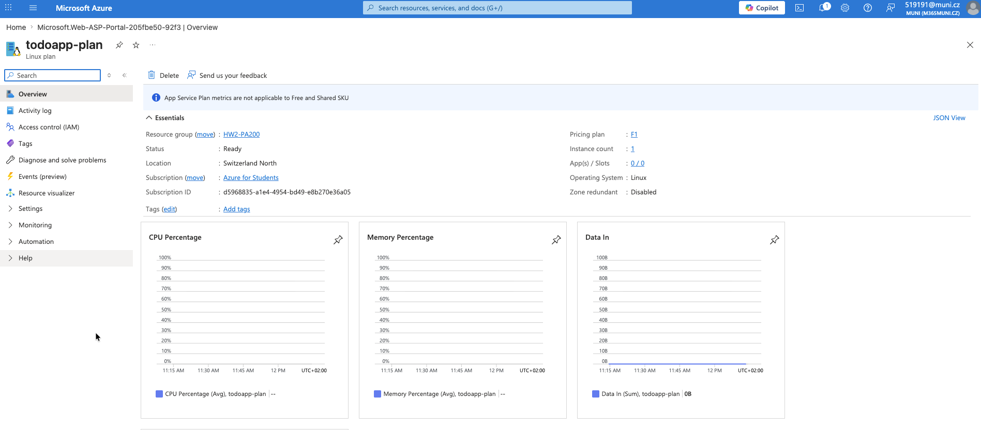

Vytvořil jsem Web App, pro moji aplikaci:
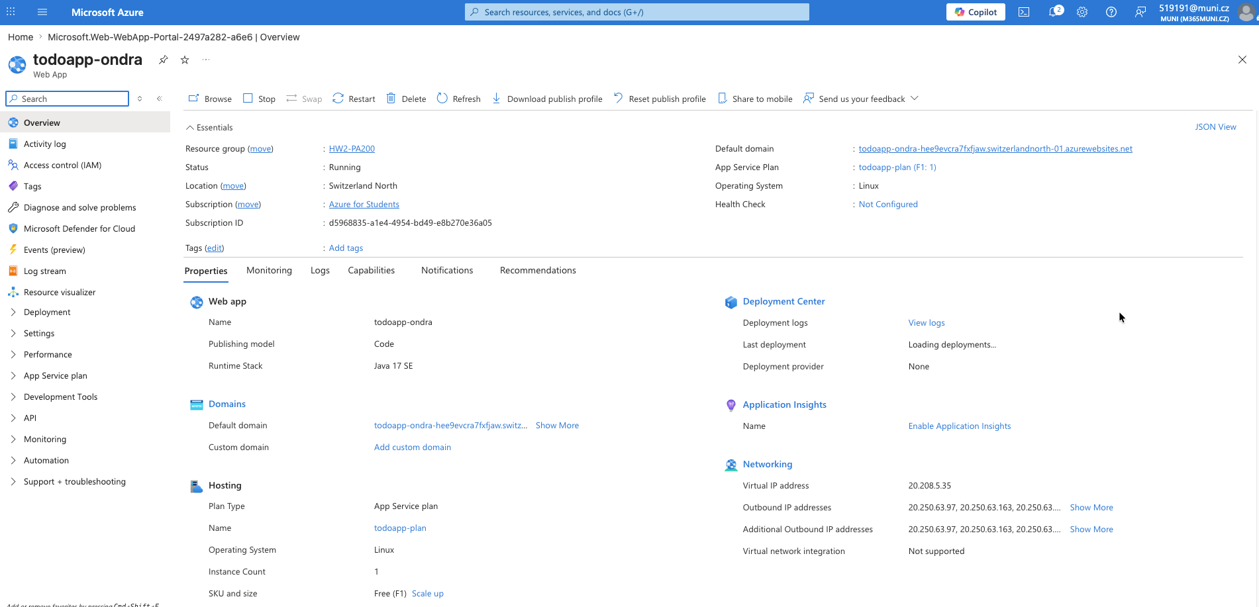

I set the credentials and URL to the database into the Web App:
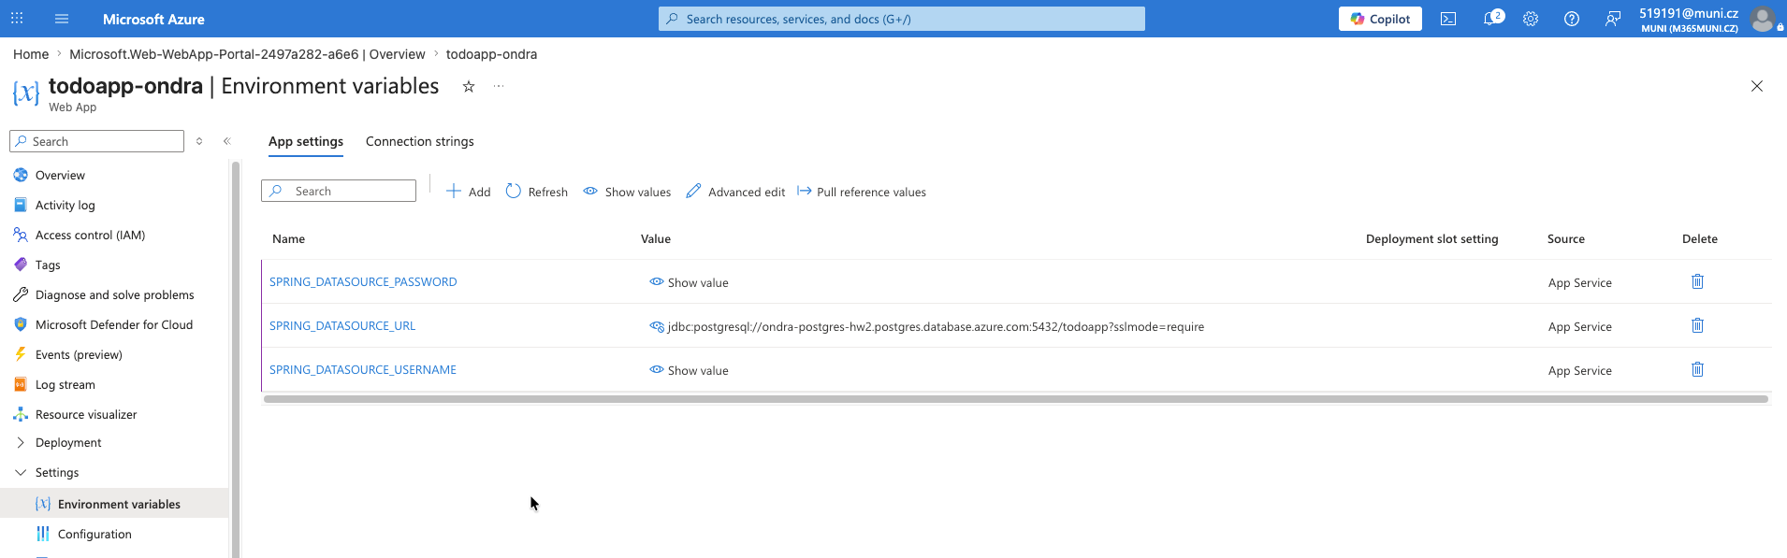

I made sure that „Allow public access from any Azure service within Azure to this server” is enabled in my PostgreSQL Flexible Server resource:
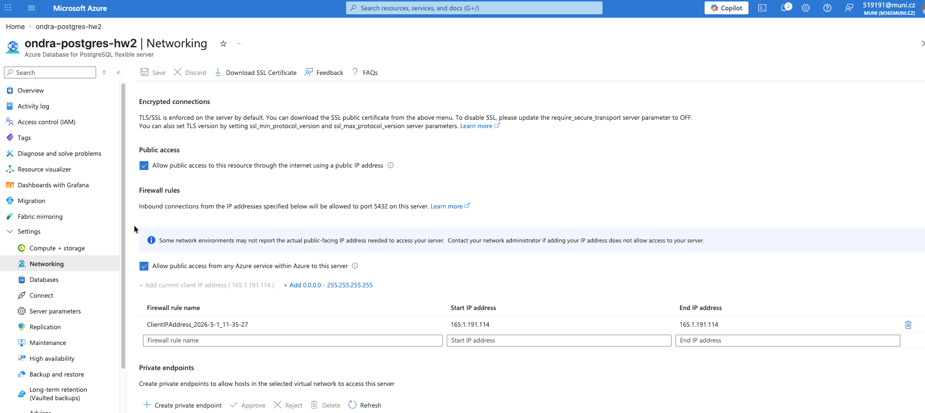

I deployed the application to my web app using az CLI command:
az webapp deploy --resource-group HW2-PA200 --name todoapp-ondra —src-path target/todoapp-1.0-SNAPSHOT.jar --type jar
And the application is now running on domain:
https://todoapp-ondra-hee9evcra7fxfjaw.switzerlandnorth-01.azurewebsites.net/
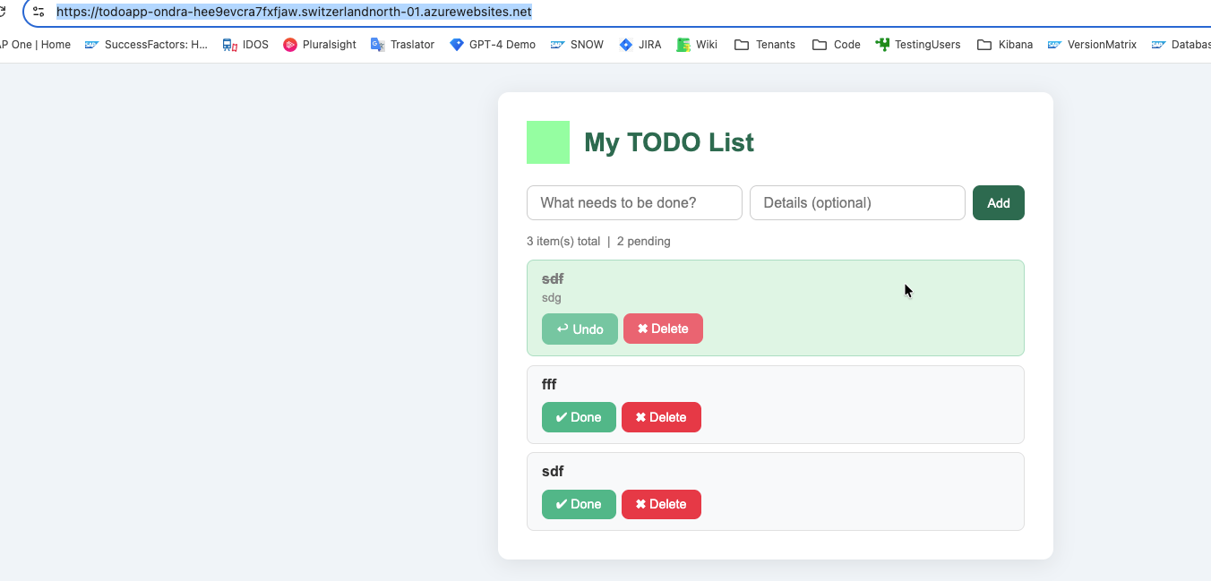

Task 3
I created a storage account:
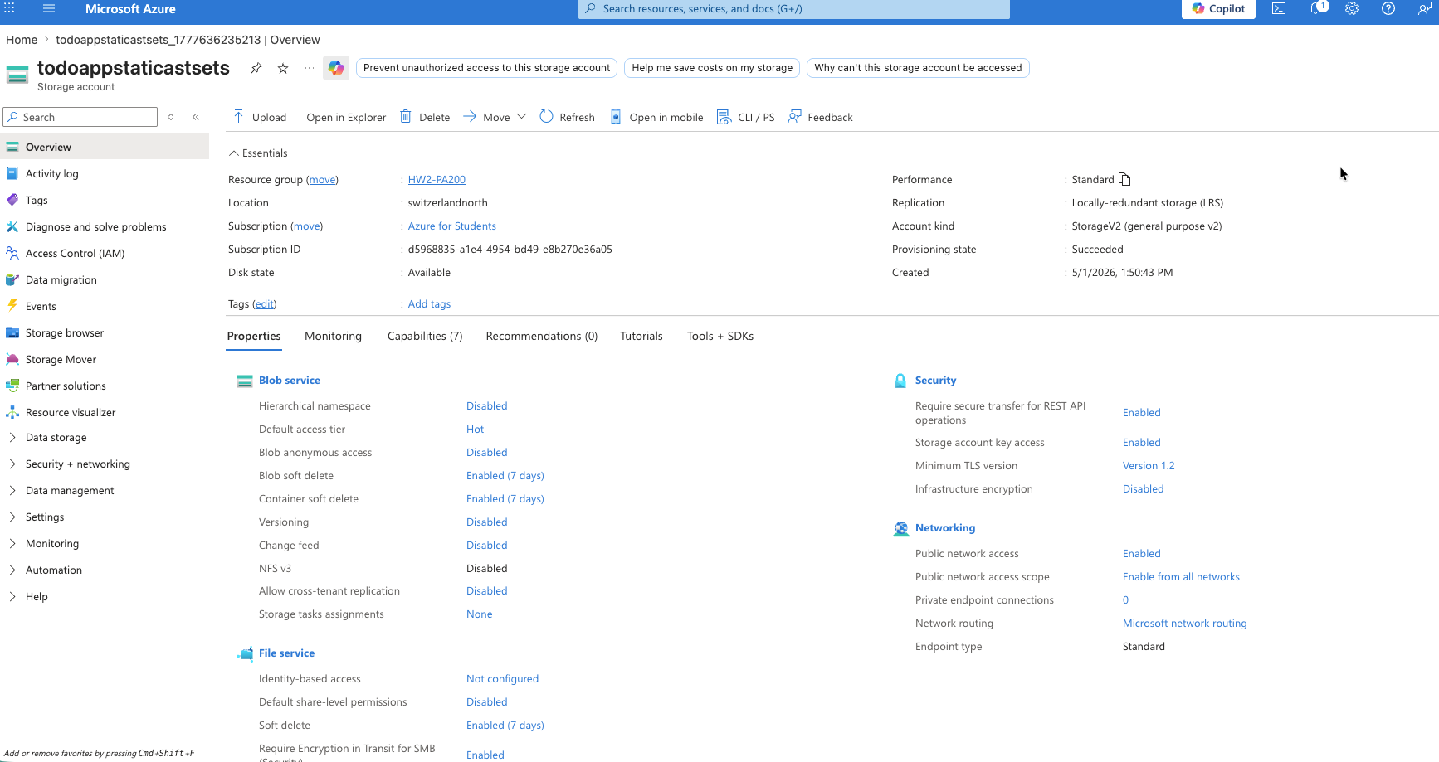
I enabled in Storage account the Blob Anonymous access:
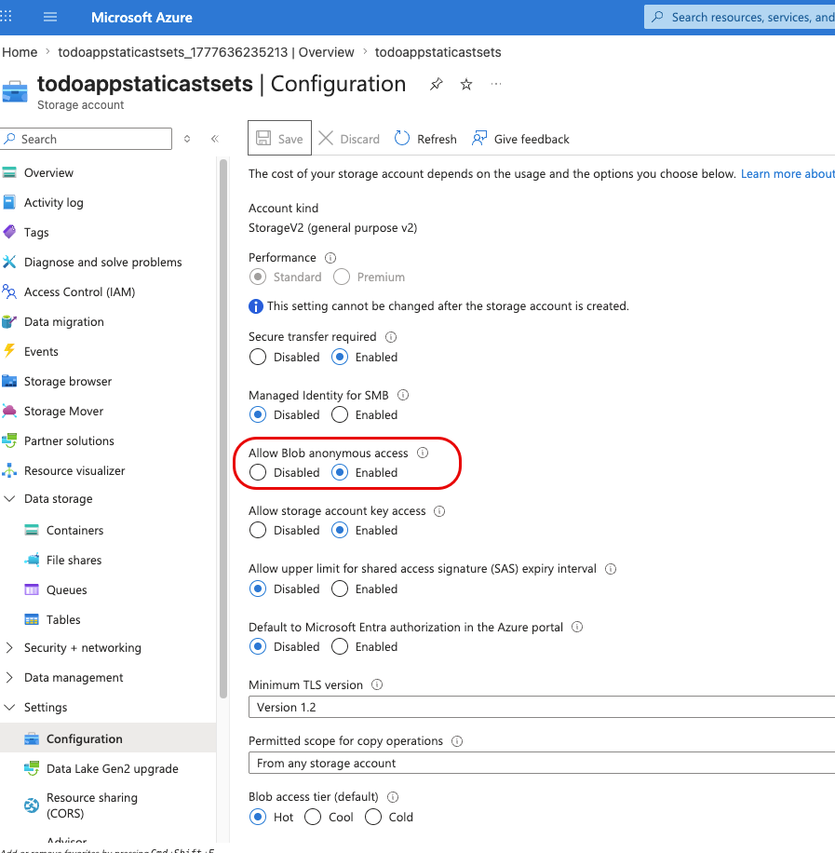
I created a blob container inside Storage account with public access level „Blob (anonymous read access for blobs only)“:
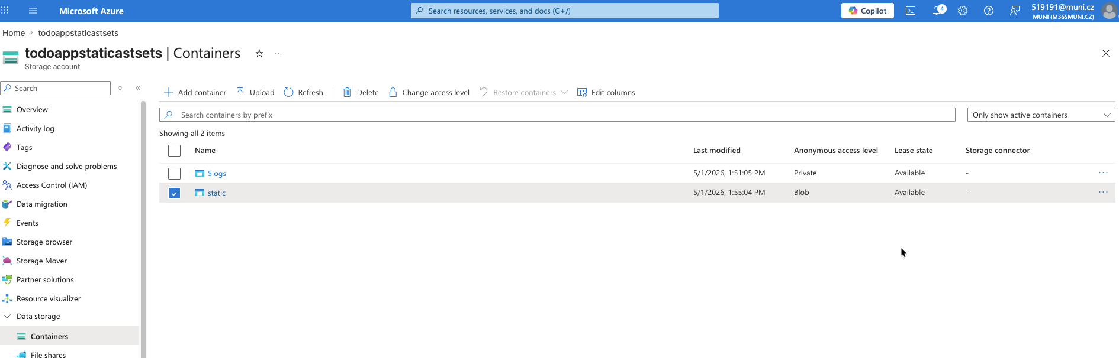

I uploaded static file into the new container into specific folders:
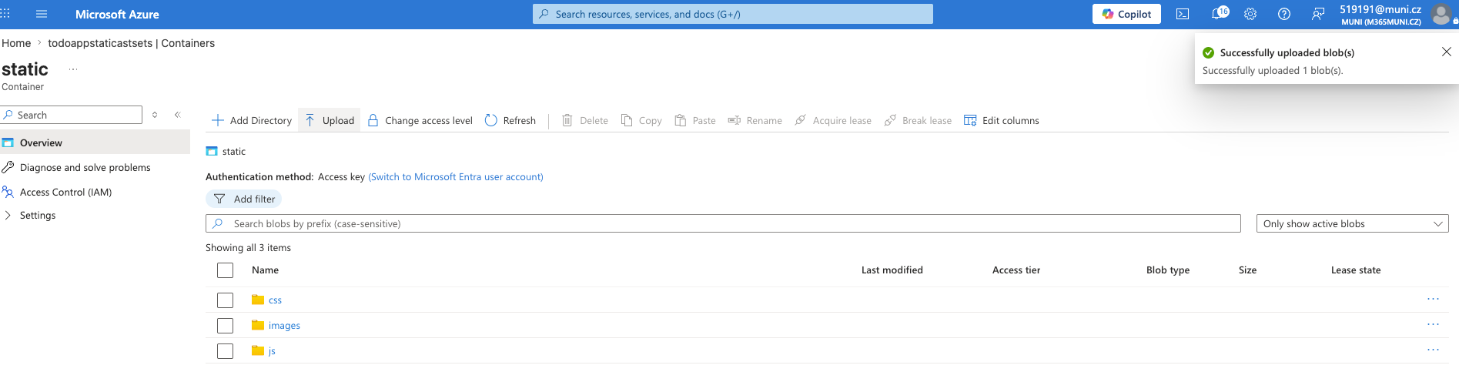

I set the environment variable AZURE_STORAGE_CDN_BASE_URL in the App service:
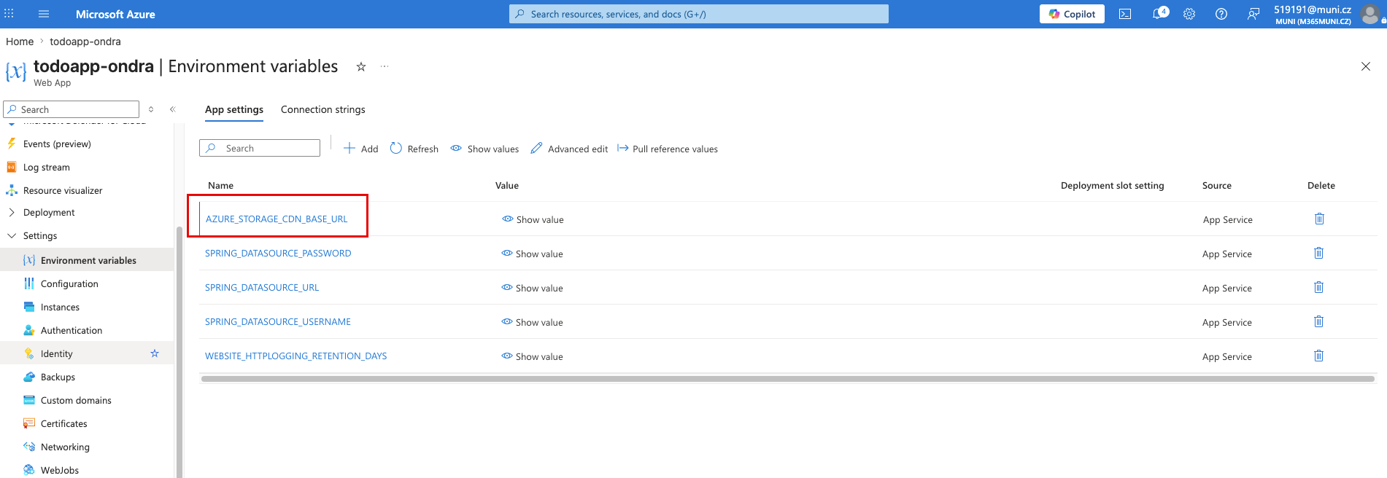

Then I made a changes in the code so it use the static files from the Blob Storage URL and redeployed the application.
After redoploying the app and opening it with development console, I can see that the static files are loaded from blob.core.windows.net:
