Emotional Stability Learning Project

1.Introduction
The Emotional Stability Learning project is based on teaching cognitive schemes (thinking algorithms) that lead to emotional stability. The aim of the project is to enable the learners to understand and train the selected cognitive schemes by means of practical exercises. Expectation is that this will help them to build, improve or refine their own philosophical insights - emotionally stable cognitive schemes. Consistent usage of a correct personal philosophy can lead to complete emotional stability.

2.Biological Justification of the Project
At the biological level, non-zero emotions (both negative and positive) are generated by activation of the emotional centers in the central part of the brain, so-called limbic system. An example may be the center of fear - amygdala - if a nerve signal arrives and the amygdala is activated, we feel fear.
Neuroplasticity is a well-known and accepted phenomenon, meaning the ability of neurons to change their synapses as a consequence of the thinking process. Synapses can be created, disappear or change their strength.
The used cognitive schemes (thinking algorithms) have fundamental impact on the topology of neuronal paths around emotional centers, thus the resulting emotions and emotional stability.

An example of a neural network and the location of the fear center (amygdala):

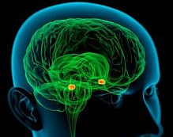

3.Model of Neural Network with Emotions
For the emotional stability learning we use the following model of a neural network with emotions:

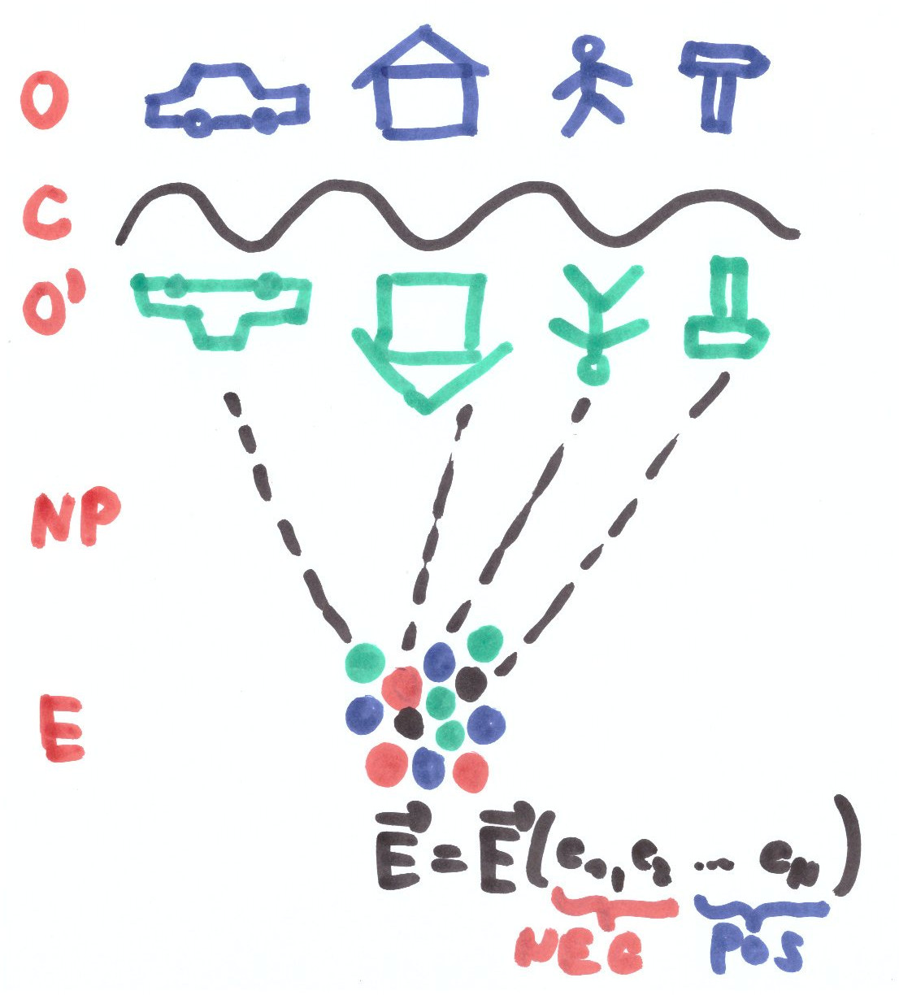

O = objects of the external world – for example personal relations, work, living, property
C = brain cortex
O‘= objects of the internal world, meaning the objects of the external world mirrored into the neural activity and connections in the brain cortex
NP = neuron paths connecting the object of the internal world with the emotional centers, these paths determine what will be the result emotional vector for given status of objects O‘
E = emotional centers
vector E = the emotional vector, its components are the values of individual types of emotions, for example concentration of the stress hormones for the component „stress“. Emotional vector has got NEGative and POSitive components.

4.Time Graphs of the Negative Emotion
Example graphs of negative emotion value over time:
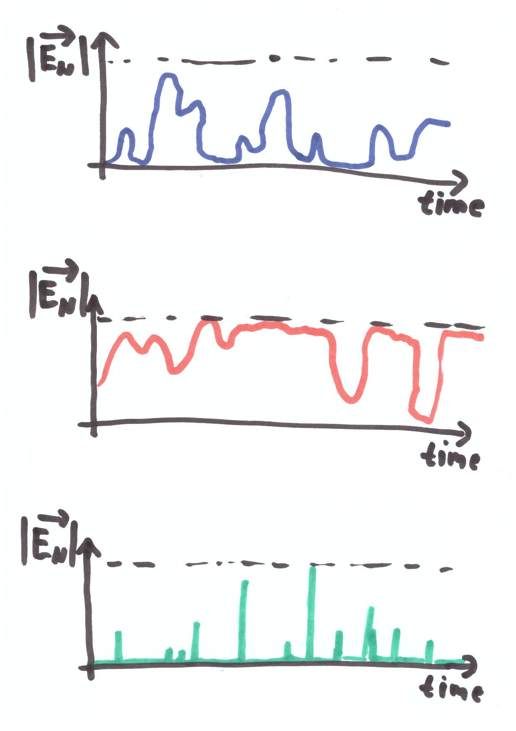

Emotional Instability

Extreme Emotional Instability

Emotional Stability

Description of the graphs:
1) In the case of emotional instability the value of negative components of the emotion (size of the vector En) is frequently non-zero.
2) In the case of extreme emotional instability as for example attack of mental illness, the value of negative components of the emotion is permanently non-zero and is not returning to zero (state of contentment).
3) In the case of emotional stability after deviation from zero, negative emotions very quickly return to zero. The more intensive, exact and fast is the thinking aligned with one of the „emotionally stable cognitive schema“, the smaller is the area below graph (integral of the vector En graph).

5.The Cognitive Schemes in Learning

5.1 The Inversion of Emotion
According to the rule „everything bad is good for something“ (a blessing in disguise) for every not-solvable problem we are searching what it can be good for. Such possibility always exists, because every problem has lot of surrounding context, part of which can (due to the unlimited neuroplasticity) connect to the positive emotional centers. Thus it is always possible to create new association between the original unsolvable problem and related context bound to the positive emotions.

5.2 The Subjectivity Principle
Due to the neuroplasticity, it is a general natural law that every problem is either solvable (there are neural paths in cortex representing solution, or such paths can be found) or the problem is important only seemingly (the neural paths towards emotional centers can disconnect, so the person has got the capability to stay completely content and happy even if ignoring the problem).
This pattern is called subjectivity principle and has exact mathematical validity even in extreme situations like close to one‘s death or in case of lost capability to solve any problems.

5.3 Faith in God
It is possible to understand every not-solvable problem as the will of God – an entity whose existence is not possible to disprove by any way.
Such thinking schema leads to very efficient disconnections of neural paths towards emotional centers and thus results into unlimited emotional stability.

5.4 The Acceptance and Cancelling of Problems
The importance of every not-solvable problem is possible to eliminate by the RUS method (link here: https://www.metodarus.cz/en/) or by accepting the problem as presented for example. by therapist Jan Havelka (video in Czech here). Both methods again work at the biological level by eliminating neural paths between brain cortex and emotional centers.

6.Common Attributes of the Cognitive Schemes
The cognitive schemes leading to the emotional stability have some common attributes:
- the basis for each cognitive schema is to solve solvable problems, while for the unsolvable problems we apply a cognitive schema (= the primary filter of resolvability which frequently runs subconsciously)
- the schemes are minimizing the activation time of the negative emotional centers, as soon as nerve signal arrives to the emotional center, the neural activity is moved back to the cortex and subsequently the neural activity “travels” somewhere else in the cortex using association mechanism
- the scientific correctness (truthfulness) of the schemes lies in the phenomenon of plasticity of neural paths between brain cortex and the emotional centers.

7.Difficult Aspects of Emotional Stability Learning

The difficult aspects are namely:
A - reaching the complete generality of thinking according to the selected cognitive scheme: for example the learner has to have the capability to distinguish individual problems P1=original problem, P2=thought about P1, P3=thought about P2 (meaning thought about “thought about P1”), P4=incapability to fall asleep because of problems P1, P2 and P3. P5=fear or other emotion because of problems P1 to P4. Everyone of the problems has to be consistently and separately processed by the selected cognitive schema.

B - reaching zero error level of the thinking process: as error we consider assigning of a non-zero importance (thus non-zero emotion) to any of the non-solvable problems. Even single errors among thousands of properly processed problems may have significant negative effect.

C - contradictions between commonly accepted ideas and habitual thinking schemes on one side and the learned cognitive schemes on the other side. It is important to understand that everybody makes mistakes very frequently in assigning importance to problems and that our habitual thinking schemes internally feel like truthful even if they are frequently defective in reality.

If there is an imperfection in A, B or C the emotional stability learning may look like not-working, while in reality if is an imperfect utilization of the selected cognitive schema.

