**Boulder Dash Game**

**Designed by Eric Ondrechak, Jianqiu Chen**

The project “Boulder Dash Game” creates the traditional game “Boulder Dash” using Java GUI and let users choose different levels along with different background landscape. The result of the users will be registered and written back to a local database in MySQL.

Technologies used: Java Swing, Java Canvas, Database (cloud) mySQL.

**Database Structure:**

Paste reverse engineering image here.

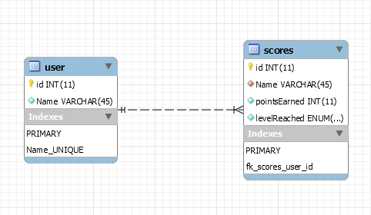

Here are the tables that will be used to store the different users and their scores on the different levels.

**Dialogs to be used:**

The next Dialog that we have is to see the scores that you have made in the past. Using the back menu item to bring the user back to the original frame when finished.

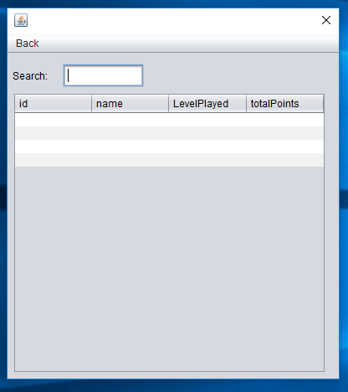

We have also a dialog that allows the user to choose the preferred landscape and the level they wish to do. As well as input their name.

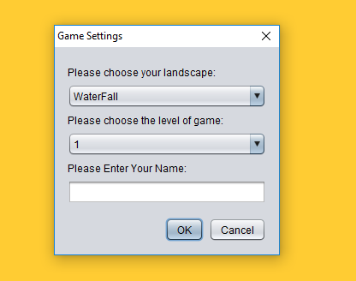

Another dialog that we have put was to display the rules.

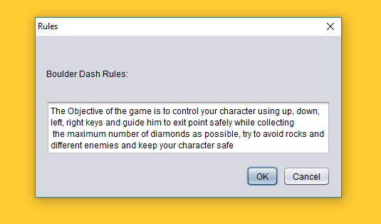

This is the design of the frame that we will be using When playing the game.

