BildAktVR data analysis 2

Ondrej Havlicek

Table of Contents

[ohavlicek@gmail.com](mailto:ohavlicek@gmail.com) 06/2018

## Preparations

### Load packages

### Defititions

### Read data

### convert column types

### Manually fill in some subject IDs based on datetime of experiment

### Verify the subject IDs and numbers of trials (incl.practice) we have

|  |  |
| --- | --- |
| subject | n |
| 7 | 168 |
| 8 | 168 |
| 9 | 168 |
| 10 | 168 |
| 11 | 168 |
| 12 | 168 |
| 13 | 168 |
| 14 | 168 |
| 15 | 168 |
| 16 | 168 |
| 18 | 168 |
| 19 | 168 |
| 20 | 168 |
| 21 | 168 |
| 22 | 168 |
| 23 | 168 |
| 26 | 168 |
| 27 | 168 |
| 28 | 168 |
| 29 | 168 |
| 30 | 160 |
| 31 | 168 |
| 32 | 168 |
| 33 | 168 |
| 34 | 168 |
| 35 | 168 |
| 36 | 168 |
| 37 | 168 |
| 38 | 168 |
| 39 | 168 |
| 40 | 168 |
| 41 | 168 |
| 42 | 168 |
| 43 | 168 |
| 44 | 168 |
| 45 | 168 |
| 46 | 168 |
| 47 | 168 |
| 48 | 168 |
| 49 | 168 |
| 50 | 168 |
| 51 | 168 |
| 52 | 168 |
| NA | 504 |

### Prepare subset of data for analysis, create new columns

## Main results

### Intervals estimation error distributions

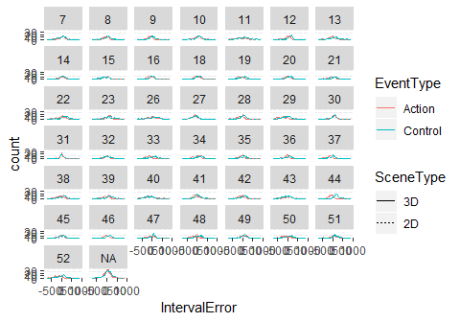

Interval estimation errors (Estimated - Actual) are pretty much normally distributed with pretty much similar variance across subjects and conditions

### Main figure

Means of individual estimation errors as a distribution (violin plot with median of means) and a point estimate (mean of means) plus 95% CI for the mean

## Warning: Ignoring unknown aesthetics: y

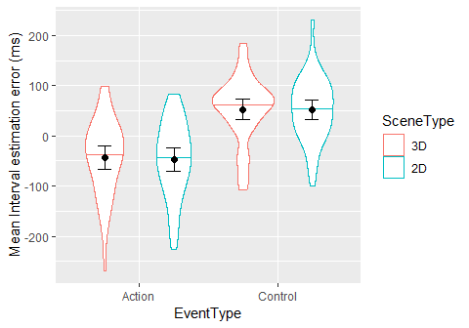

Intervals are judged more accurately in Action (Press-Beep) action, where they are slightly underestimated, than in Control (Vibration-Beep) condition, where they are overestimated. No obvious influence of 2D/3D scene type. Similar for mean and for median.

### Interval estimation error per interval length

Error bars are 95% CI for the mean 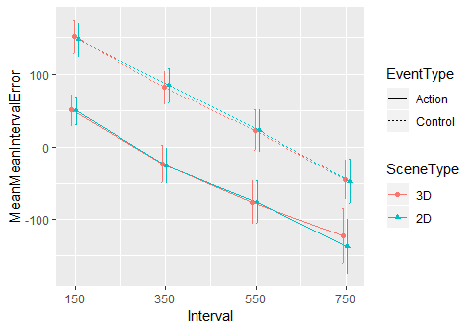 No influence of Scene type :-(

### Intervals: mixed-effects models - main output of analysis

* Model 1: Basic: IntervalError ~ IntervalS + SceneType * EventType + (1+IntervalS + SceneType + EventType|Subject)
* Model 2: Extd.: IntervalError ~ IntervalS + SceneType * EventType + abs(ObjectsError) + ObjectsCount * ObjectsRT + IntervalLogRT + (1+IntervalS+SceneType + EventType|Subject)
* Interval Error
* Interval Error
* Predictors
* Estimates
* CI
* p
* Estimates
* CI
* p
* (Intercept)
* -44.49
* -67.05 – -21.92
* <0.001
* 170.37
* 83.63 – 257.10
* <0.001
* Interval S
* -70.42
* -81.92 – -58.92
* <0.001
* -71.41
* -82.80 – -60.01
* <0.001
* SceneType2D
* -3.92
* -16.17 – 8.32
* 0.530
* -4.06
* -16.26 – 8.14
* 0.515
* EventTypeControl
* 96.74
* 76.40 – 117.08
* <0.001
* 97.41
* 73.41 – 121.42
* <0.001
* SceneType2D:EventTypeControl
* 2.97
* -9.98 – 15.92
* 0.653
* 2.27
* -10.60 – 15.14
* 0.730
* abs(Objects Error)
* 4.98
* -2.34 – 12.30
* 0.182
* Objects Count
* 1.18
* -1.86 – 4.21
* 0.448
* Objects RT
* -0.00
* -0.01 – 0.00
* 0.304
* Interval Log RT
* -28.55
* -37.76 – -19.35
* <0.001
* Trial Total
* 0.24
* 0.10 – 0.37
* 0.001
* ObjectsCount:ObjectsRT
* 0.00
* -0.00 – 0.00
* 0.791
* Random Effects

σ2

18764.69

18532.80

τ00

5232.09 Subject

6799.98 Subject

τ11

1363.35 Subject.IntervalS

1336.50 Subject.IntervalS

740.35 Subject.SceneType2D

739.77 Subject.SceneType2D

3692.13 Subject.EventTypeControl

5512.86 Subject.EventTypeControl

ρ01

0.35 Subject.IntervalS

0.29 Subject.IntervalS

-0.19 Subject.SceneType2D

-0.28 Subject.SceneType2D

-0.58 Subject.EventTypeControl

-0.69 Subject.EventTypeControl

ICC

0.22 Subject

0.27 Subject

Observations

6880

6880

Marginal R2 / Conditional R2

0.231 / 0.412

0.241 / 0.435

Interval Error

Interval Error

Predictors

Estimates

CI

p

Estimates

CI

p

(Intercept)

-44.49

-67.05 – -21.92

<0.001

170.37

83.63 – 257.10

<0.001

Interval S

-70.42

-81.92 – -58.92

<0.001

-71.41

-82.80 – -60.01

<0.001

SceneType2D

-3.92

-16.17 – 8.32

0.530

-4.06

-16.26 – 8.14

0.515

EventTypeControl

96.74

76.40 – 117.08

<0.001

97.41

73.41 – 121.42

<0.001

SceneType2D:EventTypeControl

2.97

-9.98 – 15.92

0.653

2.27

-10.60 – 15.14

0.730

abs(Objects Error)

4.98

-2.34 – 12.30

0.182

Objects Count

1.18

-1.86 – 4.21

0.448

Objects RT

-0.00

-0.01 – 0.00

0.304

Interval Log RT

-28.55

-37.76 – -19.35

<0.001

Trial Total

0.24

0.10 – 0.37

0.001

ObjectsCount:ObjectsRT

0.00

-0.00 – 0.00

0.791

Random Effects

σ2

18764.69

18532.80

τ00

5232.09 Subject

6799.98 Subject

τ11

1363.35 Subject.IntervalS

1336.50 Subject.IntervalS

740.35 Subject.SceneType2D

739.77 Subject.SceneType2D

3692.13 Subject.EventTypeControl

5512.86 Subject.EventTypeControl

ρ01

0.35 Subject.IntervalS

0.29 Subject.IntervalS

-0.19 Subject.SceneType2D

-0.28 Subject.SceneType2D

-0.58 Subject.EventTypeControl

-0.69 Subject.EventTypeControl

ICC

0.22 Subject

0.27 Subject

Observations

6880

6880

Marginal R2 / Conditional R2

0.231 / 0.412

0.241 / 0.435

* Beta coefficients are in ms
* Intervals are more underestimated for longer (actual) intervals.
* :-( There is no effect of scene type, but we hypothesised that intervals will be underestimated more in 3D than in 2D..
* :-) The intervals are overestimated more in the Control than in Action condition - consistent with agency hypothesis, but it may be driven by factually different intervals in action than in control due to the VR SW and HW.. So we should probably rather look for an interaction:
* There is no interaction between Scene type (2D/3D) and Event type (Action/Control), but we wanted to find a bigger underestimation in 3D than 2D, in the Action than in the Control condition, right?
* Model which includes also error in objects estimation (measure of difficulty of the counting task, in absolute numbers) shows no interesting difference.

## Exploratory analyses and checks

### Effects found in the model

There was an effect of time (TrialTotal), but it seems to be small..

## `geom_smooth()` using method = 'gam' and formula 'y ~ s(x, bs = "cs")'

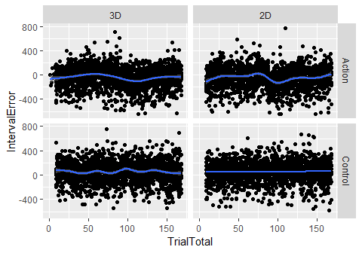

There was an effect of interval RT on interval error, but again seems to be not very interesting..

## `geom_smooth()` using method = 'gam' and formula 'y ~ s(x, bs = "cs")'

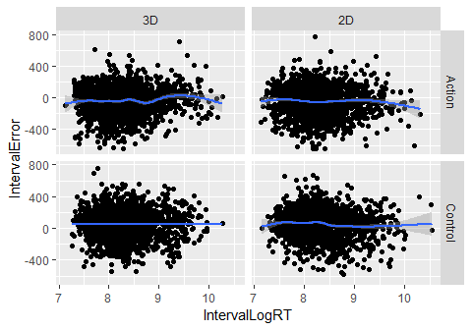

### Exclude trials which had inaccurate object estimation and too fast object responses

## `stat_bin()` using `bins = 30`. Pick better value with `binwidth`.

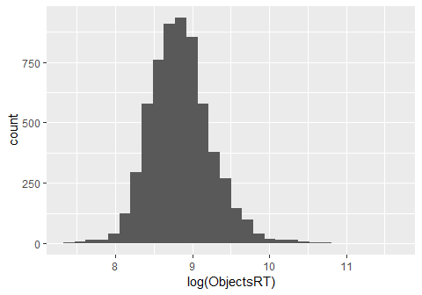

## [1] 7360

## [1] 1774

### Main results after excluding object counting errors and outlier RTs

## Warning in cor(Interval, IntervalResp): the standard deviation is zero  
  
## Warning in cor(Interval, IntervalResp): the standard deviation is zero  
  
## Warning in cor(Interval, IntervalResp): the standard deviation is zero  
  
## Warning in cor(Interval, IntervalResp): the standard deviation is zero  
  
## Warning in cor(Interval, IntervalResp): the standard deviation is zero  
  
## Warning in cor(Interval, IntervalResp): the standard deviation is zero

## Warning: Ignoring unknown aesthetics: y

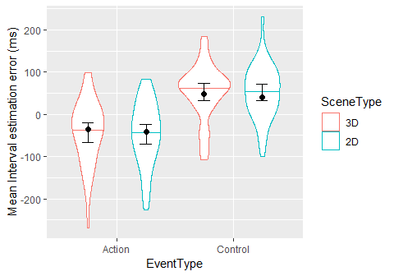 ### The same per object count (more objects = more exploration = more effect?)

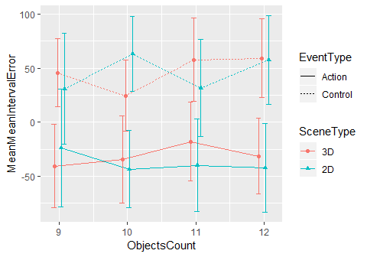 ### Inferential test for outliers removed

## Caution! ICC for random-slope-intercept models usually not meaningful. See 'Note' in `?icc`.

Interval Error

Predictors

Estimates

CI

p

(Intercept)

-41.96

-65.40 – -18.53

0.001

Interval S

-65.74

-72.71 – -58.77

<0.001

SceneType2D

-1.43

-20.59 – 17.72

0.883

EventTypeControl

89.27

60.20 – 118.33

<0.001

SceneType2D:EventTypeControl

0.62

-26.20 – 27.44

0.964

Random Effects

σ2

18899.93

τ00 Subject

3947.33

τ11 Subject.SceneType2D

82.31

τ11 Subject.EventTypeControl

5265.90

ρ01 Subject.SceneType2D

1.00

ρ01 Subject.EventTypeControl

-0.63

ICC Subject

0.17

Observations

1655

Marginal R2 / Conditional R2

0.212 / 0.353

Interval Error

Predictors

Estimates

CI

p

(Intercept)

-41.96

-65.40 – -18.53

0.001

Interval S

-65.74

-72.71 – -58.77

<0.001

SceneType2D

-1.43

-20.59 – 17.72

0.883

EventTypeControl

89.27

60.20 – 118.33

<0.001

SceneType2D:EventTypeControl

0.62

-26.20 – 27.44

0.964

Random Effects

σ2

18899.93

τ00 Subject

3947.33

τ11 Subject.SceneType2D

82.31

τ11 Subject.EventTypeControl

5265.90

ρ01 Subject.SceneType2D

1.00

ρ01 Subject.EventTypeControl

-0.63

ICC Subject

0.17

Observations

1655

Marginal R2 / Conditional R2

0.212 / 0.353

### Explore a bit scenes distribution and randomization

Is the number of objects in a scene unrelated to the event-sound interval? 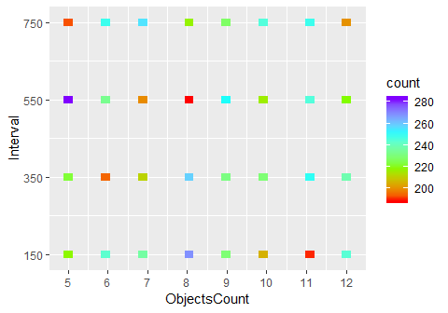 Number of objects inside a scene is not uniform across time interval: some combinations appear often, some less often. But the VR code seems properly randomized..

Let’s visualize it a bit more

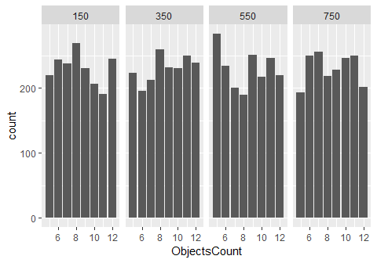

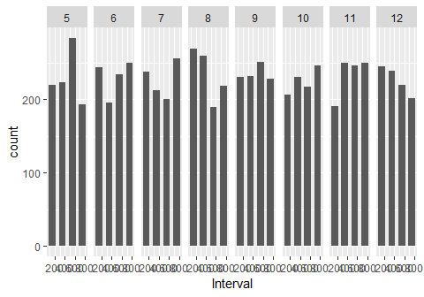

##   
## Pearson's product-moment correlation  
##   
## data: ObjectsCount and Interval  
## t = 0.098036, df = 7358, p-value = 0.9219  
## alternative hypothesis: true correlation is not equal to 0  
## 95 percent confidence interval:  
## -0.0217043 0.0239889  
## sample estimates:  
## cor   
## 0.001142895

At least there is no linear relationship?

##   
## Call:  
## lm(formula = ObjectsCount ~ Interval + I(Interval^2) + I(Interval^3),   
## data = data)  
##   
## Residuals:  
## Min 1Q Median 3Q Max   
## -3.6125 -1.8162 -0.0198 1.7765 3.5728   
##   
## Coefficients:  
## Estimate Std. Error t value Pr(>|t|)   
## (Intercept) 7.700e+00 2.939e-01 26.202 < 2e-16 ***  
## Interval 7.364e-03 2.679e-03 2.749 0.00600 **   
## I(Interval^2) -1.815e-05 6.735e-06 -2.696 0.00704 **   
## I(Interval^3) 1.303e-08 4.964e-09 2.625 0.00868 **   
## ---  
## Signif. codes: 0 '***' 0.001 '**' 0.01 '*' 0.05 '.' 0.1 ' ' 1  
##   
## Residual standard error: 2.286 on 7356 degrees of freedom  
## Multiple R-squared: 0.001033, Adjusted R-squared: 0.000626   
## F-statistic: 2.536 on 3 and 7356 DF, p-value: 0.0549

Interestingly we have now linear, quadratic and cubic trend, but overal R2 is pretty much zero, so there is no practically significant relation between interval and number of objects.

### Objects error exploration

Distributions of object estimation errors (error = estimated - actual) for each participant: 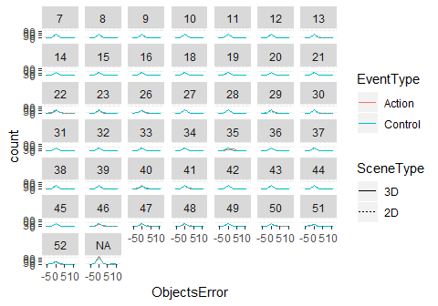

People are mostly correct about the object count.

What about relation of error on the number of actual objects? 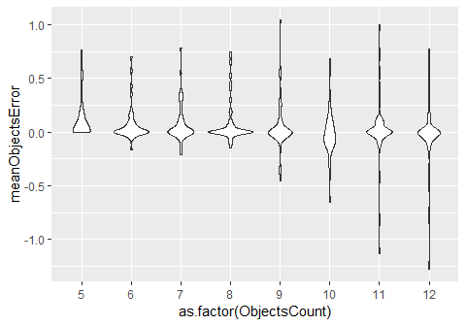 More objects do not mean on average larger error, but more variance..

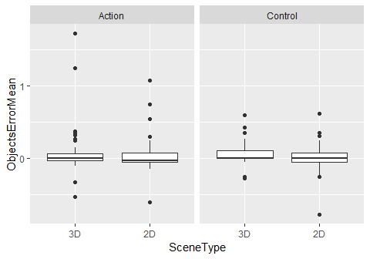

There seems to be no difference in object count estimation among conditions, which is good.

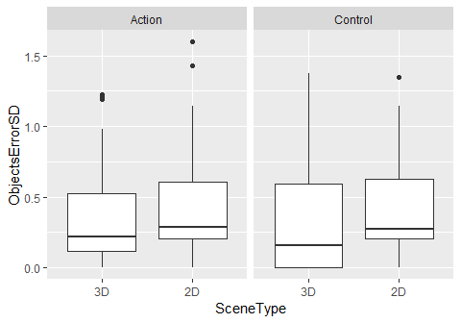

Precision seems to be slightly better for 3D than for 2D scenes

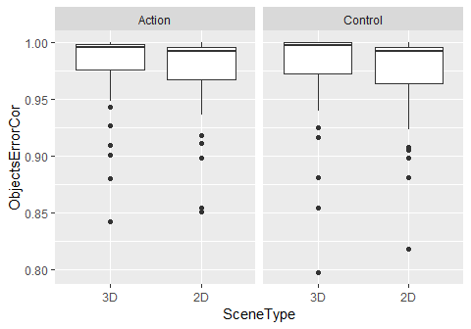

Not much of a difference in correlation between actual and estimated number of objects, only very tiny benefit of 3D.

### Objects: mixed-effects model

ObjectsError ~ ObjectsCount + SceneType*EventType + (1+ObjectsCount + SceneType + EventType|Subject)

Objects Error

Predictors

Estimates

CI

p

(Intercept)

0.25

0.12 – 0.39

0.001

Objects Count

-0.02

-0.03 – -0.00

0.017

SceneType2D

-0.05

-0.10 – -0.00

0.053

EventTypeControl

-0.04

-0.11 – 0.04

0.320

SceneType2D:EventTypeControl

0.00

-0.05 – 0.05

0.919

Random Effects

σ2

0.26

τ00 Subject

0.18

τ11 Subject.ObjectsCount

0.00

τ11 Subject.SceneType2D

0.01

τ11 Subject.EventTypeControl

0.05

ρ01 Subject.ObjectsCount

-0.73

ρ01 Subject.SceneType2D

-0.72

ρ01 Subject.EventTypeControl

-0.54

ICC Subject

0.40

Observations

6880

Marginal R2 / Conditional R2

0.008 / 0.196

Objects Error

Predictors

Estimates

CI

p

(Intercept)

0.25

0.12 – 0.39

0.001

Objects Count

-0.02

-0.03 – -0.00

0.017

SceneType2D

-0.05

-0.10 – -0.00

0.053

EventTypeControl

-0.04

-0.11 – 0.04

0.320

SceneType2D:EventTypeControl

0.00

-0.05 – 0.05

0.919

Random Effects

σ2

0.26

τ00 Subject

0.18

τ11 Subject.ObjectsCount

0.00

τ11 Subject.SceneType2D

0.01

τ11 Subject.EventTypeControl

0.05

ρ01 Subject.ObjectsCount

-0.73

ρ01 Subject.SceneType2D

-0.72

ρ01 Subject.EventTypeControl

-0.54

ICC Subject

0.40

Observations

6880

Marginal R2 / Conditional R2

0.008 / 0.196

The error in object count is (sig.) influenced by number of objects in the scene and by the scene type (2D = more underestimation of the count), but the coefficients are tiny.

### Explore interval estimation precision and correlation

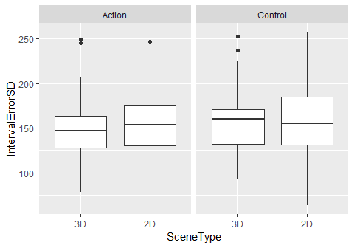

No apparent difference in precision.

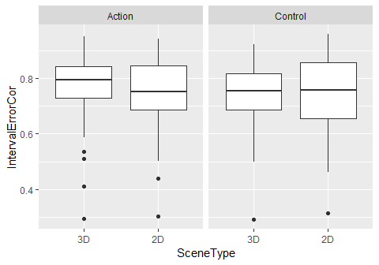

Correlation between reality and estimate seems slightly worse for 2D in Action condition..

### Intervals RT exploration

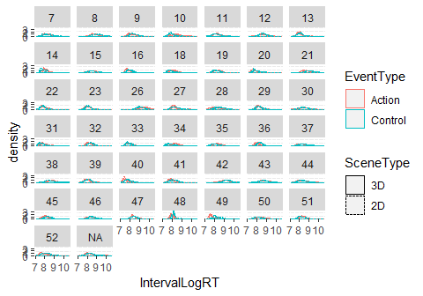 Log RTs seem sufficiently normally distributed with similar variances

Are ther outlier trials in the RTs?

RTs are around 2-10 seconds, there is a pretty long tail, but log-transformed seems ok-ish, seems no need to remove outliers.. But not much of a difference among conditions..

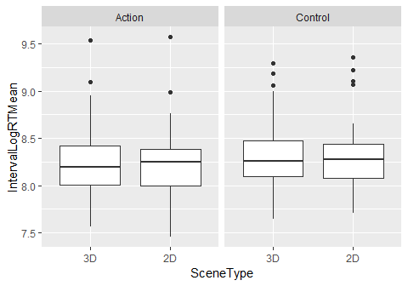

Interval RTs seem to be very similar acrosss conditions

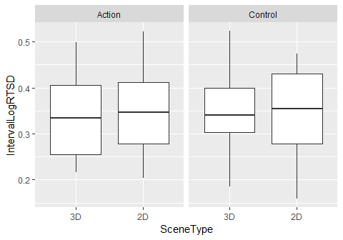

No interesting difference..

### Interval RT mixed-effects model

IntervalLogRT ~ ObjectsCount + Interval + SceneType * EventType + (1+SceneType + EventType|Subject)

Interval Log RT

Predictors

Estimates

CI

p

(Intercept)

8.33598

8.21394 – 8.45801

<0.001

Objects Count

-0.00250

-0.00615 – 0.00115

0.180

Interval

-0.00015

-0.00018 – -0.00011

<0.001

SceneType2D

-0.00143

-0.03419 – 0.03133

0.932

EventTypeControl

0.06199

-0.01309 – 0.13706

0.112

SceneType2D:EventTypeControl

-0.02013

-0.05350 – 0.01324

0.237

Random Effects

σ2

0.12

τ00 Subject

0.15

τ11 Subject.SceneType2D

0.01

τ11 Subject.EventTypeControl

0.06

ρ01 Subject.SceneType2D

-0.22

ρ01 Subject.EventTypeControl

-0.40

ICC Subject

0.55

Observations

6880

Marginal R2 / Conditional R2

0.007 / 0.534

Interval Log RT

Predictors

Estimates

CI

p

(Intercept)

8.33598

8.21394 – 8.45801

<0.001

Objects Count

-0.00250

-0.00615 – 0.00115

0.180

Interval

-0.00015

-0.00018 – -0.00011

<0.001

SceneType2D

-0.00143

-0.03419 – 0.03133

0.932

EventTypeControl

0.06199

-0.01309 – 0.13706

0.112

SceneType2D:EventTypeControl

-0.02013

-0.05350 – 0.01324

0.237

Random Effects

σ2

0.12

τ00 Subject

0.15

τ11 Subject.SceneType2D

0.01

τ11 Subject.EventTypeControl

0.06

ρ01 Subject.SceneType2D

-0.22

ρ01 Subject.EventTypeControl

-0.40

ICC Subject

0.55

Observations

6880

Marginal R2 / Conditional R2

0.007 / 0.534

Nothing very interesting

## Explore removing first half of each block

WP: “Sometimes participants need a number of initial trials to adapt to the processing conditions of a given experimental block (particularly if this block was preceded by another one with quite different processing requirements). If this happens, it may be useful to take still another look at the data, disregarding, say, the first half of trials of each block and just concentrating on the trials in the second half.”

## Caution! ICC for random-slope-intercept models usually not meaningful. See 'Note' in `?icc`.

Interval Error

Predictors

Estimates

CI

p

(Intercept)

-42.04

-65.50 – -18.59

0.001

Interval S

-68.22

-80.22 – -56.23

<0.001

SceneType2D

1.64

-12.81 – 16.08

0.825

EventTypeControl

97.50

74.10 – 120.89

<0.001

SceneType2D:EventTypeControl

2.88

-15.27 – 21.02

0.756

Random Effects

σ2

18391.04

τ00 Subject

5225.00

τ11 Subject.IntervalS

1366.83

τ11 Subject.SceneType2D

493.97

τ11 Subject.EventTypeControl

4270.22

ρ01 Subject.IntervalS

0.25

ρ01 Subject.SceneType2D

0.05

ρ01 Subject.EventTypeControl

-0.59

ICC Subject

0.22

Observations

3440

Marginal R2 / Conditional R2

0.223 / 0.417

Interval Error

Predictors

Estimates

CI

p

(Intercept)

-42.04

-65.50 – -18.59

0.001

Interval S

-68.22

-80.22 – -56.23

<0.001

SceneType2D

1.64

-12.81 – 16.08

0.825

EventTypeControl

97.50

74.10 – 120.89

<0.001

SceneType2D:EventTypeControl

2.88

-15.27 – 21.02

0.756

Random Effects

σ2

18391.04

τ00 Subject

5225.00

τ11 Subject.IntervalS

1366.83

τ11 Subject.SceneType2D

493.97

τ11 Subject.EventTypeControl

4270.22

ρ01 Subject.IntervalS

0.25

ρ01 Subject.SceneType2D

0.05

ρ01 Subject.EventTypeControl

-0.59

ICC Subject

0.22

Observations

3440

Marginal R2 / Conditional R2

0.223 / 0.417

Removing first half of each block still does not produce significant effect of 2Dvs3D nor interaction with EventType

## Explore sequence effects

WP: As I understand, there were always four blocks in a session, resulting from 2x2 scene types and event types. Now, if the sequence of these blocks is balanced over participants, some of them will have sequences like 2-2-3-3 and 3-3-2-2, whereas others will have mixed sequences like 2-3-2-3 or -3-2-3-2 (where 2 and 3 stand for 2D/3D). I don’t have directed hypotheses, but it could be interesting to take a look at whether these sequence-defined subgroups show any differences in terms of agency strength.

OH: Regarding the sequence effects, the design looked like this: there were 8 blocks, each block had 20 trials. There were 2 between-subjects factors: FirstSceneType (first block was 2D or 3D, then the type changed after each block) and FirstEventType (first four blocks were Action and last four blocks were Control (Vibration) or vice versa). Therefore there were 2x2 groups of participants.

Let’s try to have a look at (an almost) full model: IntervalError ~ Interval + SceneType * EventType * FirstSceneType * FirstEventType + (1+Interval + SceneType * EventType|Subject)

## Caution! ICC for random-slope-intercept models usually not meaningful. See 'Note' in `?icc`.

Interval Error

Predictors

Estimates

CI

p

(Intercept)

-14.28

-54.48 – 25.93

0.490

Interval S

-70.42

-81.92 – -58.92

<0.001

SceneType2D

13.23

-13.24 – 39.70

0.333

EventTypeControl

103.15

63.77 – 142.53

<0.001

FirstSceneType2D

5.01

-49.56 – 59.58

0.858

FirstEventTypeControl

-64.34

-120.09 – -8.60

0.029

SceneType2D:EventTypeControl

-32.22

-67.37 – 2.93

0.080

SceneType2D:FirstSceneType2D

-37.03

-73.65 – -0.42

0.055

EventTypeControl:FirstSceneType2D

-55.20

-109.30 – -1.10

0.053

SceneType2D:FirstEventTypeControl

-4.25

-41.65 – 33.15

0.825

EventTypeControl:FirstEventTypeControl

25.33

-29.94 – 80.59

0.375

FirstSceneType2D:FirstEventTypeControl

-13.03

-93.22 – 67.16

0.752

SceneType2D:EventTypeControl:FirstSceneType2D

63.49

14.84 – 112.15

0.015

SceneType2D:EventTypeControl:FirstEventTypeControl

15.96

-33.74 – 65.66

0.533

SceneType2D:FirstSceneType2D:FirstEventTypeControl

13.92

-39.89 – 67.72

0.615

EventTypeControl:FirstSceneType2D:FirstEventTypeControl

41.88

-37.62 – 121.39

0.308

SceneType2D:EventTypeControl:FirstSceneType2D:FirstEventTypeControl

-15.49

-86.99 – 56.00

0.673

Random Effects

σ2

18621.50

τ00 Subject

4682.07

τ11 Subject.IntervalS

1364.24

τ11 Subject.SceneType2D

1084.33

τ11 Subject.EventTypeControl

3705.24

τ11 Subject.SceneType2D:EventTypeControl

1683.15

ρ01 Subject.IntervalS

0.40

ρ01 Subject.SceneType2D

-0.33

ρ01 Subject.EventTypeControl

-0.57

ρ01 Subject.SceneType2D:EventTypeControl

0.33

ICC Subject

0.20

Observations

6880

Marginal R2 / Conditional R2

0.253 / 0.423

Interval Error

Predictors

Estimates

CI

p

(Intercept)

-14.28

-54.48 – 25.93

0.490

Interval S

-70.42

-81.92 – -58.92

<0.001

SceneType2D

13.23

-13.24 – 39.70

0.333

EventTypeControl

103.15

63.77 – 142.53

<0.001

FirstSceneType2D

5.01

-49.56 – 59.58

0.858

FirstEventTypeControl

-64.34

-120.09 – -8.60

0.029

SceneType2D:EventTypeControl

-32.22

-67.37 – 2.93

0.080

SceneType2D:FirstSceneType2D

-37.03

-73.65 – -0.42

0.055

EventTypeControl:FirstSceneType2D

-55.20

-109.30 – -1.10

0.053

SceneType2D:FirstEventTypeControl

-4.25

-41.65 – 33.15

0.825

EventTypeControl:FirstEventTypeControl

25.33

-29.94 – 80.59

0.375

FirstSceneType2D:FirstEventTypeControl

-13.03

-93.22 – 67.16

0.752

SceneType2D:EventTypeControl:FirstSceneType2D

63.49

14.84 – 112.15

0.015

SceneType2D:EventTypeControl:FirstEventTypeControl

15.96

-33.74 – 65.66

0.533

SceneType2D:FirstSceneType2D:FirstEventTypeControl

13.92

-39.89 – 67.72

0.615

EventTypeControl:FirstSceneType2D:FirstEventTypeControl

41.88

-37.62 – 121.39

0.308

SceneType2D:EventTypeControl:FirstSceneType2D:FirstEventTypeControl

-15.49

-86.99 – 56.00

0.673

Random Effects

σ2

18621.50

τ00 Subject

4682.07

τ11 Subject.IntervalS

1364.24

τ11 Subject.SceneType2D

1084.33

τ11 Subject.EventTypeControl

3705.24

τ11 Subject.SceneType2D:EventTypeControl

1683.15

ρ01 Subject.IntervalS

0.40

ρ01 Subject.SceneType2D

-0.33

ρ01 Subject.EventTypeControl

-0.57

ρ01 Subject.SceneType2D:EventTypeControl

0.33

ICC Subject

0.20

Observations

6880

Marginal R2 / Conditional R2

0.253 / 0.423

Model is too complex to work with (at least we see there is no interaction of FirstSceneType:FirstEventType), so let’s split it by investigating the two between-subjects factors separately.

### Effects of FirstSceneType: starting with 2D or 3D block

## Caution! ICC for random-slope-intercept models usually not meaningful. See 'Note' in `?icc`.

Interval Error

Predictors

Estimates

CI

p

(Intercept)

-45.74

-77.49 – -13.98

0.007

Interval S

-70.42

-81.92 – -58.92

<0.001

SceneType2D

11.03

-7.31 – 29.37

0.245

EventTypeControl

115.24

86.04 – 144.45

<0.001

FirstSceneType2D

2.56

-41.87 – 46.99

0.911

SceneType2D:EventTypeControl

-24.27

-48.64 – 0.11

0.058

SceneType2D:FirstSceneType2D

-30.62

-56.82 – -4.43

0.027

EventTypeControl:FirstSceneType2D

-37.88

-79.32 – 3.55

0.080

SceneType2D:EventTypeControl:FirstSceneType2D

55.77

20.91 – 90.62

0.003

Random Effects

σ2

18621.50

τ00 Subject

5550.52

τ11 Subject.IntervalS

1364.24

τ11 Subject.SceneType2D

1003.70

τ11 Subject.EventTypeControl

4035.36

τ11 Subject.SceneType2D:EventTypeControl

1543.88

ρ01 Subject.IntervalS

0.31

ρ01 Subject.SceneType2D

-0.31

ρ01 Subject.EventTypeControl

-0.63

ρ01 Subject.SceneType2D:EventTypeControl

0.25

ICC Subject

0.23

Observations

6880

Marginal R2 / Conditional R2

0.235 / 0.418

Interval Error

Predictors

Estimates

CI

p

(Intercept)

-45.74

-77.49 – -13.98

0.007

Interval S

-70.42

-81.92 – -58.92

<0.001

SceneType2D

11.03

-7.31 – 29.37

0.245

EventTypeControl

115.24

86.04 – 144.45

<0.001

FirstSceneType2D

2.56

-41.87 – 46.99

0.911

SceneType2D:EventTypeControl

-24.27

-48.64 – 0.11

0.058

SceneType2D:FirstSceneType2D

-30.62

-56.82 – -4.43

0.027

EventTypeControl:FirstSceneType2D

-37.88

-79.32 – 3.55

0.080

SceneType2D:EventTypeControl:FirstSceneType2D

55.77

20.91 – 90.62

0.003

Random Effects

σ2

18621.50

τ00 Subject

5550.52

τ11 Subject.IntervalS

1364.24

τ11 Subject.SceneType2D

1003.70

τ11 Subject.EventTypeControl

4035.36

τ11 Subject.SceneType2D:EventTypeControl

1543.88

ρ01 Subject.IntervalS

0.31

ρ01 Subject.SceneType2D

-0.31

ρ01 Subject.EventTypeControl

-0.63

ρ01 Subject.SceneType2D:EventTypeControl

0.25

ICC Subject

0.23

Observations

6880

Marginal R2 / Conditional R2

0.235 / 0.418

Interaction SceneType:FirstSceneType seems trivial: practice effect. The 3-way interaction may be interesting. Split the 3-way interaction to two 2-way interactions, one for each FirstSceneType. First when people started with 2D block:

## Caution! ICC for random-slope-intercept models usually not meaningful. See 'Note' in `?icc`.

Interval Error

Predictors

Estimates

CI

p

(Intercept)

-47.14

-85.92 – -8.36

0.027

Interval S

-77.29

-92.79 – -61.78

<0.001

SceneType2D

-20.30

-39.42 – -1.17

0.051

EventTypeControl

79.65

47.07 – 112.23

<0.001

SceneType2D:EventTypeControl

32.00

0.92 – 63.08

0.057

Random Effects

σ2

19610.32

τ00 Subject

7730.76

τ11 Subject.IntervalS

1191.32

τ11 Subject.SceneType2D

1019.40

τ11 Subject.EventTypeControl

4822.98

τ11 Subject.SceneType2D:EventTypeControl

3319.22

ρ01 Subject.IntervalS

0.19

ρ01 Subject.SceneType2D

-0.57

ρ01 Subject.EventTypeControl

-0.66

ρ01 Subject.SceneType2D:EventTypeControl

0.49

ICC Subject

0.28

Observations

3360

Marginal R2 / Conditional R2

0.238 / 0.439

Interval Error

Predictors

Estimates

CI

p

(Intercept)

-47.14

-85.92 – -8.36

0.027

Interval S

-77.29

-92.79 – -61.78

<0.001

SceneType2D

-20.30

-39.42 – -1.17

0.051

EventTypeControl

79.65

47.07 – 112.23

<0.001

SceneType2D:EventTypeControl

32.00

0.92 – 63.08

0.057

Random Effects

σ2

19610.32

τ00 Subject

7730.76

τ11 Subject.IntervalS

1191.32

τ11 Subject.SceneType2D

1019.40

τ11 Subject.EventTypeControl

4822.98

τ11 Subject.SceneType2D:EventTypeControl

3319.22

ρ01 Subject.IntervalS

0.19

ρ01 Subject.SceneType2D

-0.57

ρ01 Subject.EventTypeControl

-0.66

ρ01 Subject.SceneType2D:EventTypeControl

0.49

ICC Subject

0.28

Observations

3360

Marginal R2 / Conditional R2

0.238 / 0.439

For those who started with 2D block, there is a marginal main effect of SceneType (Intervals were underestimated more by 20 ms), which may be just the practice effect (with a lot of practice there may be no under- or over-estimation), but interestingly there is marginal interaction between SceneType and EventType. See chart below.

## Caution! ICC for random-slope-intercept models usually not meaningful. See 'Note' in `?icc`.

Interval Error

Predictors

Estimates

CI

p

(Intercept)

-41.95

-68.18 – -15.72

0.005

Interval S

-63.87

-80.68 – -47.06

<0.001

SceneType2D

11.70

-6.87 – 30.27

0.230

EventTypeControl

113.05

85.60 – 140.50

<0.001

SceneType2D:EventTypeControl

-24.75

-44.36 – -5.13

0.017

Random Effects

σ2

17640.53

τ00 Subject

3498.80

τ11 Subject.IntervalS

1507.68

τ11 Subject.SceneType2D

1092.76

τ11 Subject.EventTypeControl

3433.27

τ11 Subject.SceneType2D:EventTypeControl

439.61

ρ01 Subject.IntervalS

0.48

ρ01 Subject.SceneType2D

0.02

ρ01 Subject.EventTypeControl

-0.59

ρ01 Subject.SceneType2D:EventTypeControl

-0.65

ICC Subject

0.17

Observations

3520

Marginal R2 / Conditional R2

0.229 / 0.393

Interval Error

Predictors

Estimates

CI

p

(Intercept)

-41.95

-68.18 – -15.72

0.005

Interval S

-63.87

-80.68 – -47.06

<0.001

SceneType2D

11.70

-6.87 – 30.27

0.230

EventTypeControl

113.05

85.60 – 140.50

<0.001

SceneType2D:EventTypeControl

-24.75

-44.36 – -5.13

0.017

Random Effects

σ2

17640.53

τ00 Subject

3498.80

τ11 Subject.IntervalS

1507.68

τ11 Subject.SceneType2D

1092.76

τ11 Subject.EventTypeControl

3433.27

τ11 Subject.SceneType2D:EventTypeControl

439.61

ρ01 Subject.IntervalS

0.48

ρ01 Subject.SceneType2D

0.02

ρ01 Subject.EventTypeControl

-0.59

ρ01 Subject.SceneType2D:EventTypeControl

-0.65

ICC Subject

0.17

Observations

3520

Marginal R2 / Conditional R2

0.229 / 0.393

Starting with a 3D block, now there is a trully significant interaction of SceneType and EventType. What does this mean? Let’s graph it..

## Warning: Ignoring unknown aesthetics: y

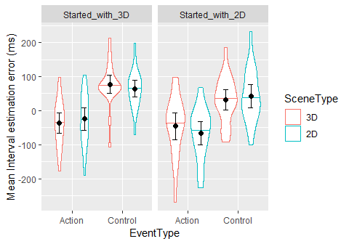

In Started_with_3D (left panel) there is an interaction of SceneType and EventType. Interval estimation errors are “more extreme” for 3D scenes. In Started_with_2D it is a bit (nonsig) reversed: more extreme errors for 2D. This could be learning effect, learning to estimate closer to reality (error of zero) after some practice. This is still hard to interpret, so let’s take a difference score of Control - Action (“agency effect”, higher values = stronger effect).

## Warning: Converting "Subject" to factor for ANOVA.

## Warning: Converting "SceneType" to factor for ANOVA.

## Warning: Converting "FirstSceneTypeGraph" to factor for ANOVA.

## Warning: The column supplied as the wid variable contains non-unique values  
## across levels of the supplied between-Ss variables. Automatically fixing  
## this by generating unique wid labels.

## Warning: Data is unbalanced (unequal N per group). Make sure you specified  
## a well-considered value for the type argument to ezANOVA().

## $ANOVA  
## Effect DFn DFd F p p<.05  
## 2 FirstSceneTypeGraph 1 43 0.1582346 0.692755076   
## 3 SceneType 1 43 0.1399187 0.710200000   
## 4 FirstSceneTypeGraph:SceneType 1 43 11.1168461 0.001768471 *  
## ges  
## 2 0.0030648086  
## 3 0.0005352539  
## 4 0.0408132560

Agency size sig. depends on interaction of SceneType (2D vs 3D) and FirstSceneType (first block being 2D vs 3D).

## Warning: Ignoring unknown aesthetics: y

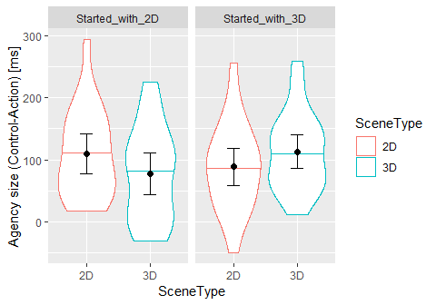

Does this mean anything? People learn to estimate better? That would be my (and probably reviewers’) first explanation, which we cannot exclude using our data, which is why our primary analysis uses all data from a balanced design (and finds nothing :-( )..

### Effects of FirstEventType: starting with an Action or Control (Vibration) block

## Caution! ICC for random-slope-intercept models usually not meaningful. See 'Note' in `?icc`.

Interval Error

Predictors

Estimates

CI

p

(Intercept)

-11.68

-39.44 – 16.07

0.414

Interval S

-70.42

-81.92 – -58.92

<0.001

SceneType2D

-5.78

-24.84 – 13.29

0.556

EventTypeControl

74.78

46.84 – 102.72

<0.001

FirstEventTypeControl

-70.53

-109.56 – -31.49

0.001

SceneType2D:EventTypeControl

0.34

-26.19 – 26.87

0.980

SceneType2D:FirstEventTypeControl

3.98

-23.83 – 31.79

0.780

EventTypeControl:FirstEventTypeControl

47.21

6.60 – 87.82

0.028

SceneType2D:EventTypeControl:FirstEventTypeControl

5.65

-33.09 – 44.39

0.776

Random Effects

σ2

18621.50

τ00 Subject

4467.38

τ11 Subject.IntervalS

1364.24

τ11 Subject.SceneType2D

1263.58

τ11 Subject.EventTypeControl

3812.85

τ11 Subject.SceneType2D:EventTypeControl

2383.47

ρ01 Subject.IntervalS

0.41

ρ01 Subject.SceneType2D

-0.25

ρ01 Subject.EventTypeControl

-0.53

ρ01 Subject.SceneType2D:EventTypeControl

0.22

ICC Subject

0.19

Observations

6880

Marginal R2 / Conditional R2

0.249 / 0.421

Interval Error

Predictors

Estimates

CI

p

(Intercept)

-11.68

-39.44 – 16.07

0.414

Interval S

-70.42

-81.92 – -58.92

<0.001

SceneType2D

-5.78

-24.84 – 13.29

0.556

EventTypeControl

74.78

46.84 – 102.72

<0.001

FirstEventTypeControl

-70.53

-109.56 – -31.49

0.001

SceneType2D:EventTypeControl

0.34

-26.19 – 26.87

0.980

SceneType2D:FirstEventTypeControl

3.98

-23.83 – 31.79

0.780

EventTypeControl:FirstEventTypeControl

47.21

6.60 – 87.82

0.028

SceneType2D:EventTypeControl:FirstEventTypeControl

5.65

-33.09 – 44.39

0.776

Random Effects

σ2

18621.50

τ00 Subject

4467.38

τ11 Subject.IntervalS

1364.24

τ11 Subject.SceneType2D

1263.58

τ11 Subject.EventTypeControl

3812.85

τ11 Subject.SceneType2D:EventTypeControl

2383.47

ρ01 Subject.IntervalS

0.41

ρ01 Subject.SceneType2D

-0.25

ρ01 Subject.EventTypeControl

-0.53

ρ01 Subject.SceneType2D:EventTypeControl

0.22

ICC Subject

0.19

Observations

6880

Marginal R2 / Conditional R2

0.249 / 0.421

Only trivial effects. No 3-way interaction, so no need to make the detailed split analyses as for FirstSceneType above.. (I tried anyway and there was still no interesting effect related to agency, no effect of SceneType nor interaction with EventType). At least a chart:

## Warning: Ignoring unknown aesthetics: y

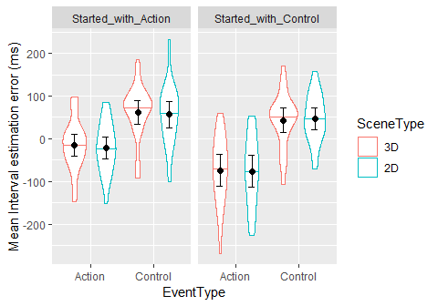

Those who started with Control blocks (right panel; first half of experiment was Control) underestimated the intervals more in Action blocks (second half of experiment), than did people who started with Action blocks (left panel). This could be trivial, or there could be some story like: People get used to having no control over production of the tone in the first half of experiment and then, in the second half, when they get to cause the tones by their actions, they underestimate a lot = have strong sense of agency. In comparison, people who start with Action are fairly accurate, do not underestimate much, and later when they lose control in the Control blocks, they for some reason do not feel less in control than people who started with control block. Does it make sense? What would it mean? What followup could confirm it?

In any case, there is no influence of Scene type.

Let’s have a look also at the difference scores of Control-Action.

## Warning: Converting "Subject" to factor for ANOVA.

## Warning: Converting "SceneType" to factor for ANOVA.

## Warning: Converting "FirstEventTypeGraph" to factor for ANOVA.

## Warning: Data is unbalanced (unequal N per group). Make sure you specified  
## a well-considered value for the type argument to ezANOVA().

## $ANOVA  
## Effect DFn DFd F p p<.05  
## 2 FirstEventTypeGraph 1 42 5.56474218 0.02305258 *  
## 3 SceneType 1 42 0.11435581 0.73692319   
## 4 FirstEventTypeGraph:SceneType 1 42 0.04886317 0.82612454   
## ges  
## 2 0.0937827754  
## 3 0.0005957134  
## 4 0.0002546297

## Warning: Ignoring unknown aesthetics: y

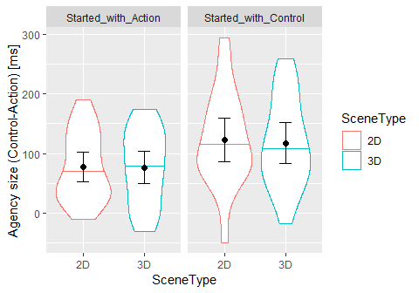

There is a sig. difference between left and right panel. But it is really hard to say whether this is trivial, due to practice, it is an order effect.. Any ideas?