User groups:

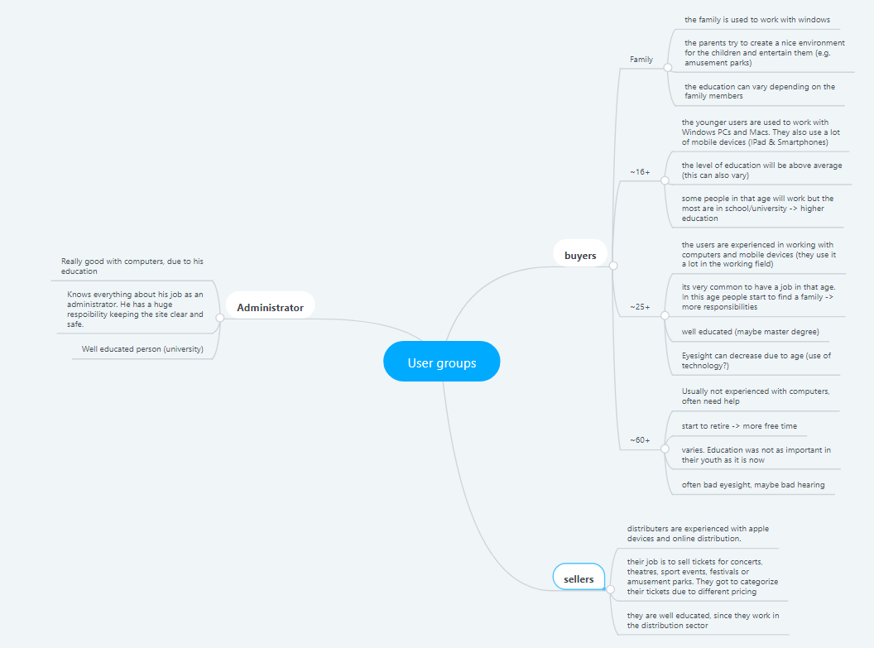

User stories:

**Buyers:**

As a buyer I want to buy a ticket so that I can visit some events.

As a buyer I want to check my bought tickets so that I can look up some information about them.

As a buyer I want to check reviews so that I can be more convinced that I buy tickets for a nice event.

As a buyer I want to search for events so that I can get some inspiration on what I want to do in, for example, the vacations.

As a buyer I want to log in, so that I can buy tickets.

**Sellers:**

As a seller I want to add an event so that I can sell more tickets.

As a seller I want to search for (other) events so that I can compare them to mine so I can keep my prices affordable.

As a seller I want to check reviews, so that I can have feedback on my event.

As a seller I want to remove unwanted data, so that I can change the data I posted on my event page.

As a seller I want to log in, so that I can sell my tickets.

**Administrators:**

As an administrator I want to check the sold tickets, so that I can keep track of the finance and make sure that everyone has paid.

As an administrator I want to check the reviews, so that I can make sure there are no inappropriate comments.

As an administrator I want to search events, so I can make sure there are no inappropriate events on the website.

As an administrator I want to remove unwanted data, so that customers get a clean and understandable page.

As an administrator I want to log in, so that not everyone has the rights that I have.