[](https://www.google.com/url?sa=i&rct=j&q=&esrc=s&source=images&cd=&cad=rja&uact=8&ved=2ahUKEwiCm-HZquXdAhXEJVAKHbHgC88QjRx6BAgBEAU&url=https://pixiedustpartyspot.com/collections/balloons&psig=AOvVaw0_sGxAz3qqVdjcu-fuuodY&ust=1538486397003796)[](https://www.limburger.nl/cnt/dmf20171026_00049680/dagje-disneyland-parijs-kost-binnenkort-100-euro)[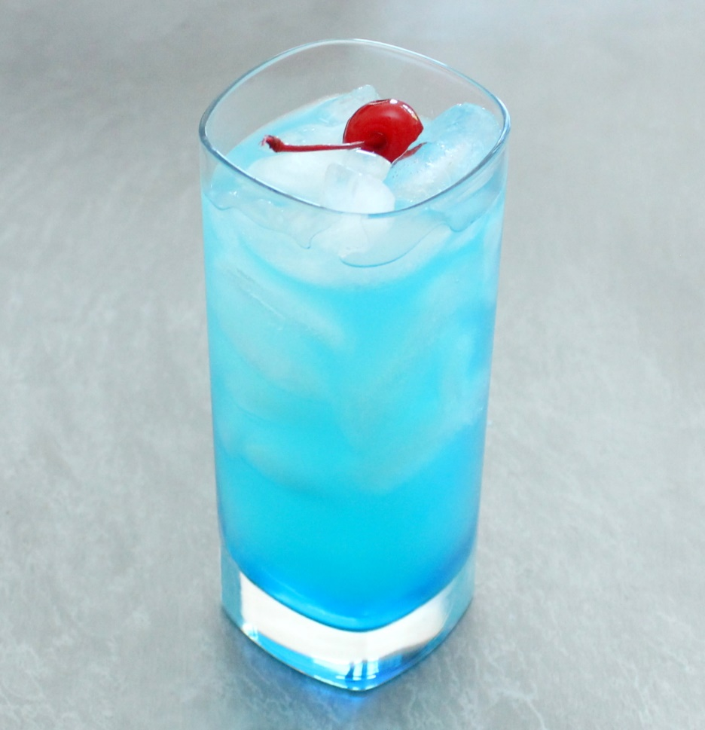](https://howtofeedaloon.com/how-to-make-a-blue-lagoon-cocktail/)

[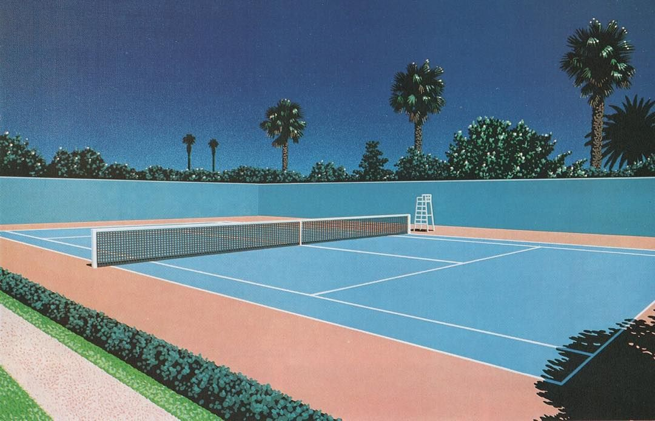](https://www.pinterest.co.uk/pin/319474167296539276/)

[](https://www.nh-hotels.nl/reisgidsen/barcelona/concert-barcelona)

Tickify