

Europass - CV |  | 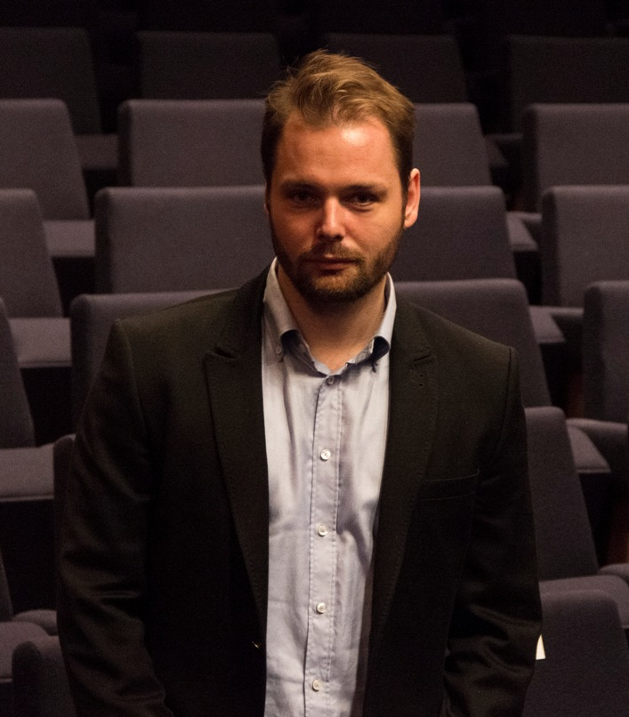
Personal data
Surname / Name |  | ŠTEFIK Ondrej, Ing.
Address |  | Wuppertálska, 17, 04023, Košice, Slovakia
Phone |  | Mobile:+421911810784
E-mails |  | stefik.ondrej@gmail.com; toadie2000@gmail.com
Nationality |  | Slovak
Date of birth |  | 07/23/1981
Sex |  | Male
Field of interest / Occupation |  | Information technologies and code-writing, Trading, services, electro-technics, financial management of the EU, Political events, security
Political skills
From - to  Engagement |  | 04/2015-03/05/2016  Candidate for a parliamentarian of the NC SR in elections of 2016
Practical working skills

From - to |  | 11/07/2016 - 05/05/2017
Occupation or job classification |  | Long-term course under the leadership of Global Logic, focusing on basic knowledge and programming in programming languages ​​and working with IT technologies: JAVA, C, JAVA-Script, Jquery, JSON, AJAX, HTML, CSS, Bootstrap, Material Design, UML.
 |  | Academy SOVY - Private grammar school, Dneperská 1, Košice 04012
From - to |  | 05/15/2015-01/01/2016
Occupation or job classification |  | Regional manager for Košice county in a national project " Support of the professional orientation of the pupils at elementary school towards a vocational education and preparation through the development of a polytechnic education targeted on working skills´ development and on work with a talent. "
Main activities and responsibilities |  | Managing individual activities in the national project in Košice county and in particular:  - negotiation-related activities with the elementary schools´ managements,  - varied organizational activities,  - support during personnel selections,  - securing the acquisition, delivery of material and technical equipment and usage of didactic tools for vocational classrooms in fields of education such as biology, chemistry, physics and technics,  - securing the consultancy, guidance, supportive materials and questionnaires,  - securing the continual education for the teachers of biology, chemistry, physics and technics at elementary schools.  Support of the polytechnical education at elementary schools and further education of the teachers and pupils at elementary schools of polytechnical education.  Support of the elementary schools pupils´ professional orientation towards vocational education and preparation by the implementation of the tools for the elementary school pupil´s potential orientation determination.  Work with equipment for elementary and secondary schools via execution and participation at vocational contests of vocational education and preparation.
Employer´s name and address |  | State institute of vocational education, Bellova 54/A, 837 63 Bratislava 37
Type of work or sector of economy |  | Project and financial management from EU sources,
From - to |  | 09/18/2012 – 03/15/2015
Occupation or job classification |  | General state adviser – section of European social fund´s management, Ministry of labour, social affairs and family SR.
Main activities and responsibilities |  | Execution of activities related to creation and preservation of a suitable system for implementation of programs supported by the EU resources and particularly: securing the execution and updating of internal procedure manual, handbooks and regulations which are being issued by the managing authority, regulation of authorities to which has been transferred execution of several competencies. Execution of activities related to adherence of state support´s conditions, processing and updating the documents related to offering the state support/support de minimis. Monitoring the relevant legal regulations and their transposition into the environment where are being implemented programmes supported by the EU resources.  Cooperation with the preparation of the methodical and legal statements suggested for smooth implementation of a programme supported by the EU resources. Managing and storing the documentation related to the methodical activity. Storing the documentation related to work activity. Participation on preparation process of new programme period 2013-2020. Offering cooperation at controls´ and audits´ performance, accepting corrective actions talking for a section of ESF management and deduction of its fulfillment.  Elaboration and coordination of action plans´ fulfillment to system deficiencies identified by the European Commission´s audit and forecasting the fulfillment of actions from the action plan for the certification authority.
Employer´s name and address |  | Špitálska 4,6,8, Bratislava 816 43, Ministry of labour, social affairs and family SR.
Type of work or sector of economy  From - to |  | Financial management, ESF publicity, orientation and applying of the EU structural funds´ rules, operational programmes of the EU.  09/02/1999 – 08/31/2012
Occupation or job classification |  | state service – professional soldier
Main activities and responsibilities |  | Managing the training of aviation specialists AF SR in operation and maintenance of special aerial electric ground security devices and means. Proposal of systemic solutions, legislative and conceptual activity in conditions of a military aerial educational system. Processor and coordinator of learning and educational projects of the training aimed at the training of operators of electrical security means of armed forces SR. Material responsibility for educational and training-related devices of aerial operational service. Cooperation and participation at legislative and work and security-related measures with a Labour Inspectorate from a Ministry of defence SR and an Aviation Authority MOSR. Guarantee of learning and educational process and creation of learning and educational projects of aerial devices for the specialists in aerial operational service, individual trainings and forces trainings of fighting activity and preparation at the tactical level.  Managing and steering of human resources in various conditions with regard to an extreme environment endangering health and life of subordinates. Responsibility for a technical state of aerial technics and its operational ability. Material and tangible responsibility for the material of various nature and category, mainly wiring, automobile and aerial in value over 10 000 000 €.
Employer´s name and address |  | Armed Forces of the Slovak Republic– more military formations and units.
Type of work or sector of economy |  | Securing the partial tasks in the system of state´s outer security realized by AF SR.
Education and preparation
From - to |  | 2010 – interrupted
Name of gained qualification |  | 3.3.16 Economics and management of a company
Main subjects / professional skills |  | Management of innovations, quality management, project management, marketing management,
Name and type of organization which is offering education and preparation |  | University of Economics in Bratislava
Educational grade in national or international classification |  | Academic education of the III. grade, expected a degree in field „doctor of philosophy“ abr.: PhD.
From - to |  | 2001 -2007
Name of gained qualification |  | Field of study: 921 1801 Civil security, specialization: Security management
Main subjects / professional skills |  | State exams from subjects: Security legislation, Solving the crisis situations, Security management, Security service of a company, System of a peripheral security
Name and type of organization which is offering education and preparation |  | University of Žilina, Faculty of Special Engineering
Educational grade in national or international classification |  | Academic education I. and II. grade, assigned degrees on level „Bachelor“ abr.: Bc. and „engineer“ abr..: Ing.
From - to |  | 1995-1999
Name of gained qualification |  | Field of study: 95-26-6-02 Devices of heavy-current electro-technics, specialization ČVO 441 Airport operational service
Main subjects / professional skills |  | Airport operational electric and pressure devices and their technical operation, Material management, Military preparation basic and vocational.
Name and type of organization which is offering education and preparation  Educational grade in national or international classification |  | Military grammar school SNU in Banská Bystrica (first year)- cancellation, Military aerial secondary school in Košice  Complete secondary school vocational education
Personal competency
Mather language |  | Slovak language
Other languages
Self-evaluation |  |  | Understanding |  |  |  |  | Speaking |  |  |  |  | Writing
European level (*) |  |  | Listening |  | Reading |  |  | Verbal interaction |  | Separate verbal speech
Language |  |  | EL | B1 |  | B1 |  |  | B1 |  |  | B1 |  | B1
Language |  |  | RL | A2 |  | A2 |  |  | A2 |  |  | A2 |  | A2
Language |  |  | FL | A1 |  | A1 |  |  | A1 |  |  | A1 |  | A1
 |  | (*) Level according to Common European framework (CEF)
Social skills and competences |  | - ability to handle stress,  - ability to work in a team,  - ability to lead a team,  - ability to solve conflicts,  - ability to engage the attention and to present,  - good ability to adapt in a multicultural environment.
Organizational skills and competences |  | - leading people and managing processes,  - sense for the organization,  - good experience with managing and coordination of the project and the team,  - certificate of graduation more courses such as time management, stress handling etc.
Technical skills and competences |  | - Certificate of the lector´s vocational competency  Certificate´s scope:  - initial guidance of operations about SHPW and PO  - training related to operation and maintenance of Aerial operational technics (AOT)  - execution and confirmation of staff´s knowledge  Type of electronic devices: Launching ground devices SPZ-1, Hot-air heater TO-5, Universal launching electric device SUEZ-M. SUEZ-3, Mobile accumulator chargable stations PANS-1M, PANS-20, PANS-10  Issued by : IP MO SR  - Certificate of vocational competency in electrotechnics Certificate´s scope: Electrotechnician for activity managing or for operation managing according to article 87, General regulation - 21-2  - Certificate of vocational competency in electro-technics  Certificate´s scope:  Electrotechnician for activity managing or for operation managing according to § 23 from Notice 718/2002 statute.  Issued by: Vocational training aviation school, Košice  - Certificate of vocational competency of persons  Certificate´s scope:  The operation, running operation and maintenance of aerial operational electric technics PANS-20, PANS- 10, PANS-1M, TO – 5, SUEZ M, SUEZ 3, SPZ-1
Computer skills and competences |  | User level of operating systems Linux, Windows, Android,  Installations of simple programmes,  User level of Microsoft office package  and other.
Artistic skills and competences |  | Playing the guitar
Other skills and competences |  | martial arts, self-defence, combat shooting, fighting military training (shooting from handguns, surviving in terrain etc.)
Driving licence |  | A, B, C, T  Driving license of confirmation of driver´s competency to drive fighting band and wheel technics.
Additional information |  | Certificate „Lector minimum for security technicians“  Subjects´ composition: Adults´ pedagogy, Psychology and communication training, Content structure of SHPW trainings  Issued by: Technical university in Košice, Institute of the lifetime education  Certificate for participation at the training for the need of psychological preparation. Issued by: Personal authority AF SR, Centre of psychological and sociological activities  Certification of the language test´s execution according to NATO STANAG 6001 in the English language  Listening with comprehension (listening) 1,  Speaking 1  Reading 1  Writing 1+  Issued by the Ministry of defence SR, language institute

