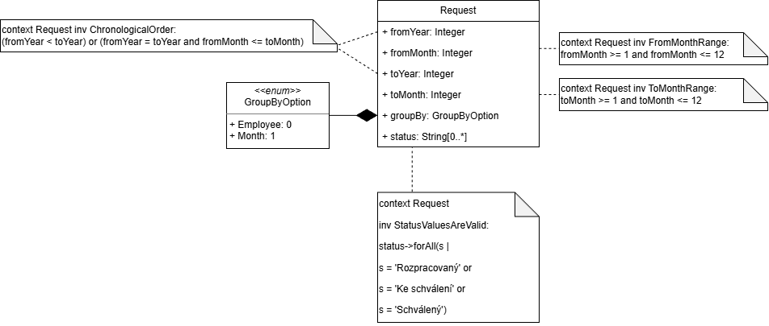
https://vykazy.ci.ujep.cz/api/contracts/{id}/timesheets?fromYear=...&fromMonth=...&toYear=...&toMonth=...&groupBy=...&status=...

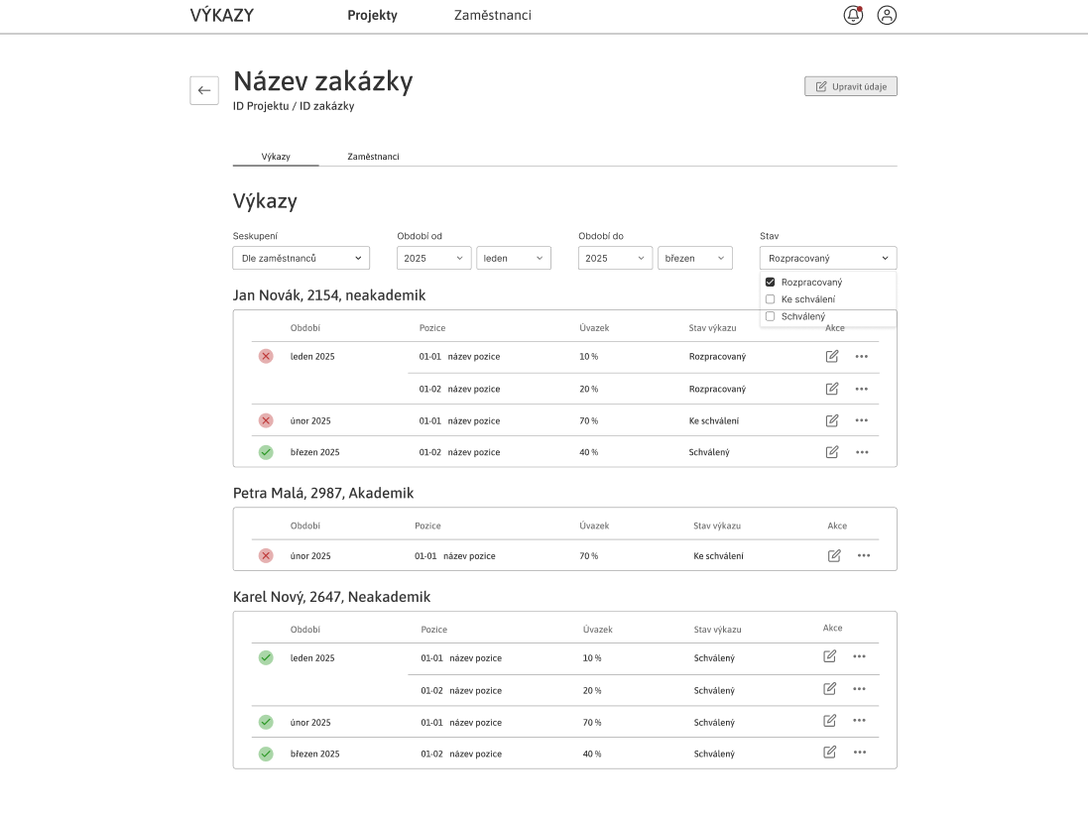
https://vykazy.ci.ujep.cz/api/contracts/8f92d1ce-9c44-4e6e-bb72-1baa8d8870fd/timesheets?fromYear=2025&fromMonth=1&toYear=2025&toMonth=3&groupBy=0&status=Rozpracovaný

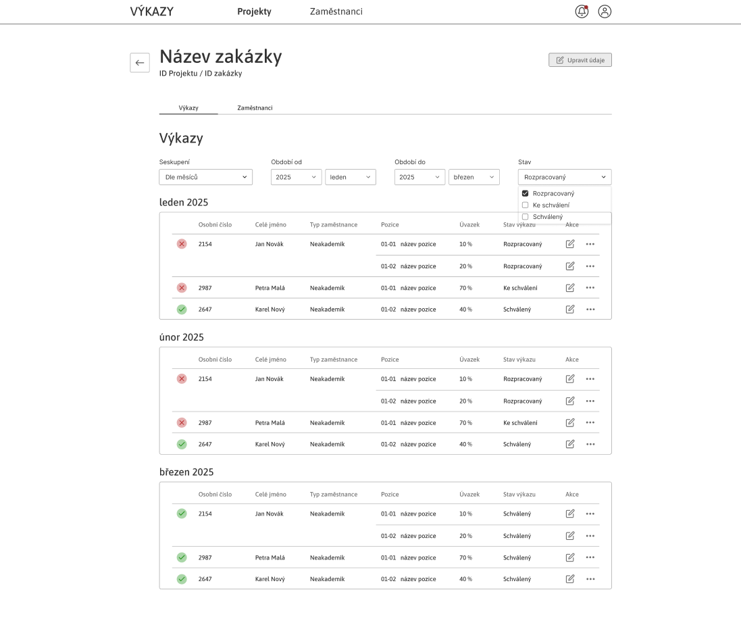
https://vykazy.ci.ujep.cz/api/contracts/8f92d1ce-9c44-4e6e-bb72-1baa8d8870fd/timesheets?fromYear=2025&fromMonth=1&toYear=2025&toMonth=3&groupBy=1&status=Rozpracovaný

