Understanding requirements.txt

1. Web Framework & API
These tools act as the "bridge" between your Next.js frontend and your Python logic.
- fastapi:
  - Why: It is the core framework for building your backend. It handles incoming requests from your frontend and routes them to the correct Python functions.
  - Where: In your main routing files (e.g., main.py).
  - How: When Next.js asks, "Find schemes for this user," FastAPI receives that HTTP request, triggers the AI logic, and sends the final matched schemes back as a JSON response.
- uvicorn:
  - Why: FastAPI is just a set of rules; Uvicorn is the actual web server engine that runs those rules and listens to the internet (or your local network).
  - Where: It is launched from your terminal to start the backend.
  - How: It continuously runs in the background, keeping port 8000 open so your frontend can communicate with the backend.
- pydantic & pydantic-settings:
  - Why: For strict data validation. Government logic requires exact data types (e.g., Income must be a number, not text). Pydantic enforces these rules.
  - Where: In your schema and configuration files.
  - How: If the frontend accidentally sends an age of "Twenty" instead of 20, Pydantic catches the error immediately before it crashes your AI logic. pydantic-settings does the same thing for your .env file, ensuring your API keys are loaded correctly.
- python-multipart:
  - Why: To handle form data and file uploads.
  - Where: In the API endpoints.
  - How: If you eventually want to build an admin panel where someone can upload a new CSV of schemes directly through the website, this package processes that file upload.

2. AI & LLM Orchestration
These tools control how the AI thinks and processes information.
- langchain-core & langchain-openai:
  - Why: LangChain is a framework that standardizes how you talk to different AI models. Even though you are using Cerebras (not OpenAI), Cerebras is designed to accept the exact same API format as OpenAI.
  - Where: Inside the files containing your AI logic.
  - How: Instead of writing complex, raw HTTP requests to the Cerebras servers, these packages let you send prompts and receive responses using clean, simple Python commands.
- langgraph:
  - Why: Standard AI just chats. LangGraph forces the AI to follow a strict, stateful workflow (a flowchart).
  - Where: In the core reasoning files of your backend.
  - How: It ensures the system follows exact steps: First, search the database. Second, read the eligibility rules. Third, check the rules against the user's profile. Fourth, format the output. It prevents the AI from skipping steps or making guesses.

3. Vector Database & Embeddings
These tools allow the system to understand the meaning of the text in your dataset.
- qdrant-client:
  - Why: This is the official Python communicator for your Qdrant vector database.
  - Where: In your database connection setup and data ingestion scripts.
  - How: It allows your Python code to push new scheme vectors into Qdrant and query Qdrant to find schemes that semantically match a user's profile.
- sentence-transformers & torch:
  - Why: To convert human language (like the "details" column of your CSV) into vectors (lists of numbers). torch is the machine learning engine that powers the transformers.
  - Where: In your data ingestion script and the search logic.
  - How: Because you are running embeddings locally to save costs, this package downloads a small, free AI model to your laptop. When you feed it a paragraph about a farming scheme, it translates that paragraph into a mathematical coordinate that Qdrant can store and search.

4. Primary Database (Local PostgreSQL)
These tools manage your structured, relational data.
- SQLAlchemy:
  - Why: It is an Object-Relational Mapper (ORM). Writing raw SQL queries (like SELECT * FROM users) inside Python can get messy and is prone to security risks.
  - Where: In your database model files.
  - How: It allows you to define your PostgreSQL tables as normal Python classes, making it much easier to save, update, and delete user profiles using Python syntax.
- psycopg2-binary:
  - Why: SQLAlchemy is just a translator; it still needs a driver to physically connect to the PostgreSQL database engine.
  - Where: It operates silently in the background when you establish your database connection.
  - How: It handles the actual network protocol required to send and receive data from pgAdmin 4.

5. Data Processing & Utilities
These are the foundational tools for preparing your environment and data.
- pandas:
  - Why: It is the industry standard for handling tabular data (like spreadsheets and CSVs) in Python.
  - Where: In the script you will use to prepare your dataset.
  - How: You use it to load corrected_schemes_data.csv, filter out empty rows, combine columns together, and loop through the 3,400 schemes so they can be fed into the embedding model.
- python-dotenv:
  - Why: For security and environment management.
  - Where: At the very start of your application startup.
  - How: It automatically finds your .env file, reads your hidden passwords and API keys, and securely loads them into the system's memory so your code can use them without you having to type passwords directly into your scripts.

Here is the exact conceptual journey of how we find the perfect schemes for a user, with absolutely zero code:

Step 1: The "Profile Translation" (User Input)
A citizen fills out the Next.js form. The backend receives a neat package of facts: Age 22, Female, State: Karnataka, Income: ₹1,50,000, Occupation: Student, Caste: OBC.
We save this in PostgreSQL so they don't have to type it again next time.
Then, we take those facts and translate them into a natural language sentence: "Schemes for a 22-year-old female student belonging to OBC category in Karnataka with an annual family income of 1.5 lakhs."

Step 2: The "Hard Filter" (The Bouncer)
We don't want the AI to waste time reading schemes the user obviously doesn't qualify for.
Before we do any complex AI math, we tell Qdrant to act like a bouncer. We say: "Immediately block any scheme where the 'State' tag does not equal 'Karnataka' or 'Central'." Instantly, the pool of 3,400 schemes drops down to maybe 300 relevant ones.

Step 3: The "Semantic Match" (Vector Search)
Now we take that translated sentence from Step 1 and pass it through your local HuggingFace embedding model. It turns that sentence into a vector (a long list of coordinates).
Qdrant takes this "User Coordinate" and plots it on a map alongside the 300 remaining "Scheme Coordinates." It measures the distance between them.
Because the user vector mentions "Student," "Female," and "Education," it naturally drifts closest to schemes about scholarships, women's empowerment, and youth laptops.
Qdrant grabs the Top 10 closest schemes and hands them back to us.

Step 4: The "AI Auditor" (The Cerebras Brain)
Here is the problem: Qdrant only knows similarity, it doesn't know logic. A scheme might say "Income MUST be strictly under ₹1,00,000." Qdrant might pull it anyway because the words match closely.
This is where the high-end magic happens. We take those Top 10 schemes and send them to the Cerebras LLM (gpt-oss-120b). We give the AI a very strict instruction:
- "You are a strict government auditor. Here is the User's exact profile. Here is the exact eligibility text of this scheme. Do the math. Check the gender. Check the caste. Does this user qualify? Answer YES or NO, and give a 1-sentence reason."
The LLM acts as the human brain. It reads the fine print of all 10 schemes. It realizes the user's income is ₹1.5L, so it rejects the scheme that requires under ₹1L. It narrows the 10 schemes down to the 3 perfect, mathematically verified matches.

Step 5: The "Document Extraction" (Final Polish)
For those 3 perfect matches, the LLM takes a quick look at the documents column for each scheme. It reads the messy text and formats it into a clean, bulleted checklist (e.g., 1. Aadhaar Card, 2. Income Certificate).
Finally, FastAPI packages those 3 verified schemes, the AI's explanation of why they qualify, and the document checklists, and shoots it back to the Next.js frontend for the user to see.

Summary of the Funnel:
3,400 Total Schemes $\rightarrow$ (Filtered by State) $\rightarrow$ 300 Schemes $\rightarrow$ (Vector Search by Context) $\rightarrow$ 10 Schemes $\rightarrow$ (LLM Logical Audit) $\rightarrow$ 3 Perfect Matches.

The "Conversational Government Agent" RAG Combo
To make this work seamlessly, you need a combination of three advanced RAG techniques:

1. Memory-Augmented RAG (The "Interviewer")
- Why you need it: A chatbot doesn't get all the info at once. A user might just say, "Hi, I need financial help." The bot needs memory to remember what it has asked and what it still needs.
- How it fits your dataset: The bot will have an internal checklist (State, Age, Income, Gender, Occupation, Caste). If the user says "I'm a 22-year-old student from Karnataka," the bot's memory checks off Age, Occupation, and State, and then naturally replies, "Got it! To find the best scholarships, could you tell me your caste category and approximate family income?"

2. Self-Querying Retrieval (The "Translator")
- Why you need it: Your CSV has strict categorical columns like state (e.g., "Telangana", "Central") and level.
- How it fits your dataset: When the chatbot realizes it has enough information to do a search, it uses a Self-Querying Agent. This agent takes the chat history and translates it into a database command. It automatically separates the Hard Filters from the Semantic Search.
  - Example: It tells Qdrant: FILTER: state == 'Karnataka' OR level == 'Central' and SEARCH: "financial help for students".

3. Evaluative / Agentic RAG (The "Fact-Checker")
- Why you need it: Your dataset's eligibility column is complex text (e.g., "Must not have availed any other government scheme" or "Annual income should not exceed ₹75,000/-"). Vector search cannot do math or logic.
- How it fits your dataset: Once Qdrant returns the top 5 schemes, the chatbot doesn't just blindly show them to the user. Behind the scenes, the LLM reads the exact eligibility column for those 5 schemes, compares them to the facts gathered in the chat, and throws away any where the user doesn't strictly qualify.

How the New Chatbot Flow Works (Conceptually)
- The Greeting: User types, "I'm a farmer looking for machinery subsidies."
- The Interview: The LLM checks its required profile list. It sees "Occupation: Farmer", but it's missing the State and Income. It asks the user for them.
- The Trigger: Once the core details are collected, the LLM silently triggers the Self-Query Retriever.
- The Search: Qdrant filters by the user's state and pulls the most relevant schemes based on the vector embeddings of your details and benefits columns.
- The Audit: The LLM reads the eligibility of the results, drops the invalid ones, and reads the documents column of the winning schemes.
- The Final Answer: The chatbot replies: "I found 2 perfect schemes for you! Here is the 'AGR 2 Farm Mechanization Scheme'. Based on what you told me, you qualify. To apply, you will need to get these 3 documents ready..."

To make the bot handle both cases smoothly, we introduce an Intent Router at the very beginning of the chat. When the user types a message, the LLM first acts as a traffic cop.

Case A: The "Specific" Route (e.g., "I want Gruha Jyothi Yojana")
- The Router: The AI reads the prompt and realizes, "Ah, the user is asking for a specific scheme by name."
- The Direct Fetch: Instead of doing a broad semantic search, the bot tells Qdrant: "Search strictly for the name 'Gruha Jyothi Yojana' and State 'Karnataka'."
- The Audit: The bot pulls the scheme, looks at the user’s profile (22 years old), and reads the eligibility rules.
- The Answer: It replies: "Yes, you qualify for Gruha Jyothi! Here are the steps to apply... and here are the documents you need..." (Or, if they don't qualify, it says: "Actually, you need to be the head of the household to apply for this, but here are the documents anyway...")

Case B: The "General" Route (e.g., "What schemes can I get?")
- The Router: The AI reads the prompt and realizes, "The user doesn't know what they want. Let's do a discovery search."
- The Semantic Fetch: The bot tells Qdrant: "Find me the top 10 schemes related to students, youth, and education in Karnataka."
- The Audit: It checks the strict eligibility for all 10.
- The Answer: It replies: "Based on your profile, I found 3 perfect schemes for you. Scheme 1 is X, Scheme 2 is Y..."

The "Aha!" Moment for the Architecture
Because we are using an Agentic AI, you don't need two different bots. The Cerebras LLM is smart enough to dynamically choose whether to do a "Name Search" (Case A) or a "Vector Meaning Search" (Case B) based purely on what the user types.

How They Communicate (The "Shared Memory")
In LangGraph, nodes don't actually "talk" directly to each other. Instead, they all share a digital clipboard called the State.
When a user messages the bot, here is how the clipboard gets passed around:
- The Setup: A new clipboard is created containing the chat_history.
- Node 1 (Profile Manager): Reads the clipboard. If it finds the user's profile is complete, it writes profile_status: complete on the clipboard and hands it to Node 3. (If not, it hands it to Node 2 to ask a question and pauses the graph).
- Node 3 (Intent Router): Reads the user's last message on the clipboard. It writes route: Case A or route: Case B on the clipboard. LangGraph sees this and automatically routes the clipboard to Node 4A or 4B.
- Node 4A/4B (Fetchers): Takes the clipboard, searches your Qdrant database, and staples the top 5 raw scheme files (from your CSV) to the clipboard. Hands it to the Auditor.
- Node 5 (Strict Auditor): Takes the clipboard, looks at the User Profile on page 1, looks at the 5 raw schemes on page 2. It crosses out the ones the user doesn't qualify for, writes down why they qualify for the remaining ones, and passes it to the Clerk.
- Node 6 (The Clerk): Writes the final, polite chatbot message (using the documents list) and sends it to the user's screen.

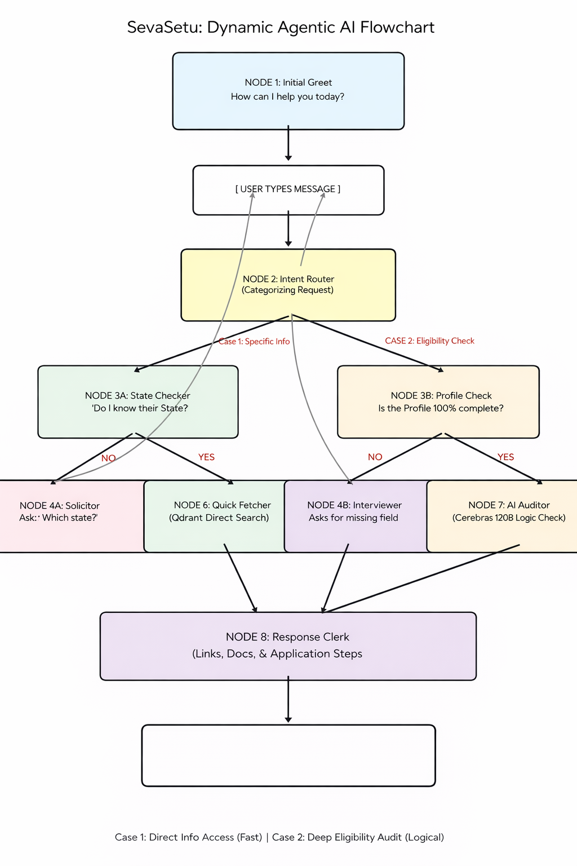
================================================================================
PROJECT: SEVASETU - AGENTIC GOVT. SCHEME ASSISTANT
================================================================================

1. TECH STACK
--------------------------------------------------------------------------------
- Frontend: Next.js (Modern UI / Chat Interface)
- Backend: FastAPI (High-performance Python API)
- Relational Database: PostgreSQL via pgAdmin 4 (User Profiles & History)
- Vector Database: Qdrant (Local Semantic Search for 3,400+ Schemes)
- AI Model: Cerebras Llama-3-70b/120b (High-speed inference via API)
- Orchestration: LangGraph (State-machine for Agent workflows)
- Embeddings: Local HuggingFace Models (Sentence-Transformers)

2. RAG ARCHITECTURE (RETRIEVAL-AUGMENTED GENERATION)
--------------------------------------------------------------------------------
- Why: To provide real-time, hallucination-free scheme data without retraining.
- Retrieval: Uses semantic similarity search in Qdrant based on 'Search Context'
(Scheme Name + Category + Use/Description).
- Augmentation: Combines User Profile facts with retrieved scheme eligibility text.
- Generation: LLM processes the facts to verify eligibility and format checklists.

3. AGENTS & DESCRIPTIONS
--------------------------------------------------------------------------------
- NODE 1: Profile Manager: Monitors the user's data state. Identifies if
mandatory fields (State, Age, Income) are missing.
- NODE 2: Intent Router: Analyzes user input to decide between 'Direct Info'
(Case 1) or 'Eligibility Audit' (Case 2).
- NODE 3: The Solicitor: Specific to Case 1. Only asks for the State if it is
needed to filter specific scheme names.
- NODE 4: The Interviewer: Specific to Case 2. Conducts a polite conversation
to gather missing profile details.
- NODE 5: The Fetcher (Specific/Semantic): The "Librarian." Queries Qdrant
using the "Primary Key" logic (Name or Description/Use).
- NODE 6: The Strict Auditor: The "Brain." Uses the LLM to cross-reference
the User Profile against the 'Eligibility' column text.
- NODE 7: The Response Clerk: The "Writer." Formats the final answer, links,
and document checklists for the UI.

4. LANGGRAPH ROUTING & FLOW
--------------------------------------------------------------------------------
- PHASE 1: Detection. The Router detects if the user wants information about
a specific scheme or wants to find what they qualify for.
- PHASE 2: Data Gathering. The graph loops between the user and the
Interviewer/Solicitor nodes until the 'Hard Filters' (State) or full
Profile are satisfied.
- PHASE 3: Retrieval. The Fetcher pulls relevant rows from the 3,400-scheme
prepared CSV data stored in Qdrant.
- PHASE 4: Reasoning. Case 1 bypasses the Auditor for speed. Case 2 passes
through the Auditor for mathematical/logical verification.
- PHASE 5: Delivery. The Clerk finalizes the message.
================================================================================

