第1章 Semantic Knowledge Engineering(SKE) 1

1.1 Conceptual Modeling with Semantic Networks 1

1.2 Decision Trees 2

第2章 课本知识的语义网建模 3

第3章 学习过程的基本框架 5

第4章 模糊决策 7

4.1 模糊集fuzzy set 7

4.2成员关系函数membership function. 7

4.3 文字/语言变量verbal/linguistic variables 8

4.4 Fuzzy inference 8

第5章 ITS框架 8

4.1 专家模块 9

4.2 学生模块 10

4.3 指导模块 12

4.4 指导环境 12

## 第1章 Semantic Knowledge Engineering(SKE)

In order to build knowledge-based systems we need to have some basic understanding of the terms knowledge and knowledge representation.

We may define knowledge as a “theoretical or practical understanding of a subject or a domain”. In a classic book, knowledge is understood as a set of propositonal beliefs, and a such is declarative. Knowledge Representation may be undertuood as “symbolic encoding of propositions believed”.

### 1.1 Conceptual Modeling with Semantic Networks

Semantic Networks (SN)are a classic AI knowledge representation technique developed independently by many researchers in several domains.Their introduction to the ﬁelds of AI and computer scienceis often attributed to Quillian. Moreover, the representation itself was not standardized. Originally, neither of them had a uniform logical representation.

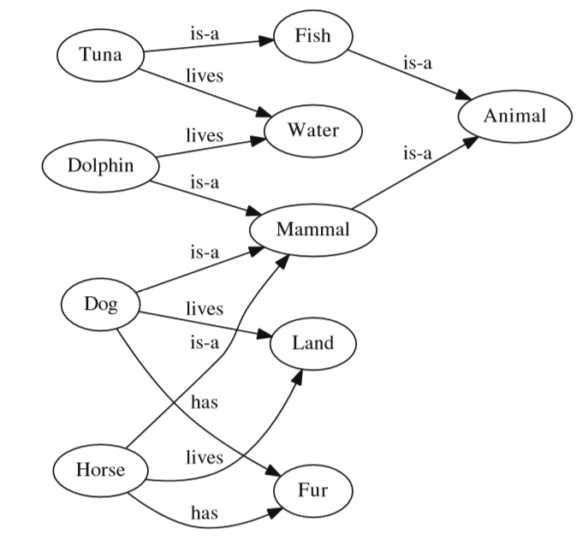

### 1.2 Inference with Decision Trees

The nodes of a tree contain conditional expressions while the edges correspond to the value of this expression. The final decision determined by the tree is given in leaves.

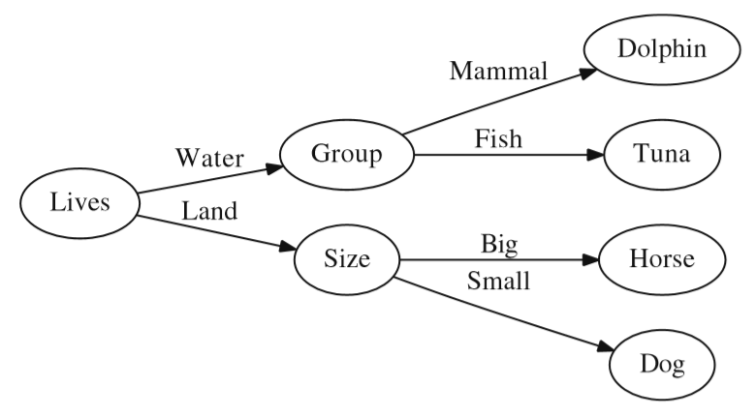

### 1.3 Knowledge Bases

Specific KR methods are used to capture and store knowledge in a Knowledge Base (KB). In fact, a KBS is composed of two main components:

* A knowledge base that contains some domain-specific knowledge, but is encoded with the use of domain-independent method (selected KR method), and
* An automated inference mechanism (engine) that infers new facts basd on given facts and rules.

In the case of KBS these two components will in fact be a rule base and a rule-based inference engine.

Having a rule based, a number of automated reasoning techniques can be used by the inference engine. One of the two main inference strategies is Forward Chaining (data driven) which allows for the drawing of conclusions based upon the input knowledge. The second one is Backward Chaining (Goal Driven) which allows for the proving of statemetns in terms of the current knowledge, or demonstrate what facts are needed to satisfy given goals.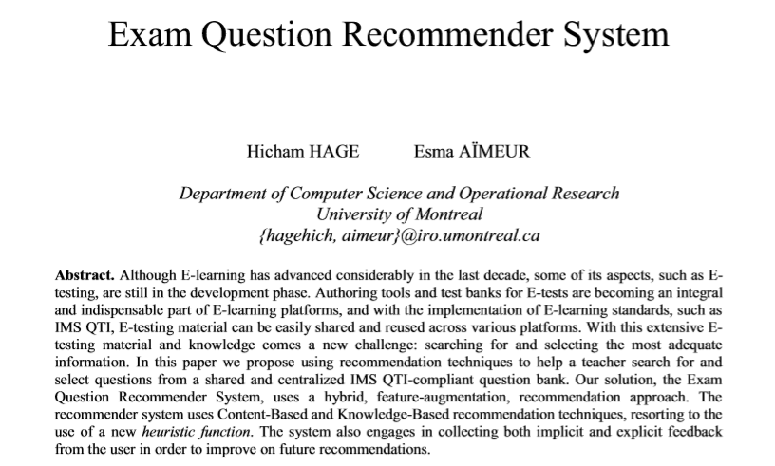

## 第2章 课本知识的语义网建模

语义网建模使用我们自己开发的KRLab软件。课本的一章做成一个语义网文件，每章中的小节做成KRLab中的一个Diagram。

每一小节的知识分类为：概念定义、定律陈述、公式表达，所以每个KRLab中的Diagram都可以包括这三方面的内容。为了自动产生学习问题和评分，每个Diagram还添加相关故事内容和小节总分的结点。为了方便问题的自动生成，网络中的语义结构分为以下几种：

* ConceptType，纯粹的概念型
* PrincipleType，纯粹的原理型
* CalculationType，纯粹的计算型

一个语义网可以是其中一种，或多种类型的混合型。从文件中读取网络，并进行网络解析，将网络类型存在一个链表中。

下面我们分别讲述故事、概念、定律和公式的语义建模。

1 故事

2 概念

3 定律

4 公式

4.1. 公式的语义图建模

公式语义网包括：

（1）变量名；

（2）变量符号；

（3）变量单位；

（4）变量的定义式：变量的定义式用一个RESULT边，将一个运算符结点与一个变量结点连接起来，则这个变量结点对应了这个变量的定义式。

（5）公式本身；

4.2. 公式语义图的解析

在FormulaElement类的Check()函数中对语义图中的每个运算符的语义进行检查。进行语义图的语法确认，检查是否有错误。

4.3. 公式的字符表示

利用MathNet的Symbolics库，将公式字符串翻译为公式的字符表达式。

## 第3章 学习过程的基本框架

1. 学习问题的格式

当学生打开一个小节进行学习时，如果学生有该小节的学习记录和成绩。如果学习成绩满意，可以继续开始，否则可以重新开始新的学习。

如果学生没有学习记录，则作为一个新的考试过程，从基本概念、定律/原理和公式计算逐个进行。从编程的角度来看，每个问题都是一个Problem。为此，我们定义了多个Problem的派生类，用于定义基本概念、定律和公式问题。其中ProblemType表示问题类型，物理中的计算问题和数学中的计算问题有些许区别，所以分别用一个类进行表述。

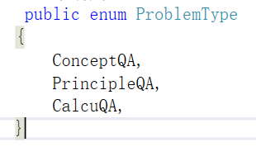



1.1 概念问题格式

（1）写出每个物理量的定义式；（2）

1.2 物理计算问题格式

分为难度不同的5个等级：0,1,2,3,4。

等级为0的问题适用于初次学习的学生，题目内容包括：有哪些物理变量，分别列出这些变量的名称；

等级1：某个物理量的定义式是什么？其单位是什么？

等级2的难度大于等级1，只有完成等级1的学生才可以进入等级2的学习，题目内容包括：已知某些物理量，得到某个物理量的计算式；

等级3的难度大于等级2，完成等级2之后，可以进入等级3的学习，题目内容主要是已知某些物理量的值，计算给定物理量，包括正确给出物理量的大小和单位。

等级4的难度大于等级3，完成等级3之后，才可以进入等级4的学习，题目内容主要是必须多个物理公式联立求解才能得到相应的物理量。

2. 学生成绩的评定方法

语义网是课程的一章做成一个文件的。目前以一章作为一个完整考试内容，满分100。当学生打开学习主题时，系统读取这个文件中的某个Diagram，形成一个语义网Semantic Network。该语义网必须要有一个分数结点，指明该Diagram对应的小节是多少分，占比整个一个章是多少。

## 第4章 模糊决策

### 4.1 模糊集fuzzy set

In contrast to classical sets, the membership degree of the elements of fuzzy sets can vary in infinite numbers between the range of [0,1].

### 4.2成员关系函数membership function.

Fuzzy sets $\tilde{A}$ are defined by membership functions $μ\tilde{A}(x)$. Although there are a large number of membership functions, generally triangular, trapezoidal, Gaussian, and bell-shaped membership functions are used.

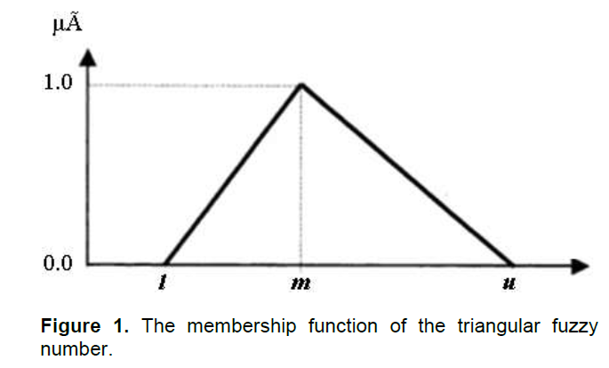

### 4.3 文字/语言变量verbal/linguistic variables

Linguistic variables are used to express human’s feelings and decisions. The value of linguistic variables in natural languages is not numbers but words or sentences. The studies in the literature indicated that the evaluations via linguistic variables are more comfortable for the decision-makers and more realistic results are revealed.

### 4.4 Fuzzy inference

Fuzzy inference involves the following processes:

Fuzzification

Aggregation

Composition

Defuzzification

## 第5章 ITS框架

Computer-assisted instruction evolves toward intelligent tutoring systems (ITSs) by passing three tests of intelligence. First,the subject matter, or domain, muste be “known” to the computer system well enough for this embedded expert to draw inference or solve problems in the domain. Second, the system must be able to deduce a learner’s approximation of the knowledge. Third, the tutorial strategy or pedagogy must be intelligent in that the “instructor in the box” can implement strategies to reduce the difference between expert and student performance. Figure 1 illustrates the basic modules of ITSs.

The expert module contains the domain knowledge. The student diagnostic module diagnoses what the student knows. The instructor module identifies which deficiencies in knowledge to focus on and selects strategies to present that knowledge. The instructional environment and human-computer interface channel tutorial communication.

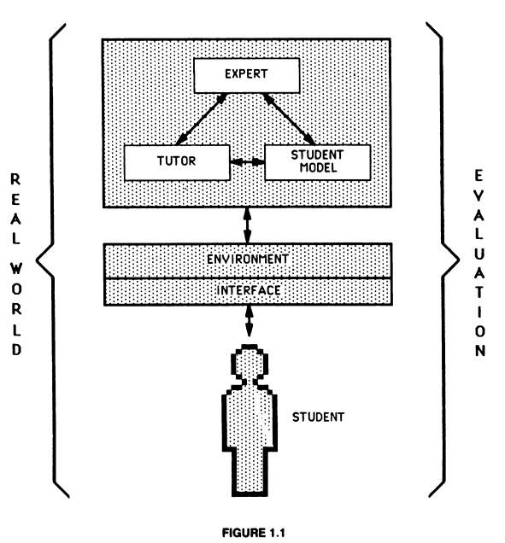

### 5.1 专家模块

Any expert module must have an abundance of specific and detailed knowledge derived from people who have year of experience in a particular domain. Consequently, much effort is expended in the research field of ITSs for discovering and codifying the domain knowledge. Thus, investigating how to encode knowledge and how to represent such expertise in an ITS remains the central focus of developing an expert module.

Knowledge-engineering tools and techniques, that is, ways of extracting and codifying information, are becoming more and more useful for ITS development as attention is paid toward making representations more faithful to the breadth and depth of expert reasoning.

Another approach to encoding the domain knowledge simulates not only the knowledge but also the way a human uses that knowledge. In this area of cognitive modeling, the cognitive science community sees the greatest payoff for the design and development of ITSs.

For the design of the domain module, a research question must be answered: how should different types of knowledge be treated----proceducral, declarative, and qualitative. Procedural knowledge is knowledge about how to perform a task and is well represented in the lieterature on expert systems as rule-based, production systems. Declarative knowledge contrasts with procedural knowledge in that it is fact-like, not specialized for a particular use. Finally, qualitative knowledge is the causal understanding that allows a human to reason about behavior using mental models of systems.

### 5.2 学生模块

The knowledge structure that depicts the student’s current state is the student model, and the reasoning process to develop it is called “student diagnosis”. Outputs from student diagnostic modules can be used for a variety of purposes, such as advancing through selected curriculums, coaching or offering unsolicited advice, generating new problems, and adapting sets of explanations.

The student model and the diagnostic module are tightly interwoven. The student model is a data structure, and diagnosis is a process that manipulates it. The two components must be designed together.

How much of the learner’s activity is available to the diagnostic program? This is the bandwidth qeustion. Most programs work on the low end of the information band where only the final state, that is, the student’s answer to a question, is available to the system. Access to an intermediate state allows the diagnostic module to assess the obserable physical activity. The bandwidth of potentially the greatest value allows ITSs access to the learner’s mental state, step by step as reasoning proceeds. Because the student diagnostic module needs reliable knowledge about the learner’s mental state, bandwidth is critical in designing ITSs.

In programming a studen diagnostic module, most ITS designers use the same knowledge representation scheme as was used in the expert module so that the expert and student modules actually share the same knowledge base. This is called the overlay method student modeling, where the student’s knowledge is represented as a subset of the experts. Hence, missing conceptions are represented, but not misconceptions.

The next level of complexity in student modeling is to represent misconceptions, erroneous and incorrect knowledge, as opposed to simply incomplete knowledge. Designing the student diagnostic module is a high-risk venture and, consequently, presents a wide range of issues to be investigated.

Student models can actually solve the same problems that students do and can therefore be used to predict the students’ answers. Solving problems requires some kind of interpretation process that applies knowledge in the student model to the problem. There are two common types of interpretation, one for procedural knowledge and one for declarative knowledge. Here we must make clear the difference between interpretation and diagnosis. In fact, diagnosis is the inverse of interpretation. Interpretation takes a knowledge base and a problem and produces a solution. Diagnosis takes a problem and a solution and produces a knowledge base.

* Differences between student and expert

ITSs usually employ an expert model as well as a student model. The expert model is used for many purposes, such as providing explanatins of the correct way to solve a problem. Because sutdents will move gradually from their initial state of knowledge toward mastery, student models must be ables

### 5.3 指导模块

An ITS should have three tutoring characteristics: (a) controls over the representation of the instructional knowledge for selecting and sequencing the subject matter; (b) capabilities for responding to students’ qeustions about instructional goals and content; and (c) strategies for determining when students need help an dfor delivering the appropriate help. The goal of the instructional module is to circumscribe the nature of teaching and to implement teaching as a solution to the educational communication problem.

Instructional knowledge routines should allow a student to relate theory to practice, to propose solutions, to develop more effective problem-solving strategies. They should also minimize the load on the student’s working memory while new concepts are being internalized.

Another challenge to artificial intelligence involves understanding instructional discourse. Such understanding, for example, would include strategies appropriately intervening in the course of a student’s problem-solving activity. Intervention, on the one hand, allows the ITS control of the tutorial process, but it is also important in keeping a learner on the right track by preventing inapropriate or incorrect learning. Beyond intervention, that is, offering advice, hints or guidance, other strategies are needed for answering questions and providing explanations.

### 5.4 指导环境

An instructional environment consists of those elements of an ITS that support what the leaner is doing: situations, activities, and tools provided by the system to facilitate learning. The activities and tools presented to the learner in an ITS always reflect an underlying educational philiosophy.

The instructional environment should be designed so that students feel self-monitored, allowing effective learners to assume responsibility for their own learning.