1.连线跳转

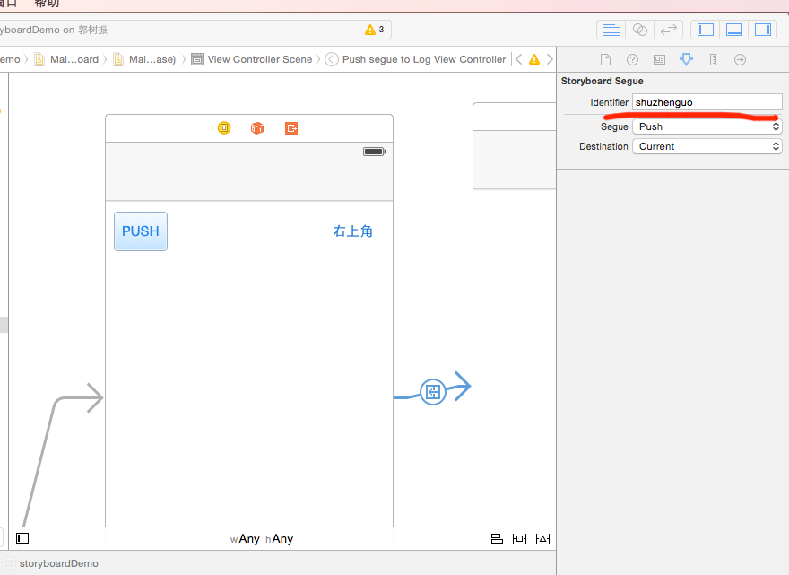

- (void)prepareForSegue:(UIStoryboardSegue \*)segue sender:(id)sender {

// segue.identifier：获取连线的ID

if ([segue.identifier isEqualToString:@"shuzhenguo"]) {

// segue.destinationViewController：获取连线时所指的界面（VC）

LogViewController \*receive = segue.destinationViewController;

receive.LogViewStr=@"LogViewStr";

// 这里不需要指定跳转了，因为在按扭的事件里已经有跳转的代码

// [self.navigationController pushViewController:receive animated:YES];

}

}

2.代码跳转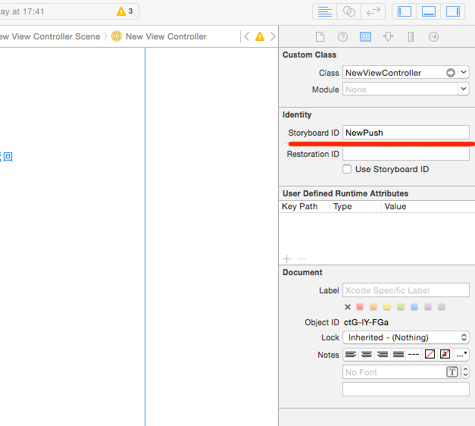

//跳转传值

- (IBAction)buttonPush:(id)sender {

UIStoryboard \*storyboard=[UIStoryboard storyboardWithName:@"Storyboard" bundle:nil];

NewViewController \*vc=[storyboard instantiateViewControllerWithIdentifier:@"NewPush"];

vc.str=@"dfvnfdkjnjk";

vc.str1=@"str1";

vc.str2=@"str2";

[self.navigationController pushViewController:vc animated:NO];

}