Used Java Library:

https://commons.apache.org/proper/commons-text/javadocs/api-release/org/apache/commons/text/similarity/CosineSimilarity.html

Explanation:

the cosine similarity between two lists of strings using the Apache Commons Text library's CosineSimilarity class. The feature input (user, corresponding features from location)- which act as two input list string. The input lists are converted into vectors where the keys are the unique elements from the lists, and the values represent the frequencies of occurrence of those elements. This is done using Java Streams and Collectors.

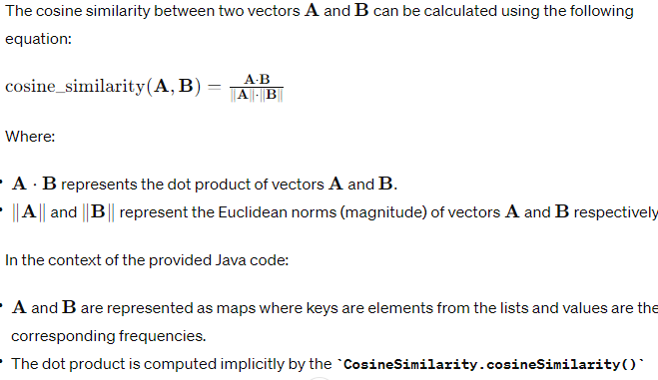



public static double cosineSimilarity(List<String> list1, List<String> list2) {

CosineSimilarity cosineSimilarity = new CosineSimilarity();

Map<CharSequence, Integer> vector1 = list1.stream()

.collect(Collectors.toMap(c -> c, c -> 1, Integer::sum));

Map<CharSequence, Integer> vector2 = list2.stream()

.collect(Collectors.toMap(c -> c, c -> 1, Integer::sum));

return cosineSimilarity.cosineSimilarity(vector1, vector2);

}