OneChannelAdmin UI Component Inventory
Generated: 2026-10-05T02:39:11.981Z
Base URL: https://admin.onechanneladmin.com
Pages scanned: 112
Unique components: 694

Summary by kind
Kind | Count
button | 120
card | 65
chart | 70
chip | 29
dropdown | 63
input | 46
metric-card | 54
nav-button | 80
sidebar | 40
table | 70
tabs | 47
toggle | 10

button

014-button-today — Today
Kind: button
First seen: Home / Dashboard (`/home/dashboard`)
Size: 64×40 at (893, 81)
Tag/role: div role=button
Classes: p-button.p-component.p-highlight
Selector: [role="button"][aria-label="Today"]
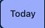

015-button-last-7-days — Last 7 days
Kind: button
First seen: Home / Dashboard (`/home/dashboard`)
Size: 96×40 at (956, 81)
Tag/role: div role=button
Classes: p-button.p-component
Selector: [role="button"][aria-label="Last 7 days"]


016-button-this-month — This month
Kind: button
First seen: Home / Dashboard (`/home/dashboard`)
Size: 96×40 at (1053, 81)
Tag/role: div role=button
Classes: p-button.p-component
Selector: [role="button"][aria-label="This month"]


017-button-this-year — This year
Kind: button
First seen: Home / Dashboard (`/home/dashboard`)
Size: 83×40 at (1149, 81)
Tag/role: div role=button
Classes: p-button.p-component
Selector: [role="button"][aria-label="This year"]


018-button-custom — Custom
Kind: button
First seen: Home / Dashboard (`/home/dashboard`)
Size: 76×40 at (1232, 81)
Tag/role: div role=button
Classes: p-button.p-component
Selector: [role="button"][aria-label="Custom"]
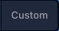

019-button-export — Export
Kind: button
First seen: Home / Dashboard (`/home/dashboard`)
Size: 113×40 at (1315, 81)
Tag/role: button
Classes: p-button.p-component
Selector: div:nth-of-type(1) > div:nth-of-type(3) > div:nth-of-type(1) > button:nth-of-type(1)


020-button-button — Button
Kind: button
First seen: Home / Dashboard (`/home/dashboard`)
Size: 40×32 at (1370, 167)
Tag/role: button
Classes: p-button.p-component.select-card-button.p-button-icon-only
Selector: div:nth-of-type(1) > div:nth-of-type(1) > div:nth-of-type(1) > button:nth-of-type(1)
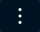

049-button-seed-sandbox — Seed Sandbox
Kind: button
First seen: Accounting / Account Statements (`/accounting/account-statements`)
Size: 123×42 at (910, 108)
Tag/role: button
Classes: tw-rounded-xl.tw-border.tw-px-4.tw-py-2.5.tw-text-sm.tw-text-slate-400
Selector: div:nth-of-type(1) > div:nth-of-type(1) > div:nth-of-type(2) > button:nth-of-type(1)


050-button-export-csv — Export CSV
Kind: button
First seen: Accounting / Account Statements (`/accounting/account-statements`)
Size: 129×42 at (1041, 108)
Tag/role: button
Classes: tw-inline-flex.tw-items-center.tw-gap-2.tw-rounded-xl.tw-border.tw-px-4.tw-py-2.5.tw-text-sm
Selector: div:nth-of-type(1) > div:nth-of-type(1) > div:nth-of-type(2) > button:nth-of-type(2)


051-button-refresh — Refresh
Kind: button
First seen: Accounting / Account Statements (`/accounting/account-statements`)
Size: 107×42 at (1178, 108)
Tag/role: button
Classes: tw-inline-flex.tw-items-center.tw-gap-2.tw-rounded-xl.tw-border.tw-px-4.tw-py-2.5.tw-text-sm
Selector: div:nth-of-type(1) > div:nth-of-type(1) > div:nth-of-type(2) > button:nth-of-type(3)


052-button-new — New
Kind: button
First seen: Accounting / Account Statements (`/accounting/account-statements`)
Size: 84×42 at (1292, 108)
Tag/role: button
Classes: tw-inline-flex.tw-items-center.tw-gap-2.tw-rounded-xl.tw-bg-blue-600.tw-px-4.tw-py-2.5.tw-text-sm
Selector: div:nth-of-type(1) > div:nth-of-type(1) > div:nth-of-type(2) > button:nth-of-type(4)


053-button-edit — Edit
Kind: button
First seen: Accounting / Account Statements (`/accounting/account-statements`)
Size: 28×28 at (1299, 262)
Tag/role: button
Classes: tw-p-1.5.tw-rounded-lg.tw-text-slate-400.hover:tw-text-blue-500
Selector: tr:nth-of-type(1) > td:nth-of-type(6) > div:nth-of-type(1) > button:nth-of-type(1)

054-button-delete — Delete
Kind: button
First seen: Accounting / Account Statements (`/accounting/account-statements`)
Size: 28×28 at (1331, 262)
Tag/role: button
Classes: tw-p-1.5.tw-rounded-lg.tw-text-slate-400.hover:tw-text-rose-500
Selector: tr:nth-of-type(1) > td:nth-of-type(6) > div:nth-of-type(1) > button:nth-of-type(2)

077-button-seed-sandbox — Seed Sandbox
Kind: button
First seen: Accounting / AP/AR Workflows (`/accounting/apar-workflows`)
Size: 115×38 at (918, 108)
Tag/role: button
Classes: tw-px-3.tw-py-2.tw-rounded-lg.tw-text-sm.tw-border.tw-border-slate-500/40.tw-text-slate-300.hover:tw-bg-slate-700/40
Selector: div:nth-of-type(1) > div:nth-of-type(1) > div:nth-of-type(2) > button:nth-of-type(1)


078-button-refresh — Refresh
Kind: button
First seen: Accounting / AP/AR Workflows (`/accounting/apar-workflows`)
Size: 99×38 at (1042, 108)
Tag/role: button
Classes: tw-px-3.tw-py-2.tw-rounded-lg.tw-text-sm.tw-border.tw-border-slate-500/40.tw-text-slate-300.hover:tw-bg-slate-700/40
Selector: div:nth-of-type(1) > div:nth-of-type(1) > div:nth-of-type(2) > button:nth-of-type(2)


079-button-export-csv — Export CSV
Kind: button
First seen: Accounting / AP/AR Workflows (`/accounting/apar-workflows`)
Size: 121×38 at (1148, 108)
Tag/role: button
Classes: tw-px-3.tw-py-2.tw-rounded-lg.tw-text-sm.tw-border.tw-border-slate-500/40.tw-text-slate-300.hover:tw-bg-slate-700/40
Selector: div:nth-of-type(1) > div:nth-of-type(1) > div:nth-of-type(2) > button:nth-of-type(3)


080-button-new-bill — New Bill
Kind: button
First seen: Accounting / AP/AR Workflows (`/accounting/apar-workflows`)
Size: 107×36 at (1277, 109)
Tag/role: button
Classes: tw-px-4.tw-py-2.tw-bg-violet-600.hover:tw-bg-violet-500.tw-rounded-lg.tw-text-sm.tw-font-medium.tw-text-white
Selector: div:nth-of-type(1) > div:nth-of-type(1) > div:nth-of-type(2) > button:nth-of-type(4)


081-button-accounts-payable — Accounts Payable
Kind: button
First seen: Accounting / AP/AR Workflows (`/accounting/apar-workflows`)
Size: 168×36 at (324, 175)
Tag/role: button
Classes: tw-px-4.tw-py-2.tw-text-sm.tw-rounded.tw-inline-flex.tw-items-center.tw-gap-2.tw-bg-violet-600
Selector: div:nth-of-type(1) > div:nth-of-type(2) > div:nth-of-type(1) > button:nth-of-type(1)


082-button-accounts-receivable — Accounts Receivable
Kind: button
First seen: Accounting / AP/AR Workflows (`/accounting/apar-workflows`)
Size: 187×36 at (500, 175)
Tag/role: button
Classes: tw-px-4.tw-py-2.tw-text-sm.tw-rounded.tw-inline-flex.tw-items-center.tw-gap-2.tw-text-slate-400
Selector: div:nth-of-type(1) > div:nth-of-type(2) > div:nth-of-type(1) > button:nth-of-type(2)


083-button-edit — Edit
Kind: button
First seen: Accounting / AP/AR Workflows (`/accounting/apar-workflows`)
Size: 28×28 at (1324, 400)
Tag/role: button
Classes: tw-p-1.5.tw-rounded.hover:tw-bg-violet-500/20
Selector: tr:nth-of-type(1) > td:nth-of-type(7) > div:nth-of-type(1) > button:nth-of-type(1)

084-button-delete — Delete
Kind: button
First seen: Accounting / AP/AR Workflows (`/accounting/apar-workflows`)
Size: 28×28 at (1356, 400)
Tag/role: button
Classes: tw-p-1.5.tw-rounded.hover:tw-bg-red-500/20
Selector: tr:nth-of-type(1) > td:nth-of-type(7) > div:nth-of-type(1) > button:nth-of-type(2)

089-button-import — Import
Kind: button
First seen: Accounting / Chart of Accounts (`/accounting/chart-of-accounts`)
Size: 98×36 at (978, 109)
Tag/role: button
Classes: tw-px-4.tw-py-2.tw-rounded-lg.tw-transition-all.tw-text-sm.tw-font-medium.tw-flex.tw-items-center
Selector: div:nth-of-type(1) > div:nth-of-type(1) > div:nth-of-type(2) > button:nth-of-type(1)


090-button-export — Export
Kind: button
First seen: Accounting / Chart of Accounts (`/accounting/chart-of-accounts`)
Size: 97×36 at (1088, 109)
Tag/role: button
Classes: tw-px-4.tw-py-2.tw-rounded-lg.tw-transition-all.tw-text-sm.tw-font-medium.tw-flex.tw-items-center
Selector: div:nth-of-type(1) > div:nth-of-type(1) > div:nth-of-type(2) > button:nth-of-type(2)


091-button-new-account — New Account
Kind: button
First seen: Accounting / Chart of Accounts (`/accounting/chart-of-accounts`)
Size: 139×36 at (1197, 109)
Tag/role: button
Classes: tw-px-4.tw-py-2.tw-bg-violet-600.hover:tw-bg-violet-500.tw-rounded-lg.tw-transition-all.tw-text-sm.tw-font-medium
Selector: div:nth-of-type(1) > div:nth-of-type(1) > div:nth-of-type(2) > button:nth-of-type(3)


092-button-button — Button
Kind: button
First seen: Accounting / Chart of Accounts (`/accounting/chart-of-accounts`)
Size: 36×36 at (1348, 109)
Tag/role: button
Classes: tw-p-2.tw-rounded-xl.tw-transition-all.hover:tw-bg-slate-800/50
Selector: div:nth-of-type(1) > div:nth-of-type(1) > div:nth-of-type(2) > button:nth-of-type(4)


093-button-button — Button
Kind: button
First seen: Accounting / Chart of Accounts (`/accounting/chart-of-accounts`)
Size: 28×28 at (1332, 293)
Tag/role: button
Classes: tw-p-1.5.tw-rounded.tw-transition-all.hover:tw-bg-slate-600/50
Selector: div:nth-of-type(1) > div:nth-of-type(3) > div:nth-of-type(1) > button:nth-of-type(1)

094-button-button — Button
Kind: button
First seen: Accounting / Chart of Accounts (`/accounting/chart-of-accounts`)
Size: 28×28 at (1364, 293)
Tag/role: button
Classes: tw-p-1.5.hover:tw-bg-red-500/20.tw-rounded.tw-transition-all.disabled:tw-opacity-50
Selector: div:nth-of-type(1) > div:nth-of-type(3) > div:nth-of-type(1) > button:nth-of-type(2)

103-button-import — Import
Kind: button
First seen: Accounting / Customer Payments (`/accounting/customer-payments`)
Size: 100×42 at (1026, 106)
Tag/role: button
Classes: tw-inline-flex.tw-items-center.tw-gap-2.tw-rounded-xl.tw-border.tw-px-4.tw-py-2.5.tw-text-sm
Selector: div:nth-of-type(1) > div:nth-of-type(1) > div:nth-of-type(2) > button:nth-of-type(2)


104-button-export — Export
Kind: button
First seen: Accounting / Customer Payments (`/accounting/customer-payments`)
Size: 99×42 at (1134, 106)
Tag/role: button
Classes: tw-inline-flex.tw-items-center.tw-gap-2.tw-rounded-xl.tw-border.tw-px-4.tw-py-2.5.tw-text-sm
Selector: div:nth-of-type(1) > div:nth-of-type(1) > div:nth-of-type(2) > button:nth-of-type(3)


105-button-new-payment — New Payment
Kind: button
First seen: Accounting / Customer Payments (`/accounting/customer-payments`)
Size: 143×40 at (1241, 107)
Tag/role: button
Classes: tw-inline-flex.tw-items-center.tw-gap-2.tw-rounded-xl.tw-bg-violet-600.hover:tw-bg-violet-500.tw-px-4.tw-py-2.5
Selector: div:nth-of-type(1) > div:nth-of-type(1) > div:nth-of-type(2) > button:nth-of-type(4)


106-button-date — DATE
Kind: button
First seen: Accounting / Customer Payments (`/accounting/customer-payments`)
Size: 32×16 at (360, 256)
Tag/role: button
Classes: tw-inline-flex.tw-items-center.tw-gap-1.tw-uppercase
Selector: thead:nth-of-type(1) > tr:nth-of-type(1) > th:nth-of-type(2) > button:nth-of-type(1)

107-button-type — TYPE
Kind: button
First seen: Accounting / Customer Payments (`/accounting/customer-payments`)
Size: 32×16 at (459, 256)
Tag/role: button
Classes: tw-inline-flex.tw-items-center.tw-gap-1.tw-uppercase
Selector: thead:nth-of-type(1) > tr:nth-of-type(1) > th:nth-of-type(3) > button:nth-of-type(1)

108-button-number — NUMBER
Kind: button
First seen: Accounting / Customer Payments (`/accounting/customer-payments`)
Size: 53×16 at (546, 256)
Tag/role: button
Classes: tw-inline-flex.tw-items-center.tw-gap-1.tw-uppercase
Selector: thead:nth-of-type(1) > tr:nth-of-type(1) > th:nth-of-type(4) > button:nth-of-type(1)

109-button-memo — MEMO
Kind: button
First seen: Accounting / Customer Payments (`/accounting/customer-payments`)
Size: 38×16 at (691, 256)
Tag/role: button
Classes: tw-inline-flex.tw-items-center.tw-gap-1.tw-uppercase
Selector: thead:nth-of-type(1) > tr:nth-of-type(1) > th:nth-of-type(5) > button:nth-of-type(1)

110-button-payment-method — PAYMENT METHOD
Kind: button
First seen: Accounting / Customer Payments (`/accounting/customer-payments`)
Size: 101×32 at (924, 248)
Tag/role: button
Classes: tw-inline-flex.tw-items-center.tw-gap-1.tw-uppercase
Selector: thead:nth-of-type(1) > tr:nth-of-type(1) > th:nth-of-type(6) > button:nth-of-type(1)


111-button-ref-no — REF NO.
Kind: button
First seen: Accounting / Customer Payments (`/accounting/customer-payments`)
Size: 48×16 at (1057, 256)
Tag/role: button
Classes: tw-inline-flex.tw-items-center.tw-gap-1.tw-uppercase
Selector: thead:nth-of-type(1) > tr:nth-of-type(1) > th:nth-of-type(7) > button:nth-of-type(1)

112-button-download-pdf — Download PDF
Kind: button
First seen: Accounting / Customer Payments (`/accounting/customer-payments`)
Size: 28×28 at (1332, 307)
Tag/role: button
Classes: tw-p-1.5.tw-rounded-lg.tw-text-slate-400.hover:tw-text-violet-500
Selector: tr:nth-of-type(1) > td:nth-of-type(8) > div:nth-of-type(1) > button:nth-of-type(2)

116-button-add-customer — Add Customer
Kind: button
First seen: Accounting / Customers (`/accounting/customers`)
Size: 146×36 at (1238, 109)
Tag/role: button
Classes: tw-px-4.tw-py-2.tw-bg-violet-600.hover:tw-bg-violet-500.tw-rounded-lg.tw-transition-all.tw-text-sm.tw-font-medium
Selector: div:nth-of-type(1) > div:nth-of-type(1) > div:nth-of-type(2) > button:nth-of-type(1)


117-button-filters — Filters
Kind: button
First seen: Accounting / Customers (`/accounting/customers`)
Size: 95×40 at (1180, 297)
Tag/role: button
Classes: tw-px-4.tw-py-2.5.tw-rounded-xl.tw-text-sm.tw-font-medium.tw-transition-all.tw-flex.tw-items-center
Selector: div:nth-of-type(1) > div:nth-of-type(1) > div:nth-of-type(3) > button:nth-of-type(1)


118-button-export — Export
Kind: button
First seen: Accounting / Customers (`/accounting/customers`)
Size: 97×40 at (1287, 297)
Tag/role: button
Classes: tw-px-4.tw-py-2.5.tw-rounded-xl.tw-text-sm.tw-font-medium.tw-transition-all.tw-flex.tw-items-center
Selector: div:nth-of-type(1) > div:nth-of-type(1) > div:nth-of-type(3) > button:nth-of-type(2)


119-button-qty-edge-user-b2b-qtyedge-20260926160419-example-com-1-5550100100-los-angeles-c — Qty Edge user B2B qtyedge.20260926160419@example.com 1-5550100100 Los Angeles, C
Kind: button
First seen: Accounting / Customers (`/accounting/customers`)
Size: 1112×72 at (296, 399)
Tag/role: div role=button
Classes: tw-px-6.tw-py-4.tw-transition-colors.tw-cursor-pointer.hover:tw-bg-slate-800/30
Selector: div:nth-of-type(1) > div:nth-of-type(2) > div:nth-of-type(2) > div:nth-of-type(1)

120-button-qty-api-user-b2b-qtyapi-20260926154515-example-com-1-5550100100-los-angeles-ca — Qty Api user B2B qtyapi.20260926154515@example.com 1-5550100100 Los Angeles, CA
Kind: button
First seen: Accounting / Customers (`/accounting/customers`)
Size: 1112×73 at (296, 471)
Tag/role: div role=button
Classes: tw-px-6.tw-py-4.tw-transition-colors.tw-cursor-pointer.hover:tw-bg-slate-800/30
Selector: div:nth-of-type(1) > div:nth-of-type(2) > div:nth-of-type(2) > div:nth-of-type(2)

121-button-user-b2b-overnight-qa-onechanneladmin-com-4075550100-orlando-fl-active-0-0-00 — user B2B overnight-qa@onechanneladmin.com 4075550100 Orlando, FL Active 0 $0.00
Kind: button
First seen: Accounting / Customers (`/accounting/customers`)
Size: 1112×69 at (296, 690)
Tag/role: div role=button
Classes: tw-px-6.tw-py-4.tw-transition-colors.tw-cursor-pointer.hover:tw-bg-slate-800/30
Selector: div:nth-of-type(1) > div:nth-of-type(2) > div:nth-of-type(2) > div:nth-of-type(5)

122-button-ajith-k-user-b2b-ajithkt817-gmail-com-1-1119528626-malappuram-kerala-active-1 — Ajith K user B2B ajithkt817@gmail.com 1-1119528626 MALAPPURAM, Kerala Active 1 $
Kind: button
First seen: Accounting / Customers (`/accounting/customers`)
Size: 1112×73 at (296, 759)
Tag/role: div role=button
Classes: tw-px-6.tw-py-4.tw-transition-colors.tw-cursor-pointer.hover:tw-bg-slate-800/30
Selector: div:nth-of-type(1) > div:nth-of-type(2) > div:nth-of-type(2) > div:nth-of-type(6)

123-button-amarender-13-june-user-b2b-amarender13june-gmail-com-1-1456328966-mesa-arizona — Amarender 13 june user B2B amarender13june@gmail.com 1-1456328966 Mesa, Arizona
Kind: button
First seen: Accounting / Customers (`/accounting/customers`)
Size: 1112×73 at (296, 832)
Tag/role: div role=button
Classes: tw-px-6.tw-py-4.tw-transition-colors.tw-cursor-pointer.hover:tw-bg-slate-800/30
Selector: div:nth-of-type(1) > div:nth-of-type(2) > div:nth-of-type(2) > div:nth-of-type(7)

127-button-export-report — Export Report
Kind: button
First seen: Accounting / Dashboard (`/accounting/dashboard`)
Size: 142×40 at (1234, 109)
Tag/role: button
Classes: tw-px-4.tw-py-2.5.tw-bg-gradient-to-r.tw-from-violet-600.tw-to-purple-600.hover:tw-from-violet-500.hover:tw-to-purple-500.tw-text-white
Selector: div:nth-of-type(1) > div:nth-of-type(1) > div:nth-of-type(2) > button:nth-of-type(1)


137-button-export — Export
Kind: button
First seen: Accounting / Expenses (`/accounting/expenses`)
Size: 97×40 at (1010, 109)
Tag/role: button
Classes: tw-px-4.tw-py-2.5.tw-rounded-xl.tw-text-sm.tw-font-medium.tw-transition-all.tw-duration-200.tw-flex
Selector: div:nth-of-type(1) > div:nth-of-type(1) > div:nth-of-type(2) > button:nth-of-type(1)


138-button-reports — Reports
Kind: button
First seen: Accounting / Expenses (`/accounting/expenses`)
Size: 105×40 at (1119, 109)
Tag/role: button
Classes: tw-px-4.tw-py-2.5.tw-rounded-xl.tw-text-sm.tw-font-medium.tw-transition-all.tw-duration-200.tw-flex
Selector: div:nth-of-type(1) > div:nth-of-type(1) > div:nth-of-type(2) > button:nth-of-type(2)


139-button-new-expense — New Expense
Kind: button
First seen: Accounting / Expenses (`/accounting/expenses`)
Size: 140×40 at (1236, 109)
Tag/role: button
Classes: tw-px-4.tw-py-2.5.tw-bg-gradient-to-r.tw-from-violet-600.tw-to-purple-600.hover:tw-from-violet-500.hover:tw-to-purple-500.tw-text-white
Selector: div:nth-of-type(1) > div:nth-of-type(1) > div:nth-of-type(2) > button:nth-of-type(3)


140-button-button — Button
Kind: button
First seen: Accounting / Expenses (`/accounting/expenses`)
Size: 40×40 at (1311, 358)
Tag/role: button
Classes: tw-p-2.5.tw-rounded-xl.tw-transition-all.hover:tw-border-violet-500/50.tw-bg-slate-800/50.hover:tw-border-violet-500/50.tw-border-slate-700/50.tw-text-slate-200
Selector: div:nth-of-type(2) > div:nth-of-type(2) > div:nth-of-type(1) > button:nth-of-type(1)


141-button-view-details — View Details
Kind: button
First seen: Accounting / Expenses (`/accounting/expenses`)
Size: 28×28 at (1143, 525)
Tag/role: button
Classes: tw-p-1.5.tw-shrink-0.tw-rounded-md.tw-transition-all.tw-bg-slate-800/50.hover:tw-bg-slate-700/50.tw-text-slate-400.hover:tw-text-white
Selector: div:nth-of-type(1) > div:nth-of-type(1) > div:nth-of-type(6) > button:nth-of-type(1)

142-button-approve — Approve
Kind: button
First seen: Accounting / Expenses (`/accounting/expenses`)
Size: 28×28 at (1173, 525)
Tag/role: button
Classes: tw-p-1.5.tw-shrink-0.tw-rounded-md.tw-transition-all.hover:tw-bg-emerald-600/20.tw-text-emerald-500.hover:tw-text-emerald-600
Selector: div:nth-of-type(1) > div:nth-of-type(1) > div:nth-of-type(6) > button:nth-of-type(2)

143-button-reject — Reject
Kind: button
First seen: Accounting / Expenses (`/accounting/expenses`)
Size: 28×28 at (1203, 525)
Tag/role: button
Classes: tw-p-1.5.tw-shrink-0.tw-rounded-md.tw-transition-all.hover:tw-bg-rose-600/20.tw-text-rose-500.hover:tw-text-rose-600
Selector: div:nth-of-type(1) > div:nth-of-type(1) > div:nth-of-type(6) > button:nth-of-type(3)

144-button-edit — Edit
Kind: button
First seen: Accounting / Expenses (`/accounting/expenses`)
Size: 28×28 at (1233, 525)
Tag/role: button
Classes: tw-p-1.5.tw-shrink-0.tw-rounded-md.tw-transition-all.tw-bg-slate-800/50.hover:tw-bg-slate-700/50.tw-text-slate-400.hover:tw-text-white
Selector: div:nth-of-type(1) > div:nth-of-type(1) > div:nth-of-type(6) > button:nth-of-type(4)

145-button-download-receipt — Download Receipt
Kind: button
First seen: Accounting / Expenses (`/accounting/expenses`)
Size: 28×28 at (1263, 525)
Tag/role: button
Classes: tw-p-1.5.tw-shrink-0.tw-rounded-md.tw-transition-all.tw-bg-slate-800/50.hover:tw-bg-slate-700/50.tw-text-slate-400.hover:tw-text-white
Selector: div:nth-of-type(1) > div:nth-of-type(1) > div:nth-of-type(6) > button:nth-of-type(5)

146-button-duplicate — Duplicate
Kind: button
First seen: Accounting / Expenses (`/accounting/expenses`)
Size: 28×28 at (1293, 525)
Tag/role: button
Classes: tw-p-1.5.tw-shrink-0.tw-rounded-md.tw-transition-all.tw-bg-slate-800/50.hover:tw-bg-slate-700/50.tw-text-slate-400.hover:tw-text-white
Selector: div:nth-of-type(1) > div:nth-of-type(1) > div:nth-of-type(6) > button:nth-of-type(6)

147-button-delete — Delete
Kind: button
First seen: Accounting / Expenses (`/accounting/expenses`)
Size: 28×28 at (1323, 525)
Tag/role: button
Classes: tw-p-1.5.tw-shrink-0.tw-rounded-md.tw-transition-all.tw-text-slate-400.hover:tw-text-rose-500.disabled:tw-opacity-50
Selector: div:nth-of-type(1) > div:nth-of-type(1) > div:nth-of-type(6) > button:nth-of-type(7)

155-button-refresh — Refresh
Kind: button
First seen: Accounting / General Ledger (`/accounting/general-ledger`)
Size: 105×36 at (1073, 109)
Tag/role: button
Classes: tw-px-4.tw-py-2.tw-rounded-lg.tw-text-sm.tw-font-medium.tw-flex.tw-items-center.tw-gap-2
Selector: div:nth-of-type(1) > div:nth-of-type(1) > div:nth-of-type(2) > button:nth-of-type(1)


156-button-print — Print
Kind: button
First seen: Accounting / General Ledger (`/accounting/general-ledger`)
Size: 86×36 at (1189, 109)
Tag/role: button
Classes: tw-px-4.tw-py-2.tw-rounded-lg.tw-text-sm.tw-font-medium.tw-flex.tw-items-center.tw-gap-2
Selector: div:nth-of-type(1) > div:nth-of-type(1) > div:nth-of-type(2) > button:nth-of-type(2)


157-button-export — Export
Kind: button
First seen: Accounting / General Ledger (`/accounting/general-ledger`)
Size: 97×36 at (1287, 109)
Tag/role: button
Classes: tw-px-4.tw-py-2.tw-rounded-lg.tw-text-sm.tw-font-medium.tw-flex.tw-items-center.tw-gap-2
Selector: div:nth-of-type(1) > div:nth-of-type(1) > div:nth-of-type(2) > button:nth-of-type(3)


158-button-detailed — Detailed
Kind: button
First seen: Accounting / General Ledger (`/accounting/general-ledger`)
Size: 75×32 at (324, 259)
Tag/role: button
Classes: tw-px-3.tw-py-1.5.tw-text-sm.tw-rounded.tw-bg-violet-600.tw-text-white
Selector: div:nth-of-type(1) > div:nth-of-type(3) > div:nth-of-type(1) > button:nth-of-type(1)


159-button-summary — Summary
Kind: button
First seen: Accounting / General Ledger (`/accounting/general-ledger`)
Size: 84×32 at (407, 259)
Tag/role: button
Classes: tw-px-3.tw-py-1.5.tw-text-sm.tw-rounded.tw-text-slate-400.hover:tw-text-white
Selector: div:nth-of-type(1) > div:nth-of-type(3) > div:nth-of-type(1) > button:nth-of-type(2)


165-button-refresh — Refresh
Kind: button
First seen: Accounting / Invoices (`/accounting/invoices`)
Size: 105×40 at (909, 109)
Tag/role: button
Classes: tw-px-4.tw-py-2.5.tw-rounded-xl.tw-text-sm.tw-font-medium.tw-transition-all.tw-duration-200.tw-flex
Selector: div:nth-of-type(1) > div:nth-of-type(1) > div:nth-of-type(2) > button:nth-of-type(1)


166-button-import — Import
Kind: button
First seen: Accounting / Invoices (`/accounting/invoices`)
Size: 98×40 at (1025, 109)
Tag/role: button
Classes: tw-px-4.tw-py-2.5.tw-rounded-xl.tw-text-sm.tw-font-medium.tw-transition-all.tw-duration-200.tw-flex
Selector: div:nth-of-type(1) > div:nth-of-type(1) > div:nth-of-type(2) > button:nth-of-type(2)


167-button-new-invoice — New Invoice
Kind: button
First seen: Accounting / Invoices (`/accounting/invoices`)
Size: 132×40 at (1244, 109)
Tag/role: button
Classes: tw-px-4.tw-py-2.5.tw-bg-gradient-to-r.tw-from-violet-600.tw-to-purple-600.hover:tw-from-violet-500.hover:tw-to-purple-500.tw-text-white
Selector: div:nth-of-type(1) > div:nth-of-type(1) > div:nth-of-type(2) > button:nth-of-type(4)


168-button-all-status — All Status
Kind: button
First seen: Accounting / Invoices (`/accounting/invoices`)
Size: 150×42 at (773, 231)
Tag/role: button
Classes: tw-w-full.tw-flex.tw-items-center.tw-justify-between.tw-gap-2.tw-px-4.tw-py-2.5.tw-rounded-xl
Selector: div:nth-of-type(1) > div:nth-of-type(1) > div:nth-of-type(2) > button:nth-of-type(1)


169-button-all-order-types — All Order Types
Kind: button
First seen: Accounting / Invoices (`/accounting/invoices`)
Size: 160×42 at (939, 231)
Tag/role: button
Classes: tw-w-full.tw-flex.tw-items-center.tw-justify-between.tw-gap-2.tw-px-4.tw-py-2.5.tw-rounded-xl
Selector: div:nth-of-type(1) > div:nth-of-type(1) > div:nth-of-type(3) > button:nth-of-type(1)


170-button-all-customer-types — All Customer Types
Kind: button
First seen: Accounting / Invoices (`/accounting/invoices`)
Size: 180×42 at (1115, 231)
Tag/role: button
Classes: tw-w-full.tw-flex.tw-items-center.tw-justify-between.tw-gap-2.tw-px-4.tw-py-2.5.tw-rounded-xl
Selector: div:nth-of-type(1) > div:nth-of-type(1) > div:nth-of-type(4) > button:nth-of-type(1)


171-button-send-payment-link — Send Payment Link
Kind: button
First seen: Accounting / Invoices (`/accounting/invoices`)
Size: 28×28 at (1263, 406)
Tag/role: button
Classes: tw-p-1.5.hover:tw-bg-violet-600/20.tw-rounded-lg.tw-text-violet-500.hover:tw-text-violet-600.tw-transition-all.disabled:tw-opacity-40
Selector: div:nth-of-type(1) > div:nth-of-type(7) > div:nth-of-type(1) > button:nth-of-type(1)

172-button-view — View
Kind: button
First seen: Accounting / Invoices (`/accounting/invoices`)
Size: 28×28 at (1293, 406)
Tag/role: button
Classes: tw-p-1.5.tw-rounded-lg.tw-transition-all.disabled:tw-opacity-40.tw-bg-slate-800.hover:tw-bg-slate-700.tw-text-slate-400.hover:tw-text-white
Selector: div:nth-of-type(1) > div:nth-of-type(7) > div:nth-of-type(1) > button:nth-of-type(2)

173-button-edit — Edit
Kind: button
First seen: Accounting / Invoices (`/accounting/invoices`)
Size: 28×28 at (1323, 406)
Tag/role: button
Classes: tw-p-1.5.tw-rounded-lg.tw-transition-all.disabled:tw-opacity-40.tw-bg-slate-800.hover:tw-bg-slate-700.tw-text-slate-400.hover:tw-text-white
Selector: div:nth-of-type(1) > div:nth-of-type(7) > div:nth-of-type(1) > button:nth-of-type(3)

174-button-download-pdf — Download PDF
Kind: button
First seen: Accounting / Invoices (`/accounting/invoices`)
Size: 28×28 at (1263, 436)
Tag/role: button
Classes: tw-p-1.5.tw-rounded-lg.tw-transition-all.disabled:tw-opacity-40.tw-bg-slate-800.hover:tw-bg-slate-700.tw-text-slate-400.hover:tw-text-white
Selector: div:nth-of-type(1) > div:nth-of-type(7) > div:nth-of-type(1) > button:nth-of-type(4)

175-button-send-invoice — Send Invoice
Kind: button
First seen: Accounting / Invoices (`/accounting/invoices`)
Size: 28×28 at (1293, 436)
Tag/role: button
Classes: tw-p-1.5.tw-rounded-lg.tw-transition-all.disabled:tw-opacity-40.tw-bg-slate-800.hover:tw-bg-slate-700.tw-text-slate-400.hover:tw-text-white
Selector: div:nth-of-type(1) > div:nth-of-type(7) > div:nth-of-type(1) > button:nth-of-type(5)

176-button-delete — Delete
Kind: button
First seen: Accounting / Invoices (`/accounting/invoices`)
Size: 28×28 at (1323, 436)
Tag/role: button
Classes: tw-p-1.5.tw-rounded-lg.tw-transition-all.tw-text-slate-400.hover:tw-text-rose-500.disabled:tw-opacity-40
Selector: div:nth-of-type(1) > div:nth-of-type(7) > div:nth-of-type(1) > button:nth-of-type(6)

182-button-new-entry — New Entry
Kind: button
First seen: Accounting / Journal Entries (`/accounting/journal-entries`)
Size: 120×36 at (1216, 109)
Tag/role: button
Classes: tw-px-4.tw-py-2.tw-bg-violet-600.hover:tw-bg-violet-500.tw-rounded-lg.tw-transition-all.tw-text-sm.tw-font-medium
Selector: div:nth-of-type(1) > div:nth-of-type(1) > div:nth-of-type(2) > button:nth-of-type(2)


183-button-duplicate — Duplicate
Kind: button
First seen: Accounting / Journal Entries (`/accounting/journal-entries`)
Size: 28×28 at (1336, 288)
Tag/role: button
Classes: tw-p-1.5.tw-rounded.tw-transition-all.hover:tw-bg-slate-600/50
Selector: tr:nth-of-type(1) > td:nth-of-type(8) > div:nth-of-type(1) > button:nth-of-type(3)

188-button-entities — Entities
Kind: button
First seen: Accounting / Multi Entity (`/accounting/multi-entity`)
Size: 71×32 at (1012, 111)
Tag/role: button
Classes: tw-px-3.tw-py-1.5.tw-text-sm.tw-rounded.tw-transition-all.tw-bg-violet-600.tw-text-white
Selector: div:nth-of-type(1) > div:nth-of-type(2) > div:nth-of-type(1) > button:nth-of-type(1)


189-button-consolidated — Consolidated
Kind: button
First seen: Accounting / Multi Entity (`/accounting/multi-entity`)
Size: 107×32 at (1091, 111)
Tag/role: button
Classes: tw-px-3.tw-py-1.5.tw-text-sm.tw-rounded.tw-transition-all.tw-text-slate-400.hover:tw-text-white
Selector: div:nth-of-type(1) > div:nth-of-type(2) > div:nth-of-type(1) > button:nth-of-type(2)


190-button-new-entity — New Entity
Kind: button
First seen: Accounting / Multi Entity (`/accounting/multi-entity`)
Size: 123×36 at (1213, 109)
Tag/role: button
Classes: tw-px-4.tw-py-2.tw-bg-violet-600.hover:tw-bg-violet-500.tw-rounded-lg.tw-transition-all.tw-text-sm.tw-font-medium
Selector: div:nth-of-type(1) > div:nth-of-type(1) > div:nth-of-type(2) > button:nth-of-type(1)


191-button-button — Button
Kind: button
First seen: Accounting / Multi Entity (`/accounting/multi-entity`)
Size: 36×36 at (1348, 109)
Tag/role: button
Classes: tw-p-2.tw-rounded-xl.tw-transition-all.hover:tw-bg-slate-800/50
Selector: div:nth-of-type(1) > div:nth-of-type(1) > div:nth-of-type(2) > button:nth-of-type(2)


195-button-export-report — Export Report
Kind: button
First seen: Accounting / Period Close (`/accounting/period-close`)
Size: 164×36 at (1172, 109)
Tag/role: button
Classes: tw-px-4.tw-py-2.tw-rounded-lg.tw-transition-all.tw-text-sm.tw-font-medium.tw-flex.tw-items-center
Selector: div:nth-of-type(1) > div:nth-of-type(2) > div:nth-of-type(1) > button:nth-of-type(1)


196-button-view-checklist — View Checklist
Kind: button
First seen: Accounting / Period Close (`/accounting/period-close`)
Size: 1014×44 at (345, 429)
Tag/role: button
Classes: tw-w-full.tw-px-4.tw-py-3.tw-bg-violet-600.hover:tw-bg-violet-500.tw-rounded-lg.tw-transition-all.tw-text-sm
Selector: div:nth-of-type(2) > div:nth-of-type(1) > div:nth-of-type(1) > button:nth-of-type(1)

199-button-export-csv — Export CSV
Kind: button
First seen: Accounting / Reconciliation (`/accounting/reconciliation`)
Size: 127×36 at (1032, 109)
Tag/role: button
Classes: tw-px-4.tw-py-2.tw-rounded-lg.tw-text-sm.tw-inline-flex.tw-items-center.tw-gap-2.tw-bg-slate-700
Selector: div:nth-of-type(1) > div:nth-of-type(1) > div:nth-of-type(2) > button:nth-of-type(1)


200-button-auto-match — Auto Match
Kind: button
First seen: Accounting / Reconciliation (`/accounting/reconciliation`)
Size: 104×36 at (1167, 109)
Tag/role: button
Classes: tw-px-4.tw-py-2.tw-rounded-lg.tw-bg-violet-600.tw-text-white.tw-text-sm.tw-font-medium
Selector: div:nth-of-type(1) > div:nth-of-type(1) > div:nth-of-type(2) > button:nth-of-type(2)


205-button-create-new-report — Create New Report
Kind: button
First seen: Accounting / Reports (`/accounting/reports`)
Size: 174×36 at (1210, 109)
Tag/role: button
Classes: tw-px-4.tw-py-2.tw-bg-violet-600.hover:tw-bg-violet-500.tw-rounded-lg.tw-transition-all.tw-text-sm.tw-font-medium
Selector: div:nth-of-type(1) > div:nth-of-type(1) > div:nth-of-type(2) > button:nth-of-type(1)


206-button-all-reports-24 — All Reports 24
Kind: button
First seen: Accounting / Reports (`/accounting/reports`)
Size: 223×40 at (312, 248)
Tag/role: button
Classes: tw-w-full.tw-flex.tw-items-center.tw-justify-between.tw-gap-3.tw-px-3.tw-py-2.5.tw-rounded-xl
Selector: div:nth-of-type(2) > div:nth-of-type(1) > div:nth-of-type(1) > button:nth-of-type(1)


207-button-financial-6 — Financial 6
Kind: button
First seen: Accounting / Reports (`/accounting/reports`)
Size: 223×40 at (312, 292)
Tag/role: button
Classes: tw-w-full.tw-flex.tw-items-center.tw-justify-between.tw-gap-3.tw-px-3.tw-py-2.5.tw-rounded-xl
Selector: div:nth-of-type(2) > div:nth-of-type(1) > div:nth-of-type(1) > button:nth-of-type(2)


208-button-expenses-5 — Expenses 5
Kind: button
First seen: Accounting / Reports (`/accounting/reports`)
Size: 223×40 at (312, 336)
Tag/role: button
Classes: tw-w-full.tw-flex.tw-items-center.tw-justify-between.tw-gap-3.tw-px-3.tw-py-2.5.tw-rounded-xl
Selector: div:nth-of-type(2) > div:nth-of-type(1) > div:nth-of-type(1) > button:nth-of-type(3)


209-button-revenue-4 — Revenue 4
Kind: button
First seen: Accounting / Reports (`/accounting/reports`)
Size: 223×40 at (312, 380)
Tag/role: button
Classes: tw-w-full.tw-flex.tw-items-center.tw-justify-between.tw-gap-3.tw-px-3.tw-py-2.5.tw-rounded-xl
Selector: div:nth-of-type(2) > div:nth-of-type(1) > div:nth-of-type(1) > button:nth-of-type(4)


210-button-tax-compliance-3 — Tax & Compliance 3
Kind: button
First seen: Accounting / Reports (`/accounting/reports`)
Size: 223×40 at (312, 424)
Tag/role: button
Classes: tw-w-full.tw-flex.tw-items-center.tw-justify-between.tw-gap-3.tw-px-3.tw-py-2.5.tw-rounded-xl
Selector: div:nth-of-type(2) > div:nth-of-type(1) > div:nth-of-type(1) > button:nth-of-type(5)


211-button-operational-4 — Operational 4
Kind: button
First seen: Accounting / Reports (`/accounting/reports`)
Size: 223×40 at (312, 468)
Tag/role: button
Classes: tw-w-full.tw-flex.tw-items-center.tw-justify-between.tw-gap-3.tw-px-3.tw-py-2.5.tw-rounded-xl
Selector: div:nth-of-type(2) > div:nth-of-type(1) > div:nth-of-type(1) > button:nth-of-type(6)


212-button-analytics-2 — Analytics 2
Kind: button
First seen: Accounting / Reports (`/accounting/reports`)
Size: 223×40 at (312, 512)
Tag/role: button
Classes: tw-w-full.tw-flex.tw-items-center.tw-justify-between.tw-gap-3.tw-px-3.tw-py-2.5.tw-rounded-xl
Selector: div:nth-of-type(2) > div:nth-of-type(1) > div:nth-of-type(1) > button:nth-of-type(7)


219-button-general — General
Kind: button
First seen: Accounting / Settings (`/accounting/accounting-settings`)
Size: 223×48 at (312, 192)
Tag/role: button
Classes: tw-w-full.tw-flex.tw-items-center.tw-gap-3.tw-px-4.tw-py-3.tw-rounded-lg.tw-transition-all
Selector: div:nth-of-type(2) > div:nth-of-type(1) > div:nth-of-type(1) > button:nth-of-type(1)


220-button-tax-settings — Tax Settings
Kind: button
First seen: Accounting / Settings (`/accounting/accounting-settings`)
Size: 223×48 at (312, 244)
Tag/role: button
Classes: tw-w-full.tw-flex.tw-items-center.tw-gap-3.tw-px-4.tw-py-3.tw-rounded-lg.tw-transition-all
Selector: div:nth-of-type(2) > div:nth-of-type(1) > div:nth-of-type(1) > button:nth-of-type(2)


221-button-payment — Payment
Kind: button
First seen: Accounting / Settings (`/accounting/accounting-settings`)
Size: 223×48 at (312, 296)
Tag/role: button
Classes: tw-w-full.tw-flex.tw-items-center.tw-gap-3.tw-px-4.tw-py-3.tw-rounded-lg.tw-transition-all
Selector: div:nth-of-type(2) > div:nth-of-type(1) > div:nth-of-type(1) > button:nth-of-type(3)


222-button-fiscal-year — Fiscal Year
Kind: button
First seen: Accounting / Settings (`/accounting/accounting-settings`)
Size: 223×48 at (312, 348)
Tag/role: button
Classes: tw-w-full.tw-flex.tw-items-center.tw-gap-3.tw-px-4.tw-py-3.tw-rounded-lg.tw-transition-all
Selector: div:nth-of-type(2) > div:nth-of-type(1) > div:nth-of-type(1) > button:nth-of-type(4)


223-button-account-codes — Account Codes
Kind: button
First seen: Accounting / Settings (`/accounting/accounting-settings`)
Size: 223×48 at (312, 400)
Tag/role: button
Classes: tw-w-full.tw-flex.tw-items-center.tw-gap-3.tw-px-4.tw-py-3.tw-rounded-lg.tw-transition-all
Selector: div:nth-of-type(2) > div:nth-of-type(1) > div:nth-of-type(1) > button:nth-of-type(5)


224-button-integrations — Integrations
Kind: button
First seen: Accounting / Settings (`/accounting/accounting-settings`)
Size: 223×48 at (312, 452)
Tag/role: button
Classes: tw-w-full.tw-flex.tw-items-center.tw-gap-3.tw-px-4.tw-py-3.tw-rounded-lg.tw-transition-all
Selector: div:nth-of-type(2) > div:nth-of-type(1) > div:nth-of-type(1) > button:nth-of-type(6)


225-button-automation — Automation
Kind: button
First seen: Accounting / Settings (`/accounting/accounting-settings`)
Size: 223×48 at (312, 504)
Tag/role: button
Classes: tw-w-full.tw-flex.tw-items-center.tw-gap-3.tw-px-4.tw-py-3.tw-rounded-lg.tw-transition-all
Selector: div:nth-of-type(2) > div:nth-of-type(1) > div:nth-of-type(1) > button:nth-of-type(7)


226-button-security — Security
Kind: button
First seen: Accounting / Settings (`/accounting/accounting-settings`)
Size: 223×48 at (312, 556)
Tag/role: button
Classes: tw-w-full.tw-flex.tw-items-center.tw-gap-3.tw-px-4.tw-py-3.tw-rounded-lg.tw-transition-all
Selector: div:nth-of-type(2) > div:nth-of-type(1) > div:nth-of-type(1) > button:nth-of-type(8)


231-button-refresh — Refresh
Kind: button
First seen: Accounting / Tax Engine (`/accounting/tax-engine`)
Size: 105×36 at (1079, 109)
Tag/role: button
Classes: tw-px-4.tw-py-2.tw-rounded-lg.tw-transition-all.tw-text-sm.tw-font-medium.tw-flex.tw-items-center
Selector: div:nth-of-type(1) > div:nth-of-type(1) > div:nth-of-type(2) > button:nth-of-type(1)


232-button-new-tax-rule — New Tax Rule
Kind: button
First seen: Accounting / Tax Engine (`/accounting/tax-engine`)
Size: 140×36 at (1196, 109)
Tag/role: button
Classes: tw-px-4.tw-py-2.tw-bg-violet-600.hover:tw-bg-violet-500.tw-rounded-lg.tw-transition-all.tw-text-sm.tw-font-medium
Selector: div:nth-of-type(1) > div:nth-of-type(1) > div:nth-of-type(2) > button:nth-of-type(2)


233-button-tax-rules — Tax Rules
Kind: button
First seen: Accounting / Tax Engine (`/accounting/tax-engine`)
Size: 93×36 at (324, 175)
Tag/role: button
Classes: tw-px-4.tw-py-2.tw-text-sm.tw-rounded.tw-transition-all.tw-bg-violet-600.tw-text-white
Selector: div:nth-of-type(1) > div:nth-of-type(2) > div:nth-of-type(1) > button:nth-of-type(1)


234-button-calculations — Calculations
Kind: button
First seen: Accounting / Tax Engine (`/accounting/tax-engine`)
Size: 110×36 at (425, 175)
Tag/role: button
Classes: tw-px-4.tw-py-2.tw-text-sm.tw-rounded.tw-transition-all.tw-text-slate-400.hover:tw-text-white
Selector: div:nth-of-type(1) > div:nth-of-type(2) > div:nth-of-type(1) > button:nth-of-type(2)


235-button-reporting — Reporting
Kind: button
First seen: Accounting / Tax Engine (`/accounting/tax-engine`)
Size: 93×36 at (542, 175)
Tag/role: button
Classes: tw-px-4.tw-py-2.tw-text-sm.tw-rounded.tw-transition-all.tw-text-slate-400.hover:tw-text-white
Selector: div:nth-of-type(1) > div:nth-of-type(2) > div:nth-of-type(1) > button:nth-of-type(3)


241-button-classic-view — Classic View
Kind: button
First seen: Accounting / Transactions (`/accounting/transactions`)
Size: 106×38 at (779, 95)
Tag/role: button
Classes: tw-rounded-xl.tw-border.tw-px-3.tw-py-2.tw-text-sm.tw-border-slate-800/50.tw-text-slate-400
Selector: div:nth-of-type(1) > div:nth-of-type(1) > div:nth-of-type(1) > button:nth-of-type(1)


242-button-saved-views — Saved Views
Kind: button
First seen: Accounting / Transactions (`/accounting/transactions`)
Size: 105×38 at (893, 95)
Tag/role: button
Classes: tw-rounded-xl.tw-border.tw-px-3.tw-py-2.tw-text-sm.tw-border-slate-800/50.tw-text-slate-400
Selector: div:nth-of-type(1) > div:nth-of-type(1) > div:nth-of-type(1) > button:nth-of-type(2)


243-button-sync-orders — Sync Orders
Kind: button
First seen: Accounting / Transactions (`/accounting/transactions`)
Size: 102×38 at (1006, 95)
Tag/role: button
Classes: tw-rounded-xl.tw-border.tw-px-3.tw-py-2.tw-text-sm.disabled:tw-opacity-50.tw-border-slate-800/50.tw-text-slate-400
Selector: div:nth-of-type(1) > div:nth-of-type(1) > div:nth-of-type(1) > button:nth-of-type(3)


244-button-refresh — Refresh
Kind: button
First seen: Accounting / Transactions (`/accounting/transactions`)
Size: 99×38 at (1116, 95)
Tag/role: button
Classes: tw-inline-flex.tw-items-center.tw-gap-2.tw-rounded-xl.tw-border.tw-px-3.tw-py-2.tw-text-sm
Selector: div:nth-of-type(1) > div:nth-of-type(1) > div:nth-of-type(1) > button:nth-of-type(4)


245-button-new-transaction — New Transaction
Kind: button
First seen: Accounting / Transactions (`/accounting/transactions`)
Size: 161×36 at (1223, 96)
Tag/role: button
Classes: tw-inline-flex.tw-items-center.tw-gap-2.tw-rounded-xl.tw-bg-violet-600.hover:tw-bg-violet-500.tw-px-4.tw-py-2
Selector: div:nth-of-type(1) > div:nth-of-type(1) > div:nth-of-type(1) > button:nth-of-type(1)


246-button-all — All
Kind: button
First seen: Accounting / Transactions (`/accounting/transactions`)
Size: 38×28 at (320, 145)
Tag/role: button
Classes: tw-rounded-full.tw-px-3.tw-py-1.5.tw-text-xs.tw-font-semibold.tw-transition-all.tw-bg-violet-600.tw-text-white
Selector: div:nth-of-type(1) > div:nth-of-type(1) > div:nth-of-type(2) > button:nth-of-type(1)

247-button-money-in — Money In
Kind: button
First seen: Accounting / Transactions (`/accounting/transactions`)
Size: 74×28 at (366, 145)
Tag/role: button
Classes: tw-rounded-full.tw-px-3.tw-py-1.5.tw-text-xs.tw-font-semibold.tw-transition-all.tw-bg-slate-800.tw-text-slate-300
Selector: div:nth-of-type(1) > div:nth-of-type(1) > div:nth-of-type(2) > button:nth-of-type(2)

248-button-money-out — Money Out
Kind: button
First seen: Accounting / Transactions (`/accounting/transactions`)
Size: 83×28 at (448, 145)
Tag/role: button
Classes: tw-rounded-full.tw-px-3.tw-py-1.5.tw-text-xs.tw-font-semibold.tw-transition-all.tw-bg-slate-800.tw-text-slate-300
Selector: div:nth-of-type(1) > div:nth-of-type(1) > div:nth-of-type(2) > button:nth-of-type(3)

249-button-receivables — Receivables
Kind: button
First seen: Accounting / Transactions (`/accounting/transactions`)
Size: 89×28 at (539, 145)
Tag/role: button
Classes: tw-rounded-full.tw-px-3.tw-py-1.5.tw-text-xs.tw-font-semibold.tw-transition-all.tw-bg-slate-800.tw-text-slate-300
Selector: div:nth-of-type(1) > div:nth-of-type(1) > div:nth-of-type(2) > button:nth-of-type(4)

250-button-payables — Payables
Kind: button
First seen: Accounting / Transactions (`/accounting/transactions`)
Size: 73×28 at (636, 145)
Tag/role: button
Classes: tw-rounded-full.tw-px-3.tw-py-1.5.tw-text-xs.tw-font-semibold.tw-transition-all.tw-bg-slate-800.tw-text-slate-300
Selector: div:nth-of-type(1) > div:nth-of-type(1) > div:nth-of-type(2) > button:nth-of-type(5)

251-button-unpaid — Unpaid
Kind: button
First seen: Accounting / Transactions (`/accounting/transactions`)
Size: 62×28 at (717, 145)
Tag/role: button
Classes: tw-rounded-full.tw-px-3.tw-py-1.5.tw-text-xs.tw-font-semibold.tw-transition-all.tw-bg-slate-800.tw-text-slate-300
Selector: div:nth-of-type(1) > div:nth-of-type(1) > div:nth-of-type(2) > button:nth-of-type(6)

252-button-past-due — Past Due
Kind: button
First seen: Accounting / Transactions (`/accounting/transactions`)
Size: 72×28 at (786, 145)
Tag/role: button
Classes: tw-rounded-full.tw-px-3.tw-py-1.5.tw-text-xs.tw-font-semibold.tw-transition-all.tw-bg-slate-800.tw-text-slate-300
Selector: div:nth-of-type(1) > div:nth-of-type(1) > div:nth-of-type(2) > button:nth-of-type(7)

253-button-pending-approval — Pending Approval
Kind: button
First seen: Accounting / Transactions (`/accounting/transactions`)
Size: 119×28 at (867, 145)
Tag/role: button
Classes: tw-rounded-full.tw-px-3.tw-py-1.5.tw-text-xs.tw-font-semibold.tw-transition-all.tw-bg-slate-800.tw-text-slate-300
Selector: div:nth-of-type(1) > div:nth-of-type(1) > div:nth-of-type(2) > button:nth-of-type(8)

254-button-unreconciled — Unreconciled
Kind: button
First seen: Accounting / Transactions (`/accounting/transactions`)
Size: 95×28 at (994, 145)
Tag/role: button
Classes: tw-rounded-full.tw-px-3.tw-py-1.5.tw-text-xs.tw-font-semibold.tw-transition-all.tw-bg-slate-800.tw-text-slate-300
Selector: div:nth-of-type(1) > div:nth-of-type(1) > div:nth-of-type(2) > button:nth-of-type(9)

255-button-exceptions — Exceptions
Kind: button
First seen: Accounting / Transactions (`/accounting/transactions`)
Size: 83×28 at (1097, 145)
Tag/role: button
Classes: tw-rounded-full.tw-px-3.tw-py-1.5.tw-text-xs.tw-font-semibold.tw-transition-all.tw-bg-slate-800.tw-text-slate-300
Selector: div:nth-of-type(1) > div:nth-of-type(1) > div:nth-of-type(2) > button:nth-of-type(10)

card

264-card-date-invoice-no-organization-amount-status-invoice-actions-payment-march-4-202 — Date Invoice No. Organization Amount Status Invoice Actions Payment March 4, 202
Kind: card
First seen: Admin / Addons & Invoices (`/settings/billing-invoices`)
Size: 1080×205 at (312, 215)
Tag/role: div
Classes: p-tabview-panels
Selector: div:nth-of-type(2) > div:nth-of-type(1) > div:nth-of-type(1) > div:nth-of-type(2)
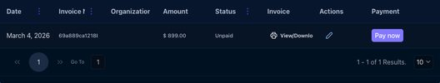

265-card-date-invoice-no-organization-amount-status-invoice-actions-payment-march-4-202 — Date Invoice No. Organization Amount Status Invoice Actions Payment March 4, 202
Kind: card
First seen: Admin / Addons & Invoices (`/settings/billing-invoices`)
Size: 1080×317 at (312, 103)
Tag/role: div role=tabpanel
Classes: p-tabview-panel
Selector: #pr_id_30_content
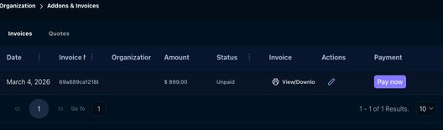

282-card-ebay-store-connected-walmart-store-connect-walmart-ca-store-co — eBay ***** Store Connected Walmart ***** Store Connect Walmart CA ***** Store Co
Kind: card
First seen: Admin / Channel Integration (`/settings/channel-settings`)
Size: 1112×704 at (296, 215)
Tag/role: div
Classes: p-tabview-panels
Selector: div:nth-of-type(2) > div:nth-of-type(1) > div:nth-of-type(1) > div:nth-of-type(2)
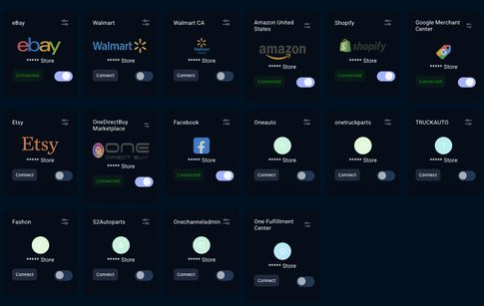

283-card-ebay-store-connected-walmart-store-connect-walmart-ca-store-co — eBay ***** Store Connected Walmart ***** Store Connect Walmart CA ***** Store Co
Kind: card
First seen: Admin / Channel Integration (`/settings/channel-settings`)
Size: 1112×688 at (296, 231)
Tag/role: div role=tabpanel
Classes: p-tabview-panel
Selector: #pr_id_30_content
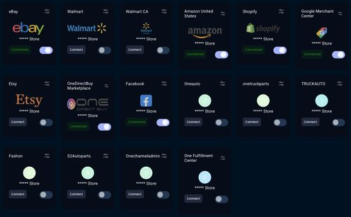

289-card-my-open-tickets-2-a-admin-3-22-2024-3-47-05-pm-crm-companies-crm-companies — My open tickets (2) A Admin 3/22/2024, 3:47:05 PM CRM Companies — CRM Companies
Kind: card
First seen: Admin / Help Desk (`/settings/help-center`)
Size: 230×636 at (320, 264)
Tag/role: div
Classes: p-panel.p-component.p-panel-toggleable.p-mt-3.custom-panel-css
Selector: div:nth-of-type(3) > div:nth-of-type(1) > div:nth-of-type(1) > div:nth-of-type(2)


290-card-a-admin-3-22-2024-3-47-05-pm-crm-companies-crm-companies-needed-open-high-sal — A Admin 3/22/2024, 3:47:05 PM CRM Companies — CRM Companies needed open high Sal
Kind: card
First seen: Admin / Help Desk (`/settings/help-center`)
Size: 230×580 at (320, 320)
Tag/role: div
Classes: p-panel-content
Selector: div:nth-of-type(1) > div:nth-of-type(2) > div:nth-of-type(2) > div:nth-of-type(1)
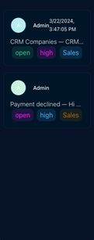

291-card-a-admin-3-22-2024-3-47-05-pm-crm-companies-crm-companies-needed-open-high-sal — A Admin 3/22/2024, 3:47:05 PM CRM Companies — CRM Companies needed open high Sal
Kind: card
First seen: Admin / Help Desk (`/settings/help-center`)
Size: 214×135 at (328, 344)
Tag/role: div
Classes: ticket-card.p-mt-3
Selector: div:nth-of-type(2) > div:nth-of-type(1) > div:nth-of-type(1) > div:nth-of-type(1)
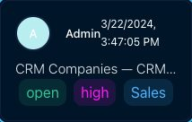

292-card-a-admin-payment-declined-hi-team-i-have-added-credits-to-my-account-payment-is — A Admin Payment declined — Hi Team;I have added credits to my account payment is
Kind: card
First seen: Admin / Help Desk (`/settings/help-center`)
Size: 214×135 at (328, 495)
Tag/role: div
Classes: ticket-card.p-mt-3
Selector: div:nth-of-type(2) > div:nth-of-type(1) > div:nth-of-type(1) > div:nth-of-type(2)
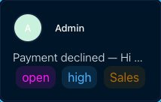

293-card-ticket-actions-select-a-ticket-to-update-status — Ticket actions Select a ticket to update status.
Kind: card
First seen: Admin / Help Desk (`/settings/help-center`)
Size: 230×71 at (1154, 179)
Tag/role: div
Classes: p-panel.p-component.p-panel-toggleable.custom-panel-css
Selector: div:nth-of-type(3) > div:nth-of-type(1) > div:nth-of-type(1) > div:nth-of-type(1)


297-card-invoices-recurring-series-organizations-quotes-organizations-all-transactions-ad — Invoices Recurring Series Organizations Quotes Organizations All Transactions Ad
Kind: card
First seen: Admin / Manage Billing & AddOns (`/settings/managebillings-addons`)
Size: 1080×738 at (312, 215)
Tag/role: div
Classes: p-tabview-panels
Selector: div:nth-of-type(1) > div:nth-of-type(2) > div:nth-of-type(1) > div:nth-of-type(2)
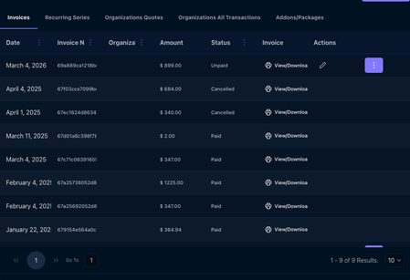

298-card-invoices-recurring-series-organizations-quotes-organizations-all-transactions-ad — Invoices Recurring Series Organizations Quotes Organizations All Transactions Ad
Kind: card
First seen: Admin / Manage Billing & AddOns (`/settings/managebillings-addons`)
Size: 1080×722 at (312, 231)
Tag/role: div role=tabpanel
Classes: p-tabview-panel
Selector: #pr_id_60_content
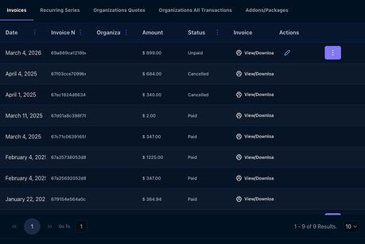

299-card-create-invoice-date-invoice-no-organization-amount-status-invoice-actions-march — Create Invoice Date Invoice No. Organization Amount Status Invoice Actions March
Kind: card
First seen: Admin / Manage Billing & AddOns (`/settings/managebillings-addons`)
Size: 1080×662 at (312, 291)
Tag/role: div
Classes: p-tabview-panels
Selector: div:nth-of-type(1) > div:nth-of-type(1) > div:nth-of-type(1) > div:nth-of-type(2)
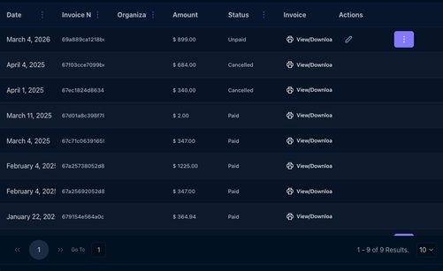

300-card-create-invoice-date-invoice-no-organization-amount-status-invoice-actions-march — Create Invoice Date Invoice No. Organization Amount Status Invoice Actions March
Kind: card
First seen: Admin / Manage Billing & AddOns (`/settings/managebillings-addons`)
Size: 1080×774 at (312, 179)
Tag/role: div role=tabpanel
Classes: p-tabview-panel
Selector: #pr_id_50_content
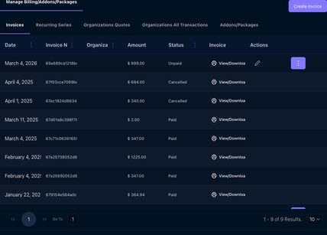

306-card-no-data-found-go-to-0-0-of-0-results-50-50 — No Data Found! Go To 0 - 0 of 0 Results. 50 50
Kind: card
First seen: Admin / Marketplace Plans (`/settings/marketplace-plans`)
Size: 1080×126 at (312, 215)
Tag/role: div
Classes: p-tabview-panels
Selector: div:nth-of-type(2) > div:nth-of-type(1) > div:nth-of-type(1) > div:nth-of-type(2)


307-card-no-data-found-go-to-0-0-of-0-results-50-50 — No Data Found! Go To 0 - 0 of 0 Results. 50 50
Kind: card
First seen: Admin / Marketplace Plans (`/settings/marketplace-plans`)
Size: 1080×110 at (312, 231)
Tag/role: div role=tabpanel
Classes: p-tabview-panel
Selector: #pr_id_30_content


332-card-add-new-pic-live-email-current-roles-organizations-status-action-sales-person-fu — Add New PIC Live Email Current Roles Organizations Status Action Sales Person Fu
Kind: card
First seen: Admin / User Permissions (`/settings/user-permission`)
Size: 1080×975 at (312, 215)
Tag/role: div
Classes: p-tabview-panels
Selector: div:nth-of-type(1) > div:nth-of-type(2) > div:nth-of-type(1) > div:nth-of-type(2)
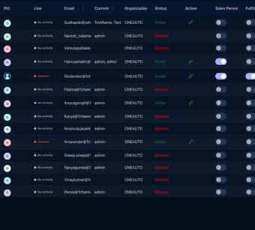

333-card-add-new-pic-live-email-current-roles-organizations-status-action-sales-person-fu — Add New PIC Live Email Current Roles Organizations Status Action Sales Person Fu
Kind: card
First seen: Admin / User Permissions (`/settings/user-permission`)
Size: 1080×1087 at (312, 103)
Tag/role: div role=tabpanel
Classes: p-tabview-panel
Selector: #pr_id_30_content
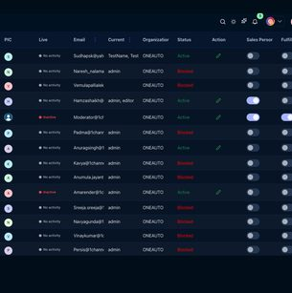

361-card-total-sales-0-avg-order-value-0-total-orders-0-net-sales-0-cancelled-orders — Total Sales $0 Avg. Order Value $0 Total Orders 0 Net Sales $0 Cancelled Orders
Kind: card
First seen: Analytics & Reports / Dashboard (`/analytics/analytics-dashboard`)
Size: 1112×3635 at (296, 215)
Tag/role: div
Classes: p-tabview-panels
Selector: div:nth-of-type(1) > div:nth-of-type(2) > div:nth-of-type(1) > div:nth-of-type(2)
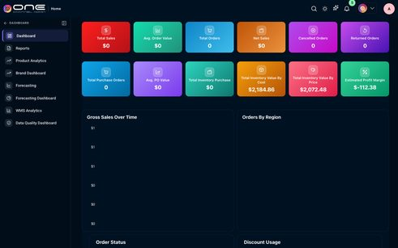

362-card-total-sales-0-avg-order-value-0-total-orders-0-net-sales-0-cancelled-orders — Total Sales $0 Avg. Order Value $0 Total Orders 0 Net Sales $0 Cancelled Orders
Kind: card
First seen: Analytics & Reports / Dashboard (`/analytics/analytics-dashboard`)
Size: 1112×3619 at (296, 231)
Tag/role: div role=tabpanel
Classes: p-tabview-panel
Selector: #pr_id_21_content_0
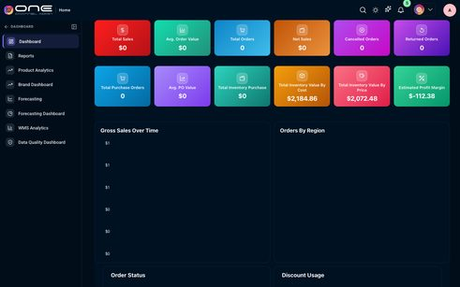

369-card-order-status — Order Status
Kind: card
First seen: B2B / Dashboard (`/b2b/dashboard`)
Size: 550×443 at (296, 774)
Tag/role: div
Classes: card
Selector: div:nth-of-type(2) > div:nth-of-type(3) > div:nth-of-type(1) > div:nth-of-type(1)
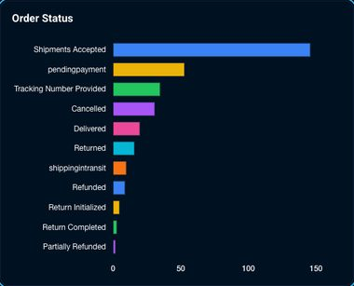

370-card-discount-usage — Discount Usage
Kind: card
First seen: B2B / Dashboard (`/b2b/dashboard`)
Size: 550×443 at (858, 774)
Tag/role: div
Classes: card
Selector: div:nth-of-type(2) > div:nth-of-type(3) > div:nth-of-type(1) > div:nth-of-type(2)
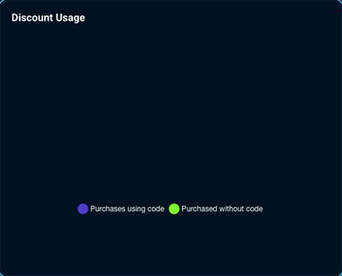

382-card-product-count-by-brand-brand-name-product-count-published-draft-all-qtys-price-v — Product Count By Brand Brand Name Product Count Published Draft All Qtys Price v
Kind: card
First seen: Catalog / Dashboard (`/products/dashboard`)
Size: 564×458 at (276, 463)
Tag/role: div
Classes: top-card-div.radius
Selector: div:nth-of-type(2) > div:nth-of-type(1) > div:nth-of-type(1) > div:nth-of-type(1)
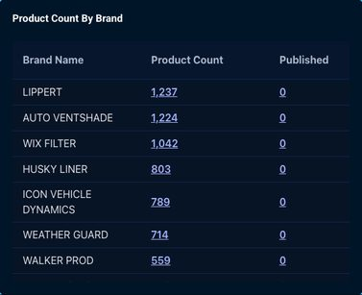

383-card-product-count-by-category-performance-1-not-assigned — Product Count By Category PERFORMANCE 1 Not Assigned
Kind: card
First seen: Catalog / Dashboard (`/products/dashboard`)
Size: 564×495 at (856, 463)
Tag/role: div
Classes: top-card-div.radius
Selector: div:nth-of-type(2) > div:nth-of-type(2) > div:nth-of-type(1) > div:nth-of-type(1)
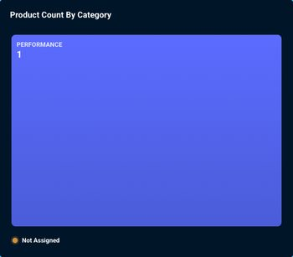

408-card-columns — Columns
Kind: card
First seen: Channel / B2B (`/channel/b2b-products`)
Size: 1128×61 at (284, 199)
Tag/role: div
Classes: p-tabview-panels
Selector: div:nth-of-type(2) > div:nth-of-type(1) > div:nth-of-type(1) > div:nth-of-type(2)

419-card-sync-raju-sudhakar-raju-sudhakar-all-all-columns-id-name-retailer-id-25353784230 — Sync Raju Sudhakar Raju Sudhakar All All Columns ID Name Retailer ID 25353784230
Kind: card
First seen: Channel / Facebook (`/channel/facebook-products`)
Size: 1112×226 at (296, 215)
Tag/role: div
Classes: p-tabview-panels
Selector: div:nth-of-type(2) > div:nth-of-type(1) > div:nth-of-type(1) > div:nth-of-type(2)
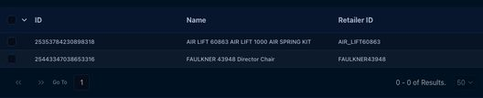

420-card-sync-raju-sudhakar-raju-sudhakar-all-all-columns-id-name-retailer-id-25353784230 — Sync Raju Sudhakar Raju Sudhakar All All Columns ID Name Retailer ID 25353784230
Kind: card
First seen: Channel / Facebook (`/channel/facebook-products`)
Size: 1112×210 at (296, 231)
Tag/role: div role=tabpanel
Classes: p-tabview-panel
Selector: #pr_id_30_content
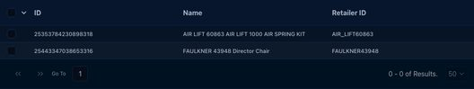

425-card-sync-5365424557-5365424557-columns-no-data-found-1-1-100-100 — Sync 5365424557 5365424557 Columns No Data Found! 1 - 1 100 100
Kind: card
First seen: Channel / Google Merchant (`/channel/google-merchant-products`)
Size: 1112×186 at (296, 215)
Tag/role: div
Classes: p-tabview-panels
Selector: div:nth-of-type(2) > div:nth-of-type(1) > div:nth-of-type(1) > div:nth-of-type(2)
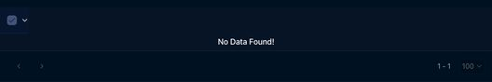

426-card-sync-5365424557-5365424557-columns-no-data-found-1-1-100-100 — Sync 5365424557 5365424557 Columns No Data Found! 1 - 1 100 100
Kind: card
First seen: Channel / Google Merchant (`/channel/google-merchant-products`)
Size: 1112×170 at (296, 231)
Tag/role: div role=tabpanel
Classes: p-tabview-panel
Selector: #pr_id_30_content


462-card-columns-export-link-new-website-name-link-email-catalog-name-oneauto-onetruckpar — Columns Export Link New Website Name Link Email Catalog Name Oneauto Onetruckpar
Kind: card
First seen: CRM / Websites (`/b2b/b2bwebsites`)
Size: 1112×486 at (296, 213)
Tag/role: div
Classes: p-tabview-panels
Selector: div:nth-of-type(2) > div:nth-of-type(1) > div:nth-of-type(1) > div:nth-of-type(2)
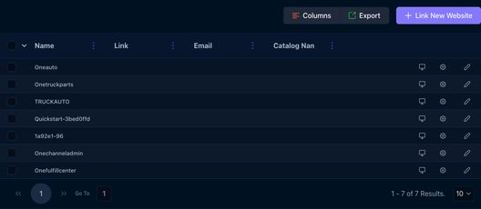

463-card-columns-export-link-new-website-name-link-email-catalog-name-oneauto-onetruckpar — Columns Export Link New Website Name Link Email Catalog Name Oneauto Onetruckpar
Kind: card
First seen: CRM / Websites (`/b2b/b2bwebsites`)
Size: 1112×470 at (296, 229)
Tag/role: div role=tabpanel
Classes: p-tabview-panel
Selector: #pr_id_30_content
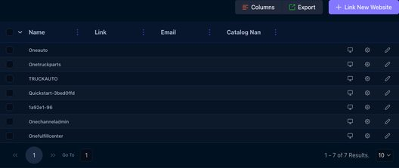

522-card-logo-save-logo-company-id-store-contact-person-currency-currency-currency-time-z — Logo Save Logo Company ID Store Contact Person Currency currency currency Time Z
Kind: card
First seen: Fulfillment / Default Shipping Address (`/settings/general`)
Size: 1160×908 at (268, 199)
Tag/role: div
Classes: p-tabview-panels
Selector: div:nth-of-type(2) > div:nth-of-type(1) > div:nth-of-type(1) > div:nth-of-type(2)
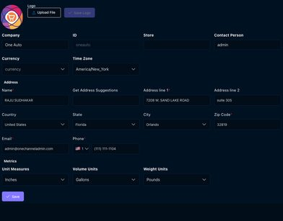

523-card-logo-save-logo-company-id-store-contact-person-currency-currency-currency-time-z — Logo Save Logo Company ID Store Contact Person Currency currency currency Time Z
Kind: card
First seen: Fulfillment / Default Shipping Address (`/settings/general`)
Size: 1160×892 at (268, 215)
Tag/role: div role=tabpanel
Classes: p-tabview-panel
Selector: #pr_id_30_content
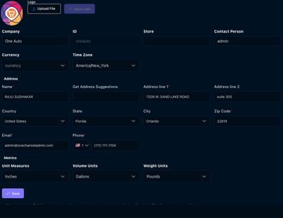

544-card-delivery-operations-dashboard-store-delivery-assignments-fulfillmentdeliverby — Delivery Operations Dashboard Store delivery assignments (fulfillmentdeliverBy)
Kind: card
First seen: Fulfillment / Deliveries/Pickups (`/fulfill/orders/deliveries`)
Size: 1120×89 at (292, 79)
Tag/role: div
Classes: tw-sticky.tw-top-0.tw-backdrop-blur-sm.tw-border-b.tw-border-[var(--border-color,#10213d)].tw-px-4.md:tw-px-6.tw-py-4
Selector: div:nth-of-type(3) > div:nth-of-type(1) > div:nth-of-type(1) > div:nth-of-type(1)

545-card-live-delivery-tracking-3-gps-from-drivers-app-refreshes-every-15s-onech — Live Delivery Tracking 3 GPS From Drivers app · refreshes every 15s + – 🚚 ONECH
Kind: card
First seen: Fulfillment / Deliveries/Pickups (`/fulfill/orders/deliveries`)
Size: 1072×503 at (316, 336)
Tag/role: div
Classes: tw-rounded-xl.tw-p-4.tw-mb-6.tw-border.tw-border-[var(--border-color,#10213d)]
Selector: div:nth-of-type(1) > div:nth-of-type(1) > div:nth-of-type(2) > div:nth-of-type(2)
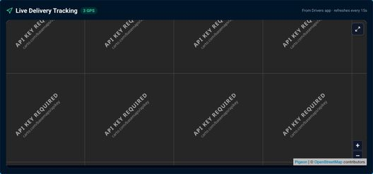

546-card-card — Card
Kind: card
First seen: Fulfillment / Deliveries/Pickups (`/fulfill/orders/deliveries`)
Size: 1036×420 at (334, 394)
Tag/role: div
Classes: pigeon-tiles-box
Selector: div:nth-of-type(2) > div:nth-of-type(2) > div:nth-of-type(1) > div:nth-of-type(1)
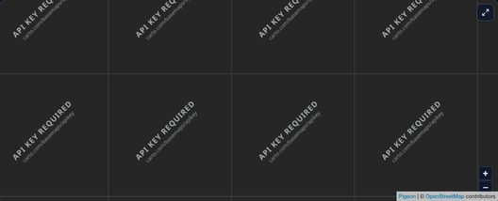

547-card-card — Card
Kind: card
First seen: Fulfillment / Deliveries/Pickups (`/fulfill/orders/deliveries`)
Size: 1280×768 at (303, 293)
Tag/role: div
Classes: pigeon-tiles
Selector: div:nth-of-type(2) > div:nth-of-type(1) > div:nth-of-type(1) > div:nth-of-type(1)
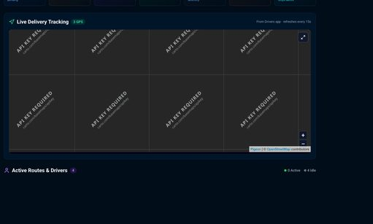

591-card-columns-order-id-order-date-print-order-total-source-payment-status-sku-title-fu — Columns Order ID Order Date Print Order Total Source Payment Status SKU Title Fu
Kind: card
First seen: Fulfillment / Invoices (`/settings/accounting-invoices`)
Size: 1160×772 at (268, 199)
Tag/role: div
Classes: p-tabview-panels
Selector: div:nth-of-type(1) > div:nth-of-type(1) > div:nth-of-type(1) > div:nth-of-type(2)
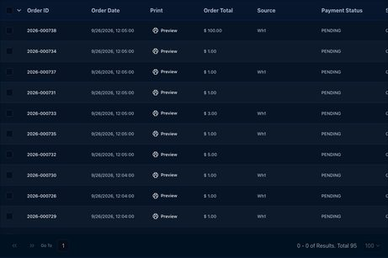

592-card-columns-order-id-order-date-print-order-total-source-payment-status-sku-title-fu — Columns Order ID Order Date Print Order Total Source Payment Status SKU Title Fu
Kind: card
First seen: Fulfillment / Invoices (`/settings/accounting-invoices`)
Size: 1160×756 at (268, 215)
Tag/role: div role=tabpanel
Classes: p-tabview-panel
Selector: #pr_id_30_content
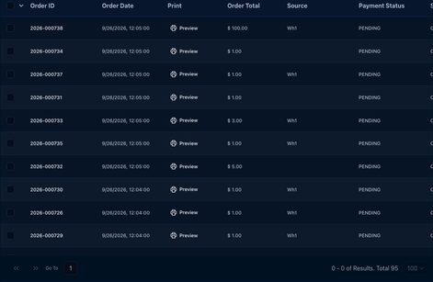

601-card-revenue-analytics-last-6-months-performance — Revenue Analytics Last 6 months performance
Kind: card
First seen: Fulfillment / Rental Orders (`/fulfill/orders/rentals`)
Size: 736×347 at (296, 285)
Tag/role: div
Classes: tw-rounded-xl.tw-border.tw-border-[var(--border-color,#10213d)].tw-shadow-sm.tw-flex.tw-flex-col.tw-p-0.lg:tw-min-h-0
Selector: div:nth-of-type(1) > div:nth-of-type(1) > div:nth-of-type(2) > div:nth-of-type(1)
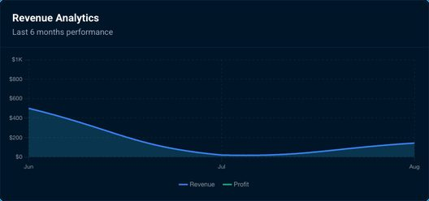

602-card-category-mix-rental-distribution-single-13 — Category Mix Rental distribution single 13%
Kind: card
First seen: Fulfillment / Rental Orders (`/fulfill/orders/rentals`)
Size: 360×347 at (1048, 285)
Tag/role: div
Classes: tw-rounded-xl.tw-border.tw-border-[var(--border-color,#10213d)].tw-shadow-sm.tw-flex.tw-min-h-0.tw-flex-col.tw-p-0
Selector: div:nth-of-type(1) > div:nth-of-type(1) > div:nth-of-type(2) > div:nth-of-type(2)
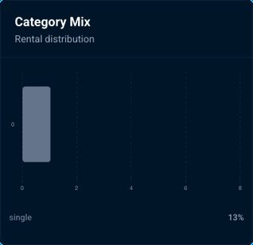

603-card-top-performers-most-rented-items-view-all-1-air-lift-57297-leaf-spring-leveling — Top Performers Most rented items View all 1 AIR LIFT 57297 LEAF SPRING LEVELING
Kind: card
First seen: Fulfillment / Rental Orders (`/fulfill/orders/rentals`)
Size: 360×408 at (296, 652)
Tag/role: div
Classes: tw-flex.tw-h-full.tw-min-w-0.tw-flex-1.tw-flex-col.tw-rounded-xl.tw-border.tw-border-[var(--border-color,#10213d)]
Selector: div:nth-of-type(1) > div:nth-of-type(1) > div:nth-of-type(3) > div:nth-of-type(1)
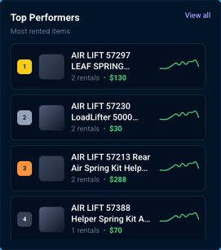

604-card-upcoming-returns-next-7-days-view-all-no-upcoming-returns — Upcoming Returns Next 7 days View all No upcoming returns
Kind: card
First seen: Fulfillment / Rental Orders (`/fulfill/orders/rentals`)
Size: 360×408 at (672, 652)
Tag/role: div
Classes: tw-flex.tw-h-full.tw-min-w-0.tw-flex-1.tw-flex-col.tw-rounded-xl.tw-border.tw-border-[var(--border-color,#10213d)]
Selector: div:nth-of-type(1) > div:nth-of-type(1) > div:nth-of-type(3) > div:nth-of-type(2)
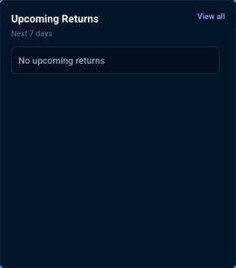

605-card-top-customers-best-clients-view-all-an-anurag-1channeladmin-com-4-rentals-105-a — Top Customers Best clients View all AN anurag@1channeladmin.com 4 rentals $105 A
Kind: card
First seen: Fulfillment / Rental Orders (`/fulfill/orders/rentals`)
Size: 360×408 at (1048, 652)
Tag/role: div
Classes: tw-flex.tw-h-full.tw-min-w-0.tw-flex-1.tw-flex-col.tw-rounded-xl.tw-border.tw-border-[var(--border-color,#10213d)]
Selector: div:nth-of-type(1) > div:nth-of-type(1) > div:nth-of-type(3) > div:nth-of-type(3)
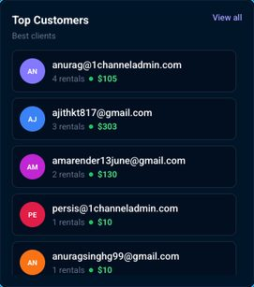

610-card-columns-export-state-zipcode-tax-region-name-estimated-combined-rate-state-rate — Columns Export State ZipCode Tax Region Name Estimated Combined Rate State Rate
Kind: card
First seen: Fulfillment / Tax Rates (`/fulfill/settings/taxRates`)
Size: 1160×758 at (268, 199)
Tag/role: div
Classes: p-tabview-panels
Selector: div:nth-of-type(2) > div:nth-of-type(1) > div:nth-of-type(1) > div:nth-of-type(2)
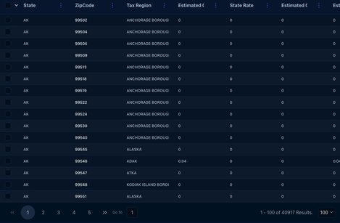

611-card-columns-export-state-zipcode-tax-region-name-estimated-combined-rate-state-rate — Columns Export State ZipCode Tax Region Name Estimated Combined Rate State Rate
Kind: card
First seen: Fulfillment / Tax Rates (`/fulfill/settings/taxRates`)
Size: 1160×770 at (268, 188)
Tag/role: div role=tabpanel
Classes: p-tabview-panel
Selector: #pr_id_30_content
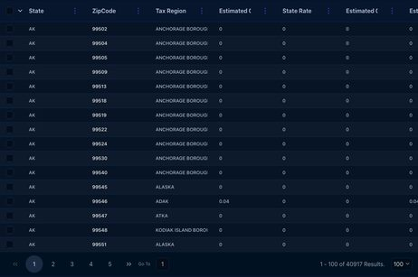

616-card-products-in-violations — Products in Violations
Kind: card
First seen: Map Price / Dashboard (`/map-price/dashboard`)
Size: 1140×400 at (278, 497)
Tag/role: div
Classes: card
Selector: div:nth-of-type(1) > div:nth-of-type(3) > div:nth-of-type(2) > div:nth-of-type(1)
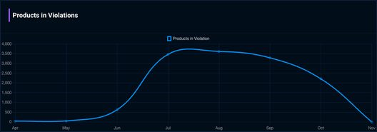

618-card-add-new-name-description-active-outbound-created-on-modified-by-mapprice-default — Add New Name Description Active Outbound Created On Modified By MapPrice Default
Kind: card
First seen: Map Price / Settings (`/map-price/settings`)
Size: 1160×186 at (268, 199)
Tag/role: div
Classes: p-tabview-panels
Selector: div:nth-of-type(1) > div:nth-of-type(2) > div:nth-of-type(2) > div:nth-of-type(2)
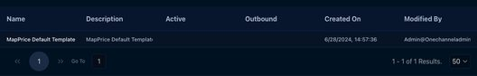

619-card-add-new-name-description-active-outbound-created-on-modified-by-mapprice-default — Add New Name Description Active Outbound Created On Modified By MapPrice Default
Kind: card
First seen: Map Price / Settings (`/map-price/settings`)
Size: 1160×170 at (268, 215)
Tag/role: div role=tabpanel
Classes: p-tabview-panel
Selector: #pr_id_30_content
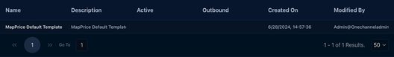

626-card-columns-export-add-new-ignore-end-date-name-method-campaign-type-apply-for-all-c — Columns Export Add New Ignore End Date Name Method Campaign Type Apply For All C
Kind: card
First seen: Marketing / Discounts (`/marketing/campaigns`)
Size: 1160×693 at (268, 157)
Tag/role: div
Classes: p-tabview-panels
Selector: div:nth-of-type(3) > div:nth-of-type(1) > div:nth-of-type(1) > div:nth-of-type(2)
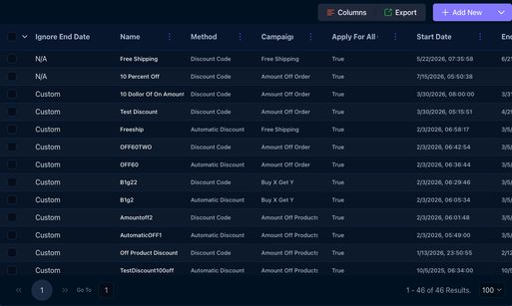

627-card-columns-export-add-new-ignore-end-date-name-method-campaign-type-apply-for-all-c — Columns Export Add New Ignore End Date Name Method Campaign Type Apply For All C
Kind: card
First seen: Marketing / Discounts (`/marketing/campaigns`)
Size: 1160×685 at (268, 165)
Tag/role: div role=tabpanel
Classes: p-tabview-panel
Selector: #pr_id_30_content
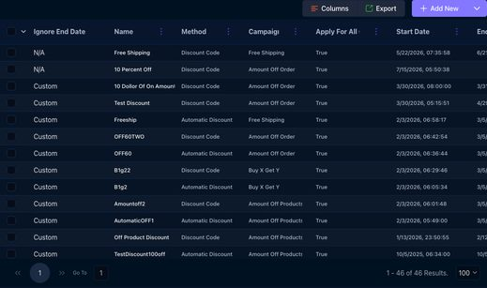

640-card-lot-expiry-coverage-3-critical-30d-2-warning-30-60d-5-safe-60d-recent-lo — Lot Expiry Coverage 3 Critical (<30d) 2 Warning (30–60d) 5 Safe (>60d) Recent Lo
Kind: card
First seen: Operations Hub / Dashboard (`/operations/dashboard`)
Size: 570×443 at (268, 145)
Tag/role: div
Classes: jsx-6e8a0b57148edd97.chart-panel
Selector: div:nth-of-type(1) > div:nth-of-type(2) > div:nth-of-type(1) > div:nth-of-type(1)
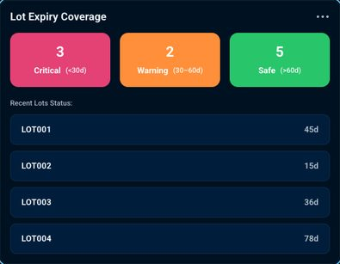

641-card-lot-expiry-coverage-3-critical-30d-2-warning-30-60d-5-safe-60d-recent-lo — Lot Expiry Coverage 3 Critical (<30d) 2 Warning (30–60d) 5 Safe (>60d) Recent Lo
Kind: card
First seen: Operations Hub / Dashboard (`/operations/dashboard`)
Size: 570×443 at (268, 145)
Tag/role: section role=region
Classes: lec-card.lec-dark
Selector: [role="region"][aria-label="Lot Expiry Coverage"]
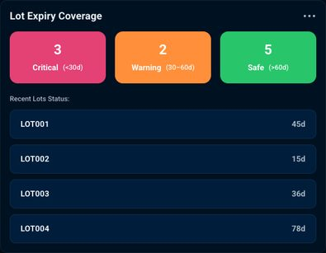

642-card-supplier-delivery-rate-87-5-current-87-5-target-95-previous-92-3-7-5-bel — Supplier Delivery Rate 87.5% Current: 87.5% Target: 95% Previous: 92.3% 7.5% bel
Kind: card
First seen: Operations Hub / Dashboard (`/operations/dashboard`)
Size: 570×443 at (858, 145)
Tag/role: div
Classes: jsx-6e8a0b57148edd97.chart-panel
Selector: div:nth-of-type(1) > div:nth-of-type(2) > div:nth-of-type(1) > div:nth-of-type(2)
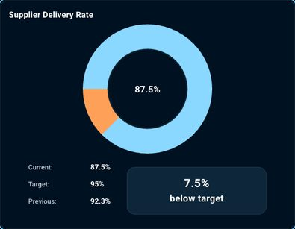

643-card-material-scrap-rate-3-2-current-scrap-rate-target-95-previous-92-3-variance — Material Scrap Rate 3.2%Current Scrap Rate Target: 95% Previous: 92.3% Variance:
Kind: card
First seen: Operations Hub / Dashboard (`/operations/dashboard`)
Size: 570×450 at (268, 608)
Tag/role: div
Classes: jsx-6e8a0b57148edd97.chart-panel
Selector: div:nth-of-type(1) > div:nth-of-type(2) > div:nth-of-type(2) > div:nth-of-type(1)
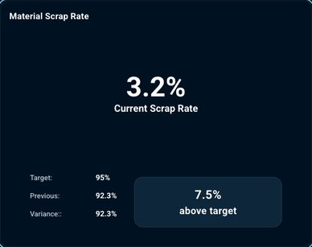

644-card-detailed-lot-expiry-status-lot-id-material-quantity-days-to-expiry-status-lot001 — Detailed Lot Expiry Status Lot ID Material Quantity Days To Expiry Status LOT001
Kind: card
First seen: Operations Hub / Dashboard (`/operations/dashboard`)
Size: 570×450 at (858, 608)
Tag/role: div
Classes: jsx-6e8a0b57148edd97.chart-panel
Selector: div:nth-of-type(1) > div:nth-of-type(2) > div:nth-of-type(2) > div:nth-of-type(2)
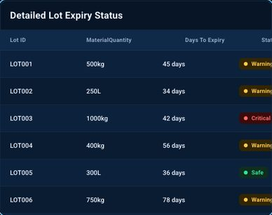

646-card-sku-mpn-status-brand-quantity-batch-number-created-at-newmanufacturerprod-newman — SKU MPN Status Brand Quantity Batch Number Created At NEWMANUFACTURERPROD NewMan
Kind: card
First seen: Operations Hub / Production (`/operations/production`)
Size: 1160×546 at (268, 199)
Tag/role: div
Classes: p-tabview-panels
Selector: div:nth-of-type(1) > div:nth-of-type(1) > div:nth-of-type(2) > div:nth-of-type(2)
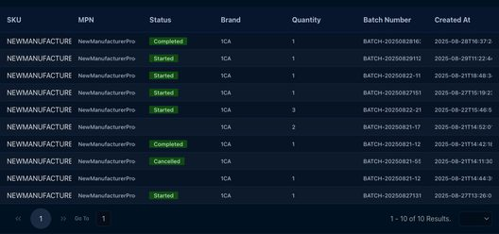

647-card-sku-mpn-status-brand-quantity-batch-number-created-at-newmanufacturerprod-newman — SKU MPN Status Brand Quantity Batch Number Created At NEWMANUFACTURERPROD NewMan
Kind: card
First seen: Operations Hub / Production (`/operations/production`)
Size: 1160×530 at (268, 215)
Tag/role: div role=tabpanel
Classes: p-tabview-panel
Selector: #pr_id_7_content_0
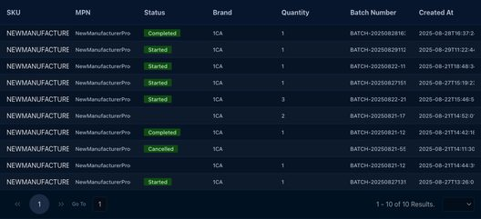

652-card-name-equipment-id-manufacturer-category-added-on-cable-machine-machin1-1ca-machi — Name Equipment ID Manufacturer Category Added On Cable Machine Machin1 1CA Machi
Kind: card
First seen: Operations Hub / Settings (`/operations/equipments`)
Size: 1160×186 at (268, 199)
Tag/role: div
Classes: p-tabview-panels
Selector: div:nth-of-type(1) > div:nth-of-type(3) > div:nth-of-type(1) > div:nth-of-type(2)
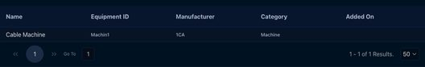

653-card-name-equipment-id-manufacturer-category-added-on-cable-machine-machin1-1ca-machi — Name Equipment ID Manufacturer Category Added On Cable Machine Machin1 1CA Machi
Kind: card
First seen: Operations Hub / Settings (`/operations/equipments`)
Size: 1160×170 at (268, 215)
Tag/role: div role=tabpanel
Classes: p-tabview-panel
Selector: #pr_id_7_content_0
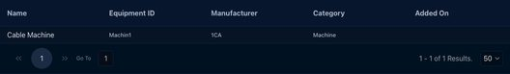

656-card-code-name-users-warehouse-address-245-choice-parts-amarender-1channeladmin-com-a — Code Name Users Warehouse Address 245 Choice Parts amarender@1channeladmin.com,a
Kind: card
First seen: WMS / 3PL Clients (`/wms/3plclients`)
Size: 1112×697 at (296, 215)
Tag/role: div
Classes: p-tabview-panels
Selector: div:nth-of-type(1) > div:nth-of-type(3) > div:nth-of-type(1) > div:nth-of-type(2)
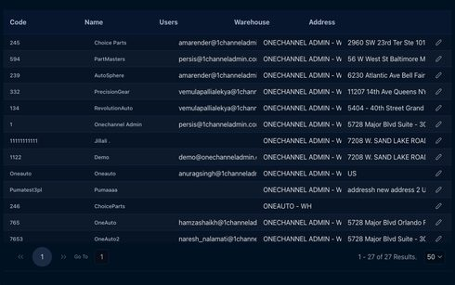

657-card-code-name-users-warehouse-address-245-choice-parts-amarender-1channeladmin-com-a — Code Name Users Warehouse Address 245 Choice Parts amarender@1channeladmin.com,a
Kind: card
First seen: WMS / 3PL Clients (`/wms/3plclients`)
Size: 1112×681 at (296, 231)
Tag/role: div role=tabpanel
Classes: p-tabview-panel
Selector: #pr_id_30_content
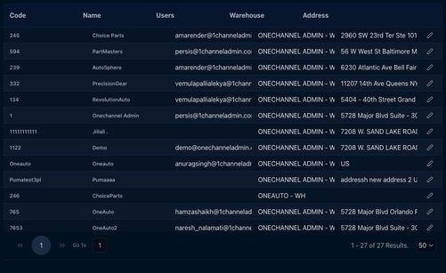

666-card-create-invoice-date-invoice-no-3pl-client-amount-status-invoice-actions-may-2 — Create Invoice Date Invoice No. 3PL Client Amount Status Invoice Actions May 2,
Kind: card
First seen: WMS / Manage 3pl Billing/Addons (`/wms/manage3pladdons`)
Size: 1112×275 at (296, 215)
Tag/role: div
Classes: p-tabview-panels
Selector: div:nth-of-type(1) > div:nth-of-type(1) > div:nth-of-type(1) > div:nth-of-type(2)
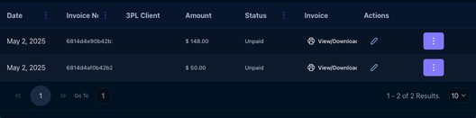

667-card-create-invoice-date-invoice-no-3pl-client-amount-status-invoice-actions-may-2 — Create Invoice Date Invoice No. 3PL Client Amount Status Invoice Actions May 2,
Kind: card
First seen: WMS / Manage 3pl Billing/Addons (`/wms/manage3pladdons`)
Size: 1112×387 at (296, 103)
Tag/role: div role=tabpanel
Classes: p-tabview-panel
Selector: #pr_id_30_content
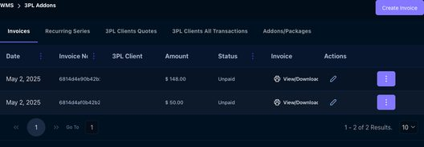

676-card-3-months-3-months-columns-export-sku-code-part-number-wh1-on-hand-qty-wh2-on-ha — 3 Months 3 Months Columns Export SKU Code Part Number WH1 On Hand QTY. WH2 On Ha
Kind: card
First seen: WMS / Order Replenishment (`/wms/order_replenishment?isWms=true`)
Size: 1112×816 at (296, 215)
Tag/role: div
Classes: p-tabview-panels
Selector: div:nth-of-type(2) > div:nth-of-type(1) > div:nth-of-type(1) > div:nth-of-type(2)
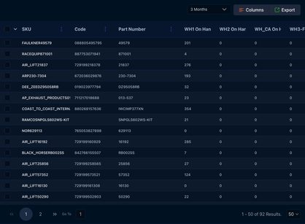

677-card-3-months-3-months-columns-export-sku-code-part-number-wh1-on-hand-qty-wh2-on-ha — 3 Months 3 Months Columns Export SKU Code Part Number WH1 On Hand QTY. WH2 On Ha
Kind: card
First seen: WMS / Order Replenishment (`/wms/order_replenishment?isWms=true`)
Size: 1112×800 at (296, 231)
Tag/role: div role=tabpanel
Classes: p-tabview-panel
Selector: #pr_id_30_content
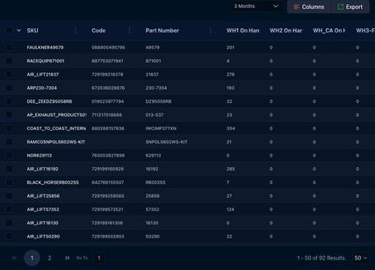

chart

001-chart-chart — Chart
Kind: chart
First seen: Home / Dashboard (`/home/dashboard`)
Size: 16×16 at (24, 393)
Tag/role: svg
Classes: [object.SVGAnimatedString]
Selector: div:nth-of-type(2) > button:nth-of-type(7) > div:nth-of-type(1) > svg:nth-of-type(1)

202-chart-chart — Chart
Kind: chart
First seen: Accounting / Reports (`/accounting/reports`)
Size: 24×24 at (320, 103)
Tag/role: svg
Classes: [object.SVGAnimatedString]
Selector: div:nth-of-type(1) > div:nth-of-type(1) > h2:nth-of-type(1) > svg:nth-of-type(1)

314-chart-chart — Chart
Kind: chart
First seen: Admin / Menu Editor (`/settings/pageflipcanvaseditor`)
Size: 410×574 at (649, 272)
Tag/role: div
Classes: canvas-container
Selector: div:nth-of-type(1) > div:nth-of-type(1) > div:nth-of-type(1) > div:nth-of-type(1)
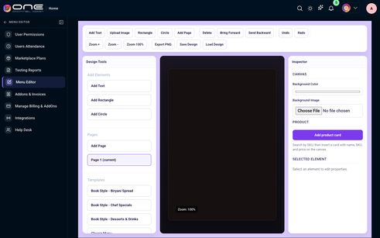

342-chart-chart — Chart
Kind: chart
First seen: Analytics & Reports / Dashboard (`/analytics/analytics-dashboard`)
Size: 15×15 at (563, 255)
Tag/role: i
Classes: pi-chart-bar
Selector: div:nth-of-type(1) > div:nth-of-type(2) > span:nth-of-type(1) > i:nth-of-type(1)

343-chart-chart — Chart
Kind: chart
First seen: Analytics & Reports / Dashboard (`/analytics/analytics-dashboard`)
Size: 15×15 at (563, 406)
Tag/role: i
Classes: pi-chart-line
Selector: div:nth-of-type(2) > div:nth-of-type(2) > span:nth-of-type(1) > i:nth-of-type(1)

344-chart-chart — Chart
Kind: chart
First seen: Analytics & Reports / Dashboard (`/analytics/analytics-dashboard`)
Size: 513×375 at (315, 601)
Tag/role: div
Classes: p-chart
Selector: div:nth-of-type(1) > div:nth-of-type(1) > div:nth-of-type(1) > div:nth-of-type(1)
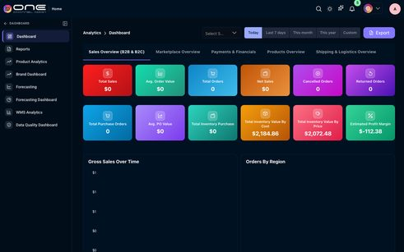

345-chart-chart — Chart
Kind: chart
First seen: Analytics & Reports / Dashboard (`/analytics/analytics-dashboard`)
Size: 513×300 at (877, 601)
Tag/role: div
Classes: p-chart
Selector: div:nth-of-type(1) > div:nth-of-type(2) > div:nth-of-type(1) > div:nth-of-type(1)

379-chart-performance-1 — PERFORMANCE 1
Kind: chart
First seen: Catalog / Dashboard (`/products/dashboard`)
Size: 526×375 at (875, 527)
Tag/role: div
Classes: recharts-responsive-container
Selector: div:nth-of-type(1) > div:nth-of-type(1) > div:nth-of-type(1) > div:nth-of-type(1)


380-chart-chart — Chart
Kind: chart
First seen: Catalog / Dashboard (`/products/dashboard`)
Size: 526×375 at (875, 527)
Tag/role: svg
Classes: [object.SVGAnimatedString]
Selector: div:nth-of-type(1) > div:nth-of-type(1) > div:nth-of-type(1) > svg:nth-of-type(1)


381-chart-chart — Chart
Kind: chart
First seen: Catalog / Dashboard (`/products/dashboard`)
Size: 520×369 at (878, 530)
Tag/role: g
Classes: [object.SVGAnimatedString]
Selector: div:nth-of-type(1) > div:nth-of-type(1) > svg:nth-of-type(1) > g:nth-of-type(1)


414-chart-selling-cost — Selling Cost
Kind: chart
First seen: Channel / Etsy (`/channel/etsy-dashboard`)
Size: 510×426 at (334, 735)
Tag/role: div
Classes: eBay-dashboard-chart.bg-white
Selector: div:nth-of-type(2) > div:nth-of-type(1) > div:nth-of-type(1) > div:nth-of-type(1)
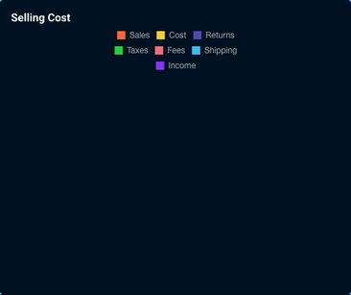

415-chart-chart — Chart
Kind: chart
First seen: Channel / Etsy (`/channel/etsy-dashboard`)
Size: 239×375 at (470, 770)
Tag/role: div
Classes: p-chart
Selector: div:nth-of-type(1) > div:nth-of-type(1) > div:nth-of-type(2) > div:nth-of-type(1)
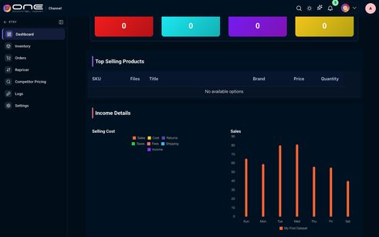

416-chart-sales — Sales
Kind: chart
First seen: Channel / Etsy (`/channel/etsy-dashboard`)
Size: 510×426 at (860, 735)
Tag/role: div
Classes: eBay-dashboard-chart.bg-white
Selector: div:nth-of-type(2) > div:nth-of-type(2) > div:nth-of-type(1) > div:nth-of-type(1)
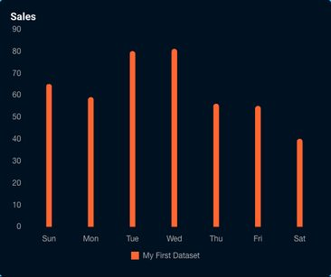

417-chart-chart — Chart
Kind: chart
First seen: Channel / Etsy (`/channel/etsy-dashboard`)
Size: 478×375 at (876, 770)
Tag/role: div
Classes: p-chart
Selector: div:nth-of-type(2) > div:nth-of-type(1) > div:nth-of-type(1) > div:nth-of-type(2)

435-chart-income-0 — Income $ 0
Kind: chart
First seen: Channel / Shopify (`/channel/shopify-dashboard`)
Size: 510×426 at (334, 802)
Tag/role: div
Classes: eBay-dashboard-chart
Selector: div:nth-of-type(2) > div:nth-of-type(1) > div:nth-of-type(1) > div:nth-of-type(1)


436-chart-chart — Chart
Kind: chart
First seen: Channel / Shopify (`/channel/shopify-dashboard`)
Size: 300×380 at (439, 837)
Tag/role: div
Classes: p-chart
Selector: div:nth-of-type(1) > div:nth-of-type(1) > div:nth-of-type(3) > div:nth-of-type(1)
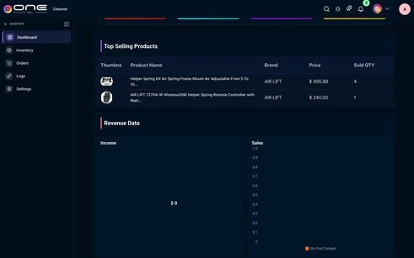

437-chart-sales — Sales
Kind: chart
First seen: Channel / Shopify (`/channel/shopify-dashboard`)
Size: 510×426 at (860, 802)
Tag/role: div
Classes: eBay-dashboard-chart
Selector: div:nth-of-type(2) > div:nth-of-type(2) > div:nth-of-type(1) > div:nth-of-type(1)
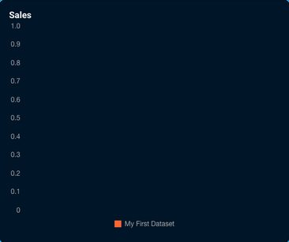

441-chart-income-0 — Income $ 0
Kind: chart
First seen: Channel / Walmart CA (`/channel/walmartca-dashboard`)
Size: 510×426 at (334, 735)
Tag/role: div
Classes: eBay-dashboard-chart.bg-white
Selector: div:nth-of-type(2) > div:nth-of-type(1) > div:nth-of-type(1) > div:nth-of-type(1)
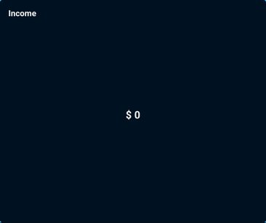

449-chart-chart — Chart
Kind: chart
First seen: CRM / Dashboard (`/crm/dashboard`)
Size: 512×352 at (305, 460)
Tag/role: div
Classes: p-chart
Selector: div:nth-of-type(1) > div:nth-of-type(2) > div:nth-of-type(1) > div:nth-of-type(1)
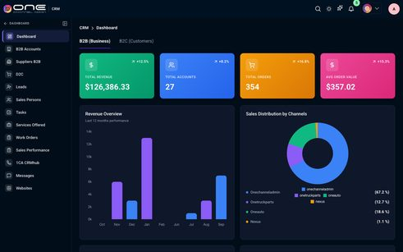

450-chart-chart — Chart
Kind: chart
First seen: CRM / Dashboard (`/crm/dashboard`)
Size: 220×300 at (1025, 436)
Tag/role: div
Classes: p-chart
Selector: div:nth-of-type(1) > div:nth-of-type(1) > div:nth-of-type(1) > div:nth-of-type(1)

482-chart-chart — Chart
Kind: chart
First seen: Fulfillment / Dashboard (`/fulfill/orders/dashboard`)
Size: 536×342 at (294, 198)
Tag/role: div
Classes: p-chart
Selector: div:nth-of-type(1) > div:nth-of-type(1) > div:nth-of-type(1) > div:nth-of-type(2)
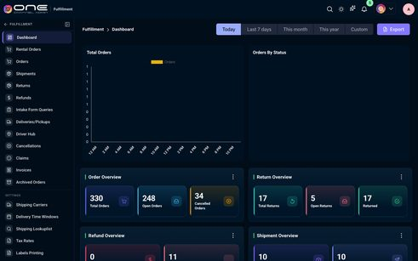

549-chart-customer-deliveries-completedwarehouse-outbound-dispatched-06-am-08-am-10-am-12 — Customer Deliveries CompletedWarehouse Outbound Dispatched 06 AM 08 AM 10 AM 12
Kind: chart
First seen: Fulfillment / Driver Hub (`/delivery/hub`)
Size: 597×272 at (313, 397)
Tag/role: div
Classes: recharts-responsive-container
Selector: div:nth-of-type(2) > div:nth-of-type(1) > div:nth-of-type(2) > div:nth-of-type(1)
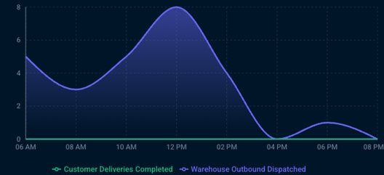

550-chart-customer-deliveries-completedwarehouse-outbound-dispatched-06-am-08-am-10-am-12 — Customer Deliveries CompletedWarehouse Outbound Dispatched 06 AM 08 AM 10 AM 12
Kind: chart
First seen: Fulfillment / Driver Hub (`/delivery/hub`)
Size: 597×272 at (313, 397)
Tag/role: div
Classes: recharts-wrapper
Selector: div:nth-of-type(2) > div:nth-of-type(1) > div:nth-of-type(1) > div:nth-of-type(1)

551-chart-customer-deliveries-completedwarehouse-outbound-dispatched — Customer Deliveries CompletedWarehouse Outbound Dispatched
Kind: chart
First seen: Fulfillment / Driver Hub (`/delivery/hub`)
Size: 607×26 at (293, 643)
Tag/role: div
Classes: recharts-legend-wrapper
Selector: div:nth-of-type(1) > div:nth-of-type(1) > div:nth-of-type(1) > div:nth-of-type(2)

552-chart-customer-deliveries-completedwarehouse-outbound-dispatched — Customer Deliveries CompletedWarehouse Outbound Dispatched
Kind: chart
First seen: Fulfillment / Driver Hub (`/delivery/hub`)
Size: 607×18 at (293, 651)
Tag/role: ul
Classes: recharts-default-legend
Selector: div:nth-of-type(1) > div:nth-of-type(1) > div:nth-of-type(2) > ul:nth-of-type(1)

553-chart-customer-deliveries-completed — Customer Deliveries Completed
Kind: chart
First seen: Fulfillment / Driver Hub (`/delivery/hub`)
Size: 188×18 at (394, 651)
Tag/role: li
Classes: recharts-legend-item.legend-item-0
Selector: div:nth-of-type(1) > div:nth-of-type(2) > ul:nth-of-type(1) > li:nth-of-type(1)

554-chart-customer-deliveries-completed-legend-icon — Customer Deliveries Completed legend icon
Kind: chart
First seen: Fulfillment / Driver Hub (`/delivery/hub`)
Size: 14×14 at (394, 653)
Tag/role: svg
Classes: [object.SVGAnimatedString]
Selector: div:nth-of-type(2) > ul:nth-of-type(1) > li:nth-of-type(1) > svg:nth-of-type(1)

555-chart-customer-deliveries-completed — Customer Deliveries Completed
Kind: chart
First seen: Fulfillment / Driver Hub (`/delivery/hub`)
Size: 170×14 at (412, 653)
Tag/role: span
Classes: recharts-legend-item-text
Selector: div:nth-of-type(2) > ul:nth-of-type(1) > li:nth-of-type(1) > span:nth-of-type(1)

556-chart-warehouse-outbound-dispatched — Warehouse Outbound Dispatched
Kind: chart
First seen: Fulfillment / Driver Hub (`/delivery/hub`)
Size: 197×18 at (592, 651)
Tag/role: li
Classes: recharts-legend-item.legend-item-1
Selector: div:nth-of-type(1) > div:nth-of-type(2) > ul:nth-of-type(1) > li:nth-of-type(2)

557-chart-warehouse-outbound-dispatched-legend-icon — Warehouse Outbound Dispatched legend icon
Kind: chart
First seen: Fulfillment / Driver Hub (`/delivery/hub`)
Size: 14×14 at (592, 653)
Tag/role: svg
Classes: [object.SVGAnimatedString]
Selector: div:nth-of-type(2) > ul:nth-of-type(1) > li:nth-of-type(2) > svg:nth-of-type(1)

558-chart-warehouse-outbound-dispatched — Warehouse Outbound Dispatched
Kind: chart
First seen: Fulfillment / Driver Hub (`/delivery/hub`)
Size: 179×14 at (610, 653)
Tag/role: span
Classes: recharts-legend-item-text
Selector: div:nth-of-type(2) > ul:nth-of-type(1) > li:nth-of-type(2) > span:nth-of-type(1)

559-chart-chart — Chart
Kind: chart
First seen: Fulfillment / Driver Hub (`/delivery/hub`)
Size: 597×272 at (313, 397)
Tag/role: svg role=application
Classes: [object.SVGAnimatedString]
Selector: div:nth-of-type(1) > div:nth-of-type(1) > div:nth-of-type(1) > svg:nth-of-type(1)

560-chart-chart — Chart
Kind: chart
First seen: Fulfillment / Driver Hub (`/delivery/hub`)
Size: 547×206 at (353, 407)
Tag/role: g
Classes: [object.SVGAnimatedString]
Selector: div:nth-of-type(1) > svg:nth-of-type(1) > g:nth-of-type(1) > g:nth-of-type(1)
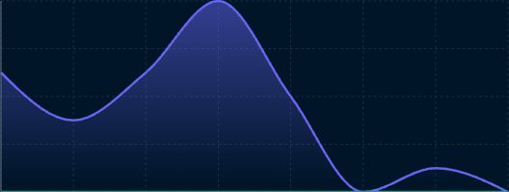

561-chart-chart — Chart
Kind: chart
First seen: Fulfillment / Driver Hub (`/delivery/hub`)
Size: 547×206 at (353, 407)
Tag/role: path
Classes: [object.SVGAnimatedString]
Selector: path[name="Warehouse Outbound Dispatched"]
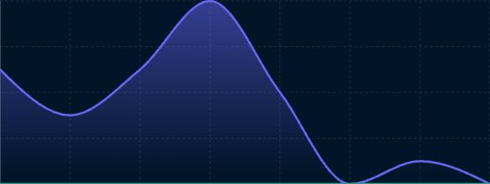

562-chart-chart — Chart
Kind: chart
First seen: Fulfillment / Driver Hub (`/delivery/hub`)
Size: 573×13 at (337, 618)
Tag/role: g
Classes: [object.SVGAnimatedString]
Selector: div:nth-of-type(1) > svg:nth-of-type(1) > g:nth-of-type(12) > g:nth-of-type(1)

563-chart-chart — Chart
Kind: chart
First seen: Fulfillment / Driver Hub (`/delivery/hub`)
Size: 32×13 at (337, 618)
Tag/role: g
Classes: [object.SVGAnimatedString]
Selector: svg:nth-of-type(1) > g:nth-of-type(12) > g:nth-of-type(1) > g:nth-of-type(1)

564-chart-chart — Chart
Kind: chart
First seen: Fulfillment / Driver Hub (`/delivery/hub`)
Size: 32×13 at (337, 618)
Tag/role: text
Classes: [object.SVGAnimatedString]
Selector: g:nth-of-type(12) > g:nth-of-type(1) > g:nth-of-type(1) > text:nth-of-type(1)

565-chart-delivered-packagesin-transit-active-mountain-west-midwest-east-coast-0-4-8-12-16 — Delivered PackagesIn-Transit Active Mountain West Midwest East Coast 0 4 8 12 16
Kind: chart
First seen: Fulfillment / Driver Hub (`/delivery/hub`)
Size: 407×272 at (976, 397)
Tag/role: div
Classes: recharts-responsive-container
Selector: div:nth-of-type(2) > div:nth-of-type(2) > div:nth-of-type(2) > div:nth-of-type(1)
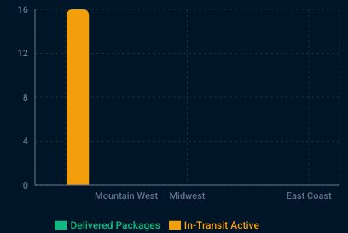

566-chart-delivered-packagesin-transit-active-mountain-west-midwest-east-coast-0-4-8-12-16 — Delivered PackagesIn-Transit Active Mountain West Midwest East Coast 0 4 8 12 16
Kind: chart
First seen: Fulfillment / Driver Hub (`/delivery/hub`)
Size: 407×272 at (976, 397)
Tag/role: div
Classes: recharts-wrapper
Selector: div:nth-of-type(2) > div:nth-of-type(1) > div:nth-of-type(1) > div:nth-of-type(1)

567-chart-delivered-packagesin-transit-active — Delivered PackagesIn-Transit Active
Kind: chart
First seen: Fulfillment / Driver Hub (`/delivery/hub`)
Size: 417×26 at (956, 643)
Tag/role: div
Classes: recharts-legend-wrapper
Selector: div:nth-of-type(1) > div:nth-of-type(1) > div:nth-of-type(1) > div:nth-of-type(2)

568-chart-delivered-packagesin-transit-active — Delivered PackagesIn-Transit Active
Kind: chart
First seen: Fulfillment / Driver Hub (`/delivery/hub`)
Size: 417×18 at (956, 651)
Tag/role: ul
Classes: recharts-default-legend
Selector: div:nth-of-type(1) > div:nth-of-type(1) > div:nth-of-type(2) > ul:nth-of-type(1)

569-chart-delivered-packages — Delivered Packages
Kind: chart
First seen: Fulfillment / Driver Hub (`/delivery/hub`)
Size: 123×18 at (1039, 651)
Tag/role: li
Classes: recharts-legend-item.legend-item-0
Selector: div:nth-of-type(1) > div:nth-of-type(2) > ul:nth-of-type(1) > li:nth-of-type(1)

570-chart-delivered-packages-legend-icon — Delivered Packages legend icon
Kind: chart
First seen: Fulfillment / Driver Hub (`/delivery/hub`)
Size: 14×14 at (1039, 653)
Tag/role: svg
Classes: [object.SVGAnimatedString]
Selector: div:nth-of-type(2) > ul:nth-of-type(1) > li:nth-of-type(1) > svg:nth-of-type(1)

571-chart-chart — Chart
Kind: chart
First seen: Fulfillment / Driver Hub (`/delivery/hub`)
Size: 14×11 at (1039, 655)
Tag/role: path
Classes: [object.SVGAnimatedString]
Selector: ul:nth-of-type(1) > li:nth-of-type(1) > svg:nth-of-type(1) > path:nth-of-type(1)

572-chart-delivered-packages — Delivered Packages
Kind: chart
First seen: Fulfillment / Driver Hub (`/delivery/hub`)
Size: 105×14 at (1057, 653)
Tag/role: span
Classes: recharts-legend-item-text
Selector: div:nth-of-type(2) > ul:nth-of-type(1) > li:nth-of-type(1) > span:nth-of-type(1)

573-chart-in-transit-active — In-Transit Active
Kind: chart
First seen: Fulfillment / Driver Hub (`/delivery/hub`)
Size: 106×18 at (1173, 651)
Tag/role: li
Classes: recharts-legend-item.legend-item-1
Selector: div:nth-of-type(1) > div:nth-of-type(2) > ul:nth-of-type(1) > li:nth-of-type(2)

574-chart-in-transit-active-legend-icon — In-Transit Active legend icon
Kind: chart
First seen: Fulfillment / Driver Hub (`/delivery/hub`)
Size: 14×14 at (1173, 653)
Tag/role: svg
Classes: [object.SVGAnimatedString]
Selector: div:nth-of-type(2) > ul:nth-of-type(1) > li:nth-of-type(2) > svg:nth-of-type(1)

575-chart-in-transit-active — In-Transit Active
Kind: chart
First seen: Fulfillment / Driver Hub (`/delivery/hub`)
Size: 88×14 at (1191, 653)
Tag/role: span
Classes: recharts-legend-item-text
Selector: div:nth-of-type(2) > ul:nth-of-type(1) > li:nth-of-type(2) > span:nth-of-type(1)

576-chart-chart — Chart
Kind: chart
First seen: Fulfillment / Driver Hub (`/delivery/hub`)
Size: 407×272 at (976, 397)
Tag/role: svg role=application
Classes: [object.SVGAnimatedString]
Selector: div:nth-of-type(1) > div:nth-of-type(1) > div:nth-of-type(1) > svg:nth-of-type(1)

577-chart-chart — Chart
Kind: chart
First seen: Fulfillment / Driver Hub (`/delivery/hub`)
Size: 357×206 at (1016, 407)
Tag/role: g
Classes: [object.SVGAnimatedString]
Selector: div:nth-of-type(1) > svg:nth-of-type(1) > g:nth-of-type(1) > g:nth-of-type(1)
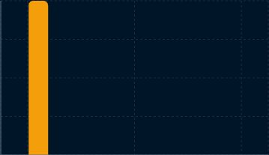

578-chart-chart — Chart
Kind: chart
First seen: Fulfillment / Driver Hub (`/delivery/hub`)
Size: 26×206 at (1053, 407)
Tag/role: g
Classes: [object.SVGAnimatedString]
Selector: div:nth-of-type(1) > svg:nth-of-type(1) > g:nth-of-type(5) > g:nth-of-type(2)

579-chart-chart — Chart
Kind: chart
First seen: Fulfillment / Driver Hub (`/delivery/hub`)
Size: 26×206 at (1053, 407)
Tag/role: path
Classes: [object.SVGAnimatedString]
Selector: path[name="In-Transit Active"]

580-chart-chart — Chart
Kind: chart
First seen: Fulfillment / Driver Hub (`/delivery/hub`)
Size: 278×13 at (1086, 618)
Tag/role: g
Classes: [object.SVGAnimatedString]
Selector: div:nth-of-type(1) > svg:nth-of-type(1) > g:nth-of-type(12) > g:nth-of-type(1)

581-chart-chart — Chart
Kind: chart
First seen: Fulfillment / Driver Hub (`/delivery/hub`)
Size: 74×13 at (1086, 618)
Tag/role: g
Classes: [object.SVGAnimatedString]
Selector: svg:nth-of-type(1) > g:nth-of-type(12) > g:nth-of-type(1) > g:nth-of-type(1)

582-chart-chart — Chart
Kind: chart
First seen: Fulfillment / Driver Hub (`/delivery/hub`)
Size: 74×13 at (1086, 618)
Tag/role: text
Classes: [object.SVGAnimatedString]
Selector: g:nth-of-type(12) > g:nth-of-type(1) > g:nth-of-type(1) > text:nth-of-type(1)

583-chart-chart — Chart
Kind: chart
First seen: Fulfillment / Driver Hub (`/delivery/hub`)
Size: 13×219 at (995, 400)
Tag/role: g
Classes: [object.SVGAnimatedString]
Selector: div:nth-of-type(1) > svg:nth-of-type(1) > g:nth-of-type(12) > g:nth-of-type(2)

584-chart-chart — Chart
Kind: chart
First seen: Fulfillment / Driver Hub (`/delivery/hub`)
Size: 13×13 at (995, 452)
Tag/role: g
Classes: [object.SVGAnimatedString]
Selector: svg:nth-of-type(1) > g:nth-of-type(12) > g:nth-of-type(2) > g:nth-of-type(4)

585-chart-chart — Chart
Kind: chart
First seen: Fulfillment / Driver Hub (`/delivery/hub`)
Size: 13×13 at (995, 452)
Tag/role: text
Classes: [object.SVGAnimatedString]
Selector: g:nth-of-type(12) > g:nth-of-type(2) > g:nth-of-type(4) > text:nth-of-type(1)

586-chart-chart — Chart
Kind: chart
First seen: Fulfillment / Driver Hub (`/delivery/hub`)
Size: 407×440 at (313, 798)
Tag/role: div
Classes: recharts-responsive-container
Selector: div:nth-of-type(3) > div:nth-of-type(1) > div:nth-of-type(2) > div:nth-of-type(1)


587-chart-chart — Chart
Kind: chart
First seen: Fulfillment / Driver Hub (`/delivery/hub`)
Size: 407×440 at (313, 798)
Tag/role: div
Classes: recharts-wrapper
Selector: div:nth-of-type(2) > div:nth-of-type(1) > div:nth-of-type(1) > div:nth-of-type(1)


588-chart-chart — Chart
Kind: chart
First seen: Fulfillment / Driver Hub (`/delivery/hub`)
Size: 407×440 at (313, 798)
Tag/role: svg role=application
Classes: [object.SVGAnimatedString]
Selector: div:nth-of-type(1) > div:nth-of-type(1) > div:nth-of-type(1) > svg:nth-of-type(1)

598-chart-chart — Chart
Kind: chart
First seen: Fulfillment / Rental Orders (`/fulfill/orders/rentals`)
Size: 710×240 at (309, 379)
Tag/role: div
Classes: p-chart.tw-h-[240px].tw-w-full
Selector: div:nth-of-type(2) > div:nth-of-type(1) > div:nth-of-type(2) > div:nth-of-type(1)
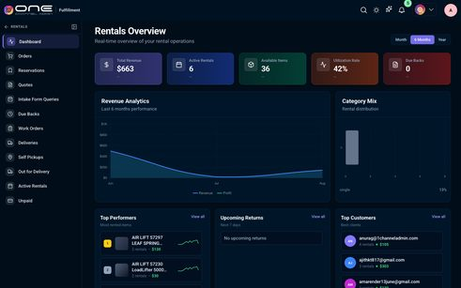

599-chart-chart — Chart
Kind: chart
First seen: Fulfillment / Rental Orders (`/fulfill/orders/rentals`)
Size: 334×180 at (1061, 379)
Tag/role: div
Classes: p-chart.tw-h-full.tw-w-full
Selector: div:nth-of-type(2) > div:nth-of-type(2) > div:nth-of-type(1) > div:nth-of-type(1)

600-chart-chart — Chart
Kind: chart
First seen: Fulfillment / Rental Orders (`/fulfill/orders/rentals`)
Size: 64×32 at (556, 745)
Tag/role: div
Classes: p-chart.tw-h-full.tw-w-full
Selector: ul:nth-of-type(1) > li:nth-of-type(1) > div:nth-of-type(3) > div:nth-of-type(1)

615-chart-chart — Chart
Kind: chart
First seen: Map Price / Dashboard (`/map-price/dashboard`)
Size: 1136×297 at (280, 598)
Tag/role: div
Classes: p-chart
Selector: div:nth-of-type(3) > div:nth-of-type(2) > div:nth-of-type(1) > div:nth-of-type(2)
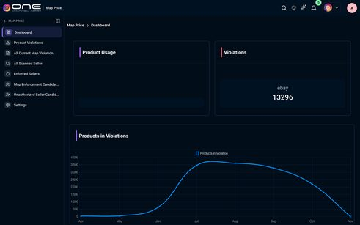

635-chart-lot-expiry-coverage-3-critical-30d-2-warning-30-60d-5-safe-60d-recent-lo — Lot Expiry Coverage 3 Critical (<30d) 2 Warning (30–60d) 5 Safe (>60d) Recent Lo
Kind: chart
First seen: Operations Hub / Dashboard (`/operations/dashboard`)
Size: 570×443 at (268, 145)
Tag/role: div
Classes: jsx-6e8a0b57148edd97.chart-panel
Selector: div:nth-of-type(1) > div:nth-of-type(2) > div:nth-of-type(1) > div:nth-of-type(1)
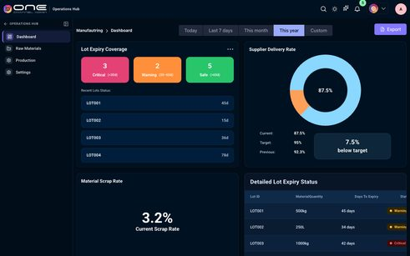

636-chart-supplier-delivery-rate-87-5-current-87-5-target-95-previous-92-3-7-5-bel — Supplier Delivery Rate 87.5% Current: 87.5% Target: 95% Previous: 92.3% 7.5% bel
Kind: chart
First seen: Operations Hub / Dashboard (`/operations/dashboard`)
Size: 570×443 at (858, 145)
Tag/role: div
Classes: jsx-6e8a0b57148edd97.chart-panel
Selector: div:nth-of-type(1) > div:nth-of-type(2) > div:nth-of-type(1) > div:nth-of-type(2)

637-chart-chart — Chart
Kind: chart
First seen: Operations Hub / Dashboard (`/operations/dashboard`)
Size: 250×250 at (1018, 192)
Tag/role: div
Classes: p-chart
Selector: div:nth-of-type(2) > div:nth-of-type(1) > div:nth-of-type(1) > div:nth-of-type(1)

638-chart-material-scrap-rate-3-2-current-scrap-rate-target-95-previous-92-3-variance — Material Scrap Rate 3.2%Current Scrap Rate Target: 95% Previous: 92.3% Variance:
Kind: chart
First seen: Operations Hub / Dashboard (`/operations/dashboard`)
Size: 570×450 at (268, 608)
Tag/role: div
Classes: jsx-6e8a0b57148edd97.chart-panel
Selector: div:nth-of-type(1) > div:nth-of-type(2) > div:nth-of-type(2) > div:nth-of-type(1)

639-chart-detailed-lot-expiry-status-lot-id-material-quantity-days-to-expiry-status-lot001 — Detailed Lot Expiry Status Lot ID Material Quantity Days To Expiry Status LOT001
Kind: chart
First seen: Operations Hub / Dashboard (`/operations/dashboard`)
Size: 570×450 at (858, 608)
Tag/role: div
Classes: jsx-6e8a0b57148edd97.chart-panel
Selector: div:nth-of-type(1) > div:nth-of-type(2) > div:nth-of-type(2) > div:nth-of-type(2)

chip

009-chip-5 — 5
Kind: chip
First seen: Home / Dashboard (`/home/dashboard`)
Size: 39×44 at (1235, 10)
Tag/role: i
Classes: pi-bell.p-overlay-badge
Selector: div:nth-of-type(1) > div:nth-of-type(6) > span:nth-of-type(1) > i:nth-of-type(1)


010-chip-5 — 5
Kind: chip
First seen: Home / Dashboard (`/home/dashboard`)
Size: 24×24 at (1262, -2)
Tag/role: span
Classes: p-badge.p-component.p-badge-no-gutter.p-badge-success
Selector: div:nth-of-type(6) > span:nth-of-type(1) > i:nth-of-type(1) > span:nth-of-type(1)

011-chip-a — A
Kind: chip
First seen: Home / Dashboard (`/home/dashboard`)
Size: 40×40 at (1388, 12)
Tag/role: div
Classes: org-badge-container
Selector: div:nth-of-type(1) > nav:nth-of-type(1) > div:nth-of-type(1) > div:nth-of-type(8)


012-chip-a — A
Kind: chip
First seen: Home / Dashboard (`/home/dashboard`)
Size: 9×20 at (1403, 22)
Tag/role: div
Classes: org-badge-text
Selector: nav:nth-of-type(1) > div:nth-of-type(1) > div:nth-of-type(8) > div:nth-of-type(1)

013-chip-today-last-7-days-this-month-this-year-custom — Today Last 7 days This month This year Custom
Kind: chip
First seen: Home / Dashboard (`/home/dashboard`)
Size: 415×40 at (893, 81)
Tag/role: div
Classes: dashboard-select.home-date-pills
Selector: div:nth-of-type(1) > div:nth-of-type(1) > div:nth-of-type(1) > div:nth-of-type(1)

039-chip-returned — Returned
Kind: chip
First seen: 3PL / Dashboard (`/3pl/dashboard`)
Size: 77×18 at (825, 392)
Tag/role: span
Classes: custom-table-badge.status-table-returned
Selector: td:nth-of-type(6) > div:nth-of-type(1) > span:nth-of-type(1) > span:nth-of-type(1)

330-chip-html — HTML
Kind: chip
First seen: Admin / Testing Reports (`/settings/testing-reports`)
Size: 48×26 at (617, 349)
Tag/role: span
Classes: p-tag.p-component.p-tag-info.p-tag-rounded
Selector: tr:nth-of-type(1) > td:nth-of-type(2) > div:nth-of-type(1) > span:nth-of-type(1)

331-chip-html — HTML
Kind: chip
First seen: Admin / Testing Reports (`/settings/testing-reports`)
Size: 35×18 at (623, 353)
Tag/role: span
Classes: p-tag-value
Selector: td:nth-of-type(2) > div:nth-of-type(1) > span:nth-of-type(1) > span:nth-of-type(1)

367-chip-chip — Chip
Kind: chip
First seen: Analytics & Reports / Dashboard (`/analytics/analytics-dashboard`)
Size: 15×15 at (1125, 398)
Tag/role: i
Classes: pi-tags
Selector: div:nth-of-type(2) > div:nth-of-type(5) > span:nth-of-type(1) > i:nth-of-type(1)

368-chip-chip — Chip
Kind: chip
First seen: Analytics & Reports / Dashboard (`/analytics/analytics-dashboard`)
Size: 15×15 at (1313, 406)
Tag/role: i
Classes: pi-percentage
Selector: div:nth-of-type(2) > div:nth-of-type(6) > span:nth-of-type(1) > i:nth-of-type(1)

394-chip-percent — Percent
Kind: chip
First seen: Catalog / Import / Export (`/products/import-export`)
Size: 60×18 at (1080, 168)
Tag/role: span
Classes: custome-targetpercentage
Selector: th:nth-of-type(5) > div:nth-of-type(1) > span:nth-of-type(1) > span:nth-of-type(1)

395-chip-50 — 50
Kind: chip
First seen: Catalog / Import / Export (`/products/import-export`)
Size: 37×18 at (1336, 218)
Tag/role: span
Classes: custom-table-badge.status-table-50
Selector: td:nth-of-type(6) > div:nth-of-type(1) > span:nth-of-type(1) > span:nth-of-type(1)

396-chip-0 — 0
Kind: chip
First seen: Catalog / Import / Export (`/products/import-export`)
Size: 28×18 at (1336, 338)
Tag/role: span
Classes: custom-table-badge.status-table-0
Selector: td:nth-of-type(6) > div:nth-of-type(1) > span:nth-of-type(1) > span:nth-of-type(1)

397-chip-95 — 95
Kind: chip
First seen: Catalog / Import / Export (`/products/import-export`)
Size: 37×18 at (1336, 458)
Tag/role: span
Classes: custom-table-badge.status-table-95
Selector: td:nth-of-type(6) > div:nth-of-type(1) > span:nth-of-type(1) > span:nth-of-type(1)

398-chip-87 — 87
Kind: chip
First seen: Catalog / Import / Export (`/products/import-export`)
Size: 36×18 at (1336, 538)
Tag/role: span
Classes: custom-table-badge.status-table-87
Selector: td:nth-of-type(6) > div:nth-of-type(1) > span:nth-of-type(1) > span:nth-of-type(1)

405-chip-0 — 0
Kind: chip
First seen: Channel / 1XA (`/channel/onechanneladmin-products`)
Size: 24×24 at (1262, -2)
Tag/role: span
Classes: p-badge.p-component.p-badge-dot.p-badge-success
Selector: div:nth-of-type(6) > span:nth-of-type(1) > i:nth-of-type(1) > span:nth-of-type(1)

459-chip-processing — Processing
Kind: chip
First seen: CRM / Tasks (`/crm/tasks`)
Size: 89×22 at (536, 279)
Tag/role: span
Classes: custom-table-badge.status-table-processing
Selector: td:nth-of-type(3) > div:nth-of-type(1) > div:nth-of-type(1) > span:nth-of-type(1)

460-chip-upcoming — Upcoming
Kind: chip
First seen: CRM / Tasks (`/crm/tasks`)
Size: 83×22 at (536, 319)
Tag/role: span
Classes: custom-table-badge.status-table-upcoming
Selector: td:nth-of-type(3) > div:nth-of-type(1) > div:nth-of-type(1) > span:nth-of-type(1)

461-chip-completed — Completed
Kind: chip
First seen: CRM / Tasks (`/crm/tasks`)
Size: 88×22 at (536, 359)
Tag/role: span
Classes: custom-table-badge.status-table-completed
Selector: td:nth-of-type(3) > div:nth-of-type(1) > div:nth-of-type(1) > span:nth-of-type(1)

470-chip-chip — Chip
Kind: chip
First seen: CRM / Work Orders (`/crm/workorders`)
Size: 16×16 at (1371, 161)
Tag/role: span
Classes: p-badge
Selector: div:nth-of-type(1) > div:nth-of-type(1) > button:nth-of-type(2) > span:nth-of-type(3)

477-chip-d2c — D2C
Kind: chip
First seen: Fulfillment / Cancellations (`/fulfill/orders/cancel`)
Size: 34×20 at (521, 190)
Tag/role: span
Classes: p-tag.p-component.p-tag-info
Selector: a:nth-of-type(1) > span:nth-of-type(1) > span:nth-of-type(1) > span:nth-of-type(1)

478-chip-d2c — D2C
Kind: chip
First seen: Fulfillment / Cancellations (`/fulfill/orders/cancel`)
Size: 22×16 at (527, 192)
Tag/role: span
Classes: p-tag-value
Selector: span:nth-of-type(1) > span:nth-of-type(1) > span:nth-of-type(1) > span:nth-of-type(1)

479-chip-b2b — B2B
Kind: chip
First seen: Fulfillment / Cancellations (`/fulfill/orders/cancel`)
Size: 33×20 at (523, 750)
Tag/role: span
Classes: p-tag.p-component.p-tag-success
Selector: a:nth-of-type(1) > span:nth-of-type(1) > span:nth-of-type(1) > span:nth-of-type(1)

480-chip-b2b — B2B
Kind: chip
First seen: Fulfillment / Cancellations (`/fulfill/orders/cancel`)
Size: 21×16 at (529, 752)
Tag/role: span
Classes: p-tag-value
Selector: span:nth-of-type(1) > span:nth-of-type(1) > span:nth-of-type(1) > span:nth-of-type(1)

624-chip-chip — Chip
Kind: chip
First seen: Marketing / Common Socials (`/marketing/common-socials`)
Size: 16×16 at (436, 224)
Tag/role: svg
Classes: [object.SVGAnimatedString]
Selector: div:nth-of-type(3) > div:nth-of-type(1) > button:nth-of-type(2) > svg:nth-of-type(1)

650-chip-started — Started
Kind: chip
First seen: Operations Hub / Production (`/operations/production`)
Size: 66×18 at (615, 326)
Tag/role: span
Classes: custom-table-badge.status-table-started
Selector: td:nth-of-type(4) > div:nth-of-type(1) > span:nth-of-type(1) > span:nth-of-type(1)

651-chip-cancelled — Cancelled
Kind: chip
First seen: Operations Hub / Production (`/operations/production`)
Size: 81×18 at (615, 566)
Tag/role: span
Classes: custom-table-badge.status-table-cancelled
Selector: td:nth-of-type(4) > div:nth-of-type(1) > span:nth-of-type(1) > span:nth-of-type(1)

663-chip-chip — Chip
Kind: chip
First seen: WMS / Blind Receive (`/wms/blindRecieve`)
Size: 32×16 at (1350, 103)
Tag/role: span
Classes: p-badge
Selector: div:nth-of-type(2) > div:nth-of-type(5) > button:nth-of-type(1) > span:nth-of-type(3)

690-chip-partial-completed — Partial Completed
Kind: chip
First seen: WMS / PO Outbound (`/wms/purchaseorders?warehouse=wh1`)
Size: 140×25 at (936, 282)
Tag/role: span
Classes: quality-check-chip.quality-check-chip--partial
Selector: tbody:nth-of-type(1) > tr:nth-of-type(1) > td:nth-of-type(6) > span:nth-of-type(1)

dropdown

004-dropdown-home — Home
Kind: dropdown
First seen: Home / Dashboard (`/home/dashboard`)
Size: 209×36 at (12, 14)
Tag/role: div
Classes: navdropdown-span.logo-span
Selector: div:nth-of-type(1) > div:nth-of-type(2) > div:nth-of-type(1) > div:nth-of-type(1)


005-dropdown-select-a-organization-oneauto — Select a Organization ONEAUTO
Kind: dropdown
First seen: Home / Dashboard (`/home/dashboard`)
Size: 76×40 at (1288, 10)
Tag/role: div
Classes: p-dropdown.p-component.p-inputwrapper.navdrop.organiztion-dropdown.p-inputwrapper-filled
Selector: nav:nth-of-type(1) > div:nth-of-type(1) > div:nth-of-type(7) > div:nth-of-type(1)
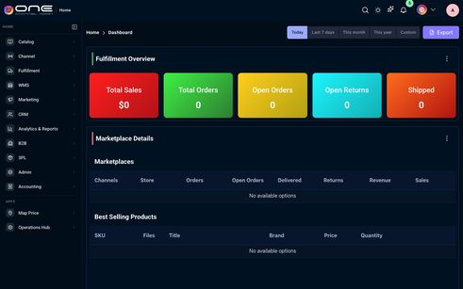

006-dropdown-dropdown — Dropdown
Kind: dropdown
First seen: Home / Dashboard (`/home/dashboard`)
Size: 32×32 at (1296, 14)
Tag/role: div
Classes: flex.align-item-center.org-dropdown-selected
Selector: div:nth-of-type(7) > div:nth-of-type(1) > span:nth-of-type(1) > div:nth-of-type(1)


007-dropdown-dropdown — Dropdown
Kind: dropdown
First seen: Home / Dashboard (`/home/dashboard`)
Size: 32×16 at (1331, 22)
Tag/role: div role=button
Classes: p-dropdown-trigger
Selector: div:nth-of-type(1) > div:nth-of-type(7) > div:nth-of-type(1) > div:nth-of-type(3)

037-dropdown-3pl — 3PL
Kind: dropdown
First seen: 3PL / Dashboard (`/3pl/dashboard`)
Size: 196×36 at (12, 14)
Tag/role: div
Classes: navdropdown-span.logo-span
Selector: div:nth-of-type(1) > div:nth-of-type(2) > div:nth-of-type(1) > div:nth-of-type(1)


047-dropdown-accounting — Accounting
Kind: dropdown
First seen: Accounting / Account Statements (`/accounting/account-statements`)
Size: 242×36 at (12, 14)
Tag/role: div
Classes: navdropdown-span.logo-span
Selector: div:nth-of-type(1) > div:nth-of-type(2) > div:nth-of-type(1) > div:nth-of-type(1)


074-dropdown-accounts-payable-accounts-receivable-all-status-pending-approval-approved-schedu — Accounts Payable Accounts Receivable All Status Pending Approval Approved Schedu
Kind: dropdown
First seen: Accounting / AP/AR Workflows (`/accounting/apar-workflows`)
Size: 1064×44 at (320, 171)
Tag/role: div
Classes: tw-flex.tw-items-center.tw-gap-4.tw-mt-4
Selector: div:nth-of-type(1) > div:nth-of-type(1) > div:nth-of-type(1) > div:nth-of-type(2)

086-dropdown-all-types-assets-liabilities-equity-revenue-expenses — All Types Assets Liabilities Equity Revenue Expenses
Kind: dropdown
First seen: Accounting / Chart of Accounts (`/accounting/chart-of-accounts`)
Size: 1064×40 at (320, 171)
Tag/role: div
Classes: tw-flex.tw-items-center.tw-gap-4.tw-mt-4
Selector: div:nth-of-type(1) > div:nth-of-type(1) > div:nth-of-type(1) > div:nth-of-type(2)

125-dropdown-today-this-week-this-month-this-quarter-this-year-custom-export-report — Today This Week This Month This Quarter This Year Custom Export Report
Kind: dropdown
First seen: Accounting / Dashboard (`/accounting/dashboard`)
Size: 286×40 at (1090, 109)
Tag/role: div
Classes: tw-flex.tw-items-center.tw-gap-3
Selector: div:nth-of-type(1) > div:nth-of-type(1) > div:nth-of-type(1) > div:nth-of-type(2)


128-dropdown-all-status-draft-submitted-approved-rejected-paid-reimbursed-void-all-categories — All Status Draft Submitted Approved Rejected Paid Reimbursed Void All Categories
Kind: dropdown
First seen: Accounting / Expenses (`/accounting/expenses`)
Size: 998×44 at (353, 356)
Tag/role: div
Classes: tw-flex.tw-flex-wrap.tw-items-center.tw-gap-4
Selector: div:nth-of-type(1) > div:nth-of-type(2) > div:nth-of-type(2) > div:nth-of-type(1)
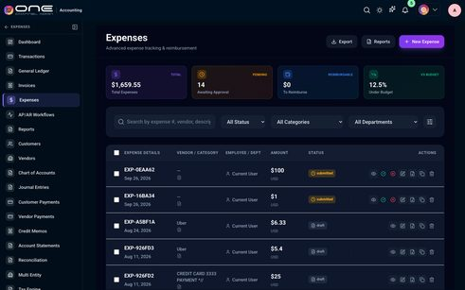

149-dropdown-all-accounts-1ca-bank-1ca-bank-cash-and-cash-equivalents-1110-onechanneladmi — All Accounts 1CA Bank (1CA Bank) Cash and Cash Equivalents (1110) Onechanneladmi
Kind: dropdown
First seen: Accounting / General Ledger (`/accounting/general-ledger`)
Size: 416×44 at (320, 195)
Tag/role: div
Classes: tw-relative
Selector: div:nth-of-type(1) > div:nth-of-type(2) > div:nth-of-type(1) > div:nth-of-type(1)


150-dropdown-account-date-type — Account Date Type
Kind: dropdown
First seen: Accounting / General Ledger (`/accounting/general-ledger`)
Size: 200×44 at (1184, 195)
Tag/role: div
Classes: tw-relative
Selector: div:nth-of-type(1) > div:nth-of-type(2) > div:nth-of-type(4) > div:nth-of-type(1)


179-dropdown-all-status-draft-posted-voided-all-types-manual-automated-adjusting-closing-reve — All Status Draft Posted Voided All Types Manual Automated Adjusting Closing Reve
Kind: dropdown
First seen: Accounting / Journal Entries (`/accounting/journal-entries`)
Size: 1064×40 at (320, 171)
Tag/role: div
Classes: tw-flex.tw-items-center.tw-gap-4.tw-mt-4
Selector: div:nth-of-type(1) > div:nth-of-type(1) > div:nth-of-type(1) > div:nth-of-type(2)
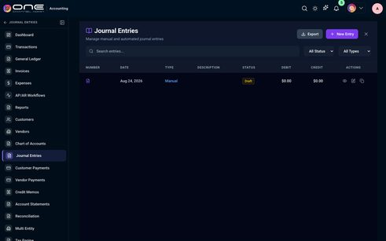

214-dropdown-currency-usd-us-dollar-eur-euro-gbp-british-pound-cad-canadian-dollar — Currency USD - US Dollar EUR - Euro GBP - British Pound CAD - Canadian Dollar
Kind: dropdown
First seen: Accounting / Settings (`/accounting/accounting-settings`)
Size: 351×71 at (601, 407)
Tag/role: div
Selector: div:nth-of-type(1) > div:nth-of-type(2) > div:nth-of-type(2) > div:nth-of-type(1)


215-dropdown-date-format-mm-dd-yyyy-dd-mm-yyyy-yyyy-mm-dd — Date Format MM/DD/YYYY DD/MM/YYYY YYYY-MM-DD
Kind: dropdown
First seen: Accounting / Settings (`/accounting/accounting-settings`)
Size: 351×71 at (968, 407)
Tag/role: div
Selector: div:nth-of-type(1) > div:nth-of-type(2) > div:nth-of-type(2) > div:nth-of-type(2)
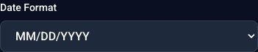

216-dropdown-timezone-eastern-time-et-central-time-ct-mountain-time-mt-pacific-time-pt — Timezone Eastern Time (ET) Central Time (CT) Mountain Time (MT) Pacific Time (PT
Kind: dropdown
First seen: Accounting / Settings (`/accounting/accounting-settings`)
Size: 718×71 at (601, 498)
Tag/role: div
Selector: div:nth-of-type(2) > div:nth-of-type(1) > div:nth-of-type(2) > div:nth-of-type(3)

269-dropdown-10-10 — 10 10
Kind: dropdown
First seen: Admin / Addons & Invoices (`/settings/billing-invoices`)
Size: 48×35 at (1328, 352)
Tag/role: div
Classes: p-dropdown.p-component.p-inputwrapper.p-inputwrapper-filled
Selector: div:nth-of-type(1) > div:nth-of-type(1) > div:nth-of-type(2) > div:nth-of-type(2)
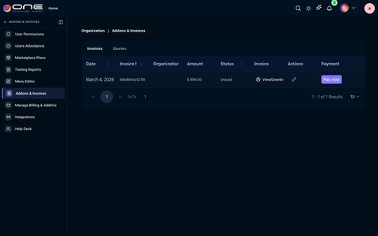

311-dropdown-50-50 — 50 50
Kind: dropdown
First seen: Admin / Marketplace Plans (`/settings/marketplace-plans`)
Size: 51×35 at (1325, 288)
Tag/role: div
Classes: p-dropdown.p-component.p-inputwrapper.p-disabled.p-inputwrapper-filled
Selector: div:nth-of-type(1) > div:nth-of-type(1) > div:nth-of-type(2) > div:nth-of-type(2)
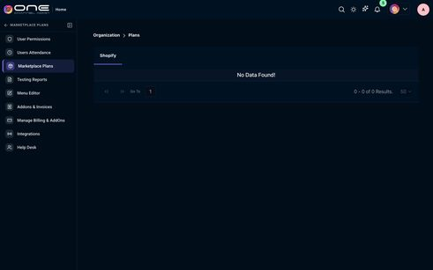

338-dropdown-all-users-15-ajith-onechanneladmin-com-amarender-onechanneladmin-com-anurag3pl — All users (15) ajith@onechanneladmin.com amarender@onechanneladmin.com anurag3pl
Kind: dropdown
First seen: Admin / Users Attendance (`/settings/users-attendance`)
Size: 928×38 at (331, 244)
Tag/role: div
Classes: tw-flex.tw-flex-wrap.tw-items-center.tw-gap-2
Selector: div:nth-of-type(3) > div:nth-of-type(1) > div:nth-of-type(1) > div:nth-of-type(2)
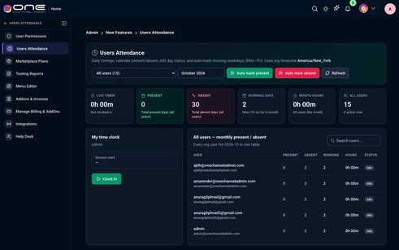

364-dropdown-select-sku-select-sku — Select SKU Select SKU
Kind: dropdown
First seen: Analytics & Reports / Dashboard (`/analytics/analytics-dashboard`)
Size: 140×40 at (721, 97)
Tag/role: div
Classes: p-dropdown.p-component.p-inputwrapper.p-inputtext-sm
Selector: div:nth-of-type(1) > div:nth-of-type(1) > div:nth-of-type(1) > div:nth-of-type(1)

365-dropdown-dropdown — Dropdown
Kind: dropdown
First seen: Analytics & Reports / Dashboard (`/analytics/analytics-dashboard`)
Size: 48×38 at (812, 98)
Tag/role: div role=button
Classes: p-dropdown-trigger
Selector: div:nth-of-type(1) > div:nth-of-type(1) > div:nth-of-type(1) > div:nth-of-type(3)

373-dropdown-catalog — Catalog
Kind: dropdown
First seen: Catalog / Addons (`/products/addons`)
Size: 220×36 at (12, 14)
Tag/role: div
Classes: navdropdown-span.logo-span
Selector: div:nth-of-type(1) > div:nth-of-type(2) > div:nth-of-type(1) > div:nth-of-type(1)


376-dropdown-dropdown — Dropdown
Kind: dropdown
First seen: Catalog / Bundles (`/products/bundlekits`)
Size: 211×40 at (789, 79)
Tag/role: div
Selector: div:nth-of-type(1) > div:nth-of-type(1) > div:nth-of-type(1) > div:nth-of-type(1)
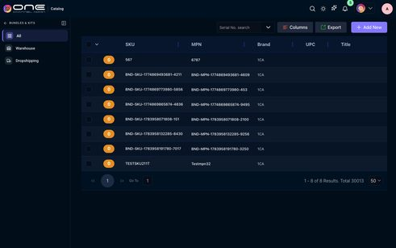

387-dropdown-select-filter-select-filter — Select Filter Select Filter
Kind: dropdown
First seen: Catalog / Images (`/products/images`)
Size: 148×39 at (537, 77)
Tag/role: div
Classes: p-dropdown.p-component.p-inputwrapper.p-inputtext-sm.p-inputwrapper-filled
Selector: div:nth-of-type(1) > div:nth-of-type(2) > div:nth-of-type(1) > div:nth-of-type(1)
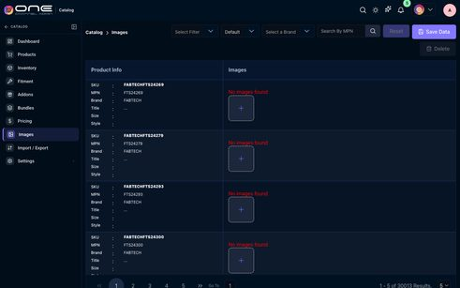

388-dropdown-select-a-marketplace-default-default — Select a Marketplace Default Default
Kind: dropdown
First seen: Catalog / Images (`/products/images`)
Size: 120×39 at (692, 77)
Tag/role: div
Classes: p-dropdown.p-component.p-inputwrapper.p-inputtext-sm.p-inputwrapper-filled
Selector: div:nth-of-type(1) > div:nth-of-type(2) > div:nth-of-type(1) > div:nth-of-type(2)

389-dropdown-select-a-brand-select-a-brand — Select a Brand Select a Brand
Kind: dropdown
First seen: Catalog / Images (`/products/images`)
Size: 165×39 at (820, 77)
Tag/role: div
Classes: p-dropdown.p-component.p-inputwrapper.p-inputtext-sm
Selector: div:nth-of-type(1) > div:nth-of-type(2) > div:nth-of-type(1) > div:nth-of-type(3)

403-dropdown-choose-view-all-all — Choose View All All
Kind: dropdown
First seen: Catalog / Products (`/products/catalog`)
Size: 128×40 at (872, 79)
Tag/role: div
Classes: p-dropdown.p-component.p-inputwrapper.p-inputtext-sm.p-inputwrapper-filled
Selector: div:nth-of-type(1) > div:nth-of-type(1) > div:nth-of-type(3) > div:nth-of-type(1)
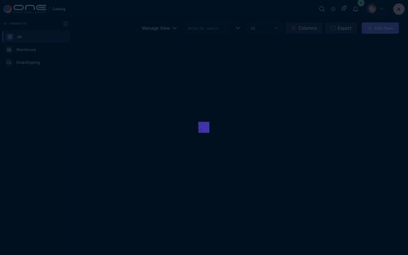

404-dropdown-channel — Channel
Kind: dropdown
First seen: Channel / 1XA (`/channel/onechanneladmin-products`)
Size: 222×36 at (12, 14)
Tag/role: div
Classes: navdropdown-span.logo-span
Selector: div:nth-of-type(1) > div:nth-of-type(2) > div:nth-of-type(1) > div:nth-of-type(1)


407-dropdown-dropdown — Dropdown
Kind: dropdown
First seen: Channel / Amazon (`/channel/amazon-dashboard`)
Size: 112×40 at (1176, 93)
Tag/role: div
Classes: p-dropdown.p-component.p-inputwrapper.p-inputtext-sm
Selector: div:nth-of-type(3) > div:nth-of-type(2) > div:nth-of-type(1) > div:nth-of-type(1)
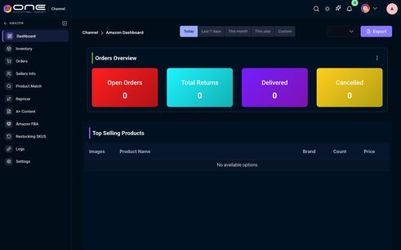

411-dropdown-dropdown — Dropdown
Kind: dropdown
First seen: Channel / B2B (`/channel/b2b-products`)
Size: 144×45 at (1113, 215)
Tag/role: div
Classes: p-dropdown.p-component.p-inputwrapper.p-inputtext-sm
Selector: div:nth-of-type(1) > div:nth-of-type(2) > div:nth-of-type(1) > div:nth-of-type(1)
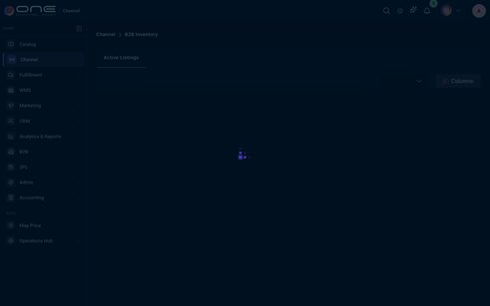

413-dropdown-onetruckstore-onetruckstore — Onetruckstore Onetruckstore
Kind: dropdown
First seen: Channel / eBay (`/channel/ebay-dashboard`)
Size: 163×40 at (1124, 93)
Tag/role: div
Classes: p-dropdown.p-component.p-inputwrapper.p-inputtext-sm.p-inputwrapper-filled
Selector: div:nth-of-type(3) > div:nth-of-type(2) > div:nth-of-type(1) > div:nth-of-type(1)
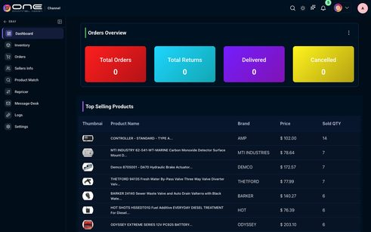

423-dropdown-raju-sudhakar-raju-sudhakar — Raju Sudhakar Raju Sudhakar
Kind: dropdown
First seen: Channel / Facebook (`/channel/facebook-products`)
Size: 144×45 at (941, 95)
Tag/role: div
Classes: p-dropdown.p-component.p-inputwrapper.p-inputtext-sm.p-inputwrapper-filled
Selector: div:nth-of-type(1) > div:nth-of-type(2) > div:nth-of-type(1) > div:nth-of-type(1)
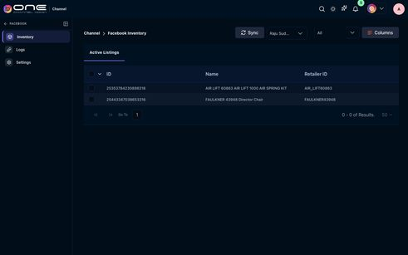

424-dropdown-all-all — All All
Kind: dropdown
First seen: Channel / Facebook (`/channel/facebook-products`)
Size: 160×40 at (1109, 95)
Tag/role: div
Classes: p-dropdown.p-component.p-inputwrapper.p-inputtext-sm
Selector: div:nth-of-type(1) > div:nth-of-type(2) > div:nth-of-type(2) > div:nth-of-type(1)

429-dropdown-5365424557-5365424557 — 5365424557 5365424557
Kind: dropdown
First seen: Channel / Google Merchant (`/channel/google-merchant-products`)
Size: 144×45 at (1117, 103)
Tag/role: div
Classes: p-dropdown.p-component.p-inputwrapper.p-inputtext-sm.p-inputwrapper-filled
Selector: div:nth-of-type(1) > div:nth-of-type(2) > div:nth-of-type(1) > div:nth-of-type(1)
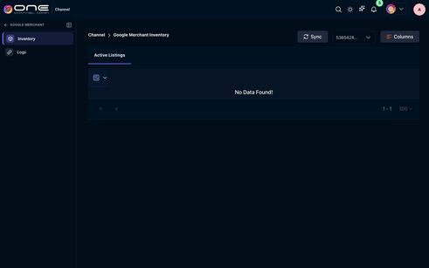

431-dropdown-filter-by-category-filter-by-category — Filter by Category Filter by Category
Kind: dropdown
First seen: Channel / OneDirectBuy (`/marketplaceseller`)
Size: 219×50 at (557, 133)
Tag/role: div
Classes: p-dropdown.p-component.p-inputwrapper.w-15rem.p-dropdown-clearable
Selector: div:nth-of-type(1) > div:nth-of-type(1) > div:nth-of-type(1) > div:nth-of-type(1)
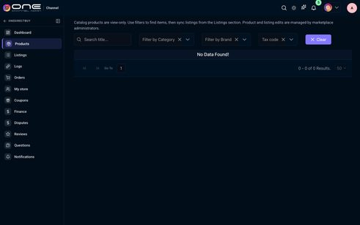

432-dropdown-filter-by-brand-filter-by-brand — Filter by Brand Filter by Brand
Kind: dropdown
First seen: Channel / OneDirectBuy (`/marketplaceseller`)
Size: 195×50 at (808, 133)
Tag/role: div
Classes: p-dropdown.p-component.p-inputwrapper.w-15rem.p-dropdown-clearable
Selector: div:nth-of-type(1) > div:nth-of-type(1) > div:nth-of-type(1) > div:nth-of-type(2)

433-dropdown-tax-code-tax-code — Tax code Tax code
Kind: dropdown
First seen: Channel / OneDirectBuy (`/marketplaceseller`)
Size: 155×50 at (1035, 133)
Tag/role: div
Classes: p-dropdown.p-component.p-inputwrapper.w-16rem.p-dropdown-clearable
Selector: div:nth-of-type(1) > div:nth-of-type(1) > div:nth-of-type(1) > div:nth-of-type(3)

439-dropdown-1a92e1-96-1a92e1-96 — 1a92e1-96 1a92e1-96
Kind: dropdown
First seen: Channel / Shopify (`/channel/shopify-dashboard`)
Size: 140×40 at (1117, 104)
Tag/role: div
Classes: p-dropdown.p-component.p-inputwrapper.p-inputtext-sm.p-inputwrapper-filled
Selector: div:nth-of-type(3) > div:nth-of-type(2) > div:nth-of-type(1) > div:nth-of-type(1)

446-dropdown-crm — CRM
Kind: dropdown
First seen: CRM / B2B Accounts (`/crm/company`)
Size: 202×36 at (12, 14)
Tag/role: div
Classes: navdropdown-span.logo-span
Selector: div:nth-of-type(1) > div:nth-of-type(2) > div:nth-of-type(1) > div:nth-of-type(1)


468-dropdown-custom-last-60-days-last-60-days — Custom Last 60 days Last 60 days
Kind: dropdown
First seen: CRM / Work Orders (`/crm/workorders`)
Size: 124×34 at (900, 152)
Tag/role: div
Classes: p-dropdown.p-component.p-inputwrapper.p-inputtext-sm.fulfill-orders-ref-period.p-inputwrapper-filled
Selector: div:nth-of-type(2) > div:nth-of-type(1) > div:nth-of-type(1) > div:nth-of-type(2)
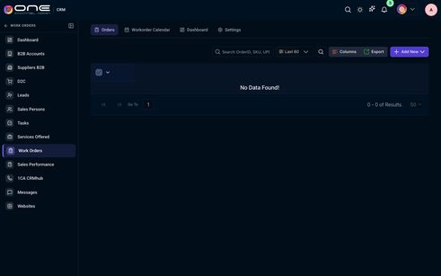

472-dropdown-fulfillment — Fulfillment
Kind: dropdown
First seen: Fulfillment / Archived Orders (`/fulfill/orders/archived`)
Size: 238×36 at (12, 14)
Tag/role: div
Classes: navdropdown-span.logo-span
Selector: div:nth-of-type(1) > div:nth-of-type(2) > div:nth-of-type(1) > div:nth-of-type(1)


473-dropdown-last-60-days-last-60-days — Last 60 days Last 60 days
Kind: dropdown
First seen: Fulfillment / Archived Orders (`/fulfill/orders/archived`)
Size: 136×35 at (1041, 78)
Tag/role: div
Classes: p-float-label.pickpackbtndivs.fulfill-orders-period-dropdown-wrap
Selector: div:nth-of-type(2) > div:nth-of-type(2) > div:nth-of-type(2) > div:nth-of-type(1)


474-dropdown-last-60-days-last-60-days — Last 60 days Last 60 days
Kind: dropdown
First seen: Fulfillment / Archived Orders (`/fulfill/orders/archived`)
Size: 136×35 at (1041, 78)
Tag/role: div
Classes: p-dropdown.p-component.p-inputwrapper.p-inputtext-sm.fulfill-orders-period-dropdown.p-inputwrapper-filled
Selector: div:nth-of-type(2) > div:nth-of-type(2) > div:nth-of-type(1) > div:nth-of-type(1)
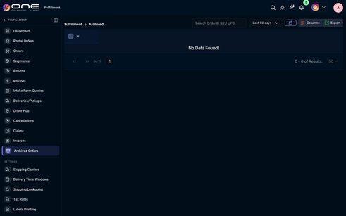

526-dropdown-currency-currency — currency currency
Kind: dropdown
First seen: Fulfillment / Default Shipping Address (`/settings/general`)
Size: 274×50 at (276, 458)
Tag/role: div
Classes: p-dropdown.p-component.p-inputwrapper
Selector: div:nth-of-type(1) > div:nth-of-type(4) > div:nth-of-type(5) > div:nth-of-type(1)
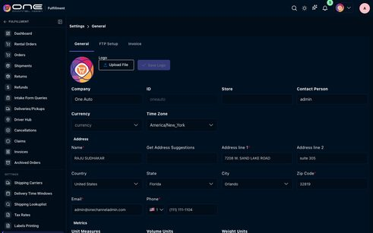

527-dropdown-time-zone-america-new-york-america-new-york — Time Zone America/New_York America/New_York
Kind: dropdown
First seen: Fulfillment / Default Shipping Address (`/settings/general`)
Size: 274×50 at (566, 458)
Tag/role: div
Classes: p-dropdown.p-component.p-inputwrapper.p-inputwrapper-filled
Selector: div:nth-of-type(1) > div:nth-of-type(4) > div:nth-of-type(6) > div:nth-of-type(1)

528-dropdown-united-states-united-states-united-states — United States United States United States
Kind: dropdown
First seen: Fulfillment / Default Shipping Address (`/settings/general`)
Size: 274×44 at (276, 688)
Tag/role: div
Classes: p-dropdown.p-component.p-inputwrapper.p-inputtext-sm.width-100perc.undefined.p-inputwrapper-filled
Selector: div:nth-of-type(1) > div:nth-of-type(6) > div:nth-of-type(5) > div:nth-of-type(1)

529-dropdown-florida-florida-florida — Florida Florida Florida
Kind: dropdown
First seen: Fulfillment / Default Shipping Address (`/settings/general`)
Size: 274×44 at (566, 688)
Tag/role: div
Classes: p-dropdown.p-component.p-inputwrapper.p-inputtext-sm.width-100perc.undefined.p-inputwrapper-filled
Selector: #stateOrRegion

530-dropdown-orlando-orlando-orlando — Orlando Orlando Orlando
Kind: dropdown
First seen: Fulfillment / Default Shipping Address (`/settings/general`)
Size: 274×44 at (856, 688)
Tag/role: div
Classes: p-dropdown.p-component.p-inputwrapper.p-inputtext-sm.width-100perc.undefined.p-inputwrapper-filled
Selector: div:nth-of-type(1) > div:nth-of-type(6) > div:nth-of-type(7) > div:nth-of-type(1)

531-dropdown-select-country-1-1 — Select Country 1 🇺🇸 1
Kind: dropdown
First seen: Fulfillment / Default Shipping Address (`/settings/general`)
Size: 69×44 at (566, 788)
Tag/role: div
Classes: p-dropdown.p-component.p-inputwrapper.p-inputtext-sm.p-inputwrapper-filled
Selector: div:nth-of-type(1) > div:nth-of-type(2) > div:nth-of-type(1) > div:nth-of-type(1)

590-dropdown-dropdown — Dropdown
Kind: dropdown
First seen: Fulfillment / Intake Form Queries (`/fulfill/orders/intake-quote`)
Size: 77×35 at (1335, 405)
Tag/role: div
Classes: p-dropdown.p-component.p-inputwrapper.p-inputwrapper-filled
Selector: div:nth-of-type(1) > div:nth-of-type(1) > div:nth-of-type(2) > div:nth-of-type(2)
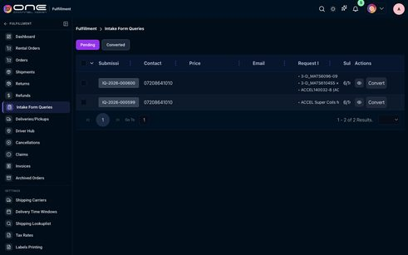

607-dropdown-last-90-days-last-90-days — Last 90 days Last 90 days
Kind: dropdown
First seen: Fulfillment / Returns (`/fulfill/orders/return`)
Size: 160×40 at (999, 63)
Tag/role: div
Classes: p-dropdown.p-component.p-inputwrapper.p-inputtext-sm.p-inputwrapper-filled
Selector: div:nth-of-type(2) > div:nth-of-type(1) > div:nth-of-type(1) > div:nth-of-type(1)
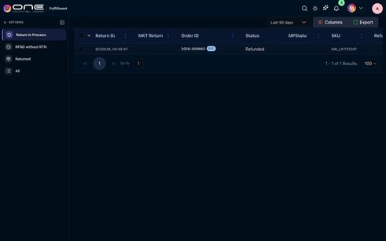

617-dropdown-map-price — Map Price
Kind: dropdown
First seen: Map Price / Dashboard (`/map-price/dashboard`)
Size: 234×36 at (12, 14)
Tag/role: div
Classes: navdropdown-span.logo-span
Selector: div:nth-of-type(1) > div:nth-of-type(2) > div:nth-of-type(1) > div:nth-of-type(1)


623-dropdown-marketing — Marketing
Kind: dropdown
First seen: Marketing / Common Socials (`/marketing/common-socials`)
Size: 234×36 at (12, 14)
Tag/role: div
Classes: navdropdown-span.logo-span
Selector: div:nth-of-type(1) > div:nth-of-type(2) > div:nth-of-type(1) > div:nth-of-type(1)


633-dropdown-all-types-store-competitor-event-custom-all-status-active-archived — All Types Store Competitor Event Custom All Status Active Archived
Kind: dropdown
First seen: Marketing / Geo Fencing (`/marketing/geo-fencing`)
Size: 328×39 at (1059, 448)
Tag/role: div
Classes: tw-flex.tw-flex-wrap.tw-items-center.tw-gap-2
Selector: div:nth-of-type(2) > div:nth-of-type(3) > div:nth-of-type(1) > div:nth-of-type(2)
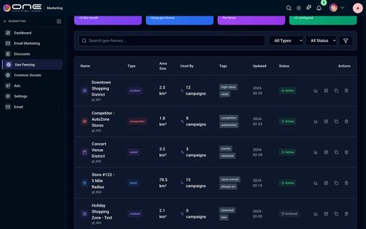

645-dropdown-operations-hub — Operations Hub
Kind: dropdown
First seen: Operations Hub / Dashboard (`/operations/dashboard`)
Size: 267×36 at (12, 14)
Tag/role: div
Classes: navdropdown-span.logo-span
Selector: div:nth-of-type(1) > div:nth-of-type(2) > div:nth-of-type(1) > div:nth-of-type(1)


660-dropdown-wms — WMS
Kind: dropdown
First seen: WMS / 3PL Clients (`/wms/3plclients`)
Size: 204×36 at (12, 14)
Tag/role: div
Classes: navdropdown-span.logo-span
Selector: div:nth-of-type(1) > div:nth-of-type(2) > div:nth-of-type(1) > div:nth-of-type(1)


661-dropdown-warehouse-warehouse — Warehouse Warehouse
Kind: dropdown
First seen: WMS / 3PL Clients (`/wms/3plclients`)
Size: 143×44 at (1083, 93)
Tag/role: div
Classes: p-dropdown.p-component.p-inputwrapper.p-inputtext-sm.p-mr-2
Selector: div:nth-of-type(1) > div:nth-of-type(2) > div:nth-of-type(1) > div:nth-of-type(1)
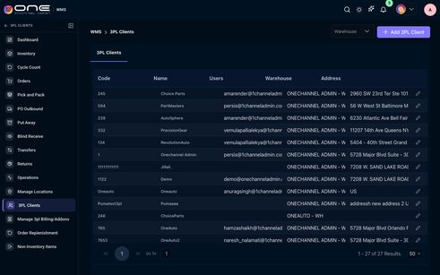

662-dropdown-onechannel-admin-wh-onechannel-admin-wh — ONECHANNEL ADMIN - WH ONECHANNEL ADMIN - WH
Kind: dropdown
First seen: WMS / Blind Receive (`/wms/blindRecieve`)
Size: 160×40 at (433, 91)
Tag/role: div
Classes: p-dropdown.p-component.p-inputwrapper.p-inputtext-sm.p-inputwrapper-filled
Selector: div:nth-of-type(2) > div:nth-of-type(2) > div:nth-of-type(2) > div:nth-of-type(1)
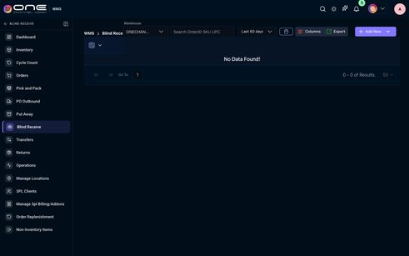

664-dropdown-warehouse-onechannel-admin-wh-onechannel-admin-wh — Warehouse ONECHANNEL ADMIN - WH ONECHANNEL ADMIN - WH
Kind: dropdown
First seen: WMS / Dashboard (`/wms/dashboard?warehouse=wh1`)
Size: 253×40 at (1108, 99)
Tag/role: div
Classes: p-dropdown.p-component.p-inputwrapper.p-inputtext-sm.p-inputwrapper-filled
Selector: div:nth-of-type(1) > div:nth-of-type(2) > div:nth-of-type(1) > div:nth-of-type(1)
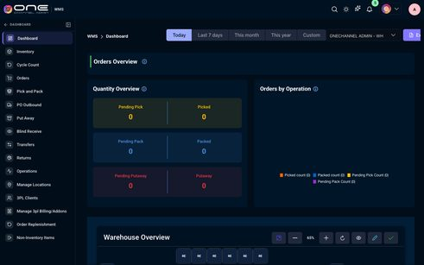

671-dropdown-onechannel-admin-onechannel-admin — Onechannel admin Onechannel admin
Kind: dropdown
First seen: WMS / Manage Locations (`/wms/setup`)
Size: 200×44 at (296, 93)
Tag/role: div
Classes: p-dropdown.p-component.p-inputwrapper.p-inputtext-sm.p-inputwrapper-filled
Selector: div:nth-of-type(2) > div:nth-of-type(1) > span:nth-of-type(1) > div:nth-of-type(1)
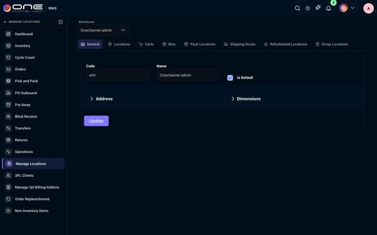

675-dropdown-3pl-all-all — 3PL All All
Kind: dropdown
First seen: WMS / Non-Inventory Items (`/wms/non_inventory_item?warehouse=all`)
Size: 152×40 at (749, 136)
Tag/role: div
Classes: p-dropdown.p-component.p-inputwrapper.p-inputtext-sm.p-inputwrapper-filled
Selector: div:nth-of-type(2) > div:nth-of-type(1) > div:nth-of-type(2) > div:nth-of-type(1)
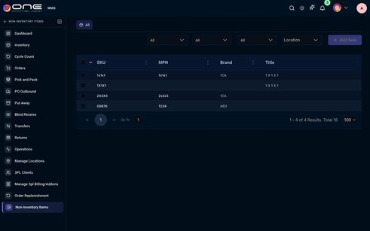

681-dropdown-3-months-3-months — 3 Months 3 Months
Kind: dropdown
First seen: WMS / Order Replenishment (`/wms/order_replenishment?isWms=true`)
Size: 160×36 at (979, 231)
Tag/role: div
Classes: p-dropdown.p-component.p-inputwrapper.p-inputtext-sm.p-inputwrapper-filled
Selector: div:nth-of-type(2) > div:nth-of-type(1) > div:nth-of-type(1) > div:nth-of-type(1)
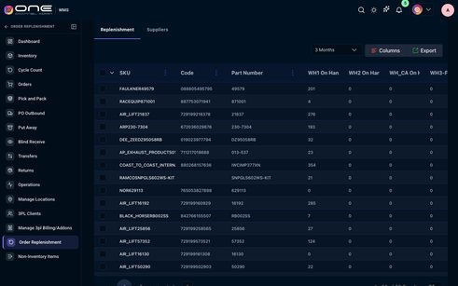

686-dropdown-user — User
Kind: dropdown
First seen: WMS / Pick and Pack (`/wms/pickpack`)
Size: 211×40 at (529, 152)
Tag/role: div
Selector: div:nth-of-type(1) > div:nth-of-type(1) > div:nth-of-type(1) > div:nth-of-type(1)
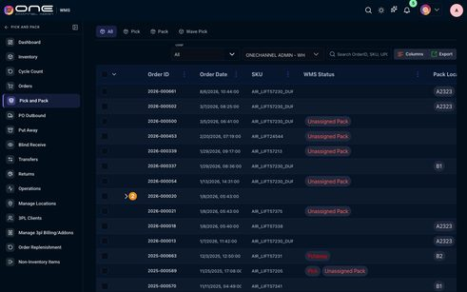

input

076-input-search-bills — Search bills...
Kind: input
First seen: Accounting / AP/AR Workflows (`/accounting/apar-workflows`)
Size: 482×40 at (707, 173)
Tag/role: div
Classes: tw-flex-1.tw-relative
Selector: div:nth-of-type(1) > div:nth-of-type(1) > div:nth-of-type(2) > div:nth-of-type(2)

088-input-search-accounts — Search accounts...
Kind: input
First seen: Accounting / Chart of Accounts (`/accounting/chart-of-accounts`)
Size: 935×40 at (320, 171)
Tag/role: div
Classes: tw-flex-1.tw-relative
Selector: div:nth-of-type(1) > div:nth-of-type(1) > div:nth-of-type(2) > div:nth-of-type(1)

101-input-search-number-method-ref-no — Search number, method, ref no...
Kind: input
First seen: Accounting / Customer Payments (`/accounting/customer-payments`)
Size: 576×40 at (320, 175)
Tag/role: div
Classes: tw-mt-5.tw-relative.tw-max-w-xl
Selector: div:nth-of-type(1) > div:nth-of-type(1) > div:nth-of-type(1) > div:nth-of-type(2)

115-input-search-customers-by-name-email-id-or-phone — Search customers by name, email, ID, or phone...
Kind: input
First seen: Accounting / Customers (`/accounting/customers`)
Size: 848×40 at (320, 297)
Tag/role: div
Classes: tw-flex-1.tw-relative
Selector: div:nth-of-type(1) > div:nth-of-type(1) > div:nth-of-type(3) > div:nth-of-type(1)

130-input-search-by-expense-vendor-description — Search by expense #, vendor, description...
Kind: input
First seen: Accounting / Expenses (`/accounting/expenses`)
Size: 314×44 at (353, 356)
Tag/role: div
Classes: tw-relative
Selector: div:nth-of-type(2) > div:nth-of-type(1) > div:nth-of-type(1) > div:nth-of-type(1)


152-input-start-date — Start Date
Kind: input
First seen: Accounting / General Ledger (`/accounting/general-ledger`)
Size: 200×68 at (752, 171)
Tag/role: div
Selector: div:nth-of-type(1) > div:nth-of-type(1) > div:nth-of-type(2) > div:nth-of-type(2)
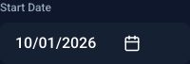

153-input-end-date — End Date
Kind: input
First seen: Accounting / General Ledger (`/accounting/general-ledger`)
Size: 200×68 at (968, 171)
Tag/role: div
Selector: div:nth-of-type(1) > div:nth-of-type(1) > div:nth-of-type(2) > div:nth-of-type(3)


154-input-search-transactions — Search transactions...
Kind: input
First seen: Accounting / General Ledger (`/accounting/general-ledger`)
Size: 872×40 at (512, 255)
Tag/role: div
Classes: tw-flex-1.tw-relative
Selector: div:nth-of-type(1) > div:nth-of-type(1) > div:nth-of-type(3) > div:nth-of-type(2)

162-input-search-by-invoice-order-customer — Search by invoice #, order #, customer...
Kind: input
First seen: Accounting / Invoices (`/accounting/invoices`)
Size: 404×46 at (353, 229)
Tag/role: div
Classes: tw-relative
Selector: div:nth-of-type(1) > div:nth-of-type(1) > div:nth-of-type(1) > div:nth-of-type(1)


181-input-search-entries — Search entries...
Kind: input
First seen: Accounting / Journal Entries (`/accounting/journal-entries`)
Size: 797×40 at (320, 171)
Tag/role: div
Classes: tw-flex-1.tw-relative
Selector: div:nth-of-type(1) > div:nth-of-type(1) > div:nth-of-type(2) > div:nth-of-type(1)

187-input-search-entities — Search entities...
Kind: input
First seen: Accounting / Multi Entity (`/accounting/multi-entity`)
Size: 1064×40 at (320, 171)
Tag/role: div
Classes: tw-flex-1.tw-relative
Selector: div:nth-of-type(1) > div:nth-of-type(1) > div:nth-of-type(2) > div:nth-of-type(1)

204-input-search-reports — Search reports...
Kind: input
First seen: Accounting / Reports (`/accounting/reports`)
Size: 1064×40 at (320, 171)
Tag/role: div
Classes: tw-relative
Selector: div:nth-of-type(1) > div:nth-of-type(1) > div:nth-of-type(2) > div:nth-of-type(1)

218-input-company-name — Company Name
Kind: input
First seen: Accounting / Settings (`/accounting/accounting-settings`)
Size: 718×74 at (601, 313)
Tag/role: div
Selector: div:nth-of-type(2) > div:nth-of-type(1) > div:nth-of-type(2) > div:nth-of-type(1)


230-input-search — Search...
Kind: input
First seen: Accounting / Tax Engine (`/accounting/tax-engine`)
Size: 728×36 at (656, 175)
Tag/role: div
Classes: tw-flex-1.tw-relative
Selector: div:nth-of-type(1) > div:nth-of-type(1) > div:nth-of-type(2) > div:nth-of-type(2)

239-input-search-transaction-party-reference-memo — Search transaction #, party, reference, memo...
Kind: input
First seen: Accounting / Transactions (`/accounting/transactions`)
Size: 788×40 at (320, 190)
Tag/role: div
Classes: tw-relative.tw-flex-1.tw-min-w-[220px]
Selector: div:nth-of-type(1) > div:nth-of-type(1) > div:nth-of-type(3) > div:nth-of-type(1)

262-input-search-vendors-by-name-company-email-id-or-phone — Search vendors by name, company, email, ID, or phone...
Kind: input
First seen: Accounting / Vendors (`/accounting/vendors`)
Size: 848×40 at (320, 297)
Tag/role: div
Classes: tw-flex-1.tw-relative
Selector: div:nth-of-type(1) > div:nth-of-type(1) > div:nth-of-type(3) > div:nth-of-type(1)

271-input-go-to — Go To
Kind: input
First seen: Admin / Addons & Invoices (`/settings/billing-invoices`)
Size: 118×36 at (486, 351)
Tag/role: div
Classes: flex.gap01.align-item-center
Selector: div:nth-of-type(1) > div:nth-of-type(1) > div:nth-of-type(2) > div:nth-of-type(1)


295-input-search-title-or-message — Search title or message
Kind: input
First seen: Admin / Help Desk (`/settings/help-center`)
Size: 230×44 at (320, 204)
Tag/role: div
Selector: div:nth-of-type(3) > div:nth-of-type(1) > div:nth-of-type(1) > div:nth-of-type(1)


318-input-add-text-upload-image-rectangle-circle-add-page-delete-bring-forward-send-backwa — Add Text Upload Image Rectangle Circle Add Page Delete Bring Forward Send Backwa
Kind: input
First seen: Admin / Menu Editor (`/settings/pageflipcanvaseditor`)
Size: 1054×80 at (325, 106)
Tag/role: div
Selector: div:nth-of-type(1) > div:nth-of-type(1) > div:nth-of-type(1) > div:nth-of-type(1)

319-input-canvas-background-color-background-image-product-add-product-card-search-by-sku — CANVAS Background Color Background Image PRODUCT Add product card Search by SKU,
Kind: input
First seen: Admin / Menu Editor (`/settings/pageflipcanvaseditor`)
Size: 298×409 at (1093, 257)
Tag/role: div
Selector: div:nth-of-type(2) > aside:nth-of-type(2) > div:nth-of-type(2) > div:nth-of-type(1)

340-input-all-users-15-ajith-onechanneladmin-com-amarender-onechanneladmin-com-anurag3pl — All users (15) ajith@onechanneladmin.com amarender@onechanneladmin.com anurag3pl
Kind: input
First seen: Admin / Users Attendance (`/settings/users-attendance`)
Size: 928×38 at (331, 244)
Tag/role: div
Classes: tw-flex.tw-flex-wrap.tw-items-center.tw-gap-2
Selector: div:nth-of-type(3) > div:nth-of-type(1) > div:nth-of-type(1) > div:nth-of-type(2)

341-input-search-users — Search users…
Kind: input
First seen: Admin / Users Attendance (`/settings/users-attendance`)
Size: 192×38 at (1181, 487)
Tag/role: div
Classes: tw-relative
Selector: div:nth-of-type(3) > div:nth-of-type(2) > div:nth-of-type(1) > div:nth-of-type(2)


378-input-serial-no-search — Serial No. search
Kind: input
First seen: Catalog / Bundles (`/products/bundlekits`)
Size: 211×40 at (789, 79)
Tag/role: div
Selector: div:nth-of-type(1) > div:nth-of-type(1) > div:nth-of-type(1) > div:nth-of-type(1)


390-input-search-by-mpn — Search By MPN
Kind: input
First seen: Catalog / Images (`/products/images`)
Size: 198×39 at (993, 77)
Tag/role: div
Selector: div:nth-of-type(1) > div:nth-of-type(4) > span:nth-of-type(1) > div:nth-of-type(1)


391-input-input — Input
Kind: input
First seen: Catalog / Images (`/products/images`)
Size: 80×80 at (715, 298)
Tag/role: div
Classes: file-upload
Selector: tr:nth-of-type(1) > td:nth-of-type(2) > div:nth-of-type(1) > div:nth-of-type(1)


434-input-filter-by-category-filter-by-category-filter-by-brand-filter-by-brand-tax-code-t — Filter by Category Filter by Category Filter by Brand Filter by Brand Tax code T
Kind: input
First seen: Channel / OneDirectBuy (`/marketplaceseller`)
Size: 1112×50 at (296, 133)
Tag/role: div
Classes: flex.flex-wrap.gap-2.align-items-center
Selector: div:nth-of-type(1) > div:nth-of-type(1) > div:nth-of-type(1) > div:nth-of-type(1)

443-input-item — ⌕
Kind: input
First seen: CRM / 1CA CRMhub (`/marketing/engage`)
Size: 330×40 at (524, 484)
Tag/role: div
Classes: css-g5y9jx.r-1awozwy.r-1q9bdsx.r-rs99b7.r-18u37iz.r-1cmwbt1.r-ero68b.r-3o4zer
Selector: div:nth-of-type(2) > div:nth-of-type(1) > div:nth-of-type(2) > div:nth-of-type(1)


469-input-search-orderid-sku-upc — Search OrderID, SKU, UPC...
Kind: input
First seen: CRM / Work Orders (`/crm/workorders`)
Size: 200×34 at (693, 152)
Tag/role: input
Classes: p-inputtext.p-component.p-inputtext-sm.fulfill-orders-ref-search
Selector: div:nth-of-type(1) > div:nth-of-type(1) > div:nth-of-type(1) > input:nth-of-type(1)


475-input-search-orderid-sku-upc — Search OrderID SKU UPC
Kind: input
First seen: Fulfillment / Archived Orders (`/fulfill/orders/archived`)
Size: 224×40 at (801, 75)
Tag/role: input
Classes: p-inputtext.p-component.p-inputtext-sm.p-mr-2.fulfill-orders-toolbar-search
Selector: div:nth-of-type(4) > div:nth-of-type(2) > div:nth-of-type(2) > input:nth-of-type(1)


532-input-save-logo — Save Logo
Kind: input
First seen: Fulfillment / Default Shipping Address (`/settings/general`)
Size: 276×40 at (381, 231)
Tag/role: div
Selector: div:nth-of-type(1) > div:nth-of-type(3) > div:nth-of-type(2) > div:nth-of-type(1)


533-input-company — Company
Kind: input
First seen: Fulfillment / Default Shipping Address (`/settings/general`)
Size: 290×88 at (268, 323)
Tag/role: div
Classes: p-field.p-col-12.p-md-3.p-mb-2.p-p-2
Selector: div:nth-of-type(1) > div:nth-of-type(1) > div:nth-of-type(4) > div:nth-of-type(1)
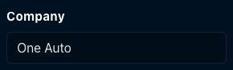

534-input-id — ID
Kind: input
First seen: Fulfillment / Default Shipping Address (`/settings/general`)
Size: 290×88 at (558, 323)
Tag/role: div
Classes: p-field.p-col-12.p-md-3.p-mb-2.p-p-2
Selector: div:nth-of-type(1) > div:nth-of-type(1) > div:nth-of-type(4) > div:nth-of-type(2)


535-input-store — Store
Kind: input
First seen: Fulfillment / Default Shipping Address (`/settings/general`)
Size: 290×88 at (848, 323)
Tag/role: div
Classes: p-field.p-col-12.p-md-3.p-mb-2.p-p-2
Selector: div:nth-of-type(1) > div:nth-of-type(1) > div:nth-of-type(4) > div:nth-of-type(3)
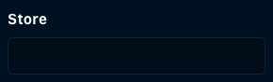

536-input-contact-person — Contact Person
Kind: input
First seen: Fulfillment / Default Shipping Address (`/settings/general`)
Size: 290×88 at (1138, 323)
Tag/role: div
Classes: p-field.p-col-12.p-md-3.p-mb-2.p-p-2
Selector: div:nth-of-type(1) > div:nth-of-type(1) > div:nth-of-type(4) > div:nth-of-type(4)
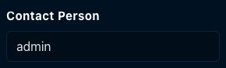

537-input-name — Name*
Kind: input
First seen: Fulfillment / Default Shipping Address (`/settings/general`)
Size: 290×92 at (268, 549)
Tag/role: div
Classes: p-field.p-col-3.p-mb-2.p-p-2
Selector: div:nth-of-type(1) > div:nth-of-type(1) > div:nth-of-type(6) > div:nth-of-type(1)


538-input-get-address-suggestions — Get Address Suggestions
Kind: input
First seen: Fulfillment / Default Shipping Address (`/settings/general`)
Size: 290×92 at (558, 549)
Tag/role: div
Classes: p-field.p-col-3.p-mb-2.p-p-2
Selector: div:nth-of-type(1) > div:nth-of-type(1) > div:nth-of-type(6) > div:nth-of-type(2)
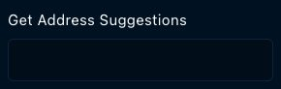

539-input-address-line-1 — Address line 1*
Kind: input
First seen: Fulfillment / Default Shipping Address (`/settings/general`)
Size: 290×92 at (848, 549)
Tag/role: div
Classes: p-field.p-col-3.p-mb-2.p-p-2
Selector: div:nth-of-type(1) > div:nth-of-type(1) > div:nth-of-type(6) > div:nth-of-type(3)
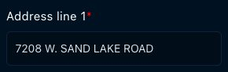

540-input-address-line-2 — Address line 2
Kind: input
First seen: Fulfillment / Default Shipping Address (`/settings/general`)
Size: 290×92 at (1138, 549)
Tag/role: div
Classes: p-field.p-col-3.p-mb-2.p-p-2
Selector: div:nth-of-type(1) > div:nth-of-type(1) > div:nth-of-type(6) > div:nth-of-type(4)
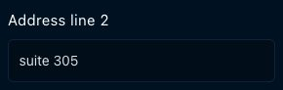

541-input-zip-code — Zip Code*
Kind: input
First seen: Fulfillment / Default Shipping Address (`/settings/general`)
Size: 290×92 at (1138, 649)
Tag/role: div
Classes: p-field.p-col-3.p-mb-2.p-p-2
Selector: div:nth-of-type(1) > div:nth-of-type(1) > div:nth-of-type(6) > div:nth-of-type(8)
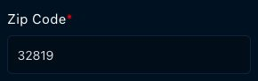

542-input-email — Email*
Kind: input
First seen: Fulfillment / Default Shipping Address (`/settings/general`)
Size: 290×92 at (268, 748)
Tag/role: div
Classes: p-field.p-col-3.p-mb-2.p-p-2
Selector: div:nth-of-type(1) > div:nth-of-type(1) > div:nth-of-type(6) > div:nth-of-type(9)


543-input-select-country-1-1 — Select Country 1 🇺🇸 1
Kind: input
First seen: Fulfillment / Default Shipping Address (`/settings/general`)
Size: 274×44 at (566, 788)
Tag/role: div
Classes: addcontact
Selector: div:nth-of-type(6) > div:nth-of-type(10) > div:nth-of-type(1) > div:nth-of-type(2)


631-input-search-campaigns — Search campaigns...
Kind: input
First seen: Marketing / Email Marketing (`/marketing/marketingemails`)
Size: 397×46 at (536, 163)
Tag/role: div
Classes: tw-relative.tw-flex-1.tw-min-w-[220px]
Selector: div:nth-of-type(1) > div:nth-of-type(1) > div:nth-of-type(2) > div:nth-of-type(1)


634-input-search-geo-fences — Search geo-fences...
Kind: input
First seen: Marketing / Geo Fencing (`/marketing/geo-fencing`)
Size: 734×42 at (309, 447)
Tag/role: div
Classes: tw-flex-1.tw-relative
Selector: div:nth-of-type(2) > div:nth-of-type(3) > div:nth-of-type(1) > div:nth-of-type(1)

672-input-code — Code
Kind: input
First seen: WMS / Manage Locations (`/wms/setup`)
Size: 270×100 at (313, 225)
Tag/role: div
Classes: p-xl-3.p-lg-3.p-md-6.p-sm-12.p-col-12
Selector: div:nth-of-type(2) > form:nth-of-type(1) > div:nth-of-type(1) > div:nth-of-type(1)
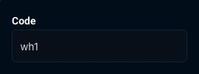

673-input-name — Name
Kind: input
First seen: WMS / Manage Locations (`/wms/setup`)
Size: 270×100 at (583, 225)
Tag/role: div
Classes: p-xl-3.p-lg-3.p-md-6.p-sm-12.p-col-12
Selector: div:nth-of-type(2) > form:nth-of-type(1) > div:nth-of-type(1) > div:nth-of-type(2)
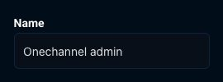

687-input-user — User
Kind: input
First seen: WMS / Pick and Pack (`/wms/pickpack`)
Size: 211×40 at (529, 152)
Tag/role: div
Selector: div:nth-of-type(1) > div:nth-of-type(1) > div:nth-of-type(1) > div:nth-of-type(1)


metric-card

346-metric-card-total-sales-0-avg-order-value-0-total-orders-0-net-sales-0-cancelled-orders — Total Sales $0 Avg. Order Value $0 Total Orders 0 Net Sales $0 Cancelled Orders
Kind: metric-card
First seen: Analytics & Reports / Dashboard (`/analytics/analytics-dashboard`)
Size: 1112×112 at (296, 231)
Tag/role: div
Classes: tw-mb-4.tw-max-w-full.analytics-kpi-row.analytics-sales-kpi-row
Selector: div:nth-of-type(1) > div:nth-of-type(1) > div:nth-of-type(1) > div:nth-of-type(1)


347-metric-card-total-sales-0 — Total Sales $0
Kind: metric-card
First seen: Analytics & Reports / Dashboard (`/analytics/analytics-dashboard`)
Size: 175×112 at (296, 231)
Tag/role: div
Classes: tw-text-center.tw-rounded-xl.tw-shadow.analytics-kpi-card.analytics-sales-kpi-card
Selector: div:nth-of-type(1) > div:nth-of-type(1) > div:nth-of-type(1) > div:nth-of-type(1)
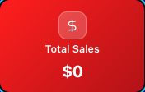

348-metric-card-metric-card — Metric card
Kind: metric-card
First seen: Analytics & Reports / Dashboard (`/analytics/analytics-dashboard`)
Size: 34×34 at (367, 245)
Tag/role: span
Classes: analytics-solid-kpi-icon
Selector: div:nth-of-type(1) > div:nth-of-type(1) > div:nth-of-type(1) > span:nth-of-type(1)


349-metric-card-avg-order-value-0 — Avg. Order Value $0
Kind: metric-card
First seen: Analytics & Reports / Dashboard (`/analytics/analytics-dashboard`)
Size: 175×112 at (483, 231)
Tag/role: div
Classes: tw-text-center.tw-rounded-xl.tw-shadow.analytics-kpi-card.analytics-sales-kpi-card
Selector: div:nth-of-type(1) > div:nth-of-type(1) > div:nth-of-type(1) > div:nth-of-type(2)
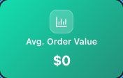

350-metric-card-total-orders-0 — Total Orders 0
Kind: metric-card
First seen: Analytics & Reports / Dashboard (`/analytics/analytics-dashboard`)
Size: 175×112 at (671, 231)
Tag/role: div
Classes: tw-text-center.tw-rounded-xl.tw-shadow.analytics-kpi-card.analytics-sales-kpi-card
Selector: div:nth-of-type(1) > div:nth-of-type(1) > div:nth-of-type(1) > div:nth-of-type(3)
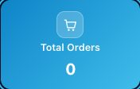

351-metric-card-net-sales-0 — Net Sales $0
Kind: metric-card
First seen: Analytics & Reports / Dashboard (`/analytics/analytics-dashboard`)
Size: 175×112 at (858, 231)
Tag/role: div
Classes: tw-text-center.tw-rounded-xl.tw-shadow.analytics-kpi-card.analytics-sales-kpi-card
Selector: div:nth-of-type(1) > div:nth-of-type(1) > div:nth-of-type(1) > div:nth-of-type(4)


352-metric-card-cancelled-orders-0 — Cancelled Orders 0
Kind: metric-card
First seen: Analytics & Reports / Dashboard (`/analytics/analytics-dashboard`)
Size: 175×112 at (1045, 231)
Tag/role: div
Classes: tw-text-center.tw-rounded-xl.tw-shadow.analytics-kpi-card.analytics-sales-kpi-card
Selector: div:nth-of-type(1) > div:nth-of-type(1) > div:nth-of-type(1) > div:nth-of-type(5)
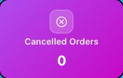

353-metric-card-returned-orders-0 — Returned Orders 0
Kind: metric-card
First seen: Analytics & Reports / Dashboard (`/analytics/analytics-dashboard`)
Size: 175×112 at (1233, 231)
Tag/role: div
Classes: tw-text-center.tw-rounded-xl.tw-shadow.analytics-kpi-card.analytics-sales-kpi-card
Selector: div:nth-of-type(1) > div:nth-of-type(1) > div:nth-of-type(1) > div:nth-of-type(6)
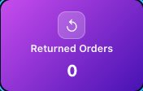

354-metric-card-total-purchase-orders-0-avg-po-value-0-total-inventory-purchase-0-total-inven — Total Purchase Orders 0 Avg. PO Value $0 Total Inventory Purchase $0 Total Inven
Kind: metric-card
First seen: Analytics & Reports / Dashboard (`/analytics/analytics-dashboard`)
Size: 1112×127 at (296, 375)
Tag/role: div
Classes: tw-mb-4.tw-max-w-full.analytics-kpi-row.analytics-sales-kpi-row
Selector: div:nth-of-type(1) > div:nth-of-type(1) > div:nth-of-type(1) > div:nth-of-type(2)
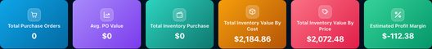

355-metric-card-total-purchase-orders-0 — Total Purchase Orders 0
Kind: metric-card
First seen: Analytics & Reports / Dashboard (`/analytics/analytics-dashboard`)
Size: 175×127 at (296, 375)
Tag/role: div
Classes: tw-text-center.tw-rounded-xl.tw-shadow.analytics-kpi-card.analytics-sales-kpi-card
Selector: div:nth-of-type(1) > div:nth-of-type(1) > div:nth-of-type(2) > div:nth-of-type(1)
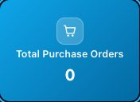

356-metric-card-avg-po-value-0 — Avg. PO Value $0
Kind: metric-card
First seen: Analytics & Reports / Dashboard (`/analytics/analytics-dashboard`)
Size: 175×127 at (483, 375)
Tag/role: div
Classes: tw-text-center.tw-rounded-xl.tw-shadow.analytics-kpi-card.analytics-sales-kpi-card
Selector: div:nth-of-type(1) > div:nth-of-type(1) > div:nth-of-type(2) > div:nth-of-type(2)
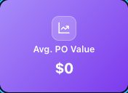

357-metric-card-total-inventory-purchase-0 — Total Inventory Purchase $0
Kind: metric-card
First seen: Analytics & Reports / Dashboard (`/analytics/analytics-dashboard`)
Size: 175×127 at (671, 375)
Tag/role: div
Classes: tw-text-center.tw-rounded-xl.tw-shadow.analytics-kpi-card.analytics-sales-kpi-card
Selector: div:nth-of-type(1) > div:nth-of-type(1) > div:nth-of-type(2) > div:nth-of-type(3)
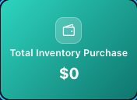

358-metric-card-total-inventory-value-by-cost-2-184-86 — Total Inventory Value By Cost $2,184.86
Kind: metric-card
First seen: Analytics & Reports / Dashboard (`/analytics/analytics-dashboard`)
Size: 175×127 at (858, 375)
Tag/role: div
Classes: tw-text-center.tw-rounded-xl.tw-shadow.analytics-kpi-card.analytics-sales-kpi-card
Selector: div:nth-of-type(1) > div:nth-of-type(1) > div:nth-of-type(2) > div:nth-of-type(4)
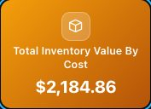

359-metric-card-total-inventory-value-by-price-2-072-48 — Total Inventory Value By Price $2,072.48
Kind: metric-card
First seen: Analytics & Reports / Dashboard (`/analytics/analytics-dashboard`)
Size: 175×127 at (1045, 375)
Tag/role: div
Classes: tw-text-center.tw-rounded-xl.tw-shadow.analytics-kpi-card.analytics-sales-kpi-card
Selector: div:nth-of-type(1) > div:nth-of-type(1) > div:nth-of-type(2) > div:nth-of-type(5)
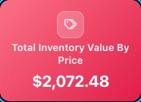

360-metric-card-estimated-profit-margin-112-38 — Estimated Profit Margin $-112.38
Kind: metric-card
First seen: Analytics & Reports / Dashboard (`/analytics/analytics-dashboard`)
Size: 175×127 at (1233, 375)
Tag/role: div
Classes: tw-text-center.tw-rounded-xl.tw-shadow.analytics-kpi-card.analytics-sales-kpi-card
Selector: div:nth-of-type(1) > div:nth-of-type(1) > div:nth-of-type(2) > div:nth-of-type(6)
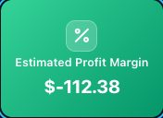

483-metric-card-330-total-orders-248-open-orders-34-cancelled-orders — 330 Total Orders 248 Open Orders 34 Cancelled Orders
Kind: metric-card
First seen: Fulfillment / Dashboard (`/fulfill/orders/dashboard`)
Size: 530×108 at (293, 640)
Tag/role: div
Classes: dash-metrics.dash-metrics--3
Selector: div:nth-of-type(1) > div:nth-of-type(2) > div:nth-of-type(1) > div:nth-of-type(2)
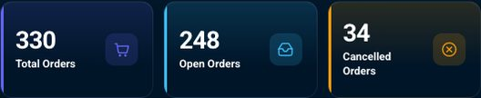

484-metric-card-330-total-orders — 330 Total Orders
Kind: metric-card
First seen: Fulfillment / Dashboard (`/fulfill/orders/dashboard`)
Size: 169×108 at (293, 640)
Tag/role: div
Classes: dash-metric-wrap
Selector: div:nth-of-type(2) > div:nth-of-type(1) > div:nth-of-type(2) > div:nth-of-type(1)
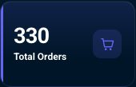

485-metric-card-330-total-orders — 330 Total Orders
Kind: metric-card
First seen: Fulfillment / Dashboard (`/fulfill/orders/dashboard`)
Size: 169×108 at (293, 640)
Tag/role: div role=button
Classes: dash-metric
Selector: div:nth-of-type(1) > div:nth-of-type(2) > div:nth-of-type(1) > div:nth-of-type(1)

486-metric-card-330-total-orders — 330 Total Orders
Kind: metric-card
First seen: Fulfillment / Dashboard (`/fulfill/orders/dashboard`)
Size: 135×49 at (310, 670)
Tag/role: div
Classes: dash-metric-top
Selector: div:nth-of-type(2) > div:nth-of-type(1) > div:nth-of-type(1) > div:nth-of-type(1)


487-metric-card-330-total-orders — 330 Total Orders
Kind: metric-card
First seen: Fulfillment / Dashboard (`/fulfill/orders/dashboard`)
Size: 86×49 at (310, 670)
Tag/role: div
Classes: dash-metric-copy
Selector: div:nth-of-type(1) > div:nth-of-type(1) > div:nth-of-type(1) > div:nth-of-type(1)
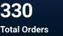

488-metric-card-330 — 330
Kind: metric-card
First seen: Fulfillment / Dashboard (`/fulfill/orders/dashboard`)
Size: 86×30 at (310, 670)
Tag/role: p
Classes: dash-metric-value
Selector: div:nth-of-type(1) > div:nth-of-type(1) > div:nth-of-type(1) > p:nth-of-type(1)

489-metric-card-total-orders — Total Orders
Kind: metric-card
First seen: Fulfillment / Dashboard (`/fulfill/orders/dashboard`)
Size: 86×16 at (310, 703)
Tag/role: p
Classes: dash-metric-label
Selector: div:nth-of-type(1) > div:nth-of-type(1) > div:nth-of-type(1) > p:nth-of-type(2)

490-metric-card-metric-card — Metric card
Kind: metric-card
First seen: Fulfillment / Dashboard (`/fulfill/orders/dashboard`)
Size: 36×36 at (409, 676)
Tag/role: span
Classes: dash-metric-icon
Selector: div:nth-of-type(1) > div:nth-of-type(1) > div:nth-of-type(1) > span:nth-of-type(1)


491-metric-card-248-open-orders — 248 Open Orders
Kind: metric-card
First seen: Fulfillment / Dashboard (`/fulfill/orders/dashboard`)
Size: 169×108 at (473, 640)
Tag/role: div
Classes: dash-metric-wrap
Selector: div:nth-of-type(2) > div:nth-of-type(1) > div:nth-of-type(2) > div:nth-of-type(2)
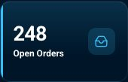

492-metric-card-248-open-orders — 248 Open Orders
Kind: metric-card
First seen: Fulfillment / Dashboard (`/fulfill/orders/dashboard`)
Size: 169×108 at (473, 640)
Tag/role: div role=button
Classes: dash-metric
Selector: div:nth-of-type(1) > div:nth-of-type(2) > div:nth-of-type(2) > div:nth-of-type(1)

493-metric-card-248-open-orders — 248 Open Orders
Kind: metric-card
First seen: Fulfillment / Dashboard (`/fulfill/orders/dashboard`)
Size: 135×49 at (490, 670)
Tag/role: div
Classes: dash-metric-top
Selector: div:nth-of-type(2) > div:nth-of-type(2) > div:nth-of-type(1) > div:nth-of-type(1)


494-metric-card-248-open-orders — 248 Open Orders
Kind: metric-card
First seen: Fulfillment / Dashboard (`/fulfill/orders/dashboard`)
Size: 86×49 at (490, 670)
Tag/role: div
Classes: dash-metric-copy
Selector: div:nth-of-type(2) > div:nth-of-type(1) > div:nth-of-type(1) > div:nth-of-type(1)
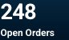

495-metric-card-open-orders — Open Orders
Kind: metric-card
First seen: Fulfillment / Dashboard (`/fulfill/orders/dashboard`)
Size: 86×16 at (490, 703)
Tag/role: p
Classes: dash-metric-label
Selector: div:nth-of-type(1) > div:nth-of-type(1) > div:nth-of-type(1) > p:nth-of-type(2)

496-metric-card-34-cancelled-orders — 34 Cancelled Orders
Kind: metric-card
First seen: Fulfillment / Dashboard (`/fulfill/orders/dashboard`)
Size: 169×108 at (654, 640)
Tag/role: div
Classes: dash-metric-wrap
Selector: div:nth-of-type(2) > div:nth-of-type(1) > div:nth-of-type(2) > div:nth-of-type(3)
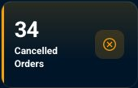

497-metric-card-34-cancelled-orders — 34 Cancelled Orders
Kind: metric-card
First seen: Fulfillment / Dashboard (`/fulfill/orders/dashboard`)
Size: 169×108 at (654, 640)
Tag/role: div role=button
Classes: dash-metric
Selector: div:nth-of-type(1) > div:nth-of-type(2) > div:nth-of-type(3) > div:nth-of-type(1)

498-metric-card-34-cancelled-orders — 34 Cancelled Orders
Kind: metric-card
First seen: Fulfillment / Dashboard (`/fulfill/orders/dashboard`)
Size: 135×64 at (671, 662)
Tag/role: div
Classes: dash-metric-top
Selector: div:nth-of-type(2) > div:nth-of-type(3) > div:nth-of-type(1) > div:nth-of-type(1)
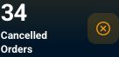

499-metric-card-34-cancelled-orders — 34 Cancelled Orders
Kind: metric-card
First seen: Fulfillment / Dashboard (`/fulfill/orders/dashboard`)
Size: 86×64 at (671, 662)
Tag/role: div
Classes: dash-metric-copy
Selector: div:nth-of-type(3) > div:nth-of-type(1) > div:nth-of-type(1) > div:nth-of-type(1)
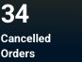

500-metric-card-cancelled-orders — Cancelled Orders
Kind: metric-card
First seen: Fulfillment / Dashboard (`/fulfill/orders/dashboard`)
Size: 86×31 at (671, 695)
Tag/role: p
Classes: dash-metric-label
Selector: div:nth-of-type(1) > div:nth-of-type(1) > div:nth-of-type(1) > p:nth-of-type(2)
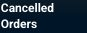

501-metric-card-17-total-returns-5-open-returns-17-returned — 17 Total Returns 5 Open Returns 17 Returned
Kind: metric-card
First seen: Fulfillment / Dashboard (`/fulfill/orders/dashboard`)
Size: 530×108 at (873, 640)
Tag/role: div
Classes: dash-metrics.dash-metrics--3
Selector: div:nth-of-type(1) > div:nth-of-type(3) > div:nth-of-type(1) > div:nth-of-type(2)
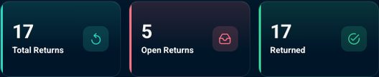

502-metric-card-17-total-returns — 17 Total Returns
Kind: metric-card
First seen: Fulfillment / Dashboard (`/fulfill/orders/dashboard`)
Size: 169×108 at (873, 640)
Tag/role: div
Classes: dash-metric-wrap
Selector: div:nth-of-type(3) > div:nth-of-type(1) > div:nth-of-type(2) > div:nth-of-type(1)
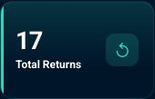

503-metric-card-17-total-returns — 17 Total Returns
Kind: metric-card
First seen: Fulfillment / Dashboard (`/fulfill/orders/dashboard`)
Size: 169×108 at (873, 640)
Tag/role: div role=button
Classes: dash-metric
Selector: div:nth-of-type(1) > div:nth-of-type(2) > div:nth-of-type(1) > div:nth-of-type(1)

504-metric-card-17-total-returns — 17 Total Returns
Kind: metric-card
First seen: Fulfillment / Dashboard (`/fulfill/orders/dashboard`)
Size: 135×49 at (890, 670)
Tag/role: div
Classes: dash-metric-top
Selector: div:nth-of-type(2) > div:nth-of-type(1) > div:nth-of-type(1) > div:nth-of-type(1)


505-metric-card-17-total-returns — 17 Total Returns
Kind: metric-card
First seen: Fulfillment / Dashboard (`/fulfill/orders/dashboard`)
Size: 86×49 at (890, 670)
Tag/role: div
Classes: dash-metric-copy
Selector: div:nth-of-type(1) > div:nth-of-type(1) > div:nth-of-type(1) > div:nth-of-type(1)


506-metric-card-total-returns — Total Returns
Kind: metric-card
First seen: Fulfillment / Dashboard (`/fulfill/orders/dashboard`)
Size: 86×16 at (890, 703)
Tag/role: p
Classes: dash-metric-label
Selector: div:nth-of-type(1) > div:nth-of-type(1) > div:nth-of-type(1) > p:nth-of-type(2)

507-metric-card-5-open-returns — 5 Open Returns
Kind: metric-card
First seen: Fulfillment / Dashboard (`/fulfill/orders/dashboard`)
Size: 169×108 at (1053, 640)
Tag/role: div
Classes: dash-metric-wrap
Selector: div:nth-of-type(3) > div:nth-of-type(1) > div:nth-of-type(2) > div:nth-of-type(2)


508-metric-card-5-open-returns — 5 Open Returns
Kind: metric-card
First seen: Fulfillment / Dashboard (`/fulfill/orders/dashboard`)
Size: 169×108 at (1053, 640)
Tag/role: div role=button
Classes: dash-metric
Selector: div:nth-of-type(1) > div:nth-of-type(2) > div:nth-of-type(2) > div:nth-of-type(1)

509-metric-card-5-open-returns — 5 Open Returns
Kind: metric-card
First seen: Fulfillment / Dashboard (`/fulfill/orders/dashboard`)
Size: 135×49 at (1070, 670)
Tag/role: div
Classes: dash-metric-top
Selector: div:nth-of-type(2) > div:nth-of-type(2) > div:nth-of-type(1) > div:nth-of-type(1)


510-metric-card-5-open-returns — 5 Open Returns
Kind: metric-card
First seen: Fulfillment / Dashboard (`/fulfill/orders/dashboard`)
Size: 86×49 at (1070, 670)
Tag/role: div
Classes: dash-metric-copy
Selector: div:nth-of-type(2) > div:nth-of-type(1) > div:nth-of-type(1) > div:nth-of-type(1)


511-metric-card-open-returns — Open Returns
Kind: metric-card
First seen: Fulfillment / Dashboard (`/fulfill/orders/dashboard`)
Size: 86×16 at (1070, 703)
Tag/role: p
Classes: dash-metric-label
Selector: div:nth-of-type(1) > div:nth-of-type(1) > div:nth-of-type(1) > p:nth-of-type(2)

512-metric-card-17-returned — 17 Returned
Kind: metric-card
First seen: Fulfillment / Dashboard (`/fulfill/orders/dashboard`)
Size: 169×108 at (1234, 640)
Tag/role: div
Classes: dash-metric-wrap
Selector: div:nth-of-type(3) > div:nth-of-type(1) > div:nth-of-type(2) > div:nth-of-type(3)
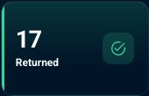

513-metric-card-17-returned — 17 Returned
Kind: metric-card
First seen: Fulfillment / Dashboard (`/fulfill/orders/dashboard`)
Size: 169×108 at (1234, 640)
Tag/role: div role=button
Classes: dash-metric
Selector: div:nth-of-type(1) > div:nth-of-type(2) > div:nth-of-type(3) > div:nth-of-type(1)

514-metric-card-17-returned — 17 Returned
Kind: metric-card
First seen: Fulfillment / Dashboard (`/fulfill/orders/dashboard`)
Size: 135×49 at (1251, 670)
Tag/role: div
Classes: dash-metric-top
Selector: div:nth-of-type(2) > div:nth-of-type(3) > div:nth-of-type(1) > div:nth-of-type(1)


515-metric-card-17-returned — 17 Returned
Kind: metric-card
First seen: Fulfillment / Dashboard (`/fulfill/orders/dashboard`)
Size: 86×49 at (1251, 670)
Tag/role: div
Classes: dash-metric-copy
Selector: div:nth-of-type(3) > div:nth-of-type(1) > div:nth-of-type(1) > div:nth-of-type(1)


516-metric-card-returned — Returned
Kind: metric-card
First seen: Fulfillment / Dashboard (`/fulfill/orders/dashboard`)
Size: 86×16 at (1251, 703)
Tag/role: p
Classes: dash-metric-label
Selector: div:nth-of-type(1) > div:nth-of-type(1) > div:nth-of-type(1) > p:nth-of-type(2)

517-metric-card-0-total-refunds-11-refunded-0-refund-initialized-0-refund-without-return — 0 Total Refunds 11 Refunded 0 Refund Initialized 0 Refund without Return
Kind: metric-card
First seen: Fulfillment / Dashboard (`/fulfill/orders/dashboard`)
Size: 530×227 at (293, 842)
Tag/role: div
Classes: dash-metrics.dash-metrics--4
Selector: div:nth-of-type(1) > div:nth-of-type(4) > div:nth-of-type(1) > div:nth-of-type(2)
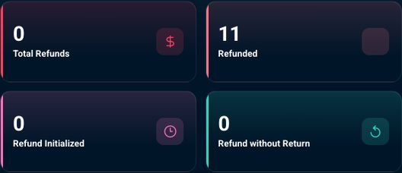

518-metric-card-0-total-refunds — 0 Total Refunds
Kind: metric-card
First seen: Fulfillment / Dashboard (`/fulfill/orders/dashboard`)
Size: 259×108 at (293, 842)
Tag/role: div
Classes: dash-metric-wrap
Selector: div:nth-of-type(4) > div:nth-of-type(1) > div:nth-of-type(2) > div:nth-of-type(1)
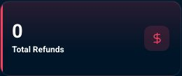

519-metric-card-0-total-refunds — 0 Total Refunds
Kind: metric-card
First seen: Fulfillment / Dashboard (`/fulfill/orders/dashboard`)
Size: 259×108 at (293, 842)
Tag/role: div role=button
Classes: dash-metric
Selector: div:nth-of-type(1) > div:nth-of-type(2) > div:nth-of-type(1) > div:nth-of-type(1)
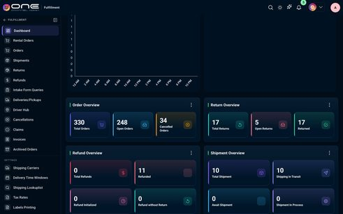

520-metric-card-0-total-refunds — 0 Total Refunds
Kind: metric-card
First seen: Fulfillment / Dashboard (`/fulfill/orders/dashboard`)
Size: 225×49 at (310, 872)
Tag/role: div
Classes: dash-metric-top
Selector: div:nth-of-type(2) > div:nth-of-type(1) > div:nth-of-type(1) > div:nth-of-type(1)


521-metric-card-0-total-refunds — 0 Total Refunds
Kind: metric-card
First seen: Fulfillment / Dashboard (`/fulfill/orders/dashboard`)
Size: 176×49 at (310, 872)
Tag/role: div
Classes: dash-metric-copy
Selector: div:nth-of-type(1) > div:nth-of-type(1) > div:nth-of-type(1) > div:nth-of-type(1)


nav-button

021-nav-button-nav-button — Nav button
Kind: nav-button
First seen: Home / Dashboard (`/home/dashboard`)
Size: 32×16 at (1331, 22)
Tag/role: div role=button
Classes: p-dropdown-trigger
Selector: div:nth-of-type(1) > div:nth-of-type(7) > div:nth-of-type(1) > div:nth-of-type(3)

022-nav-button-collapse-home-menu — Collapse home menu
Kind: nav-button
First seen: Home / Dashboard (`/home/dashboard`)
Size: 30×30 at (217, 69)
Tag/role: button
Classes: tw-inline-flex.tw-items-center.tw-justify-center.tw-rounded-lg.tw-p-1.5.tw-shrink-0.hover:tw-opacity-80
Selector: div:nth-of-type(3) > aside:nth-of-type(1) > div:nth-of-type(1) > button:nth-of-type(1)

023-nav-button-catalog — Catalog
Kind: nav-button
First seen: Home / Dashboard (`/home/dashboard`)
Size: 239×43 at (8, 108)
Tag/role: button
Classes: tw-w-full.tw-flex.tw-items-center.tw-gap-3.tw-rounded-lg.tw-text-left.hover:tw-opacity-90.tw-px-2.5
Selector: div:nth-of-type(3) > aside:nth-of-type(1) > div:nth-of-type(2) > button:nth-of-type(1)


024-nav-button-channel — Channel
Kind: nav-button
First seen: Home / Dashboard (`/home/dashboard`)
Size: 239×43 at (8, 153)
Tag/role: button
Classes: tw-w-full.tw-flex.tw-items-center.tw-gap-3.tw-rounded-lg.tw-text-left.hover:tw-opacity-90.tw-px-2.5
Selector: div:nth-of-type(3) > aside:nth-of-type(1) > div:nth-of-type(2) > button:nth-of-type(2)


025-nav-button-fulfillment — Fulfillment
Kind: nav-button
First seen: Home / Dashboard (`/home/dashboard`)
Size: 239×43 at (8, 198)
Tag/role: button
Classes: tw-w-full.tw-flex.tw-items-center.tw-gap-3.tw-rounded-lg.tw-text-left.hover:tw-opacity-90.tw-px-2.5
Selector: div:nth-of-type(3) > aside:nth-of-type(1) > div:nth-of-type(2) > button:nth-of-type(3)


026-nav-button-wms — WMS
Kind: nav-button
First seen: Home / Dashboard (`/home/dashboard`)
Size: 239×43 at (8, 244)
Tag/role: button
Classes: tw-w-full.tw-flex.tw-items-center.tw-gap-3.tw-rounded-lg.tw-text-left.hover:tw-opacity-90.tw-px-2.5
Selector: div:nth-of-type(3) > aside:nth-of-type(1) > div:nth-of-type(2) > button:nth-of-type(4)


027-nav-button-marketing — Marketing
Kind: nav-button
First seen: Home / Dashboard (`/home/dashboard`)
Size: 239×43 at (8, 289)
Tag/role: button
Classes: tw-w-full.tw-flex.tw-items-center.tw-gap-3.tw-rounded-lg.tw-text-left.hover:tw-opacity-90.tw-px-2.5
Selector: div:nth-of-type(3) > aside:nth-of-type(1) > div:nth-of-type(2) > button:nth-of-type(5)


028-nav-button-crm — CRM
Kind: nav-button
First seen: Home / Dashboard (`/home/dashboard`)
Size: 239×43 at (8, 334)
Tag/role: button
Classes: tw-w-full.tw-flex.tw-items-center.tw-gap-3.tw-rounded-lg.tw-text-left.hover:tw-opacity-90.tw-px-2.5
Selector: div:nth-of-type(3) > aside:nth-of-type(1) > div:nth-of-type(2) > button:nth-of-type(6)


029-nav-button-analytics-reports — Analytics & Reports
Kind: nav-button
First seen: Home / Dashboard (`/home/dashboard`)
Size: 239×43 at (8, 379)
Tag/role: button
Classes: tw-w-full.tw-flex.tw-items-center.tw-gap-3.tw-rounded-lg.tw-text-left.hover:tw-opacity-90.tw-px-2.5
Selector: div:nth-of-type(3) > aside:nth-of-type(1) > div:nth-of-type(2) > button:nth-of-type(7)


030-nav-button-b2b — B2B
Kind: nav-button
First seen: Home / Dashboard (`/home/dashboard`)
Size: 239×43 at (8, 424)
Tag/role: button
Classes: tw-w-full.tw-flex.tw-items-center.tw-gap-3.tw-rounded-lg.tw-text-left.hover:tw-opacity-90.tw-px-2.5
Selector: div:nth-of-type(3) > aside:nth-of-type(1) > div:nth-of-type(2) > button:nth-of-type(8)


031-nav-button-3pl — 3PL
Kind: nav-button
First seen: Home / Dashboard (`/home/dashboard`)
Size: 239×43 at (8, 470)
Tag/role: button
Classes: tw-w-full.tw-flex.tw-items-center.tw-gap-3.tw-rounded-lg.tw-text-left.hover:tw-opacity-90.tw-px-2.5
Selector: div:nth-of-type(3) > aside:nth-of-type(1) > div:nth-of-type(2) > button:nth-of-type(9)


032-nav-button-admin — Admin
Kind: nav-button
First seen: Home / Dashboard (`/home/dashboard`)
Size: 239×43 at (8, 515)
Tag/role: button
Classes: tw-w-full.tw-flex.tw-items-center.tw-gap-3.tw-rounded-lg.tw-text-left.hover:tw-opacity-90.tw-px-2.5
Selector: div:nth-of-type(3) > aside:nth-of-type(1) > div:nth-of-type(2) > button:nth-of-type(10)


033-nav-button-accounting — Accounting
Kind: nav-button
First seen: Home / Dashboard (`/home/dashboard`)
Size: 239×43 at (8, 560)
Tag/role: button
Classes: tw-w-full.tw-flex.tw-items-center.tw-gap-3.tw-rounded-lg.tw-text-left.hover:tw-opacity-90.tw-px-2.5
Selector: div:nth-of-type(3) > aside:nth-of-type(1) > div:nth-of-type(2) > button:nth-of-type(11)


034-nav-button-map-price — Map Price
Kind: nav-button
First seen: Home / Dashboard (`/home/dashboard`)
Size: 239×43 at (8, 641)
Tag/role: button
Classes: tw-w-full.tw-flex.tw-items-center.tw-gap-3.tw-rounded-lg.tw-text-left.hover:tw-opacity-90.tw-px-2.5
Selector: div:nth-of-type(3) > aside:nth-of-type(1) > div:nth-of-type(2) > button:nth-of-type(12)


035-nav-button-operations-hub — Operations Hub
Kind: nav-button
First seen: Home / Dashboard (`/home/dashboard`)
Size: 239×43 at (8, 686)
Tag/role: button
Classes: tw-w-full.tw-flex.tw-items-center.tw-gap-3.tw-rounded-lg.tw-text-left.hover:tw-opacity-90.tw-px-2.5
Selector: div:nth-of-type(3) > aside:nth-of-type(1) > div:nth-of-type(2) > button:nth-of-type(13)


040-nav-button-dashboard — DASHBOARD
Kind: nav-button
First seen: 3PL / Dashboard (`/3pl/dashboard`)
Size: 205×21 at (8, 74)
Tag/role: button
Classes: tw-flex.tw-min-w-0.tw-items-center.tw-gap-1.5.tw-rounded-md.tw-text-left.hover:tw-opacity-80.tw-flex-1
Selector: div:nth-of-type(3) > aside:nth-of-type(1) > div:nth-of-type(1) > button:nth-of-type(1)

041-nav-button-dashboard — Dashboard
Kind: nav-button
First seen: 3PL / Dashboard (`/3pl/dashboard`)
Size: 239×43 at (8, 108)
Tag/role: button
Classes: tw-w-full.tw-flex.tw-items-center.tw-gap-3.tw-rounded-lg.tw-text-left.hover:tw-opacity-90.tw-px-2.5
Selector: div:nth-of-type(3) > aside:nth-of-type(1) > div:nth-of-type(2) > button:nth-of-type(1)


042-nav-button-inventory — Inventory
Kind: nav-button
First seen: 3PL / Dashboard (`/3pl/dashboard`)
Size: 239×43 at (8, 153)
Tag/role: button
Classes: tw-w-full.tw-flex.tw-items-center.tw-gap-3.tw-rounded-lg.tw-text-left.hover:tw-opacity-90.tw-px-2.5
Selector: div:nth-of-type(3) > aside:nth-of-type(1) > div:nth-of-type(2) > button:nth-of-type(2)


043-nav-button-orders — Orders
Kind: nav-button
First seen: 3PL / Dashboard (`/3pl/dashboard`)
Size: 239×43 at (8, 198)
Tag/role: button
Classes: tw-w-full.tw-flex.tw-items-center.tw-gap-3.tw-rounded-lg.tw-text-left.hover:tw-opacity-90.tw-px-2.5
Selector: div:nth-of-type(3) > aside:nth-of-type(1) > div:nth-of-type(2) > button:nth-of-type(3)


044-nav-button-addons-and-invoices — Addons and Invoices
Kind: nav-button
First seen: 3PL / Dashboard (`/3pl/dashboard`)
Size: 239×43 at (8, 244)
Tag/role: button
Classes: tw-w-full.tw-flex.tw-items-center.tw-gap-3.tw-rounded-lg.tw-text-left.hover:tw-opacity-90.tw-px-2.5
Selector: div:nth-of-type(3) > aside:nth-of-type(1) > div:nth-of-type(2) > button:nth-of-type(4)


045-nav-button-send-to-3pl-replenishment — Send to 3pl (Replenishment)
Kind: nav-button
First seen: 3PL / Dashboard (`/3pl/dashboard`)
Size: 239×43 at (8, 289)
Tag/role: button
Classes: tw-w-full.tw-flex.tw-items-center.tw-gap-3.tw-rounded-lg.tw-text-left.hover:tw-opacity-90.tw-px-2.5
Selector: div:nth-of-type(3) > aside:nth-of-type(1) > div:nth-of-type(2) > button:nth-of-type(5)


055-nav-button-account-statements — ACCOUNT STATEMENTS
Kind: nav-button
First seen: Accounting / Account Statements (`/accounting/account-statements`)
Size: 205×21 at (8, 74)
Tag/role: button
Classes: tw-flex.tw-min-w-0.tw-items-center.tw-gap-1.5.tw-rounded-md.tw-text-left.hover:tw-opacity-80.tw-flex-1
Selector: div:nth-of-type(3) > aside:nth-of-type(1) > div:nth-of-type(1) > button:nth-of-type(1)

056-nav-button-transactions — Transactions
Kind: nav-button
First seen: Accounting / Account Statements (`/accounting/account-statements`)
Size: 239×43 at (8, 153)
Tag/role: button
Classes: tw-w-full.tw-flex.tw-items-center.tw-gap-3.tw-rounded-lg.tw-text-left.hover:tw-opacity-90.tw-px-2.5
Selector: div:nth-of-type(3) > aside:nth-of-type(1) > div:nth-of-type(2) > button:nth-of-type(2)


057-nav-button-general-ledger — General Ledger
Kind: nav-button
First seen: Accounting / Account Statements (`/accounting/account-statements`)
Size: 239×43 at (8, 198)
Tag/role: button
Classes: tw-w-full.tw-flex.tw-items-center.tw-gap-3.tw-rounded-lg.tw-text-left.hover:tw-opacity-90.tw-px-2.5
Selector: div:nth-of-type(3) > aside:nth-of-type(1) > div:nth-of-type(2) > button:nth-of-type(3)


058-nav-button-invoices — Invoices
Kind: nav-button
First seen: Accounting / Account Statements (`/accounting/account-statements`)
Size: 239×43 at (8, 244)
Tag/role: button
Classes: tw-w-full.tw-flex.tw-items-center.tw-gap-3.tw-rounded-lg.tw-text-left.hover:tw-opacity-90.tw-px-2.5
Selector: div:nth-of-type(3) > aside:nth-of-type(1) > div:nth-of-type(2) > button:nth-of-type(4)


059-nav-button-expenses — Expenses
Kind: nav-button
First seen: Accounting / Account Statements (`/accounting/account-statements`)
Size: 239×43 at (8, 289)
Tag/role: button
Classes: tw-w-full.tw-flex.tw-items-center.tw-gap-3.tw-rounded-lg.tw-text-left.hover:tw-opacity-90.tw-px-2.5
Selector: div:nth-of-type(3) > aside:nth-of-type(1) > div:nth-of-type(2) > button:nth-of-type(5)


060-nav-button-ap-ar-workflows — AP/AR Workflows
Kind: nav-button
First seen: Accounting / Account Statements (`/accounting/account-statements`)
Size: 239×43 at (8, 334)
Tag/role: button
Classes: tw-w-full.tw-flex.tw-items-center.tw-gap-3.tw-rounded-lg.tw-text-left.hover:tw-opacity-90.tw-px-2.5
Selector: div:nth-of-type(3) > aside:nth-of-type(1) > div:nth-of-type(2) > button:nth-of-type(6)


061-nav-button-reports — Reports
Kind: nav-button
First seen: Accounting / Account Statements (`/accounting/account-statements`)
Size: 239×43 at (8, 379)
Tag/role: button
Classes: tw-w-full.tw-flex.tw-items-center.tw-gap-3.tw-rounded-lg.tw-text-left.hover:tw-opacity-90.tw-px-2.5
Selector: div:nth-of-type(3) > aside:nth-of-type(1) > div:nth-of-type(2) > button:nth-of-type(7)


062-nav-button-customers — Customers
Kind: nav-button
First seen: Accounting / Account Statements (`/accounting/account-statements`)
Size: 239×43 at (8, 424)
Tag/role: button
Classes: tw-w-full.tw-flex.tw-items-center.tw-gap-3.tw-rounded-lg.tw-text-left.hover:tw-opacity-90.tw-px-2.5
Selector: div:nth-of-type(3) > aside:nth-of-type(1) > div:nth-of-type(2) > button:nth-of-type(8)


063-nav-button-vendors — Vendors
Kind: nav-button
First seen: Accounting / Account Statements (`/accounting/account-statements`)
Size: 239×43 at (8, 470)
Tag/role: button
Classes: tw-w-full.tw-flex.tw-items-center.tw-gap-3.tw-rounded-lg.tw-text-left.hover:tw-opacity-90.tw-px-2.5
Selector: div:nth-of-type(3) > aside:nth-of-type(1) > div:nth-of-type(2) > button:nth-of-type(9)


064-nav-button-chart-of-accounts — Chart of Accounts
Kind: nav-button
First seen: Accounting / Account Statements (`/accounting/account-statements`)
Size: 239×43 at (8, 515)
Tag/role: button
Classes: tw-w-full.tw-flex.tw-items-center.tw-gap-3.tw-rounded-lg.tw-text-left.hover:tw-opacity-90.tw-px-2.5
Selector: div:nth-of-type(3) > aside:nth-of-type(1) > div:nth-of-type(2) > button:nth-of-type(10)


065-nav-button-journal-entries — Journal Entries
Kind: nav-button
First seen: Accounting / Account Statements (`/accounting/account-statements`)
Size: 239×43 at (8, 560)
Tag/role: button
Classes: tw-w-full.tw-flex.tw-items-center.tw-gap-3.tw-rounded-lg.tw-text-left.hover:tw-opacity-90.tw-px-2.5
Selector: div:nth-of-type(3) > aside:nth-of-type(1) > div:nth-of-type(2) > button:nth-of-type(11)


066-nav-button-customer-payments — Customer Payments
Kind: nav-button
First seen: Accounting / Account Statements (`/accounting/account-statements`)
Size: 239×43 at (8, 605)
Tag/role: button
Classes: tw-w-full.tw-flex.tw-items-center.tw-gap-3.tw-rounded-lg.tw-text-left.hover:tw-opacity-90.tw-px-2.5
Selector: div:nth-of-type(3) > aside:nth-of-type(1) > div:nth-of-type(2) > button:nth-of-type(12)


067-nav-button-vendor-payments — Vendor Payments
Kind: nav-button
First seen: Accounting / Account Statements (`/accounting/account-statements`)
Size: 239×43 at (8, 650)
Tag/role: button
Classes: tw-w-full.tw-flex.tw-items-center.tw-gap-3.tw-rounded-lg.tw-text-left.hover:tw-opacity-90.tw-px-2.5
Selector: div:nth-of-type(3) > aside:nth-of-type(1) > div:nth-of-type(2) > button:nth-of-type(13)


068-nav-button-credit-memos — Credit Memos
Kind: nav-button
First seen: Accounting / Account Statements (`/accounting/account-statements`)
Size: 239×43 at (8, 695)
Tag/role: button
Classes: tw-w-full.tw-flex.tw-items-center.tw-gap-3.tw-rounded-lg.tw-text-left.hover:tw-opacity-90.tw-px-2.5
Selector: div:nth-of-type(3) > aside:nth-of-type(1) > div:nth-of-type(2) > button:nth-of-type(14)


069-nav-button-account-statements — Account Statements
Kind: nav-button
First seen: Accounting / Account Statements (`/accounting/account-statements`)
Size: 239×43 at (8, 741)
Tag/role: button
Classes: tw-w-full.tw-flex.tw-items-center.tw-gap-3.tw-rounded-lg.tw-text-left.hover:tw-opacity-90.tw-px-2.5
Selector: div:nth-of-type(3) > aside:nth-of-type(1) > div:nth-of-type(2) > button:nth-of-type(15)


070-nav-button-reconciliation — Reconciliation
Kind: nav-button
First seen: Accounting / Account Statements (`/accounting/account-statements`)
Size: 239×43 at (8, 786)
Tag/role: button
Classes: tw-w-full.tw-flex.tw-items-center.tw-gap-3.tw-rounded-lg.tw-text-left.hover:tw-opacity-90.tw-px-2.5
Selector: div:nth-of-type(3) > aside:nth-of-type(1) > div:nth-of-type(2) > button:nth-of-type(16)


071-nav-button-multi-entity — Multi Entity
Kind: nav-button
First seen: Accounting / Account Statements (`/accounting/account-statements`)
Size: 239×43 at (8, 831)
Tag/role: button
Classes: tw-w-full.tw-flex.tw-items-center.tw-gap-3.tw-rounded-lg.tw-text-left.hover:tw-opacity-90.tw-px-2.5
Selector: div:nth-of-type(3) > aside:nth-of-type(1) > div:nth-of-type(2) > button:nth-of-type(17)


072-nav-button-tax-engine — Tax Engine
Kind: nav-button
First seen: Accounting / Account Statements (`/accounting/account-statements`)
Size: 239×43 at (8, 876)
Tag/role: button
Classes: tw-w-full.tw-flex.tw-items-center.tw-gap-3.tw-rounded-lg.tw-text-left.hover:tw-opacity-90.tw-px-2.5
Selector: div:nth-of-type(3) > aside:nth-of-type(1) > div:nth-of-type(2) > button:nth-of-type(18)


085-nav-button-ap-ar-workflows — AP/AR WORKFLOWS
Kind: nav-button
First seen: Accounting / AP/AR Workflows (`/accounting/apar-workflows`)
Size: 205×21 at (8, 74)
Tag/role: button
Classes: tw-flex.tw-min-w-0.tw-items-center.tw-gap-1.5.tw-rounded-md.tw-text-left.hover:tw-opacity-80.tw-flex-1
Selector: div:nth-of-type(3) > aside:nth-of-type(1) > div:nth-of-type(1) > button:nth-of-type(1)

095-nav-button-chart-of-accounts — CHART OF ACCOUNTS
Kind: nav-button
First seen: Accounting / Chart of Accounts (`/accounting/chart-of-accounts`)
Size: 205×21 at (8, 74)
Tag/role: button
Classes: tw-flex.tw-min-w-0.tw-items-center.tw-gap-1.5.tw-rounded-md.tw-text-left.hover:tw-opacity-80.tw-flex-1
Selector: div:nth-of-type(3) > aside:nth-of-type(1) > div:nth-of-type(1) > button:nth-of-type(1)

098-nav-button-credit-memos — CREDIT MEMOS
Kind: nav-button
First seen: Accounting / Credit Memos (`/accounting/credit-memos`)
Size: 205×21 at (8, 74)
Tag/role: button
Classes: tw-flex.tw-min-w-0.tw-items-center.tw-gap-1.5.tw-rounded-md.tw-text-left.hover:tw-opacity-80.tw-flex-1
Selector: div:nth-of-type(3) > aside:nth-of-type(1) > div:nth-of-type(1) > button:nth-of-type(1)

113-nav-button-customer-payments — CUSTOMER PAYMENTS
Kind: nav-button
First seen: Accounting / Customer Payments (`/accounting/customer-payments`)
Size: 205×21 at (8, 74)
Tag/role: button
Classes: tw-flex.tw-min-w-0.tw-items-center.tw-gap-1.5.tw-rounded-md.tw-text-left.hover:tw-opacity-80.tw-flex-1
Selector: div:nth-of-type(3) > aside:nth-of-type(1) > div:nth-of-type(1) > button:nth-of-type(1)

124-nav-button-customers — CUSTOMERS
Kind: nav-button
First seen: Accounting / Customers (`/accounting/customers`)
Size: 205×21 at (8, 74)
Tag/role: button
Classes: tw-flex.tw-min-w-0.tw-items-center.tw-gap-1.5.tw-rounded-md.tw-text-left.hover:tw-opacity-80.tw-flex-1
Selector: div:nth-of-type(3) > aside:nth-of-type(1) > div:nth-of-type(1) > button:nth-of-type(1)

148-nav-button-expenses — EXPENSES
Kind: nav-button
First seen: Accounting / Expenses (`/accounting/expenses`)
Size: 205×21 at (8, 74)
Tag/role: button
Classes: tw-flex.tw-min-w-0.tw-items-center.tw-gap-1.5.tw-rounded-md.tw-text-left.hover:tw-opacity-80.tw-flex-1
Selector: div:nth-of-type(3) > aside:nth-of-type(1) > div:nth-of-type(1) > button:nth-of-type(1)

160-nav-button-general-ledger — GENERAL LEDGER
Kind: nav-button
First seen: Accounting / General Ledger (`/accounting/general-ledger`)
Size: 205×21 at (8, 74)
Tag/role: button
Classes: tw-flex.tw-min-w-0.tw-items-center.tw-gap-1.5.tw-rounded-md.tw-text-left.hover:tw-opacity-80.tw-flex-1
Selector: div:nth-of-type(3) > aside:nth-of-type(1) > div:nth-of-type(1) > button:nth-of-type(1)

177-nav-button-invoices — INVOICES
Kind: nav-button
First seen: Accounting / Invoices (`/accounting/invoices`)
Size: 205×21 at (8, 74)
Tag/role: button
Classes: tw-flex.tw-min-w-0.tw-items-center.tw-gap-1.5.tw-rounded-md.tw-text-left.hover:tw-opacity-80.tw-flex-1
Selector: div:nth-of-type(3) > aside:nth-of-type(1) > div:nth-of-type(1) > button:nth-of-type(1)

184-nav-button-journal-entries — JOURNAL ENTRIES
Kind: nav-button
First seen: Accounting / Journal Entries (`/accounting/journal-entries`)
Size: 205×21 at (8, 74)
Tag/role: button
Classes: tw-flex.tw-min-w-0.tw-items-center.tw-gap-1.5.tw-rounded-md.tw-text-left.hover:tw-opacity-80.tw-flex-1
Selector: div:nth-of-type(3) > aside:nth-of-type(1) > div:nth-of-type(1) > button:nth-of-type(1)

192-nav-button-multi-entity — MULTI ENTITY
Kind: nav-button
First seen: Accounting / Multi Entity (`/accounting/multi-entity`)
Size: 205×21 at (8, 74)
Tag/role: button
Classes: tw-flex.tw-min-w-0.tw-items-center.tw-gap-1.5.tw-rounded-md.tw-text-left.hover:tw-opacity-80.tw-flex-1
Selector: div:nth-of-type(3) > aside:nth-of-type(1) > div:nth-of-type(1) > button:nth-of-type(1)

197-nav-button-period-close — PERIOD CLOSE
Kind: nav-button
First seen: Accounting / Period Close (`/accounting/period-close`)
Size: 205×21 at (8, 74)
Tag/role: button
Classes: tw-flex.tw-min-w-0.tw-items-center.tw-gap-1.5.tw-rounded-md.tw-text-left.hover:tw-opacity-80.tw-flex-1
Selector: div:nth-of-type(3) > aside:nth-of-type(1) > div:nth-of-type(1) > button:nth-of-type(1)

201-nav-button-reconciliation — RECONCILIATION
Kind: nav-button
First seen: Accounting / Reconciliation (`/accounting/reconciliation`)
Size: 205×21 at (8, 74)
Tag/role: button
Classes: tw-flex.tw-min-w-0.tw-items-center.tw-gap-1.5.tw-rounded-md.tw-text-left.hover:tw-opacity-80.tw-flex-1
Selector: div:nth-of-type(3) > aside:nth-of-type(1) > div:nth-of-type(1) > button:nth-of-type(1)

213-nav-button-reports — REPORTS
Kind: nav-button
First seen: Accounting / Reports (`/accounting/reports`)
Size: 205×21 at (8, 74)
Tag/role: button
Classes: tw-flex.tw-min-w-0.tw-items-center.tw-gap-1.5.tw-rounded-md.tw-text-left.hover:tw-opacity-80.tw-flex-1
Selector: div:nth-of-type(3) > aside:nth-of-type(1) > div:nth-of-type(1) > button:nth-of-type(1)

227-nav-button-settings — SETTINGS
Kind: nav-button
First seen: Accounting / Settings (`/accounting/accounting-settings`)
Size: 205×21 at (8, 74)
Tag/role: button
Classes: tw-flex.tw-min-w-0.tw-items-center.tw-gap-1.5.tw-rounded-md.tw-text-left.hover:tw-opacity-80.tw-flex-1
Selector: div:nth-of-type(3) > aside:nth-of-type(1) > div:nth-of-type(1) > button:nth-of-type(1)

236-nav-button-tax-engine — TAX ENGINE
Kind: nav-button
First seen: Accounting / Tax Engine (`/accounting/tax-engine`)
Size: 205×21 at (8, 74)
Tag/role: button
Classes: tw-flex.tw-min-w-0.tw-items-center.tw-gap-1.5.tw-rounded-md.tw-text-left.hover:tw-opacity-80.tw-flex-1
Selector: div:nth-of-type(3) > aside:nth-of-type(1) > div:nth-of-type(1) > button:nth-of-type(1)

256-nav-button-transactions — TRANSACTIONS
Kind: nav-button
First seen: Accounting / Transactions (`/accounting/transactions`)
Size: 205×21 at (8, 74)
Tag/role: button
Classes: tw-flex.tw-min-w-0.tw-items-center.tw-gap-1.5.tw-rounded-md.tw-text-left.hover:tw-opacity-80.tw-flex-1
Selector: div:nth-of-type(3) > aside:nth-of-type(1) > div:nth-of-type(1) > button:nth-of-type(1)

259-nav-button-vendor-payments — VENDOR PAYMENTS
Kind: nav-button
First seen: Accounting / Vendor Payments (`/accounting/vendor-payments`)
Size: 205×21 at (8, 74)
Tag/role: button
Classes: tw-flex.tw-min-w-0.tw-items-center.tw-gap-1.5.tw-rounded-md.tw-text-left.hover:tw-opacity-80.tw-flex-1
Selector: div:nth-of-type(3) > aside:nth-of-type(1) > div:nth-of-type(1) > button:nth-of-type(1)

263-nav-button-vendors — VENDORS
Kind: nav-button
First seen: Accounting / Vendors (`/accounting/vendors`)
Size: 205×21 at (8, 74)
Tag/role: button
Classes: tw-flex.tw-min-w-0.tw-items-center.tw-gap-1.5.tw-rounded-md.tw-text-left.hover:tw-opacity-80.tw-flex-1
Selector: div:nth-of-type(3) > aside:nth-of-type(1) > div:nth-of-type(1) > button:nth-of-type(1)

272-nav-button-addons-invoices — ADDONS & INVOICES
Kind: nav-button
First seen: Admin / Addons & Invoices (`/settings/billing-invoices`)
Size: 205×21 at (8, 74)
Tag/role: button
Classes: tw-flex.tw-min-w-0.tw-items-center.tw-gap-1.5.tw-rounded-md.tw-text-left.hover:tw-opacity-80.tw-flex-1
Selector: div:nth-of-type(3) > aside:nth-of-type(1) > div:nth-of-type(1) > button:nth-of-type(1)

273-nav-button-user-permissions — User Permissions
Kind: nav-button
First seen: Admin / Addons & Invoices (`/settings/billing-invoices`)
Size: 239×43 at (8, 108)
Tag/role: button
Classes: tw-w-full.tw-flex.tw-items-center.tw-gap-3.tw-rounded-lg.tw-text-left.hover:tw-opacity-90.tw-px-2.5
Selector: div:nth-of-type(3) > aside:nth-of-type(1) > div:nth-of-type(2) > button:nth-of-type(1)


274-nav-button-users-attendance — Users Attendance
Kind: nav-button
First seen: Admin / Addons & Invoices (`/settings/billing-invoices`)
Size: 239×43 at (8, 153)
Tag/role: button
Classes: tw-w-full.tw-flex.tw-items-center.tw-gap-3.tw-rounded-lg.tw-text-left.hover:tw-opacity-90.tw-px-2.5
Selector: div:nth-of-type(3) > aside:nth-of-type(1) > div:nth-of-type(2) > button:nth-of-type(2)


275-nav-button-marketplace-plans — Marketplace Plans
Kind: nav-button
First seen: Admin / Addons & Invoices (`/settings/billing-invoices`)
Size: 239×43 at (8, 198)
Tag/role: button
Classes: tw-w-full.tw-flex.tw-items-center.tw-gap-3.tw-rounded-lg.tw-text-left.hover:tw-opacity-90.tw-px-2.5
Selector: div:nth-of-type(3) > aside:nth-of-type(1) > div:nth-of-type(2) > button:nth-of-type(3)


276-nav-button-testing-reports — Testing Reports
Kind: nav-button
First seen: Admin / Addons & Invoices (`/settings/billing-invoices`)
Size: 239×43 at (8, 244)
Tag/role: button
Classes: tw-w-full.tw-flex.tw-items-center.tw-gap-3.tw-rounded-lg.tw-text-left.hover:tw-opacity-90.tw-px-2.5
Selector: div:nth-of-type(3) > aside:nth-of-type(1) > div:nth-of-type(2) > button:nth-of-type(4)


277-nav-button-menu-editor — Menu Editor
Kind: nav-button
First seen: Admin / Addons & Invoices (`/settings/billing-invoices`)
Size: 239×43 at (8, 289)
Tag/role: button
Classes: tw-w-full.tw-flex.tw-items-center.tw-gap-3.tw-rounded-lg.tw-text-left.hover:tw-opacity-90.tw-px-2.5
Selector: div:nth-of-type(3) > aside:nth-of-type(1) > div:nth-of-type(2) > button:nth-of-type(5)


278-nav-button-addons-invoices — Addons & Invoices
Kind: nav-button
First seen: Admin / Addons & Invoices (`/settings/billing-invoices`)
Size: 239×43 at (8, 334)
Tag/role: button
Classes: tw-w-full.tw-flex.tw-items-center.tw-gap-3.tw-rounded-lg.tw-text-left.hover:tw-opacity-90.tw-px-2.5
Selector: div:nth-of-type(3) > aside:nth-of-type(1) > div:nth-of-type(2) > button:nth-of-type(6)


279-nav-button-manage-billing-addons — Manage Billing & AddOns
Kind: nav-button
First seen: Admin / Addons & Invoices (`/settings/billing-invoices`)
Size: 239×43 at (8, 379)
Tag/role: button
Classes: tw-w-full.tw-flex.tw-items-center.tw-gap-3.tw-rounded-lg.tw-text-left.hover:tw-opacity-90.tw-px-2.5
Selector: div:nth-of-type(3) > aside:nth-of-type(1) > div:nth-of-type(2) > button:nth-of-type(7)


280-nav-button-integrations — Integrations
Kind: nav-button
First seen: Admin / Addons & Invoices (`/settings/billing-invoices`)
Size: 239×43 at (8, 424)
Tag/role: button
Classes: tw-w-full.tw-flex.tw-items-center.tw-gap-3.tw-rounded-lg.tw-text-left.hover:tw-opacity-90.tw-px-2.5
Selector: div:nth-of-type(3) > aside:nth-of-type(1) > div:nth-of-type(2) > button:nth-of-type(8)


281-nav-button-help-desk — Help Desk
Kind: nav-button
First seen: Admin / Addons & Invoices (`/settings/billing-invoices`)
Size: 239×43 at (8, 470)
Tag/role: button
Classes: tw-w-full.tw-flex.tw-items-center.tw-gap-3.tw-rounded-lg.tw-text-left.hover:tw-opacity-90.tw-px-2.5
Selector: div:nth-of-type(3) > aside:nth-of-type(1) > div:nth-of-type(2) > button:nth-of-type(9)


287-nav-button-channel-integration — CHANNEL INTEGRATION
Kind: nav-button
First seen: Admin / Channel Integration (`/settings/channel-settings`)
Size: 205×21 at (8, 74)
Tag/role: button
Classes: tw-flex.tw-min-w-0.tw-items-center.tw-gap-1.5.tw-rounded-md.tw-text-left.hover:tw-opacity-80.tw-flex-1
Selector: div:nth-of-type(3) > aside:nth-of-type(1) > div:nth-of-type(1) > button:nth-of-type(1)

288-nav-button-channel-integration — Channel Integration
Kind: nav-button
First seen: Admin / Channel Integration (`/settings/channel-settings`)
Size: 239×43 at (8, 108)
Tag/role: button
Classes: tw-w-full.tw-flex.tw-items-center.tw-gap-3.tw-rounded-lg.tw-text-left.hover:tw-opacity-90.tw-px-2.5
Selector: div:nth-of-type(3) > aside:nth-of-type(1) > div:nth-of-type(2) > button:nth-of-type(1)


296-nav-button-help-desk — HELP DESK
Kind: nav-button
First seen: Admin / Help Desk (`/settings/help-center`)
Size: 205×21 at (8, 74)
Tag/role: button
Classes: tw-flex.tw-min-w-0.tw-items-center.tw-gap-1.5.tw-rounded-md.tw-text-left.hover:tw-opacity-80.tw-flex-1
Selector: div:nth-of-type(3) > aside:nth-of-type(1) > div:nth-of-type(1) > button:nth-of-type(1)

305-nav-button-manage-billing-addons — MANAGE BILLING & ADDONS
Kind: nav-button
First seen: Admin / Manage Billing & AddOns (`/settings/managebillings-addons`)
Size: 205×21 at (8, 74)
Tag/role: button
Classes: tw-flex.tw-min-w-0.tw-items-center.tw-gap-1.5.tw-rounded-md.tw-text-left.hover:tw-opacity-80.tw-flex-1
Selector: div:nth-of-type(3) > aside:nth-of-type(1) > div:nth-of-type(1) > button:nth-of-type(1)

313-nav-button-marketplace-plans — MARKETPLACE PLANS
Kind: nav-button
First seen: Admin / Marketplace Plans (`/settings/marketplace-plans`)
Size: 205×21 at (8, 74)
Tag/role: button
Classes: tw-flex.tw-min-w-0.tw-items-center.tw-gap-1.5.tw-rounded-md.tw-text-left.hover:tw-opacity-80.tw-flex-1
Selector: div:nth-of-type(3) > aside:nth-of-type(1) > div:nth-of-type(1) > button:nth-of-type(1)

320-nav-button-menu-editor — MENU EDITOR
Kind: nav-button
First seen: Admin / Menu Editor (`/settings/pageflipcanvaseditor`)
Size: 205×21 at (8, 74)
Tag/role: button
Classes: tw-flex.tw-min-w-0.tw-items-center.tw-gap-1.5.tw-rounded-md.tw-text-left.hover:tw-opacity-80.tw-flex-1
Selector: div:nth-of-type(3) > aside:nth-of-type(1) > div:nth-of-type(1) > button:nth-of-type(1)

321-nav-button-add-text — Add Text
Kind: nav-button
First seen: Admin / Menu Editor (`/settings/pageflipcanvaseditor`)
Size: 242×44 at (331, 303)
Tag/role: button
Selector: div:nth-of-type(2) > div:nth-of-type(1) > div:nth-of-type(1) > button:nth-of-type(1)


322-nav-button-add-rectangle — Add Rectangle
Kind: nav-button
First seen: Admin / Menu Editor (`/settings/pageflipcanvaseditor`)
Size: 242×44 at (331, 357)
Tag/role: button
Selector: div:nth-of-type(2) > div:nth-of-type(1) > div:nth-of-type(1) > button:nth-of-type(2)
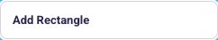

323-nav-button-add-circle — Add Circle
Kind: nav-button
First seen: Admin / Menu Editor (`/settings/pageflipcanvaseditor`)
Size: 242×44 at (331, 410)
Tag/role: button
Selector: div:nth-of-type(2) > div:nth-of-type(1) > div:nth-of-type(1) > button:nth-of-type(3)


324-nav-button-add-page — Add Page
Kind: nav-button
First seen: Admin / Menu Editor (`/settings/pageflipcanvaseditor`)
Size: 242×44 at (331, 530)
Tag/role: button
Selector: div:nth-of-type(2) > div:nth-of-type(1) > div:nth-of-type(2) > button:nth-of-type(1)
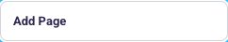

325-nav-button-page-1-current — Page 1 (current)
Kind: nav-button
First seen: Admin / Menu Editor (`/settings/pageflipcanvaseditor`)
Size: 242×44 at (331, 583)
Tag/role: button
Selector: div:nth-of-type(2) > div:nth-of-type(1) > div:nth-of-type(2) > button:nth-of-type(2)


326-nav-button-book-style-biryani-spread — Book Style - Biryani Spread
Kind: nav-button
First seen: Admin / Menu Editor (`/settings/pageflipcanvaseditor`)
Size: 242×44 at (331, 700)
Tag/role: button
Selector: div:nth-of-type(2) > div:nth-of-type(1) > div:nth-of-type(3) > button:nth-of-type(1)


327-nav-button-book-style-chef-specials — Book Style - Chef Specials
Kind: nav-button
First seen: Admin / Menu Editor (`/settings/pageflipcanvaseditor`)
Size: 242×44 at (331, 754)
Tag/role: button
Selector: div:nth-of-type(2) > div:nth-of-type(1) > div:nth-of-type(3) > button:nth-of-type(2)


sidebar

008-sidebar-home-catalog-channel-fulfillment-wms-marketing-crm-analytics-reports-b2b-3pl-a — HOME Catalog Channel Fulfillment WMS Marketing CRM Analytics & Reports B2B 3PL A
Kind: sidebar
First seen: Home / Dashboard (`/home/dashboard`)
Size: 256×837 at (0, 63)
Tag/role: aside
Classes: tw-hidden.min-[1026px]:tw-flex.tw-flex-col.tw-shrink-0.tw-h-full.tw-self-stretch.tw-overflow-hidden.tw-bg-[var(--main-bg)]
Selector: div:nth-of-type(1) > div:nth-of-type(1) > div:nth-of-type(3) > aside:nth-of-type(1)
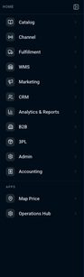

038-sidebar-dashboard-dashboard-inventory-orders-addons-and-invoices-send-to-3pl-replenishm — DASHBOARD Dashboard Inventory Orders Addons and Invoices Send to 3pl (Replenishm
Kind: sidebar
First seen: 3PL / Dashboard (`/3pl/dashboard`)
Size: 256×837 at (0, 63)
Tag/role: aside
Classes: tw-hidden.min-[1026px]:tw-flex.tw-flex-col.tw-shrink-0.tw-h-full.tw-self-stretch.tw-overflow-hidden.tw-bg-[var(--main-bg)]
Selector: div:nth-of-type(1) > div:nth-of-type(1) > div:nth-of-type(3) > aside:nth-of-type(1)
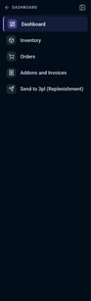

048-sidebar-account-statements-dashboard-transactions-general-ledger-invoices-expenses-ap-ar — ACCOUNT STATEMENTS Dashboard Transactions General Ledger Invoices Expenses AP/AR
Kind: sidebar
First seen: Accounting / Account Statements (`/accounting/account-statements`)
Size: 256×837 at (0, 63)
Tag/role: aside
Classes: tw-hidden.min-[1026px]:tw-flex.tw-flex-col.tw-shrink-0.tw-h-full.tw-self-stretch.tw-overflow-hidden.tw-bg-[var(--main-bg)]
Selector: div:nth-of-type(1) > div:nth-of-type(1) > div:nth-of-type(3) > aside:nth-of-type(1)
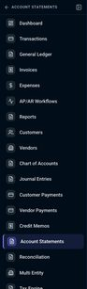

075-sidebar-ap-ar-workflows-dashboard-transactions-general-ledger-invoices-expenses-ap-ar-wo — AP/AR WORKFLOWS Dashboard Transactions General Ledger Invoices Expenses AP/AR Wo
Kind: sidebar
First seen: Accounting / AP/AR Workflows (`/accounting/apar-workflows`)
Size: 256×837 at (0, 63)
Tag/role: aside
Classes: tw-hidden.min-[1026px]:tw-flex.tw-flex-col.tw-shrink-0.tw-h-full.tw-self-stretch.tw-overflow-hidden.tw-bg-[var(--main-bg)]
Selector: div:nth-of-type(1) > div:nth-of-type(1) > div:nth-of-type(3) > aside:nth-of-type(1)
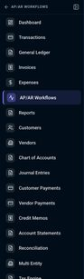

087-sidebar-chart-of-accounts-dashboard-transactions-general-ledger-invoices-expenses-ap-ar — CHART OF ACCOUNTS Dashboard Transactions General Ledger Invoices Expenses AP/AR
Kind: sidebar
First seen: Accounting / Chart of Accounts (`/accounting/chart-of-accounts`)
Size: 256×837 at (0, 63)
Tag/role: aside
Classes: tw-hidden.min-[1026px]:tw-flex.tw-flex-col.tw-shrink-0.tw-h-full.tw-self-stretch.tw-overflow-hidden.tw-bg-[var(--main-bg)]
Selector: div:nth-of-type(1) > div:nth-of-type(1) > div:nth-of-type(3) > aside:nth-of-type(1)
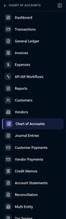

097-sidebar-credit-memos-dashboard-transactions-general-ledger-invoices-expenses-ap-ar-workf — CREDIT MEMOS Dashboard Transactions General Ledger Invoices Expenses AP/AR Workf
Kind: sidebar
First seen: Accounting / Credit Memos (`/accounting/credit-memos`)
Size: 256×837 at (0, 63)
Tag/role: aside
Classes: tw-hidden.min-[1026px]:tw-flex.tw-flex-col.tw-shrink-0.tw-h-full.tw-self-stretch.tw-overflow-hidden.tw-bg-[var(--main-bg)]
Selector: div:nth-of-type(1) > div:nth-of-type(1) > div:nth-of-type(3) > aside:nth-of-type(1)
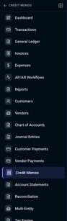

100-sidebar-customer-payments-dashboard-transactions-general-ledger-invoices-expenses-ap-ar — CUSTOMER PAYMENTS Dashboard Transactions General Ledger Invoices Expenses AP/AR
Kind: sidebar
First seen: Accounting / Customer Payments (`/accounting/customer-payments`)
Size: 256×837 at (0, 63)
Tag/role: aside
Classes: tw-hidden.min-[1026px]:tw-flex.tw-flex-col.tw-shrink-0.tw-h-full.tw-self-stretch.tw-overflow-hidden.tw-bg-[var(--main-bg)]
Selector: div:nth-of-type(1) > div:nth-of-type(1) > div:nth-of-type(3) > aside:nth-of-type(1)
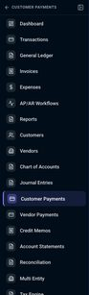

114-sidebar-customers-dashboard-transactions-general-ledger-invoices-expenses-ap-ar-workflow — CUSTOMERS Dashboard Transactions General Ledger Invoices Expenses AP/AR Workflow
Kind: sidebar
First seen: Accounting / Customers (`/accounting/customers`)
Size: 256×837 at (0, 63)
Tag/role: aside
Classes: tw-hidden.min-[1026px]:tw-flex.tw-flex-col.tw-shrink-0.tw-h-full.tw-self-stretch.tw-overflow-hidden.tw-bg-[var(--main-bg)]
Selector: div:nth-of-type(1) > div:nth-of-type(1) > div:nth-of-type(3) > aside:nth-of-type(1)
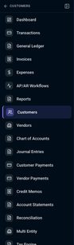

126-sidebar-dashboard-dashboard-transactions-general-ledger-invoices-expenses-ap-ar-workflow — DASHBOARD Dashboard Transactions General Ledger Invoices Expenses AP/AR Workflow
Kind: sidebar
First seen: Accounting / Dashboard (`/accounting/dashboard`)
Size: 256×837 at (0, 63)
Tag/role: aside
Classes: tw-hidden.min-[1026px]:tw-flex.tw-flex-col.tw-shrink-0.tw-h-full.tw-self-stretch.tw-overflow-hidden.tw-bg-[var(--main-bg)]
Selector: div:nth-of-type(1) > div:nth-of-type(1) > div:nth-of-type(3) > aside:nth-of-type(1)
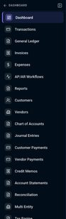

129-sidebar-expenses-dashboard-transactions-general-ledger-invoices-expenses-ap-ar-workflows — EXPENSES Dashboard Transactions General Ledger Invoices Expenses AP/AR Workflows
Kind: sidebar
First seen: Accounting / Expenses (`/accounting/expenses`)
Size: 256×837 at (0, 63)
Tag/role: aside
Classes: tw-hidden.min-[1026px]:tw-flex.tw-flex-col.tw-shrink-0.tw-h-full.tw-self-stretch.tw-overflow-hidden.tw-bg-[var(--main-bg)]
Selector: div:nth-of-type(1) > div:nth-of-type(1) > div:nth-of-type(3) > aside:nth-of-type(1)
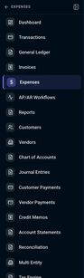

151-sidebar-general-ledger-dashboard-transactions-general-ledger-invoices-expenses-ap-ar-wor — GENERAL LEDGER Dashboard Transactions General Ledger Invoices Expenses AP/AR Wor
Kind: sidebar
First seen: Accounting / General Ledger (`/accounting/general-ledger`)
Size: 256×837 at (0, 63)
Tag/role: aside
Classes: tw-hidden.min-[1026px]:tw-flex.tw-flex-col.tw-shrink-0.tw-h-full.tw-self-stretch.tw-overflow-hidden.tw-bg-[var(--main-bg)]
Selector: div:nth-of-type(1) > div:nth-of-type(1) > div:nth-of-type(3) > aside:nth-of-type(1)
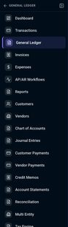

161-sidebar-invoices-dashboard-transactions-general-ledger-invoices-expenses-ap-ar-workflows — INVOICES Dashboard Transactions General Ledger Invoices Expenses AP/AR Workflows
Kind: sidebar
First seen: Accounting / Invoices (`/accounting/invoices`)
Size: 256×837 at (0, 63)
Tag/role: aside
Classes: tw-hidden.min-[1026px]:tw-flex.tw-flex-col.tw-shrink-0.tw-h-full.tw-self-stretch.tw-overflow-hidden.tw-bg-[var(--main-bg)]
Selector: div:nth-of-type(1) > div:nth-of-type(1) > div:nth-of-type(3) > aside:nth-of-type(1)
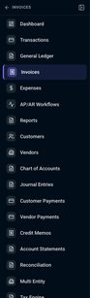

180-sidebar-journal-entries-dashboard-transactions-general-ledger-invoices-expenses-ap-ar-wo — JOURNAL ENTRIES Dashboard Transactions General Ledger Invoices Expenses AP/AR Wo
Kind: sidebar
First seen: Accounting / Journal Entries (`/accounting/journal-entries`)
Size: 256×837 at (0, 63)
Tag/role: aside
Classes: tw-hidden.min-[1026px]:tw-flex.tw-flex-col.tw-shrink-0.tw-h-full.tw-self-stretch.tw-overflow-hidden.tw-bg-[var(--main-bg)]
Selector: div:nth-of-type(1) > div:nth-of-type(1) > div:nth-of-type(3) > aside:nth-of-type(1)
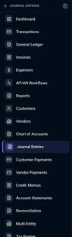

186-sidebar-multi-entity-dashboard-transactions-general-ledger-invoices-expenses-ap-ar-workf — MULTI ENTITY Dashboard Transactions General Ledger Invoices Expenses AP/AR Workf
Kind: sidebar
First seen: Accounting / Multi Entity (`/accounting/multi-entity`)
Size: 256×837 at (0, 63)
Tag/role: aside
Classes: tw-hidden.min-[1026px]:tw-flex.tw-flex-col.tw-shrink-0.tw-h-full.tw-self-stretch.tw-overflow-hidden.tw-bg-[var(--main-bg)]
Selector: div:nth-of-type(1) > div:nth-of-type(1) > div:nth-of-type(3) > aside:nth-of-type(1)
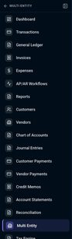

194-sidebar-period-close-dashboard-transactions-general-ledger-invoices-expenses-ap-ar-workf — PERIOD CLOSE Dashboard Transactions General Ledger Invoices Expenses AP/AR Workf
Kind: sidebar
First seen: Accounting / Period Close (`/accounting/period-close`)
Size: 256×837 at (0, 63)
Tag/role: aside
Classes: tw-hidden.min-[1026px]:tw-flex.tw-flex-col.tw-shrink-0.tw-h-full.tw-self-stretch.tw-overflow-hidden.tw-bg-[var(--main-bg)]
Selector: div:nth-of-type(1) > div:nth-of-type(1) > div:nth-of-type(3) > aside:nth-of-type(1)
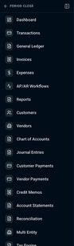

198-sidebar-reconciliation-dashboard-transactions-general-ledger-invoices-expenses-ap-ar-wor — RECONCILIATION Dashboard Transactions General Ledger Invoices Expenses AP/AR Wor
Kind: sidebar
First seen: Accounting / Reconciliation (`/accounting/reconciliation`)
Size: 256×837 at (0, 63)
Tag/role: aside
Classes: tw-hidden.min-[1026px]:tw-flex.tw-flex-col.tw-shrink-0.tw-h-full.tw-self-stretch.tw-overflow-hidden.tw-bg-[var(--main-bg)]
Selector: div:nth-of-type(1) > div:nth-of-type(1) > div:nth-of-type(3) > aside:nth-of-type(1)
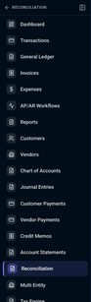

203-sidebar-reports-dashboard-transactions-general-ledger-invoices-expenses-ap-ar-workflows — REPORTS Dashboard Transactions General Ledger Invoices Expenses AP/AR Workflows
Kind: sidebar
First seen: Accounting / Reports (`/accounting/reports`)
Size: 256×837 at (0, 63)
Tag/role: aside
Classes: tw-hidden.min-[1026px]:tw-flex.tw-flex-col.tw-shrink-0.tw-h-full.tw-self-stretch.tw-overflow-hidden.tw-bg-[var(--main-bg)]
Selector: div:nth-of-type(1) > div:nth-of-type(1) > div:nth-of-type(3) > aside:nth-of-type(1)
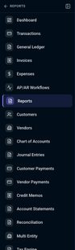

217-sidebar-settings-dashboard-transactions-general-ledger-invoices-expenses-ap-ar-workflows — SETTINGS Dashboard Transactions General Ledger Invoices Expenses AP/AR Workflows
Kind: sidebar
First seen: Accounting / Settings (`/accounting/accounting-settings`)
Size: 256×837 at (0, 63)
Tag/role: aside
Classes: tw-hidden.min-[1026px]:tw-flex.tw-flex-col.tw-shrink-0.tw-h-full.tw-self-stretch.tw-overflow-hidden.tw-bg-[var(--main-bg)]
Selector: div:nth-of-type(1) > div:nth-of-type(1) > div:nth-of-type(3) > aside:nth-of-type(1)
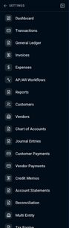

229-sidebar-tax-engine-dashboard-transactions-general-ledger-invoices-expenses-ap-ar-workflo — TAX ENGINE Dashboard Transactions General Ledger Invoices Expenses AP/AR Workflo
Kind: sidebar
First seen: Accounting / Tax Engine (`/accounting/tax-engine`)
Size: 256×837 at (0, 63)
Tag/role: aside
Classes: tw-hidden.min-[1026px]:tw-flex.tw-flex-col.tw-shrink-0.tw-h-full.tw-self-stretch.tw-overflow-hidden.tw-bg-[var(--main-bg)]
Selector: div:nth-of-type(1) > div:nth-of-type(1) > div:nth-of-type(3) > aside:nth-of-type(1)
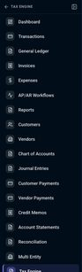

238-sidebar-transactions-dashboard-transactions-general-ledger-invoices-expenses-ap-ar-workf — TRANSACTIONS Dashboard Transactions General Ledger Invoices Expenses AP/AR Workf
Kind: sidebar
First seen: Accounting / Transactions (`/accounting/transactions`)
Size: 256×837 at (0, 63)
Tag/role: aside
Classes: tw-hidden.min-[1026px]:tw-flex.tw-flex-col.tw-shrink-0.tw-h-full.tw-self-stretch.tw-overflow-hidden.tw-bg-[var(--main-bg)]
Selector: div:nth-of-type(1) > div:nth-of-type(1) > div:nth-of-type(3) > aside:nth-of-type(1)
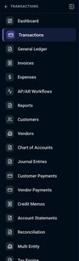

258-sidebar-vendor-payments-dashboard-transactions-general-ledger-invoices-expenses-ap-ar-wo — VENDOR PAYMENTS Dashboard Transactions General Ledger Invoices Expenses AP/AR Wo
Kind: sidebar
First seen: Accounting / Vendor Payments (`/accounting/vendor-payments`)
Size: 256×837 at (0, 63)
Tag/role: aside
Classes: tw-hidden.min-[1026px]:tw-flex.tw-flex-col.tw-shrink-0.tw-h-full.tw-self-stretch.tw-overflow-hidden.tw-bg-[var(--main-bg)]
Selector: div:nth-of-type(1) > div:nth-of-type(1) > div:nth-of-type(3) > aside:nth-of-type(1)
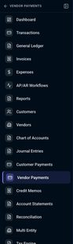

261-sidebar-vendors-dashboard-transactions-general-ledger-invoices-expenses-ap-ar-workflows — VENDORS Dashboard Transactions General Ledger Invoices Expenses AP/AR Workflows
Kind: sidebar
First seen: Accounting / Vendors (`/accounting/vendors`)
Size: 256×837 at (0, 63)
Tag/role: aside
Classes: tw-hidden.min-[1026px]:tw-flex.tw-flex-col.tw-shrink-0.tw-h-full.tw-self-stretch.tw-overflow-hidden.tw-bg-[var(--main-bg)]
Selector: div:nth-of-type(1) > div:nth-of-type(1) > div:nth-of-type(3) > aside:nth-of-type(1)
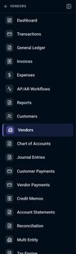

270-sidebar-addons-invoices-user-permissions-users-attendance-marketplace-plans-testing-re — ADDONS & INVOICES User Permissions Users Attendance Marketplace Plans Testing Re
Kind: sidebar
First seen: Admin / Addons & Invoices (`/settings/billing-invoices`)
Size: 256×837 at (0, 63)
Tag/role: aside
Classes: tw-hidden.min-[1026px]:tw-flex.tw-flex-col.tw-shrink-0.tw-h-full.tw-self-stretch.tw-overflow-hidden.tw-bg-[var(--main-bg)]
Selector: div:nth-of-type(1) > div:nth-of-type(1) > div:nth-of-type(3) > aside:nth-of-type(1)


286-sidebar-channel-integration-channel-integration — CHANNEL INTEGRATION Channel Integration
Kind: sidebar
First seen: Admin / Channel Integration (`/settings/channel-settings`)
Size: 256×837 at (0, 63)
Tag/role: aside
Classes: tw-hidden.min-[1026px]:tw-flex.tw-flex-col.tw-shrink-0.tw-h-full.tw-self-stretch.tw-overflow-hidden.tw-bg-[var(--main-bg)]
Selector: div:nth-of-type(1) > div:nth-of-type(1) > div:nth-of-type(3) > aside:nth-of-type(1)


294-sidebar-help-desk-user-permissions-users-attendance-marketplace-plans-testing-reports-me — HELP DESK User Permissions Users Attendance Marketplace Plans Testing Reports Me
Kind: sidebar
First seen: Admin / Help Desk (`/settings/help-center`)
Size: 256×837 at (0, 63)
Tag/role: aside
Classes: tw-hidden.min-[1026px]:tw-flex.tw-flex-col.tw-shrink-0.tw-h-full.tw-self-stretch.tw-overflow-hidden.tw-bg-[var(--main-bg)]
Selector: div:nth-of-type(1) > div:nth-of-type(1) > div:nth-of-type(3) > aside:nth-of-type(1)


304-sidebar-manage-billing-addons-user-permissions-users-attendance-marketplace-plans-test — MANAGE BILLING & ADDONS User Permissions Users Attendance Marketplace Plans Test
Kind: sidebar
First seen: Admin / Manage Billing & AddOns (`/settings/managebillings-addons`)
Size: 256×837 at (0, 63)
Tag/role: aside
Classes: tw-hidden.min-[1026px]:tw-flex.tw-flex-col.tw-shrink-0.tw-h-full.tw-self-stretch.tw-overflow-hidden.tw-bg-[var(--main-bg)]
Selector: div:nth-of-type(1) > div:nth-of-type(1) > div:nth-of-type(3) > aside:nth-of-type(1)


312-sidebar-marketplace-plans-user-permissions-users-attendance-marketplace-plans-testing-re — MARKETPLACE PLANS User Permissions Users Attendance Marketplace Plans Testing Re
Kind: sidebar
First seen: Admin / Marketplace Plans (`/settings/marketplace-plans`)
Size: 256×837 at (0, 63)
Tag/role: aside
Classes: tw-hidden.min-[1026px]:tw-flex.tw-flex-col.tw-shrink-0.tw-h-full.tw-self-stretch.tw-overflow-hidden.tw-bg-[var(--main-bg)]
Selector: div:nth-of-type(1) > div:nth-of-type(1) > div:nth-of-type(3) > aside:nth-of-type(1)


315-sidebar-menu-editor-user-permissions-users-attendance-marketplace-plans-testing-reports — MENU EDITOR User Permissions Users Attendance Marketplace Plans Testing Reports
Kind: sidebar
First seen: Admin / Menu Editor (`/settings/pageflipcanvaseditor`)
Size: 256×837 at (0, 63)
Tag/role: aside
Classes: tw-hidden.min-[1026px]:tw-flex.tw-flex-col.tw-shrink-0.tw-h-full.tw-self-stretch.tw-overflow-hidden.tw-bg-[var(--main-bg)]
Selector: div:nth-of-type(1) > div:nth-of-type(1) > div:nth-of-type(3) > aside:nth-of-type(1)


316-sidebar-design-tools-add-elements-add-textadd-rectangleadd-circle-pages-add-pagepage-1 — Design Tools Add Elements Add TextAdd RectangleAdd Circle Pages Add PagePage 1 (
Kind: sidebar
First seen: Admin / Menu Editor (`/settings/pageflipcanvaseditor`)
Size: 280×672 at (312, 211)
Tag/role: aside
Selector: div:nth-of-type(1) > div:nth-of-type(1) > div:nth-of-type(2) > aside:nth-of-type(1)
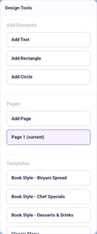

317-sidebar-inspector-canvas-background-color-background-image-product-add-product-card-sear — Inspector CANVAS Background Color Background Image PRODUCT Add product card Sear
Kind: sidebar
First seen: Admin / Menu Editor (`/settings/pageflipcanvaseditor`)
Size: 300×672 at (1092, 211)
Tag/role: aside
Selector: div:nth-of-type(1) > div:nth-of-type(1) > div:nth-of-type(2) > aside:nth-of-type(2)
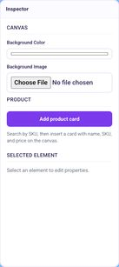

329-sidebar-testing-reports-user-permissions-users-attendance-marketplace-plans-testing-repo — TESTING REPORTS User Permissions Users Attendance Marketplace Plans Testing Repo
Kind: sidebar
First seen: Admin / Testing Reports (`/settings/testing-reports`)
Size: 256×837 at (0, 63)
Tag/role: aside
Classes: tw-hidden.min-[1026px]:tw-flex.tw-flex-col.tw-shrink-0.tw-h-full.tw-self-stretch.tw-overflow-hidden.tw-bg-[var(--main-bg)]
Selector: div:nth-of-type(1) > div:nth-of-type(1) > div:nth-of-type(3) > aside:nth-of-type(1)


336-sidebar-user-permissions-user-permissions-users-attendance-marketplace-plans-testing-rep — USER PERMISSIONS User Permissions Users Attendance Marketplace Plans Testing Rep
Kind: sidebar
First seen: Admin / User Permissions (`/settings/user-permission`)
Size: 256×837 at (0, 63)
Tag/role: aside
Classes: tw-hidden.min-[1026px]:tw-flex.tw-flex-col.tw-shrink-0.tw-h-full.tw-self-stretch.tw-overflow-hidden.tw-bg-[var(--main-bg)]
Selector: div:nth-of-type(1) > div:nth-of-type(1) > div:nth-of-type(3) > aside:nth-of-type(1)


339-sidebar-users-attendance-user-permissions-users-attendance-marketplace-plans-testing-rep — USERS ATTENDANCE User Permissions Users Attendance Marketplace Plans Testing Rep
Kind: sidebar
First seen: Admin / Users Attendance (`/settings/users-attendance`)
Size: 256×837 at (0, 63)
Tag/role: aside
Classes: tw-hidden.min-[1026px]:tw-flex.tw-flex-col.tw-shrink-0.tw-h-full.tw-self-stretch.tw-overflow-hidden.tw-bg-[var(--main-bg)]
Selector: div:nth-of-type(1) > div:nth-of-type(1) > div:nth-of-type(3) > aside:nth-of-type(1)


366-sidebar-dashboard-dashboard-reports-product-analytics-brand-dashboard-forecasting-foreca — DASHBOARD Dashboard Reports Product Analytics Brand Dashboard Forecasting Foreca
Kind: sidebar
First seen: Analytics & Reports / Dashboard (`/analytics/analytics-dashboard`)
Size: 256×837 at (0, 63)
Tag/role: aside
Classes: tw-hidden.min-[1026px]:tw-flex.tw-flex-col.tw-shrink-0.tw-h-full.tw-self-stretch.tw-overflow-hidden.tw-bg-[var(--main-bg)]
Selector: div:nth-of-type(1) > div:nth-of-type(1) > div:nth-of-type(3) > aside:nth-of-type(1)


371-sidebar-dashboard-dashboard-catalogs-b2b-customer-pricing-inbound-orders-vendor-pos-so — DASHBOARD Dashboard Catalogs B2B Customer Pricing Inbound orders Vendor POs SO -
Kind: sidebar
First seen: B2B / Dashboard (`/b2b/dashboard`)
Size: 256×837 at (0, 63)
Tag/role: aside
Classes: tw-hidden.min-[1026px]:tw-flex.tw-flex-col.tw-shrink-0.tw-h-full.tw-self-stretch.tw-overflow-hidden.tw-bg-[var(--main-bg)]
Selector: div:nth-of-type(1) > div:nth-of-type(1) > div:nth-of-type(3) > aside:nth-of-type(1)


374-sidebar-catalog-dashboard-products-inventory-fitment-addons-bundles-pricing-images-impor — CATALOG Dashboard Products Inventory Fitment Addons Bundles Pricing Images Impor
Kind: sidebar
First seen: Catalog / Addons (`/products/addons`)
Size: 256×837 at (0, 63)
Tag/role: aside
Classes: tw-hidden.min-[1026px]:tw-flex.tw-flex-col.tw-shrink-0.tw-h-full.tw-self-stretch.tw-overflow-hidden.tw-bg-[var(--main-bg)]
Selector: div:nth-of-type(1) > div:nth-of-type(1) > div:nth-of-type(3) > aside:nth-of-type(1)


377-sidebar-bundles-kits-all-warehouse-dropshipping — BUNDLES & KITS All Warehouse Dropshipping
Kind: sidebar
First seen: Catalog / Bundles (`/products/bundlekits`)
Size: 256×837 at (0, 63)
Tag/role: aside
Classes: tw-hidden.min-[1026px]:tw-flex.tw-flex-col.tw-shrink-0.tw-h-full.tw-self-stretch.tw-overflow-hidden.tw-bg-[var(--main-bg)]
Selector: div:nth-of-type(1) > div:nth-of-type(1) > div:nth-of-type(3) > aside:nth-of-type(1)


393-sidebar-import-export-imports-scheduled-imports-exports — IMPORT / EXPORT Imports Scheduled Imports Exports
Kind: sidebar
First seen: Catalog / Import / Export (`/products/import-export`)
Size: 256×837 at (0, 63)
Tag/role: aside
Classes: tw-hidden.min-[1026px]:tw-flex.tw-flex-col.tw-shrink-0.tw-h-full.tw-self-stretch.tw-overflow-hidden.tw-bg-[var(--main-bg)]
Selector: div:nth-of-type(1) > div:nth-of-type(1) > div:nth-of-type(3) > aside:nth-of-type(1)


400-sidebar-inventory-all-marketplace-supplier-warehouse-dropshipping — INVENTORY All Marketplace Supplier Warehouse Dropshipping
Kind: sidebar
First seen: Catalog / Inventory (`/products/inventory`)
Size: 256×837 at (0, 63)
Tag/role: aside
Classes: tw-hidden.min-[1026px]:tw-flex.tw-flex-col.tw-shrink-0.tw-h-full.tw-self-stretch.tw-overflow-hidden.tw-bg-[var(--main-bg)]
Selector: div:nth-of-type(1) > div:nth-of-type(1) > div:nth-of-type(3) > aside:nth-of-type(1)


402-sidebar-pricing-store-map-marketplaces-supplier-shipping — PRICING Store MAP Marketplaces Supplier Shipping
Kind: sidebar
First seen: Catalog / Pricing (`/products/pricing`)
Size: 256×837 at (0, 63)
Tag/role: aside
Classes: tw-hidden.min-[1026px]:tw-flex.tw-flex-col.tw-shrink-0.tw-h-full.tw-self-stretch.tw-overflow-hidden.tw-bg-[var(--main-bg)]
Selector: div:nth-of-type(1) > div:nth-of-type(1) > div:nth-of-type(3) > aside:nth-of-type(1)


table

002-table-channels-store-orders-open-orders-delivered-returns-revenue-sales-no-available-o — Channels Store Orders Open Orders Delivered Returns Revenue Sales No available o
Kind: table
First seen: Home / Dashboard (`/home/dashboard`)
Size: 1140×100 at (278, 531)
Tag/role: table role=table
Classes: p-datatable-table
Selector: div:nth-of-type(1) > div:nth-of-type(2) > div:nth-of-type(1) > table:nth-of-type(1)

003-table-sku-files-title-brand-price-quantity-no-available-options — SKU Files Title Brand Price Quantity No available options
Kind: table
First seen: Home / Dashboard (`/home/dashboard`)
Size: 1140×100 at (278, 703)
Tag/role: table role=table
Classes: p-datatable-table
Selector: div:nth-of-type(1) > div:nth-of-type(2) > div:nth-of-type(1) > table:nth-of-type(1)

036-table-order-id-sku-user-name-order-total-status-last-updated-2026-000597-air-lift57213 — Order ID SKU User Name Order Total Status Last Updated 2026-000597 AIR_LIFT57213
Kind: table
First seen: 3PL / Dashboard (`/3pl/dashboard`)
Size: 768×460 at (297, 321)
Tag/role: table role=table
Classes: p-datatable-table
Selector: div:nth-of-type(1) > div:nth-of-type(1) > div:nth-of-type(1) > table:nth-of-type(1)
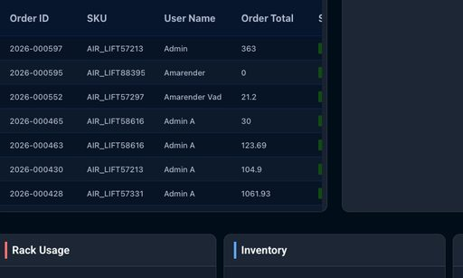

046-table-number-party-account-date-amount-status-actions-stmt-sb-1-sandbox-customer-a-2 — Number Party / Account Date Amount Status Actions STMT-SB-1 Sandbox Customer A 2
Kind: table
First seen: Accounting / Account Statements (`/accounting/account-statements`)
Size: 1046×103 at (329, 205)
Tag/role: table
Classes: tw-w-full.tw-text-sm
Selector: div:nth-of-type(1) > div:nth-of-type(2) > div:nth-of-type(1) > table:nth-of-type(1)

073-table-vendor-number-date-due-amount-status-actions-auto-ewrwerw-2026-08-07-2222-02-22 — VENDOR NUMBER DATE DUE AMOUNT STATUS ACTIONS auto ewrwerw 2026-08-07 2222-02-22
Kind: table
First seen: Accounting / AP/AR Workflows (`/accounting/apar-workflows`)
Size: 1112×100 at (296, 347)
Tag/role: table
Classes: tw-w-full
Selector: div:nth-of-type(1) > div:nth-of-type(1) > div:nth-of-type(3) > table:nth-of-type(1)

096-table-number-customer-date-amount-status-actions-cm-sb-1-sandbox-customer-a-2026-08-25 — Number Customer Date Amount Status Actions CM-SB-1 Sandbox Customer A 2026-08-25
Kind: table
First seen: Accounting / Credit Memos (`/accounting/credit-memos`)
Size: 1046×103 at (329, 205)
Tag/role: table
Classes: tw-w-full.tw-text-sm
Selector: div:nth-of-type(1) > div:nth-of-type(2) > div:nth-of-type(1) > table:nth-of-type(1)

099-table-date-type-number-memo-payment-method-ref-no-actions-9-15-2026-payment-rcp-2026 — DATE TYPE NUMBER MEMO PAYMENT METHOD REF NO. ACTIONS 9/15/2026 Payment RCP-2026-
Kind: table
First seen: Accounting / Customer Payments (`/accounting/customer-payments`)
Size: 1112×835 at (296, 236)
Tag/role: table
Classes: tw-w-full
Selector: div:nth-of-type(1) > div:nth-of-type(1) > div:nth-of-type(2) > table:nth-of-type(1)
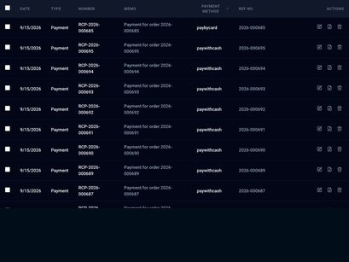

178-table-number-date-type-description-status-debit-credit-actions-aug-24-2026-manual-dra — NUMBER DATE TYPE DESCRIPTION STATUS DEBIT CREDIT ACTIONS Aug 24, 2026 Manual Dra
Kind: table
First seen: Accounting / Journal Entries (`/accounting/journal-entries`)
Size: 1112×100 at (296, 232)
Tag/role: table
Classes: tw-w-full
Selector: div:nth-of-type(1) > div:nth-of-type(1) > div:nth-of-type(2) > table:nth-of-type(1)

185-table-date-from-to-description-type-amount-status-feb-14-2024-medequip-rentals-corp-m — DATE FROM TO DESCRIPTION TYPE AMOUNT STATUS Feb 14, 2024 MedEquip Rentals Corp M
Kind: table
First seen: Accounting / Multi Entity (`/accounting/multi-entity`)
Size: 1062×331 at (321, 338)
Tag/role: table
Classes: tw-w-full
Selector: div:nth-of-type(2) > div:nth-of-type(1) > div:nth-of-type(2) > table:nth-of-type(1)
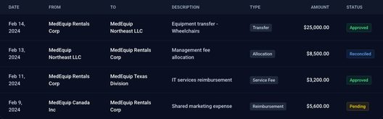

193-table-period-type-date-range-status-closed-by-closed-at-actions — PERIOD TYPE DATE RANGE STATUS CLOSED BY CLOSED AT ACTIONS
Kind: table
First seen: Accounting / Period Close (`/accounting/period-close`)
Size: 1062×40 at (321, 580)
Tag/role: table
Classes: tw-w-full
Selector: div:nth-of-type(2) > div:nth-of-type(1) > div:nth-of-type(2) > table:nth-of-type(1)

228-table-rule-name-jurisdiction-type-rate-effective-from-status-actions — RULE NAME JURISDICTION TYPE RATE EFFECTIVE FROM STATUS ACTIONS
Kind: table
First seen: Accounting / Tax Engine (`/accounting/tax-engine`)
Size: 1112×40 at (296, 347)
Tag/role: table
Classes: tw-w-full
Selector: div:nth-of-type(1) > div:nth-of-type(1) > div:nth-of-type(3) > table:nth-of-type(1)

237-table-date-transaction-type-customer-vendor-reference-source-account-money-in-money — DATE TRANSACTION # TYPE CUSTOMER/VENDOR REFERENCE SOURCE ACCOUNT MONEY IN MONEY
Kind: table
First seen: Accounting / Transactions (`/accounting/transactions`)
Size: 1516×6374 at (296, 248)
Tag/role: table
Classes: tw-w-full.tw-text-sm
Selector: div:nth-of-type(1) > div:nth-of-type(1) > div:nth-of-type(2) > table:nth-of-type(1)
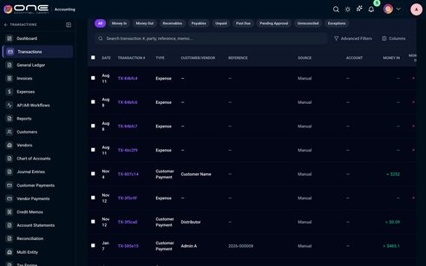

257-table-number-vendor-date-amount-status-actions-vp-sb-1-office-supplies-co-2026-07-20 — Number Vendor Date Amount Status Actions VP-SB-1 Office Supplies Co 2026-07-20 $
Kind: table
First seen: Accounting / Vendor Payments (`/accounting/vendor-payments`)
Size: 1046×103 at (329, 205)
Tag/role: table
Classes: tw-w-full.tw-text-sm
Selector: div:nth-of-type(1) > div:nth-of-type(2) > div:nth-of-type(1) > table:nth-of-type(1)

260-table-vendor-category-contact-location-status-rating-purchases-total-spent-lead-time-a — VENDOR CATEGORY CONTACT LOCATION STATUS RATING PURCHASES TOTAL SPENT LEAD TIME A
Kind: table
First seen: Accounting / Vendors (`/accounting/vendors`)
Size: 1989×2050 at (296, 358)
Tag/role: table
Classes: tw-w-full
Selector: div:nth-of-type(1) > div:nth-of-type(1) > div:nth-of-type(2) > table:nth-of-type(1)
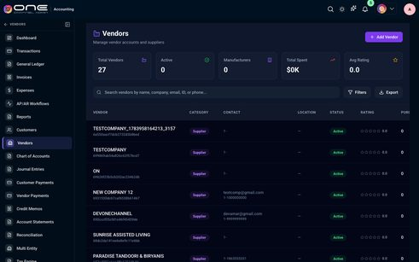

266-table-date-invoice-no-organization-amount-status-invoice-actions-payment-march-4-202 — Date Invoice No. Organization Amount Status Invoice Actions Payment March 4, 202
Kind: table
First seen: Admin / Addons & Invoices (`/settings/billing-invoices`)
Size: 1080×122 at (312, 213)
Tag/role: table role=table
Classes: p-datatable-table
Selector: div:nth-of-type(1) > div:nth-of-type(1) > div:nth-of-type(1) > table:nth-of-type(1)
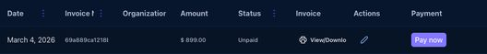

301-table-date-invoice-no-organization-amount-status-invoice-actions-march-4-2026-69a889 — Date Invoice No. Organization Amount Status Invoice Actions March 4, 2026 69a889
Kind: table
First seen: Admin / Manage Billing & AddOns (`/settings/managebillings-addons`)
Size: 1080×616 at (312, 297)
Tag/role: table role=table
Classes: p-datatable-table
Selector: div:nth-of-type(1) > div:nth-of-type(1) > div:nth-of-type(1) > table:nth-of-type(1)
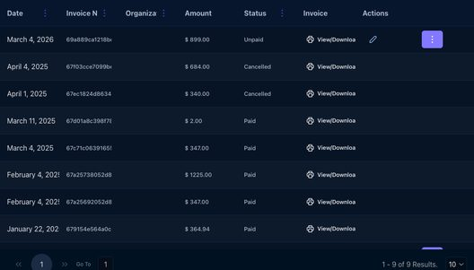

308-table-no-data-found — No Data Found!
Kind: table
First seen: Admin / Marketplace Plans (`/settings/marketplace-plans`)
Size: 1080×40 at (312, 231)
Tag/role: table role=table
Classes: p-datatable-table
Selector: div:nth-of-type(1) > div:nth-of-type(1) > div:nth-of-type(1) > table:nth-of-type(1)

328-table-report-name-report-file-uploaded-by-uploaded-time-actions-ui-report-test-html-ui — Report Name Report File Uploaded By Uploaded Time Actions ui report test HTML ui
Kind: table
First seen: Admin / Testing Reports (`/settings/testing-reports`)
Size: 1369×977 at (312, 251)
Tag/role: table role=table
Classes: p-datatable-table
Selector: div:nth-of-type(3) > div:nth-of-type(2) > div:nth-of-type(1) > table:nth-of-type(1)
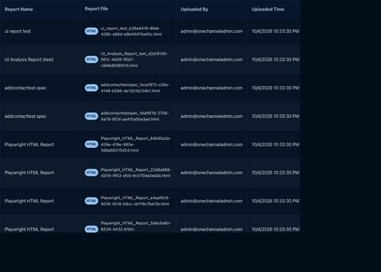

334-table-pic-live-email-current-roles-organizations-status-action-sales-person-fulfill-dr — PIC Live Email Current Roles Organizations Status Action Sales Person Fulfill Dr
Kind: table
First seen: Admin / User Permissions (`/settings/user-permission`)
Size: 1408×2315 at (312, 220)
Tag/role: table role=table
Classes: p-datatable-table
Selector: div:nth-of-type(1) > div:nth-of-type(1) > div:nth-of-type(1) > table:nth-of-type(1)
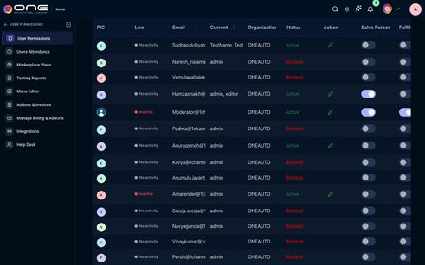

337-table-user-present-absent-working-hours-status-ajith-onechanneladmin-com-ajith-onechan — USER PRESENT ABSENT WORKING HOURS STATUS ajith@onechanneladmin.com ajith@onechan
Kind: table
First seen: Admin / Users Attendance (`/settings/users-attendance`)
Size: 675×888 at (698, 542)
Tag/role: table
Classes: tw-w-full.tw-text-sm.tw-text-slate-100
Selector: div:nth-of-type(3) > div:nth-of-type(2) > div:nth-of-type(2) > table:nth-of-type(1)
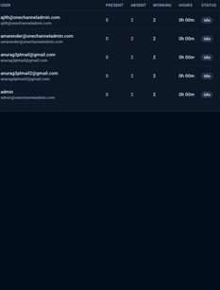

372-table-title-addons-spice-levels-spice-level-new-addon-edit-delete — Title Addons Spice Levels spice level, new addon Edit Delete
Kind: table
First seen: Catalog / Addons (`/products/addons`)
Size: 1160×114 at (268, 139)
Tag/role: table role=table
Classes: p-datatable-table
Selector: div:nth-of-type(1) > div:nth-of-type(1) > div:nth-of-type(1) > table:nth-of-type(1)

375-table-sku-mpn-brand-upc-title-retail-price-available-qty-images-channels-status-catego — SKU MPN Brand UPC Title Retail Price Available QTY Images Channels Status Catego
Kind: table
First seen: Catalog / Bundles (`/products/bundlekits`)
Size: 5328×490 at (296, 131)
Tag/role: table role=table
Classes: p-datatable-table
Selector: div:nth-of-type(1) > div:nth-of-type(1) > div:nth-of-type(1) > table:nth-of-type(1)

384-table-brand-name-product-count-published-draft-all-qtys-price-value-map-price-products — Brand Name Product Count Published Draft All Qtys Price value MAP Price Products
Kind: table
First seen: Catalog / Dashboard (`/products/dashboard`)
Size: 1800×704 at (295, 527)
Tag/role: table role=table
Classes: p-datatable-table
Selector: div:nth-of-type(1) > div:nth-of-type(1) > div:nth-of-type(1) > table:nth-of-type(1)
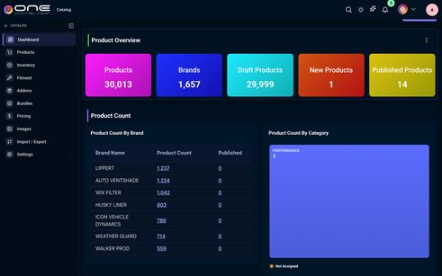

385-table-sku-mpn-brand-title-retail-price-images-status-category-description-fitment-coun — SKU MPN Brand Title Retail Price Images Status Category Description Fitment Coun
Kind: table
First seen: Catalog / Fitment (`/products/fitment`)
Size: 2544×4088 at (268, 139)
Tag/role: table role=table
Classes: p-datatable-table
Selector: div:nth-of-type(1) > div:nth-of-type(1) > div:nth-of-type(1) > table:nth-of-type(1)
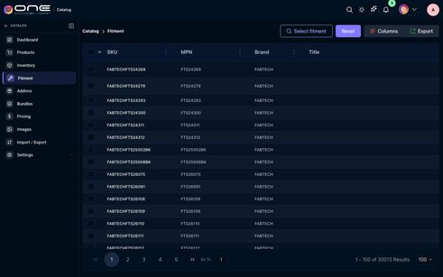

386-table-product-info-images-sku-mpn-brand-title-size-style-fabtechfts24269-f — Product Info Images SKU MPN Brand Title Size Style : : : : : : FABTECHFTS24269 F
Kind: table
First seen: Catalog / Images (`/products/images`)
Size: 1160×854 at (268, 189)
Tag/role: table role=table
Classes: p-datatable-table
Selector: div:nth-of-type(3) > div:nth-of-type(1) > div:nth-of-type(1) > table:nth-of-type(1)
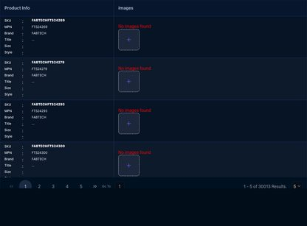

392-table-date-file-name-message-percent-status-error-count-matched-count-new-count-modifi — Date File Name Message Percent Status Error Count Matched Count New Count Modifi
Kind: table
First seen: Catalog / Import / Export (`/products/import-export`)
Size: 1824×2180 at (296, 147)
Tag/role: table role=table
Classes: p-datatable-table
Selector: div:nth-of-type(1) > div:nth-of-type(1) > div:nth-of-type(1) > table:nth-of-type(1)
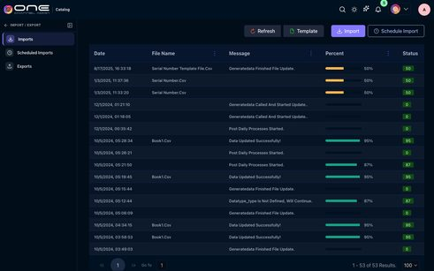

399-table-sku-mpn-brand-title-retail-price-available-qty-website-intake-query-only-hcpc-on — SKU MPN Brand Title Retail Price Available QTY Website Intake query only HCPC On
Kind: table
First seen: Catalog / Inventory (`/products/inventory`)
Size: 2608×4060 at (297, 104)
Tag/role: table role=table
Classes: p-datatable-table
Selector: div:nth-of-type(1) > div:nth-of-type(1) > div:nth-of-type(1) > table:nth-of-type(1)
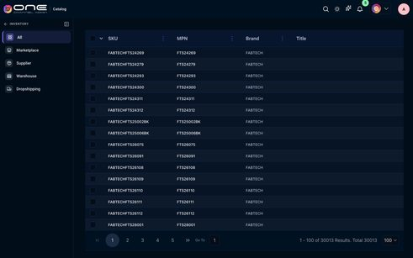

401-table-table — Table
Kind: table
First seen: Catalog / Pricing (`/products/pricing`)
Size: 1110×60 at (297, 144)
Tag/role: table role=table
Classes: p-datatable-table
Selector: div:nth-of-type(1) > div:nth-of-type(1) > div:nth-of-type(2) > table:nth-of-type(1)

406-table-images-product-name-brand-count-price-no-available-options — Images Product Name Brand Count Price No available options
Kind: table
First seen: Channel / Amazon (`/channel/amazon-dashboard`)
Size: 1096×100 at (304, 515)
Tag/role: table role=table
Classes: p-datatable-table
Selector: div:nth-of-type(1) > div:nth-of-type(2) > div:nth-of-type(1) > table:nth-of-type(1)

412-table-thumbnail-product-name-brand-price-sold-qty-controller-standard-type-a-am — Thumbnail Product Name Brand Price Sold QTY CONTROLLER - STANDARD - TYPE A... AM
Kind: table
First seen: Channel / eBay (`/channel/ebay-dashboard`)
Size: 1096×618 at (304, 531)
Tag/role: table role=table
Classes: p-datatable-table
Selector: div:nth-of-type(1) > div:nth-of-type(2) > div:nth-of-type(1) > table:nth-of-type(1)
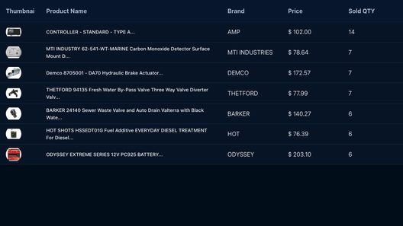

418-table-sku-files-title-brand-price-quantity-no-available-options — SKU Files Title Brand Price Quantity No available options
Kind: table
First seen: Channel / Etsy (`/channel/etsy-dashboard`)
Size: 1036×100 at (334, 531)
Tag/role: table role=table
Classes: p-datatable-table
Selector: div:nth-of-type(1) > div:nth-of-type(2) > div:nth-of-type(1) > table:nth-of-type(1)

421-table-id-name-retailer-id-25353784230898318-air-lift-60863-air-lift-1000-air-spring-ki — ID Name Retailer ID 25353784230898318 AIR LIFT 60863 AIR LIFT 1000 AIR SPRING KI
Kind: table
First seen: Channel / Facebook (`/channel/facebook-products`)
Size: 1112×140 at (296, 231)
Tag/role: table role=table
Classes: p-datatable-table
Selector: div:nth-of-type(1) > div:nth-of-type(1) > div:nth-of-type(1) > table:nth-of-type(1)
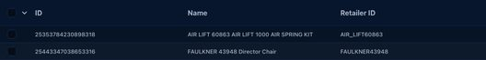

427-table-no-data-found — No Data Found!
Kind: table
First seen: Channel / Google Merchant (`/channel/google-merchant-products`)
Size: 1112×100 at (296, 231)
Tag/role: table role=table
Classes: p-datatable-table
Selector: div:nth-of-type(1) > div:nth-of-type(1) > div:nth-of-type(1) > table:nth-of-type(1)

430-table-no-data-found — No Data Found!
Kind: table
First seen: Channel / OneDirectBuy (`/marketplaceseller`)
Size: 1112×40 at (296, 199)
Tag/role: table role=table
Classes: p-datatable-table
Selector: div:nth-of-type(1) > div:nth-of-type(1) > div:nth-of-type(1) > table:nth-of-type(1)

438-table-thumbnail-product-name-brand-price-sold-qty-helper-spring-kit-air-spring-frame-m — Thumbnail Product Name Brand Price Sold QTY Helper Spring Kit Air Spring Frame M
Kind: table
First seen: Channel / Shopify (`/channel/shopify-dashboard`)
Size: 1036×172 at (334, 526)
Tag/role: table role=table
Classes: p-datatable-table
Selector: div:nth-of-type(1) > div:nth-of-type(2) > div:nth-of-type(1) > table:nth-of-type(1)
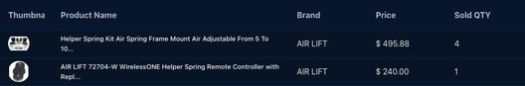

442-table-thumbnail-product-name-brand-price-sold-qty-no-available-options — Thumbnail Product Name Brand Price Sold QTY No available options
Kind: table
First seen: Channel / Walmart CA (`/channel/walmartca-dashboard`)
Size: 1036×100 at (334, 531)
Tag/role: table role=table
Classes: p-datatable-table
Selector: div:nth-of-type(1) > div:nth-of-type(2) > div:nth-of-type(1) > table:nth-of-type(1)

444-table-internal-id-account-email-domain-description-phone-title-industry-owner-sales — Internal ID Account Email Domain Description Phone Title Industry Owner / Sales
Kind: table
First seen: CRM / B2B Accounts (`/crm/company`)
Size: 2720×1140 at (296, 189)
Tag/role: table role=table
Classes: p-datatable-table
Selector: div:nth-of-type(1) > div:nth-of-type(1) > div:nth-of-type(1) > table:nth-of-type(1)
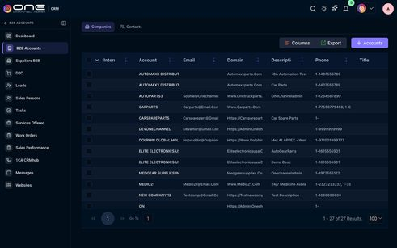

447-table-mkt-email-first-name-last-name-phone-no-labels-websites-title-assigned-to-qtyed — MKT Email First Name Last Name Phone No Labels/ Websites Title Assigned To Qtyed
Kind: table
First seen: CRM / D2C (`/crm/ContactManage`)
Size: 1664×4060 at (296, 189)
Tag/role: table role=table
Classes: p-datatable-table
Selector: div:nth-of-type(1) > div:nth-of-type(1) > div:nth-of-type(1) > table:nth-of-type(1)
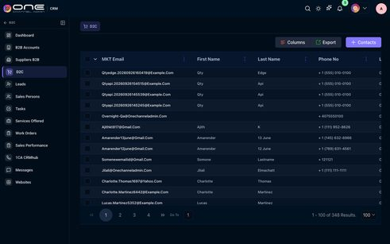

451-table-email-first-person-domain-last-name-industry-companys-phone-no-lead-source-lead — Email First Person Domain Last Name Industry Companys Phone No Lead Source Lead
Kind: table
First seen: CRM / Leads (`/crm/leads`)
Size: 2352×4060 at (296, 189)
Tag/role: table role=table
Classes: p-datatable-table
Selector: div:nth-of-type(1) > div:nth-of-type(1) > div:nth-of-type(1) > table:nth-of-type(1)
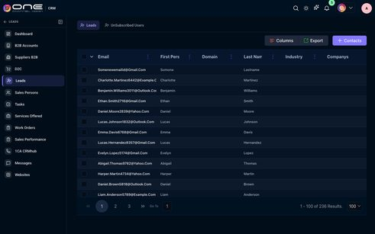

454-table-email-status-last-signed-in-a-amarender-onechanneladmin-com-active-9-19-2026-12 — Email Status Last Signed In A amarender@onechanneladmin.com ACTIVE 9/19/2026, 12
Kind: table
First seen: CRM / Sales Persons (`/crm/salespersons`)
Size: 1112×259 at (296, 155)
Tag/role: table role=table
Classes: p-datatable-table
Selector: div:nth-of-type(1) > div:nth-of-type(1) > div:nth-of-type(1) > table:nth-of-type(1)
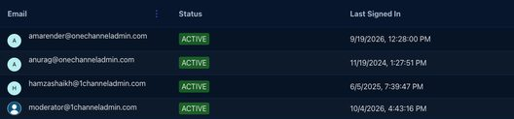

455-table-vendor-name-phone-email-keystone-ka-keystone-automotive-1-999-988-8899-admin — Vendor Name Phone Email KEYSTONE KA Keystone Automotive + 1 (999) 988-8899 Admin
Kind: table
First seen: CRM / Suppliers B2B (`/crm/contacts-customers`)
Size: 1112×351 at (296, 197)
Tag/role: table role=table
Classes: p-datatable-table
Selector: div:nth-of-type(1) > div:nth-of-type(1) > div:nth-of-type(1) > table:nth-of-type(1)
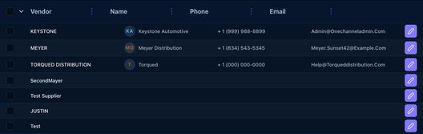

457-table-title-status-priority-task-type-due-date-assigned-to-reminder-created-on-notes-c — Title Status Priority Task Type Due Date Assigned To Reminder Created On Notes C
Kind: table
First seen: CRM / Tasks (`/crm/tasks`)
Size: 2096×3900 at (296, 210)
Tag/role: table role=table
Classes: p-datatable-table
Selector: div:nth-of-type(1) > div:nth-of-type(1) > div:nth-of-type(1) > table:nth-of-type(1)
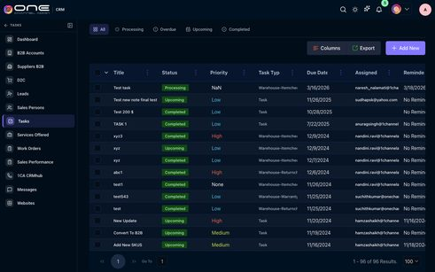

464-table-name-link-email-catalog-name-oneauto-onetruckparts-truckauto-quickstart-3bed0ffd — Name Link Email Catalog Name Oneauto Onetruckparts TRUCKAUTO Quickstart-3bed0ffd
Kind: table
First seen: CRM / Websites (`/b2b/b2bwebsites`)
Size: 1112×340 at (296, 289)
Tag/role: table role=table
Classes: p-datatable-table
Selector: div:nth-of-type(1) > div:nth-of-type(1) > div:nth-of-type(1) > table:nth-of-type(1)
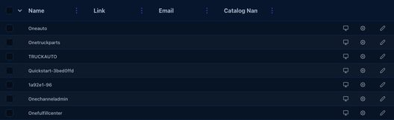

471-table-no-data-found — No Data Found!
Kind: table
First seen: Fulfillment / Archived Orders (`/fulfill/orders/archived`)
Size: 1160×100 at (268, 121)
Tag/role: table role=table
Classes: p-datatable-table
Selector: div:nth-of-type(1) > div:nth-of-type(1) > div:nth-of-type(1) > table:nth-of-type(1)

476-table-order-id-order-date-order-total-source-payment-status-sku-title-fulfillment-stat — Order ID Order Date Order Total Source Payment Status SKU Title Fulfillment Stat
Kind: table
First seen: Fulfillment / Cancellations (`/fulfill/orders/cancel`)
Size: 4048×700 at (268, 121)
Tag/role: table role=table
Classes: p-datatable-table
Selector: div:nth-of-type(1) > div:nth-of-type(1) > div:nth-of-type(1) > table:nth-of-type(1)
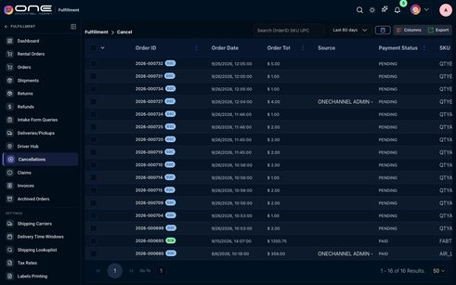

481-table-claim-id-shipment-id-claimant-name-claimant-contact-claimant-email-claim-date-sh — Claim ID Shipment ID Claimant Name Claimant Contact Claimant Email Claim Date Sh
Kind: table
First seen: Fulfillment / Claims (`/fulfill/orders/claims`)
Size: 3264×980 at (292, 137)
Tag/role: table role=table
Classes: p-datatable-table
Selector: div:nth-of-type(1) > div:nth-of-type(1) > div:nth-of-type(1) > table:nth-of-type(1)
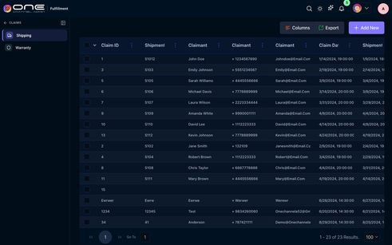

548-table-order-key-label-start-end-active-actions-8-11-8-am-11-am-08-00-11-00-08-00-1 — Order Key Label Start End Active Actions 8-11 8 AM – 11 AM · 08:00–11:00 08:00 1
Kind: table
First seen: Fulfillment / Delivery Time Windows (`/fulfill/settings/delivery-time-windows`)
Size: 1128×366 at (284, 162)
Tag/role: table role=table
Classes: p-datatable-table
Selector: div:nth-of-type(3) > div:nth-of-type(1) > div:nth-of-type(1) > table:nth-of-type(1)
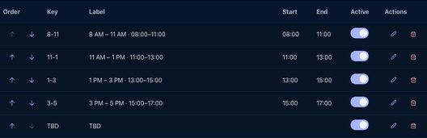

589-table-submission-id-contact-price-email-request-items-submitted-status-priority-creati — Submission Id Contact Price Email Request Items Submitted Status Priority Creati
Kind: table
First seen: Fulfillment / Intake Form Queries (`/fulfill/orders/intake-quote`)
Size: 4039×196 at (268, 193)
Tag/role: table role=table
Classes: p-datatable-table
Selector: div:nth-of-type(1) > div:nth-of-type(1) > div:nth-of-type(1) > table:nth-of-type(1)

593-table-order-id-order-date-print-order-total-source-payment-status-sku-title-fulfillmen — Order ID Order Date Print Order Total Source Payment Status SKU Title Fulfillmen
Kind: table
First seen: Fulfillment / Invoices (`/settings/accounting-invoices`)
Size: 4080×5929 at (269, 200)
Tag/role: table role=table
Classes: p-datatable-table
Selector: div:nth-of-type(1) > div:nth-of-type(1) > div:nth-of-type(1) > table:nth-of-type(1)
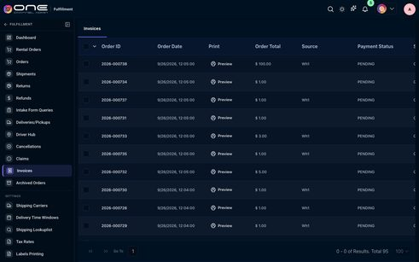

596-table-tracking-id-carrier-code-carrier-service-order-id-service-type-created-rate-pack — Tracking ID Carrier Code Carrier Service Order ID Service Type Created Rate Pack
Kind: table
First seen: Fulfillment / Labels Printing (`/fulfill/settings/label-printing`)
Size: 1448×6238 at (268, 139)
Tag/role: table role=table
Classes: p-datatable-table
Selector: div:nth-of-type(1) > div:nth-of-type(1) > div:nth-of-type(1) > table:nth-of-type(1)
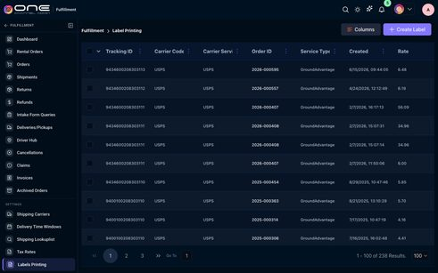

597-table-name-description-active-outbound-created-on-modified-by-order-po-template-10-17 — Name Description Active Outbound Created On Modified By Order PO Template 10/17/
Kind: table
First seen: Fulfillment / Order Templates (`/fulfill/orders/templates`)
Size: 1120×100 at (292, 79)
Tag/role: table role=table
Classes: p-datatable-table
Selector: div:nth-of-type(1) > div:nth-of-type(1) > div:nth-of-type(1) > table:nth-of-type(1)

606-table-return-date-mkt-return-id-order-id-status-mpstatus-sku-refund-approve-return — Return Date MKT Return ID Order ID Status MPStatus SKU Refund - Approve Return -
Kind: table
First seen: Fulfillment / Returns (`/fulfill/orders/return`)
Size: 3472×100 at (276, 103)
Tag/role: table role=table
Classes: p-datatable-table
Selector: div:nth-of-type(1) > div:nth-of-type(1) > div:nth-of-type(1) > table:nth-of-type(1)

608-table-order-id-order-date-approvals-fulfillment-print-label-order-total-source-payment — Order ID Order Date Approvals Fulfillment Print Label Order Total Source Payment
Kind: table
First seen: Fulfillment / Shipments (`/fulfill/orders/shipment`)
Size: 4816×1342 at (268, 125)
Tag/role: table role=table
Classes: p-datatable-table
Selector: div:nth-of-type(1) > div:nth-of-type(1) > div:nth-of-type(1) > table:nth-of-type(1)
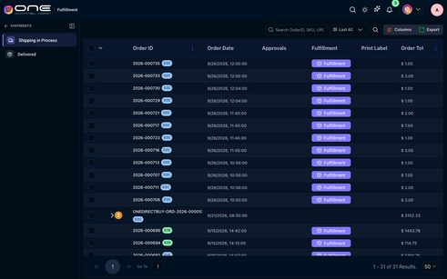

609-table-name-updated-by-update-on-ups-shipping-chart-admin-onechanneladmin-com-10-24-202 — Name Updated By Update On UPS Shipping Chart Admin@Onechanneladmin.Com 10/24/202
Kind: table
First seen: Fulfillment / Shipping Lookuplist (`/fulfill/settings/rates`)
Size: 1160×220 at (268, 121)
Tag/role: table role=table
Classes: p-datatable-table
Selector: div:nth-of-type(1) > div:nth-of-type(1) > div:nth-of-type(1) > table:nth-of-type(1)
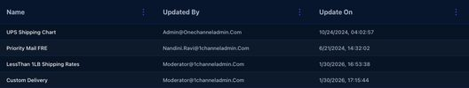

612-table-state-zipcode-tax-region-name-estimated-combined-rate-state-rate-estimated-count — State ZipCode Tax Region Name Estimated Combined Rate State Rate Estimated Count
Kind: table
First seen: Fulfillment / Tax Rates (`/fulfill/settings/taxRates`)
Size: 1552×4060 at (268, 188)
Tag/role: table role=table
Classes: p-datatable-table
Selector: div:nth-of-type(1) > div:nth-of-type(1) > div:nth-of-type(1) > table:nth-of-type(1)
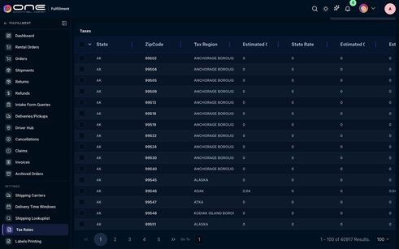

620-table-name-description-active-outbound-created-on-modified-by-mapprice-default-templat — Name Description Active Outbound Created On Modified By MapPrice Default Templat
Kind: table
First seen: Map Price / Settings (`/map-price/settings`)
Size: 1160×100 at (268, 215)
Tag/role: table role=table
Classes: p-datatable-table
Selector: div:nth-of-type(1) > div:nth-of-type(1) > div:nth-of-type(1) > table:nth-of-type(1)

622-table-name-status-impressions-clicks-ctr-engagement-spend-date-facebook-carousel-promo — Name Status Impressions Clicks CTR Engagement Spend Date Facebook Carousel Promo
Kind: table
First seen: Marketing / Common Socials (`/marketing/common-socials`)
Size: 939×136 at (293, 421)
Tag/role: table role=table
Classes: p-datatable-table
Selector: div:nth-of-type(3) > div:nth-of-type(4) > div:nth-of-type(1) > table:nth-of-type(1)
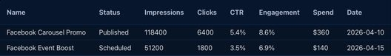

625-table-marketplace-revenue-orders-units-aov-impressions-clicks-cpc-conv-rate-cac-ad-sp — Marketplace Revenue Orders Units AOV Impressions Clicks CPC Conv. Rate CAC Ad Sp
Kind: table
First seen: Marketing / Dashboard (`/marketing/market-dashboard`)
Size: 1486×367 at (293, 307)
Tag/role: table
Classes: tw-w-full
Selector: div:nth-of-type(1) > div:nth-of-type(2) > div:nth-of-type(1) > table:nth-of-type(1)
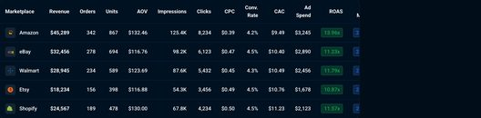

628-table-ignore-end-date-name-method-campaign-type-apply-for-all-customers-start-date-end — Ignore End Date Name Method Campaign Type Apply For All Customers Start Date End
Kind: table
First seen: Marketing / Discounts (`/marketing/campaigns`)
Size: 2128×1900 at (268, 211)
Tag/role: table role=table
Classes: p-datatable-table
Selector: div:nth-of-type(1) > div:nth-of-type(1) > div:nth-of-type(1) > table:nth-of-type(1)
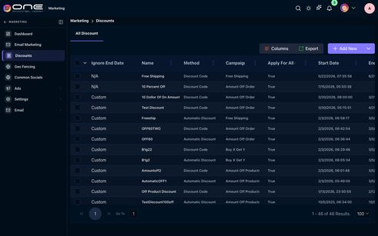

632-table-name-type-area-size-used-by-tags-updated-status-actions-downtown-shopping-distri — Name Type Area Size Used By Tags Updated Status Actions Downtown Shopping Distri
Kind: table
First seen: Marketing / Geo Fencing (`/marketing/geo-fencing`)
Size: 1110×677 at (293, 531)
Tag/role: table
Classes: tw-w-full
Selector: div:nth-of-type(2) > div:nth-of-type(4) > div:nth-of-type(1) > table:nth-of-type(1)
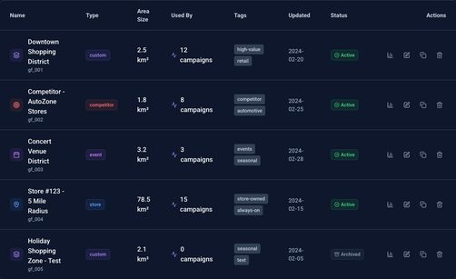

648-table-sku-mpn-status-brand-quantity-batch-number-created-at-newmanufacturerprod-newman — SKU MPN Status Brand Quantity Batch Number Created At NEWMANUFACTURERPROD NewMan
Kind: table
First seen: Operations Hub / Production (`/operations/production`)
Size: 1160×460 at (268, 215)
Tag/role: table role=table
Classes: p-datatable-table
Selector: div:nth-of-type(1) > div:nth-of-type(1) > div:nth-of-type(1) > table:nth-of-type(1)
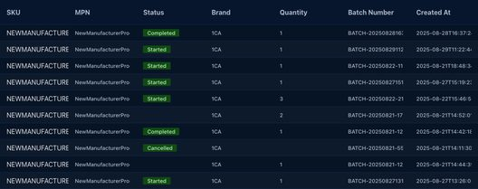

654-table-name-equipment-id-manufacturer-category-added-on-cable-machine-machin1-1ca-machi — Name Equipment ID Manufacturer Category Added On Cable Machine Machin1 1CA Machi
Kind: table
First seen: Operations Hub / Settings (`/operations/equipments`)
Size: 1160×100 at (268, 215)
Tag/role: table role=table
Classes: p-datatable-table
Selector: div:nth-of-type(1) > div:nth-of-type(1) > div:nth-of-type(1) > table:nth-of-type(1)

658-table-code-name-users-warehouse-address-245-choice-parts-amarender-1channeladmin-com-a — Code Name Users Warehouse Address 245 Choice Parts amarender@1channeladmin.com,a
Kind: table
First seen: WMS / 3PL Clients (`/wms/3plclients`)
Size: 1096×1140 at (304, 239)
Tag/role: table role=table
Classes: p-datatable-table
Selector: div:nth-of-type(1) > div:nth-of-type(1) > div:nth-of-type(1) > table:nth-of-type(1)
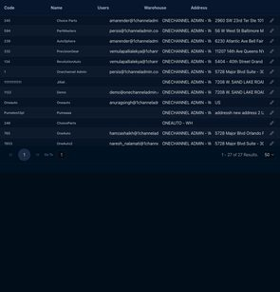

668-table-date-invoice-no-3pl-client-amount-status-invoice-actions-may-2-2025-6814d4e90b — Date Invoice No. 3PL Client Amount Status Invoice Actions May 2, 2025 6814d4e90b
Kind: table
First seen: WMS / Manage 3pl Billing/Addons (`/wms/manage3pladdons`)
Size: 1112×184 at (296, 221)
Tag/role: table role=table
Classes: p-datatable-table
Selector: div:nth-of-type(1) > div:nth-of-type(1) > div:nth-of-type(1) > table:nth-of-type(1)
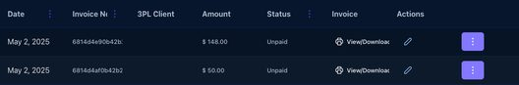

674-table-sku-mpn-brand-title-retail-price-available-qty-website-intake-query-only-hcpc-on — SKU MPN Brand Title Retail Price Available QTY Website Intake query only HCPC On
Kind: table
First seen: WMS / Non-Inventory Items (`/wms/non_inventory_item?warehouse=all`)
Size: 2608×220 at (297, 213)
Tag/role: table role=table
Classes: p-datatable-table
Selector: div:nth-of-type(1) > div:nth-of-type(1) > div:nth-of-type(1) > table:nth-of-type(1)

678-table-sku-code-part-number-wh1-on-hand-qty-wh2-on-hand-qty-wh-ca-on-hand-qty-wh3-fl — SKU Code Part Number WH1 On Hand QTY. WH2 On Hand QTY. WH_CA On Hand QTY. WH3-FL
Kind: table
First seen: WMS / Order Replenishment (`/wms/order_replenishment?isWms=true`)
Size: 8768×2060 at (296, 291)
Tag/role: table role=table
Classes: p-datatable-table
Selector: div:nth-of-type(1) > div:nth-of-type(1) > div:nth-of-type(1) > table:nth-of-type(1)
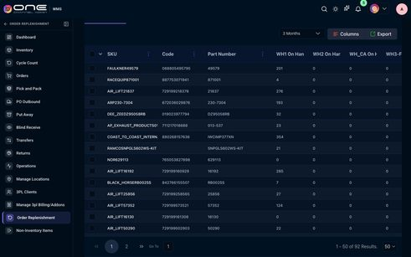

682-table-order-id-sku-action-order-date-last-updated-pack-location-pick-location-assigned — Order ID SKU Action Order Date Last Updated Pack Location Pick Location Assigned
Kind: table
First seen: WMS / Orders (`/wms/orders?warehouse=wh1`)
Size: 3744×2655 at (296, 204)
Tag/role: table role=table
Classes: p-datatable-table
Selector: div:nth-of-type(1) > div:nth-of-type(1) > div:nth-of-type(1) > table:nth-of-type(1)
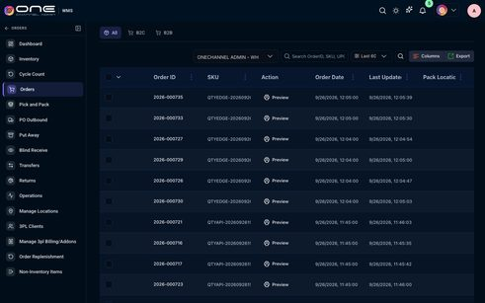

684-table-order-id-order-date-sku-wms-status-pack-location-pick-location-assigned-to-pack — Order ID Order Date SKU WMS Status Pack Location Pick Location Assigned to Pack
Kind: table
First seen: WMS / Pick and Pack (`/wms/pickpack`)
Size: 4192×2318 at (296, 204)
Tag/role: table role=table
Classes: p-datatable-table
Selector: div:nth-of-type(1) > div:nth-of-type(1) > div:nth-of-type(1) > table:nth-of-type(1)

688-table-order-id-sku-action-quality-check-order-date-last-updated-putaway-location-assig — Order ID SKU Action Quality Check Order Date Last Updated PutAway Location Assig
Kind: table
First seen: WMS / PO Outbound (`/wms/purchaseorders?warehouse=wh1`)
Size: 3696×122 at (296, 204)
Tag/role: table role=table
Classes: p-datatable-table
Selector: div:nth-of-type(1) > div:nth-of-type(1) > div:nth-of-type(1) > table:nth-of-type(1)
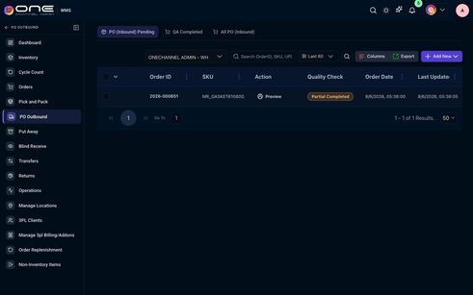

691-table-order-id-order-date-sku-wms-status-putaway-location-assigned-to-putaway-email-lp — Order ID Order Date SKU WMS Status PutAway Location Assigned to Putaway Email LP
Kind: table
First seen: WMS / Put Away (`/wms/putaway`)
Size: 3808×198 at (296, 204)
Tag/role: table role=table
Classes: p-datatable-table
Selector: div:nth-of-type(1) > div:nth-of-type(1) > div:nth-of-type(1) > table:nth-of-type(1)
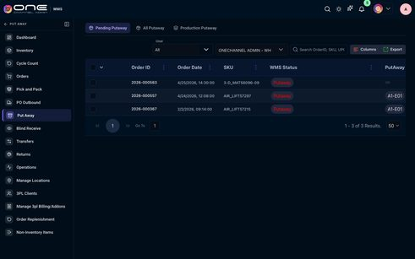

tabs

267-tabs-invoices-quotes-date-invoice-no-organization-amount-status-invoice-actions-paym — Invoices Quotes Date Invoice No. Organization Amount Status Invoice Actions Paym
Kind: tabs
First seen: Admin / Addons & Invoices (`/settings/billing-invoices`)
Size: 1080×265 at (312, 155)
Tag/role: div
Classes: custom-tabs-style.custom-tabs-format
Selector: div:nth-of-type(1) > div:nth-of-type(1) > div:nth-of-type(2) > div:nth-of-type(1)
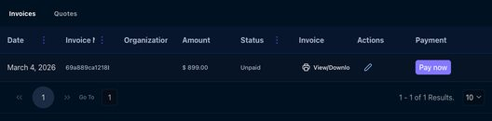

268-tabs-invoices-quotes — Invoices Quotes
Kind: tabs
First seen: Admin / Addons & Invoices (`/settings/billing-invoices`)
Size: 1080×60 at (312, 155)
Tag/role: ul role=tablist
Classes: p-tabview-nav
Selector: div:nth-of-type(1) > div:nth-of-type(1) > div:nth-of-type(1) > ul:nth-of-type(1)

284-tabs-marketplaces-3pl-payment-gateway-digital-marketing-pos-accounting-carriers-ai-b2 — Marketplaces 3PL Payment Gateway Digital Marketing POS Accounting Carriers AI B2
Kind: tabs
First seen: Admin / Channel Integration (`/settings/channel-settings`)
Size: 1112×764 at (296, 155)
Tag/role: div
Classes: custom-tabs-style.custom-tabs-format
Selector: div:nth-of-type(1) > div:nth-of-type(1) > div:nth-of-type(2) > div:nth-of-type(1)
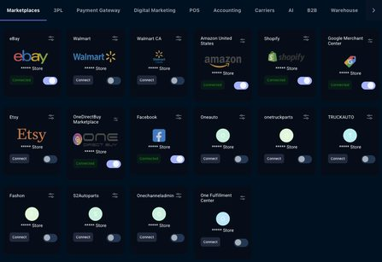

285-tabs-marketplaces-3pl-payment-gateway-digital-marketing-pos-accounting-carriers-ai-b2 — Marketplaces 3PL Payment Gateway Digital Marketing POS Accounting Carriers AI B2
Kind: tabs
First seen: Admin / Channel Integration (`/settings/channel-settings`)
Size: 1112×60 at (296, 155)
Tag/role: ul role=tablist
Classes: p-tabview-nav
Selector: div:nth-of-type(1) > div:nth-of-type(1) > div:nth-of-type(1) > ul:nth-of-type(1)

302-tabs-manage-billing-addons-packages — Manage Billing/Addons/Packages
Kind: tabs
First seen: Admin / Manage Billing & AddOns (`/settings/managebillings-addons`)
Size: 1080×60 at (312, 155)
Tag/role: ul role=tablist
Classes: p-tabview-nav
Selector: div:nth-of-type(1) > div:nth-of-type(1) > div:nth-of-type(1) > ul:nth-of-type(1)

303-tabs-invoices-recurring-series-organizations-quotes-organizations-all-transactions-ad — Invoices Recurring Series Organizations Quotes Organizations All Transactions Ad
Kind: tabs
First seen: Admin / Manage Billing & AddOns (`/settings/managebillings-addons`)
Size: 1080×60 at (312, 231)
Tag/role: ul role=tablist
Classes: p-tabview-nav
Selector: div:nth-of-type(1) > div:nth-of-type(1) > div:nth-of-type(1) > ul:nth-of-type(1)

309-tabs-shopify-no-data-found-go-to-0-0-of-0-results-50-50 — Shopify No Data Found! Go To 0 - 0 of 0 Results. 50 50
Kind: tabs
First seen: Admin / Marketplace Plans (`/settings/marketplace-plans`)
Size: 1080×186 at (312, 155)
Tag/role: div
Classes: custom-tabs-style.custom-tabs-format
Selector: div:nth-of-type(1) > div:nth-of-type(1) > div:nth-of-type(2) > div:nth-of-type(1)
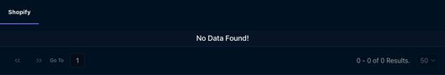

310-tabs-shopify — Shopify
Kind: tabs
First seen: Admin / Marketplace Plans (`/settings/marketplace-plans`)
Size: 1080×60 at (312, 155)
Tag/role: ul role=tablist
Classes: p-tabview-nav
Selector: div:nth-of-type(1) > div:nth-of-type(1) > div:nth-of-type(1) > ul:nth-of-type(1)

335-tabs-users-roles-organizations — USERS ROLES ORGANIZATIONS
Kind: tabs
First seen: Admin / User Permissions (`/settings/user-permission`)
Size: 1080×60 at (312, 155)
Tag/role: ul role=tablist
Classes: p-tabview-nav
Selector: div:nth-of-type(1) > div:nth-of-type(1) > div:nth-of-type(1) > ul:nth-of-type(1)

363-tabs-sales-overview-b2b-b2c-marketplace-overview-payments-financials-products-o — Sales Overview (B2B & B2C) Marketplace Overview Payments & Financials Products O
Kind: tabs
First seen: Analytics & Reports / Dashboard (`/analytics/analytics-dashboard`)
Size: 1112×60 at (296, 155)
Tag/role: ul role=tablist
Classes: p-tabview-nav
Selector: div:nth-of-type(1) > div:nth-of-type(1) > div:nth-of-type(1) > ul:nth-of-type(1)

409-tabs-active-listings-columns — Active Listings Columns
Kind: tabs
First seen: Channel / B2B (`/channel/b2b-products`)
Size: 1128×121 at (284, 139)
Tag/role: div
Classes: custom-tabs-style
Selector: div:nth-of-type(1) > div:nth-of-type(1) > div:nth-of-type(2) > div:nth-of-type(1)


410-tabs-active-listings — Active Listings
Kind: tabs
First seen: Channel / B2B (`/channel/b2b-products`)
Size: 1128×60 at (284, 139)
Tag/role: ul role=tablist
Classes: p-tabview-nav
Selector: div:nth-of-type(1) > div:nth-of-type(1) > div:nth-of-type(1) > ul:nth-of-type(1)

422-tabs-active-listings-sync-raju-sudhakar-raju-sudhakar-all-all-columns-id-name-retaile — Active Listings Sync Raju Sudhakar Raju Sudhakar All All Columns ID Name Retaile
Kind: tabs
First seen: Channel / Facebook (`/channel/facebook-products`)
Size: 1112×286 at (296, 155)
Tag/role: div
Classes: custom-tabs-style
Selector: div:nth-of-type(1) > div:nth-of-type(1) > div:nth-of-type(2) > div:nth-of-type(1)
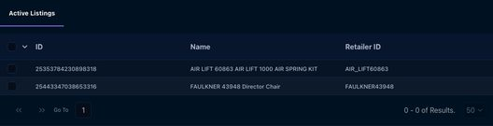

428-tabs-active-listings-sync-5365424557-5365424557-columns-no-data-found-1-1-100-100 — Active Listings Sync 5365424557 5365424557 Columns No Data Found! 1 - 1 100 100
Kind: tabs
First seen: Channel / Google Merchant (`/channel/google-merchant-products`)
Size: 1112×246 at (296, 155)
Tag/role: div
Classes: custom-tabs-style
Selector: div:nth-of-type(1) > div:nth-of-type(1) > div:nth-of-type(2) > div:nth-of-type(1)
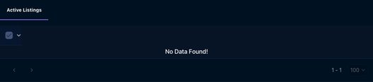

440-tabs-active-listings-sync-all-all-columns — Active Listings Sync All All Columns
Kind: tabs
First seen: Channel / Square (`/channel/square-products`)
Size: 1112×76 at (296, 155)
Tag/role: div
Classes: custom-tabs-style
Selector: div:nth-of-type(1) > div:nth-of-type(1) > div:nth-of-type(2) > div:nth-of-type(1)

445-tabs-companies-contacts — Companies Contacts
Kind: tabs
First seen: CRM / B2B Accounts (`/crm/company`)
Size: 1112×45 at (296, 79)
Tag/role: div role=tablist
Classes: tw-flex.tw-flex-wrap.tw-gap-2.tw-mb-3.tw-pb-2
Selector: div:nth-of-type(1) > div:nth-of-type(1) > div:nth-of-type(1) > div:nth-of-type(1)

448-tabs-d2c — D2C
Kind: tabs
First seen: CRM / D2C (`/crm/ContactManage`)
Size: 1112×45 at (296, 79)
Tag/role: div role=tablist
Classes: tw-flex.tw-flex-wrap.tw-gap-2.tw-mb-3.tw-pb-2
Selector: div:nth-of-type(1) > div:nth-of-type(1) > div:nth-of-type(1) > div:nth-of-type(1)

452-tabs-leads-unsubscribed-users — Leads UnSubscribed Users
Kind: tabs
First seen: CRM / Leads (`/crm/leads`)
Size: 1112×45 at (296, 79)
Tag/role: div role=tablist
Classes: tw-flex.tw-flex-wrap.tw-gap-2.tw-mb-3.tw-pb-2
Selector: div:nth-of-type(1) > div:nth-of-type(1) > div:nth-of-type(1) > div:nth-of-type(1)

453-tabs-overview-trends-team-performance-product-performance — Overview & Trends Team Performance Product Performance
Kind: tabs
First seen: CRM / Sales Performance (`/crm/sales-performance`)
Size: 1108×45 at (296, 79)
Tag/role: div role=tablist
Classes: tw-flex.tw-flex-wrap.tw-gap-2.tw-mb-3.tw-pb-2
Selector: div:nth-of-type(3) > div:nth-of-type(1) > div:nth-of-type(1) > div:nth-of-type(1)

456-tabs-vendors-suppliers-contacts — Vendors / Suppliers Contacts
Kind: tabs
First seen: CRM / Suppliers B2B (`/crm/contacts-customers`)
Size: 1112×45 at (296, 79)
Tag/role: div role=tablist
Classes: tw-flex.tw-flex-wrap.tw-gap-2.tw-mb-3.tw-pb-2
Selector: div:nth-of-type(1) > div:nth-of-type(1) > div:nth-of-type(1) > div:nth-of-type(1)

458-tabs-all-processing-overdue-upcoming-completed — All Processing Overdue Upcoming Completed
Kind: tabs
First seen: CRM / Tasks (`/crm/tasks`)
Size: 1112×45 at (296, 79)
Tag/role: div role=tablist
Classes: tw-flex.tw-flex-wrap.tw-gap-2.tw-mb-3.tw-pb-2
Selector: div:nth-of-type(3) > div:nth-of-type(1) > div:nth-of-type(1) > div:nth-of-type(1)

465-tabs-websites-columns-export-link-new-website-name-link-email-catalog-name-oneauto-on — Websites Columns Export Link New Website Name Link Email Catalog Name Oneauto On
Kind: tabs
First seen: CRM / Websites (`/b2b/b2bwebsites`)
Size: 1112×546 at (296, 153)
Tag/role: div
Classes: custom-tabs-style
Selector: div:nth-of-type(1) > div:nth-of-type(1) > div:nth-of-type(2) > div:nth-of-type(1)
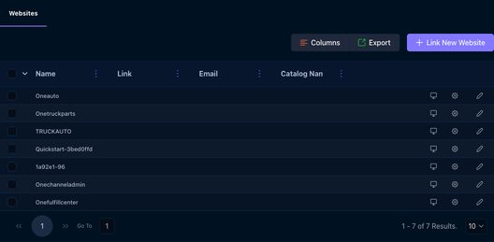

466-tabs-websites — Websites
Kind: tabs
First seen: CRM / Websites (`/b2b/b2bwebsites`)
Size: 1112×60 at (296, 153)
Tag/role: ul role=tablist
Classes: p-tabview-nav
Selector: div:nth-of-type(1) > div:nth-of-type(1) > div:nth-of-type(1) > ul:nth-of-type(1)

467-tabs-orders-workorder-calendar-dashboard-settings — Orders Workorder Calendar Dashboard Settings
Kind: tabs
First seen: CRM / Work Orders (`/crm/workorders`)
Size: 1108×45 at (296, 79)
Tag/role: div role=tablist
Classes: tw-flex.tw-flex-wrap.tw-gap-2.tw-mb-3.tw-pb-2
Selector: div:nth-of-type(3) > div:nth-of-type(1) > div:nth-of-type(1) > div:nth-of-type(1)

524-tabs-general-ftp-setup-invoice-logo-save-logo-company-id-store-contact-person-currenc — General FTP Setup Invoice Logo Save Logo Company ID Store Contact Person Currenc
Kind: tabs
First seen: Fulfillment / Default Shipping Address (`/settings/general`)
Size: 1160×968 at (268, 139)
Tag/role: div
Classes: custom-tabs-style
Selector: div:nth-of-type(1) > div:nth-of-type(1) > div:nth-of-type(2) > div:nth-of-type(1)
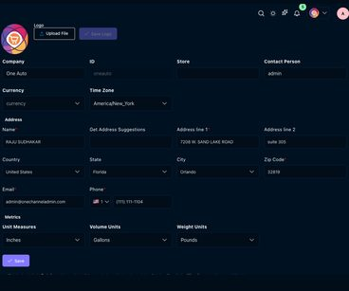

525-tabs-general-ftp-setup-invoice — General FTP Setup Invoice
Kind: tabs
First seen: Fulfillment / Default Shipping Address (`/settings/general`)
Size: 1160×60 at (268, 139)
Tag/role: ul role=tablist
Classes: p-tabview-nav
Selector: div:nth-of-type(1) > div:nth-of-type(1) > div:nth-of-type(1) > ul:nth-of-type(1)

594-tabs-invoices-columns-order-id-order-date-print-order-total-source-payment-status-sku — Invoices Columns Order ID Order Date Print Order Total Source Payment Status SKU
Kind: tabs
First seen: Fulfillment / Invoices (`/settings/accounting-invoices`)
Size: 1160×832 at (268, 139)
Tag/role: div
Classes: custom-tabs-style
Selector: div:nth-of-type(1) > div:nth-of-type(2) > div:nth-of-type(1) > div:nth-of-type(1)
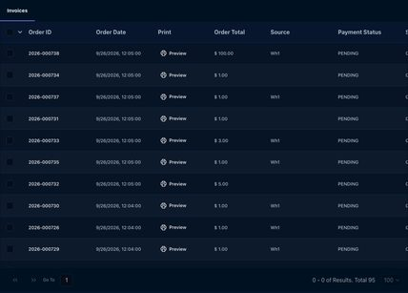

595-tabs-invoices — Invoices
Kind: tabs
First seen: Fulfillment / Invoices (`/settings/accounting-invoices`)
Size: 1160×60 at (268, 139)
Tag/role: ul role=tablist
Classes: p-tabview-nav
Selector: div:nth-of-type(1) > div:nth-of-type(1) > div:nth-of-type(1) > ul:nth-of-type(1)

613-tabs-taxes-columns-export-state-zipcode-tax-region-name-estimated-combined-rate-state — Taxes Columns Export State ZipCode Tax Region Name Estimated Combined Rate State
Kind: tabs
First seen: Fulfillment / Tax Rates (`/fulfill/settings/taxRates`)
Size: 1160×818 at (268, 139)
Tag/role: div
Classes: custom-tabs-style
Selector: div:nth-of-type(1) > div:nth-of-type(1) > div:nth-of-type(2) > div:nth-of-type(1)
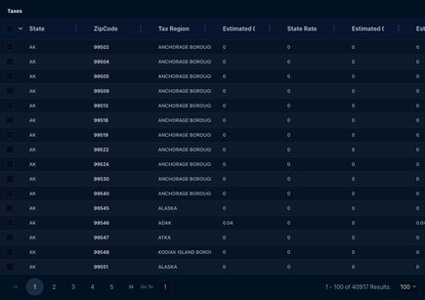

614-tabs-taxes — Taxes
Kind: tabs
First seen: Fulfillment / Tax Rates (`/fulfill/settings/taxRates`)
Size: 1160×60 at (268, 139)
Tag/role: ul role=tablist
Classes: p-tabview-nav
Selector: div:nth-of-type(1) > div:nth-of-type(1) > div:nth-of-type(1) > ul:nth-of-type(1)

621-tabs-templates — Templates
Kind: tabs
First seen: Map Price / Settings (`/map-price/settings`)
Size: 1160×60 at (268, 139)
Tag/role: ul role=tablist
Classes: p-tabview-nav
Selector: div:nth-of-type(2) > div:nth-of-type(1) > div:nth-of-type(1) > ul:nth-of-type(1)

629-tabs-all-discount-columns-export-add-new-ignore-end-date-name-method-campaign-type-ap — All Discount Columns Export Add New Ignore End Date Name Method Campaign Type Ap
Kind: tabs
First seen: Marketing / Discounts (`/marketing/campaigns`)
Size: 1160×753 at (268, 97)
Tag/role: div
Classes: custom-tabs-style
Selector: div:nth-of-type(1) > div:nth-of-type(1) > div:nth-of-type(3) > div:nth-of-type(1)
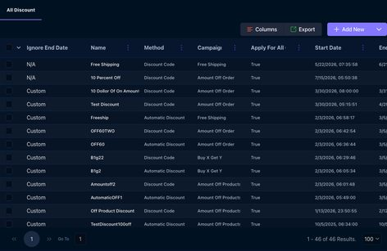

630-tabs-all-discount — All Discount
Kind: tabs
First seen: Marketing / Discounts (`/marketing/campaigns`)
Size: 1160×60 at (268, 97)
Tag/role: ul role=tablist
Classes: p-tabview-nav
Selector: div:nth-of-type(1) > div:nth-of-type(1) > div:nth-of-type(1) > ul:nth-of-type(1)

649-tabs-all-started-cancelled-completed-scheduled-pending-production — All Started Cancelled Completed Scheduled Pending Production
Kind: tabs
First seen: Operations Hub / Production (`/operations/production`)
Size: 1160×60 at (268, 139)
Tag/role: ul role=tablist
Classes: p-tabview-nav
Selector: div:nth-of-type(2) > div:nth-of-type(1) > div:nth-of-type(1) > ul:nth-of-type(1)

655-tabs-equipments-stages — Equipments Stages
Kind: tabs
First seen: Operations Hub / Settings (`/operations/equipments`)
Size: 1160×60 at (268, 139)
Tag/role: ul role=tablist
Classes: p-tabview-nav
Selector: div:nth-of-type(1) > div:nth-of-type(1) > div:nth-of-type(1) > ul:nth-of-type(1)

659-tabs-3pl-clients — 3PL Clients
Kind: tabs
First seen: WMS / 3PL Clients (`/wms/3plclients`)
Size: 1112×60 at (296, 155)
Tag/role: ul role=tablist
Classes: p-tabview-nav
Selector: div:nth-of-type(1) > div:nth-of-type(1) > div:nth-of-type(1) > ul:nth-of-type(1)

665-tabs-all — All
Kind: tabs
First seen: WMS / Inventory (`/wms/inventory?warehouse=all`)
Size: 1112×45 at (296, 79)
Tag/role: div role=tablist
Classes: tw-flex.tw-flex-wrap.tw-gap-2.tw-mb-3.tw-pb-2
Selector: div:nth-of-type(1) > div:nth-of-type(1) > div:nth-of-type(1) > div:nth-of-type(1)

669-tabs-invoices-recurring-series-3pl-clients-quotes-3pl-clients-all-transactions-addons — Invoices Recurring Series 3PL Clients Quotes 3PL Clients All Transactions Addons
Kind: tabs
First seen: WMS / Manage 3pl Billing/Addons (`/wms/manage3pladdons`)
Size: 1112×60 at (296, 155)
Tag/role: ul role=tablist
Classes: p-tabview-nav
Selector: div:nth-of-type(1) > div:nth-of-type(1) > div:nth-of-type(1) > ul:nth-of-type(1)

670-tabs-general-locations-carts-bins-pack-locations-shipping-docks-refurbished-locations — General Locations Carts Bins Pack Locations Shipping Docks Refurbished Locations
Kind: tabs
First seen: WMS / Manage Locations (`/wms/setup`)
Size: 1112×45 at (296, 151)
Tag/role: div role=tablist
Classes: tw-flex.tw-flex-wrap.tw-gap-2.tw-mb-3.tw-pb-2
Selector: div:nth-of-type(3) > div:nth-of-type(1) > div:nth-of-type(3) > div:nth-of-type(1)

679-tabs-replenishment-suppliers-3-months-3-months-columns-export-sku-code-part-number-wh — Replenishment Suppliers 3 Months 3 Months Columns Export SKU Code Part Number WH
Kind: tabs
First seen: WMS / Order Replenishment (`/wms/order_replenishment?isWms=true`)
Size: 1112×876 at (296, 155)
Tag/role: div
Classes: custom-tabs-style
Selector: div:nth-of-type(1) > div:nth-of-type(1) > div:nth-of-type(2) > div:nth-of-type(1)
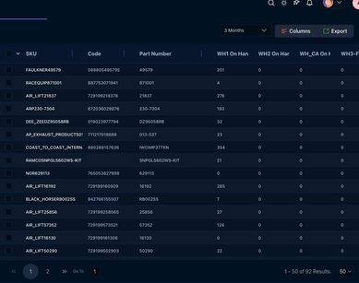

680-tabs-replenishment-suppliers — Replenishment Suppliers
Kind: tabs
First seen: WMS / Order Replenishment (`/wms/order_replenishment?isWms=true`)
Size: 1112×60 at (296, 155)
Tag/role: ul role=tablist
Classes: p-tabview-nav
Selector: div:nth-of-type(1) > div:nth-of-type(1) > div:nth-of-type(1) > ul:nth-of-type(1)

683-tabs-all-b2c-b2b — All B2C B2B
Kind: tabs
First seen: WMS / Orders (`/wms/orders?warehouse=wh1`)
Size: 1112×45 at (296, 79)
Tag/role: div role=tablist
Classes: tw-flex.tw-flex-wrap.tw-gap-2.tw-mb-3.tw-pb-2
Selector: div:nth-of-type(3) > div:nth-of-type(1) > div:nth-of-type(1) > div:nth-of-type(1)

685-tabs-all-pick-pack-wave-pick — All Pick Pack Wave Pick
Kind: tabs
First seen: WMS / Pick and Pack (`/wms/pickpack`)
Size: 1112×45 at (296, 79)
Tag/role: div role=tablist
Classes: tw-flex.tw-flex-wrap.tw-gap-2.tw-mb-3.tw-pb-2
Selector: div:nth-of-type(3) > div:nth-of-type(1) > div:nth-of-type(1) > div:nth-of-type(1)

689-tabs-po-inbound-pending-qa-completed-all-po-inbound — PO (Inbound) Pending QA Completed All PO (Inbound)
Kind: tabs
First seen: WMS / PO Outbound (`/wms/purchaseorders?warehouse=wh1`)
Size: 1112×45 at (296, 79)
Tag/role: div role=tablist
Classes: tw-flex.tw-flex-wrap.tw-gap-2.tw-mb-3.tw-pb-2
Selector: div:nth-of-type(3) > div:nth-of-type(1) > div:nth-of-type(1) > div:nth-of-type(1)

692-tabs-pending-putaway-all-putaway-production-putaway — Pending Putaway All Putaway Production Putaway
Kind: tabs
First seen: WMS / Put Away (`/wms/putaway`)
Size: 1112×45 at (296, 79)
Tag/role: div role=tablist
Classes: tw-flex.tw-flex-wrap.tw-gap-2.tw-mb-3.tw-pb-2
Selector: div:nth-of-type(3) > div:nth-of-type(1) > div:nth-of-type(1) > div:nth-of-type(1)

693-tabs-pending-b2c-b2b-blind-returns-completed-returns-all-returns — Pending B2C B2B Blind Returns Completed Returns All Returns
Kind: tabs
First seen: WMS / Returns (`/wms/returns`)
Size: 1112×45 at (296, 79)
Tag/role: div role=tablist
Classes: tw-flex.tw-flex-wrap.tw-gap-2.tw-mb-3.tw-pb-2
Selector: div:nth-of-type(3) > div:nth-of-type(1) > div:nth-of-type(1) > div:nth-of-type(1)

694-tabs-internal-transfer-external-transfer — Internal Transfer External Transfer
Kind: tabs
First seen: WMS / Transfers (`/wms/transfers`)
Size: 1112×45 at (296, 79)
Tag/role: div role=tablist
Classes: tw-flex.tw-flex-wrap.tw-gap-2.tw-mb-3.tw-pb-2
Selector: div:nth-of-type(3) > div:nth-of-type(1) > div:nth-of-type(1) > div:nth-of-type(1)

toggle

102-toggle-date-type-number-memo-payment-method-ref-no-actions-9-15-2026-payment-rcp-2026 — DATE TYPE NUMBER MEMO PAYMENT METHOD REF NO. ACTIONS 9/15/2026 Payment RCP-2026-
Kind: toggle
First seen: Accounting / Customer Payments (`/accounting/customer-payments`)
Size: 1112×663 at (296, 236)
Tag/role: div
Classes: tw-flex-1.tw-overflow-auto
Selector: div:nth-of-type(3) > div:nth-of-type(1) > div:nth-of-type(1) > div:nth-of-type(2)
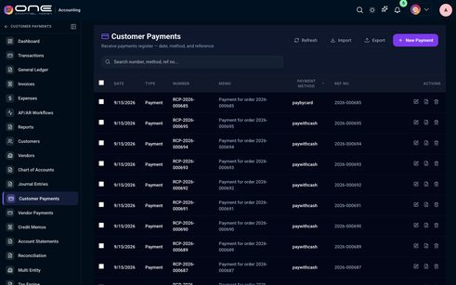

131-toggle-expense-details-vendor-category-employee-dept-amount-status-actions — EXPENSE DETAILS VENDOR / CATEGORY EMPLOYEE / DEPT AMOUNT STATUS ACTIONS
Kind: toggle
First seen: Accounting / Expenses (`/accounting/expenses`)
Size: 998×16 at (353, 466)
Tag/role: div
Classes: tw-flex.tw-items-center.tw-gap-4.tw-min-w-[58rem]
Selector: div:nth-of-type(2) > div:nth-of-type(3) > div:nth-of-type(1) > div:nth-of-type(1)

132-toggle-exp-0eaa62-sep-26-2026-current-user-100-usd-submitted — EXP-0EAA62 Sep 26, 2026 — Current User $100 USD submitted
Kind: toggle
First seen: Accounting / Expenses (`/accounting/expenses`)
Size: 1046×80 at (329, 499)
Tag/role: div
Classes: tw-px-6.tw-py-4.tw-flex.tw-items-center.tw-gap-4.tw-min-w-[58rem]
Selector: div:nth-of-type(3) > div:nth-of-type(2) > div:nth-of-type(1) > div:nth-of-type(1)

133-toggle-exp-16ba34-sep-26-2026-current-user-1-usd-submitted — EXP-16BA34 Sep 26, 2026 — Current User $1 USD submitted
Kind: toggle
First seen: Accounting / Expenses (`/accounting/expenses`)
Size: 1046×80 at (329, 580)
Tag/role: div
Classes: tw-px-6.tw-py-4.tw-flex.tw-items-center.tw-gap-4.tw-min-w-[58rem]
Selector: div:nth-of-type(3) > div:nth-of-type(2) > div:nth-of-type(2) > div:nth-of-type(1)

134-toggle-exp-a5bf1a-aug-24-2026-uber-current-user-6-33-usd-draft — EXP-A5BF1A Aug 24, 2026 Uber Current User $6.33 USD draft
Kind: toggle
First seen: Accounting / Expenses (`/accounting/expenses`)
Size: 1046×80 at (329, 661)
Tag/role: div
Classes: tw-px-6.tw-py-4.tw-flex.tw-items-center.tw-gap-4.tw-min-w-[58rem]
Selector: div:nth-of-type(3) > div:nth-of-type(2) > div:nth-of-type(3) > div:nth-of-type(1)

135-toggle-exp-926fd3-aug-11-2026-uber-current-user-5-4-usd-draft — EXP-926FD3 Aug 11, 2026 Uber Current User $5.4 USD draft
Kind: toggle
First seen: Accounting / Expenses (`/accounting/expenses`)
Size: 1046×80 at (329, 742)
Tag/role: div
Classes: tw-px-6.tw-py-4.tw-flex.tw-items-center.tw-gap-4.tw-min-w-[58rem]
Selector: div:nth-of-type(3) > div:nth-of-type(2) > div:nth-of-type(4) > div:nth-of-type(1)

136-toggle-exp-926fd2-aug-11-2026-credit-card-3333-payment-current-user-25-usd-draft — EXP-926FD2 Aug 11, 2026 CREDIT CARD 3333 PAYMENT *// Current User $25 USD draft
Kind: toggle
First seen: Accounting / Expenses (`/accounting/expenses`)
Size: 1046×90 at (329, 823)
Tag/role: div
Classes: tw-px-6.tw-py-4.tw-flex.tw-items-center.tw-gap-4.tw-min-w-[58rem]
Selector: div:nth-of-type(3) > div:nth-of-type(2) > div:nth-of-type(5) > div:nth-of-type(1)

163-toggle-invoice-order-customer-type-order-type-amount-status-payment-actions — INVOICE / ORDER # CUSTOMER / TYPE ORDER TYPE AMOUNT STATUS PAYMENT ACTIONS
Kind: toggle
First seen: Accounting / Invoices (`/accounting/invoices`)
Size: 998×32 at (353, 341)
Tag/role: div
Classes: tw-flex.tw-items-center.tw-gap-4
Selector: div:nth-of-type(2) > div:nth-of-type(2) > div:nth-of-type(1) > div:nth-of-type(1)

164-toggle-inv-2026-000735-2026-000735-qty-edge-test-direct-customer-b2c-1-usd-sent-not-se — INV-2026-000735 2026-000735 Qty Edge Test Direct Customer B2C $1 USD sent Not se
Kind: toggle
First seen: Accounting / Invoices (`/accounting/invoices`)
Size: 1046×90 at (329, 390)
Tag/role: div
Classes: tw-px-6.tw-py-4.tw-flex.tw-items-center.tw-gap-4
Selector: div:nth-of-type(2) > div:nth-of-type(2) > div:nth-of-type(1) > div:nth-of-type(1)

240-toggle-date-transaction-type-customer-vendor-reference-source-account-money-in-money — DATE TRANSACTION # TYPE CUSTOMER/VENDOR REFERENCE SOURCE ACCOUNT MONEY IN MONEY
Kind: toggle
First seen: Accounting / Transactions (`/accounting/transactions`)
Size: 1112×731 at (296, 248)
Tag/role: div
Classes: tw-flex-1.tw-overflow-auto
Selector: div:nth-of-type(3) > div:nth-of-type(1) > div:nth-of-type(1) > div:nth-of-type(2)

