TRAINING & EDUCATION

Microsoft Office Specialist MICROSOFT OFFICE 2010

Microsoft Certification 2008

Bachelor of Arts BUSINESS ADMINISTRATION

University of Illinois at Springfield 1997 – 2001

Associate’s Degree OFFICE ADMINISTRATION

Lincoln Land Community College 1995 – 1997

Executive Assistant II CHICAGO, IL

*Rev Development* Group*, June 2007 – Present*

Office Manager SPRINGFIELD, IL

*Carter Taylor Investments, October 2001 – June 2007*

Administrative Assistant SPRINGFIELD, IL

*Icon Office Solutions, May 1997 – October 2001*

ADDRESS 415 Bishop Street #303

CELL 312.555.6840

EMAIL [addie.patel@gmail.com](mailto:addie.patel@gmail.com)

April 13, 2016

Ms. Ella Jackson  
Human Resources Manager  
1234 Modern Street Drive  
Trenton, NJ 08601

Dear Ms. Jackson:

I am exceedingly interested in the Junior Marketing position with Top Tier Telephones, and I believe that my education and employment background are well suited for the position. While working toward my degree, I was employed as a marketing assistant with a local grocery company. In addition to assisting the company with their summer promotions, I was able to help the Marketing Specialist develop and carry through ideas for the company’s next commercial. I would like to use the knowledge I gained at Fresh Foods to help your company achieve its marketing goals, including reaching a broader audience across country. I will complete my degree in marketing in May and will be available for employment in early June. Enclosed is a copy of my resume, which more fully details my qualifications for the position. Within the next week, I will contact you to confirm that you received my email and resume and I’ll be happy to answer any questions that you may have. Thank you for your consideration.Sincerely,   
Adrienne Patel

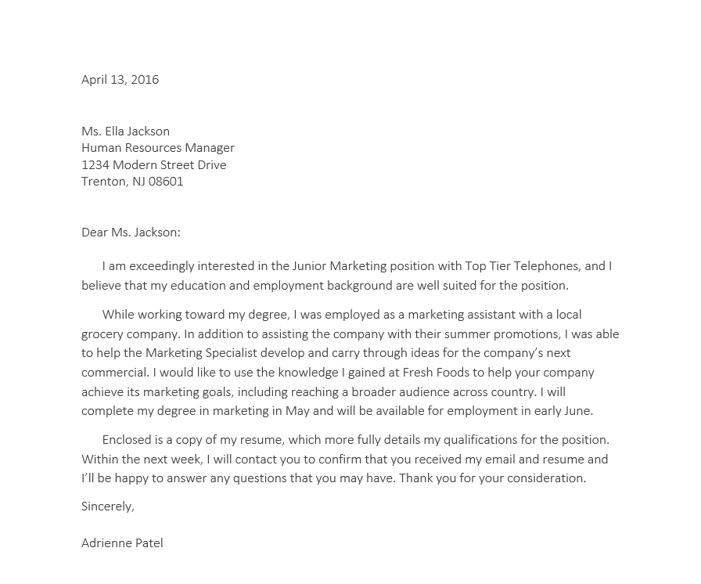

**New Members**

Carolyn Serpinski

Social Media Marketing

Jackson Hull

Fundraising

Primarily Europe

Pablo Moreno

Co-Treasurer

**Treasurer’s Report**

1. Fundraising Budget
   1. Last month’s spending
      1. Amount available this month
2. Outreach Budget
   1. Last month’s spending
   2. Future months
3. Social Media Campaign Budget
   1. Beginning Balance

**Communications Report**

1. Website overhaul
2. New marketing materials
3. New PR hires
4. Intern program

