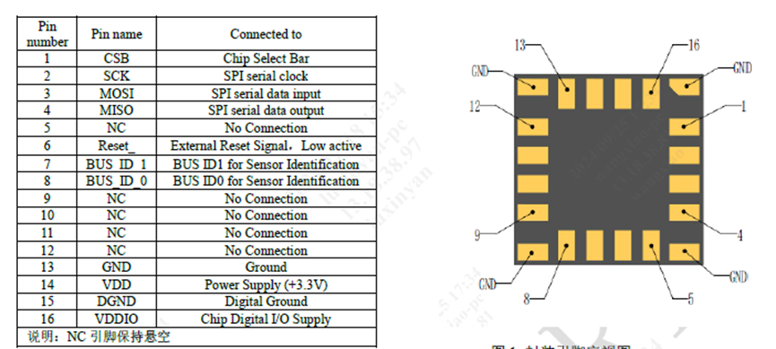

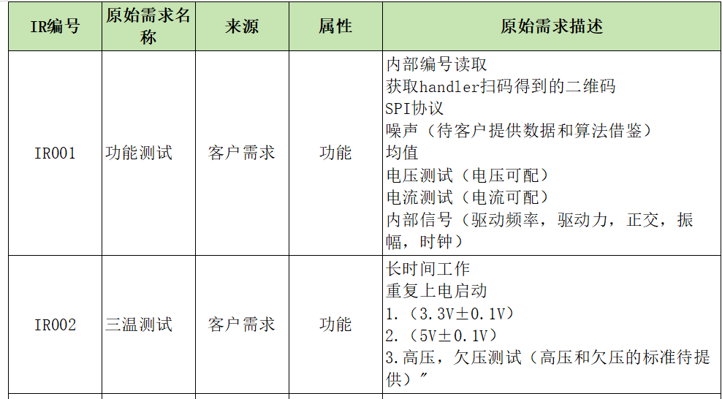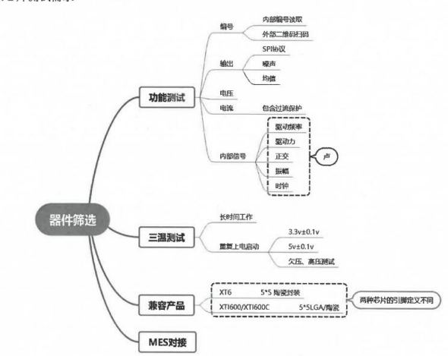

1. 驱动职责：SPI模式选择、寄存器数据读取、芯片激活
2. 通信方式是JSON还是二进制

# 1、SPI模式选择

|  |  |  |  |
| --- | --- | --- | --- |
| spi_sel | 35d | 14 | 0:normal spi(默认)  1:safe spi |

# **2、Normal-SPI**

## 2-1、寄存器系统命令说明

表2 SPI寄存器文件中的系统命令说明

|  |  |  |
| --- | --- | --- |
| 名称 | 命令 | 说明 |
| RDRF | x"01" | 读系统寄存器文件 |
| WRRF | x"02" | 写系统寄存器文件 |

表4 SPI命令读写系统寄存器文件示例

|  |  |  |  |
| --- | --- | --- | --- |
| 命令 | SPI帧 | 长度 | 说明 |
| WRRF | 0xFC 80 00 00 02 | 56 | 向系统寄存器00（00）写（02）数据（80 00） |
| RDRF | 0xFE 00 01  0xBC 00 00 | 24 | 读取（01）系统寄存器（00）的数据 |

## **2-2、SPI数据寄存器**

使用SPI命令读取SPI寄存器文件举例以及MISO和MOSI的数据流如下表和下图所示。

表3 SPI命令读取SPI数据寄存器文件示例

|  |  |  |  |  |  |
| --- | --- | --- | --- | --- | --- |
| 命令 | | SPI帧 |  | 长度 | 说明 |
| RDACCX | | 0xA0 00 00 00 |  | 32 | 读取X轴陀螺数据 |
| RDACCY | | 0xA3 00 00 00 |  | 32 | 读取Y轴陀螺数据 |
| RDACCZ | | 0xA6 00 00 00 |  | 32 | 读取Z轴陀螺数据 |
| RDGYROX | | 0xA9 00 00 00 |  | 32 | 读取X轴陀螺数据 |
| RDGYROY | | 0xAC 00 00 00 |  | 32 | 读取Y轴陀螺数据 |
| RDGYROZ | | 0xAF 00 00 00 |  | 32 | 读取Z轴陀螺数据 |
| RDTO | | 0xB2 00 00 |  | 24 | 读取温度数据 |
| RDQUAD | | 0xB4 00 00 |  | 24 | 读取正交耦合数据 |
| RDSR0 | | 0xB6 00 00 |  | 24 | 读取状态位1、状态位2 |
| RDSR1 | | 0xB8 00 00 |  | 24 | 读取状态位1、状态位2 |
|  | 注：可通过SPI帧"0xA0 00 00 00 00 00 00 00 00 00 00 00 00 00 00 00 00 00 00 00 00 00 00"连续读取X轴、Y轴、Z轴加表数据，X轴、Y轴、Z轴陀螺数据、温度数据和正交耦合数据。 | | | | |

# **3、safe spi**

|  |  |  |  |
| --- | --- | --- | --- |
| 寄存器名称 | 地址 | 位数 | 说明 |
| spi_mode | 33d | 15:14 | 0:32oof(默认)  1:48oof |

## **3-1、32oof**

**MOSI帧格式如下：**

|  |  |  |  |  |  |  |  |  |  |  |  |  |  |  |  |  |  |  |  |  |  |  |  |  |  |  |  |  |  |  |  |
| --- | --- | --- | --- | --- | --- | --- | --- | --- | --- | --- | --- | --- | --- | --- | --- | --- | --- | --- | --- | --- | --- | --- | --- | --- | --- | --- | --- | --- | --- | --- | --- |
| 31 | 30 | 29 | 28 | 27 | 26 | 25 | 24 | 23 | 22 | 21 | 20 | 19 | 18 | 17 | 16 | 15 | 14 | 13 | 12 | 11 | 10 | 9 | 8 | 7 | 6 | 5 | 4 | 3 | 2 | 1 | 0 |
| ID[1:0] | | ADR[7:0] | | | | | | | | W | 0 | 0 | WDATA[15:0] | | | | | | | | | | | | | | | | CRC[2:0] | | |

**MISO帧格式如下：**

|  |  |  |  |  |  |  |  |  |  |  |  |  |  |  |  |  |  |  |  |  |  |  |  |  |  |  |  |  |  |  |  |
| --- | --- | --- | --- | --- | --- | --- | --- | --- | --- | --- | --- | --- | --- | --- | --- | --- | --- | --- | --- | --- | --- | --- | --- | --- | --- | --- | --- | --- | --- | --- | --- |
| 31 | 30 | 29 | 28 | 27 | 26 | 25 | 24 | 23 | 22 | 21 | 20 | 19 | 18 | 17 | 16 | 15 | 14 | 13 | 12 | 11 | 10 | 9 | 8 | 7 | 6 | 5 | 4 | 3 | 2 | 1 | 0 |
| SD | ID[1:0] | | SID[4:0] | | | | | 0 | 0 | 0 | INIT | RDDATA[15:0] | | | | | | | | | | | | | | | | CS | CRC[2:0] | | |

**例子**

MOSI帧：10_01001101_1_0_0_0000011111000010_010b；向识别码为2（sp_id_1 = VDD，spi_id_0=GND）的传感器的地址4Dh，写入07C2h，该帧的CRC校验位为010b；

MISO帧：0_10_10000_0_0_0_0_0000011111000010_0_111；回复帧的SID为10000b，读取的地址4Dh对应的数据，为写后的数据07C2h，CRC校验值为111b；

## **3-2、48oof**

**MOSI帧格式如下：**

|  |  |  |  |  |  |  |  |  |  |  |  |  |  |  |  |  |  |  |  |  |  |  |  |  |  |  |  |  |
| --- | --- | --- | --- | --- | --- | --- | --- | --- | --- | --- | --- | --- | --- | --- | --- | --- | --- | --- | --- | --- | --- | --- | --- | --- | --- | --- | --- | --- |
|  |  |  |  |  |  |  |  | 47 | 46 | 45 | 44 | 43 | 42 | 41 | 40 | 39 | | 38 | 37 | 36 | 35 | 34 | 33 | 32 | 31 | 30 | 29 | 28 |
|  |  |  |  |  |  |  |  | ID[1:0] | | ADR[7:0] | | | | | | | | | W | 0 | 0 | 0 | 0 | 0 | 0 | 0 | 0 | 0 |
| 27 | 26 | 25 | 24 | 23 | 22 | 21 | 20 | 19 | 18 | 17 | 16 | 15 | 14 | 13 | 12 | 11 | | 10 | 9 | 8 | 7 | 6 | 5 | 4 | 3 | 2 | 1 | 0 |
| WDATA[15:0] | | | | | | | | | | | | | | | | 0 | 0 | | 0 | 0 | CRC[7:0] | | | | | | | |

**MISO帧格式如下：**

|  |  |  |  |  |  |  |  |  |  |  |  |  |  |  |  |  |  |  |  |  |  |  |  |  |  |  |  |
| --- | --- | --- | --- | --- | --- | --- | --- | --- | --- | --- | --- | --- | --- | --- | --- | --- | --- | --- | --- | --- | --- | --- | --- | --- | --- | --- | --- |
|  |  |  |  |  |  |  |  | 47 | 46 | 45 | 44 | 43 | 42 | 41 | 40 | 39 | 38 | 37 | 36 | 35 | 34 | 33 | 32 | 31 | 30 | 29 | 28 |
|  |  |  |  |  |  |  |  | SD | ID[1:0] | | SID[4:0] | | | | | 0 | 0 | 0 | 0 | CS | S[1:0] | | 0 | 0 | 0 | 0 | 0 |
| 27 | 26 | 25 | 24 | 23 | 22 | 21 | 20 | 19 | 18 | 17 | 16 | 15 | 14 | 13 | 12 | 11 | 10 | 9 | 8 | 7 | 6 | 5 | 4 | 3 | 2 | 1 | 0 |
| RDATA[19:0] | | | | | | | | | | | | | | | | | | | | CRC[7:0] | | | | | | | |

**例子：**

**帧1：写寄存器值**

MOSI帧：10_00000001_1_0000000000_1011001001101100_0000_01010100b；向识别码为2（sp_id_1 = VDD，spi_id_0=GND）的传感器的地址1，写入B26Ch，该帧的CRC校验位为01010100b；

MISO帧：0_10_10000_0000_0_11_00000_10110010011011000000_01100110；回复帧的SID为10000b，读取的地址00000001b对应的数据为写后的数据B26Ch，CS正常，传感器处于初始化阶段，CRC校验值为01100110b；

**帧2:读温度数据**

MOSI帧：10_00000101_0_0000000000_0000000000000000_0000_00010000b；读取识别码为2的传感器地址5的数据，即温度数据；该帧的CRC校验位为00010000b；

MISO帧：1_10_10100_0000_1_01_00000_00110110000001110000_11100101；回复帧为传感器数据，SID为10100b，即温度数据；温度数据的值为3607h（13831LSB）；CRC校验位为11100101b；

# **4、芯片激活**