

Web-based Interface Design
(CSF3133)

LAB REPORT

LECTURE: Assoc. Prof. Ts. Dr. Wan Nural Jawahir Hj Wan Yussof

DEMONSTRATOR: Madam Wan Fatin Fatihah Yahya

NAME : Wan Aimi Firdaus Bin Wan Azarie

MATRIC: S72577
Structure of an HTML Document
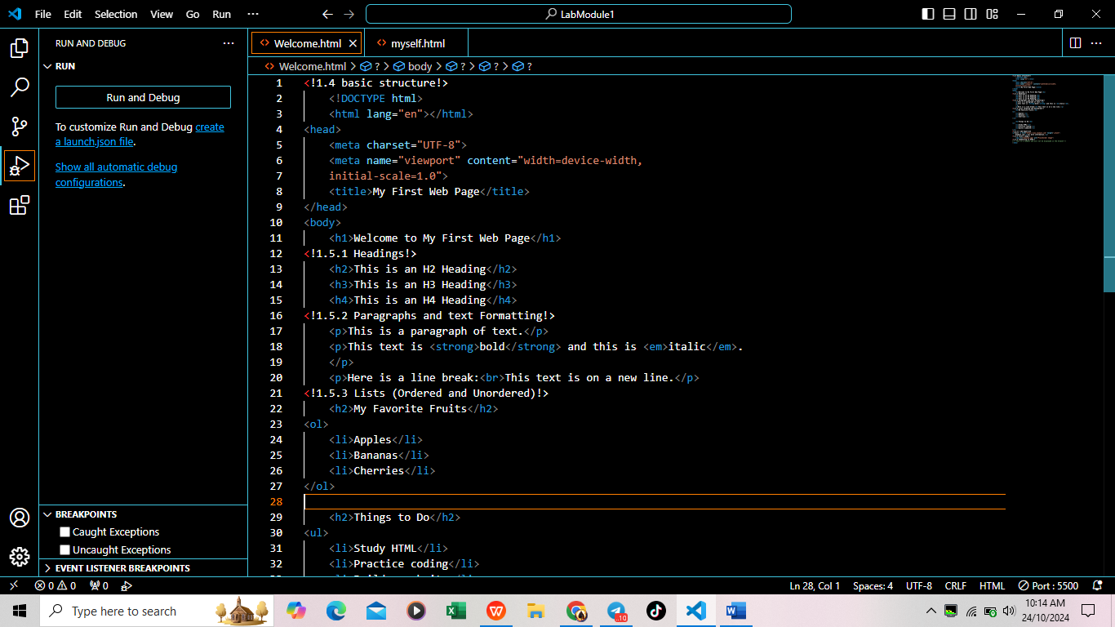
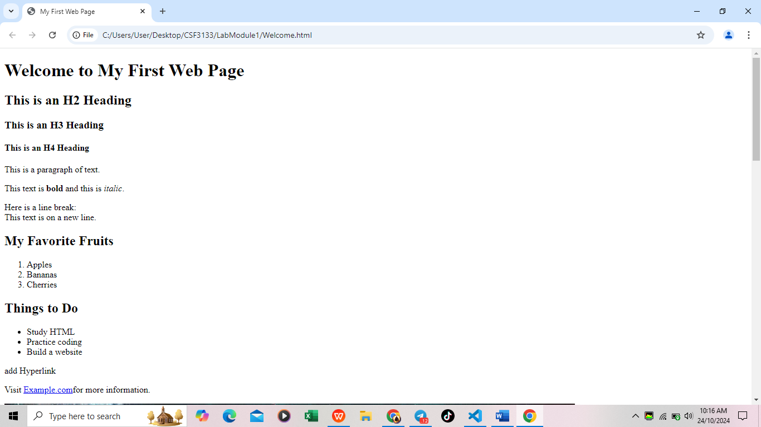

Basic HTML Tags
- Headings



- Paragraphs and Text Formatting



- List (Ordered and Unordered)
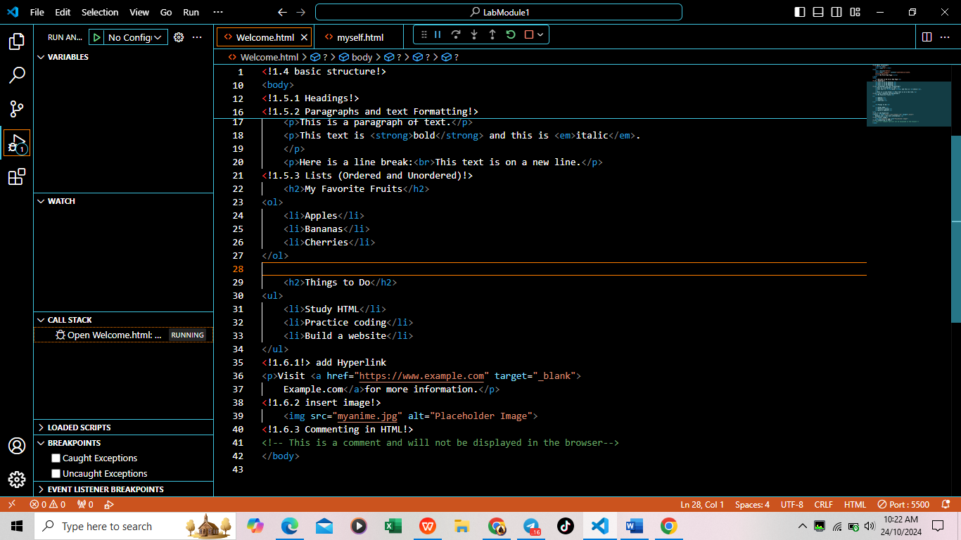


Links and Images
- Add a hyperlink



- Add an image

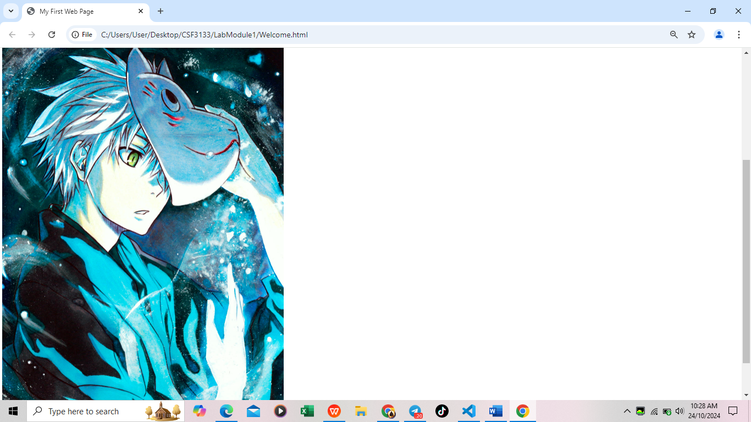
- Commenting in HTML
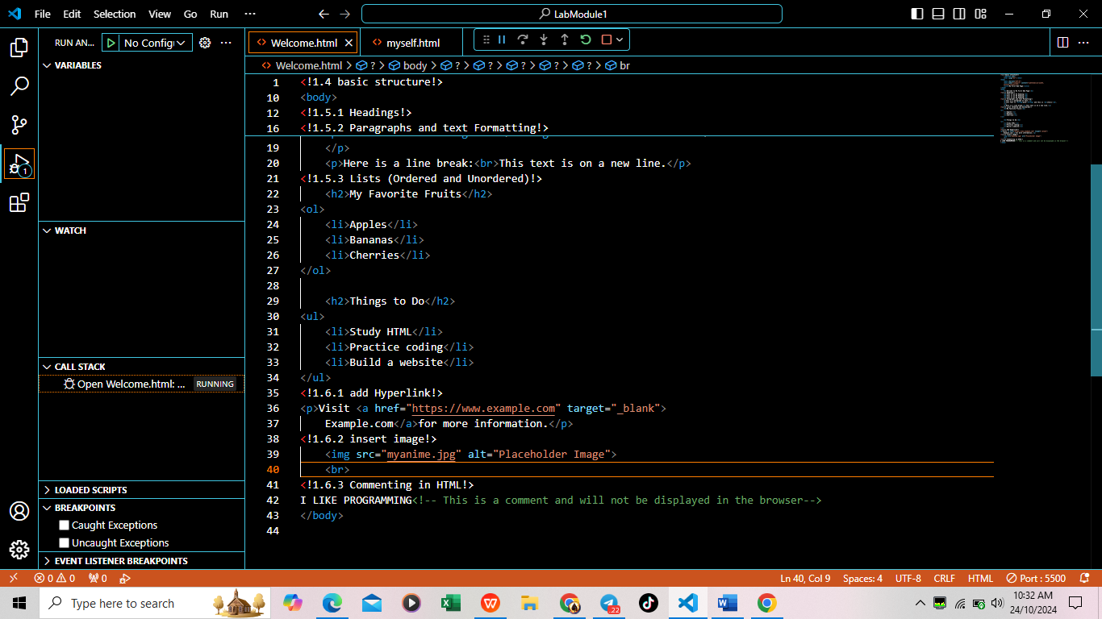
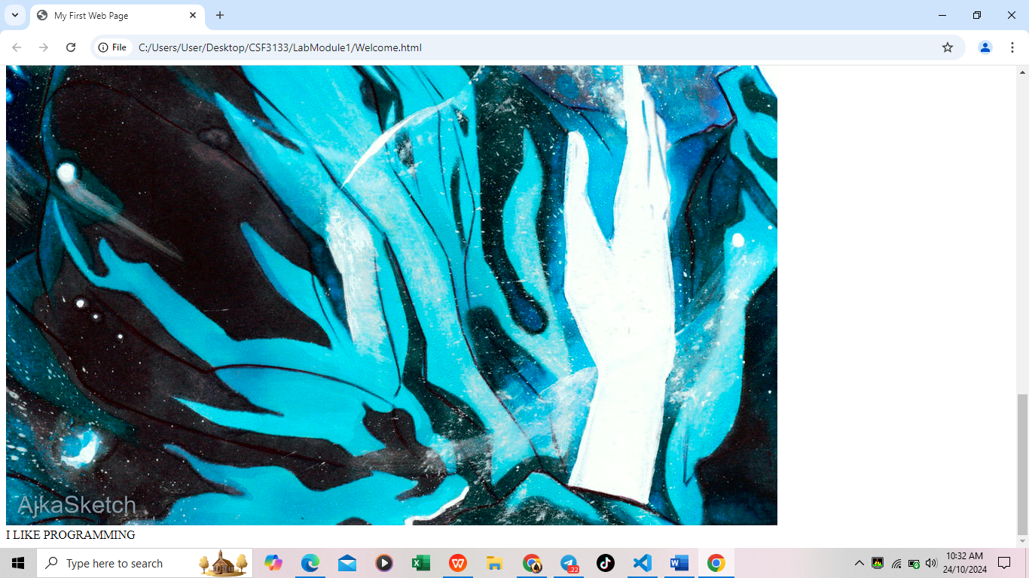

EXERCISE
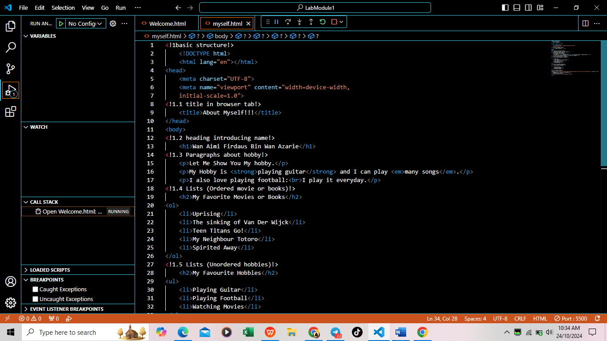
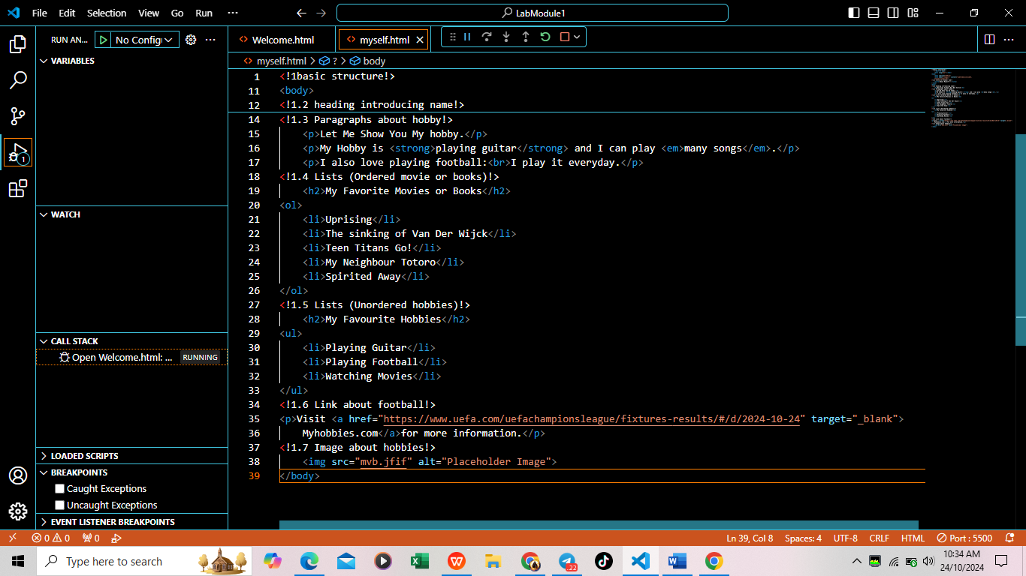

OUTPUT
