

Web-based Interface Design
(CSF3133)

LAB REPORT 2

LECTURE: Assoc. Prof. Ts. Dr. Wan Nural Jawahir Hj Wan Yussof

DEMONSTRATOR: Madam Wan Fatin Fatihah Yahya

NAME : Wan Aimi Firdaus Bin Wan Azarie

MATRIC: S72577
Activity
HEADINGS
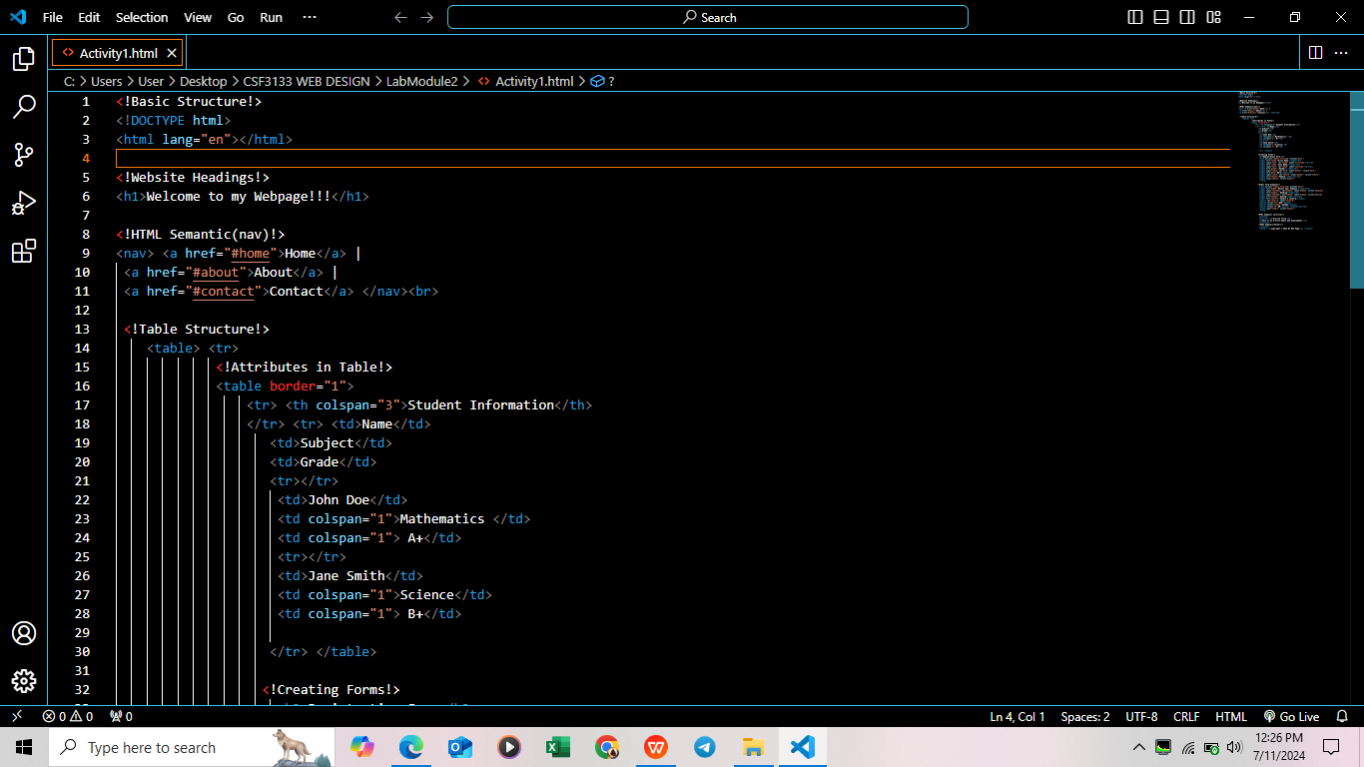
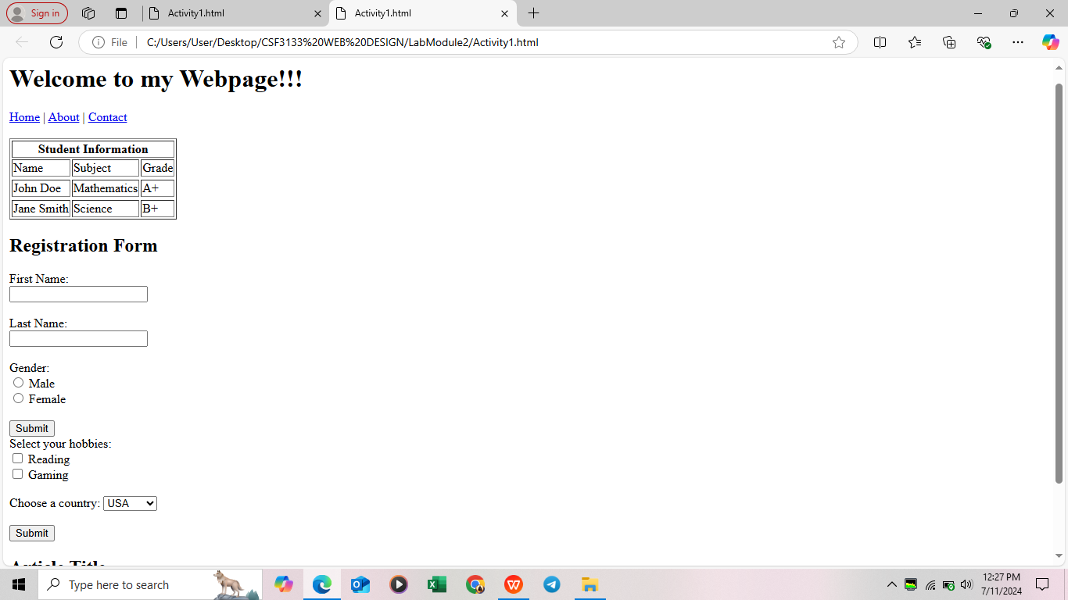

HTML SEMANTIC



TABLE STRUCTURE



CREATING FORMS
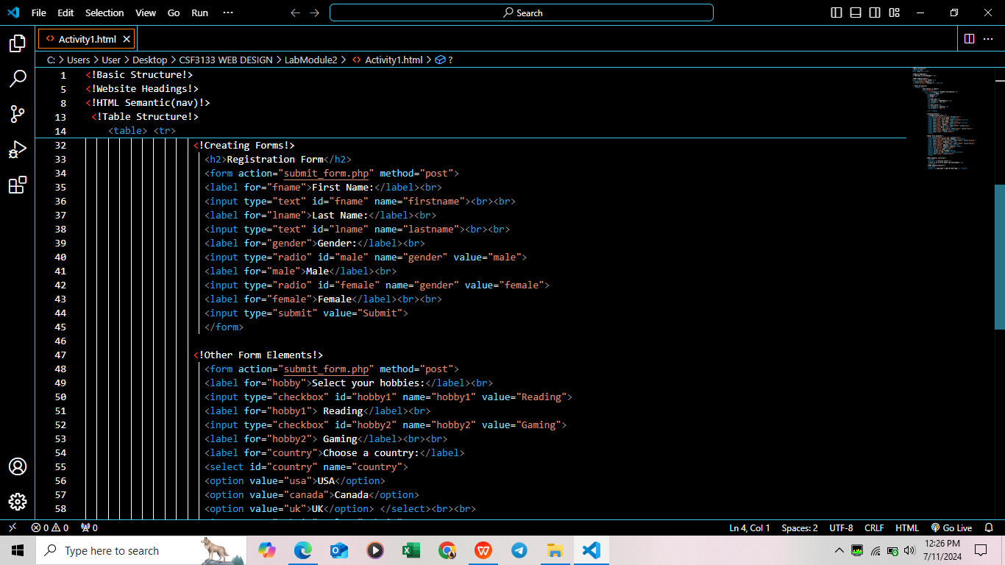


OTHER FORM ELEMENTS
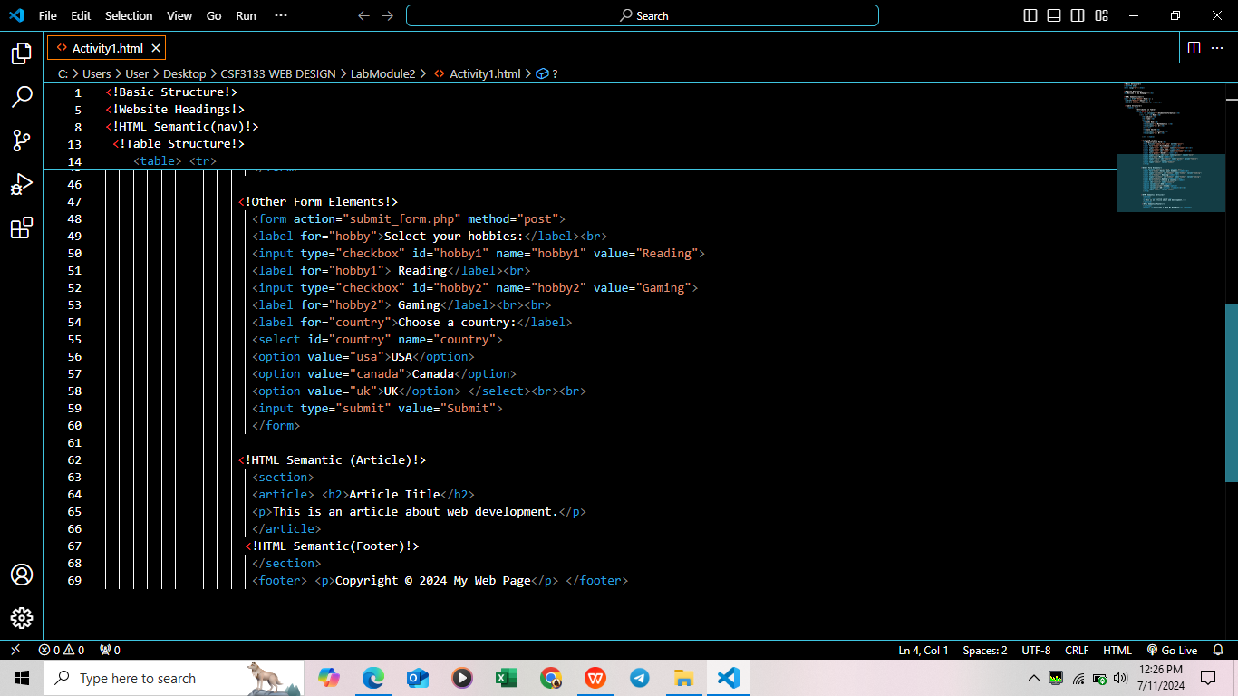


HTML SEMANTIC

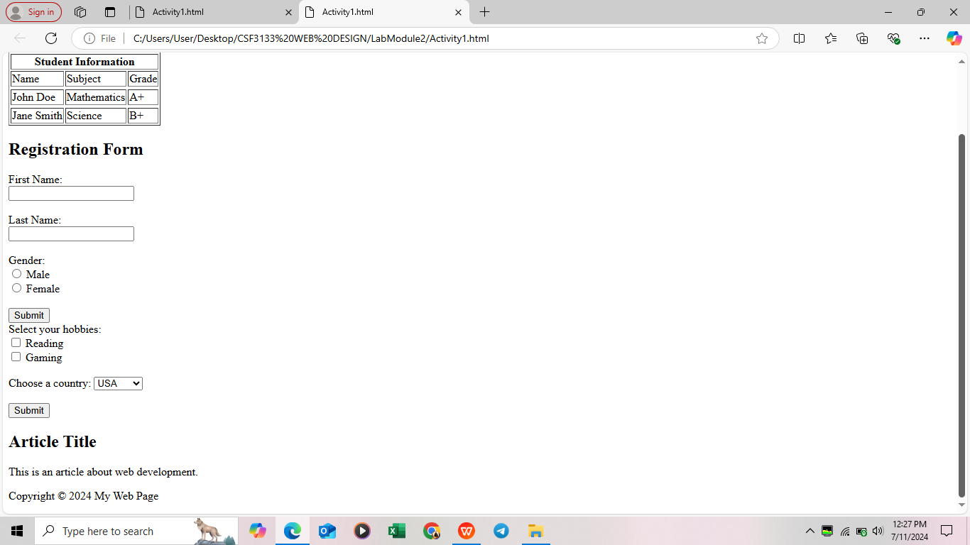

Exercise
HEADINGS
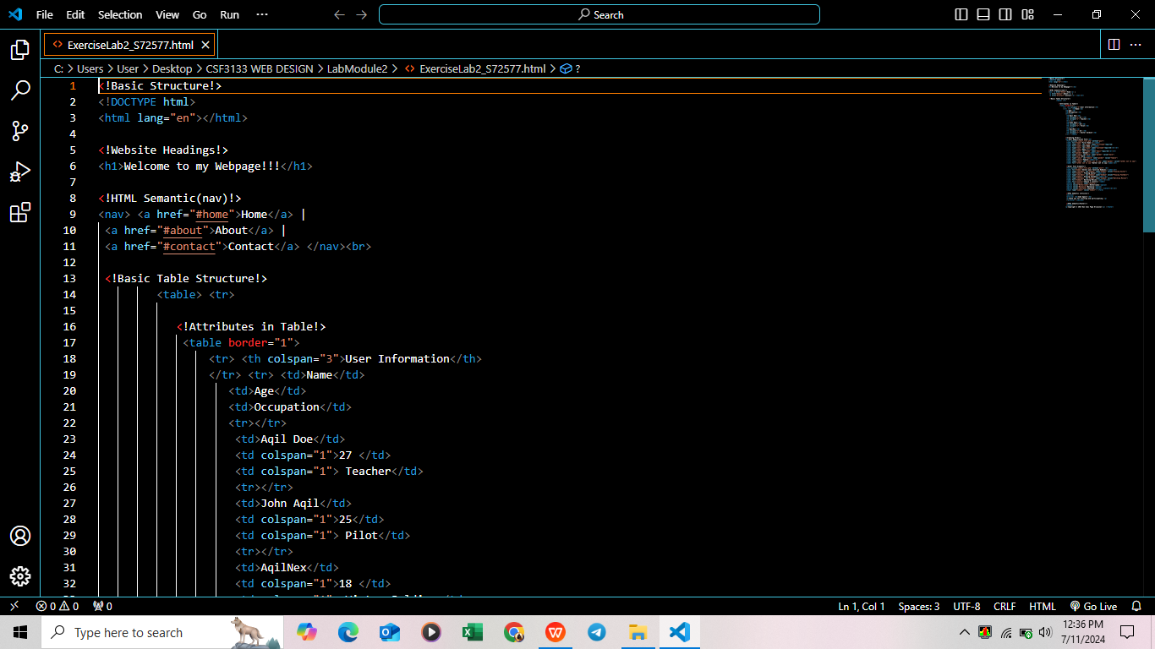


HTML SEMANTIC



TABLE STRUCTURE
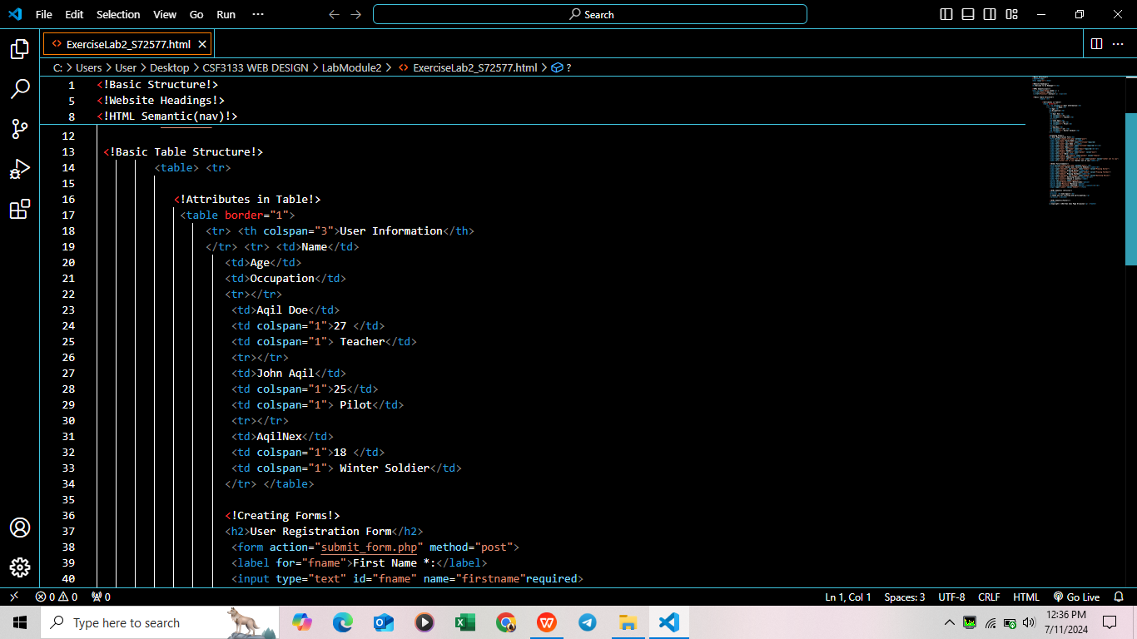
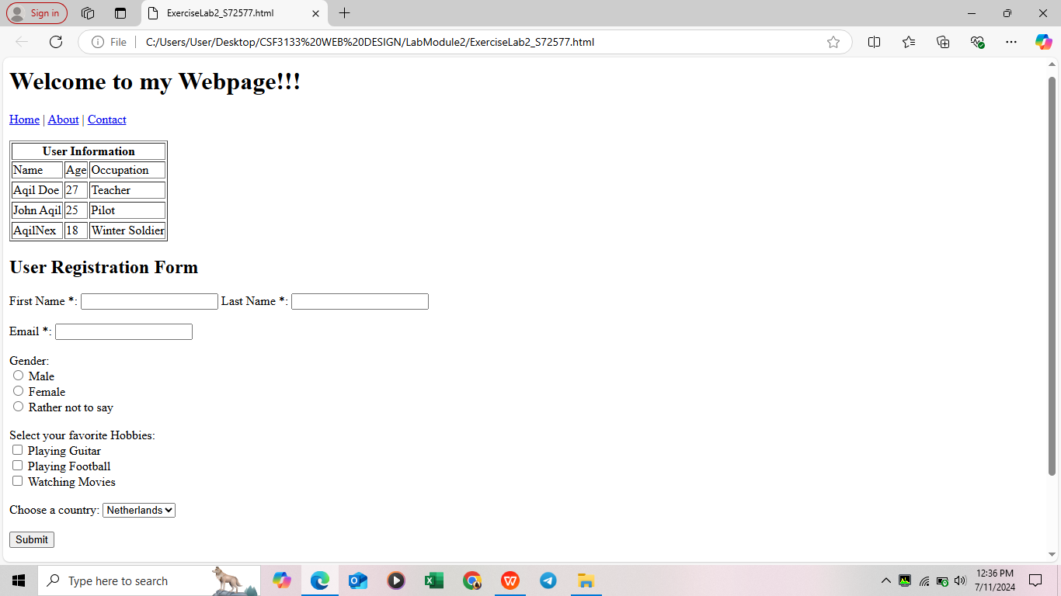

CREATING FORMS
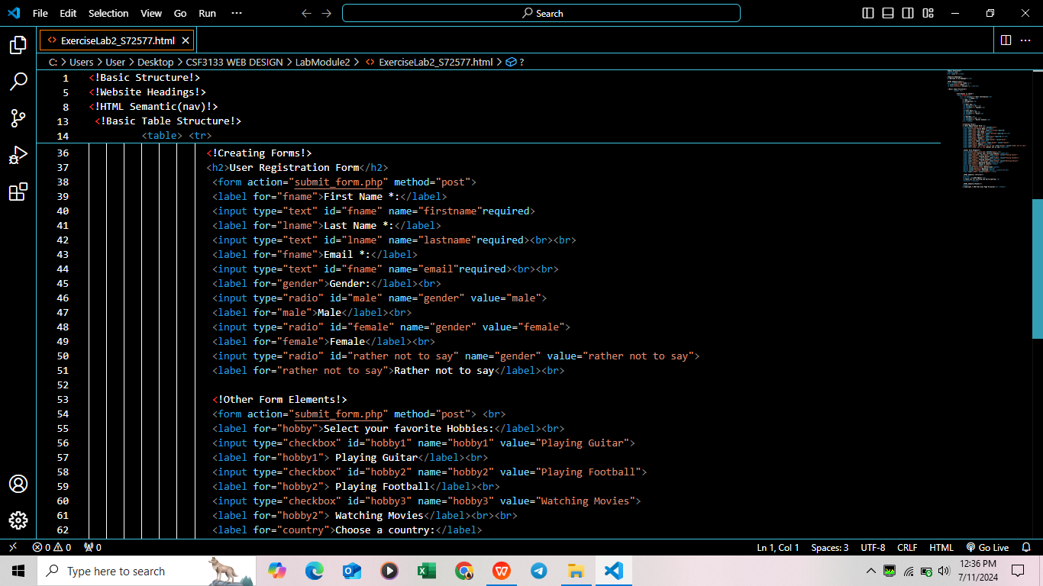


OTHER FORM ELEMENTS
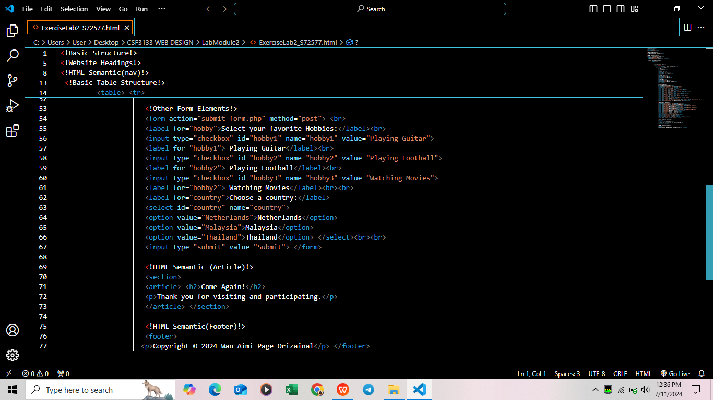
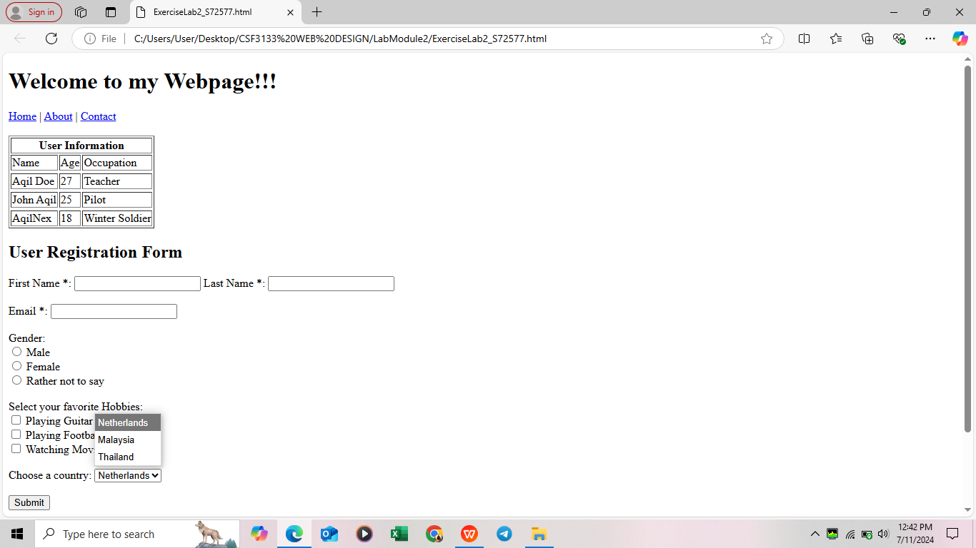

HTML SEMANTIC

