ValueDraft Software

1. **Startup**

Description- Will display all available leagues (demo and user-created). The user will have the option to Select League, Create New League, Edit Existing League, or Delete League.

1. **Select League-** Lists available leagues that have been created. User selects a league and hits SELECT. This opens the main screen with the league settings.
2. **Create League-** User selects this button and the Create New League dialog box opens (5 tabs- League Details, Owners, Players, Positions, Scoring.)
3. **League Details**
4. Enter the League name
5. Select # of owners (free form or arrows) 1-20
6. Select draft type (buttons- Auction, Snake Draft, Straight Draft)- focusing on Auction for now- others are placeholders. Free form box next to Auction with arrows- User enters salary per owner. Default- 260
7. Select Scoring Type (buttons-Roto, Points)
8. Click Next to advance to next tab or select the tab.
9. **Owners-** Lists text boxes according to answer of # of owners –User enters Owners’ names.
10. **Players**- User Selects which players will be used to draft. AL checkbox, if checked, selects all AL teams. NL checkbox, if checked, selects all NL teams. Both boxes checked selects all teams from AL and NL. User can also select individual teams: **AL**- Baltimore Orioles, Boston Red Sox, Chicago White Sox, Cleveland Indians, Detroit Tigers, Houston Astros, Kansas City Royals, Los Angeles Angels, Minnesota Twins, New York Yankees, Oakland A’s, Seattle Mariners, Tampa Bay Rays, Texas Rangers, Toronto Blue Jays; **NL**- Arizona Diamondbacks, Atlanta Braves, Chicago Cubs, Cincinnati Reds, Colorado Rockies, Florida Marlins, Los Angeles Dodgers, Milwaukee Brewers, New York Mets, Philadelphia Phillies, Pittsburgh Pirates, San Diego Padres, San Francisco Giants, St. Louis Cardinals, Washington Nationals.
11. **Positions**- user defines how many players are drafted at each position. C, 1B, 2B, SS, 3B, MI, CI, OF, DH, Utility, SP, RP, P, Bench. Free form or using arrows. Default- 1B, 2B, SS, 3B, MI, CI, Utility all 1. C-2. OF-5. P-9. Bench-10. Checkbox- Include Bench players in Salary Cap. If checked, add bench players to total players count when determining Values.
12. **Scoring-**  User selects which categories will be used for scoring. **Hitting-** (defaults checked) AVG., HR, R, RBI, SB (others) OBP, SLG, OPS, BB, H, K, 1B, 2B, 3B, TB, 2B+3B+HR, 2B+3B, SB-CS, CS, R+RBI-HR, H+BB,TB+BB, AB, HBP, SF, GDP. **Pitching-** (defaults checked)W, S, ERA, WHIP, K. (Others) IP, L, H, BB, ER, CG, W-L, QS, SHO, BS, S-BS, S+HLD, S+HLD-BS, K/9, H/9, BB/9, K/BB, K-BB, W%, HLD, R, HR, G.
13. **Save Button-**  Saves league with league settings as defined by user and opens the Main Page (Section II).
14. **Edit League** - Lists available leagues that have been created. User selects a league and hits EDIT. This opens the Create League dialog box (I.2.) with the user’s settings. The user can edit the league settings.
15. **Delete League** - Lists available leagues that have been created. User selects a league and hits DELETE. This deletes the league.

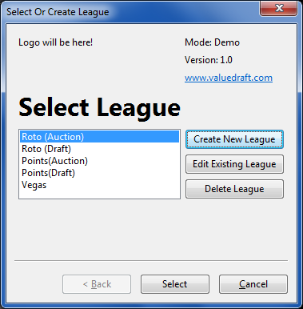

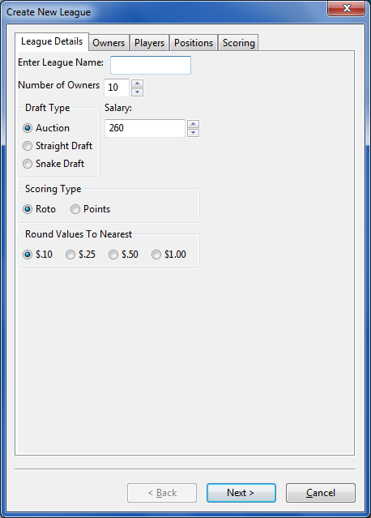

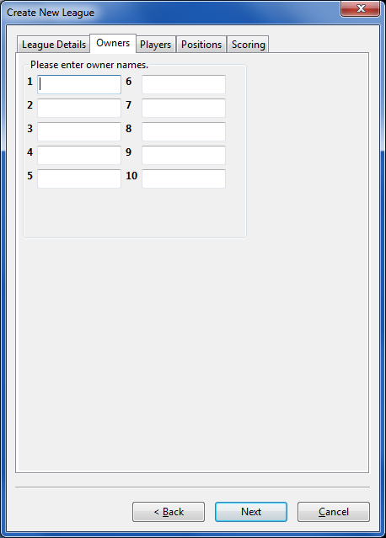

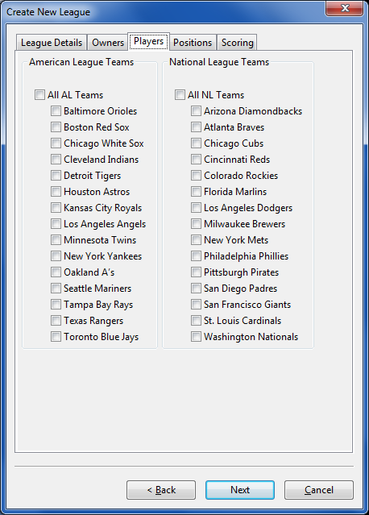

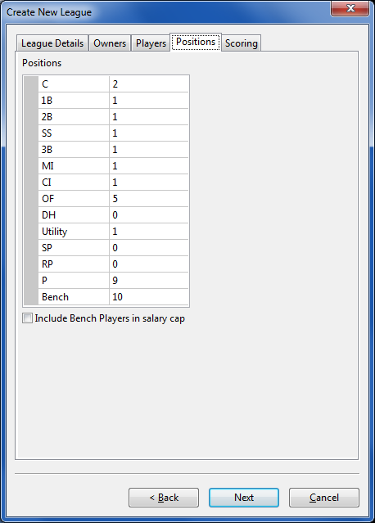

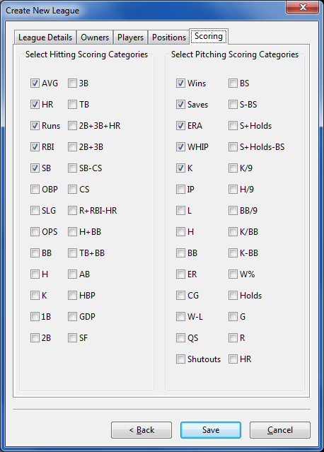

1. **Main Page**

Description: After the user creates the league and sets the league settings, the user will be taken to the Main Page. The Main Page will have Drop Down menus across the top: League, Edit, Activate, and Help. The left side of the screen will contain Roster information for a selected owner. The top section will contain the Player Draft section and a search field for players and this is where the players will be drafted (i.e. assigned to Owners). Below the Player Draft section will be the Data Section containing 4 buttons to change the Data Section- Players, Rosters, League Projections, and Draft Results. The Players Button will be the first screen shown on launch.

1. **Drop Down Menus**
2. **League** –Drop down options: Add Player, Reset to Default , Clear All Drafted Players, , Save and Exit
   1. **Add Player**- Allows user to manually add a player to the database. Will open a dialague box containing: Name, Team(options will be the MLB teams selected in league settings), Position, Value(BegValueue) and Statistics.
      1. The Positions option should have a button that opens the Select Positions box. User should be able to choose up to 5 positions.
      2. The Statistics option should have a button that opens the Enter Stats box. The default options should be: If Position equals Pitcher (P)- The scoring categories for Pitchers (as determined in settings) and “IP”. The user should use free form boxes to enter the stats. The More Categories button should expand the options to include: W, S, ERA, WHIP, K, IP, L, H, BB, ER, CG, W-L, QS, SHO, BS, S-BS, S+HLD, S+HLD-BS, K/9, H/9, BB/9, K/BB, K-BB, W%, HLD, R, HR, G and age.

If Position is anything else (hitter)- The default options should be the scoring categories for Hitters (as determined in settings) and “AB”. The user should use free form boxes to enter the stats. The More Categories button should expand the options to include: AVG., HR, Runs, RBI, SB (others) OBP, SLG, OPS, BB, H, K, 1B, 2B, 3B, TB, 2B+3B+HR, 2B+3B, SB-CS, CS, R+RBI-HR, H+BB,TB+BB, AB, HBP, SF, GDP, and age.

User enters all information and clicks Add Player:

1. Player is added to the database and Available Players.

2. All salary, inflation, and player values (BegValue and CurrValueueue) information is

updated.

* 1. BegValue - The value of the player defined by the user. This value can be edited at any time. The sum of all BegValue for all players will equal the Total salary for the league. The total salary equals Total number of owners in the league * salary cap/owner.
  2. CurrValue- The value of the player calculated after a player is drafted. Determines the player's current value based on the AmtPaid (or a change in BegValue) of other players. This value cannot be edited by the user. The sum of all CurrValue for all players will equal the Total salary for the league. The total salary equals Total number of owners in the league * salary cap/owner.
  3. The table below describes the calculation for both values in various scenarios.

**Before a Player is Drafted**

**-If new value is equal to old value.**

|  |  |  |  |
| --- | --- | --- | --- |
| Action | BegValue | CurrValue | Notes |
| Add Player | All remain the same. | BegValue * Inflation ratio.  Inflation ratio is 1.00 so:  CurrValue= BegValue | - User is prompted a box containing a list of players whose value is equal to $1. "Which player would you like to value at $0?" The user selects the player and hits OK.  - Only occurs if new player's value is $1. |
| Edit Player | All remain the same. | BegValue * Inflation ratio.  Inflation ratio is 1.00 so:  CurrValue= BegValue |  |

**Before a Player is Drafted**

**-If new value equals 0.**

|  |  |  |  |
| --- | --- | --- | --- |
| Action | BegValue | CurrValue | Notes |
| Add Player | All remain the same. | BegValue * Inflation ratio.  Inflation ratio is 1.00 so:  CurrValue= BegValue |  |
| Edit Player | Old Value -1 / (Total # of Players -1) = X  New BegValue = Old BegVal +X | BegValue * Inflation ratio.  Inflation ratio is 1.00 so:  CurrValue= BegValue | - User is prompted a box containing a list of players whose value is equal to $0. "Which player would you like to value at $1?" The user selects the player and hits OK.  * If OldValue =1, then no changes. |

**Before a Player is Drafted**

**-If new value is greater than old value.**

|  |  |  |  |
| --- | --- | --- | --- |
| Action | BegValue | CurrValue | Notes |
| Add Player | New Value -1 / (Total # of Players -1)= X  New BegValue = Old BegVal -X | BegValue * Inflation ratio.  Inflation ratio is 1.00 so:  CurrValue= BegValue | - User is prompted a box containing a list of players whose value is equal to $1. "Which player would you like to value at $0?" The user selects the player and hits OK. |
| Edit Player | New Value -Old Value / (Total # of Players -1= X  New BegValue = Old BegVal -X | BegValue * Inflation ratio.  Inflation ratio is 1.00 so:  CurrValue= BegValue |  |

**Before a Player is Drafted**

**-If new value is less than old value.**

|  |  |  |  |
| --- | --- | --- | --- |
| Action | BegValue | CurrValue | Notes |
| Add Player | All remain the same. | BegValue * Inflation ratio.  Inflation ratio is 1.00 so:  CurrValue= BegValue | This would occur when the new player is valued at $0. |
| Edit Player | Old Value -New Value / (Total # of Players -1) = X  New BegValue = Old BegVal +X | BegValue * Inflation ratio.  Inflation ratio is 1.00 so:  CurrValue= BegValue |  |

**After a Player is Drafted**

**-If new value is equal to old value.**

|  |  |  |  |
| --- | --- | --- | --- |
| Action | BegValue | CurrValue | Notes |
| Add Player | All remain the same. | Added player will be $1.  All other players:  BegValue * Inflation ratio.  *Should not change | - User is prompted a box containing a list of players whose value is equal to $1. "Which player would you like to value at $0?" The user selects the player and hits OK.  - Only occurs if new player's value is $1. |
| Edit Player | All remain the same. | BegValue * Inflation ratio. |  |
| Draft Player | All remain the same. | BegValue * Inflation ratio. | This occurs when the AmtPaid equals CurrValue. BegValue and CurrValue should not change. |

**After a Player is Drafted**

**-If new value equals 0.**

|  |  |  |  |
| --- | --- | --- | --- |
| Action | BegValue | CurrValue | Notes |
| Add Player | All remain the same. | Added Player will be $0.  All other players-  BegValue *Inflation ratio | Neither BegValue or CurrValue will change. |
| Edit Player | Old Value -1 / (Total # of available Players -1) = X  New BegValue = Old BegVal +X | BegValue * Inflation ratio. | - User is prompted a box containing a list of players whose value is equal to $0. "Which player would you like to value at $1?" The user selects the player and hits OK. |
| Draft Player | N/A- Cannot draft a player for $0 | N/A- Cannot draft a player for $0 | Error- "Please enter an AmtPaid >= $1." |

**After a Player is Drafted**

**-If new value is greater than old value.**

|  |  |  |  |
| --- | --- | --- | --- |
| Action | BegValue | CurrValue | Notes |
| Add Player | New Value -1 / (Total # of available Players -1) = X  New BegValue = Old BegVal -X | The "added" player's CurrValue is equal to the BegValue assigned.  All other players-  BegValue * Inflation ratio. | - User is prompted a box containing a list of players whose value is equal to $1. "Which player would you like to value at $0?" The user selects the player and hits OK. |
| Edit Player | New Value -Old Value / (Total # of available Players -1) = X  New BegValue = Old BegVal -X | The "edited" player's CurrValue is equal to the BegValue assigned.  All other players-  BegValue * Inflation ratio. |  |
| Draft Player | All remain the same | BegValue*Inflation ratio. | This occurs when the AmtPaid is greater than CurrValue. |

*AmtPaid cannot be 0.

** If AmtPaid is equal to CurrValue, no changes to other players are made.

**After a Player is Drafted**

**-If new value is less than old value.**

|  |  |  |  |
| --- | --- | --- | --- |
| Action | BegValue | CurrValue | Notes |
| Add Player | All remain the same. | BegValue * Inflation ratio. | This would occur when the new player is valued at $0. |
| Edit Player | Old Value -New Value / (Total # of available Players -1) = X  New BegValue = Old BegVal +X | The "edited" player's CurrValue is equal to the BegValue assigned.  All other players-  BegValue * Inflation ratio. |  |
| Draft Player | All remain the same | BegValue*Inflation ratio. | This occurs when the AmtPaid is less than CurrValue. |

*AmtPaid cannot be 0.

** If AmtPaid is equal to CurrValue, no changes to other players are made.

* 1. The Max BegValue is equal to the total of BegValue of all players minus (Total # of players minus 1). This would make every other player worth $1.
  2. The Min Value for BegValue or CurrValue is $1.
  3. In the event the user changes a player's BegValue or an AmtPaid applied to a player drafted causes another player's BegValue/CurrValue to fall below $1 then:  
     All Players below $1 will become equal to $1.  
     Then: The sum of the differences of $1 and those players' BegValue/CurrValue that fell below $1 is divided by all players (except those that are now equal to $1 AND the player being edited). This amount is then subtracted from each player's BegValue or CurrValue (except those that are now equal to $1 AND the player being edited).

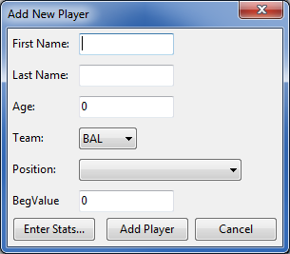

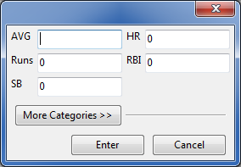

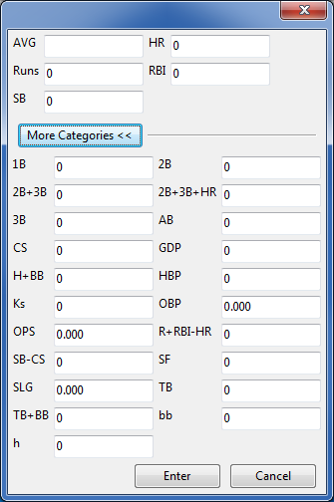

* 1. **Reset to Default-**  User selects this to reset the league to its original state. All Players will be unassigned, all added players will be removed, all edits will be deleted. The league will revert to the state immediately after being created.
  2. **Clear All Drafted Players**- User selects this to clear all drafted players. The user would receive a warning box- Are you sure you want to remove all drafted players from all Owners? Yes or Cancel. Yes- would unassign all drafted players from all Owners and:
     1. Removed from Drafted Players and added to Available Players.
     2. Removed from Draft Results.
     3. Removed from the position slot of the Owner who drafted the player.
     4. All salary, inflation, and player value information is updated.
  3. **Save and Exit –** User would select this option to Exit and all data would be saved to the league.

1. **Edit –** Drop down options: League Settings, Targets
   1. **League Settings-** User would select this to edit league settings. The League Settings dialogue box would open and the user can edit all settings. (I.2. above)
   2. **Targets-** User would select this to edit targets. (see picture below) The categories listed would equal those selected in the scoring section of league settings. (I.2.d.) above)

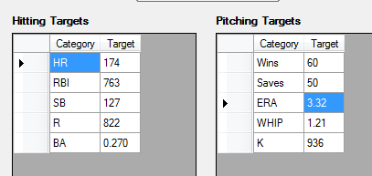

1. **Activate-** User would select this to activate their software from “Demo” to “Live” version. Dialogue box opens and the user enters their activation code. The user will receive an activation code via e-mail upon purchase and they would enter the code here. The code can be used on 2 computers before it is no longer valid.
2. **Help-** User Guide and Contact Us
   1. **User Guide-** User would select this to view the user guide. (will provide later)
   2. **Contact Us-** User would see a hyperlink to e-mail. (TBD- will provide later)
3. **Owner Rosters**

Description: The Owner Roster (left side) will contain a drop down menu that contains all Owners. This section will remain on the main page, regardless of the button the user selects in the Data Section. The Hide button will temporarily hide the Owner Roster Section and expand the Data Section. The selected Owner will show the current roster. Hitters at top, Pitchers at Bottom. Columns will be: Position, Player, Salary, and all the scoring categories(I.2.d.). . Each column will have a sum total line at the bottom (one for each: Hitter and Pitcher)

Some stats require additional calculation rather than just a sum. They are below:

Hitters  
AVG= H / AB  
OBP = (H+BB+HBP) / (AB+BB=HBP+SF)  
SLG= TB / AB  
OPS= OBP + SLG  
  
Pitchers  
ERA = (ER * 9) / IP  
WHIP = (BB+H) / IP  
W% = W / (W+L)

Below the sum total will be the users’ targets for each category as defined above. The very bottom will contain current salary information: Salary Left, Players Left, Avg. $/Player Left, Inflation, Max Bid and Profit.

1. **Salary Left**- Total Salary (as defined in settings) minus Total Spent (sum of all players’ “AmtPaid” for the selected Owner.
2. **Players Left-** Total players needed to draft (as defined in settings) minus total players drafted for the selected Owner.
3. **Avg. $/Player Left-** Salary Left divided by Players Left.
4. **Inflation-** Listed as a %. (Inflation Ratio minus 1) times 100.
5. **Inflation Ratio-** Total Salary Left (all owners) divided by Value Left.
6. **Value Left-** Total Salary (all Owners) minus Sum of BegValue of all players drafted.
7. Example 10 Owners, $260 per Owner. Total Salary= $2,600. 1 player drafted for $10 where his BegValueue=$50. Inflation%= (2600-10)/(2600-50)=inflation ratio= 1.01568. (1.01568 – 1)*100= 1.57%
8. **Profit-** Sum of Profit for all drafted players for the selected Owner. Profit= BegValueue minus AmtPaid.
9. **Max Bid-** Salary Left minus (Players Left minus one) Example: Salary Left=260. Players Left 23. Max Bid= $260 – (23-1)= $238
10. **Hide Button-** User selects Hide to expand the Data Section (Players, Rosters, League Projections, or Draft Results). User selects Show to reveal the Owner Roster again. (see Players Button below)

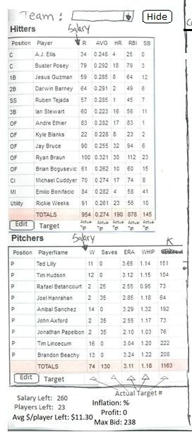

1. **Player Draft Section**

Description: This is the section where the user will assign players to Owner s. This section will remain on the main page, regardless of the button the user selects in the Data Section. The search box should dynamically list players that match the search criteria (as the user types). The user selects the player and the player’s data/stats are shown. The user selects the Owner, enters the amount paid using free form or arrows (should default to CurrValueue) and enter the position (Position should default to players first eligible position from the database) other position options would be the players other eligible positions. The user then selects Draft. The user sees a confirmation box detailing Player, Owner, Amount Paid and Position. User selects OK to close. The drafted player is then updated on the following sections:

1. Removed from Available Players and added to Drafted Players.
2. Added to Draft Results.
3. Added to the position slot of the Owner who drafted the player.
4. All salary, inflation, and player value information is updated.

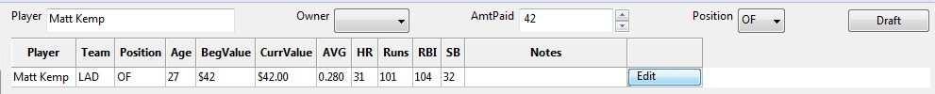

1. **Data Section**

Description: The Data Section has 4 buttons: Players, Rosters, Projected Standings, and Draft Results. User selects each tab to change the contents of the Data Section.

1. **Players Button**

Description: The Players Button is a snap shot of the database. Across the top will be position filter buttons. User can select a button (or use CTRL for multi buttons) and the data will be filtered by the selected position(s). Example: User selects SS, only all players with SS would be shown. The All Hitters filter will show all players at positions: 1B, 2B, 3B, SS, MI, CI, OF. The All Pitchers filter will show all players at positions SP and RP.

* The MI filter will show all 2B and SS.
* The CI filter will show all 1B and 3B.
* The All Players filter will show all Positions (players)
  + 1. **Columns**
  + The default columns for Hitters will be the scoring categories for Hitters (I.2.d.), Notes and AB. (Data will come from the provided database)
  + The default columns for Pitchers will be the scoring categories for Pitchers (I.2.d.), Notes and IP. (Data will come from the provided database)
  + After scoring categories, columns will be BegValueue, CurrValueueue, Amt Paid, Profit, Owner, Notes
  + BegValueue- Provided in database. Cannot be less than $1.
  + **\*\*\*CurrValueueue-**This is re-calculated for all players each time a player's BegValueue is changed OR the AmtPaid is populated when a player is drafted. If BegValueue is changed, the difference between the old and new BegValueue is divided equally among all available players. The difference is added if the new BegValueue is less than the old BegValueue. The difference is subtracted if the new BegValueue is more than the old BegValueue. Example: 10 total players. All players BegValueue is $10. User changes BegValueue of one player to $19. The Difference is +$9, so $1 is subtracted from the remaining 9 players (9/9=$1). So one player is $19 and 9 are $9. The total salary is the key, in this case both totals are $100.

Algebraically:

CurrValueue= A * B  
A= BegValue  
B= C / D

C= E - F  
E= Sum of BegValue (all players)  
F= Sum of Amt Paid (drafted players)  
  
D= E - G  
E= Sum of BegValue (all players)  
G= Sum of BegValue (drafted players)

Once a player is drafted and the AmtPaid is recorded, a new inflation% and ratio are calculated.(II.2.d.) All players' CurrValueueue is now equal to (BegValueue x new inflation ratio).

* + AmtPaid- Entered by user when a player is drafted.
  + Profit- BegValue minus AmtPaid
  + Owner - Entered by user when a player is drafted.
  + Notes- User should be able to populate notes via typing (per player). (e.g. “expect more playing time”, “sleeper”, “must have”, etc)
  + Each column should be able to sort in descending order (highest to lowest) when the column is clicked. Using CTRL and clicking another column will sort first by the first column clicked then by the second column clicked.
* For the Roto Demo:
  + Categories: Hitting Categories: AB, AVG, R, HR, RBI, SB

Pitching Categories: IP, W, ERA, WHIP, S, K

Other: BegValue, CurrValueue, AmtPaid, Profit, Owner, Notes

**Note**: Hitters and Pitchers have different stat categories. So the columns will change depending on viewing hitters or pitchers. If viewing Hitters, only the hitting categories the user selected should be shown (along with BegValueue, CurrValueueue, AmtPaid, Profit, Owner, and Notes as long as the user has selected these columns). If viewing Pitchers, only the pitching categories the user selected should be shown (along with BegValueue, CurrValueueue, AmtPaid, Profit, Owner, and Notes as long as the user has selected these columns). When All Players is selected, this will require additional columns. The Hitters columns will be shown first, then the value columns (BegValueue, CurrValueueue, AmtPaid, Profit, and Owner) then the Pitchers columns and finally the Notes column. A scroll bar on the bottom will be needed.

* **Search field** will dynamically populate players that match the search criteria entered by the user (e.g. as the user types “Gon..” the results of all players beginning with Gon will be shown, as the user types "Gonz", those without a z after "Gon" will drop off, etc). The user selects the player and the player’s row is highlighted. All other players are still visible.
* **"Top" button** will move to the first line/player depending on the sort. Example, user has clicked the HR column and all players are sorted by HR. If the user scrolls down and then clicks the "Top" button, the data would return to the player with the most HR, the very first line at the top of the data.
* **Players Filter-** The user can filter by “Show Available Players” or “Show Drafted Players”. These will be “sub-filters” of the position filters. (Example: User selects SS filter and checks Show Available Players- the data would show all available players with SS as a position.

**Available Players**- Players in the database that have yet to be drafted/assigned to an Owner.

**Drafted Players**- Players already drafted/assigned to an Owner.

If both boxes are checked all players (yet adhering to the position filter) will be shown. Example: If the user has both boxes checked and has selected the SS filter, the data would show all players at the SS position, whether drafted or not.

Default- Both boxes checked.

* **Edit Column button** will allow the user to select different stat categories for the columns to view- Similar to league settings. It will also include BegValueue, CurrValueueue, AmtPaid, Profit, Owner, and Notes. The user would select which columns they would like to view.

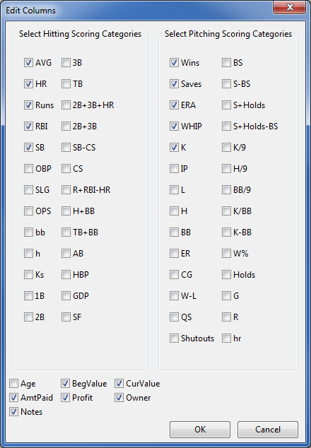

* **Add Player button** will launch the Add player dialogue box (II. 1. a. a.)
* **Player Ranking** will be associated with BegValueue and will remain static. All Players (Hitters and Pitchers) will be ranked 1(highest value) to X(lowest value), X being the total number of players in the database. This number will remain with the player regardless of sorting or players being drafted.

**Other Functionality:**

* The entire row should highlight when a player is selected.
* User should be able to click and drag to move the column’s location.
* User Right clicks on player, options will be: Edit Player, Draft, Unassign
  + Edit Player- launches the edit player box (use the Add player Box, replace “Add” with “Edit” and all the players info will be populated and the user can change all data. See II.1.a.a. If Value(BegValueue) is changed, all players CurrValueueue is updated.
  + Draft- if selected the player is populated in the Draft player section. (II. 3.)
  + Unassign- User will receive a confirmation box “Are you sure you want to unassign”. Yes or Cancel. If Yes, the player is:
    - Removed from Drafted Players and added to Available Players.
    - Removed from Draft Results.
    - Removed from the position slot of the Owner who drafted the player.
    - All salary, inflation, and player value information is updated.

Players Button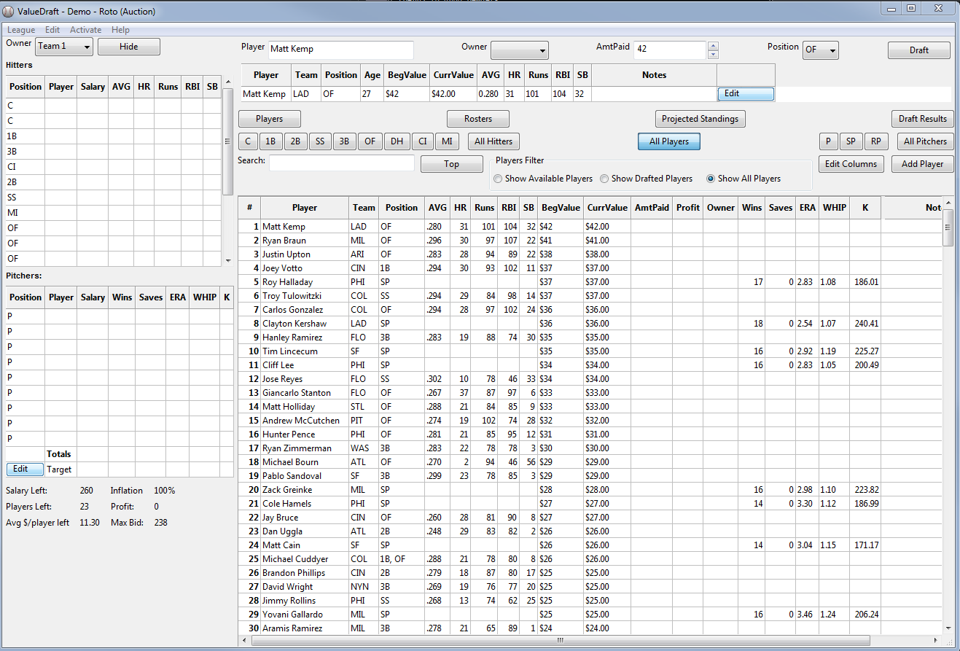

Players Button when Hide is selected:

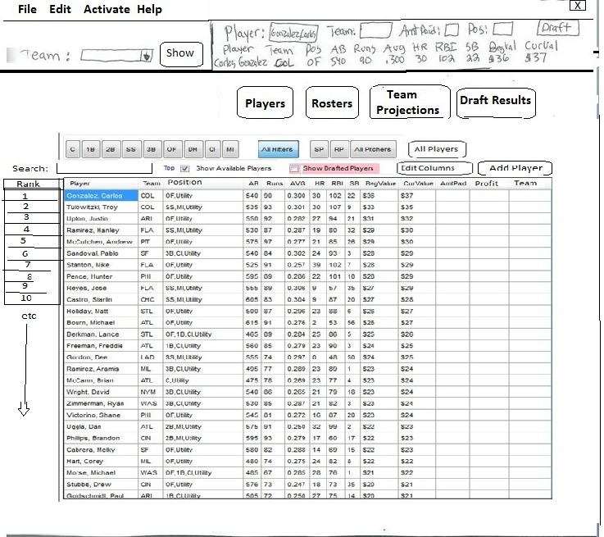

1. **Rosters Button**

Description: As players are drafted/assigned the Rosters screen will be updated. Across the top will be the Owner names as determined in League Settings. Just below the Owner name will be their salary information: $Left= Total Salary minus sum of AmtPaid of drafted players, Max Bid= Owners max bid (see II.2.f.), Avg= Avg/player (see II.2.c.) and Profit (see II.2.e.)

Down the left side will be the positions as determined in League Settings. If there is a need to scroll, both the Owner names +salary info and the position “frames” (the row and column) should be frozen. (So below Profit and to the right of the position.)

The players are placed in the cell that matches the position and Owner the user selected when they drafted the player.

The Players name should be listed followed by the AmtPaid number.

Rosters Button

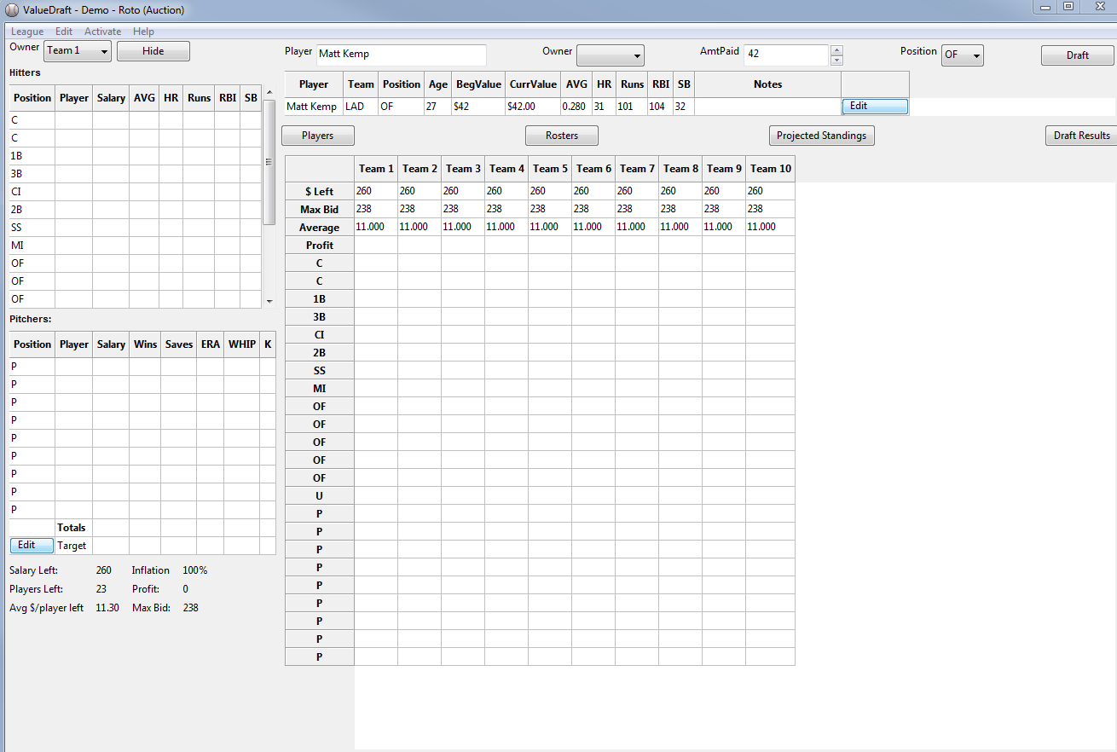

Rosters Button Hidden

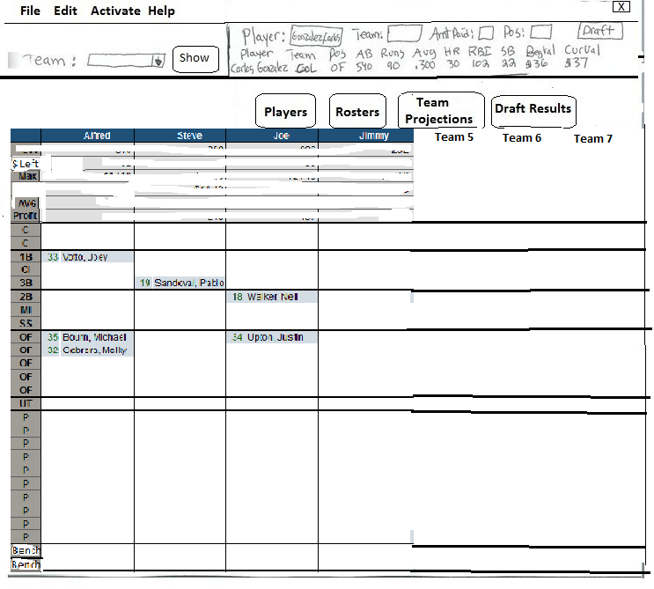

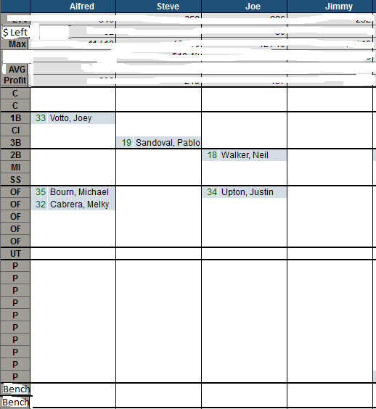

1. **Projected Standings**

Description: The Projected Standings Button will show 2 grids.

1. **The top grid** is cumulative stats for the scoring categories as players are drafted/assigned to the Owners. The scoring categories as defined in league settings will be across the top and the Owner names along the left side. As players are drafted, the players’ stats are added to create a cumulative total for each scoring category for each Owner. Example, OwnerA drafts 2 players. Player 1 has 20 HR, Player 2 has 10 HR. The cell matching OwnerA and HR would read 30.

Some stats require additional calculation rather than just a sum. They are below:

Hitters  
AVG= H / AB  
OBP = (H+BB+HBP) / (AB+BB+HBP+SF)  
SLG= TB / AB  
OPS= OBP + SLG  
  
Pitchers  
ERA = (ER * 9) / IP  
WHIP = (BB+H) / IP  
W% = W / (W+L)

All columns should be sortable by clicking on the column. (Including Owner)

For the Roto Demo:

Categories: Hitting Categories: Avg,, Runs, HR, RBI, SB

Pitching Categories: W, ERA, WHIP, S, K

All stats will be provided in the database.

AVG= Total Hits(H) of all Hitters / Total at bats (AB) of all Hitters

R= Total Runs of all Hitters

HR= Total HR of all Hitters

RBI= Total RBI of all Hitters

SB= Total SB of all Hitters

W= Total W of all Pitchers

ERA= Total earned runs(ER) of all Pitchers multiplied by 9 / Total innings Pitched(IP) of

all Pitchers

WHIP= Total walks(BB) of all Pitchers plus Total Hits(H) of all Pitchers / Total IP of all

Pitchers

S= Total Saves (S) of all Pitchers

K= Total Strikeouts (K) of all Pitchers

1. **The bottom grid** will be projected standings based on those stats. This grid displays the projected standings. For each scoring category, each Owner is assigned a point value as follows:

Categories: Avg, Runs, HR, RBI, SB, W, S, K- the Owner with highest total (number) receives a point value equal to the number of Owners. The Roto Demo has 10 owners, so the highest total for each category will receive 10. Second highest total 9 points, 3rd highest total 8 points, etc. In the event of a tie or multiple Owner tie, the points for those places are added and divided equally between the tied Owners. Example 2 Owners have 30 HR which is a tie for 7th place. So the two Owners split 13 points (7 for 3rd and 6 for 4th) and receive 6.5 points each.

Categories: ERA, WHIP- Same rules apply except it is the lowest number that receives the highest points. (e.g. 3.45 receives higher value than 3.75)

Hit column- The points for each Owner's Hitting categories are totaled.

Pitch Column- The points for each Owner's Pitching categories are totaled.

Total Column- Hit + Pitch

All columns should be sortable by clicking on the column. (Including Owner)

There is also a Show Targets button that will turn on and off the shaded portion showing the targets progress.

**Show Targets**- When the user selects this button, the category cells will be conditionally formatted to shade the cell comparing the cells total to that category target as defined by the user in Targets (II.1.b.b.). This is similar to my excel sheet (Formulas A1:K13). When the user deselects the button, no shading will be visible.

Projected Standings Button

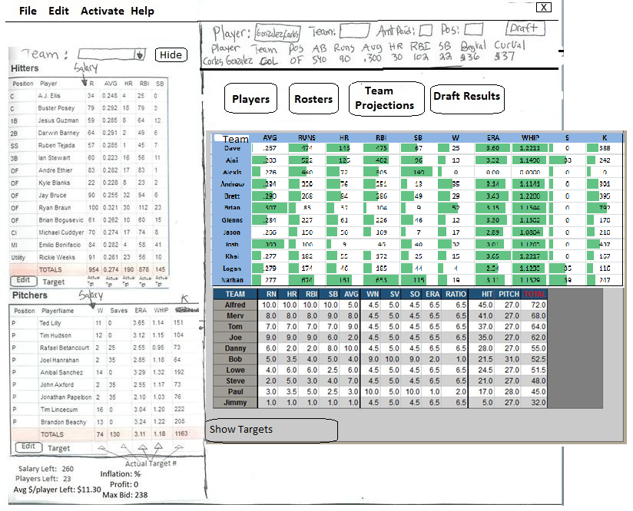

Projected Standings Button Hidden

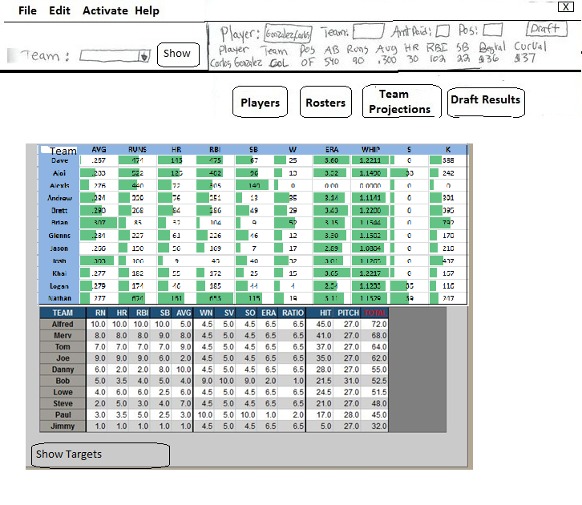

1. **Draft Results Button**

Description: User selects this button to view the draft results and salary information. This section has two buttons: Draft Results and Salary

* Draft Results: As players are drafted this area is populated. Columns include: Draft Order, Player, Owner, AmtPaid, Profit. The Draft Order number will be assigned chronologically as players are drafted and will remain with the player if sorted by another column.

The Search field will dynamically search for players as the user types and searches the draft results screen. User selects the player and the players row is highlighted and all other players remain visible.

The Owner drop down box- User selects an Owner and only that Owners results are shown.

* + Owner= the Owner that drafted the player
  + AmtPaid= the amount the Owner drafted the player
  + Profit= BegValue minus AmtPaid for the player.
  + Columns should be sortable by clicking column title.
* Salary: User selects this tab to display salary information for all Owners.
  + Owner= each Owner is listed
  + Salary= Total Salary as defined in League Settings
  + Spent= Total AmtPaid of all players for each Owner
  + $Left= Salary minus Spent
  + # of Players Left= Total number of Positions needed as defined in league settings minus total number of players drafted.
  + $/Player Left= $Left/# of Players Left
  + Max Bid= $Left minus (# of Players Left minus one) Example: $Left=260. Players Left 23. Max Bid= $260 – (23-1)= $238
  + Profit= Sum of all players profit per Owner (BegValueue-AmtPaid)

Draft Results Button (clicking Draft Results)- Will be shown when clicking Draft Results from Main page as default.

The Hide button on the Owner Roster should work for these as well.

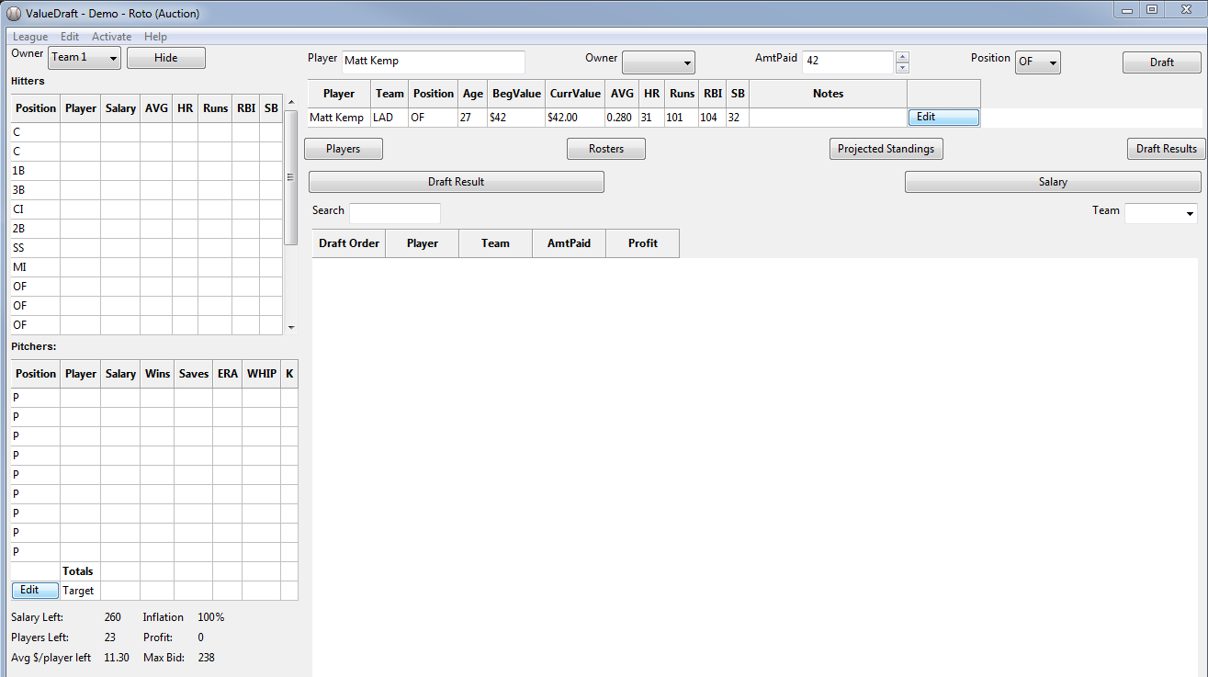

Draft Results Button (Clicking Salary Button)

