|  |  |  |
| --- | --- | --- |
| ACCOUNTS | CUSTOMERS | TRANSCATIONS |
|  |  |  |

|  |  |
| --- | --- |
| EMPLOYEES | LOANS |
|  |  |

**CONTROL STRUCTURES**

**SCENARIO 1:**BEGIN

FOR lid IN

(SELECT l.loanid, l.customerid FROM customers c JOIN loans l ON c.customerid=l.customerid

WHERE TRUNC(MONTHS_BETWEEN(sysdate, dob)/12)>60)

LOOP

UPDATE loans

SET interestrate=interestrate-1

WHERE loanid=lid.loanid;

END LOOP;

END;

**OUTPUT:(LOANS)  
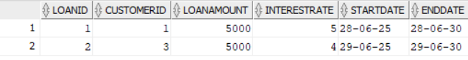**

**SCENARIO 2:**

ALTER TABLE customers ADD IsVIP VARCHAR2(6) DEFAULT 'FALSE';

UPDATE customers SET balance=20000 WHERE balance=1500;

UPDATE customers SET balance=25000 WHERE balance=1000;

BEGIN

FOR cid IN

(SELECT customerid FROM customers WHERE balance>10000)

LOOP

UPDATE customers

SET isvip='TRUE'

WHERE customerid=cid.customerid;

END LOOP;

END;

**OUTPUT:(CUSTOMERS)**

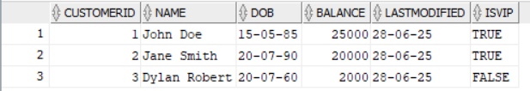

**SCENARIO 3:**

SET SERVEROUTPUT ON;

BEGIN

FOR bor IN

(SELECT l.loanid, c.name, l.enddate FROM customers c JOIN loans l ON c.customerid=l.customerid

WHERE enddate BETWEEN sysdate AND sysdate+30)

LOOP

dbms_output.put_line('Dear, ' || bor.name || ' your loan is due on ' || bor.enddate);

END LOOP;

END;

**OUTPUT:**

