Thursday, July 14, 2016 2:00pm to 4:00pm 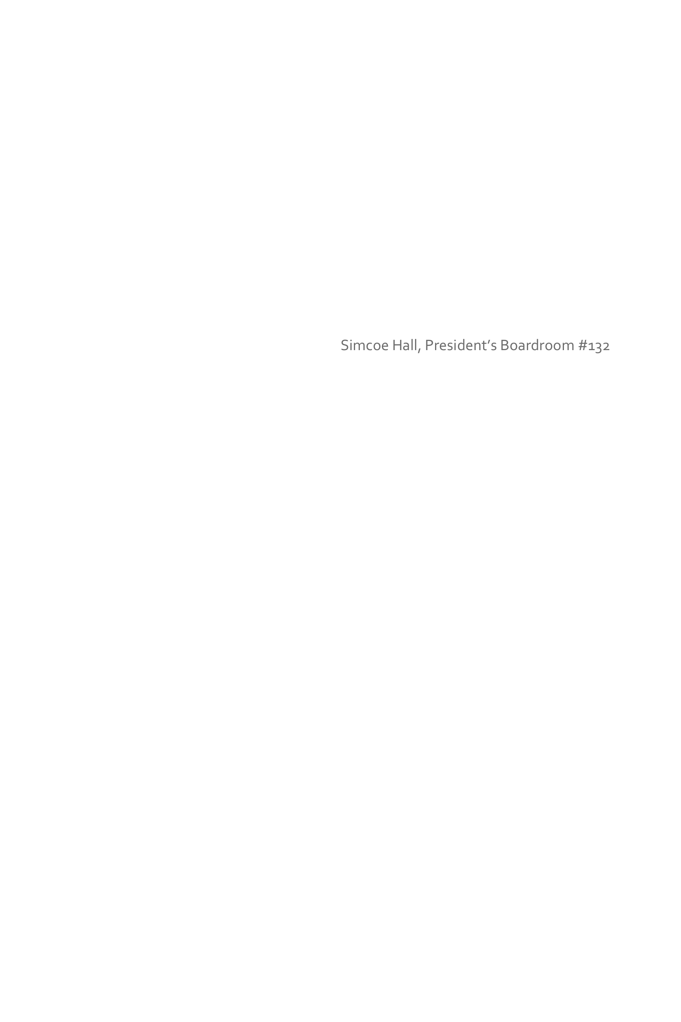 

Simcoe Hall, President’s Boardroom #132

Thursday, May 19, 2016 2:00pm to 4:00pm  

Thursday, June 16,2016 2:00pm to 4:00pm

Simcoe Hall, President’s Boardroom #132

Simcoe Hall, President’s Boardroom #132

Thursday, March 17, 2016 2:00pm to 4:00pm  

Thursday, April 21, 2016 2:00pm to 4:00pm

Simcoe Hall, President’s Boardroom #132

Simcoe Hall, President’s Boardroom #132

Thursday, January 14, 2016 2:00pm to 4:00pm  

Thursday, February 18, 2016 2:00pm to 4:00pm

Simcoe Hall, President’s Boardroom #132

Simcoe Hall, President’s Boardroom #132

Thursday, October 15, 2015 2:00pm to 4:00pm

Thursday, September 17, 2015 2:oopm to 4:00pm

Thursday, December 10, 2015 2:00pm to 4:00pm

Thursday, November 19, 2015 3:00pm to 4:00pm

Simcoe Hall, President’s Boardroom #132

Simcoe Hall, President’s Boardroom #132

Simcoe Hall, President’s Boardroom #132

TBD

### Location

### Date and time

## WGIRM Meeting Schedule 2016 Cycle *(Tentative)*

University of Toronto

Working Group on Information Risk Management