1. Assignment 1 feedback

* Layout problems - wasted space. – I reduced picture sizes, removed from pictures that were not needed and added more text content.
* Font glitch - I used the font style (serif) which is similar to the regular font style of the page as a CSS reset font.

1. Assignment 2 User Acceptance Testing feedback

* Picture size too big, over 1mb – I reduced pictures’ sizes.
* Form width too small – I reduced the picture width and increased the width of the form to favour form.
* Hamburger logic – I reworked the hamburger JavaScript function, such that on load, the nav menu is hidden, the hamburger and logo are shown. When the hamburger is clicked, the logo is reduced to a small thumbnail that appears on the left and the nav menu is shown.
* Hamburger and nav menu logic, i.e. When the logo is hidden on mobile view and the viewport is resized to tablet or desktop, it does not appear as it should in the tablet or desktop view – I reworked the hamburger JavaScript function and added extra styling to the nav menu

1. Assignment 2 Quality Assurance Testing for valid HTML results

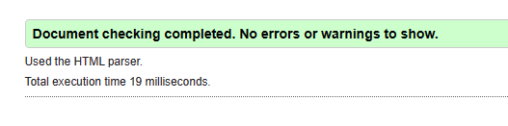

Figure 1 - Index page HTML Validator Check

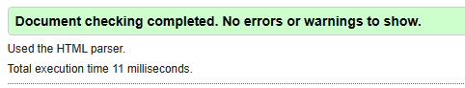

Figure 2 - About page HTML Validator Check

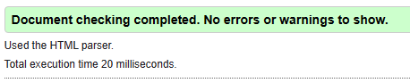

Figure 3 - Articles page HTML Validator Check

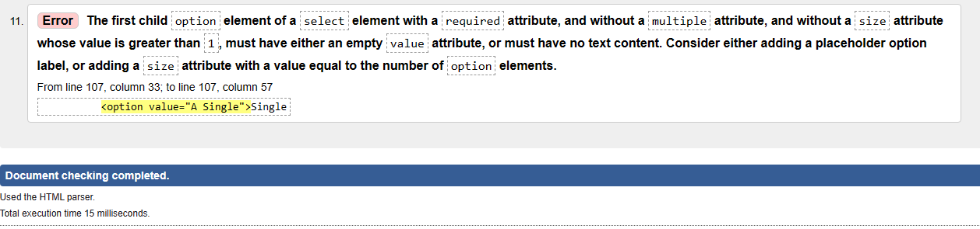

Figure 4 - Orders page HTML Validator Check 1

Adding an option with no value in the select element:

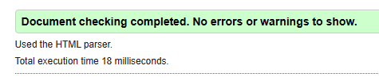

Figure 5 - Orders page HTML Validator Check Corrected

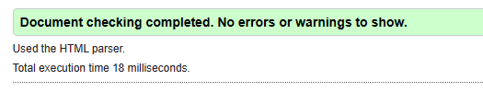

Figure 6 -Contact page HTML Validator Check

1. Assignment 2 Usability Testing feedback

Questions:

1. Are you able to learn about the BusyBee company from the site?
2. Are you able to learn anything about flowers from the site?
3. Are you able to navigate pages on the site?
4. Are you able to place an order on the site?
5. Are you able to send feedback on the site?

Feedback from user 1:

|  |  |  |  |  |  |
| --- | --- | --- | --- | --- | --- |
|  | 1 (Not Satisfied) | 2 (Somewhat Satisfied) | 3 (Averagely Satisfied) | 4 (Satisfied) | 5 (Very Satisfied) |
| Q1 |  |  |  |  |  |
| Q2 |  |  |  |  |  |
| Q3 |  |  |  |  |  |
| Q4 |  |  |  |  |  |
| Q5 |  |  |  |  |  |

Feedback from user 2:

|  |  |  |  |  |  |
| --- | --- | --- | --- | --- | --- |
|  | 1 (Not Satisfied) | 2 (Somewhat Satisfied) | 3 (Averagely Satisfied) | 4 (Satisfied) | 5 (Very Satisfied) |
| Q1 |  |  |  |  |  |
| Q2 |  |  |  |  |  |
| Q3 |  |  |  |  |  |
| Q4 |  |  |  |  |  |
| Q5 |  |  |  |  |  |

Feedback from user 3:

|  |  |  |  |  |  |
| --- | --- | --- | --- | --- | --- |
|  | 1 (Not Satisfied) | 2 (Somewhat Satisfied) | 3 (Averagely Satisfied) | 4 (Satisfied) | 5 (Very Satisfied) |
| Q1 |  |  |  |  |  |
| Q2 |  |  |  |  |  |
| Q3 |  |  |  |  |  |
| Q4 |  |  |  |  |  |
| Q5 |  |  |  |  |  |