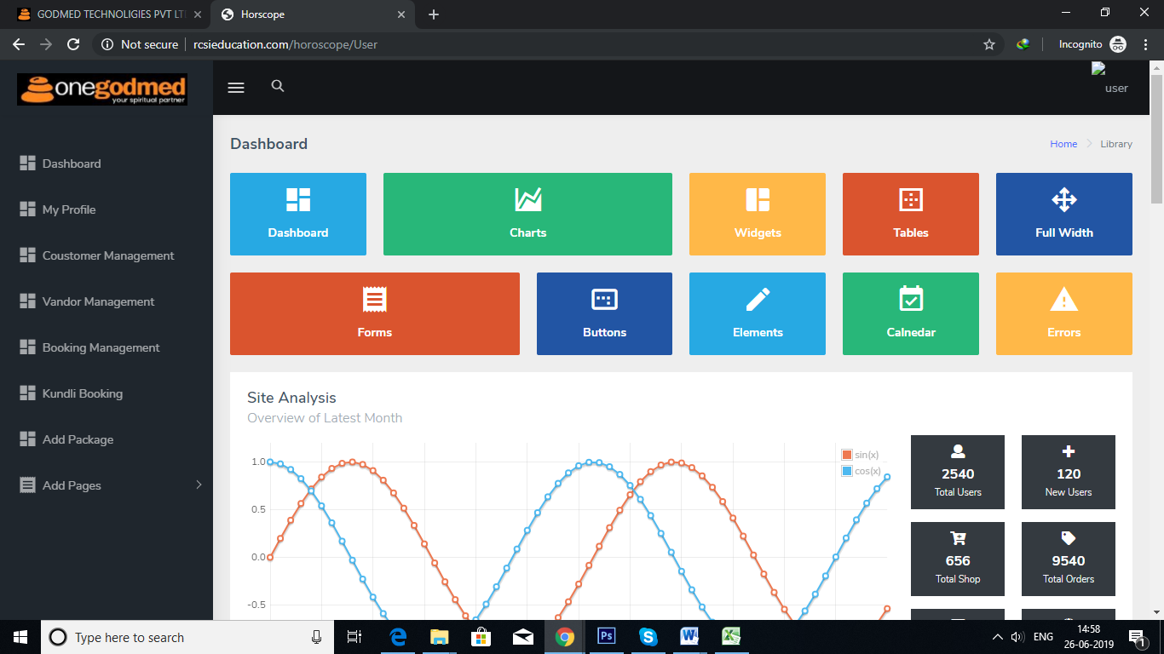

1. Total Vendor
2. Total Customer
3. Total Bookings
4. Total Kundali/Horoscope Booking

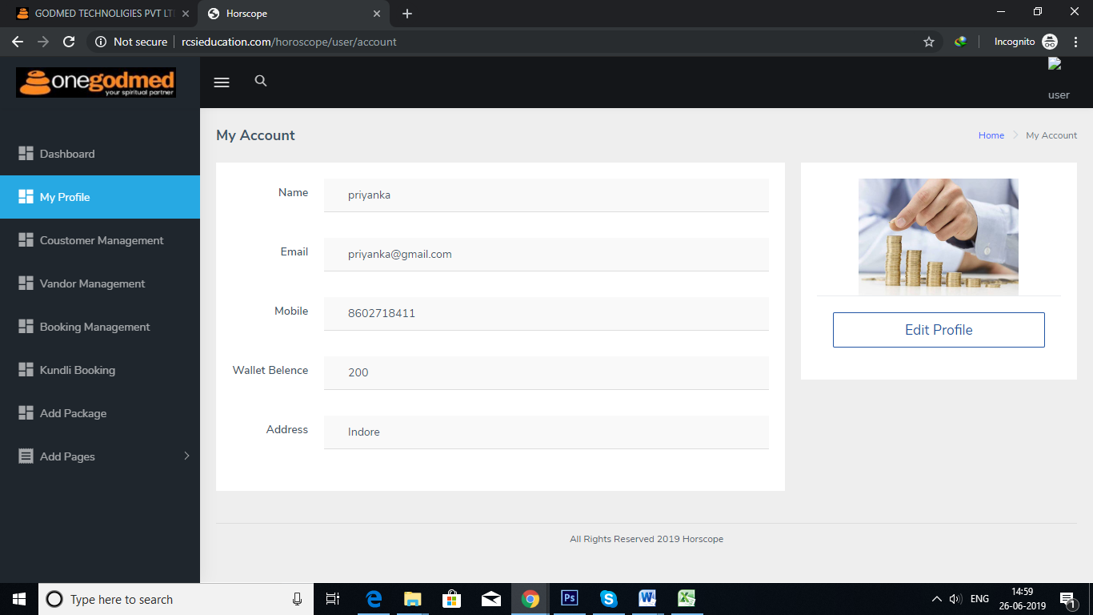

Don’t Required My profile in admin panel

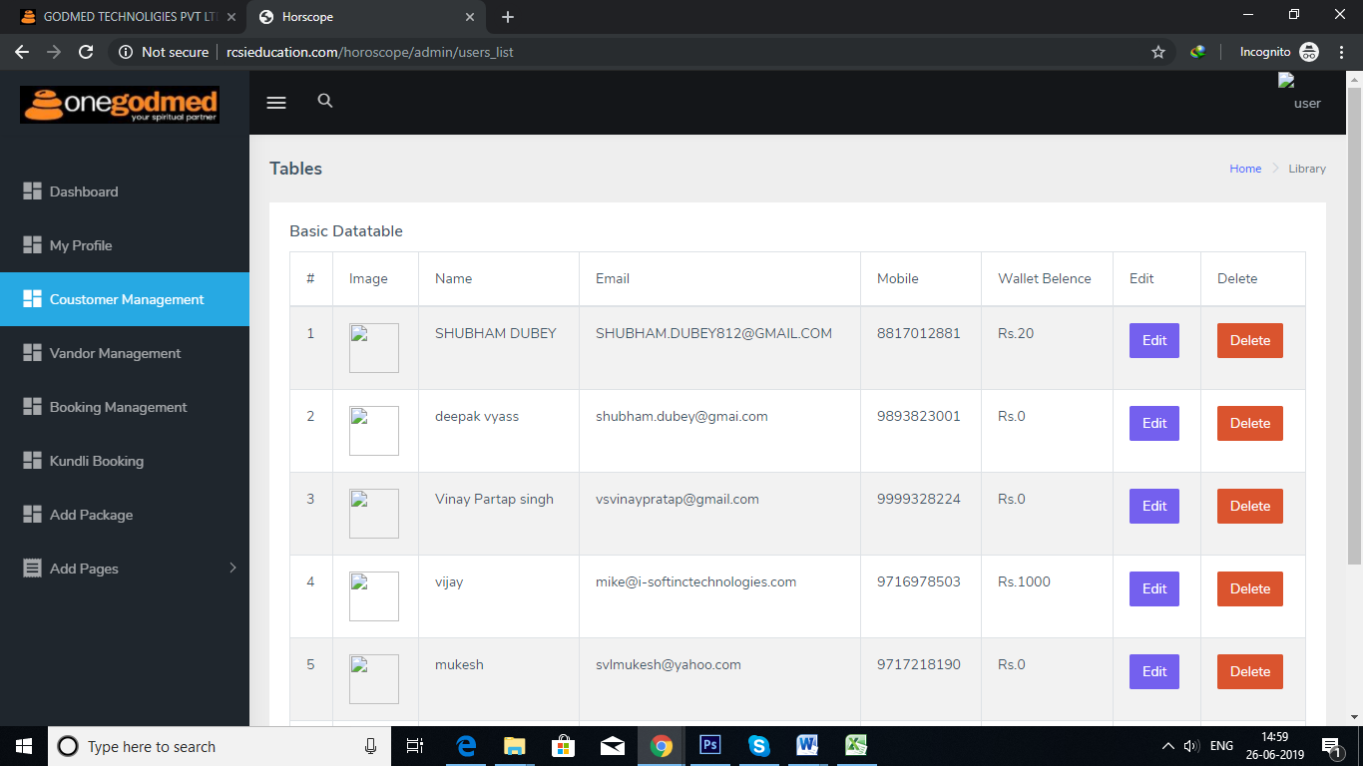

1. Correct Customer Spelling
2. Add Address

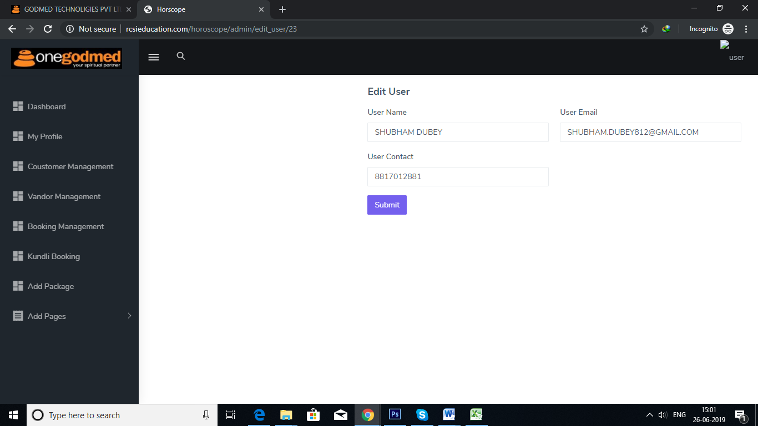

Edit User Profile**(Admin Can update all the information)**

1. Add User Image
2. Add Customer Address
3. Wallet Balance.

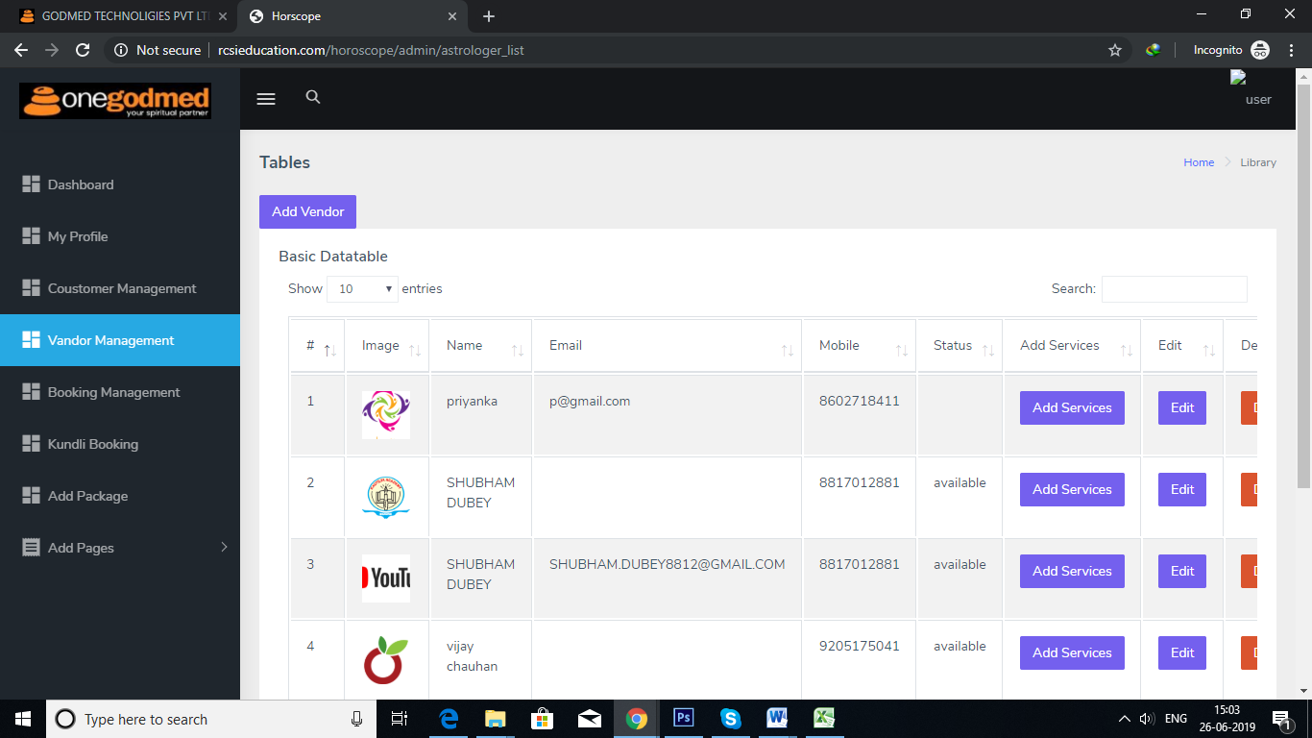

1. Correct Vendor Spelling .

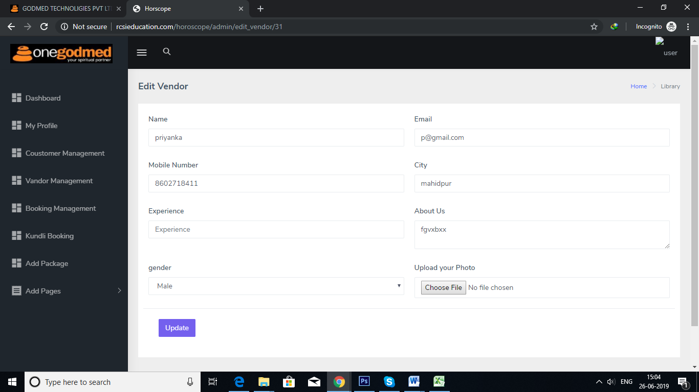

Edit Vendor

1. Add Vendor Status button (drop down value 1. Online, Offline, Busy, inactive)
2. Experience
3. Expertise
4. About me

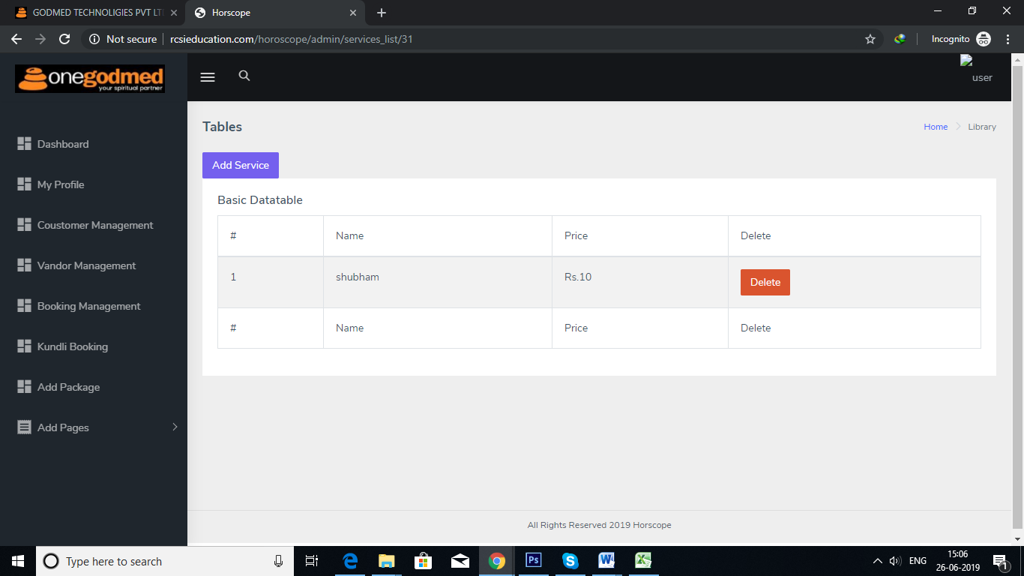

Add Vendor Service

1. Add Price Unit Like (Min, Weeks)
2. Add Edit Service Button

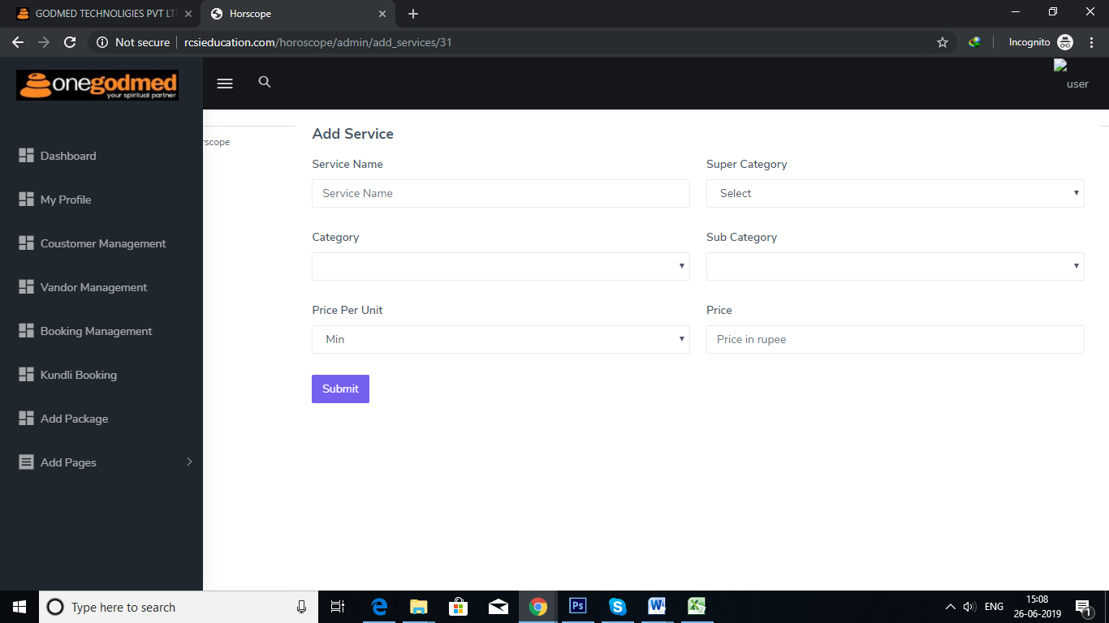

Add vendor Service

Vedic Astrology ,

S.no Service Name, Main Category, Sub Category, Vendor Price, Customer Price, Price Unit

1 Marrige Vedic ast Marrige & Child 20/- 50/- per min

Vedic Healing, Course servies

S.no Service Name, Main Category, Sub Category, Vendor Price, Customer Price, Price Unit,Duration

1 Marrige Vedic ast Marrige & Child 2000/- 50000/- Week 10

**Booking History**

Vedic Healing

S.no , Customer Name, Customer Address, Vendor Name, Services name, Price, Duration Appointment Start Date, Appointment End Date Time, Booking Date, Booking no, Change Status button (Drop down:- Cancel Complete, Running)

Course

S.no , Customer Name, Customer Address, Vendor Name, Services name, Price, Duration Appointment Start Date, Appointment End Date Time, Booking Date, Booking no, Change Status button (Drop down:- Cancel Complete, Running)

Vedic Astrlogy

S.no , Customer Name, Customer Address, Vendor Name, Services name, Price, Duration Appointment Date, Time, Booking Date, Booking no, Change Status button (Drop down:- Cancel Complete, Running)

Pooja

Online /Offline

S.no , Customer Name, Customer Address, Mobile no, Vendor Name, Services name, Price, Duration Appointment Date, Time, Booking Date, Booking no, Change Status button (Drop down:- Cancel Complete, Running)

Kundali/Horoscope

S.no , Customer Name, Customer Address, Services name, Price, Booking Date, Booking no, Upload Button (Drop down:- Cancel Complete, Running)

Vendor Rating

S.no Vendor Name, Customer Name, Rating, Comment Edit, Delete

1 vijay vashu 4 Goo service

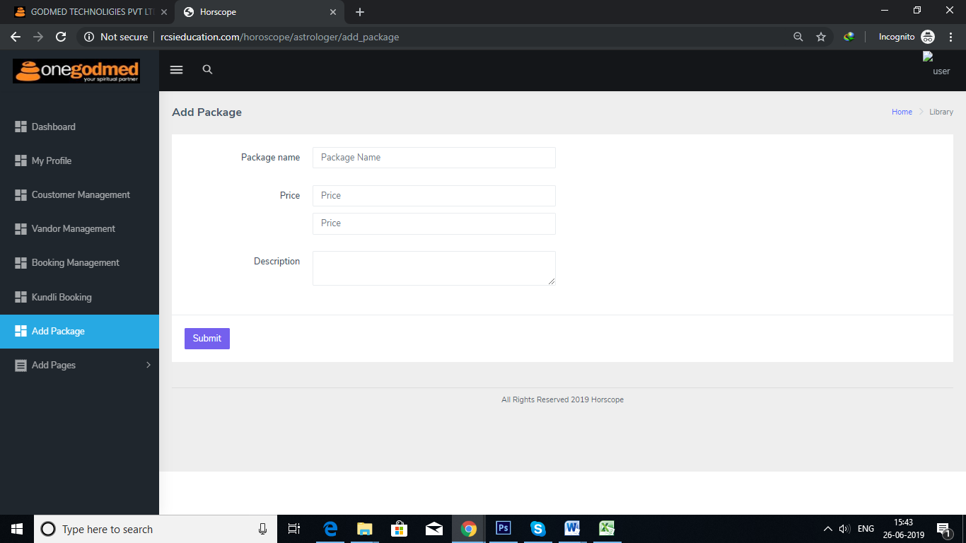Add Package Change with Wallet Package

S.no Package Name, Package Price Edit/ Delete

1 Gold 1000