

CST3310 – Business Intelligence
(Coursework 2)
Case Study: Esports Tournament Insights
O’Neil Obidiaso
M01073041

Submitted on: 12/12/2025
Computer Science Department
Faculty of Science & Technology

1. Introduction
This project analyses a dataset containing the top 200 highest-paying esports tournaments between 2014 and 2019, sourced from Kaggle. The dataset provides detailed information about major global competitive events such as The International (Dota 2) and the Fortnite World Cup, capturing essential attributes including tournament location, duration, game title, team format, and total prize pool. These attributes collectively offer insight into the evolution of high-value esports competitions and the geographical and financial distribution of major events.

Scenario and Business Intelligence Context
This dataset is highly relevant for strategic decision-making within the esports industry. Tournament organisers, publishers, investors, and esports marketing teams rely on historical tournament data to determine where to allocate resources, which game titles generate the highest engagement, and how prize pool trends influence audience growth and sponsorship value. By analysing this dataset, decision-makers can identify profitable regions, forecast future prize pool expectations, and evaluate which game ecosystems sustain competitive interest over time. This analysis directly supports business intelligence activities such as market expansion planning, event budgeting, and investment prioritisation.

Data Cleaning and Preparation
The dataset required no corrections, as it contained no missing values, duplicates, or inconsistent data types. However, if cleaning had been necessary, appropriate steps would include checking for invalid dates (e.g., End Date preceding Start Date), verifying extreme prize pool outliers against public tournament records, standardising country/city names, and converting dates into consistent formats suitable for Tableau. These processes ensure data completeness, accuracy, and reliability prior to visual and data-mining analysis.

2. Data Analysis and Visualisation
This section presents the visual analysis of the dataset using Tableau, focusing on uncovering trends in prize pools, game popularity, tournament locations, and participation formats. A total of ten visualisations were developed, beginning with broad descriptive overviews and progressing into more detailed patterns that support deeper interpretation. Together, these visualisations highlight how global esports tournaments evolved between 2014 and 2019 and reveal the key factors influencing esports growth during this period.

2.1 Top 10 Countries by Number of Tournaments (Bar Chart)
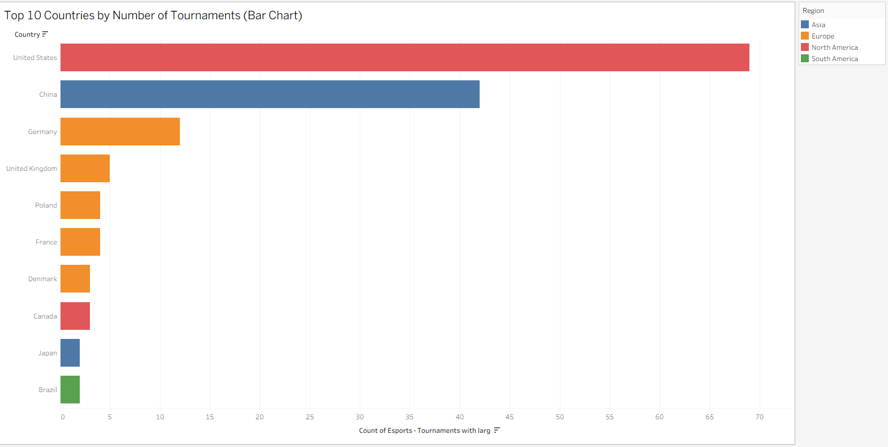
Figure 1: Countries Hosting the Most Esports Tournaments.
This chart shows the distribution of tournaments across the top esports-hosting countries. The United States (69) and China (42) dominate, followed by Germany (12), the United Kingdom (5), and several other countries hosting fewer events such as Poland, France, Denmark, Canada, Japan, and Brazil.
The results reveal a strong concentration of tournaments in North America and Asia, reflecting established esports infrastructures and investment. Europe hosts moderately fewer events, while emerging markets like Brazil and Japan show early growth.
Overall, tournament activity is clustered in traditional esports hubs, highlighting potential opportunities for expansion in underrepresented regions.

2.2 Total Prize Money by Country (Bar Chart)

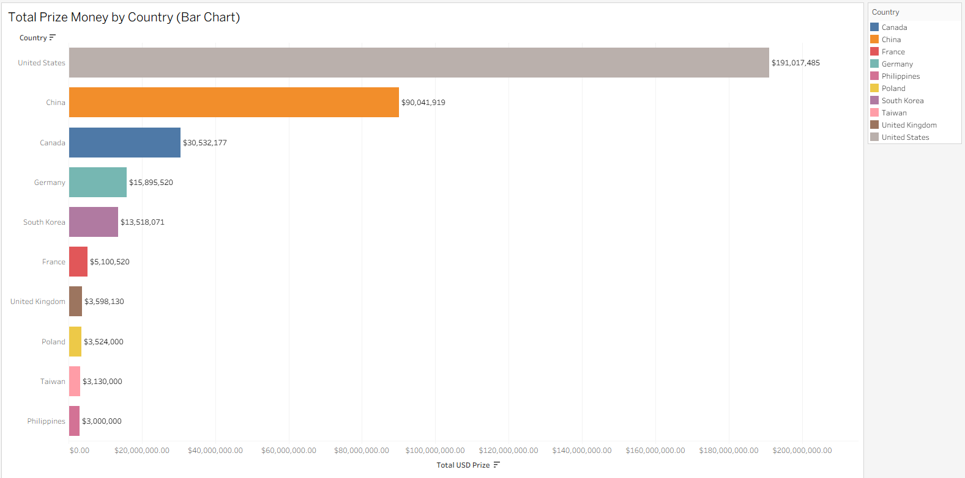
Figure 2: Total Prize Money Across Countries.

This chart compares the total prize money distributed by each country. The United States leads with $191M, followed by China ($90M) and Canada ($30.5M). Other countries such as Germany, South Korea, France, the UK, Poland, Taiwan, and the Philippines show smaller totals.
The distribution shows high-value tournaments are concentrated in a few countries, mainly in North America and Asia. Europe contributes moderately, while the rest of the world sees significantly smaller prize pools.
This visual highlights how global prize money is dominated by a small number of established esports nations.

2.3 Prize Money Trend Over Time (Line Chart)
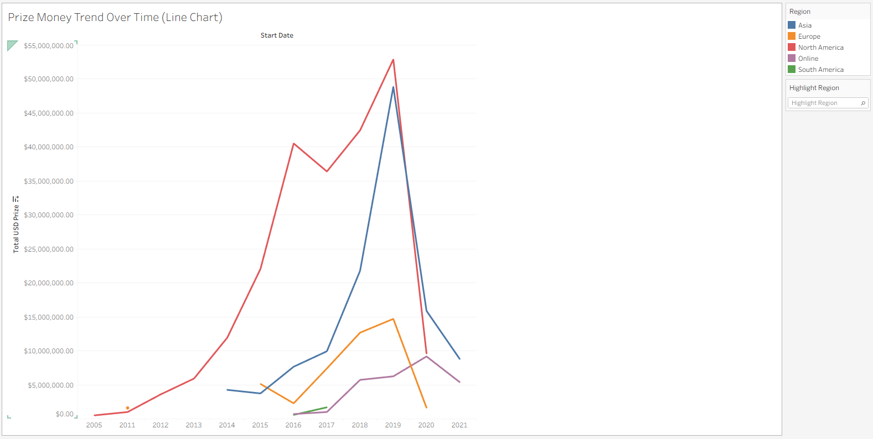
Figure 3: Esports Prize Money Growth Trend.

This line chart displays prize pool trends over time across regions, including online tournaments. Prize amounts rise sharply toward 2018–2019 before dropping around 2020.
Asia and North America see the strongest growth, while Europe grows at a smaller scale. South America increases slightly but remains low overall.
Online tournaments increase rapidly from 2016 onward and peak around 2020, reflecting the shift to remote events.
Overall, the trend highlights rapid global growth and the rising importance of online competitions during periods when physical events were disrupted.

2.4 Global Tournament Distribution (Map)
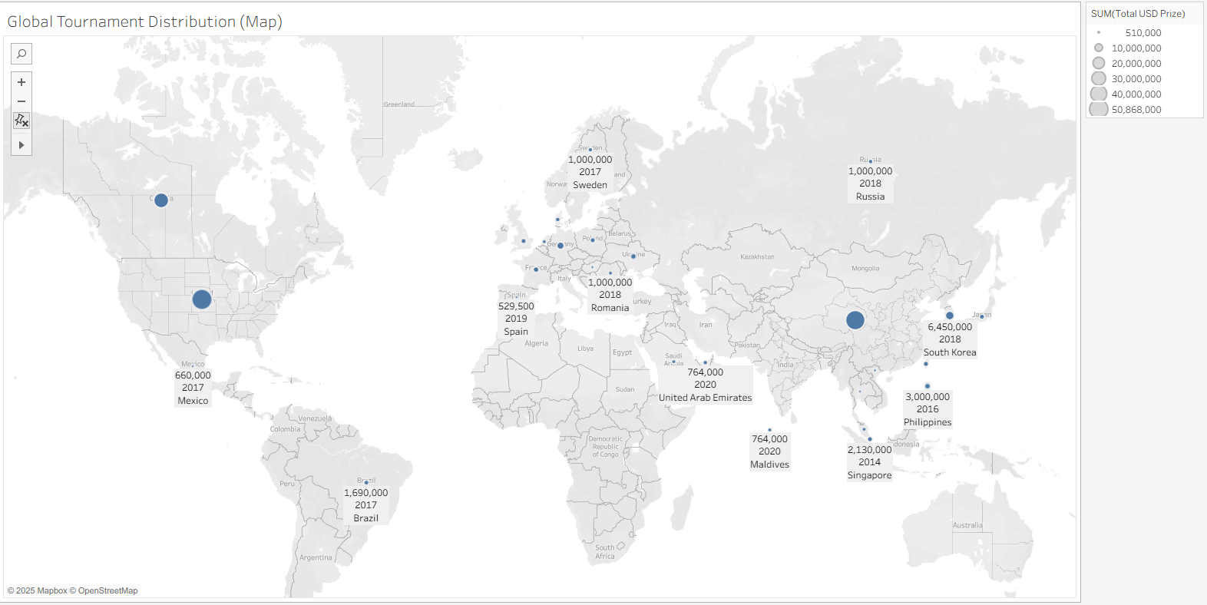
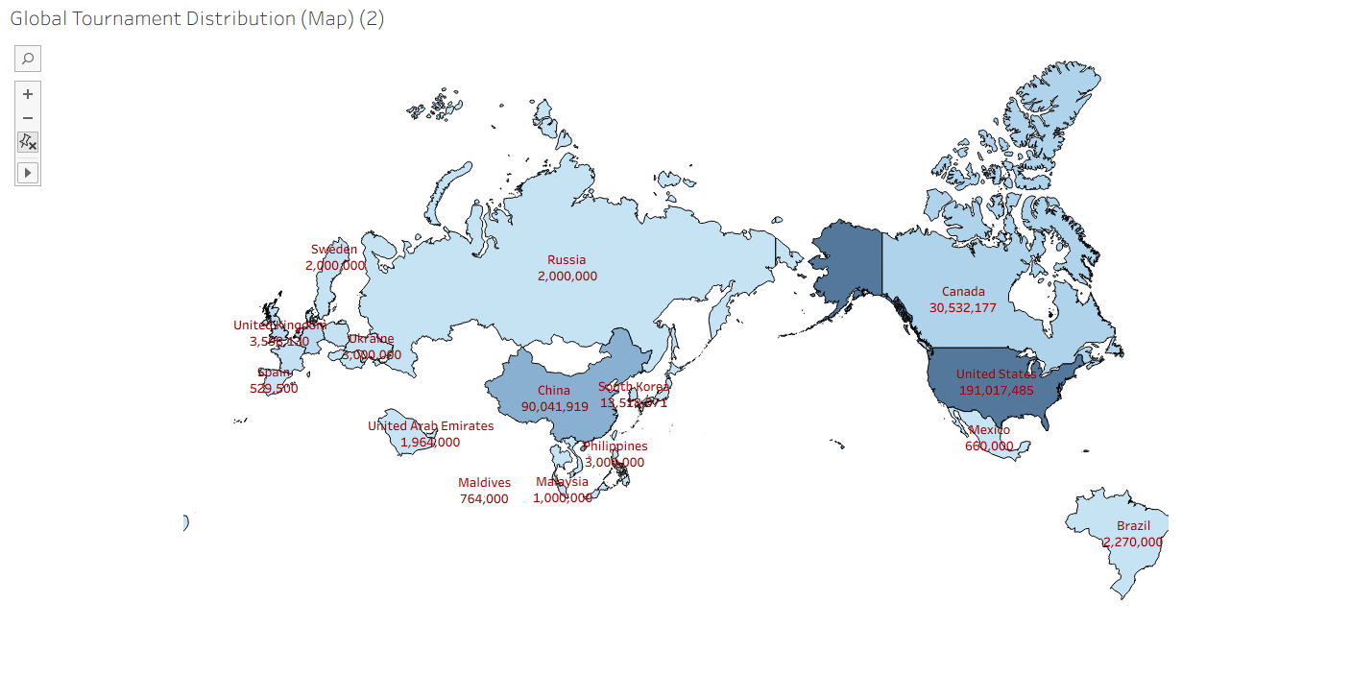
Figure 4: Global Distribution of Esports Tournaments.

This map visualises total prize money by country. The United States and China clearly stand out as the two major hubs, with Canada following behind. South Korea and Germany also show notable contributions.
Most countries display minimal prize values, indicating limited hosting of top-tier tournaments.
The results show that high-value events remain concentrated in developed esports markets with strong industry infrastructure.

2.5 Prize Money Trend Over Time (Line Chart)
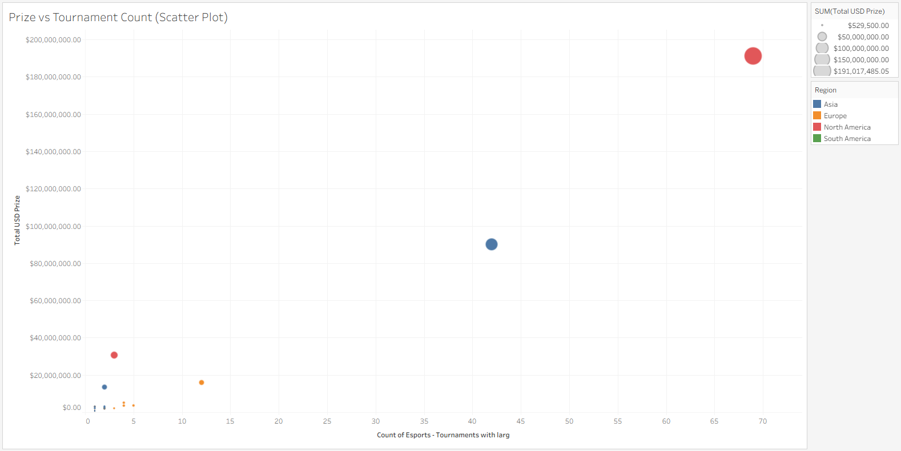
Figure 5: Relationship Between Tournament Count and Prize Value.

The scatter plot compares each country’s number of tournaments with its total prize money.
The United States hosts the most tournaments and earns the highest prize total. China follows with fewer tournaments but very high total prize money. Canada appears as a major outlier, few tournaments but extremely high prize totals, driven by a small number of massive events.
Most other countries cluster toward lower prize and lower tournament counts.
This visual shows that holding many tournaments does not necessarily lead to higher total prize money.

2.6 Prize Distribution by Country (Box Plot)
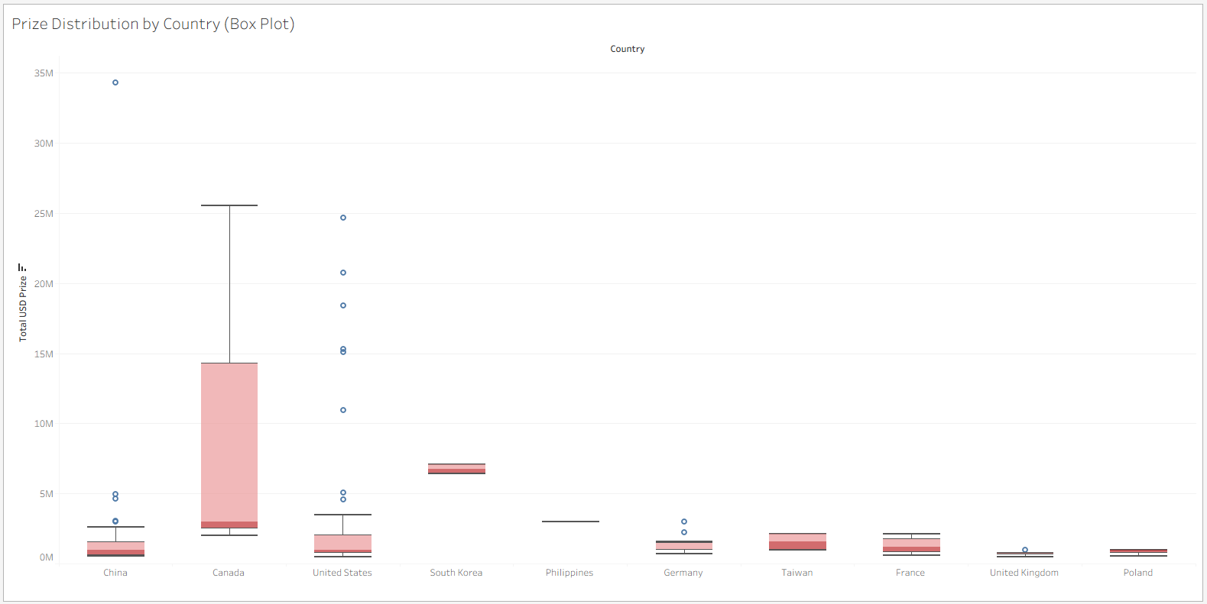
Figure 6: Prize Money Distribution Across Countries.

The box plot shows prize distributions for the top 10 countries.
China, the U.S., and Canada show wide ranges and several extreme outliers, representing landmark tournaments such as The International.
Countries like South Korea, Taiwan, and the Philippines show narrower ranges with more consistent prize levels.
European countries show moderate ranges with occasional spikes.
Overall, a small number of mega-events heavily influence total prize earnings.

2.7 Pie Chart – Prize Money by Region
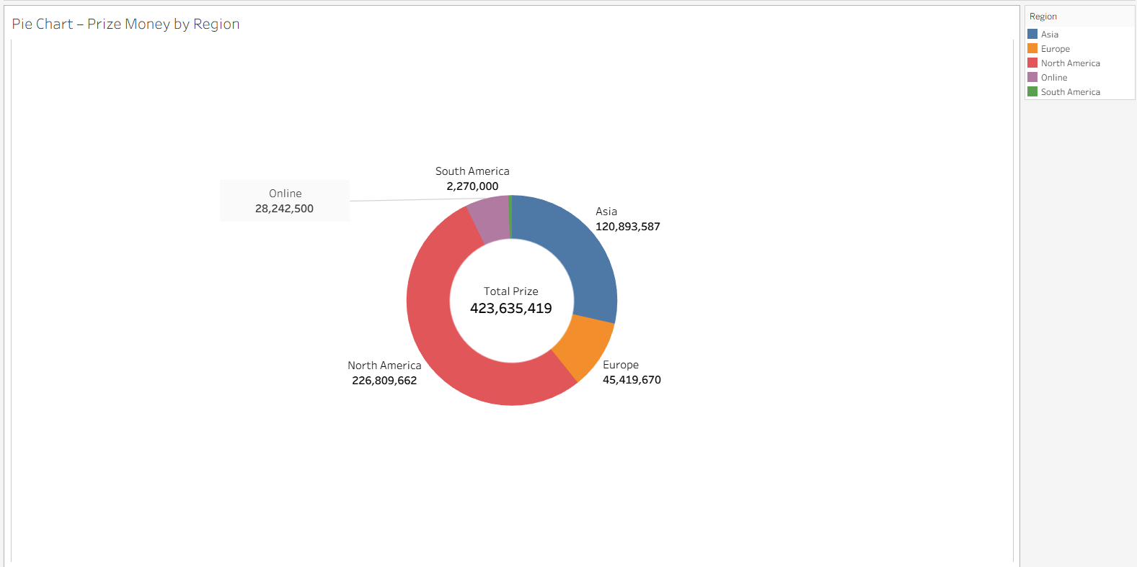

Figure 7: Prize Money Distribution Across Regions.
This chart highlights how prize money is distributed across regions.
North America and Asia lead with $226.8M and $120.9M respectively Online tournaments follows with $28.2M, while Europe contributes $5.4M and South America $2.27M.
The results show a highly uneven distribution, dominated by North America, Asia, and online events.

2.8 Stacked Bar – Team vs Solo by Region
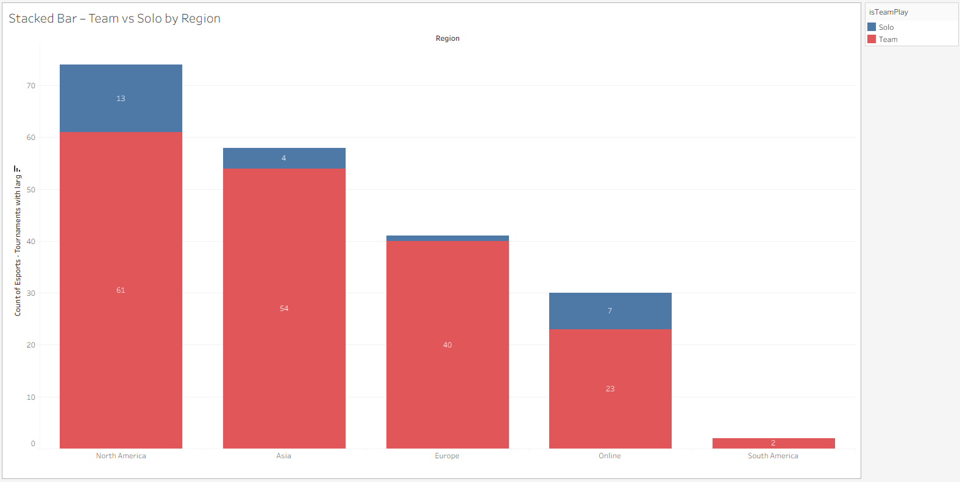
Figure 8: Regional Distribution: Team vs Solo.

Team-based tournaments dominate globally.
North America records 61 team and 13 solo tournaments, Asia has 54 team and 4 solo, and Europe has 40 team with only 1 solo. Online tournaments include 23 team and 7 solo events, while South America hosts only 2 team events.
Team formats are clearly the global standard for high-value tournaments.

2.9 Top Countries by Solo vs Team Events (Side-by-Side Bar Chart)
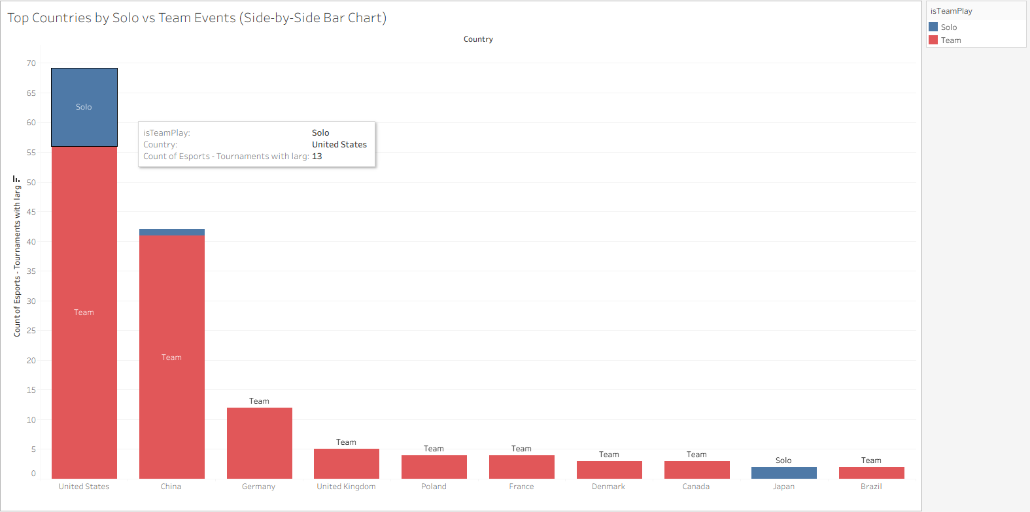
Figure 9: Country-wise Solo and Team Event Comparison.

This chart compares team and solo events per country.
The U.S. is unique, with 56 team and 13 solo tournaments. China focuses almost entirely on team events (41 team, 1 solo). Germany, Poland, France, Denmark, and Canada all host only team tournaments, while Japan hosts 2 solo events.
This reveals clear national differences in tournament format preferences.

2.10 Prize Money Trend Over Time (Line Chart)
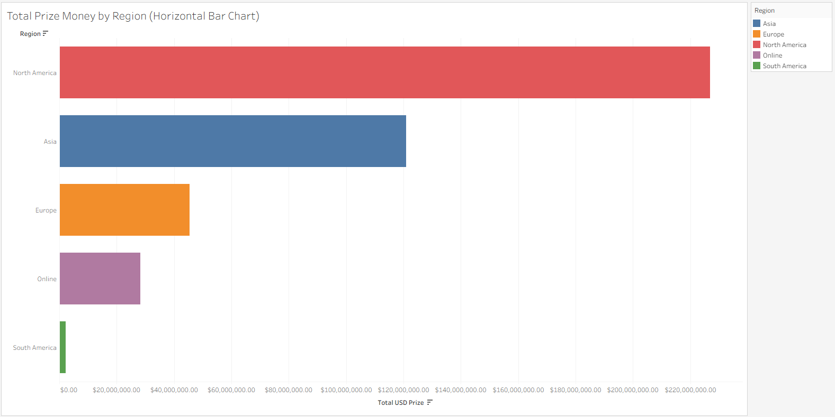
Figure 10: Regional Esports Prize Distribution.

North America leads with $226.8M, followed by Asia with $120.9M. Europe contributes $45.4M, online tournaments contribute $28.2M, and South America contributes only $2.27M.
This confirms that prize pools are heavily concentrated in a small number of regions.
More importantly is to note that Online tournaments are increasingly important, reflecting shifts in competition formats and the rising influence of virtual events in the global esports ecosystem.

Cross-Visualisation Insights
- Tournament Count vs Prize Money
The U.S. hosts the most tournaments, but Canada matches high prize totals with far fewer events, showing the impact of large flagship tournaments.

- Competitive Format vs Prize Distribution
Regions with more team-based tournaments (North America and Asia) also generate the highest prize money.

- Shift Toward Online Competitions
Online tournaments rise sharply after 2016 and account for a significant share of global prize money.

- Impact of Outliers
Mega-events in the U.S., China, and Canada create extreme outliers and heavily influence overall prize totals.

- Opportunities in Underrepresented Regions
South America has extremely low tournament activity and prize totals, indicating clear growth potential.

- Solo vs Team National Patterns
The U.S. has a strong solo-tournament potential, while most other top countries focus on team-based formats.

Summary and Conclusion
Across all visualisations, the analysis shows that esports tournaments are heavily concentrated in North America and Asia, both in frequency and prize money. Canada achieves high prize totals through a small number of large events, while Europe contributes moderately and South America remains largely underrepresented. Prize pools grow significantly up to 2018–2019 before declining in 2020, with online tournaments increasing sharply from 2016 onward. Team-based formats dominate globally, although the U.S. has a high number of solo tournaments. Outlier events play a major role in shaping prize distributions, especially in the U.S., China, and Canada. Overall, the findings highlight concentration in established hubs, the rise of online competitions, and clear opportunities for growth in emerging regions.

Selection of Data Mining Algorithm and Data Pre-processing
For the analysis of the top 200+ esports tournaments dataset, K-Means clustering was chosen as the data mining algorithm. K-Means is an unsupervised learning technique that groups similar instances into clusters based on numerical features. It works by iteratively assigning data points to the nearest cluster centroid and updating centroids until the clusters stabilize, minimizing the within-cluster variance.
K-Means is suitable for this dataset because it allows us to explore natural groupings of tournaments based on prize pools, regions, and years without needing a predefined target variable. The visualizations in the previous section indicated clear patterns in prize money distribution across countries and regions (Figs 2, 5, 7). These trends suggest that tournaments may naturally fall into meaningful groups based on financial scale, geography, or year—making clustering a suitable method for uncovering hidden patterns without needing a predefined target variable.
Selected Variables
- Numerical:
  - TotalUSDPrize
  - Year
- Categorical (encoded in Orange):
  - Region
  - Game Name
Since K-Means is an unsupervised algorithm, a class variable is not required.
Data Quality and Pre-processing
The dataset was clean and required minimal pre-processing:
- No missing values
- No duplicate rows
- All fields stored in the correct format
- No extreme outliers that would distort numerical scaling
However, to ensure the algorithm performed optimally:
- Categorical variables (Region, Game Name) were one-hot encoded in Orange.
- TotalUSDPrize was normalized to avoid large prize pools dominating the clustering results.
If anomalies were present such as missing data, inconsistent formatting, or extreme outliers; they could have been handled using:
- Mean/median imputation
- Removal of corrupted rows
- Normalisation or winsorisation of extreme values
These steps prepared the dataset for multiple iterations of K-Means and allowed meaningful clustering of esports tournaments by prize scale and temporal patterns.

- Data Mining (K-Means Clustering)
The K-Means algorithm was applied in Orange to identify natural groupings within the esports tournaments dataset. Its ability to cluster data based on similarity makes it suitable for detecting patterns in prize values, tournament scale, and changes across years.

  - Implementation Process
Three iterations were performed to evaluate the impact of different feature combinations:
Numerical fields were normalized, and categorical fields were one-hot encoded. The number of clusters (k) was set to 3.

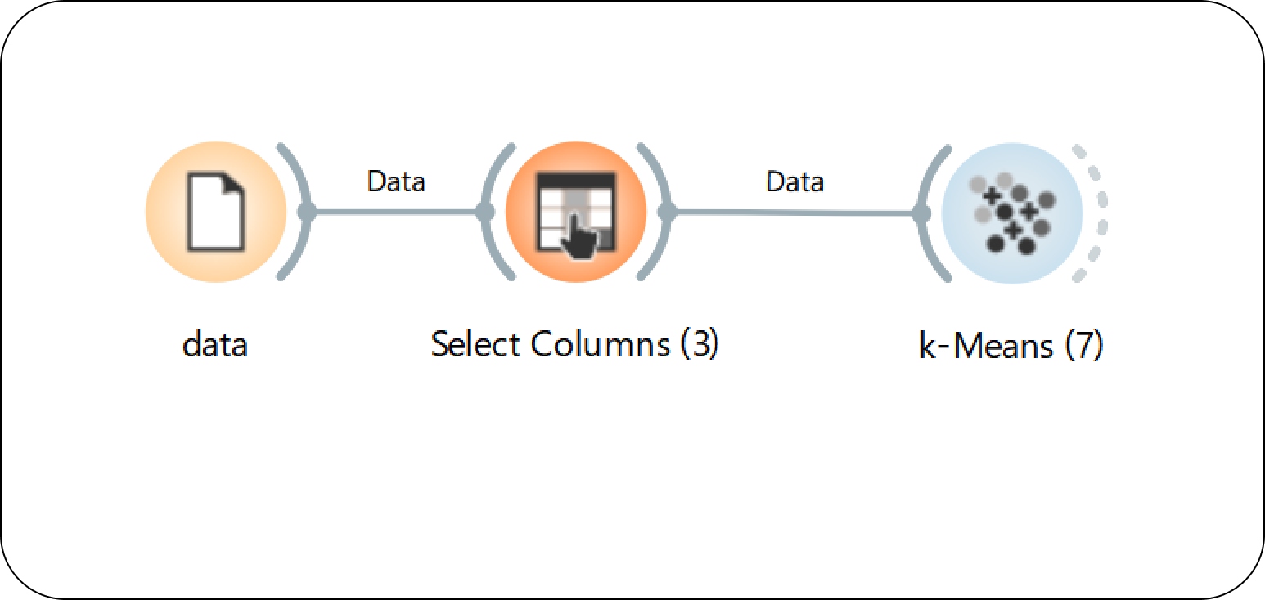
Figure 4.1 – Orange Workflow Setup
This screenshot shows the complete Orange workflow used for the K-Means analysis, including the File, Select Columns, and K-Means widgets.

Iteration 1 – All Variables Included
Features: TotalUSDPrize, Year, Region, Game Name
Clusters:
- C1 = 7
- C2 = 144
- C3 = 54
Average Silhouette Score: 0.580862
Including Game Name introduced a high degree of variability, leading to overlapping clusters. C2 contained most tournaments and lacked clear internal structure. Regional influence was visible, but cluster separation was weak.

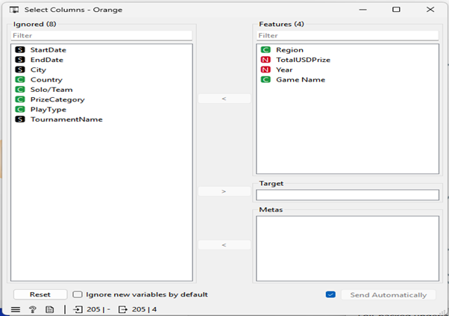
Figure 4.2 – Iteration 1: Select Columns (All Features Included)
This screenshot displays the selected features for Iteration 1, where both numerical and categorical variables including Game Name were used.

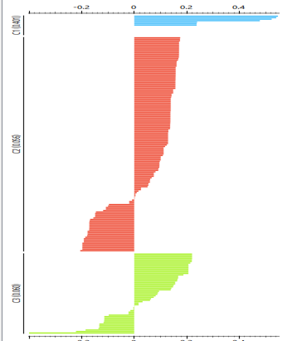
Figure 4.3 – Iteration 1: K-Means Output and Silhouette Scores
This screenshot shows the cluster sizes and silhouette values generated during Iteration 1 using all selected features.

Iteration 2 – Removing Game Name
Features: TotalUSDPrize, Year, Region
Clusters:
- C1 = 52
- C2 = 146
- C3 = 7
Average Silhouette Score: 0.603068
Without Game Name, clustering improved. C3 represented high-prize tournaments, and the silhouette score increased slightly. Regional patterns became more distinguishable, though some overlap persisted.

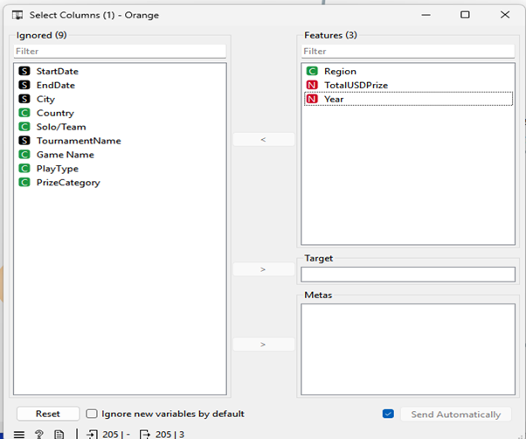
Figure 4.4 – Iteration 2: Select Columns (Game Name Removed)
This screenshot shows the revised feature selection for Iteration 2 after removing Game Name to improve clustering clarity.

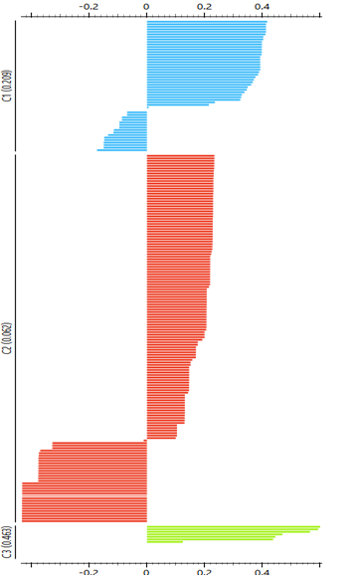
Figure 4.5 – Iteration 2: K-Means Output and Silhouette Scores
This screenshot captures the Iteration 2 clustering results, including updated cluster sizes and silhouette scores.

Iteration 3 – Using Only Numerical Features
Features: TotalUSDPrize, Year
Clusters:
- C1 = 159 (low-prize tournaments)
- C2 = 39 (medium-prize tournaments)
- C3 = 7 (high-prize tournaments)
Average Silhouette Score: 0.664604
With only numeric fields, cluster separation strengthened significantly. The highest silhouette score was recorded, showing that prize values and year form the most meaningful basis for grouping. The three clusters correspond to intuitive financial tiers commonly observed in esports.

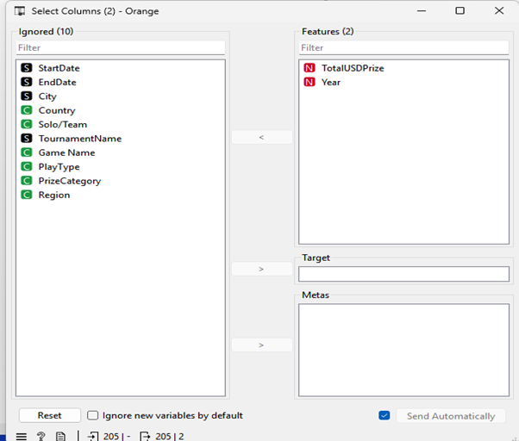
Figure 4.6 – Iteration 3: Select Columns (Only Numerical Features)
This screenshot displays the final feature selection in Iteration 3, using only numerical attributes for optimal clustering separation.

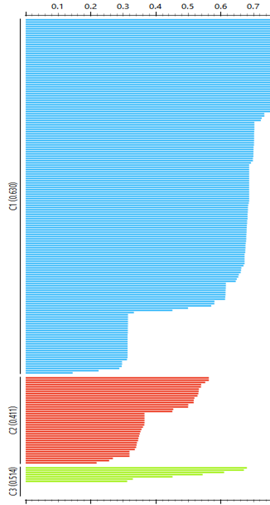
Figure 4.7 – Iteration 3: K-Means Output with Highest Silhouette Score
This screenshot shows the best-performing clustering results from Iteration 3, where the highest silhouette score was recorded.

  - Training/Test Split Analysis
A 70/30 training-test simulation was run for Iteration 3 to check cluster stability:

Cluster | Training Count | Training % | Test Count | Test %
C1 | 111 | 77% | 48 | 79%
C2 | 27 | 19% | 12 | 20%
C3 | 6 | 4% | 1 | 1%
Total | 144 | 100% | 61 | 100%

The percentages between training and test sets are nearly identical, indicating the clusters are stable and reproducible.

4.3 Interpretation and Findings
- Iteration 3 produced the clearest and most meaningful clusters, representing low-, medium-, and high-tier tournaments.
- High-prize tournaments are rare but highly influential, reflecting real esports market dynamics.
- Low-prize tournaments dominate numerically, suggesting a long-tail distribution of tournament value.
- Cluster stability and high silhouette score confirm that prize pool and year are the strongest predictors of tournament grouping.
- These patterns help explain structural differences in the esports ecosystem, such as event funding concentration and yearly shifts in tournament organisation.

- Data Ethics
Throughout the analysis of the esports tournament dataset, ethical, legal, and professional considerations were carefully followed to ensure the work met responsible data-handling standards.
Ethical Considerations:
The dataset did not contain personal or sensitive information; however, ethical integrity was still essential.
I ensured:
- Visualisations were not misleading (e.g., avoiding inappropriate scales or misaggregated data).
- Interpretations were accurate and did not exaggerate trends beyond the dataset’s scope.
- Limitations were clearly acknowledged. for example, the dataset only covers tournaments from 2014–2019, so conclusions were restricted to that period.

Legal Considerations:
The data was sourced from Kaggle under an open licence, meaning it could be legally downloaded, used, and analysed for academic work. No personal data (as defined under GDPR) was present, so issues such as data minimisation, consent, or anonymisation were not required. Nonetheless, proper citation ensures compliance with academic and copyright expectations.
Professional Considerations:
Professional responsibility requires accuracy, transparency, and accountability.
This was maintained by:
- Cleaning and preparing data in a way that maintains integrity
- Using correct methods and clearly documenting transformations
- Presenting unbiased findings supported by evidence
- Ensuring replicability by providing clear descriptions of tools, variables, and processes
Overall, the project adhered to ethical and professional standards expected in data analysis and business intelligence practice.
- Conclusion
6.1 Discussion of Overall Visualisation Results
The visualisation of the esports tournament dataset revealed several clear trends and patterns.
- Prize Distribution Trends:
The majority of tournaments offered relatively small prize pools, while only a few events had extremely high prizes.
High-prize tournaments, such as The International or Fortnite World Cup, dominate the top end of the prize spectrum, creating a clear skew in the dataset.
- Regional Patterns:
North America and China hosted a significant proportion of high-value tournaments.
Smaller prize tournaments were more evenly distributed across other regions, including Europe and emerging esports markets.
- Yearly Trends:
Over time, prize pools have generally increased, particularly for flagship tournaments, reflecting growing investment in competitive esports.
Overall, visualisations highlighted both the financial hierarchy of esports tournaments and regional concentrations, providing a clear overview of tournament landscapes.

6.2 Data Mining Results
K-Means clustering effectively categorized tournaments into three distinct tiers based on prize values:
- Cluster 1 (Low Prize): Predominantly regional or emerging events (159 tournaments)
- Cluster 2 (Medium Prize): Mid-tier international tournaments (39 tournaments), including notable online events and established but smaller international tournaments.
- Cluster 3 (High Prize): Elite events with multi-million-dollar prizes (7 tournaments)
Silhouette analysis confirmed that the model using only numerical features (Iteration 3) provided the highest cluster cohesion (average silhouette score = 0.6646), accurately reflecting the hierarchical structure of tournaments. Removal of categorical variables improved interpretability and cluster clarity.

6.3 Business Intelligence Implications
The findings from visualisation and K-Means clustering can provide actionable insights for tournament organizers, sponsors, and esports managers:
- Who Could Use the Findings:
- Esports tournament organizers
- Sponsors and investors
- Marketing and event strategy teams
- How They Could Use the Findings:
- Resource Allocation: Focus sponsorship or marketing on high-value tournaments for maximum visibility and ROI.
- Event Planning: Identify regions or types of tournaments that are underrepresented and plan events in emerging markets.
- Competitive Analysis: Benchmark tournaments against cluster categories to understand positioning within the industry.
- For What They Can Use the Findings:
- Investment Decisions: Sponsors can select tournaments that match their desired audience or prestige level.
- Strategic Expansion: Organizers can prioritize growth in regions with fewer high-value tournaments.
- Marketing Campaigns: Allocate budgets effectively according to cluster insights; e.g., high-prize tournaments for global campaigns, low-prize for local outreach.

Practical Use Cases
- Investment Decisions:
A sponsor seeking international reach should focus on high-tier tournaments primarily found in North America and China.

- Strategic Expansion:
Organizers looking to grow in developing markets can target Cluster 1 tournaments and increase prize pools to move toward Cluster 2.

- Marketing Campaigns:
Large global campaigns can be aligned with Cluster 3 events, while community-level outreach can be linked with smaller Cluster 1 tournaments.

In summary, the integration of visual analytics and K-Means clustering provides a comprehensive, data-driven understanding of the esports tournament ecosystem, highlighting financial stratification, regional dominance, and opportunities for strategic growth.

