Demographic Analysis

Craig O’Neill

February 28, 2018

devtools::install_github("brucekendall/PVA")

## Skipping install of 'PVA' from a github remote, the SHA1 (fa5d2aed) has not changed since last install.  
## Use `force = TRUE` to force installation

library(PVA)

## Loading required package: shiny

## Warning: package 'shiny' was built under R version 3.3.3

library(tidyverse)

## Warning: package 'tidyverse' was built under R version 3.3.3

## -- Attaching packages -------------------------------------------------------------------------------------------- tidyverse 1.2.1 --

## v ggplot2 2.2.1 v purrr 0.2.4  
## v tibble 1.4.2 v dplyr 0.7.4  
## v tidyr 0.8.0 v stringr 1.2.0  
## v readr 1.1.1 v forcats 0.3.0

## Warning: package 'ggplot2' was built under R version 3.3.3

## Warning: package 'tibble' was built under R version 3.3.3

## Warning: package 'tidyr' was built under R version 3.3.3

## Warning: package 'readr' was built under R version 3.3.3

## Warning: package 'purrr' was built under R version 3.3.3

## Warning: package 'dplyr' was built under R version 3.3.3

## Warning: package 'forcats' was built under R version 3.3.3

## -- Conflicts ----------------------------------------------------------------------------------------------- tidyverse_conflicts() --  
## x dplyr::filter() masks stats::filter()  
## x dplyr::lag() masks stats::lag()

library(popbio)

## Warning: package 'popbio' was built under R version 3.3.2

library(primer)

## Warning: package 'primer' was built under R version 3.3.3

## Loading required package: deSolve

## Warning: package 'deSolve' was built under R version 3.3.3

## Loading required package: lattice

## Step 1 Create Demographic Matrix

For the demographic matrix I am using a pre-breeding survey. The three stages that I am using are Tadpoles, Subadult, and Adult. Due to the semi-recent reclassification of the Yosemite population of the Yellow-Legged Frogs into it’s own distinct species, some of my data comes from studies done on Mountain Yellow-Legged Frogs (R. muscosa) rather than the Sierrian Yellow-Legged Frogs (R. Sierran).

For this demographic analysis I am only looking at breeding females. The sex ratio for this species has been observed as 1:1 (MYLF Conservation Assessment), and sex is determined at fertilization, with no environmental impacts affecting the sex determination. Therefore I am assuming that 0.5 * Eggs laid will be females.

The tadpole stage is includes the egg stage in the lifecycle (since the egg stage is very short). Subadults include recently metamorphed tadpoles, up until the frog reaches breeding size at approximately 40mm svl (snout/vent length). Adults reach maturity after approximately 1-2 years after metamorphisis (Source).

Studies have shown that a significantly large portion (99-98%) of fertilized eggs hatch into tadpoles (Source) after 18-20 days. Tadpole metamorphosis occurs between 1-2.5 years. I was not able to find specific data regarding the probability of whether tadpoles metamorphosis occurs after Year 1, or Year 2, however it appears from literature for higher elevation Mountain Yellow Legged Frogs (ie the population of interest in Yosemite National Park) they tend to take 2 years. To account for this, I am assuming that there is 60% chance that a tadpole remains as a tadpole after 1 year.

Survivorship of tadpoles into Subadults is relatively low. I could not find specific numbers for the Mountain Yellow-Legged Frogs, however found studies indicating that approximately 1-5% of tadpoles survive metamorphisis and become subadults across a variety of frog species (Source). For this analysis, I am assuming the lowest survivalship rate of 1%.

Subadult frogs typically progress into breeding adults after 1 year, however some may remain as subadults for a second year. I could not find any studies that clearly determined what proportion of subadults remain as subadults for a multiple year, but I have assumed it to be very small (10%). Mortallity of subadults is also very high, with only approximately 20% reaching the adult stage(MYLF Conservation Assessment), this is likely due to how metabollically expensive it is for the tadpole to complete metamorphisis, and the risk associated with being a smaller frog. These frogs are known to engage in canabalization, and being a subadult increases likelyhood of being eaten by a larger adult.

Adults, in comparison, have been found to have fairly high estimates. One assessment claims that over 90% of adults survive year to year, with other estimates suggesting between 56% and 86% (Source, Source). For this project I took the median value of 70%.

Reproduction only occurs in the adult stage. Breeding occurs within a distinct seasonal time period and female frogs only lay one egg mass per year. Eggmasses on average contain 150 to 300 eggs(Source). For this assessment I have assumed that 225 eggs on average are laid.

Breeding is constrained by the number of available females, so therefore this demographic analysis will only be looking at female population numbers. The sex ratio for this frog has been observed as 1:1 (MYLF Conservation Assessment), and I have found no indication that environmental factors contribute to whether or not an egg is female or not, so therefore I have assumed that half of the laid eggs will be female (112). A personal conversation with a herpatologist confirmed that for this species that would be a decent enough estimation (Conversation, Emily).

class_names <- c("Tadpole", "Subadult", "Adult")  
A <- matrix(c(0.6, 0, 16.128,  
 0.004, 0.25, 0,  
 0, 0.15, 0.70),  
 nrow = 3, ncol = 3, byrow = TRUE, dimnames = list(class_names, class_names))

The model we are using is pre-breeding. All subadults must first mature into adults before breeding can occur.

Due to time constraints this week, I used population count data from Survey Site 1764 to analyze the population demographics for the frog. This lake is the most surveyed lakes (55 surveys over 20 years). Following Knapp’s methodology to account for multiple surveys within the same year for a single lake I averaged the population counts. To build this model I set the starting population equal to the average abundance in the final year of the survey.

n_0 <- c(278, 297, 2682)  
time <- 10  
  
pop <- pop.projection(A, n_0, iterations = time)  
pop

## $lambda  
## [1] 0.7956404  
##   
## $stable.stage  
## Tadpole Subadult Adult   
## 0.98102745 0.00716303 0.01180952   
##   
## $stage.vectors  
## 0 1 2 3 4 5  
## Tadpole 278 43422.096 57050.4672 56110.6428 49448.4053 41384.9643  
## Subadult 297 75.362 192.5289 276.3341 293.5261 271.1751  
## Adult 2682 1921.950 1356.6693 978.5478 726.4336 552.5324  
## 6 7 8 9  
## Tadpole 33742.2217 27139.2301 21673.7468 17245.0311  
## Subadult 233.3336 193.3023 156.8825 125.9156  
## Adult 427.4490 334.2143 262.9454 207.5941  
##   
## $pop.sizes  
## [1] 3257.00 45419.41 58599.67 57365.52 50468.36 42208.67 34403.00  
## [8] 27666.75 22093.57 17578.54  
##   
## $pop.changes  
## [1] 13.9451667 1.2901900 0.9789395 0.8797682 0.8363392 0.8150696  
## [7] 0.8041957 0.7985606 0.7956404

stage.vector.plot(pop$stage.vector)

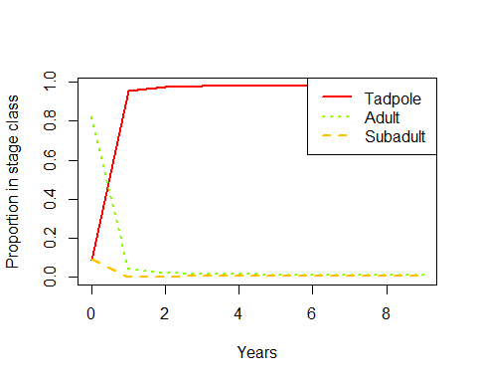

stage.vector.plot(pop$stage.vector, log = "y")

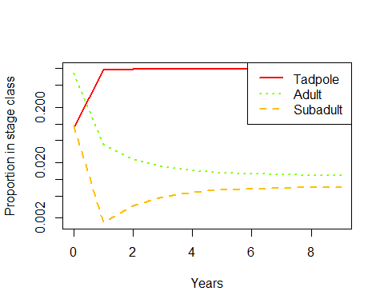

## Sensitivity and Elasticity

S <- DemoInfo(A)  
S

## $lambda  
## [1] 0.792598  
##   
## $SSD  
## [1] 0.981052173 0.007232258 0.011715570  
##   
## $RV  
## [1] 1.00000 48.14951 174.17218  
##   
## $Sensitivities  
## [,1] [,2] [,3]  
## [1,] 0.29113 0.002146193 0.003476628  
## [2,] 14.01776 0.103338118 0.167397929  
## [3,] 50.70674 0.373807058 0.605531905  
##   
## $Elasticities  
## Tadpole Subadult Adult  
## Tadpole 0.22038660 0.00000000 0.07074337  
## Subadult 0.07074337 0.03259474 0.00000000  
## Adult 0.00000000 0.07074337 0.53478853  
##   
## $PPM  
## Tadpole Subadult Adult  
## Tadpole 0.600 0.00 16.128  
## Subadult 0.004 0.25 0.000  
## Adult 0.000 0.15 0.700

The asymptomatic growth rate for this species is showing decline, with a lambda of less than 1.

According to our sensitivity analysis, the most sensitive life stage for the frogs exist for tadpoles becoming subadults. Putting in management efforts to increase survivorship of this transition would have the greatest affect on the asymptomatic growth rate for the species.

However, when we looked at the proportional effect that increasing survivorship has on increasing the asymptomatic growth rate using an elasticity analysis has shown that increasing adult survivor ship will have the greatest impact. My assumption of this related to the biology of the species: The number of eggs and tadpoles produced by each adult female, and the extreme levels of tadpole mortality, increasing the the number of breeding adults would have the greatest effect.

## Investigating Sensitivity and Elasticity of Lambda to Vital Rates

1. Recreate the matrix symbolically

A.vr <- expression((1-g0), 0, (p2*g2*f1),  
 (p0*g0), (p2*(1-g1)), 0,  
 0, (p2*g2), p3)  
  
  
p <- c(1, 0.01, 0.2, 0.7)  
g <- c(0.4, 0.2, 0.75)  
f <- c(0, 0, 112)  
  
vr.vals <- list(p0 = p[1], p1 = p[2], p2 = p[3], p3 = p[4],  
 g0 = g[1], g1 = g[2], g2 = g[3],  
 f1 = f[3])  
  
vitalsens(A.vr, vr.vals)

## estimate sensitivity elasticity  
## p0 1.00 0.326745902 0.215787230  
## p1 0.01 0.000000000 0.000000000  
## p2 0.20 3.460485116 0.457069848  
## p3 0.70 0.401307135 0.185519905  
## g0 0.40 0.459454508 0.121371886  
## g1 0.20 -0.048256523 -0.006373847  
## g2 0.75 0.871322406 0.431574461  
## f1 112.00 0.002917374 0.215787230

From this analysis I can see that the greatest impact is shown in increasing the annual survivorship of subadults both in absolute (sensitivity) and proportional effort (elasticity). This indicates that if I can get more subadults to survive, I would have the greatest increase in the asymptomatic growth rate.

## Things missing from this model

The obvious lack of data regarding lifestage survivorship and growth rates for the frog, which could drastically affect the asymptomatic growth rates and conclusions I have drawn from this analysis. Considering the dataset that I am basing this project on has shown an overall increase in population size for the frogs in Yosemite National Park, yet my demographic analysis is indicating a decrease in asymptomatic growth rates shows that something is wrong in my assumptions.

Another missing aspect of this model is that the model is not taking into account any form of density dependence. From studying the ecology of the frog I can infer that this is a potentially huge failing, as the frogs will spatially distribute themselves along the shore of the lake to mark out preferential breeding territory. At a certain point there would be too many frogs and not enough lake for them all to live in.

Environmental stochasticity is missing from this model, which greatly impacts the frog’s development and survival. Multiple “good” years could create a natural scenario where subadult survivorship grows, drastically increasing lambda for the population. Environmental stochasiticity is most likely to impact the early life stages which would be particularly vulnerable to increased streamflow (which may cause increased mortallity to eggs or tadpoles due to eggmasses being scoured from the lakes or streams, though my population is in a lake so probably not that big of a deal). Extreme cold winters would likely affect all populations equally if the cold weather is able to freeze the lake solid, preventing the frogs of all life stages from finding and hibernating in the refuge beneath the lake.

## Updated Matrix Model

class_names <- c( "Tadpole", "Tadpole2", "Subadult", "Subadult2", "Adult")  
A <- matrix(c( 0, 0, 28.5, 15, 105,  
 0.095, 0, 0, 0, 0,  
 0.001, 0.095, 0, 0, 0,  
 0, 0, 0.1, 0, 0,  
 0, 0, 0.19, 0.1, 0.7 ),  
 nrow = 5, ncol = 5, byrow = TRUE, dimnames = list(class_names, class_names))

This model is based on the estimates for survival for each life stage.

Tadpoles: 1% of tadpoles become adults. However, tadpoles may overwinter multiple times (up to 3 overwinters, the first tadpole stage is after the first overwinter. If a tadpole proceeds to Overwinter 2 they move to Tadpole2 stage. Most tadpoles will overwinter twice indicating a higher probability that Tadpole2 will become a Subadult than a Tadpole1.)

Subadult: 20% of subadults survive to become adults. Subadults become adults after either 1 or 2 years.

Adults: 70% survivalship year to year

I need to recalculate fecundintry

#N-0 <- c(Adult, Subadult2, Subadult1, Tadpole2, Tadpole1) #The format for this vector  
n_0 <- c(278, 96, 200, 670, 670) #Site 1764  
n_0 <- c(35, 25, 86, 83, 83) #Site 1634  
time <- 50  
  
pop <- pop.projection(A, n_0, iterations = time)  
pop

## $lambda  
## [1] 1.000473  
##   
## $stable.stage  
## Tadpole Tadpole2 Subadult Subadult2 Adult   
## 0.8987641969 0.0853422444 0.0090020208 0.0008997766 0.0059917613   
##   
## $stage.vectors  
## 0 1 2 3 4 5  
## Tadpole 35 12411.000 8885.38500 6586.100437 8074.85843 8306.87884  
## Tadpole2 25 3.325 1179.04500 844.111575 625.67954 767.11155  
## Subadult 86 2.410 12.72687 120.894660 86.77670 67.51441  
## Subadult2 83 8.600 0.24100 1.272687 12.08947 8.67767  
## Adult 83 82.740 59.23590 43.907336 53.83239 55.37919  
## 6 7 8 9 10  
## Tadpole 7869.141063 7923.370937 8029.036965 7994.441477 7981.340188  
## Tadpole2 789.153490 747.568401 752.720239 762.758512 759.471940  
## Subadult 81.182476 82.838723 78.942369 79.537460 80.456500  
## Subadult2 6.751441 8.118248 8.283872 7.894237 7.953746  
## Adult 52.460940 52.822473 53.526913 53.296277 53.208935  
## 11 12 13 14 15  
## Tadpole 7999.25457 8003.901425 8003.806978 8008.330617 8012.939187  
## Tadpole2 758.22732 759.929184 760.370635 760.361663 760.791409  
## Subadult 80.13117 80.030850 80.197174 80.239017 80.242689  
## Subadult2 8.04565 8.013117 8.003085 8.019717 8.023902  
## Adult 53.32836 53.359343 53.358713 53.388871 53.419595  
## 16 17 18 19 20  
## Tadpole 8016.332582 8020.008346 8023.931626 8027.722983 8031.485651  
## Tadpole2 761.229223 761.551595 761.900793 762.273504 762.633683  
## Subadult 80.288123 80.333109 80.367410 80.404507 80.443706  
## Subadult2 8.024269 8.028812 8.033311 8.036741 8.040451  
## Adult 53.442217 53.466722 53.492878 53.518153 53.543238  
## 21 22 23 24 25  
## Tadpole 8035.292334 8039.098232 8042.895625 8046.698042 8050.504126  
## Tadpole2 762.991137 763.352772 763.714332 764.075084 764.436314  
## Subadult 80.481686 80.519450 80.557612 80.595757 80.633831  
## Subadult2 8.044371 8.048169 8.051945 8.055761 8.059576  
## Adult 53.568616 53.593988 53.619304 53.644654 53.670028  
## 26 27 28 29 30  
## Tadpole 8054.310709 8058.118931 8061.929330 8065.741480 8069.555347  
## Tadpole2 764.797892 765.159517 765.521298 765.883286 766.245441  
## Subadult 80.671954 80.710110 80.748273 80.786453 80.824654  
## Subadult2 8.063383 8.067195 8.071011 8.074827 8.078645  
## Adult 53.695405 53.720793 53.746196 53.771610 53.797036  
## 31 32 33 34 35  
## Tadpole 8073.371052 8077.188575 8081.007890 8084.829011 8088.651942  
## Tadpole2 766.607758 766.970250 767.332915 767.695750 768.058756  
## Subadult 80.862872 80.901108 80.939362 80.977635 81.015925  
## Subadult2 8.082465 8.086287 8.090111 8.093936 8.097763  
## Adult 53.822474 53.847924 53.873386 53.898860 53.924346  
## 36 37 38 39 40  
## Tadpole 8092.476681 8096.303227 8100.131582 8103.961749 8107.793726  
## Tadpole2 768.421935 768.785285 769.148807 769.512500 769.876366  
## Subadult 81.054234 81.092560 81.130905 81.169268 81.207649  
## Subadult2 8.101593 8.105423 8.109256 8.113091 8.116927  
## Adult 53.949845 53.975355 54.000877 54.026412 54.051958  
## 41 42 43 44 45  
## Tadpole 8111.627515 8115.463117 8119.300532 8123.13976 8126.980808  
## Tadpole2 770.240404 770.604614 770.968996 771.33355 771.698277  
## Subadult 81.246049 81.284466 81.322901 81.36136 81.399827  
## Subadult2 8.120765 8.124605 8.128447 8.13229 8.136136  
## Adult 54.077517 54.103087 54.128670 54.15427 54.179872  
## 46 47 48 49  
## Tadpole 8130.823670 8134.668349 8138.514845 8142.363161  
## Tadpole2 772.063177 772.428249 772.793493 773.158910  
## Subadult 81.438317 81.476825 81.515352 81.553897  
## Subadult2 8.139983 8.143832 8.147683 8.151535  
## Adult 54.205491 54.231122 54.256766 54.282421  
##   
## $pop.sizes  
## [1] 312.000 12508.075 10136.634 7596.287 8853.237 9205.562 8798.689  
## [8] 8814.719 8922.510 8897.928 8882.431 8898.987 8905.234 8905.737  
## [15] 8910.340 8915.417 8919.316 8923.389 8927.726 8931.956 8936.147  
## [22] 8940.378 8944.613 8948.839 8953.069 8957.304 8961.539 8965.777  
## [29] 8970.016 8974.258 8978.501 8982.747 8986.994 8991.244 8995.495  
## [36] 8999.749 9004.004 9008.262 9012.521 9016.783 9021.047 9025.312  
## [43] 9029.580 9033.850 9038.121 9042.395 9046.671 9050.948 9055.228  
## [50] 9059.510  
##   
## $pop.changes  
## [1] 40.0899840 0.8104072 0.7493895 1.1654690 1.0397962 0.9558015  
## [7] 1.0018218 1.0122286 0.9972449 0.9982584 1.0018639 1.0007020  
## [13] 1.0000564 1.0005169 1.0005698 1.0004374 1.0004566 1.0004861  
## [19] 1.0004738 1.0004692 1.0004735 1.0004736 1.0004725 1.0004727  
## [25] 1.0004730 1.0004729 1.0004728 1.0004729 1.0004729 1.0004728  
## [31] 1.0004729 1.0004729 1.0004729 1.0004729 1.0004729 1.0004729  
## [37] 1.0004729 1.0004729 1.0004729 1.0004729 1.0004729 1.0004729  
## [43] 1.0004729 1.0004729 1.0004729 1.0004729 1.0004729 1.0004729  
## [49] 1.0004729

stage.vector.plot(pop$stage.vector)

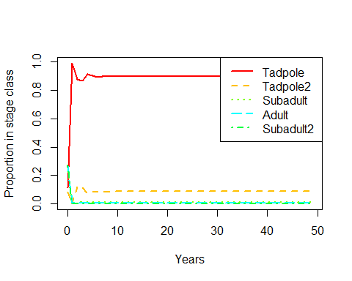

stage.vector.plot(pop$stage.vector, log = "y")

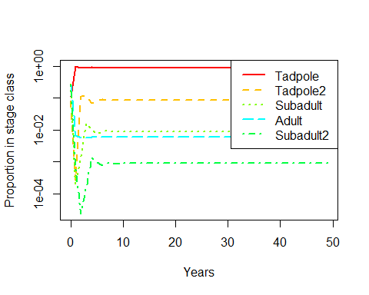

Sensitivity

S <- DemoInfo(A)  
S

## $lambda  
## [1] 1.000473  
##   
## $SSD  
## [1] 0.8987641969 0.0853422444 0.0090020208 0.0008997766 0.0059917613  
##   
## $RV  
## [1] 1.000000 9.480343 99.840271 49.921315 349.449207  
##   
## $Sensitivities  
## [,1] [,2] [,3] [,4] [,5]  
## [1,] 0.1893995 0.01798445 0.001897025 0.0001896128 0.001262663  
## [2,] 1.7955719 0.17049871 0.017984446 0.0017975946 0.011970479  
## [3,] 18.9096944 1.79557192 0.189399469 0.0189309953 0.126064629  
## [4,] 9.4550706 0.89780718 0.094701972 0.0094657214 0.063033804  
## [5,] 66.1854943 6.28465025 0.662913807 0.0662600495 0.441236629  
##   
## $Elasticities  
## Tadpole Tadpole2 Subadult Subadult2 Adult  
## Tadpole 0.00000000 0.0000000 0.054039654 0.002842848 0.1325170  
## Tadpole2 0.17049871 0.0000000 0.000000000 0.000000000 0.0000000  
## Subadult 0.01890076 0.1704987 0.000000000 0.000000000 0.0000000  
## Subadult2 0.00000000 0.0000000 0.009465721 0.000000000 0.0000000  
## Adult 0.00000000 0.0000000 0.125894094 0.006622873 0.3087197  
##   
## $PPM  
## Tadpole Tadpole2 Subadult Subadult2 Adult  
## Tadpole 0.000 0.000 28.50 15.0 105.0  
## Tadpole2 0.095 0.000 0.00 0.0 0.0  
## Subadult 0.001 0.095 0.00 0.0 0.0  
## Subadult2 0.000 0.000 0.10 0.0 0.0  
## Adult 0.000 0.000 0.19 0.1 0.7