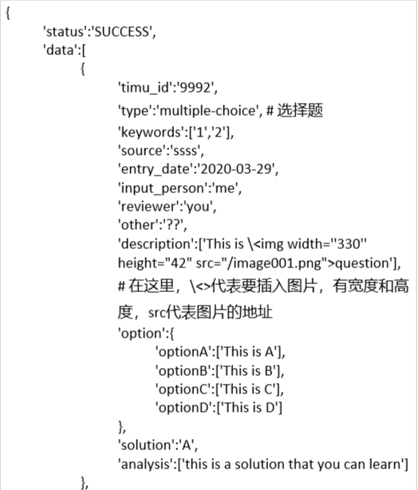

[  
  {  
    "analysis": [  
      "步骤1写出杆绕A点旋转的惯性矩，用m和L表示。",  
      "杆绕质心旋转的惯性矩为<img width=\"62\" height=\"26\" src=\"http://127.0.0.1:5000/img/0404-0400000000-00036_lov2iDcaimage154.png\" singe_line=\"False\" explanation = \"noExp\">",  
      "<img width=\"296\" height=\"78\" src=\"http://127.0.0.1:5000/img/0404-0400000000-00036_NoSSuRAWimage155.png\" singe_line=\"True\" explanation = \"noExp\">",  
      "通过平行移轴定理可得",  
      "<img width=\"242\" height=\"52\" src=\"http://127.0.0.1:5000/img/0404-0400000000-00036_lGg9B5WRimage156.png\" singe_line=\"True\" explanation = \"noExp\">",  
      "步骤2用<img width=\"86\" height=\"26\" src=\"http://127.0.0.1:5000/img/0404-0400000000-00036_G9H3L5VEimage157.png\" singe_line=\"False\" explanation = \"noExp\">表示出系统的总势能。",  
      "总势能为<img width=\"134\" height=\"52\" src=\"http://127.0.0.1:5000/img/0404-0400000000-00036_OFRWn!kaimage158.png\" singe_line=\"False\" explanation = \"noExp\">",  
      "步骤3用<img width=\"57\" height=\"52\" src=\"http://127.0.0.1:5000/img/0404-0400000000-00036_VHNV-jZZimage159.png\" singe_line=\"False\" explanation = \"noExp\">表示出系统的总动能。",  
      "总动能为<img width=\"187\" height=\"52\" src=\"http://127.0.0.1:5000/img/0404-0400000000-00036_o6YDDRU+image160.png\" singe_line=\"False\" explanation = \"noExp\">",  
      "步骤4用能量守恒原理可得出<img width=\"16\" height=\"23\" src=\"http://127.0.0.1:5000/img/0404-0400000000-00036_nvJ1E4pHimage161.png\" singe_line=\"False\" explanation = \"noExp\">满足",  
      "<img width=\"244\" height=\"52\" src=\"http://127.0.0.1:5000/img/0404-0400000000-00036_OgE8-co3image162.png\" singe_line=\"True\" explanation = \"noExp\">",  
      "因为总能量是不变的，故",  
      "<img width=\"356\" height=\"52\" src=\"http://127.0.0.1:5000/img/0404-0400000000-00036_s68Yak90image163.png\" singe_line=\"True\" explanation = \"noExp\">",  
      "对时间t进行微分有：",  
      "<img width=\"349\" height=\"52\" src=\"http://127.0.0.1:5000/img/0404-0400000000-00036_YPkv_pT1image164.png\" singe_line=\"True\" explanation = \"noExp\">",  
      "从而可得",  
      "<img width=\"257\" height=\"52\" src=\"http://127.0.0.1:5000/img/0404-0400000000-00036_WSygAZQTimage165.png\" singe_line=\"True\" explanation = \"noExp\">",  
      "步骤5最后，计算结构的自振频率。",  
      "令，<img width=\"70\" height=\"26\" src=\"http://127.0.0.1:5000/img/0404-0400000000-00036_byOsPCldimage166.png\" singe_line=\"False\" explanation = \"noExp\">",  
      "可得",  
      "<img width=\"206\" height=\"52\" src=\"http://127.0.0.1:5000/img/0404-0400000000-00036_ogobLpoDimage167.png\" singe_line=\"True\" explanation = \"noExp\">",  
      "<img width=\"162\" height=\"78\" src=\"http://127.0.0.1:5000/img/0404-0400000000-00036_NaPvZpC5image168.png\" singe_line=\"True\" explanation = \"noExp\">"  
    ],  
    "category": "分布参数系统",  
    "description": [  
      "下图中刚杆质量为m，长度为L，绕A点旋转。支座处抗扭弹簧的刚度为<img width=\"20\" height=\"16\" src=\"http://127.0.0.1:5000/img/0404-0400000000-00036_QU!D1NyLimage151.png\" singe_line=\"False\" explanation = \"noExp\">，其在A点处产生一大小为<img width=\"29\" height=\"23\" src=\"http://127.0.0.1:5000/img/0404-0400000000-00036_TCbLFHJLimage152.png\" singe_line=\"False\" explanation = \"noExp\">的回复弯矩。推导该体系的运动方程。",  
      "<img width=\"137\" height=\"271\" src=\"http://127.0.0.1:5000/img/0404-0400000000-00036_HqNMstC7image153.png\" singe_line=\"True\" explanation = \"yesExp\">",  
      "倒摆刚杆"  
    ],  
    "entry_date": "Wed, 01 Apr 2020 00:00:00 GMT",  
    "input_person": "曾东鋆",  
    "keywords": "公式推导",  
    "option": {  
      "A": [  
        "看参考答案"  
      ],  
      "B": [  
        "不看参考答案"  
      ]  
    },  
    "other": "",  
    "reviewer": "陈隽",  
    "solution": [  
      "A"  
    ],  
    "source": "BrownUniversityDynamicsandVibrations2012FinalExamination",  
    "timu_id": "0404-0400000000-00036",  
    "type": "计算题"  
  }  
]

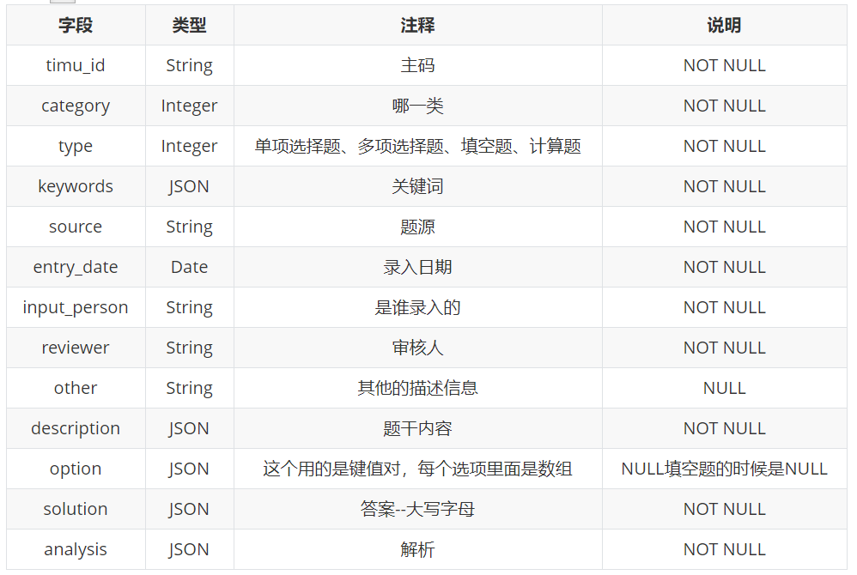 class有三种状态：  
class="noOperation"  代表不是单行 也没有说明  
class="single_line"   代表是单行 但没有说明  
class="explanation"  代表既是单行，又有说明