# **Microsoft SQL Server 2014 Express Installation Guide**

## System requirements

* Windows 7 and higher
* .NET Framework 4.5.1

## Installation SQL Server EXPRESS 2014

Download link for the Microsoft® SQL Server® 2014 Express 🡪

**http://www.microsoft.com/en-us/download/details.aspx?id=42299**

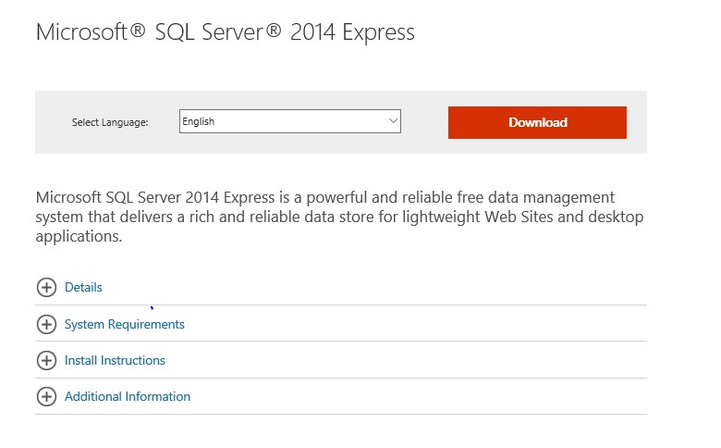

To start the download, please click on “**Download**”:

Check your system Requirement:

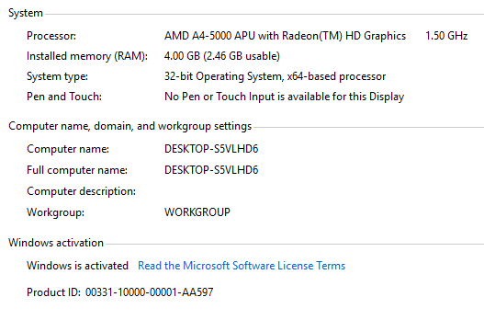

Depending on the operating system (x64 or x86) please select one of the following: **ExpressAndTools 32BIT\SQLEXPRWT_x86_ENU.exe or ExpressAndTools 64BIT\SQLEXPRWT_x64_ENU.exe**

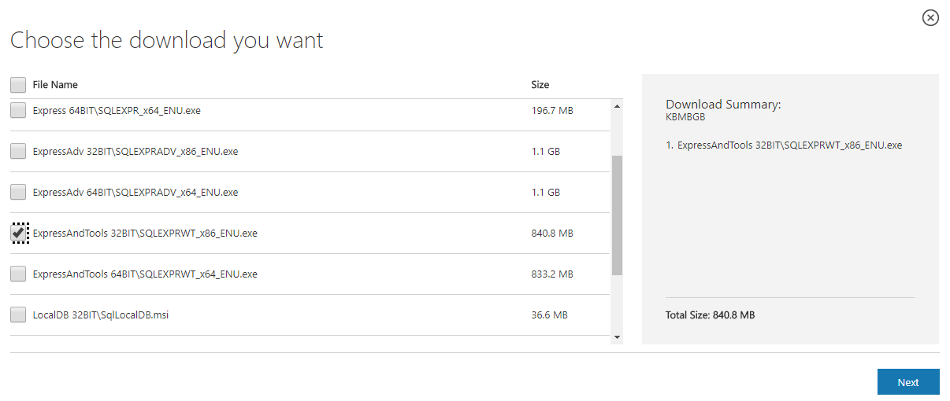

Choose the correct version and click on “Next”. The installation files will now be downloaded:

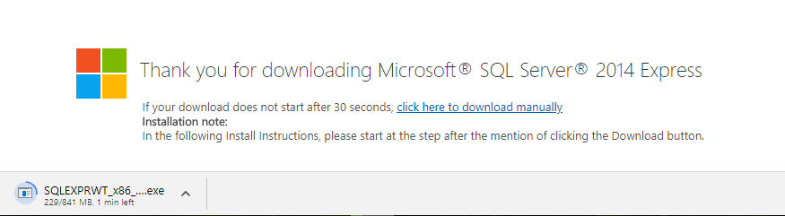

After the download, please follow the below steps:

Double-click .exe file (x64 or x86) and the application will extract all necessary files and start the installation of the database. Once the installation starts, **select the option to install a new database**

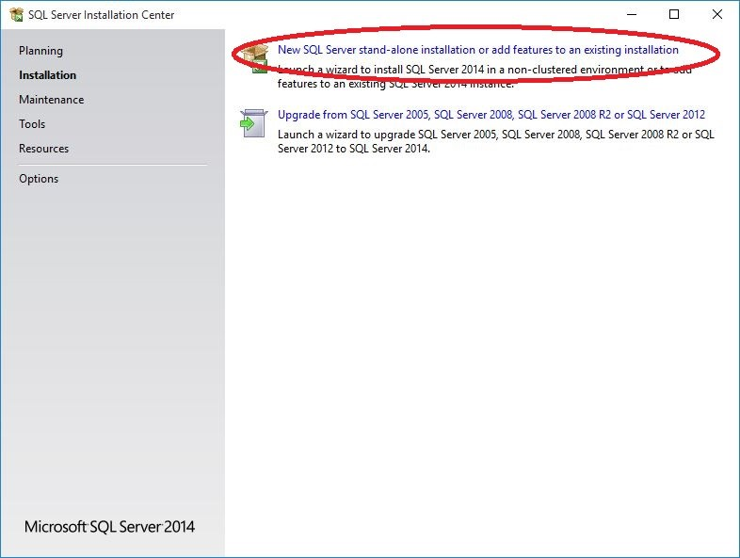

The following screen will appear next:

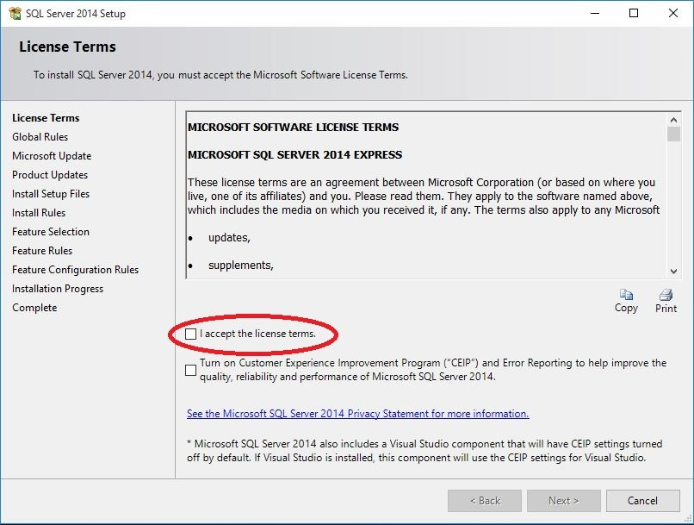

Please **Accept** the license terms and click on “Next”.

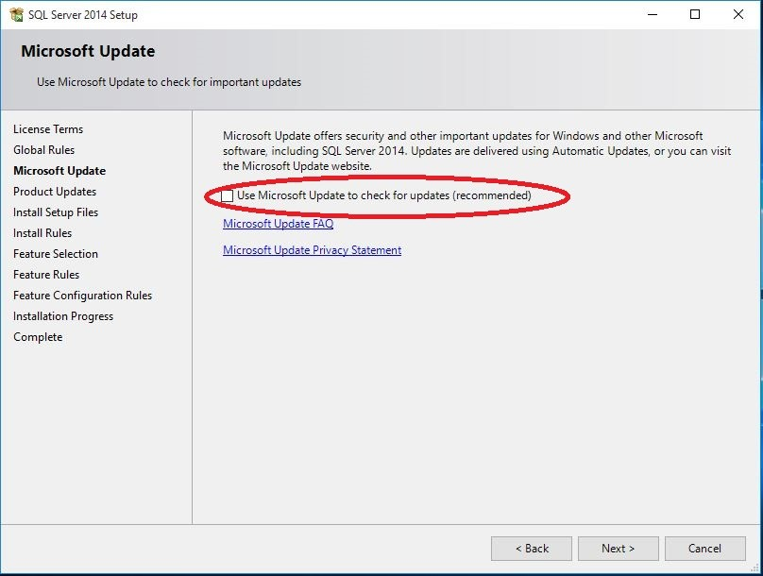

We click Accept to check for updates(Optional):

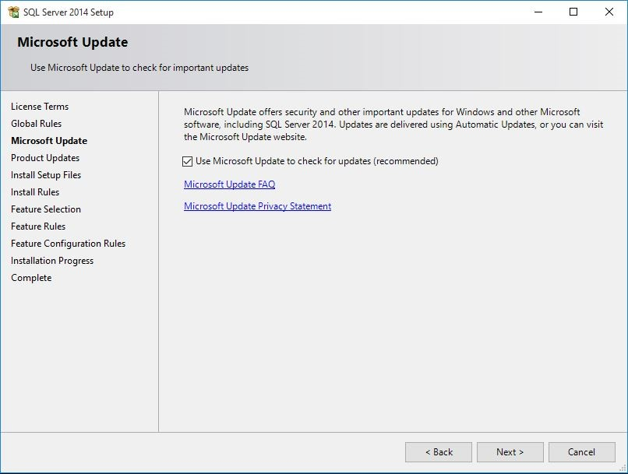

The next screen will show what can be installed. Please click on “**Select All**”:

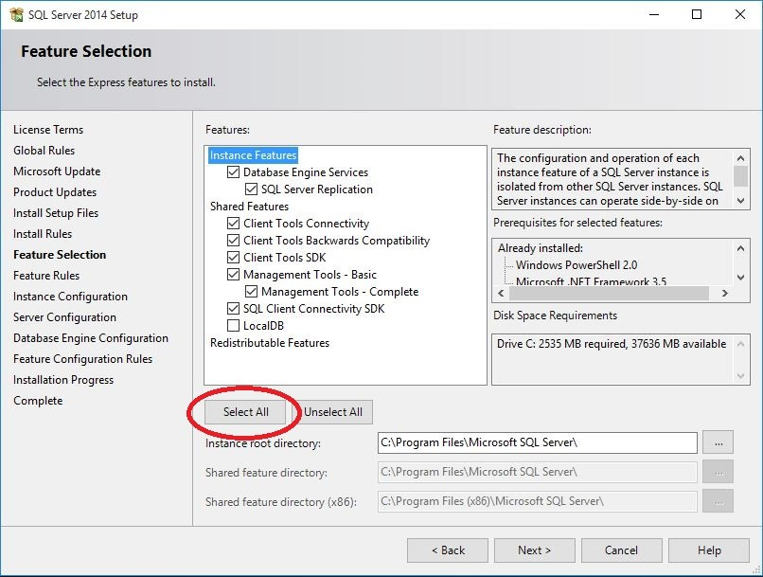

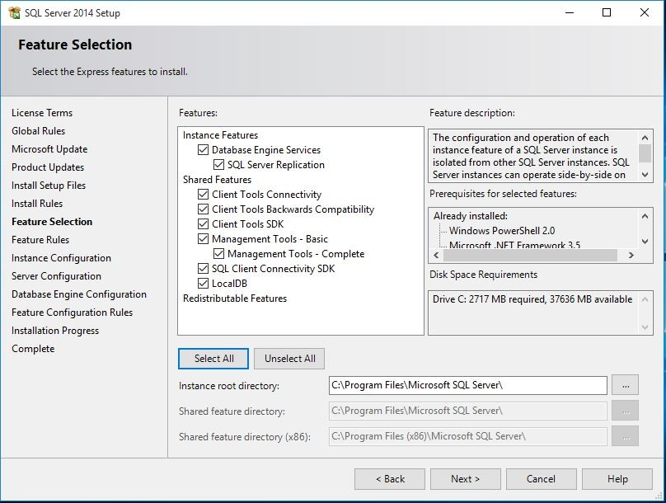

The next screen will show the instance name of the database. Please leave **Default Name** and click “Next“:

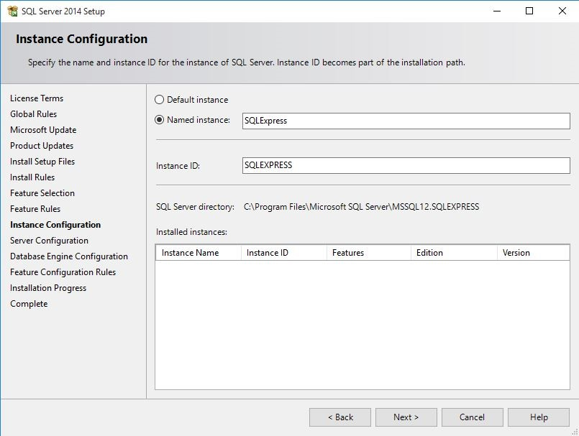

Please leave **Default Service Account Name** in the next screen and click on “Next”:

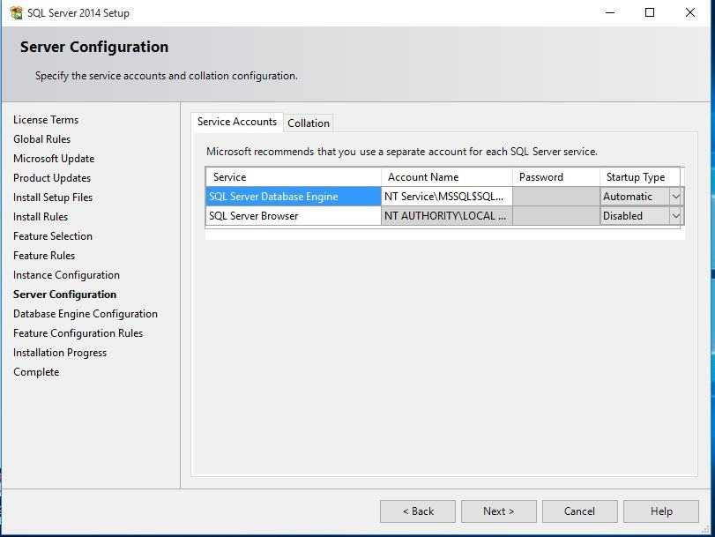

The next screen sets the database engine configuration. Please select the **Mixed Mode** option:

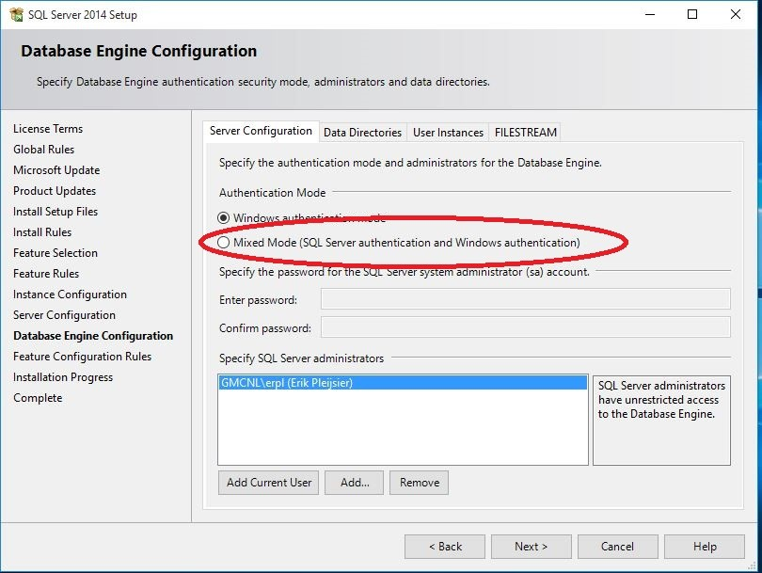

In the next screen specify the password (please remember the password you are using) and click “Next”:

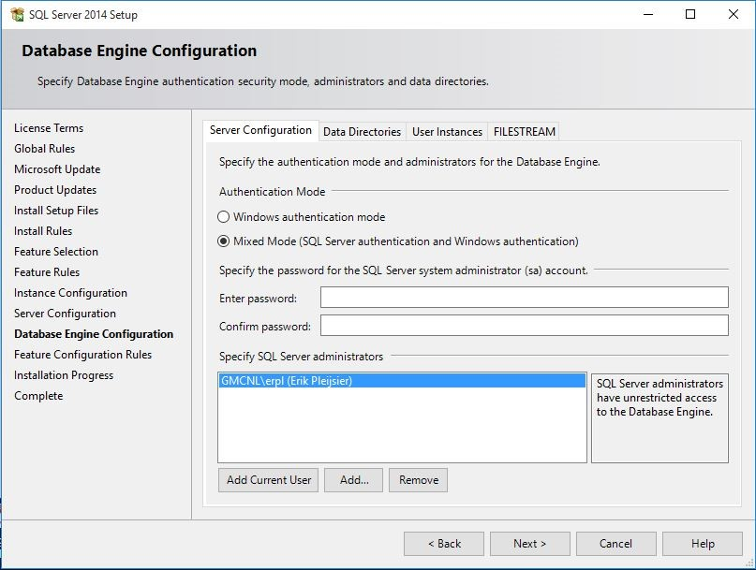

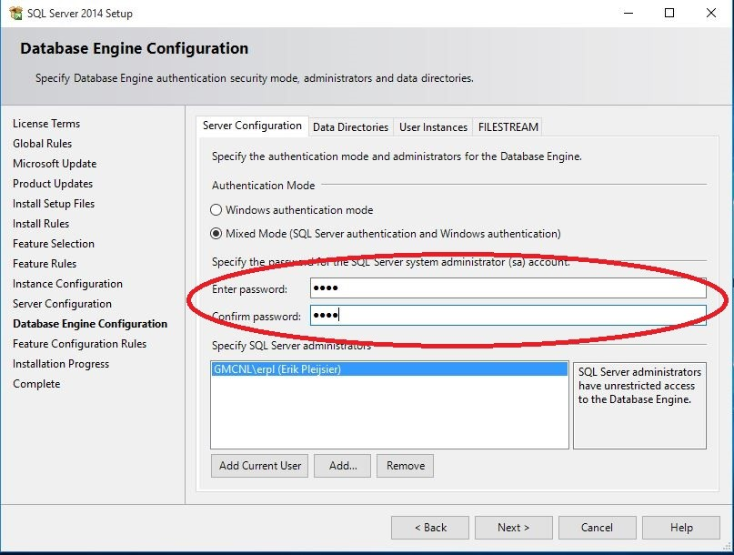

Now the actual installation starts (this can take up quite some time):

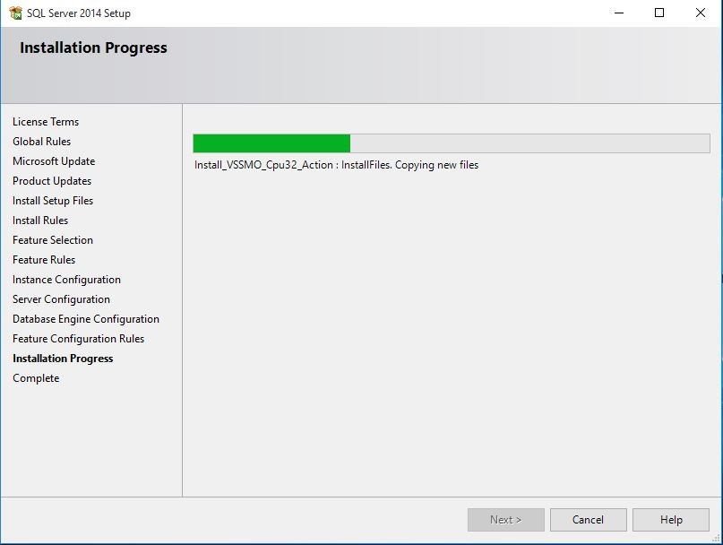

On successful installation, the following screen will be displayed (**click close**):

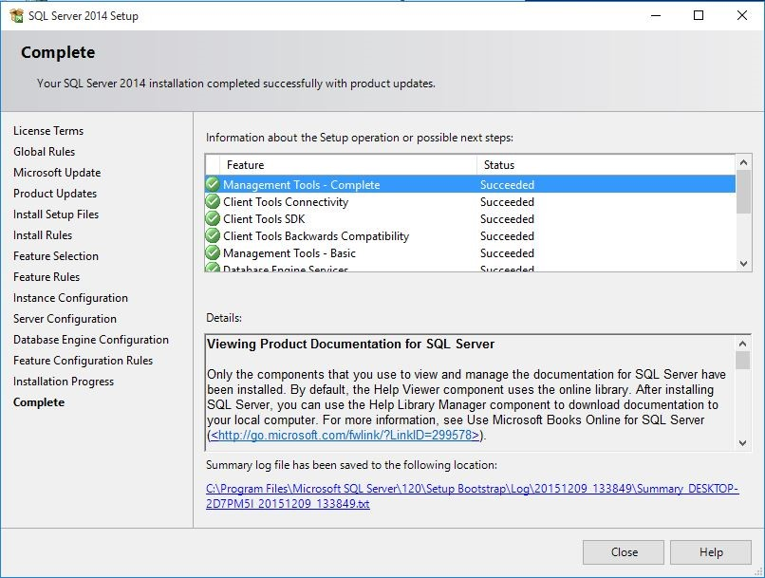

**Click X** to complete the installation process:

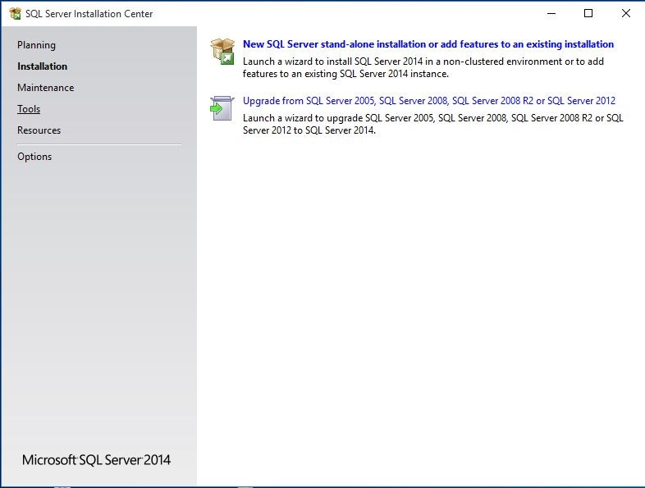

**Appendix: How to install SQL Server on a Mac**

Mac platform is not supported by SQL Server, still there are two ways to run Windows on your Mac: dual booting and using a virtual machine.

The links below provide you the videos about how to do dual booting and use VirtualBox.

**How to install Windows 10 on Macbook**

<https://www.youtube.com/watch?v=8Xc29uP7AFw>

**How to install Windows 10 on Macbook using VirtualBox**

<https://www.youtube.com/watch?v=MuAVOpO7yFc>