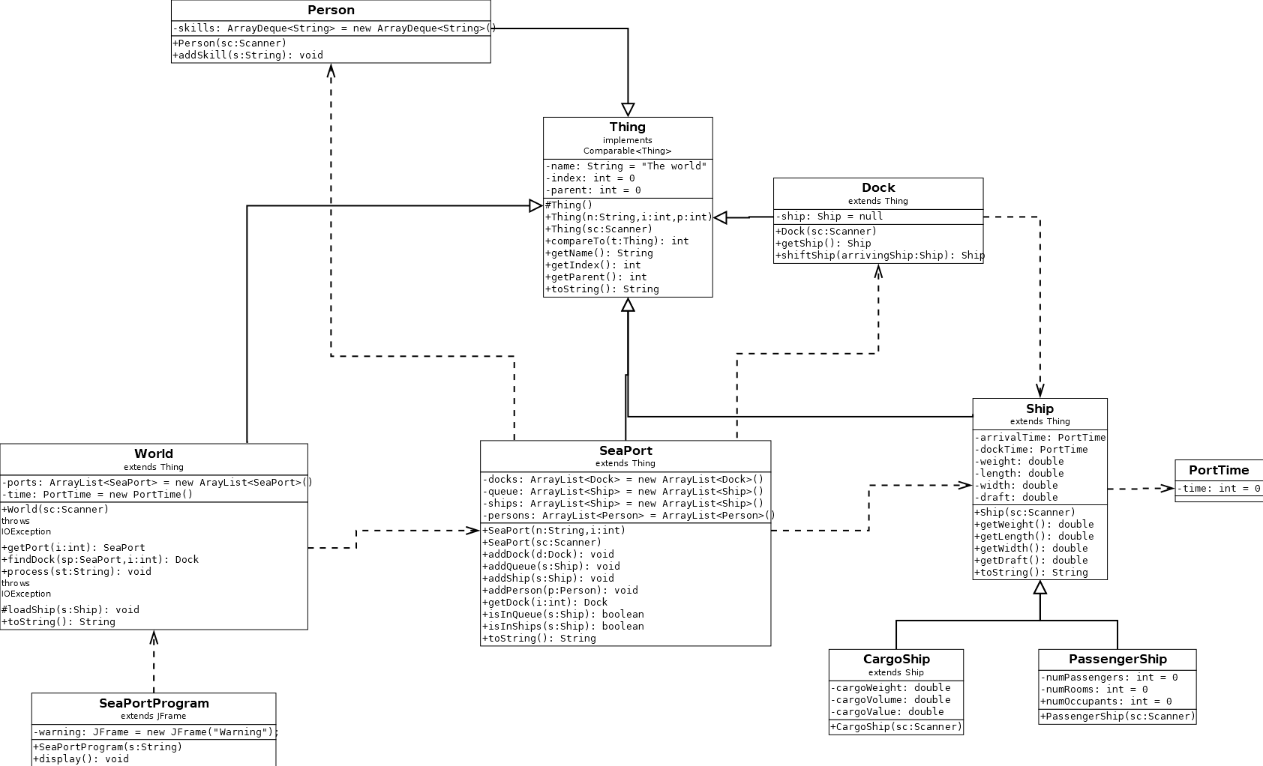Illustration 1: Project 1 UML Diagram
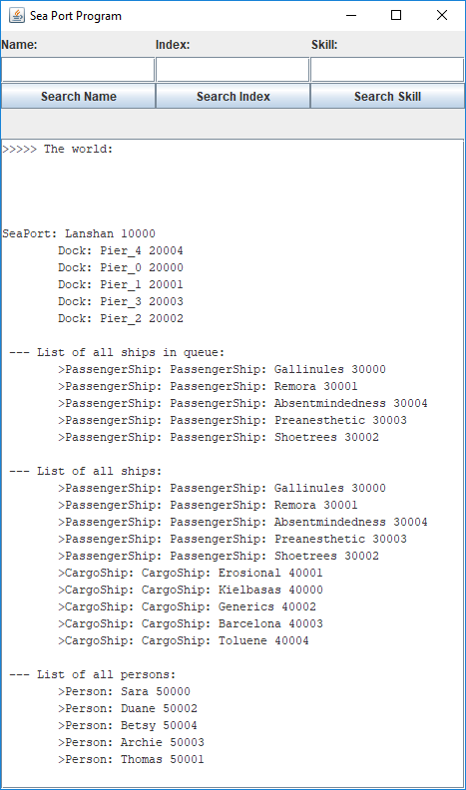Illustration 2: Sea Port Program, Mark 1
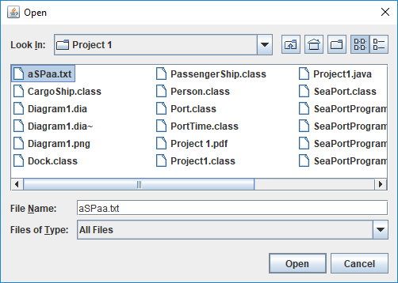Illustration 3: Select Data File

User’s Guide:

Despite the above UML diagram, this program is very easy to use. Once a data file that meets requirements is opened, its entire (well-formed) contents are displayed on startup. If a search by name or index yields no results, a prompt lets the user know how to reset.

The data file has some strict requirements, including that an entry’s proposed parent index must exist, so ordering matters. Extra fields are ignored past what is stored for a given object type.
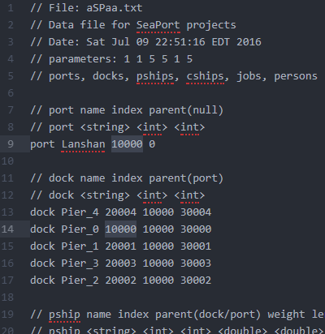Illustration 4: Testing duplicate indices

Test Plan:

I have been testing using the data provided in the Project 1 rubric.

The program didn’t complain with two objects of different type but identical indices. When pushing new members, checks are only made from within the particular ArrayList. Searching for these entries by any attribute shows no results, which differs from expected results. Ideally, it would either show the results or disallow a matching index.

Next I altered another entry: <dock Pier_2 20002 10000 30002 a a a a a>. The parser simply ignored these tokens because there are no specific attributes to store them in.

The search function for index converts it to a string for comparison, so I didn’t expect <dock Pier_2 aaaaa 10000 30002> to have an effect, but ‘aaaaa’ can’t be assigned to Integer. An IOException is caught.

Lessons Learned:

Getting a top-down view of the program logic is necessary for performing the required functions. Also, I’m not sure how well I implemented ArraList’s capabilities given time constraints. At first I tried to catch the IOException inside JfileChooser’s listener. By extending JFrame, a warning is thrown because this class implements Serializable. I had to assign a constant serialVersionUID to fulfill the class requirements.

