# **Team 10 ETL Propasal: Solar System Planets Across the Cosmos**

## Team 10: Robert Naghi, Lana Paltseva, Antonia Anderson

We would like to build a database of Confirmed Planets across galaxies. We will only include planets that are part of a star system including 2 or more planets. To do this, we will:

1. **Extract** exoplanet data from CSV (exoplanetarchive.ipac.caltech.edu) and solar system data from CSV/JSON (devstronomy.com)
2. **Transform** data by dropping rows of exoplanets that don’t have more 1 planet in their star systems. We’ll also drop columns we don’t need while keeping columns such as Planet Density, Planet Radius, Orbital Period.
3. **Load** the databases into SQL. Combine the data together along a Primary, most likely Planet ID or Name.

**Kepler-90**

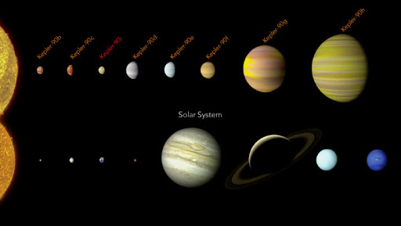

Sources:

* <https://devstronomy.com/#/datasets>
* <https://exoplanetarchive.ipac.caltech.edu/cgi-bin/TblView/nph-tblView?app=ExoTbls&config=planets>