Rejoinders are responses such as: ***That's great, I see,* or *I'm sorry to hear that.*** Rejoinders keep the conversation going and show that the listener has understood and is listening.

**Rejoinders**

|  |  |
| --- | --- |
| **Good Information**  I won the lottery!  I have a date tonight.  I’m going to Canada for summer vacation. | *MC900433820[1]       That's great! + SMILE*  *That’s terrific!*  *That's wonderful!*  *Note: Use an excited HIGH TONE!* |
| **Shows you acknowledge or that you understand the situation**  I have to go home to talk to my mother.  I have to leave now. My class starts soon. | (Oh,) I see (eee…..)  (Oh,) I understand.  Okay. (This is the most common word in the world.) |
| **Sad or bad information**  My dog died.  My boy/girlfriend broke up with me.  I got an F on my English exam. | *Oh, no!*  *That's too bad.*  *I’m sorry to hear that.*  *That’s (so) terrible….* |
| **Surprising Information**  Somebody stole my wallet.  I got married last weekend. | You’re kidding.  I can’t believe it.  Oh, really? |

**Introductory Exercise**

Fill in the blanks with the correct phrase

|  |
| --- |
| That's great! I see…. (Oh,) that's too bad I can't believe it!  That’s terrific! I understand (Oh,) I'm sorry to hear that You’re kidding!  That’s wonderful! Oh, no! Oh really! |

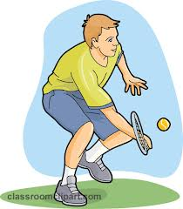

1. Hi, how was the tennis game?
2. I won!
3. _____________________. Who did you play against?
4. My brother.
5. ________________________________.
6. But during the game, he fell and hurt his ankle.
7. __________________________________________ (a follow-up question can be asked here too)
8. I just talked to my father on the phone.
9. Oh, ________________________.
10. He decided to take my family to Hawaii for winter vacation.
11. _______________________.
12. But, he said he's really busy at work these days.
13. Oh, __________________________________

**_________________________________________________________________**

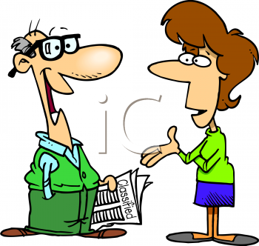Woman: Guess what the doctor told me. I'm going to have a baby!

Man: ____________________________________

Woman: And he said I'm in good health.

Man: ________________________________________

Woman: And he said you should do more housework.

Man: _____________________________________________.

Woman: The car broke down again.

Man:____________________________. What's the matter this time?

Woman: It won't start.

Man: ________________________. We had it repaired last week

Woman: I have a great idea. Let's buy a new car.

Man:____________________________________________

Practice using Rejoinders

Part 1. Student A

Say these sentences to student B. Student B will respond with a rejoinder.

1. My friend broke her leg while skiing.
2. I have one brother and one sister.
3. My father is an anchorman on TV.
4. My sister lost her Gucci handbag.
5. I got accepted to Seoul National University.

That's great! I see…. (Oh,) that's too bad I can't believe it!

That’s terrific! I understand (Oh,) I'm sorry to hear that You’re kidding!

That’s wonderful! Oh, no! Oh really!

-----------------------------------------------------------------------------------------------------------------------------------

Part 2. Student A: First fill in the blanks. You may use real information or “creative” information. Then say these sentences to Student B, who will respond with a rejoinder. If Student B says a rejoinder that doesn’t make sense, then you must say your sentence again. Try repeating the key word(s), speaking louder, or using facial and body language. Do not show your partner your paper.

1. I don’t feel well today.
2. I heard there will be two days off from school next week.
3. I like ___________ cars.
4. I’m going to play basketball in the next Olympics.
5. My brother is ________________.
6. We have a new teacher named Mr. Kim at our school.
7. I had a car accident, and the police took away my driver’s license.
8. I have a date with _______________ tonight.
9. Last night I drank five glasses of ________________ in one hour.
10. Two days ago, I bought a pencil.

Practice using Rejoinders

Part 1. Student B:

Say these sentences to student A. Student A will respond with a rejoinder

1. My mother likes ice cream.
2. I’m going to study in America next year.
3. My uncle was arrested by the police on Saturday night.
4. I got a new smart phone.
5. My old girl/boyfriend keeps following me. I think he/she is a stalker.

That's great I see That's too bad I can't believe it!

That’s terrific! I understand I'm sorry to hear that You’re kidding!

That’s wonderful Oh, no! Oh really!

-----------------------------------------------------------------------------------------------------------------------------------

Part 2. Student B: First fill in the blanks. You may use real information or “creative” information. Then say these sentences to Student A, who will respond with a rejoinder. If Student A says a rejoinder that doesn’t make sense, then you must say your sentence again. Try repeating the key word(s), speaking louder, or using facial and body language. Do not show your partner your paper.

1. In elementary school, I was the best student in my class! ☺
2. I caught a terrible cold last weekend.
3. I’m taking a trip to ____________________ on my next vacation.
4. The radio said it’s going to snow in ______________ tonight.
5. It takes me _______________ minutes to get to school every day.
6. I have a pet dog and a pet ______________.
7. I would like to work in an office someday.
8. I drink _________________ every day.
9. I’m going to have a baby.
10. I’m going to buy a new notebook tomorrow.