Regression Analysis
  - OLS Regression Modelling Methodology
    - Preprocessing data for OLS regression
Ordinary Least Squares (OLS) regression models were performed to determine potential future predictors. Data Curation was completed via:
- The raw data was imported into a Pandas DataFrame and cleaned by removing unnecessary columns, renaming columns, and engineering new features representing temporal dynamics, along with categorical data which was encoded into dummy variables.
- Latitude and longitude were accounted for via equivalent distances calculated by the haversine formula (Rapp, 1991). A reference latitude and longitude were the means. Both latitude and longitude were converted into radians and the ‘x’ and ‘y’ distance in kilometers were calculated from the reference coordinates. Longitude and latitude were then dropped from the data frame.
- Then the following temporal information was extracted, and redundant raw date columns were removed.
- Numeric columns were screened for outliers using a two-step procedure. Upper and lower outliers were first capped using the interquartile range method. Remaining outliers were then replaced with threshold values derived from the median absolute deviation. This approach retained data distribution properties while limiting the influence of extreme values.
- To normalize the distribution of continuous variables, a Yeo-Johnson power transform was applied to selected numeric predictors. This transformation helped stabilize variance and reduce skewness.
The preprocessed data was explored by computing a correlation matrix between variables.
Further analysis employed multiple linear regression with arsenic, manganese, lead, and uranium concentrations as target variables. To identify important explanatory variables, each model underwent sequential feature selection with 30-fold cross-validation. Final regression models were fitted on the selected subsets of predictors.
    - OLS regression model for the main dataset
Feature Selection for the OLS regression model for the main dataset was performed as follows:
- The preprocessed dataset was already split into predictors (Xa) and response variables (arsenic, manganese, lead, uranium). No further splitting is done.
- A linear regression model was fit on the full dataset Xa for each response variable.
- Following, backward sequential feature selection for each metal of interest (As, Mn, Pb, U) was performed using 30-fold cross-validation (r-squared). For each step, the feature with lowest importance was based on reduction in cross-validated R2 and was eliminated. Furthermore, selection was terminated when R2 started to decrease (Michael Brydon, 2021; Qingkai Kong et al., 2020). The best subset was chosen based on the highest cross-validated R2.
- A plot was generated showing the performance of each number of the feature.
Final OLS models for each metal of interest were fit for via:
- A linear regression model was fit on the best feature subset specified previously with the help of the performance plot for each response variable using stats models OLS.
- Model summary statistics, coefficients, and diagnostics which were obtained.
- Then coefficients with P>0.05, t < 2.0 and that had a zero in the confidence interval were removed [11].
- No formal model evaluation or testing were performed.
Details of these are displayed in Appendix 9.9 and Section 7.
    - OLS regression model for Saltwater intrusion, drought, flooding, increasing minimum temperatures and increasing minimum and maximum temperatures.
Datasets for Saltwater intrusion, drought, flooding and increasing minimum and maximum temperature were prepared as previously discussed in Section 3.2.
- MT, HW, FD, and Hardness were dropped afterwards to lessen multicollinearity.
- Following outliers were removed from each dataset as previously discussed.
- As well as each dataset was scaled as previously discussed.
- For each contaminant variable (As, Mn, Pb, U) of each dataset, a Pandas DataFrame was created from the preprocessed dataset by dropping the other 3 contaminant columns. This avoided multicollinearity between contaminant predictors in the regression models.
- Column headers were standardized by applying Pandas .str.replace() to remove spaces, dashes, colons, and periods for each dataset.
Models for each climate change dataset (Saltwater intrusion, drought, flooding and increasing minimum and maximum temperature) were fit by:
- For each contaminant (As, Mn, Pb, and U), a linear regression model was specified using the Stats models formula API with the response variable. Along with the contaminant column and the same set of 15 predictor variables including water chemistry, climate, geography, and time variables.
- Furthermore, an ordinary least squares model was fitted for each contaminant using the Stats models smf.ols() function.
- The fitted model.summary() method was called to extract the regression statistics including model coefficients, p-values, and overall fit metrics such as R-squared and F-statistic for each contaminate.
- Coefficients with P>0.05, t < 2.0, those that had a zero in the confidence interval and that had a standard error greater than the respective confidence intervals were removed for each contaminant datasets [11].
- The smallest coefficients were then eliminated if the number of features were above that specified by the respective performance plots generated for each metal in the steps for the OLS regression model with main data.
Residual Diagnostics plots were created for each climate change dataset [11]:
- For each metal of interest (As, Pb, Mn, and U): Histogram plots of the residuals were generated with a normal curve overlay to assess residual normality using Seaborn's distplot().
- Residual Q-Q plots for each metal of interest (As, Pb, Mn, and U) were created to compare residuals versus theoretical normal quantiles using Statsmodels sm.qqplot().
- Residual boxplots for each metal of interest (As, Pb, Mn, and U) were plotted using Seaborn's boxplot () to check for heteroscedasticity.
- Seaborn jointplots() were used to check for residual autocorrelation with each predictor variable.
The thorough residual analysis was aimed at validating the linear regression assumptions for each contaminant prediction model. Results of these are displayed in Appendix 9.9 and Section 7.

  - Ordinary Least Squares Auto Regression Models
Ordinary least squares regression models were performed due to the flexibility of said model. This method can determine the linear coefficients of equations. Judging by the Pearson correlations there are more vital than parametric equations. Future research might want to look at these relationships in the general additive model.
Ordinary least squares regression models were performed as an exploratory analysis test. This can be used as a preliminary step to identify potential predictors and response variables and how strong the linear relationship is before them. Significant predictors and trends discovered also can help for new hypothesis and guide future focuses of rigorous confirmatory analysis and future research. These models also are known to help detect with future late which feature selection as it shows which variables have the best predictive our based-on metrics while reducing the risk of overfitting. Future research should include a generalized additive model and detrending time series the trend and be trending analysis. these were originally planned for the report however had to be cut out due to lack of time.
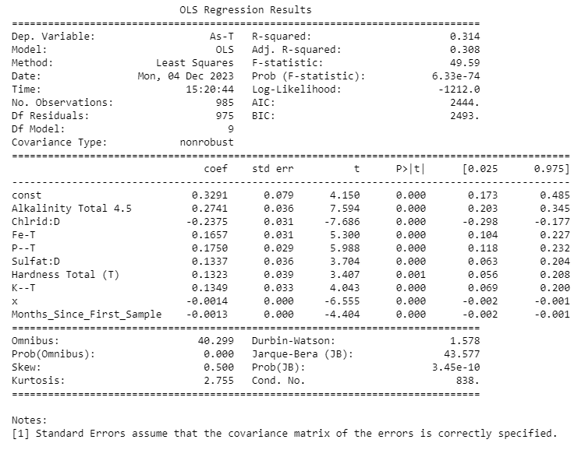
Figure 6.1: Summary of Ordinator Least Squares (OLS) auto-regression for As with the full dataset with 9 features.
Four auto regressive models for As, Mn, Pb and U were performed. The performance plots of each iteration are showing in Section 9.9, (Appendix). Figure 1 shows the OLS Auto regression for As. Nine features were found to optimize the model: 'Alkalinity', Chloride, 'Fe', 'P, 'Sulfate', 'Hardness Total (T)', 'K, 'x' and 'Months_Since_First_Sample’ with a summarized score of 0.1239. The adjusted r squared That said variables can explain 31% of As variance. The F statistics of 49.59 and extremely small p-value suggests that the group of predictors do add some statistically significant explanatory than compared to a model with no predictors. The Akaike information criteria (AIC) and Bayesian information criterion (BIC) are extremely high thus signifying that this model may not have good generalizability to other situations. Future research should further explore better predictors for more accurate model selection.
The standard error in most cases is less than the Interval confident intervals and thus indicates the likelihood of these predictors. Office this test the T hypothesis test shows larger values larger then 2 t values with p-values are less than 0.05. theoretically this should mean that the predictors to statistically significant however, as both AIC and BIC are large it may only be sticks statistically significant for this data set.
The residual tests such as skew and kurtosis indicate a slight right skewness. Both omnibus and Jarque Bera tests are tests for normality of the residuals and as the probability of both are close to zero, it indicates that these residuals are not normally distributed. The Durban Watson value is 1.578 and suggests that there is a slight positive autocorrelation, and the conditional number is not excessively large which suggests that there are not any serious multicollinearity issues.
Arsenic from exploratory data regression analysis was primarily influenced by alkalinity, chloride, iron, phosphorus, sulfate, hardness, potassium, and weekly by time and aquifer confinement. Hydraulic connectivity and bedrock interestingly seem not to show any influence. This contradicts a lot of studies done in specific sites. The best explanation for this is assuming that arsenic comes from both natural and anthropogenic means thus negating effect of one or the other. Alkalinity was the next impactful variable and matches expected geochemical relationships that influence arsenic as it impacts the redox reactions that influence the absorption and absorption of As. Alkalinity is likely demonstrated over pH as pH is more of a non-monotonic / threshold like relationship. Fe(III) I’m pretty absorbs as Fe(V). Phosphate often reflects soil or anthropogenic contamination and still influences or facilitates or competes with arsenic sorbption depending on the P:Fe ratio. Can stimulate reductive dissolution of e oxide. Potassium is not a major groundwater contamination but may indicate anthropogenic or weathering influences. Given the small amount of latitude, it indicates anthropogenic as the Centurion calculated would indicate Wells near the Southwestern portion of BC. Negative correlation of chloride Processes aligns with no one geochemical processes such as trivalent arsenic complexes that can immobilize and precipitate arsenic out of groundwater with higher Cl:As ratios. This runs counter to what is seen in the exploratory data analysis were a lot of As above CDWS were in the dataset with SWI. A possible explanation is that this could be due to anthopogenic means.

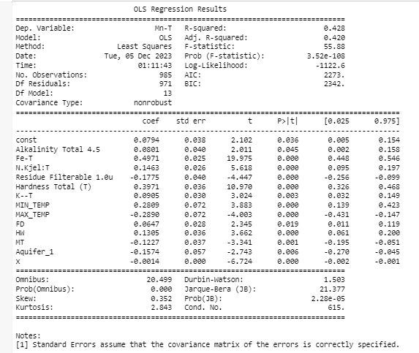
Figure 6.2: Summary of Ordinator Least Squares (OLS) auto-regression for Mn with the full dataset with 12 features.
The OLS regression results for manganese are showing in figure ****. Performance plot indicated that there is an optical number of 13 features: ‘Alkalinity Total 4.5’, ‘Fe-T’, ‘Total nitrogen’, ‘Residue Filterable 1.0u’, ‘Hardness Total (T)’, ‘K—T’, ‘MIN_TEMP’, ‘MAX_TEMP’, ‘FD’, ‘HW’, ‘MT’, ‘Aquifer_1’, and ‘x’ with a total score of 0.2229. Well fitted model Did a relatively well fitted model. Mn variance was explained by Said predictors by 42% (adjusted R-squared). That is f statistic is 55.88 with an associated extremely small p-value that signifies group of predictors add statistically significant explanatory power as compared to a model with no predictors. Which indicates that a generalized the additive model may have been a better choice for the data. AIC and B I C values are still relatively High thus indicating that this baby that these results may be specific to own this model only and it not generalizable.
The of each variable the standard area was not greater than the count of confidence intervals, the t-test Were considerably High, and all of the p-values were less than 0.05 indicating that the predictors are statistically significant. Interestingly enough total nitrogen Is a predictor despite it not showing up as a factor in the factor analysis or as any correlation. Alkalinity turned up both as a weak correlation and as a factor in the factor analysis but does have the greatest p-value which at 0.045 may not meet the cutoffs for more stricter standards.
Askew and kurtosis Hit the distribution of the residuals and show that it is a bit right skewed and a light tail relative to the normal distribution. The Omnibus and Jarque-Bera tests are also normality tests for the residuals and as the probabilities of both are close to zero, it is indicated that the residuals are not normally distributed. The Durban Watson value was 1.503 and suggest that there is a slight positive correlation in the residuals and the conditional number is 615 which is not excessively large and thus indicates that there are no serious multicollinearity issues.
Magnesium exploratory data regression analysis demonstrated multiple multicollinearity factors. Minimum temperature has a positive coefficient while the climate change effect for minimum temperature, Mt, had a negative coefficient. However, maximum temperature had the similar coefficient but negative and slightly greater as minimum temperature, and a greater positive coefficient for HW, which is the climate change effect on maximum temperature. This first could be due to measurement errors or inconsistency in the modeling data. Moreover, the seasonal and special aspects captured by Mt verse HW may have stronger influences on the complex biogeochemical cycles than direct thermodynamics controls. Thus, areas with less temperature variability (-’ve Mt), could still have high Mn for other reasons. Minimum temperature directly reflects the ambient thermal conditions at night and that could impact kinetics and solubility in general. While most general minimums increase Mn mobility up to an optimal temperature range and thus may have more of a simple linear correlation to solubility based on temperature kinetic controls. Mt shows the indirect climatic influence through temperature fluctuation impacts rather than just thermodynamics. Less temperature positive Mt values could indicate areas with greater seasonal temperature fluctuation. More dynamic freeze/thaw cycling could solubilize and immobilize Mn to a greater degree over different temperature seasonal impacts. Future research should seasonably adjust the time series data in order to negate the facts of seasonal cycling and to slowly focus on the effects of climate change.

Seasonal and special impacts of Mt versus HW may have stronger influences on the complex biochemical Mn cycle than direct thermodynamic controls. air along with non-linear mature response curves might apparently explain contradicting Mills if the characteristic geochemical thresholds exceeded by Mn verse HW. Maximum temperature is the monthly mean maximum temperature or daytime temperature. Higher temperature might increase mineral dissolution and magnesium mobilization to a point after which Mn will precipitate out. This might explain why there's a negative correlation despite a positive one. This coefficient might reflect locations with temperatures at the upper threshold where magnesium solubility decreases again due to enhanced precipitation. HW is the difference between the actual and predicted maximum temperatures, and thus indicates former aquifer regimes thermodynamically suited to higher manganese levels and perhaps more indicative of long-term climate change fluctuations. This indicates areas that are higher than expected maximum modeled value, and that are geographically or geologically distinctly conductive to sustained temperatures and longer reaction time. Prolonged warmer conditions seem to fight me solubility. HW also avoids saturation effects by only noticing relative increases of temperatures. HW isolates the climactic influences with a spatial factor and eliminates the special discrepancy that points to regional scale controls on manganese.
Iron, alkalinity and hardness represent the Rock geochemistry reactions. As previously stated, alkalinity and carbonate levels can influence Mn solubility through complex absorption processes. Iron is again closely tied to Mn geochemically and shown in the previous chapter to have a high relationship with Mn as they occur together in minerals and exhibit similar redox behavior. Potassium is not a major control on magnesium however it may serve as a proxy of mineral weathering over time and perhaps anthropogenic contamination. In this thesis, this is the first time Nitrogen is recommended as a significant factor. Nitrogen either acts as an indirect indicator of land use or anthropogenic influence on groundwater quality. Nitrogen is also a key nutrient influencing microbial activity and biogeochemical cycling in groundwater systems thus may be promoting ideal biogeochemical conditions through microbial radiation rather than direct control on Mn.
FD, or the representation of flood and drought, does show what was demonstrated before with a positive coefficient thus stating the same thing that happens during flooded as a raised Baseline flow, hydraulic hydrological settings conducting to mobilizing and transporting dissolved Mn and more groundwater weathering. Hydraulic connectivity had a negative coefficient. In this case, it could be due to topography, as topography and thinner saturated zones could result in more channelized vertical flow with less lateral mixing. Likewise, hydraulic connectivity could mean that there are more shallow, flushed and transmissive aquifers with less residence time and limited water Rock reaction.
Residue filterable has a negative correlation to Mn. This is somewhat demonstrated by the factor analysis however showing a negative coefficient instead of a positive coefficient. This might be due to its relationship to the saltwater intrusion factor in the factor analysis. Likewise, highly filterable residue waters have essentially flushed more mayonnaise from their aquifer media over longer time scales through continued rock water exchange. Turbidity itself would deteriorate that. Areas with elevated filterable residues likely experience more rock water interactions driven by factors like thicker and saturated zones, longer and carbonated rates geologies.

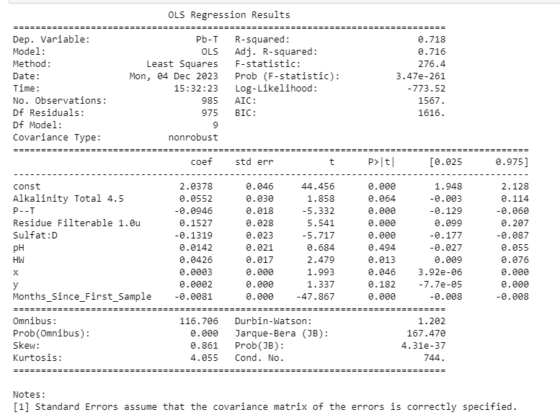
Figure 6.3: Summary of Ordinator Least Squares (OLS) auto-regression for Pb with the full dataset with 8 features.
Results for OLS regression for lead is shown in figure *****. The model was found to have nine features: ’'Alkalinity Total 4.’',‘'—-’',‘'Residue Filterable 1.0’',‘'SulfatE’',‘'pH’',‘'HW’',‘'x’',‘'y’', and time with a total score of -9.3453 (Section 9.9, Appendix). These predictors accounted for 72% of the variance of PB. The F statistic and associated p-value are very small signifying that these predictor groups add statistically significant explanatory power to the model. The log likelihood is less negative than other previous models and indicates that this is a better fit compared to the other metals. A i c and b i c are still quite smaller than other metal models and indicate that this may be more generalizable to other data.
P-value for total alkalinity and pH is above 0.05 and thus is not statistically significant. Meanwhile, the values for phosphorus, residue filterable, and sulfate show smaller standard errors than their confidence intervals and statistically significant T and p values. HW did show a significant p-value, however, the standard error nearly exceeded that of its confidence interval. “X” and time again did show statistically significant P values but an extremely small confidence interval that included zero and thus is likely suspicious.
Residual tests showed a light right skewness and heavy-tailed relative to a normal distribution with a kurtosis of 4.055. the Omnibus and Jarque Bera test respective probabilities are close to zero, indicating that the residuals are not normally distributed. The conditional number is not excessively large, thus there is no severe serious multicollinearity issues. The Durban Watson value of 1.202 suggests there's a positive or autocorrelation in the residuals.
The lead linear regression model demonstrated alkalinity, pH, X and Y are not statistically significant coefficients for that model. This presents an issue given that alkalinity is often used to engage rock geochemistry. Negative coefficients for phosphate and sulfate could be explained by multiple explanations, such as precipitation reactions from phosphate and sulfide ions forming insoluble precipitates with dissolved lead, such as lead sulfate or lead phosphate. Processes, such as geochemical processes as created by sulfate and phosphate reducing bacteria which result in an opposite condition where lead, sulfide or phosphate minerals are more stable. Residual filterable residual had a positive coefficient and indicated an association with higher lead concentrations. This is in accordance to what was found in the factor analysis. Content as this could be due to sediment composition as regions with salt and mineral or residuals might happen to have aquifer sediments with more natural pH bearing minerals to be solubilized under rock water interactions, pH buffering from ions like carbonates and bicarbonates Or that higher tedious might provide more ions available for kid on cation exchange processes on the mineral surfaces and facilitate the absorption and release of previous absorbed lead into groundwater. Time has a negative c coefficient and could be due to anthropogenic means with stronger pollution laws and better well maintenance. This indicates that less lead would be in groundwater over the last 25 years. HW or increasing maximum ambient monthly temperatures also had a slight positive coefficient. Higher daytime maximums drive faster weathering and Pb mobilizations compared to minimums temperature. Lead also had a strong seasonal component with water and thus the effect might not be at the point where it is disrupted by climate change. Likewise, this indicates that lead might tolerate higher absorption temperatures than manganese.
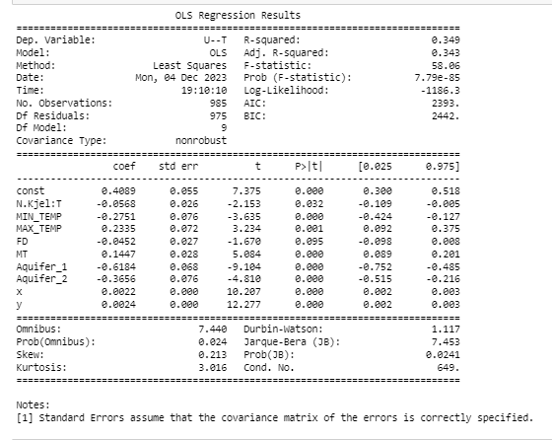
Figure 6.4: Summary of Ordinator Least Squares (OLS) auto-regression for U with the full dataset with 8 features.
The auto regressive model for Uranium was optimized with nine independent variables: 'N.', 'MIN_TEMP', 'MAX_TEMP', 'FD', 'MT', 'Aquifer_1', 'Aquifer_2', 'x', 'y' with a summed score of -1.8067 (Section 9.9, Appendix). Adjusted r squared is 0.34 + accounting for 34% of the variance of UT from these variables. The F statistic is 58.06 and associated p-value is extremely small suggested that these group predictors add statistical significant explanatory power to the model compared to something without any predictors. The log likelihood is still extremely high which does call into question the accuracy as there are a ton of residuals. AIC and B I C are extremely large and thus may not be ideal or generalizable for other data sets.
Nitrogen has a t value around -2.15 and p-value of 0.032 which makes it somewhat statistically significant. This did not appear in the factor analysis or in any correlation. Maximum temperature, minimum temperature, minimum temperature difference (MT), One aquifer group one and aquifer group 2 both have significant T values, p-values And standard errors that are less than their confidence intervals thus suggesting that they add statistical significance. X distance and y distance have significant T and P values, no standard errors and a very small confident interval which could indicate significance or could indicate potential errors. FD or the difference in expected and stimulated precipitation was a major factor behind 10 model however it's p-value is 0.095 and less is not statistically significant.
The residual tests indicate that the distribution of residuals is slightly right skewed (skew .2013) and has a light tail relative to a normal distribution. the Omnibus and JB tests along with their respective probabilities are both less than 05 and indicate that the residuals are not normally distributed. The Durbin Watson values 1.1171 suggests positive Orc autocorrelation in the residuals and a moderate conditional number of 649 suggests that there is no serious multicollinearity issue.
Uranium in groundwater for British Columbia had nine predictor variables: nitrogen, minimum temperature, maximum temperature, mt, aquifer Group 1, aquifer group 2, X, y, and FD. FD was not statistically significant. Nitrogen had a negative coefficient, and this is associated with lower uranium concentrations. This may be due to a possible few explanation. Make participate in redox reactions that immobilize uranium Nitrate can complex and with and immobilize uranium ions (UO2(NO3)2. Areas with anthropogenic nitrogen could promote competing microbial processes that outcompete uranium mobilization. Microorganisms can also involve in denature vacation can also utilize nitrate and instead of oxygen as their final electron acceptor and reduce the oxidizing conditions needed to keep uranium soluble.
Aquifer group 2, aquifer Group 1 and aquifer group 2 both have negative coefficients. The negative coefficient for aquifer Group 1 maybe due to multiple reasons. One is that there's a greater potential for oxid conditions in shallower aquifers that promote uranium precipitation and immobilization. Likewise, they increase microbial activities in the toxic near surface zones and may promote more immobilizing uranium reduction pathways. Higher permeability and porosity allow for more rapid groundwater flow and can transport uranium out of the system before a buildup of concentration. The shallower depth can also result in less geochemical buffering of reducing conditions that favor dissolve uranium. Aquifer group 2 represents confined aquifers. The consignment might isolate aquifer water from rapid recharge events that transport U throughout the system and can prevent anthropogenic uranium contamination from entering the aquifer. Likewise, there could be a special component as U is more favored in more Bedrock fractured aquifers. Competition with other redox active solutes in late due to Due to longer residence time. Shared loading variations in the sediment and let the lithology Chemistry Between the confined and confined aquifers might impact you search and mechanisms. Previous glacial loading cycles may have compacted and cemented combined sediments and hampering the pour water and thus you Mobility. Last hydraulic heterogeneity is reduced due to the lack of mixing with shallow groundwater.

Both X and Y which are the cartesian equivalents of latitude and longitude had a negative loading. This could be due to anthropogenic means as the Southwest would be more heavily polluted due to population in previous industry. It could also mean a potential difference in Bedrock and groundwater and Bedrock materials. Partial auto correction could help add further information to understand if this is an actual pattern or due to basic geology and geography.

Minimum temperature had a negative coefficient for uranium OLS regression models while maximum temperature had a positive coefficient along with mt. *****Ask About this?****

  - Ordinary Least Squares Auto Regression Models with Climate Change Events

Auto regressive OLS models similar to the ones used in R were used to analyze data sets for different climate change events or all four metals of Interest (Section 9.9, Appendix). Included are the entire 18 or 19 independent variables.
    - Ordinary Least Squares Auto Regression Models with Saltwater Intrusion, Drought, Flooding, Increasing Minimum Temperature and Increasing Maximum Temperature for As
Table 6:1: Statistically significant predictors from OLS regression models for As in B.C. groundwater. + represents a positive coefficient, – represents a negative coefficient while * represents variable only included in the regression model for the main data. Note that the model for the main dataset was done via a two-step autoregressive technique while SWI, drought, flood, Rising Maximum °C and Rising Minimum °C utilized an R like formula..
 | Main | SWI | Drought | Flood | Rising Maximum °C | Rising Minimum °C
Alkalinity | + |  | + | + | + | +
Chloride | - |  | - |  | - | -
Fe | + | + | + | + | + | +
P | + |  | + |  | + | +
Sulfate | + | + | + |  | + | +
Hardness* | +
K | + | - | + |  | + | +
pH |  |  | +
Residue Filterable |  |  |  | +
Time | - |  |  |  | -
x | - | - |  |  |  | -
N |  | - |  |  |  | -
Aquifer_1 |  | + | + | + | + | +
Aquifer_2 |  |  | + | + | +
Aquifer_3 |  | - |  | +
Precipitation |  |  |  | -
Maximum °C |  |  |  | -
Minimum °C |  |  |  | +

For Arsenic in SWI adjusted R2 values was 0.486 (Section 9.9, Appendix). The data set for saltwater intrusion had a large difference between the adjusted and regular R Square value thus indicates that a lot of the predictors might not be contributing significantly to the model. The F statistic was 6.5 and only small and p-value was extremely small suggesting that said predictors as a group statistically add significant explanatory power to the model in comparison without any predictors. The log likelihood is still negative and thus adds concern to these findings, but the AIC and BIC are far lower and thus indicates a better fit than the entire data set. Only iron, nitrogen, Potassium, sulfate, Aquifer Group 1, aquifer group 3, and X distance Create add appropriate t, p, and confidence intervals. The distance was extremely small and thus insignificant. The residual data statistics showed that the distribution of residuals was slightly and had a heavy tail relative to the normal distribution. the German Watson statistic suggests there's a slight positive autocorrelation in the residuals. Given that the probability of both the old omnibus and Jacques-Bura were greater than 0.05 and indicates somewhat more of a normal distribution. However, the large conditional number suggests serious multicollinearity issues.
An OLS regression for arsenic with saltwater intrusion gave 7 key predictors: iron, nitrogen, sulfate, potassium, aquifer Group 1, aquifer group 3 and X which is the Cartesian equivalent of latitude. Sulfate and iron are consistent throughout the OLS regressive models for the main data set and for each of the climate change events. This is likely due to general rock geochemistry. Nitrogen has a negative coefficient and this may be due to the organic nitrogen which influences subsurface biogeochemistry. Microbes may actively respire as(V) over other metals under nitrogen-rich conditions which effectively immobilizes some arsenic through intracellular incorporation. During droughts or floods, the redox conditions influencing arsenic may be dominated more by changes in oxygen, iron or sulfate levels rather than microbial nitrogen processes.

The coefficient for potassium is negative for As in groundwater with saltwater intrusion. At higher potassium levels, pH and alkalinity is increased by carbonate weathering and favors the absorption of arsenic ions onto iron oxide surfaces. Mineral alteration reactions driven by potassium could also liberate iron from silicate minerals and enhance the precipitation of f e o h 3 that co-precipitates arsenic. Higher potassium concentrations could also shift the redox buffering in a way that preserves iron as Fe(III) Arsenic which retains arsenic instead of the mobilizing Fe(II). Last, this could also be due to aquifer lithology differences that correlate with k. Phosphorus is not a predictor perhaps due to data limitations as there's insufficient special temporal measurements and perhaps just lack of synoptic sampling with P and As that obscure a statistical relationship.
Aquifer groups had a unique relationship with arsenic in groundwater with saltwater intrusion. the coefficient for aquifer Group 1 was higher than other regressive models for other climate change factors. These aquifers are primarily unconfined Fluvial and glacial Fluvial sediments that often interact directly with surface water. these aquifers are more vulnerable to tidal pumping effects from The Saltwater interface and hence that could drive more redox fluctuations. Aquifer group 3 at a negative coefficient as the Fluctuation driven by tides and pumping are attenuated aquifer type 3 and preserve the more oxid conditions that favor cynic retention. Sedimentary and crystalline Bedrock is also located in higher elevations and therefore likely to experience less title influence and mixing. Group 2 is not a predictor aquifer group 2 is not a predictor perhaps due to the special resolution of well data which would fail to sufficiently characterize heterogeneity behavior with saltwater intrusion in confined aquifers. X, which is the Cartesian version of latitude, has a negative relationship stating that it has to be proximal to the coastline.
Ordinary least squares regressive models for droughts and arsenic had an adjusted R square value accounting for 34% of the variance of As (Section 9.9, Appendix). F statistic was large, and the probability of f statistic was close to zero thus indicating that the model is more statistically significant with the predictors than without. The log likelihood was negative and far larger than saltwater intrusion as was the aicnbic which indicates that said model might not be accurate for other data sets and as predictors. Alkalinity, chloride, phosphorus, sulfate, pH, potassium, aquifer group 1, aquifer group 2, and X distance all had statistically significant p-values, appropriate T values, appropriate and appropriate confidence intervals. the residual statistics indicate that this is slightly right skewed and has a very strong tail and slight relationships between the predictors. the probability of the Omnibus and JW are close to zero and indicate that the residuals are not normally distributed. the conditional number is extremely large and the smallest and value is 5.8 e -30 Indicate that there are strong multicollinearity problems.
The OLS regression model for arsenic and groundwater during droughts had nine predictors: alkalinity, chloride, iron, phosphorus, sulfate, pH, potassium, aquifer Group 1 and aquifer Group 2. Aquifer Group 1 had a positive coefficient as lowering of the water table will introduce more arsenic containing rock to oxidation. At higher pH levels, arsenite and arsenate are more soluble and mobile in water. Lower pH favors absorption of arsenic onto metal hydroxide surfaces. The oxidation of iron minerals during drought releases previously sequestered arsenic which would be more soluble at higher pH prevailing in the aquifer. Aquifer group 2 is a positive but low coefficient and represents aquifer confinement. This might be due to mineralogical factors as the confined nature and relational sediments of the aquifer group 2 may contain higher levels of arsenic bearing minerals like sulfides compared to aquifer 1 sediments, which would be more likely to degrade and release arsenic under drought stress. Aquifer group 3 may not be a significant predictor because of aquifer heterogeneity, and this should be investigated in future research. Is commonly associated with bicarbonate ions and suggests a potential shared geochemical control. Bicarbonate is also associated with higher arsenic. More data and analysis on this relationship should be a focus with future research for predictive modeling. Last, chloride had a negative coefficient syndicating longer residential times and may signify more rapid flushing throughout the aquifer. It is likely that there could also be a geochemical or microbial influence prevented by chloride.
Flood data OLS regression for arsenic using flood data had similar results to wrote data to drought data (Section 9.9, Appendix). The predictors that had appropriate P, t, and confident intervals were alkalinity, chloride, nitrogen, phosphorus, sulfate, Aquafer Group 1, X distance and time. X distance and time had very small coefficients. Like the drought model, the residuals were skewed, had a high tail, and a non-normal distribution. And small a high conditional number and small engine value of 9.3e-30 indicated significant multicollinearity problems.
The OLS regressive model for arsenic in BC groundwater with flooding conditions had nine key predictors: Alkalinity, iron, residue filterable, precipitation, minimum temperature, maximum temperature, aquifer Group 1, aquifer group 2, and aquifer group 3. All three aquifer groups have similar positive coefficients that were greater than that in drought. This might be due to floods drastically altering hydraulic low paths and residence times within the aquifers. This destructive flushing will mobilize arsenic for more sources and also bring in anthropogenic Nick from the surface. Floods also increase weathering and can increase biological activity due to bringing in Greater nutrients. Alkalinity had a positive coefficient that isn't as high as droughts or other climate change events perhaps due to the dilution effect of floods. Sulfate, potassium, and phosphorus are not predictors in Arsenic with flooded groundwater. this might be due to the weekend relationship with alkalinity as all three are found with the bicarbonate and carbonate reactions. residual filterable has a positive coefficient and that might be due to it serving as a substrate vehicle for arsenic transportation during flooding either from natural weathering sources and sediments or anthropogenic contaminated soils. precipitation has a negative coefficient due to the dilution effect by incoming rainfall. more data and studies are necessary to understand specific mechanisms of precipitation on arsenic. Minimum temperature had a positive coefficient well maximum temperature had a negative coefficient. this indicates a very complex relationship between the Arsenic and temporal factors that will require future research to unravel. it could be that maximum temperature introduces more snow melt and run off the encouraging the dilution effect. well minimum temperature indicates more gradual warming and increases redox reaction rates.
Ordinary least squares regression model for arsenic with rising maximum temperatures had a similar model data for arsenic in the flood and drought data (Section 9.9, Appendix). Alkalinity, chloride, iron, sulfate, potassium, Aquifer Group 1, X distance and time had significant t and p-values with appropriate confident intervals. Aquifer Group 2 had appropriate t and p values but had confident intervals that passed zero. X distance and time also have very small coefficients. The residue data was slightly skewed and highly tailed. The Omnibus and JB probabilities indicate that the data is not normal and the high conditional values along with the smallest eigenvalue indicates that there is a strong multicollinearity problem with this model. Rising minimum temperature for all metals contain and follow the similar trend to that of rising maximum temperatures (Section 9.9, Appendix).
The OLS regression model for arsenic in groundwater with increasing maximum temperatures had nine key predictors: alkalinity, chloride, iron, phosphorus, sulfate, potassium, Aquifer Group 1, Aquifer Group 2 and time. While OLS regressive model for arsenic in BC groundwater with increasing minimum temperature also had nine key predictors: alkalinity, chloride, iron, nitrogen, phosphate, potassium, Aquifer Group 1, and X. Aquifer Group 1 is shallow, unconfined and hydraulically connected to water, hence probably more affected by Rising surface temperature.
    - Ordinary Least Squares Auto Regression Models with Saltwater Intrusion, Drought, Flooding, Increasing Minimum Temperature and Increasing Maximum Temperature for Mn
Table 6:2: Statistically significant predictors from OLS regression models for Mn in B.C. groundwater. + represents a positive coefficient, – represents a negative coefficient while * represents variables only included in the regression model for the main data. Note that the model for the main dataset was done via a two step autoregressive technique while SWI, drought, flood, Rising Maximum °C and Rising Minimum °C utilized an R like formula.
 | Main | SWI | Drought | Flood | Rising Maximum °C | Rising Minimum °C
Alkalinity | + | - |  | + | + | +
Chloride |  | -
P |  | +
Specific Conductance |  | + | + |  | + | +
Residue Filterable | - |  |  |  | -
pH |  | - | - |  | - | -
Fe | + |  | + | + | + | +
K | + | + | + | + | + | +
N | + |  | + | + | + | +
x | - | - | - | - | - | -
y |  | - |  |  |  | +
Aquifer_1 | -
Aquifer_2 |  | +
Aquifer_3
Maximum °C | - |  |  | - | -
Minimum °C | + |  |  |  | +
Hardness* | +
FD* | +
HW* | +
MT* | -

Manganese for saltwater intrusion had an adjusted r squared of 0.64, with the similar differences as in the Arsenic model (Section 9.9, Appendix). It had an F statistic of 11.34 and an extremely associated small p-value, suggesting that there's a significant explanatory power to the model using the predictors as a group, however not all predictors might be contributed significantly to said model. The log likelihood was still negative but less so than arsenic along with lower AIC and BIC values. Alkalinity, fluoride, specific conductance, pH, potassium, Aquifer Group 2, Y distance and X distance all had statistically significant p-values, T values, appropriate standard error and contra confidence intervals. X and Y distance did not significantly contribute to the model. The tests of residuals indicated that there was a slight right skewness with a heavy tail relative to normal distribution. The Durban Watson statistic was 1.412 and suggested a slight positive or autocorrelation. Both the probability of the Omnibus and JB tests were greater than 0.05 and indicated a normal distribution for the residuals. However again the conditional number extra was extraordinarily large and thus there might be serious multicollinearity issues. There are squared and previous models, the more predictors might suggest the model being overfitted.
Manganese contamination in groundwater with saltwater intrusion had a different set of conditions compared to regular data. This is due hardness and HW or Mt being dropped from the data set to minimize multicollinearity issues and to the differing method of regression used. The main data set used a two-step auto regression model while the methodology for the climate change factors used R like formulas. The saltwater intrusion data set was significantly smaller compared to the main data set with all characteristics. This may explain why there are more larger coefficients and different characteristics in the saltwater intrusion data set. A lot of the variables in the had high p-values. The coefficients of both rising minimum and maximum temperatures seem to be very similar to the coefficients of the drought model without pH. The subtle coefficient difference between minimum and maximum temperatures may be due to lack of data and do require further research. However, this model indicates that maximum and minimum temperatures do have subtle influences over biogeochemical and biological mechanisms of arsenic contamination in groundwater. Maximum and minimum temperatures could influence arsenic mobility through different geochemical or biological pathways operating at different intensities. Maximum temperatures might also be influential in short-term processes like oxidations while minimum temperatures might influence more weathering. Similarly, non-linear response of arsenic to temperature would have different optimal ranges for maximum and minimum values that would only be partially captured by the model. Seasonality and spartial patterns will be an issue for interactions.
Alkalinity and potassium continued to be a key variable in the saltwater intrusion regression model. Other rock chemistry factors were replaced by pH, phosphorus, specific conductance, and chloride; all saltwater intrusion variables. Specific conductance and chloride are an inverse of each other and could represent the difference between saltwater intrusion influence and regular rock geochemistry. Negatively correlated and thus perhaps carbonate geochemistry in more mineralized water favored Mn immobilization. pH once more had a negative effect, with lower pH solubilizing Mn and saltwater intrusions buffing pH upwards. Both X and Y, which represents latitude and longitude, are variables that could represent distance to the coastline due to the negative value. Aquifer Group 2 represents confinement and is perhaps more indicative of saltwater intrusion rather than hydraulic connectivity.
Manganese concentrations in drought showed a regression model that had an adjusted r squared of 0.64 and a strong indication that not all model predictors contributed to the model (Section 9.9, Appendix). The F statistic was 11.35 with probability less than zero, signifying that this group of predictors were still more statistically significant than nothing. The log likelihood was less negative than the arsenic model and the AIC and B I C were comparatively lower than, indicating that this model is still a better fit compared to arsenic. Alkalinity, chloride, pH, potassium, Aquifer Group 2, X distance and Y distance all had acceptable t, P-values, and confident intervals. Specific conductance, maximum temperature and phosphate had relevant P intervals but confidence intervals that either included zero or were less than the standard error. X distance and Y distance were extremely insignificant due to the low coefficient. The residual plot showed slight skewness, a very strong tail, and normal distribution given the probability of the Omnibus and JB statistics. The conditional number was extremely large and the smallest eigenvalue was 3.46e-31 and indicated strong multicollinearity problems.
Manganese with drought data for the OLS model showed similar values of Fe, N, K, and residual non- filterable as the main Mn models, specifying that there were still some underlying groundwater mechanisms and weathering mechanisms. As X was the substitute for latitude the data may indicate a special trend of low-lying wetland areas with longer saturation or mixing of surface groundwater. Interestingly enough hydraulic connectivity and aquifer confinement didn't seem to be as influential with coefficients. This might be due to the lack of data. pH and specific conductance followed similar trends to that of saltwater intrusion and along with K, were positively associated to drought influences and point to drought preferably impacting permanent permeable marginal zones with enhanced activity and weathering potential.
OLS regression for Mn with flooded data again had similar results to drought data (Section 9.9, Appendix). Predictors that had appropriate p, t, and confidence intervals were alkalinity, chloride, nitrogen, phosphorus, sulfate, pH, potassium, Aquifer Group 1, and X distance. X distance and time had significantly smaller coefficients. The residual distribution are similar of that as arsenic with strong multicollinearity t problems.
In flood, Mn regression models showed the same coefficients as drought values for Fe, N, and K. These coefficient values along with alkalinity being positively correlated, suggest that floods shifted favourable redox conditions in Mn solubility via mineral weathering and microbial processes. Reduced recharge allows for longer rock water interaction time and potentially leaching cations will initiate reducing conditions. Maximum temperature however has a negative effect, potentially reflecting the increased Mn precipitation and absorption under concentrated conditions.
Manganese with rising temperatures follow the same pattern as compared to the OLS regression model of drought data (Section 9.9, Appendix). Rising minimum temperature for all metals contain and follow the similar trend to that of rising maximum temperatures (Section 9.9, Appendix).
The regression model with increasing maximum temperature That of drought. and flooding. with the Maximum temperature increasing, both flooding and drought-like events occur due to run off and precipitation pattern changes. Therefore, it was difficult to discern and differentiate groundwater mechanisms. Minimum temperature had a positive coefficient reflecting the ambient thermal conditions controlling reaction kinetics, warmer minimum temperatures and solubility up to an optimal point. Meanwhile, maximum temperature influenced kinetics but exceeded the inflection point where increased precipitation and absorption of manganese dominates. Maximum temperature captures temperatures where inhibition effects could occur while minimum temperature only isolated seasonal low points with favorable solubility.
The increasing minimum temperature data set gave similar results to the increasing maximum temperature data set but without temperature as coefficients perhaps due to modeling limitations. Y, which represents the cartesian equivalent for longitude, is also a factor and could indicate how increased ambient temperatures are more affected by climate change in more northern areas
Ordinary Least Squares Auto Regression Models with Saltwater Intrusion, Drought, Flooding, Increasing Minimum Temperature and Increasing Maximum Temperature for Pb
Table 6:3: Statistically significant predictors from OLS regression models for Pb in B.C. groundwater. + represents a positive coefficient, – represents a negative coefficient while * represents variable only included in the regression model for the main data. Note that the model for the main dataset was done via a two-step autoregressive technique while SWI, drought, flood, Rising Maximum °C and Rising Minimum °C utilized an R like formula.
 | Main | SWI | Drought | Flood | Rising Maximum °C | Rising Minimum °C
P | -
Residue Filterable | + |  | + | + | + | +
Sulfate | - | - | - |  | - | -
HW* | +
Time | - | -
Fe |  | + | + | + | + | +
K |  | - | - |  | - | -
Aquifer_1 |  | + | + | + | + | +
Aquifer_2 |  | + | + | + | + | +
Aquifer_3 |  | + | + | + | + | +
N |  |  | -
Precipitation |  |  | - | - | - | -
Specific Conductance |  |  |  | -
Minimum °C |  |  |  | +
Maximum °C |  |  |  | -
pH |  |  |  |  | + | +

Nitration model for lead had less of a distance between r squared and adjusted r squared and accounted for about 76% of the variance (Section 9.9, Appendix) for SWI. The F statistic and the probability of that statistic was extremely low and thus suggested that there was a statistical significance of all of the predictors versus no predictors on the variance of PB. Iron, sulfate, potassium, Aquifer Group 1, Aquifer Group 2, Aquifer Group 3 and time had appropriate t, P-values and confidence intervals. The residual statistical descriptions were similar however strong multicollinearity problems were indicated by the conditional number and the fact that the smallest eigenvalue was 3.46 e -31.
OLS regressive model for lead in wells with saltwater intrusion had seven variables: iron, sulfate, potassium, Aquifer Group 1, Aquifer Group 2, Aquifer Group 3 and time. Time was explained in the main analysis. Iron is consistent throughout all models for different climate change factors and seems to be related to general groundwater chemistry when it comes to association with lead. This was previously supported in the exploratory data analysis.
The coefficient for potassium is relatively large for the Pb regression model with saltwater intrusion compared to the regression models of other climate change factors. This might be due to precipitation effects as in saltwater, lead sulfate and lead carbonate precipitates and potassium promotes the carbonate alkalinity supporting the carbonate precipitation of lead. Ion screening from elevated potassium levels promoting the de-absorption of lead may also be an explanation. Precipitation is an indirect influence and may already act through other drivers such as dissolution rates or redox conditions and thus do not show as a main predictor. In general for Aquifer Group 1, the hydraulic connection to the surface in unconfined settings influence geochemical fluctuations that affects Pb solubility. Increased sediment water interactions leaching lead from deposits over time, can introduce anthropogenic lead sources easily, and lower streams and beds may drain natural landscapes with higher lead into the aquifer. As showing in Mn, Aquifer Group 1 has a far smaller coefficient than the other OLS models for other climate change factors. This is as the hydraulic connectivity is not as influential on saltwater intrusion compared to those without.
The regression of lead followed a similar pattern as the regression of Mn with the flood data set but without less of a difference between the R squared and adjusted R square value (Section 9.9, Appendix). This signifies that not all of the predictors make up most of the model. The AIC and BIC values were significantly larger while the log likelihood was significantly negative thus indicating a potential poor fit or poor generalizability. Nitrogen, iron, potassium, precipitation, Aquifer Group 1, Aquifer Group 2, Aquifer Group 3, and time had appropriate T values, statistically significant P-values and appropriate confidence intervals. Y distance and residue filterable had appropriate P-values but confidence intervals that included zero. Likewise, there's some linearity with the Durban Watson test and the residue is right skewed with a very strong tail, and highly unlikely to be normal due to the probability of both the Omnibus and JB statistics being close to zero. The conditional number is extremely high, and the smallest eigenvalue is 5.8 e - 30 and indicated strong multicollinearity problems.
Modeling for lead in groundwater with flood conditions gave nine key predictors: residual filterable, specific conductance, precipitation, maximum temperature, minimum temperature, Aquifer Group 1, Aquifer Group 2 and Aquifer Group 3. Sulfate and potassium are not predictors potentially due to modeling. Other explanations could be that flooding introduced large pulses of sulfate from soils and sediments but it may not behave conservatively without prolonged contact time for reactions. The reducing conditions that sulfate requires to precipitate lead may not develop rapidly enough either.
Potassium impacts are also more gradual through competition and iron shielding at Mid mineral surfaces over a longer time scale then sliding. Likewise, the dilution effect from higher water flows may dilute point sources of sulfate and potassium before they can significantly modify Pb values. Specific conductance had a moderate negative coefficient to lead regression model. Waters with higher conductivity have greater buffering capacity against pH changes caused by floods and thus maintain in less soluble forms. Flooding can transport lead which is intuitive more quickly through natural treatment functions in more mineral-rich waters that are indicated by higher specific conductance values
Iron as a predictor for lead in flooded groundwater is lower and has a lower coefficient than other climate change regression models. This might be due to the fact that most iron enters aquifers as insoluble oxides and hydroxide that slowly dissolve over longer times time scales than a flooding event. The recharge water carrying iron are flush through more quickly under high flow conditions and have limited rock water interaction times. Aquifer Group 3 had a higher coefficient than other OLS models for the other climate change influences. The influence of fractured bedrock on lead for concentrations during floods might be due to connectivity as the dense fracture network allows for flood waters. Rapid deep infiltration to mobilize and transport lead over graded greater distances Within bedrock. flux and also with high hydraulic conductivity and actress concentrates the flow and associate in contaminate loading through bedrocks. and despite conducts, water resides intensively in Bedrock matrices allowing for more complete PB dissolution from minerals and fractures. Wells, production wells tapping fractures face also an elevated risk of direct contamination from flood borne plumes.
Minimum temperature has a positive coefficient while maximum temperature has a negative coefficient for lead in flooded groundwater. Iron maximum temperature can promote late enhanced Pb precipitation by pushing geochemical conditions towards less soluble phases. Higher solubility and a negative temperature fit a negative correlation. Lead also has a seasonal fluctuation and the metal requires Pb to transition between solubility regions each cycle. Peak solubility often occurs at immediate rather than extreme high/low temperatures. Likewise, plant and microbial activity that is attenuating Pb might be higher at an optimal temperature range and decline at very low/high maximum extremes. Minimum temperatures have a positive coefficient and promotes solubility factors that are perhaps more apparent with climate change.
OLS regression for lead in drought data follow the same pattern as regression in flooded data with similar model statistics (Section 9.9, Appendix). Iron, nitrogen, phosphorus, residual filterable, specific conductance, pH, precipitation, Max temp, Min temp, all three aquifer groups, X distance and time had acceptable t, P, and confidence intervals. X distance and time had very small coefficient so this can be excluded, and alkalinity had a standard error that was greater than its country confidence interval. Minimum and maximum temperatures were inverse of each other. The residue data was similar to that of drought conditions and showed strong multicollinearity problems.
The OLS regressive model for lead in groundwater undergoing droughts had nine predictors: iron, nitrogen, residue filterable, sulfate, potassium, precipitation, Aquifer Group 1, Aquifer Group 2, and Aquifer Group 3. Residual field triple filterable may be due to groundwater properties with concentration effects. Nitrogen has previously been shown to correlate with drought. To lower this may lead to lower Pb concentration in groundwater either due to geochemistry or biological means. Nitrate reducing bacteria could create more reducing conditions and favor for the precipitation of insoluble lead sulfides or mobilized nitrates could act as alternative centers for microbial reactions and reduce the oxidative dissolution of Pb bearing solid bases. Higher nitrogen also may signify agriculture anthropogenic influences which come with more introduced organic ligands that form complexes with immobilized ions. Nitrogen rich, especially nitrate rich waters may be more buffered and help maintain a Ph range where lead minerals have low solubility despite the increased rock water interactions during drought.
Rising minimum temperature for all metals contain and follow the similar Trend to that of rising maximum temperatures (Section 9.9, Appendix).
OLS regression model for lead with increasing maximum monthly temperatures had nine key predictors: iron, residue filterable, sulfate, pH, potassium, precipitation, Aquifer Group 1, Aquifer Group 2, and Aquifer Group 3. pH could possibly influence lead levels under increasing temperatures as the pH of absorption to aquifer solids generally decrease with higher pH since surfaces become more negatively charged. As temperature rises equilibria generally shifts to consume more hydrogen ions and indirectly raises pH through increased alkalinity. Higher pH could also mean that there was a shift in the microbial community at higher temperatures that disrupted demobilization.
Aquifer Group 2 was consistent throughout different scenarios. Confined settings mean less fluctuation in the geochemical and hydraulic conditions compared to unconfined aquifers and may result in longer residence times to facilitate continuous rock water reactions, lower permeability, concentrate solutes like Pb and higher late sediments with higher natural Pb. This represents more of the geochemical processes over time rather than transient factors that most influence elevated Pb levels. The regression model influencing minimum temperature for lead is very similar to that of maximum monthly temperature.
The residual plots show said skews and show especially the extreme right skew with lead. The box plots demonstrate the variability of the data, and the quantile plots indicate the likelihood of the fit (Section 9.9, Appendix). Lead itself has very poor fitting
    - Ordinary Least Squares Auto Regression Models with Saltwater Intrusion, Drought, Flooding, Increasing Minimum Temperature and Increasing Maximum Temperature for U
Table 6:4: Statistically significant predictors from OLS regression models for U in B.C. groundwater. + represents a positive coefficient, – represents a negative coefficient while * represents variable only included in the regression model for the main data. Note that the model for the main dataset was done via a two-step autoregressive technique while SWI, drought, flood, Rising Maximum °C and Rising Minimum °C utilized an R like formula.
 | Main | SWI | Drought | Flood | Rising Maximum °C | Rising Minimum °C
Alkalinity |  | + |  | + | + | +
Sulfate |  | + | + | + | + | +
Chloride |  |  | - |  | - | -
K |  |  | + | + | + | +
Fe |  |  |  | - |  | -
N | - |  |  | -
X | +
y | + |  |  | +
Precipitation |  |  | - |  | - | -
pH |  | -
Time |  | + | + | +
Aquifer_1 | - | - | - | - | - | -
Aquifer_2 | - |  | - |  | - | -
Aquifer_3 |  | + | + |  | + | +
Min Temp | -
Max Temp | +
MT* | +

Uranium regression models for saltwater intrusion showed a similar pattern to lead (Section 9.9, Appendix). Alkalinity, sulfate, pH, Aquifer Group 1, Aquifer Group 3, and time should appropriate P and t values with competent intervals. Residual summary statistics were similar to that of the previous two metals. The strong conditional number and the fact that the smallest eigenvalue is 3.46e- 31Multicolineary problems. The residual matrices of all four metals were plotted in histogram form, box plots and in Quantal-quantal forms. Normal distribution was seen in all of them and most generally met expected QQ plots.
The OLS regression model for uranium with saltwater intrusion had seven statistically significant predictors: alkalinity, sulfate, pH, Aquifer Group 1, Aquifer Group 3, and time. Sulfate seems to be a predictor for all climate change variables and thus must be due to general groundwater chemistry. Time is a positive coefficient and states that uranium concentration increases with longer sampling time. This is consistent throughout the other climate change regression models and perhaps the difference of that in comparison to the general uranium OLS regression model is due to the methodology. This can be as described before or groundwater circulation allowing for more complete mass transfer of uranium in mobile aqueous complexes. Aquifer Group 1 had a higher negative coefficient than that of other climate change influencers and showed regression models for uranium but it's similar to that of the main uranium OLS regressive model. Sandy and gravely settlements especially with great hydraulic hand activity has greater surface area per volume for Uranium ions to absorb onIn comparison to other geological factors in aquifers experiencing title fluctuations or saline incursion.. Reactive iron/manganese oxyhydroxide and clays precipitated into pour space can provide abundant nanoscale absorption sites. The final grain in textures and pour water chemistries altered by seawater mixing also provide highly reactive conditions that favor uranium absorption and precipitation from groundwater over time. Aquifer Group 3 represents more fractured and bedrock aquifers and has a positive coefficient. Fractured bedrocks have fewer available sites for uranium absorption than sediments due to its smaller surface area to volume flow through. This allows intrusion-driven geochemical changes within fractured networks to liberate uranium from stagnant zones that flush through cyclic flows. Saltwater intrusion can alter bedrock geochemistry over a long-time scale which could encourage uranium release from fractured coatings or low permeability matrix zones. Other changing geochemical conditions driven by intrusion fluctuations may induce periodic dissolution / representation of uranium among migration in pathways in the bedrock.
In contrast to a lot of the factor analysis for U, alkalinity only appears for saltwater intrusion as an OLS regression predictor. This might be due to the dynamic geochemical change caused by fluctuating saline conditions that promote continued rock water interactions and carbonate mineral dissolution over the long-term in a way that static freshwater does not, or the unique biogeochemical conditions selected for brackish mixing optimizing U microbial uranium-alkalinity transformation. pH as a negative coefficient suggested that uranium preferentially partitions out of solutions under alkaline conditions. In carbonate rich environments impacted by saltwater intrusion, a more alkaline pH promotes uranium precipitation as part of the carbonate hydroxide phases. Saltwater intrusion mixes with fresh water and I'll see my magnesium are replaced by sodium through ion exchange reactions which release protons and lower the ph. acidic conditions favor uranium existing in the more mobile U02 form. Aquifer Group 2 was not a predictor. Fine grain sediments, silts and clays have properties intermediate between croissants and gravels and fractured bedrocks in terms of reactive surface area and groundwater flow patterns. The behavior concerning uranium absorption and the absorption dynamics and mobilization propensity during an intrusion event may not differ markedly compared to the other two aquifer groups. Chemical and geochemical reactions influencing uranium solubility and transports in silts and clays could also be more temporal Transit and kinetically complex than other lithologies.
Uranium followed a similar pattern to lead with both the model and residue residual regression results (Section 9.9, Appendix) for drought. Chloride, sulfate, potassium, minimum temperature, Aquifer Group 1, Aquifer Group 2, Aquifer Group 3, and X-distance along with time had appropriate standard errors, T values, P-values and appropriate confidence intervals. The residual is slightly right skewed, highly tailed and likely more normalized due to the probability of Omnibus and JB tests being greater than 0.05. The conditional number is extremely large and the smallest eigenvalue is extremely small indicating significant multicollinearity problems.
Kohl's are seen on the residual plots the strong Tales are seen on the residual plots along with the variances and the until Quantum plots for all four metals for drought. note that Is somewhat linear but slightly off (Section 9.9, Appendix).
The OLS regression model for uranium in drought like conditions had 8 key predictors: chloride, sulfate, potassium, precipitation, aquifer Group 1, aquifer group 2, aquifer group 3, and time. Tends to concentrate Shows that drought appears to concentrate uranium by limiting recharge and promoting geochemical conditions uranium the precipitating uranium isotopes. chloride sources from weathering of silicate minerals and halite dissolution can be concentrated in drug like conditions. in more General redox/ph conditions uranyl chloride complexes (i.e. Na2[UO2(CO3)3]) May form removing you from solution. actually, variable ethology will control natural chloride sources and transport for influence localized uranium behaviors under drought stresses. Positive relationship with uranium potassium has a positive relationship with uranium and higher levels of that may indicate more weathering of silicate minerals that release uranium. Precipitation has a negative coefficient and this could be due to the lowering watering table and reduction of dilution and flushing of uranium out of aquifers. this leads to the concentration effects dominating over any geochemical influence is from rainfall that might precipitate uranium.
uranium Mobility is also governed by aquifer lithology. For both OLS regression models, the main data set, drought, And both increasing minimum and maximum temperature a negative had a negative coefficient for aquifer group 2. these are summarized as fine grained sedimentary aquifers like silts and Clays that are confined. fine grain sediments provide more abundant substrates for Ural ion to absorb on to Via Electrostatic electric attraction and precipitation compared to bedrock. the high specific surface area and reactivity enhances uranium sequence equation under concentrated drought geochemistry. this might also indicate that future research should look at repeated wet-dry cycling and to see if uranium absorption and desorption waves onto sediments over seasonal or multi-year time scales following a drought.
likewise the OLS model for uranium in drop That a flood data followed a similar pattern to that of flooded data (Section 9.9, Appendix). alkalinity, iron, nitrogen, sulfate, potassium, aquifer Group 1, why distance and time had acceptable standard errors, T values, p-values and confidence intervals. x distance how to confidence interval that involves zero and hence indicates an unlikely predictor and why with time both had small coefficients. the residual data was similar to that of uranium from flooded data showing a non normal skewed with a high tail data set that is highly likely to have strong multicollinearity problems.
For uranium in flooding conditions, the OLS regression model had eight key predictors: alkalinity, iron, nitrogen, sulfate, potassium , aquifer type 1, Y, and time. nitrogen and iron both have negative coefficients nitrogen and iron both have negative coefficients. anthropogenic nitrogen can be introduced with flooding. Nitrogen can boost the microbial or activity that biological chemically reduces uranium into a less soluble form through denitrification and reduction pathways. likewise nitrogen can also stimulate iron reducing bacteria. anaerobic conditions proliferate in the saturated zone and Trigger biogeochemical uranium immobilization Pathways that are linked to iron and nitrogen. Floods elevated iron mobilized during floods can precipitate uranium as uraninite (UO2) or other minerals through reduction immobilization processes. the dissolved and particular iron from soil and sediments that are introduced by flooding can serve also as an electron donor for microbial uranium reduction.

Note: Organic carbon also influence it.
Y is the Cartesian equivalent for longitude and has a small positive coefficient. given that a lot of the observation Wells are located near the Vancouver and Island area which is a temporal rainforest, this could be a possible explanation. future research should utilize special auto correction to account for topography geology and different climatic zones. aquifer group two is not a statistically significant predictor of uranium concentrations in floods. this might be due to flooding introducing a high flow conditions that any localized effects from variable sediments and Bedrock characteristics on uranium behavior that is prevalent under normal flows. fine grain faces are also likely heterogeneous across the hydrological terrains of BC that's the predictive influence May average out. Major flood events generate complex hydraulic responses that are dependent on local offer for architecture Beyond Simple lithology and thus would be a consideration for future research. strong biogeochemical immobilization of uranium through iron and nitrogen might obscure any separation of Trends across aquifer facies under flooded redox conditions.The three-dimensional hydraulic conductivity of fractured Bedrock might be to .complex for a simple least Square regression Model and the heterogeneous responses to changing water levels and pressure during flooding will complicate correlations to uranium Mobility compared to uniform sediments. Bedrock mineral geology compositions also influences geochemical buffering in less standardized ways. thus additional research that accounts for the intrinsic Bedrock heterogeneity will be likely needed to understand any predictive power it has on uranium. precipitation is not a predictor when it comes to uranium in groundwater with flooded conditions. this might be due to the fact that flood events are driven more by short-term extreme rainfalls rather than longer term monthly precipitation trends. future research will need to look at this on a shorter time scale.

Uranium also followed the same pattern for increasing maximum temperatures as drought data. Ramen box look exactly similar to that of drug data as well. however the quantum region shows that lead deviate significantly and has a lot of outliers.
Rising minimum temperature For All Metals contain and follow the similar Trend to that of rising maximum temperatures (Section 9.9, Appendix).
for increasing maximum temperature, the OLS regression results are similar to that of drought and consist of eight predictors; Alkalinity, chloride, sulfate potassium, precipitation, aquifer group 1, aquifer group 2, and aquifer group 3. alkalinity is likely due to the carbonate bedrock geochemistry in bc. Time or months since for samples is not a predictor for as pure and oral changes previously have not been shown to overcome geochemical systems in a short period of time. likely changes in air temperatures induced geochemical responses over decades instead of visibly fluctuations per what this model can detect. Legacy effects from past land uses in mining could also maintain elevated uranium independent of short-term sampling schedules.
the OLS regression for uranium with increasing minimum temperatures had similar results and patterns to the OLS regression with uranium for increasing maximum temperatures.

Conclusion
Ordinals Least Squared regression models were performed for an exploratory step to determine the underlying predictors. Are there assessment ability in perhaps even build onto the knowledge for future research, and underlying generalized additive Model should be made and multicollinearity issues should be reduced, and these results need to be verified with different data sets and Via bootlegging Ensemble for and random Forest regression models. This will allow for the generalized accuracy of the predictors and also see if more variance is covered without overfitting. Time series the trending should have been done to determine the impact of time trends versus climate change trends.

Arsenic was primarily influenced by alkalinity chloride, iron, phosphorus, sulfate, hardness, and potassium, without any hydraulic connectivity, or bedrock influences. This might suggest again that arsenic does have an anthropogenic root, influenced by rock water chemistry and that saltwater intrusion may have a negative influence with chloride and arsenic. Manganese concentration was influenced positively by minimum temperature and negatively by increasing minimum temperature is due to climate change but was negatively influenced by maximum temperature. This positively influenced by increasing maximum temperature due to climate change. This indicates that the relationship between magnesium groundwater contamination and temperature is a bit more complex than simply increasing weathering and that seasonal redox Cycles and solubility controls may play an intricate role. Future research is needed to observe and understand the differences of seasonality on groundwater versus pure climate change effects. Manganese was also positively influenced by flooding perhaps due to a raised base flow and more groundwater weathering.
Ordinals Least Square regression models review for lead revealed that potential rock geochemistry and increasing maximum temperatures due to climate change have positive influences on the concentration. This might be due to weathering effects and increased solubility. Lead was also negatively impacted by nitrogen which may be a secondary characteristic of increased climate change effects via biogeochemical reactions. Uranium had a similar interaction with temporal events as manganese. These might indicate potential vulnerabilities to groundwater systems especially when it comes to manganese and lead contamination.

Appendix Regression Analysis

Main Metals Ordinary Least Squares Regression Models
Table 9.7.3:Summary of linear regression analysis of As for the entire dataset.
OLS Regression Results
Dep. Variable: | As-T | R-squared: | 0.336
Model: | OLS | Adj. R-squared: | 0.320
Method: | Least Squares | F-statistic: | 22.08
Date: | Mon, 04 Dec 2023 | Prob (F-statistic): | 1.58e-70
Time: | 15:06:24 | Log-Likelihood: | -1196.3
No. Observations: | 985 | AIC: | 2439.
Df Residuals: | 962 | BIC: | 2551.
Df Model: | 22
Covariance Type: | nonrobust

 | coef | std err | t | P>|t| | [0.025 | 0.975]
const | 0.2036 | 0.063 | 3.230 | 0.001 | 0.080 | 0.327
Alkalinity Total 4.5 | 0.2567 | 0.052 | 4.975 | 0.000 | 0.155 | 0.358
Chlrid:D | -0.2040 | 0.039 | -5.276 | 0.000 | -0.280 | -0.128
Fe-T | 0.1834 | 0.033 | 5.627 | 0.000 | 0.119 | 0.247
N.Kjel:T | -0.0587 | 0.029 | -2.036 | 0.042 | -0.115 | -0.002
P--T | 0.1807 | 0.030 | 5.953 | 0.000 | 0.121 | 0.240
Residue Filterable 1.0u | 0.0617 | 0.063 | 0.986 | 0.324 | -0.061 | 0.185
Specific Conductance | -0.1187 | 0.081 | -1.468 | 0.142 | -0.277 | 0.040
Sulfat:D | 0.1489 | 0.039 | 3.821 | 0.000 | 0.072 | 0.225
pH | 0.1476 | 0.037 | 4.016 | 0.000 | 0.076 | 0.220
Hardness Total (T) | 0.1964 | 0.046 | 4.267 | 0.000 | 0.106 | 0.287
K--T | 0.1211 | 0.037 | 3.257 | 0.001 | 0.048 | 0.194
PRECIPITATION | -0.0327 | 0.042 | -0.771 | 0.441 | -0.116 | 0.050
MIN_TEMP | 0.0571 | 0.085 | 0.673 | 0.501 | -0.109 | 0.224
MAX_TEMP | -0.0681 | 0.085 | -0.801 | 0.424 | -0.235 | 0.099
FD | 0.0323 | 0.037 | 0.871 | 0.384 | -0.040 | 0.105
HW | 0.0044 | 0.039 | 0.113 | 0.910 | -0.073 | 0.082
MT | -0.0350 | 0.041 | -0.849 | 0.396 | -0.116 | 0.046
Aquifer_1 | 0.1721 | 0.051 | 3.383 | 0.001 | 0.072 | 0.272
Aquifer_2 | 0.0766 | 0.054 | 1.423 | 0.155 | -0.029 | 0.182
Aquifer_3 | -0.0451 | 0.059 | -0.760 | 0.448 | -0.162 | 0.071
x | -0.0017 | 0.000 | -6.440 | 0.000 | -0.002 | -0.001
y | -0.0003 | 0.000 | -1.401 | 0.162 | -0.001 | 0.000
Months_Since_First_Sample | -0.0012 | 0.000 | -3.744 | 0.000 | -0.002 | -0.001

Omnibus: | 29.419 | Durbin-Watson: | 1.571
Prob(Omnibus): | 0.000 | Jarque-Bera (JB): | 31.168
Skew: | 0.424 | Prob(JB): | 1.71e-07
Kurtosis: | 2.797 | Cond. No. | 2.55e+18
Notes:
[1] Standard Errors assume that the covariance matrix of the errors is correctly specified.
[2] The smallest eigenvalue is 1.14e-29. This might indicate that there are
strong multicollinearity problems or that the design matrix is singular.

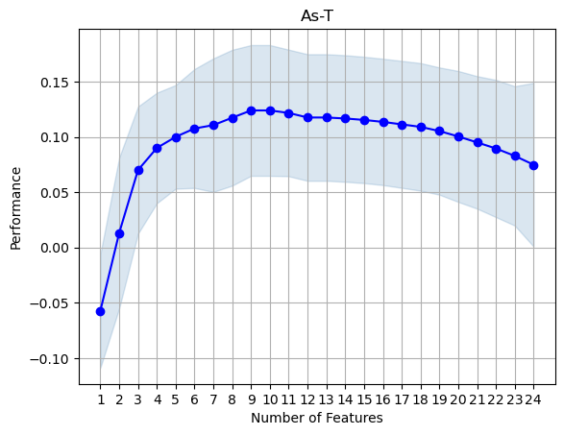
Figure 9.8.7: OLS feature performance plot for As with the entire dataset. The features were determined to be 'Alkalinity Total 4.5', 'Chlrid:D', 'Fe-T', 'P--T', 'Sulfat:D', 'Hardness Total (T)', 'K--T', 'x' and 'Months_Since_First_Sample’ with an average score of 0.12389640650093742. Iterations can be viewed on Jupyter notebook.
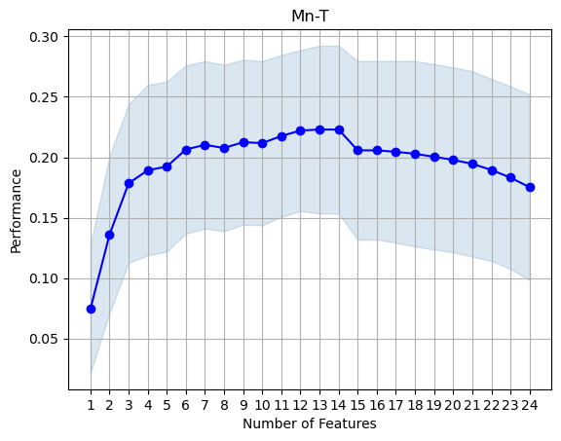
Figure 9.8.8: OLS feature performance plot for Mn with the entire dataset. The features were determined to be 'Alkalinity Total 4.5', 'Fe-T', 'N.Kjel:T', 'Residue Filterable 1.0u', 'Hardness Total (T)', 'K--T', 'MIN_TEMP', 'MAX_TEMP', 'FD', 'HW', 'MT', 'Aquifer_1', and 'x' with an average score of 0.2229. Iterations can be viewed on Jupyter notebook.
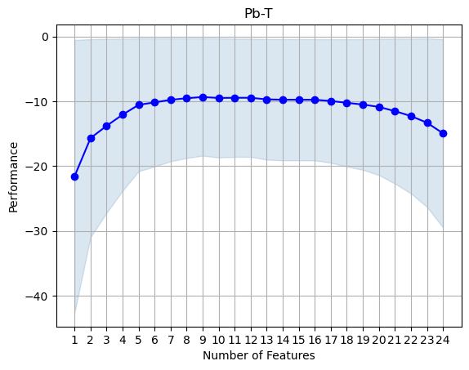
Figure 9.8.9: OLS feature performance plot for Pb with the entire dataset. The features were determined to be 'Alkalinity Total 4.5', 'P--T', 'Residue Filterable 1.0u', 'Sulfat:D', 'pH', 'HW', 'x', 'y', and 'Months_Since_First_Sample' with an average score of -9.3453. Iterations can be viewed on Jupyter notebook.
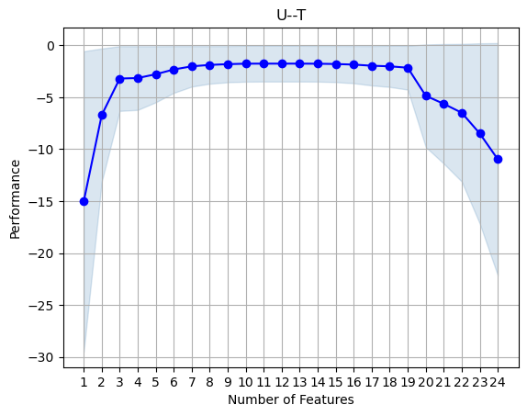
Figure 9.8.10: OLS feature performance plot for U with the entire dataset. The features were determined to be 'N.Kjel:T', 'MIN_TEMP', 'MAX_TEMP', 'FD', 'MT', 'Aquifer_1', 'Aquifer_2', 'x', 'y' with an average score of -1.8067. Iterations can be viewed on Jupyter notebook.

SWI Ordinary Least Squares Regression Models
Table 9.7.4:Summary of linear regression analysis of As for Seawater intrusion data.
SWI Summary of ksa1 model:
OLS Regression Results
==============================================================================
Dep. Variable: As_T R-squared: 0.574
Model: OLS Adj. R-squared: 0.486
Method: Least Squares F-statistic: 6.523
Date: Mon, 04 Dec 2023 Prob (F-statistic): 6.86e-10
Time: 16:13:16 Log-Likelihood: -105.13
No. Observations: 106 AIC: 248.3
Df Residuals: 87 BIC: 298.9
Df Model: 18
Covariance Type: nonrobust
=============================================================================================
coef std err t P>|t| [0.025 0.975]
---------------------------------------------------------------------------------------------
Intercept 0.1558 0.227 0.685 0.495 -0.296 0.608
Alkalinity_Total_4_5 0.1697 0.098 1.727 0.088 -0.026 0.365
Chlrid_D -0.1347 0.148 -0.910 0.365 -0.429 0.159
Fe_T 0.2064 0.097 2.120 0.037 0.013 0.400
N_Kjel_T -0.1781 0.088 -2.014 0.047 -0.354 -0.002
P__T -0.0650 0.083 -0.779 0.438 -0.231 0.101
Residue_Filterable_1_0u 0.0595 0.162 0.368 0.714 -0.262 0.381
Specific_Conductance 0.0688 0.190 0.361 0.719 -0.310 0.447
Sulfat_D 0.2827 0.120 2.358 0.021 0.044 0.521
pH -0.0434 0.089 -0.488 0.627 -0.220 0.133
K__T -0.3565 0.162 -2.204 0.030 -0.678 -0.035
PRECIPITATION -0.0977 0.094 -1.035 0.304 -0.285 0.090
MIN_TEMP -0.1989 0.226 -0.880 0.381 -0.648 0.250
MAX_TEMP 0.0576 0.218 0.263 0.793 -0.377 0.492
Aquifer_1 0.8336 0.238 3.508 0.001 0.361 1.306
Aquifer_2 0.0135 0.193 0.070 0.944 -0.370 0.397
Aquifer_3 -0.6913 0.149 -4.644 0.000 -0.987 -0.395
x -0.0025 0.001 -2.546 0.013 -0.004 -0.001
y 0.0020 0.001 1.743 0.085 -0.000 0.004
Months_Since_First_Sample 6.335e-05 0.001 0.069 0.945 -0.002 0.002
==============================================================================
Omnibus: 3.077 Durbin-Watson: 1.676
Prob(Omnibus): 0.215 Jarque-Bera (JB): 2.737
Skew: -0.192 Prob(JB): 0.255
Kurtosis: 3.687 Cond. No. 5.50e+18
==============================================================================
Notes:
[1] Standard Errors assume that the covariance matrix of the errors is correctly specified.
[2] The smallest eigenvalue is 3.46e-31. This might indicate that there are
strong multicollinearity problems or that the design matrix is singular.

Table 9.7.5:Summary of linear regression analysis of Mn for Seawater intrusion data.
SWI Summary of ksm1 model:
OLS Regression Results
==============================================================================
Dep. Variable: Mn_T R-squared: 0.701
Model: OLS Adj. R-squared: 0.640
Method: Least Squares F-statistic: 11.35
Date: Mon, 04 Dec 2023 Prob (F-statistic): 6.41e-16
Time: 16:13:16 Log-Likelihood: -86.344
No. Observations: 106 AIC: 210.7
Df Residuals: 87 BIC: 261.3
Df Model: 18
Covariance Type: nonrobust
=============================================================================================
coef std err t P>|t| [0.025 0.975]
---------------------------------------------------------------------------------------------
Intercept 0.5554 0.191 2.915 0.005 0.177 0.934
Alkalinity_Total_4_5 -0.3923 0.082 -4.767 0.000 -0.556 -0.229
Chlrid_D -0.7840 0.124 -6.325 0.000 -1.030 -0.538
Fe_T 0.0792 0.082 0.972 0.334 -0.083 0.241
N_Kjel_T 0.0256 0.074 0.346 0.730 -0.122 0.173
P__T 0.1732 0.070 2.477 0.015 0.034 0.312
Residue_Filterable_1_0u -0.2666 0.135 -1.968 0.052 -0.536 0.003
Specific_Conductance 0.3855 0.160 2.417 0.018 0.068 0.703
Sulfat_D 0.0487 0.100 0.485 0.629 -0.151 0.248
pH -0.1660 0.075 -2.228 0.028 -0.314 -0.018
K__T 0.3543 0.135 2.615 0.011 0.085 0.624
PRECIPITATION 0.0758 0.079 0.959 0.340 -0.081 0.233
MIN_TEMP -0.2834 0.189 -1.497 0.138 -0.660 0.093
MAX_TEMP 0.3236 0.183 1.769 0.080 -0.040 0.687
Aquifer_1 0.1848 0.199 0.928 0.356 -0.211 0.580
Aquifer_2 0.4531 0.161 2.806 0.006 0.132 0.774
Aquifer_3 -0.0825 0.125 -0.662 0.510 -0.330 0.165
x -0.0027 0.001 -3.244 0.002 -0.004 -0.001
y -0.0043 0.001 -4.536 0.000 -0.006 -0.002
Months_Since_First_Sample -0.0012 0.001 -1.618 0.109 -0.003 0.000
==============================================================================
Omnibus: 3.113 Durbin-Watson: 1.412
Prob(Omnibus): 0.211 Jarque-Bera (JB): 3.065
Skew: 0.114 Prob(JB): 0.216
Kurtosis: 3.801 Cond. No. 5.50e+18
==============================================================================
Notes:
[1] Standard Errors assume that the covariance matrix of the errors is correctly specified.
[2] The smallest eigenvalue is 3.46e-31. This might indicate that there are
strong multicollinearity problems or that the design matrix is singular.

Table 9.7.6:Summary of linear regression analysis of Pb for Seawater intrusion data.
SWI Summary of ksp1 model:
OLS Regression Results
==============================================================================
Dep. Variable: Pb_T R-squared: 0.799
Model: OLS Adj. R-squared: 0.757
Method: Least Squares F-statistic: 19.16
Date: Mon, 04 Dec 2023 Prob (F-statistic): 6.44e-23
Time: 16:13:16 Log-Likelihood: -65.487
No. Observations: 106 AIC: 169.0
Df Residuals: 87 BIC: 219.6
Df Model: 18
Covariance Type: nonrobust
=============================================================================================
coef std err t P>|t| [0.025 0.975]
---------------------------------------------------------------------------------------------
Intercept 1.1454 0.156 7.320 0.000 0.834 1.456
Alkalinity_Total_4_5 0.0050 0.068 0.074 0.941 -0.129 0.139
Chlrid_D 0.0758 0.102 0.745 0.458 -0.127 0.278
Fe_T 0.2221 0.067 3.316 0.001 0.089 0.355
N_Kjel_T -0.0998 0.061 -1.641 0.104 -0.221 0.021
P__T -0.0012 0.057 -0.021 0.983 -0.115 0.113
Residue_Filterable_1_0u 0.1949 0.111 1.752 0.083 -0.026 0.416
Specific_Conductance -0.0118 0.131 -0.090 0.929 -0.272 0.249
Sulfat_D -0.1689 0.082 -2.048 0.044 -0.333 -0.005
pH -0.0348 0.061 -0.569 0.571 -0.156 0.087
K__T -0.3826 0.111 -3.438 0.001 -0.604 -0.161
PRECIPITATION -0.0781 0.065 -1.202 0.233 -0.207 0.051
MIN_TEMP -0.2613 0.155 -1.681 0.096 -0.570 0.048
MAX_TEMP 0.2638 0.150 1.755 0.083 -0.035 0.563
Aquifer_1 0.3365 0.163 2.058 0.043 0.012 0.661
Aquifer_2 0.4938 0.133 3.723 0.000 0.230 0.757
Aquifer_3 0.3151 0.102 3.077 0.003 0.112 0.519
x 0.0002 0.001 0.349 0.728 -0.001 0.002
y 0.0010 0.001 1.242 0.218 -0.001 0.003
Months_Since_First_Sample -0.0057 0.001 -8.936 0.000 -0.007 -0.004
==============================================================================
Omnibus: 1.109 Durbin-Watson: 1.682
Prob(Omnibus): 0.574 Jarque-Bera (JB): 1.196
Skew: 0.224 Prob(JB): 0.550
Kurtosis: 2.733 Cond. No. 5.50e+18
==============================================================================
Notes:
[1] Standard Errors assume that the covariance matrix of the errors is correctly specified.
[2] The smallest eigenvalue is 3.46e-31. This might indicate that there are
strong multicollinearity problems or that the design matrix is singular.

Table 9.7.7:Summary of linear regression analysis of U for Seawater intrusion data.
SWI Summary of ksu1 model:
OLS Regression Results
==============================================================================
Dep. Variable: U__T R-squared: 0.760
Model: OLS Adj. R-squared: 0.710
Method: Least Squares F-statistic: 15.28
Date: Mon, 04 Dec 2023 Prob (F-statistic): 9.51e-20
Time: 16:13:16 Log-Likelihood: -74.851
No. Observations: 106 AIC: 187.7
Df Residuals: 87 BIC: 238.3
Df Model: 18
Covariance Type: nonrobust
=============================================================================================
coef std err t P>|t| [0.025 0.975]
---------------------------------------------------------------------------------------------
Intercept -0.6262 0.171 -3.663 0.000 -0.966 -0.286
Alkalinity_Total_4_5 0.4094 0.074 5.544 0.000 0.263 0.556
Chlrid_D -0.0236 0.111 -0.212 0.832 -0.245 0.197
Fe_T -0.1305 0.073 -1.784 0.078 -0.276 0.015
N_Kjel_T 0.1006 0.066 1.515 0.133 -0.031 0.233
P__T 0.0483 0.063 0.770 0.443 -0.076 0.173
Residue_Filterable_1_0u -0.0857 0.122 -0.706 0.482 -0.327 0.156
Specific_Conductance -0.1490 0.143 -1.041 0.301 -0.433 0.135
Sulfat_D 0.1895 0.090 2.104 0.038 0.010 0.369
pH -0.2015 0.067 -3.014 0.003 -0.334 -0.069
K__T 0.0517 0.122 0.426 0.671 -0.190 0.293
PRECIPITATION -0.0016 0.071 -0.023 0.982 -0.143 0.139
MIN_TEMP -0.2322 0.170 -1.367 0.175 -0.570 0.105
MAX_TEMP 0.2259 0.164 1.376 0.172 -0.100 0.552
Aquifer_1 -0.8594 0.179 -4.813 0.000 -1.214 -0.504
Aquifer_2 -0.0137 0.145 -0.095 0.925 -0.302 0.274
Aquifer_3 0.2470 0.112 2.208 0.030 0.025 0.469
x 0.0010 0.001 1.406 0.163 -0.000 0.003
y 0.0007 0.001 0.809 0.421 -0.001 0.002
Months_Since_First_Sample 0.0019 0.001 2.816 0.006 0.001 0.003
==============================================================================
Omnibus: 5.070 Durbin-Watson: 1.421
Prob(Omnibus): 0.079 Jarque-Bera (JB): 6.678
Skew: 0.144 Prob(JB): 0.0355
Kurtosis: 4.196 Cond. No. 5.50e+18
==============================================================================
Notes:
[1] Standard Errors assume that the covariance matrix of the errors is correctly specified.
[2] The smallest eigenvalue is 3.46e-31. This might indicate that there are
strong multicollinearity problems or that the design matrix is singular.

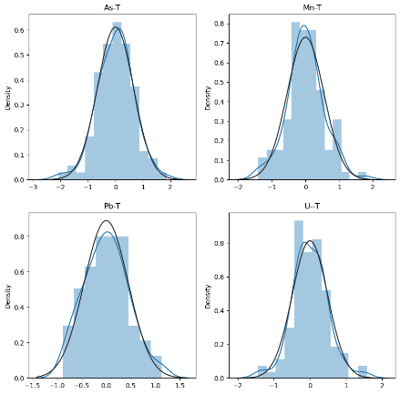
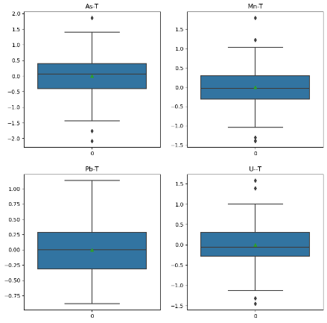
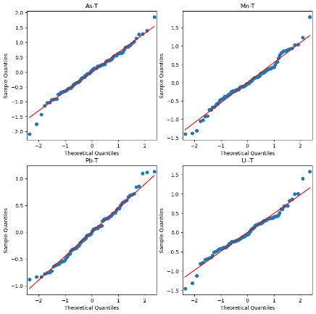
Figure 9.8.11: Top: Pairplots of the OLS model residuals for As, Mn, Pb, U with seawater intrusion data. Middle: Boxplots of the OLS model for As, Mn, Pb, U with seawater intrusion data. Bottom: Q-Q plots of the OLS model for As, Mn, Pb, U with seawater intrusion data.

Drought Metals Ordinary Least Squares Regression Models
Table 9.7.8:Summary of linear regression analysis of As for Drought data.
Drought Summary of ksa2 model:
OLS Regression Results
==============================================================================
Dep. Variable: As_T R-squared: 0.358
Model: OLS Adj. R-squared: 0.335
Method: Least Squares F-statistic: 15.83
Date: Mon, 04 Dec 2023 Prob (F-statistic): 9.70e-39
Time: 16:34:30 Log-Likelihood: -634.58
No. Observations: 530 AIC: 1307.
Df Residuals: 511 BIC: 1388.
Df Model: 18
Covariance Type: nonrobust
=============================================================================================
coef std err t P>|t| [0.025 0.975]
---------------------------------------------------------------------------------------------
Intercept 0.2900 0.086 3.378 0.001 0.121 0.459
Alkalinity_Total_4_5 0.3000 0.074 4.030 0.000 0.154 0.446
Chlrid_D -0.2121 0.053 -4.005 0.000 -0.316 -0.108
Fe_T 0.1757 0.043 4.049 0.000 0.090 0.261
N_Kjel_T 0.0297 0.039 0.767 0.443 -0.046 0.106
P__T 0.1427 0.041 3.462 0.001 0.062 0.224
Residue_Filterable_1_0u 0.1335 0.090 1.484 0.138 -0.043 0.310
Specific_Conductance -0.0887 0.125 -0.707 0.480 -0.335 0.158
Sulfat_D 0.1579 0.052 3.061 0.002 0.057 0.259
pH 0.0991 0.047 2.097 0.036 0.006 0.192
K__T 0.1283 0.054 2.377 0.018 0.022 0.234
PRECIPITATION 0.0306 0.045 0.683 0.495 -0.057 0.118
MIN_TEMP -0.0356 0.103 -0.346 0.730 -0.238 0.167
MAX_TEMP 0.0600 0.104 0.576 0.565 -0.145 0.265
Aquifer_1 0.1804 0.071 2.533 0.012 0.040 0.320
Aquifer_2 0.1846 0.071 2.617 0.009 0.046 0.323
Aquifer_3 -0.0750 0.074 -1.017 0.310 -0.220 0.070
x -0.0013 0.000 -4.097 0.000 -0.002 -0.001
y 0.0001 0.000 0.452 0.652 -0.000 0.001
Months_Since_First_Sample -0.0016 0.000 -3.674 0.000 -0.002 -0.001
==============================================================================
Omnibus: 25.276 Durbin-Watson: 1.613
Prob(Omnibus): 0.000 Jarque-Bera (JB): 27.895
Skew: 0.552 Prob(JB): 8.76e-07
Kurtosis: 2.795 Cond. No. 2.66e+18
==============================================================================

Notes:
[1] Standard Errors assume that the covariance matrix of the errors is correctly specified.
[2] The smallest eigenvalue is 5.8e-30. This might indicate that there are
strong multicollinearity problems or that the design matrix is singular.

Table 9.7.9:Summary of linear regression analysis of Mn for Drought data.
OLS Regression Results
==============================================================================
Dep. Variable: Mn_T R-squared: 0.374
Model: OLS Adj. R-squared: 0.352
Method: Least Squares F-statistic: 16.97
Date: Wed, 27 Dec 2023 Prob (F-statistic): 2.06e-41
Time: 14:02:31 Log-Likelihood: -627.83
No. Observations: 530 AIC: 1294.
Df Residuals: 511 BIC: 1375.
Df Model: 18
Covariance Type: nonrobust
=============================================================================================
coef std err t P>|t| [0.025 0.975]
---------------------------------------------------------------------------------------------
Intercept 0.0245 0.085 0.289 0.773 -0.142 0.191
Alkalinity_Total_4_5 0.0224 0.073 0.304 0.761 -0.122 0.167
Chlrid_D -0.1005 0.052 -1.922 0.055 -0.203 0.002
Fe_T 0.4547 0.043 10.615 0.000 0.371 0.539
N_Kjel_T 0.1266 0.038 3.315 0.001 0.052 0.202
P__T 0.0292 0.041 0.717 0.473 -0.051 0.109
Residue_Filterable_1_0u -0.2370 0.089 -2.669 0.008 -0.411 -0.063
Specific_Conductance 0.3752 0.124 3.029 0.003 0.132 0.618
Sulfat_D 0.0944 0.051 1.853 0.064 -0.006 0.194
pH -0.1225 0.047 -2.625 0.009 -0.214 -0.031
K__T 0.1511 0.053 2.835 0.005 0.046 0.256
PRECIPITATION -0.0006 0.044 -0.013 0.989 -0.087 0.086
MIN_TEMP 0.1520 0.102 1.495 0.135 -0.048 0.352
MAX_TEMP -0.0658 0.103 -0.639 0.523 -0.268 0.136
Aquifer_1 -0.0913 0.070 -1.298 0.195 -0.229 0.047
Aquifer_2 0.0506 0.070 0.727 0.468 -0.086 0.187
Aquifer_3 0.0651 0.073 0.894 0.372 -0.078 0.208
x -0.0013 0.000 -4.376 0.000 -0.002 -0.001
y 0.0004 0.000 1.597 0.111 -0.000 0.001
Months_Since_First_Sample -6.417e-05 0.000 -0.151 0.880 -0.001 0.001
==============================================================================
Omnibus: 17.848 Durbin-Watson: 1.533
Prob(Omnibus): 0.000 Jarque-Bera (JB): 15.986
Skew: 0.364 Prob(JB): 0.000338
Kurtosis: 2.558 Cond. No. 2.66e+18
==============================================================================

Notes:
[1] Standard Errors assume that the covariance matrix of the errors is correctly specified.
[2] The smallest eigenvalue is 5.8e-30. This might indicate that there are
strong multicollinearity problems or that the design matrix is singular.
Table 9.7.10:Summary of linear regression analysis of Pb for Drought data.
Drought Summary of ksp2 model:
OLS Regression Results
==============================================================================
Dep. Variable: Pb_T R-squared: 0.726
Model: OLS Adj. R-squared: 0.717
Method: Least Squares F-statistic: 75.29
Date: Mon, 04 Dec 2023 Prob (F-statistic): 7.57e-131
Time: 16:34:30 Log-Likelihood: -408.78
No. Observations: 530 AIC: 855.6
Df Residuals: 511 BIC: 936.8
Df Model: 18
Covariance Type: nonrobust
=============================================================================================
coef std err t P>|t| [0.025 0.975]
---------------------------------------------------------------------------------------------
Intercept 1.3501 0.056 24.083 0.000 1.240 1.460
Alkalinity_Total_4_5 0.0315 0.049 0.649 0.517 -0.064 0.127
Chlrid_D 0.0179 0.035 0.518 0.605 -0.050 0.086
Fe_T 0.1538 0.028 5.429 0.000 0.098 0.209
N_Kjel_T -0.0521 0.025 -2.061 0.040 -0.102 -0.002
P__T -0.0371 0.027 -1.377 0.169 -0.090 0.016
Residue_Filterable_1_0u 0.1497 0.059 2.549 0.011 0.034 0.265
Specific_Conductance 0.0286 0.082 0.350 0.727 -0.132 0.190
Sulfat_D -0.1373 0.034 -4.075 0.000 -0.203 -0.071
pH 0.0315 0.031 1.021 0.308 -0.029 0.092
K__T -0.0783 0.035 -2.222 0.027 -0.148 -0.009
PRECIPITATION -0.0744 0.029 -2.547 0.011 -0.132 -0.017
MIN_TEMP 0.0293 0.067 0.436 0.663 -0.103 0.161
MAX_TEMP 0.0401 0.068 0.589 0.556 -0.094 0.174
Aquifer_1 0.4721 0.047 10.152 0.000 0.381 0.563
Aquifer_2 0.4946 0.046 10.734 0.000 0.404 0.585
Aquifer_3 0.3834 0.048 7.958 0.000 0.289 0.478
x 0.0002 0.000 1.014 0.311 -0.000 0.001
y 0.0005 0.000 2.760 0.006 0.000 0.001
Months_Since_First_Sample -0.0070 0.000 -25.041 0.000 -0.008 -0.006
==============================================================================
Omnibus: 45.357 Durbin-Watson: 1.391
Prob(Omnibus): 0.000 Jarque-Bera (JB): 56.289
Skew: 0.710 Prob(JB): 5.99e-13
Kurtosis: 3.729 Cond. No. 2.66e+18
==============================================================================

Notes:
[1] Standard Errors assume that the covariance matrix of the errors is correctly specified.
[2] The smallest eigenvalue is 5.8e-30. This might indicate that there are
strong multicollinearity problems or that the design matrix is singular.

Table 9.7.11:Summary of linear regression analysis of U for Drought data.
Drought Summary of ksu2 model:
OLS Regression Results
==============================================================================
Dep. Variable: U__T R-squared: 0.580
Model: OLS Adj. R-squared: 0.565
Method: Least Squares F-statistic: 39.17
Date: Mon, 04 Dec 2023 Prob (F-statistic): 4.28e-84
Time: 16:34:30 Log-Likelihood: -522.29
No. Observations: 530 AIC: 1083.
Df Residuals: 511 BIC: 1164.
Df Model: 18
Covariance Type: nonrobust
=============================================================================================
coef std err t P>|t| [0.025 0.975]
---------------------------------------------------------------------------------------------
Intercept -0.5958 0.069 -8.579 0.000 -0.732 -0.459
Alkalinity_Total_4_5 0.1116 0.060 1.853 0.065 -0.007 0.230
Chlrid_D -0.1304 0.043 -3.043 0.002 -0.215 -0.046
Fe_T -0.0657 0.035 -1.871 0.062 -0.135 0.003
N_Kjel_T -0.0440 0.031 -1.407 0.160 -0.106 0.017
P__T 0.0427 0.033 1.280 0.201 -0.023 0.108
Residue_Filterable_1_0u -0.1250 0.073 -1.718 0.086 -0.268 0.018
Specific_Conductance 0.0336 0.101 0.331 0.741 -0.166 0.233
Sulfat_D 0.2661 0.042 6.374 0.000 0.184 0.348
pH -0.0151 0.038 -0.395 0.693 -0.090 0.060
K__T 0.1734 0.044 3.971 0.000 0.088 0.259
PRECIPITATION -0.1066 0.036 -2.945 0.003 -0.178 -0.035
MIN_TEMP -0.1669 0.083 -2.004 0.046 -0.331 -0.003
MAX_TEMP 0.1307 0.084 1.549 0.122 -0.035 0.296
Aquifer_1 -0.4268 0.058 -7.408 0.000 -0.540 -0.314
Aquifer_2 -0.3037 0.057 -5.320 0.000 -0.416 -0.192
Aquifer_3 0.1346 0.060 2.256 0.024 0.017 0.252
x 0.0011 0.000 4.569 0.000 0.001 0.002
y 0.0010 0.000 4.585 0.000 0.001 0.001
Months_Since_First_Sample 0.0033 0.000 9.403 0.000 0.003 0.004
==============================================================================
Omnibus: 5.743 Durbin-Watson: 1.382
Prob(Omnibus): 0.057 Jarque-Bera (JB): 5.659
Skew: 0.252 Prob(JB): 0.0590
Kurtosis: 3.051 Cond. No. 2.66e+18
==============================================================================
Notes:
[1] Standard Errors assume that the covariance matrix of the errors is correctly specified.
[2] The smallest eigenvalue is 5.8e-30. This might indicate that there are
strong multicollinearity problems or that the design matrix is singular.

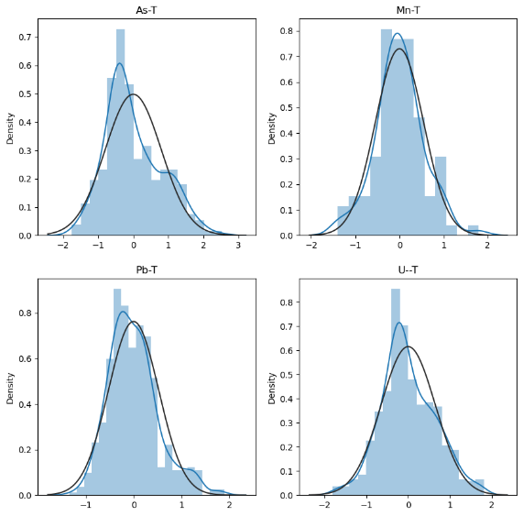
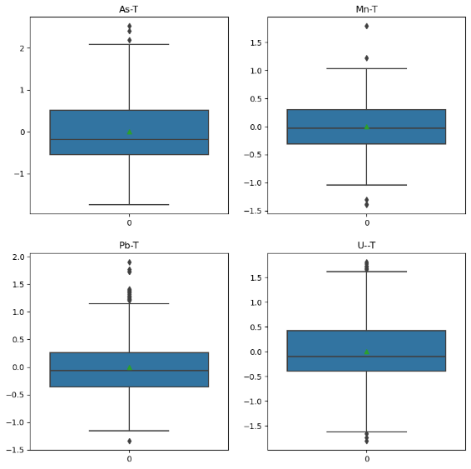
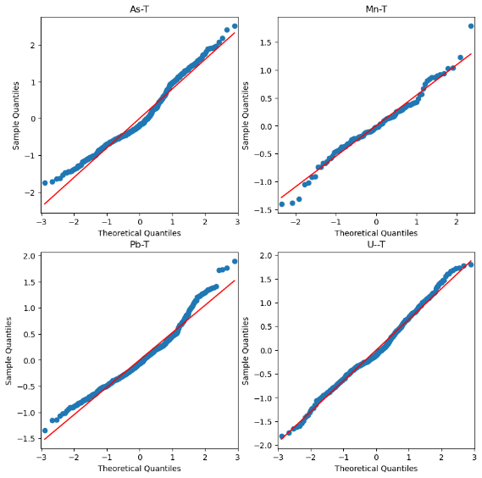
Figure 9.8.12: Top: Pairplots of the OLS model residuals for As, Mn, Pb, U with drought data. Middle: Boxplots of the OLS model for As, Mn, Pb, U with drought data. Bottom: Q-Q plots of the OLS model for As, Mn, Pb, U with drought data.

Flood Metals Ordinary Least Squares Regression Models
Table 9.7.12:Summary of linear regression analysis of As for flooded data.
Flood Summary of ksa3 model:
OLS Regression Results
==============================================================================
Dep. Variable: As_T R-squared: 0.328
Model: OLS Adj. R-squared: 0.301
Method: Least Squares F-statistic: 11.85
Date: Mon, 04 Dec 2023 Prob (F-statistic): 4.39e-28
Time: 16:31:58 Log-Likelihood: -555.04
No. Observations: 455 AIC: 1148.
Df Residuals: 436 BIC: 1226.
Df Model: 18
Covariance Type: nonrobust
=============================================================================================
coef std err t P>|t| [0.025 0.975]
---------------------------------------------------------------------------------------------
Intercept 0.1941 0.093 2.091 0.037 0.012 0.377
Alkalinity_Total_4_5 0.2659 0.072 3.712 0.000 0.125 0.407
Chlrid_D -0.2241 0.057 -3.903 0.000 -0.337 -0.111
Fe_T 0.1813 0.050 3.632 0.000 0.083 0.279
N_Kjel_T -0.1758 0.044 -4.034 0.000 -0.262 -0.090
P__T 0.2076 0.046 4.531 0.000 0.118 0.298
Residue_Filterable_1_0u 0.0704 0.087 0.808 0.420 -0.101 0.242
Specific_Conductance -0.0075 0.098 -0.076 0.940 -0.201 0.186
Sulfat_D 0.1761 0.059 2.999 0.003 0.061 0.292
pH 0.1138 0.052 2.188 0.029 0.012 0.216
K__T 0.1637 0.051 3.185 0.002 0.063 0.265
PRECIPITATION -0.0998 0.055 -1.817 0.070 -0.208 0.008
MIN_TEMP 0.1615 0.112 1.444 0.150 -0.058 0.381
MAX_TEMP -0.2055 0.111 -1.847 0.065 -0.424 0.013
Aquifer_1 0.2245 0.075 2.982 0.003 0.077 0.372
Aquifer_2 0.0302 0.082 0.366 0.715 -0.132 0.192
Aquifer_3 -0.0605 0.092 -0.659 0.510 -0.241 0.120
x -0.0017 0.000 -4.226 0.000 -0.003 -0.001
y -0.0006 0.000 -1.671 0.095 -0.001 0.000
Months_Since_First_Sample -0.0013 0.000 -2.670 0.008 -0.002 -0.000
==============================================================================
Omnibus: 7.966 Durbin-Watson: 1.717
Prob(Omnibus): 0.019 Jarque-Bera (JB): 8.121
Skew: 0.327 Prob(JB): 0.0172
Kurtosis: 2.967 Cond. No. 1.88e+18
==============================================================================

Notes:
[1] Standard Errors assume that the covariance matrix of the errors is correctly specified.
[2] The smallest eigenvalue is 9.3e-30. This might indicate that there are
strong multicollinearity problems or that the design matrix is singular.

Table 9.7.13:Summary of linear regression analysis of Mn for flooded data.
OLS Regression Results
==============================================================================
Dep. Variable: Mn_T R-squared: 0.408
Model: OLS Adj. R-squared: 0.384
Method: Least Squares F-statistic: 16.69
Date: Wed, 27 Dec 2023 Prob (F-statistic): 2.85e-39
Time: 14:03:03 Log-Likelihood: -526.37
No. Observations: 455 AIC: 1091.
Df Residuals: 436 BIC: 1169.
Df Model: 18
Covariance Type: nonrobust
=============================================================================================
coef std err t P>|t| [0.025 0.975]
---------------------------------------------------------------------------------------------
Intercept -0.0208 0.087 -0.239 0.811 -0.192 0.150
Alkalinity_Total_4_5 0.1702 0.067 2.530 0.012 0.038 0.302
Chlrid_D -0.0989 0.054 -1.835 0.067 -0.205 0.007
Fe_T 0.5798 0.047 12.368 0.000 0.488 0.672
N_Kjel_T 0.1326 0.041 3.239 0.001 0.052 0.213
P__T -0.0309 0.043 -0.718 0.473 -0.115 0.054
Residue_Filterable_1_0u 0.0118 0.082 0.145 0.885 -0.149 0.173
Specific_Conductance -0.0073 0.092 -0.079 0.937 -0.189 0.174
Sulfat_D 0.0627 0.055 1.137 0.256 -0.046 0.171
pH -0.0870 0.049 -1.781 0.076 -0.183 0.009
K__T 0.1275 0.048 2.643 0.009 0.033 0.222
PRECIPITATION -0.0676 0.052 -1.311 0.191 -0.169 0.034
MIN_TEMP 0.2092 0.105 1.992 0.047 0.003 0.416
MAX_TEMP -0.2897 0.104 -2.774 0.006 -0.495 -0.084
Aquifer_1 -0.0443 0.071 -0.627 0.531 -0.183 0.095
Aquifer_2 0.0268 0.077 0.346 0.729 -0.125 0.179
Aquifer_3 -0.0033 0.086 -0.039 0.969 -0.173 0.166
x -0.0012 0.000 -3.031 0.003 -0.002 -0.000
y 0.0004 0.000 0.969 0.333 -0.000 0.001
Months_Since_First_Sample 0.0002 0.000 0.383 0.702 -0.001 0.001
==============================================================================
Omnibus: 17.229 Durbin-Watson: 1.696
Prob(Omnibus): 0.000 Jarque-Bera (JB): 18.349
Skew: 0.491 Prob(JB): 0.000104
Kurtosis: 3.073 Cond. No. 1.88e+18
==============================================================================

Notes:
[1] Standard Errors assume that the covariance matrix of the errors is correctly specified.
[2] The smallest eigenvalue is 9.3e-30. This might indicate that there are
strong multicollinearity problems or that the design matrix is singular.
Flood Summary of ksp3 model:
Table 9.7.14:Summary of linear regression analysis of Pb for flooded data.
Flood Summary of ksp3 model:
OLS Regression Results
==============================================================================
Dep. Variable: Pb_T R-squared: 0.781
Model: OLS Adj. R-squared: 0.772
Method: Least Squares F-statistic: 86.21
Date: Mon, 04 Dec 2023 Prob (F-statistic): 4.83e-131
Time: 16:31:58 Log-Likelihood: -300.48
No. Observations: 455 AIC: 639.0
Df Residuals: 436 BIC: 717.2
Df Model: 18
Covariance Type: nonrobust
=============================================================================================
coef std err t P>|t| [0.025 0.975]
---------------------------------------------------------------------------------------------
Intercept 1.3962 0.053 26.316 0.000 1.292 1.500
Alkalinity_Total_4_5 0.0966 0.041 2.360 0.019 0.016 0.177
Chlrid_D 0.0636 0.033 1.938 0.053 -0.001 0.128
Fe_T 0.1259 0.029 4.411 0.000 0.070 0.182
N_Kjel_T 0.0546 0.025 2.193 0.029 0.006 0.104
P__T -0.0819 0.026 -3.129 0.002 -0.133 -0.030
Residue_Filterable_1_0u 0.1843 0.050 3.700 0.000 0.086 0.282
Specific_Conductance -0.1823 0.056 -3.240 0.001 -0.293 -0.072
Sulfat_D -0.0536 0.034 -1.596 0.111 -0.120 0.012
pH 0.0616 0.030 2.072 0.039 0.003 0.120
K__T -0.0497 0.029 -1.692 0.091 -0.107 0.008
PRECIPITATION -0.0946 0.031 -3.015 0.003 -0.156 -0.033
MIN_TEMP 0.1741 0.064 2.723 0.007 0.048 0.300
MAX_TEMP -0.1824 0.064 -2.869 0.004 -0.307 -0.057
Aquifer_1 0.4659 0.043 10.831 0.000 0.381 0.550
Aquifer_2 0.4197 0.047 8.912 0.000 0.327 0.512
Aquifer_3 0.5106 0.052 9.726 0.000 0.407 0.614
x 0.0005 0.000 2.052 0.041 2.04e-05 0.001
y -0.0002 0.000 -0.718 0.473 -0.001 0.000
Months_Since_First_Sample -0.0075 0.000 -27.786 0.000 -0.008 -0.007
==============================================================================
Omnibus: 56.374 Durbin-Watson: 1.370
Prob(Omnibus): 0.000 Jarque-Bera (JB): 78.125
Skew: 0.868 Prob(JB): 1.08e-17
Kurtosis: 4.051 Cond. No. 1.88e+18
==============================================================================

Notes:
[1] Standard Errors assume that the covariance matrix of the errors is correctly specified.
[2] The smallest eigenvalue is 9.3e-30. This might indicate that there are
strong multicollinearity problems or that the design matrix is singular.

Table 9.7.15:Summary of linear regression analysis of U for flooded data.
Flood Summary of ksu3 model:
OLS Regression Results
==============================================================================
Dep. Variable: U__T R-squared: 0.574
Model: OLS Adj. R-squared: 0.557
Method: Least Squares F-statistic: 32.67
Date: Mon, 04 Dec 2023 Prob (F-statistic): 2.57e-69
Time: 16:31:58 Log-Likelihood: -451.34
No. Observations: 455 AIC: 940.7
Df Residuals: 436 BIC: 1019.
Df Model: 18
Covariance Type: nonrobust
=============================================================================================
coef std err t P>|t| [0.025 0.975]
---------------------------------------------------------------------------------------------
Intercept -0.3825 0.074 -5.175 0.000 -0.528 -0.237
Alkalinity_Total_4_5 0.2063 0.057 3.616 0.000 0.094 0.318
Chlrid_D -0.0605 0.046 -1.324 0.186 -0.150 0.029
Fe_T -0.1210 0.040 -3.044 0.002 -0.199 -0.043
N_Kjel_T -0.1100 0.035 -3.169 0.002 -0.178 -0.042
P__T 0.0267 0.036 0.733 0.464 -0.045 0.098
Residue_Filterable_1_0u -0.0365 0.069 -0.526 0.599 -0.173 0.100
Specific_Conductance 0.0117 0.078 0.149 0.882 -0.142 0.166
Sulfat_D 0.2233 0.047 4.774 0.000 0.131 0.315
pH -0.0315 0.041 -0.762 0.447 -0.113 0.050
K__T 0.0881 0.041 2.154 0.032 0.008 0.169
PRECIPITATION -0.0829 0.044 -1.896 0.059 -0.169 0.003
MIN_TEMP -0.1035 0.089 -1.162 0.246 -0.278 0.072
MAX_TEMP 0.0730 0.089 0.824 0.410 -0.101 0.247
Aquifer_1 -0.3363 0.060 -5.612 0.000 -0.454 -0.219
Aquifer_2 -0.0772 0.066 -1.176 0.240 -0.206 0.052
Aquifer_3 0.0310 0.073 0.424 0.672 -0.113 0.175
x 0.0009 0.000 2.747 0.006 0.000 0.002
y 0.0015 0.000 5.017 0.000 0.001 0.002
Months_Since_First_Sample 0.0024 0.000 6.261 0.000 0.002 0.003
==============================================================================
Omnibus: 27.039 Durbin-Watson: 1.458
Prob(Omnibus): 0.000 Jarque-Bera (JB): 30.202
Skew: 0.601 Prob(JB): 2.77e-07
Kurtosis: 3.385 Cond. No. 1.88e+18
==============================================================================

Notes:
[1] Standard Errors assume that the covariance matrix of the errors is correctly specified.
[2] The smallest eigenvalue is 9.3e-30. This might indicate that there are
strong multicollinearity problems or that the design matrix is singular.

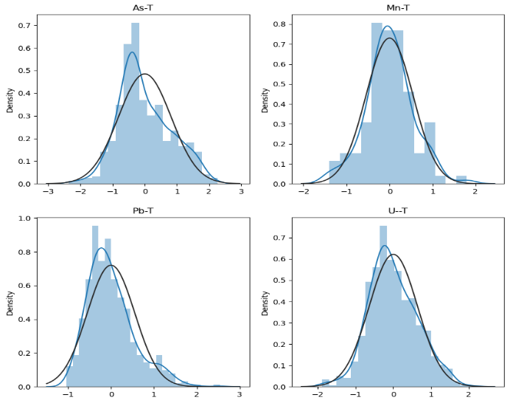
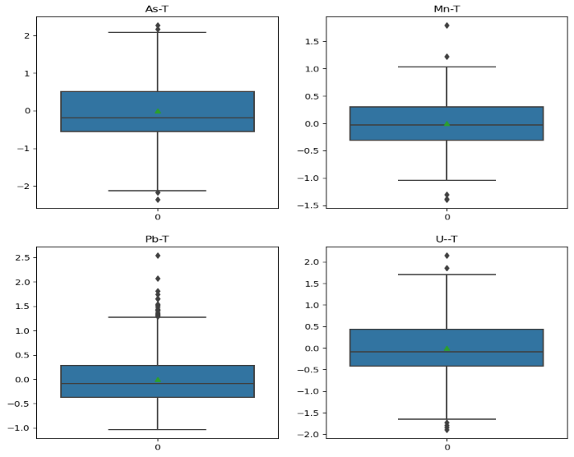
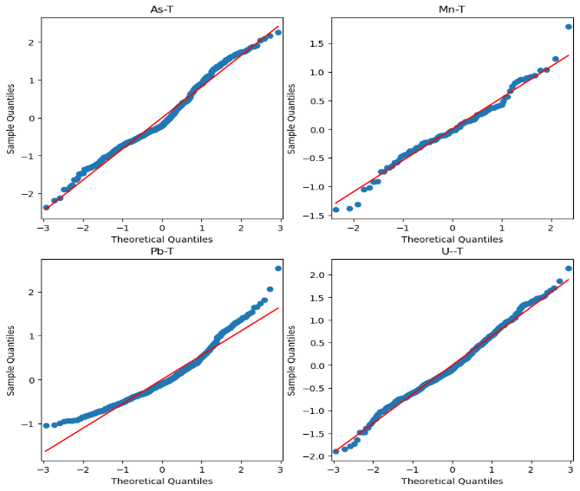
Figure 9.8.13: Top: Pairplots of the OLS model residuals for As, Mn, Pb, U with flood data. Middle: Boxplots of the OLS model for As, Mn, Pb, U with flood data. Bottom: Q-Q plots of the OLS model for As, Mn, Pb, U with flood data.

    - Metals with Rising Maximum Temperatures Ordinary Least Squares Regression Models
Table 9.7.16:Summary of linear regression analysis of As for rising maximum temperatures.
HW Summary of ksa4 model:
OLS Regression Results
==============================================================================
Dep. Variable: As_T R-squared: 0.323
Model: OLS Adj. R-squared: 0.303
Method: Least Squares F-statistic: 15.72
Date: Mon, 04 Dec 2023 Prob (F-statistic): 1.27e-39
Time: 16:32:06 Log-Likelihood: -747.64
No. Observations: 611 AIC: 1533.
Df Residuals: 592 BIC: 1617.
Df Model: 18
Covariance Type: nonrobust
=============================================================================================
coef std err t P>|t| [0.025 0.975]
---------------------------------------------------------------------------------------------
Intercept 0.3040 0.083 3.682 0.000 0.142 0.466
Alkalinity_Total_4_5 0.3470 0.064 5.453 0.000 0.222 0.472
Chlrid_D -0.2249 0.049 -4.610 0.000 -0.321 -0.129
Fe_T 0.1275 0.042 3.037 0.002 0.045 0.210
N_Kjel_T -0.0701 0.037 -1.874 0.061 -0.144 0.003
P__T 0.1421 0.040 3.581 0.000 0.064 0.220
Residue_Filterable_1_0u 0.0117 0.076 0.154 0.877 -0.137 0.161
Specific_Conductance 0.0673 0.094 0.716 0.474 -0.117 0.252
Sulfat_D 0.1528 0.049 3.131 0.002 0.057 0.249
pH 0.0698 0.044 1.570 0.117 -0.018 0.157
K__T 0.1728 0.048 3.596 0.000 0.078 0.267
PRECIPITATION -0.0023 0.042 -0.054 0.957 -0.084 0.080
MIN_TEMP 0.0588 0.090 0.650 0.516 -0.119 0.237
MAX_TEMP -0.0023 0.092 -0.026 0.980 -0.182 0.178
Aquifer_1 0.2635 0.068 3.887 0.000 0.130 0.397
Aquifer_2 0.1363 0.069 1.971 0.049 0.000 0.272
Aquifer_3 -0.0957 0.075 -1.270 0.205 -0.244 0.052
x -0.0013 0.000 -4.252 0.000 -0.002 -0.001
y -0.0005 0.000 -1.506 0.133 -0.001 0.000
Months_Since_First_Sample -0.0018 0.000 -4.240 0.000 -0.003 -0.001
==============================================================================
Omnibus: 15.123 Durbin-Watson: 1.585
Prob(Omnibus): 0.001 Jarque-Bera (JB): 15.524
Skew: 0.371 Prob(JB): 0.000426
Kurtosis: 2.754 Cond. No. 1.38e+18
==============================================================================

Notes:
[1] Standard Errors assume that the covariance matrix of the errors is correctly specified.
[2] The smallest eigenvalue is 2.4e-29. This might indicate that there are
strong multicollinearity problems or that the design matrix is singular.

Table 9.7.17:Summary of linear regression analysis of Mn for rising maximum temperatures.
OLS Regression Results
==============================================================================
Dep. Variable: Mn_T R-squared: 0.404
Model: OLS Adj. R-squared: 0.386
Method: Least Squares F-statistic: 22.29
Date: Wed, 27 Dec 2023 Prob (F-statistic): 3.78e-55
Time: 14:03:16 Log-Likelihood: -708.92
No. Observations: 611 AIC: 1456.
Df Residuals: 592 BIC: 1540.
Df Model: 18
Covariance Type: nonrobust
=============================================================================================
coef std err t P>|t| [0.025 0.975]
---------------------------------------------------------------------------------------------
Intercept 0.0659 0.078 0.851 0.395 -0.086 0.218
Alkalinity_Total_4_5 0.1450 0.060 2.428 0.015 0.028 0.262
Chlrid_D -0.0665 0.046 -1.451 0.147 -0.156 0.023
Fe_T 0.4753 0.039 12.058 0.000 0.398 0.553
N_Kjel_T 0.1326 0.035 3.778 0.000 0.064 0.202
P__T 0.0319 0.037 0.856 0.392 -0.041 0.105
Residue_Filterable_1_0u -0.1834 0.071 -2.573 0.010 -0.323 -0.043
Specific_Conductance 0.1908 0.088 2.163 0.031 0.018 0.364
Sulfat_D 0.0898 0.046 1.961 0.050 -0.000 0.180
pH -0.1368 0.042 -3.276 0.001 -0.219 -0.055
K__T 0.1813 0.045 4.021 0.000 0.093 0.270
PRECIPITATION -0.0054 0.039 -0.138 0.890 -0.082 0.072
MIN_TEMP 0.2393 0.085 2.818 0.005 0.073 0.406
MAX_TEMP -0.1759 0.086 -2.046 0.041 -0.345 -0.007
Aquifer_1 -0.0705 0.064 -1.108 0.268 -0.195 0.054
Aquifer_2 0.0385 0.065 0.593 0.553 -0.089 0.166
Aquifer_3 0.0979 0.071 1.384 0.167 -0.041 0.237
x -0.0012 0.000 -4.263 0.000 -0.002 -0.001
y 0.0009 0.000 2.956 0.003 0.000 0.002
Months_Since_First_Sample -0.0002 0.000 -0.505 0.614 -0.001 0.001
==============================================================================
Omnibus: 10.386 Durbin-Watson: 1.500
Prob(Omnibus): 0.006 Jarque-Bera (JB): 10.261
Skew: 0.288 Prob(JB): 0.00591
Kurtosis: 2.731 Cond. No. 1.38e+18
==============================================================================

Notes:
[1] Standard Errors assume that the covariance matrix of the errors is correctly specified.
[2] The smallest eigenvalue is 2.4e-29. This might indicate that there are
strong multicollinearity problems or that the design matrix is singular.
HW Summary of ksp4 model:

Table 9.7.18:Summary of linear regression analysis of Pb for rising maximum temperatures.
HW Summary of ksp4 model:
OLS Regression Results
==============================================================================
Dep. Variable: Pb_T R-squared: 0.694
Model: OLS Adj. R-squared: 0.684
Method: Least Squares F-statistic: 74.43
Date: Mon, 04 Dec 2023 Prob (F-statistic): 8.17e-139
Time: 16:32:06 Log-Likelihood: -505.65
No. Observations: 611 AIC: 1049.
Df Residuals: 592 BIC: 1133.
Df Model: 18
Covariance Type: nonrobust
=============================================================================================
coef std err t P>|t| [0.025 0.975]
---------------------------------------------------------------------------------------------
Intercept 1.2772 0.056 22.984 0.000 1.168 1.386
Alkalinity_Total_4_5 0.0179 0.043 0.418 0.676 -0.066 0.102
Chlrid_D 0.0098 0.033 0.298 0.766 -0.055 0.074
Fe_T 0.2044 0.028 7.234 0.000 0.149 0.260
N_Kjel_T 0.0071 0.025 0.280 0.779 -0.042 0.056
P__T -0.0278 0.027 -1.040 0.299 -0.080 0.025
Residue_Filterable_1_0u 0.1915 0.051 3.747 0.000 0.091 0.292
Specific_Conductance -0.0691 0.063 -1.093 0.275 -0.193 0.055
Sulfat_D -0.1078 0.033 -3.284 0.001 -0.172 -0.043
pH 0.0702 0.030 2.345 0.019 0.011 0.129
K__T -0.1345 0.032 -4.159 0.000 -0.198 -0.071
PRECIPITATION -0.1197 0.028 -4.258 0.000 -0.175 -0.065
MIN_TEMP 0.1175 0.061 1.930 0.054 -0.002 0.237
MAX_TEMP -0.0984 0.062 -1.595 0.111 -0.219 0.023
Aquifer_1 0.4358 0.046 9.553 0.000 0.346 0.525
Aquifer_2 0.4537 0.047 9.752 0.000 0.362 0.545
Aquifer_3 0.3877 0.051 7.640 0.000 0.288 0.487
x 0.0003 0.000 1.501 0.134 -9.61e-05 0.001
y 0.0005 0.000 2.233 0.026 5.91e-05 0.001
Months_Since_First_Sample -0.0067 0.000 -23.902 0.000 -0.007 -0.006
==============================================================================
Omnibus: 86.455 Durbin-Watson: 1.451
Prob(Omnibus): 0.000 Jarque-Bera (JB): 126.770
Skew: 0.965 Prob(JB): 2.97e-28
Kurtosis: 4.119 Cond. No. 1.38e+18
==============================================================================

Notes:
[1] Standard Errors assume that the covariance matrix of the errors is correctly specified.
[2] The smallest eigenvalue is 2.4e-29. This might indicate that there are
strong multicollinearity problems or that the design matrix is singular.

Table 9.7.19:Summary of linear regression analysis of U for rising maximum temperatures.
HW Summary of ksu4 model:
OLS Regression Results
==============================================================================
Dep. Variable: U__T R-squared: 0.588
Model: OLS Adj. R-squared: 0.576
Method: Least Squares F-statistic: 46.95
Date: Mon, 04 Dec 2023 Prob (F-statistic): 2.37e-101
Time: 16:32:06 Log-Likelihood: -596.04
No. Observations: 611 AIC: 1230.
Df Residuals: 592 BIC: 1314.
Df Model: 18
Covariance Type: nonrobust
=============================================================================================
coef std err t P>|t| [0.025 0.975]
---------------------------------------------------------------------------------------------
Intercept -0.4188 0.064 -6.501 0.000 -0.545 -0.292
Alkalinity_Total_4_5 0.1792 0.050 3.609 0.000 0.082 0.277
Chlrid_D -0.1248 0.038 -3.278 0.001 -0.200 -0.050
Fe_T -0.1066 0.033 -3.253 0.001 -0.171 -0.042
N_Kjel_T -0.0568 0.029 -1.948 0.052 -0.114 0.000
P__T 0.0458 0.031 1.480 0.139 -0.015 0.107
Residue_Filterable_1_0u -0.0483 0.059 -0.815 0.415 -0.165 0.068
Specific_Conductance -0.0099 0.073 -0.135 0.893 -0.154 0.134
Sulfat_D 0.2258 0.038 5.931 0.000 0.151 0.301
pH -0.0518 0.035 -1.492 0.136 -0.120 0.016
K__T 0.1692 0.037 4.514 0.000 0.096 0.243
PRECIPITATION -0.1186 0.033 -3.638 0.000 -0.183 -0.055
MIN_TEMP -0.1409 0.071 -1.996 0.046 -0.280 -0.002
MAX_TEMP 0.0669 0.071 0.936 0.350 -0.074 0.207
Aquifer_1 -0.3574 0.053 -6.757 0.000 -0.461 -0.254
Aquifer_2 -0.2280 0.054 -4.227 0.000 -0.334 -0.122
Aquifer_3 0.1666 0.059 2.833 0.005 0.051 0.282
x 0.0015 0.000 6.314 0.000 0.001 0.002
y 0.0011 0.000 4.153 0.000 0.001 0.002
Months_Since_First_Sample 0.0025 0.000 7.537 0.000 0.002 0.003
==============================================================================
Omnibus: 7.273 Durbin-Watson: 1.353
Prob(Omnibus): 0.026 Jarque-Bera (JB): 7.166
Skew: 0.259 Prob(JB): 0.0278
Kurtosis: 3.115 Cond. No. 1.38e+18
==============================================================================

Notes:
[1] Standard Errors assume that the covariance matrix of the errors is correctly specified.
[2] The smallest eigenvalue is 2.4e-29. This might indicate that there are
strong multicollinearity problems or that the design matrix is singular.

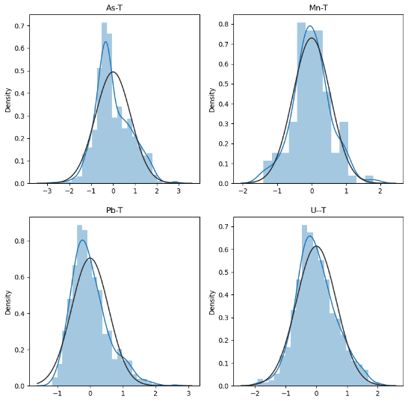
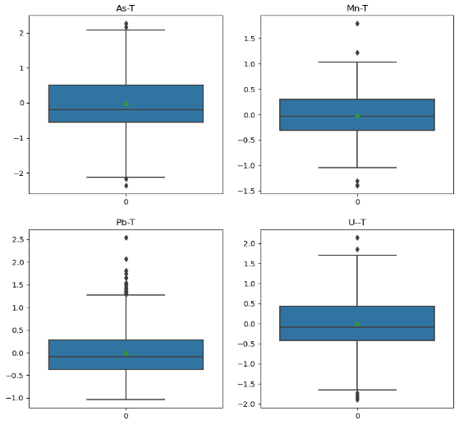
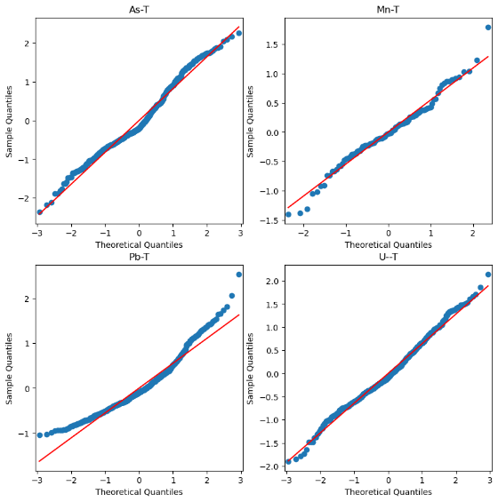
Figure 9.8.14: Top: Pairplots of the OLS model residuals for As, Mn, Pb, U with rising maximum temperatures. Middle: Boxplots of the OLS model for As, Mn, Pb, U with rising maximum temperatures. Bottom: Q-Q plots of the OLS model for As, Mn, Pb, U with rising maximum temperatures.

    - Metals with Rising Minimum Temperatures Ordinary Least Squares Regression Models
Table 9.7.20:Summary of linear regression analysis of As for rising minimum temperatures.
MT Summary of ksa5 model:
OLS Regression Results
==============================================================================
Dep. Variable: As_T R-squared: 0.349
Model: OLS Adj. R-squared: 0.332
Method: Least Squares F-statistic: 20.68
Date: Mon, 04 Dec 2023 Prob (F-statistic): 2.52e-53
Time: 16:22:59 Log-Likelihood: -858.59
No. Observations: 713 AIC: 1755.
Df Residuals: 694 BIC: 1842.
Df Model: 18
Covariance Type: nonrobust
=============================================================================================
coef std err t P>|t| [0.025 0.975]
---------------------------------------------------------------------------------------------
Intercept 0.2436 0.076 3.195 0.001 0.094 0.393
Alkalinity_Total_4_5 0.3092 0.060 5.166 0.000 0.192 0.427
Chlrid_D -0.2651 0.046 -5.820 0.000 -0.355 -0.176
Fe_T 0.1508 0.037 4.054 0.000 0.078 0.224
N_Kjel_T -0.0995 0.033 -2.987 0.003 -0.165 -0.034
P__T 0.1539 0.036 4.271 0.000 0.083 0.225
Residue_Filterable_1_0u 0.1108 0.079 1.408 0.160 -0.044 0.265
Specific_Conductance -0.0110 0.093 -0.119 0.905 -0.193 0.171
Sulfat_D 0.1448 0.043 3.343 0.001 0.060 0.230
pH 0.0680 0.042 1.609 0.108 -0.015 0.151
K__T 0.1973 0.043 4.602 0.000 0.113 0.281
PRECIPITATION 0.0075 0.038 0.195 0.846 -0.068 0.083
MIN_TEMP 0.0257 0.089 0.287 0.774 -0.150 0.201
MAX_TEMP 0.0407 0.090 0.453 0.651 -0.136 0.217
Aquifer_1 0.2228 0.062 3.576 0.000 0.100 0.345
Aquifer_2 0.0965 0.063 1.536 0.125 -0.027 0.220
Aquifer_3 -0.0757 0.070 -1.076 0.282 -0.214 0.062
x -0.0015 0.000 -5.477 0.000 -0.002 -0.001
y -2.616e-05 0.000 -0.098 0.922 -0.001 0.000
Months_Since_First_Sample -0.0014 0.000 -3.712 0.000 -0.002 -0.001
==============================================================================
Omnibus: 21.185 Durbin-Watson: 1.669
Prob(Omnibus): 0.000 Jarque-Bera (JB): 22.282
Skew: 0.425 Prob(JB): 1.45e-05
Kurtosis: 3.162 Cond. No. 3.96e+18
==============================================================================

Notes:
[1] Standard Errors assume that the covariance matrix of the errors is correctly specified.
[2] The smallest eigenvalue is 3.49e-30. This might indicate that there are
strong multicollinearity problems or that the design matrix is singular.

Table 9.7.21:Summary of linear regression analysis of Mn for rising minimum temperatures.
OLS Regression Results
==============================================================================
Dep. Variable: Mn_T R-squared: 0.380
Model: OLS Adj. R-squared: 0.364
Method: Least Squares F-statistic: 23.61
Date: Wed, 27 Dec 2023 Prob (F-statistic): 2.69e-60
Time: 14:14:16 Log-Likelihood: -841.41
No. Observations: 713 AIC: 1721.
Df Residuals: 694 BIC: 1808.
Df Model: 18
Covariance Type: nonrobust
=============================================================================================
coef std err t P>|t| [0.025 0.975]
---------------------------------------------------------------------------------------------
Intercept -0.0213 0.074 -0.287 0.775 -0.167 0.125
Alkalinity_Total_4_5 0.1218 0.058 2.085 0.037 0.007 0.237
Chlrid_D -0.1206 0.044 -2.711 0.007 -0.208 -0.033
Fe_T 0.5167 0.036 14.230 0.000 0.445 0.588
N_Kjel_T 0.1374 0.033 4.223 0.000 0.073 0.201
P__T 0.0054 0.035 0.152 0.879 -0.064 0.074
Residue_Filterable_1_0u -0.1286 0.077 -1.674 0.095 -0.279 0.022
Specific_Conductance 0.1721 0.091 1.901 0.058 -0.006 0.350
Sulfat_D 0.0720 0.042 1.702 0.089 -0.011 0.155
pH -0.0949 0.041 -2.298 0.022 -0.176 -0.014
K__T 0.1484 0.042 3.545 0.000 0.066 0.231
PRECIPITATION 0.0168 0.037 0.447 0.655 -0.057 0.090
MIN_TEMP 0.1643 0.087 1.881 0.060 -0.007 0.336
MAX_TEMP -0.1323 0.088 -1.509 0.132 -0.304 0.040
Aquifer_1 -0.0865 0.061 -1.421 0.156 -0.206 0.033
Aquifer_2 -0.0233 0.061 -0.379 0.704 -0.144 0.097
Aquifer_3 0.0884 0.069 1.288 0.198 -0.046 0.223
x -0.0013 0.000 -4.992 0.000 -0.002 -0.001
y 0.0007 0.000 2.767 0.006 0.000 0.001
Months_Since_First_Sample 0.0002 0.000 0.654 0.514 -0.000 0.001
==============================================================================
Omnibus: 21.510 Durbin-Watson: 1.438
Prob(Omnibus): 0.000 Jarque-Bera (JB): 22.013
Skew: 0.406 Prob(JB): 1.66e-05
Kurtosis: 2.712 Cond. No. 3.96e+18
==============================================================================

Notes:
[1] Standard Errors assume that the covariance matrix of the errors is correctly specified.
[2] The smallest eigenvalue is 3.49e-30. This might indicate that there are
strong multicollinearity problems or that the design matrix is singular.

Table 9.7.22:Summary of linear regression analysis of Pb for rising minimum temperatures.
MT Summary of ksp5 model:
OLS Regression Results
==============================================================================
Dep. Variable: Pb_T R-squared: 0.679
Model: OLS Adj. R-squared: 0.671
Method: Least Squares F-statistic: 81.71
Date: Mon, 04 Dec 2023 Prob (F-statistic): 9.75e-158
Time: 16:22:59 Log-Likelihood: -606.15
No. Observations: 713 AIC: 1250.
Df Residuals: 694 BIC: 1337.
Df Model: 18
Covariance Type: nonrobust
=============================================================================================
coef std err t P>|t| [0.025 0.975]
---------------------------------------------------------------------------------------------
Intercept 1.3276 0.054 24.808 0.000 1.223 1.433
Alkalinity_Total_4_5 -0.0393 0.042 -0.935 0.350 -0.122 0.043
Chlrid_D 0.0055 0.032 0.171 0.864 -0.057 0.068
Fe_T 0.2122 0.026 8.130 0.000 0.161 0.263
N_Kjel_T 0.0038 0.023 0.161 0.872 -0.042 0.050
P__T -0.0308 0.025 -1.219 0.223 -0.080 0.019
Residue_Filterable_1_0u 0.2124 0.055 3.846 0.000 0.104 0.321
Specific_Conductance -0.0440 0.065 -0.676 0.499 -0.172 0.084
Sulfat_D -0.0948 0.030 -3.118 0.002 -0.155 -0.035
pH 0.0935 0.030 3.152 0.002 0.035 0.152
K__T -0.1343 0.030 -4.463 0.000 -0.193 -0.075
PRECIPITATION -0.1222 0.027 -4.536 0.000 -0.175 -0.069
MIN_TEMP 0.0697 0.063 1.109 0.268 -0.054 0.193
MAX_TEMP -0.0444 0.063 -0.705 0.481 -0.168 0.079
Aquifer_1 0.4646 0.044 10.624 0.000 0.379 0.550
Aquifer_2 0.4597 0.044 10.430 0.000 0.373 0.546
Aquifer_3 0.4033 0.049 8.172 0.000 0.306 0.500
x 0.0003 0.000 1.447 0.148 -0.000 0.001
y 0.0005 0.000 2.495 0.013 9.99e-05 0.001
Months_Since_First_Sample -0.0069 0.000 -25.779 0.000 -0.007 -0.006
==============================================================================
Omnibus: 92.831 Durbin-Watson: 1.461
Prob(Omnibus): 0.000 Jarque-Bera (JB): 133.620
Skew: 0.918 Prob(JB): 9.66e-30
Kurtosis: 4.063 Cond. No. 3.96e+18
==============================================================================

Notes:
[1] Standard Errors assume that the covariance matrix of the errors is correctly specified.
[2] The smallest eigenvalue is 3.49e-30. This might indicate that there are
strong multicollinearity problems or that the design matrix is singular.

Table 9.7.23:Summary of linear regression analysis of U for rising minimum temperatures.
OLS Regression Results
==============================================================================
Dep. Variable: U__T R-squared: 0.578
Model: OLS Adj. R-squared: 0.567
Method: Least Squares F-statistic: 52.76
Date: Mon, 04 Dec 2023 Prob (F-statistic): 8.55e-117
Time: 16:22:59 Log-Likelihood: -704.33
No. Observations: 713 AIC: 1447.
Df Residuals: 694 BIC: 1533.
Df Model: 18
Covariance Type: nonrobust
=============================================================================================
coef std err t P>|t| [0.025 0.975]
---------------------------------------------------------------------------------------------
Intercept -0.4203 0.061 -6.844 0.000 -0.541 -0.300
Alkalinity_Total_4_5 0.2038 0.048 4.227 0.000 0.109 0.298
Chlrid_D -0.0843 0.037 -2.299 0.022 -0.156 -0.012
Fe_T -0.1355 0.030 -4.522 0.000 -0.194 -0.077
N_Kjel_T -0.0448 0.027 -1.671 0.095 -0.098 0.008
P__T 0.0639 0.029 2.203 0.028 0.007 0.121
Residue_Filterable_1_0u -0.0113 0.063 -0.179 0.858 -0.136 0.113
Specific_Conductance -0.0437 0.075 -0.586 0.558 -0.190 0.103
Sulfat_D 0.2139 0.035 6.129 0.000 0.145 0.282
pH -0.0732 0.034 -2.149 0.032 -0.140 -0.006
K__T 0.1310 0.035 3.792 0.000 0.063 0.199
PRECIPITATION -0.1141 0.031 -3.690 0.000 -0.175 -0.053
MIN_TEMP -0.1054 0.072 -1.462 0.144 -0.247 0.036
MAX_TEMP 0.0444 0.072 0.614 0.539 -0.098 0.187
Aquifer_1 -0.3732 0.050 -7.437 0.000 -0.472 -0.275
Aquifer_2 -0.1808 0.051 -3.575 0.000 -0.280 -0.082
Aquifer_3 0.1337 0.057 2.361 0.019 0.023 0.245
x 0.0014 0.000 6.083 0.000 0.001 0.002
y 0.0013 0.000 6.031 0.000 0.001 0.002
Months_Since_First_Sample 0.0025 0.000 8.077 0.000 0.002 0.003
==============================================================================
Omnibus: 12.354 Durbin-Watson: 1.321
Prob(Omnibus): 0.002 Jarque-Bera (JB): 12.496
Skew: 0.309 Prob(JB): 0.00193
Kurtosis: 3.197 Cond. No. 3.96e+18
==============================================================================

Notes:
[1] Standard Errors assume that the covariance matrix of the errors is correctly specified.
[2] The smallest eigenvalue is 3.49e-30. This might indicate that there are
strong multicollinearity problems or that the design matrix is singular.

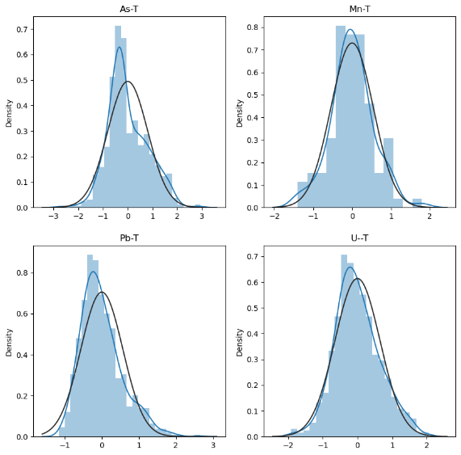
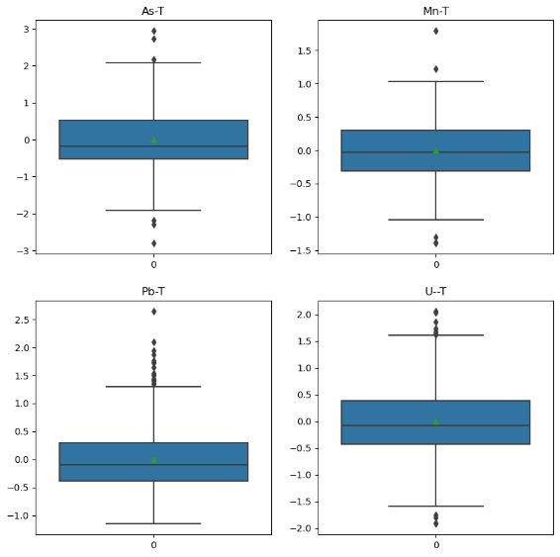
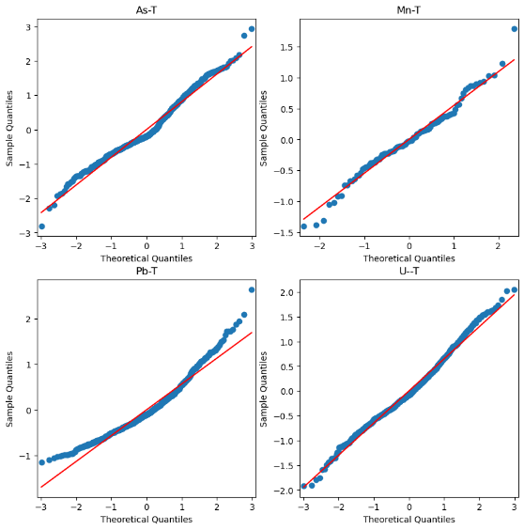
Figure 9.8.15: Top: Pairplots of the OLS model residuals for As, Mn, Pb, U with rising minimum temperatures. Middle: Boxplots of the OLS model for As, Mn, Pb, U with rising minimum temperatures. Bottom: Q-Q plots of the OLS model for As, Mn, Pb, U with rising minimum temperatures.

